APPENDICES

Appendix 1: Description of the study populations. The colum “*M. alcon*” indicates if the predator is present (1) or absent (0). X and Y coordinates are given for the centroid of the population in Swedish grid (RT 90) coordinate system. Population in Högsjön, Vättlefjäll was subsequently divided in two populations (B and C) because...

|  |  |  |  |  |  |  |
| --- | --- | --- | --- | --- | --- | --- |
| Population ID | County | Population name | *M. alcon* | X | Y | Area (Ha) |
| A | Ale | Bockemossen | 1 | 6420758 | 1277444 | 10.16 |
| B,C | Göteborg | Högsjön, Vättlefjäll | 1 | 6418804 | 1284149 | 19.88 |
| D | Göteborg | Orremossen, Vättlefjäll | 1 | 6416407 | 1278600 | 10.30 |
| E | Herrljunga | Remmene skjutfält, stora lokalen V vägen | 1 | 6439185 | 1332333 | 0.90 |
| F | Herrljunga | Remmene skjutfält, V vägen | 1 | 6438949 | 1332388 | 0.95 |
| G | Herrljunga | Remmene skjutfält, vid vallen | 1 | 6439135 | 1332460 | 0.49 |
| H | Lerum | Vite mosse NO | 1 | 6421701 | 1286925 | 2.71 |
| I | Partille | Maderna-Haketjärn, NO sidan Haketjärn | 1 | 6404125 | 1282891 | 5.80 |
| J | Vårgårda | Lida. Betesfållan | 1 | 6423501 | 1322251 | 0.92 |
| K | Vårgårda | Tånga hed | 1 | 6437602 | 1324202 | 5.35 |
| L | Ale | ST. KROKSJÖN Ö stranden | 0 | 6432023 | 1291750 | 0.68 |
| M | Borås | strand på NÄSUDDEN i FRISJÖN | 0 | 6388474 | 1328934 | 0.07 |
| N | Mark | 400 m norr om HÄRSNÄS, Härsjön vid utloppet | 0 | 6387807 | 1300990 | 0.02 |
| O | Svenljunga | 150 m nordnordväst om HJORTÅS. Strand | 0 | 6348447 | 1335103 | 0.13 |
| P | Svenljunga | 500 m östsydöst om TOVHULT. Strand (Kalvsjön) | 0 | 6344766 | 1333221 | 0.43 |
| Q | Svenljunga | KALV CAMPING Ö | 0 | 6349681 | 1334890 | 0.01 |
| R | Svenljunga | OLSHULT. Strand, betesmark | 0 | 6395122 | 1342387 | 0.65 |
| S | Tranemo | 400 m sydväst om BLÅBO. Strand, sjö (Marjebosjön) | 0 | 6371331 | 1361234 | 2.51 |
| T | Tranemo | ALGUTSTORPASJÖN. Sjöstrand | 0 | 6379112 | 1357106 | 0.13 |

Appendix 2: Graphic representations of the three-way interactions included in the models presented in Table 1 in the main text. Contour plots show the relationship between fitness and pairs of traits, while keeping the other trait constant, in populations with and without the predator: A) Predator x Phenology x Flower number (significant in 2010), B) Predator x Phenology x Shoot height (significant in 2011), C) Predator x Flower number x Shoot height (significant in 2011).

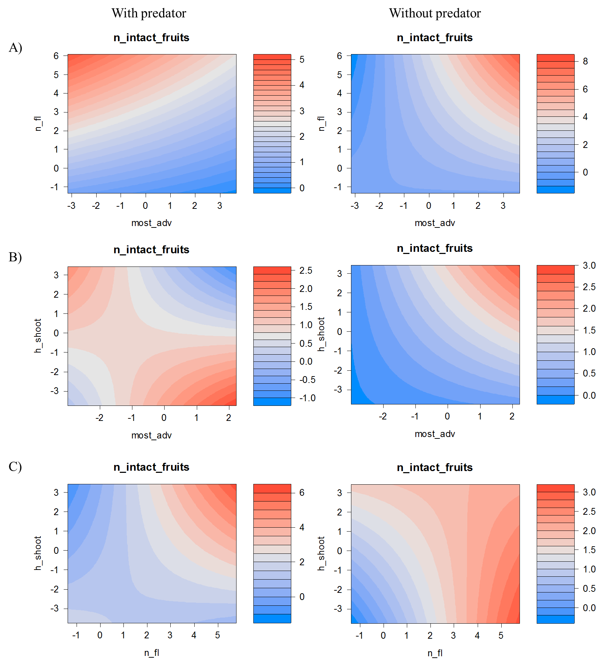

Appendix 3: Partial regression plots for non-linear effects. A) Quadratic effects of phenology on relative fitness, while keeping the other traits constant, in populations with and without the predator in 2010, B) Quadratic effects of number of flowers, while keeping the other traits constant, in populations with and without the predator in 2010 (interaction with predator not significant) and 2011(significant interaction with predator). Shaded areas represent confidence intervals.

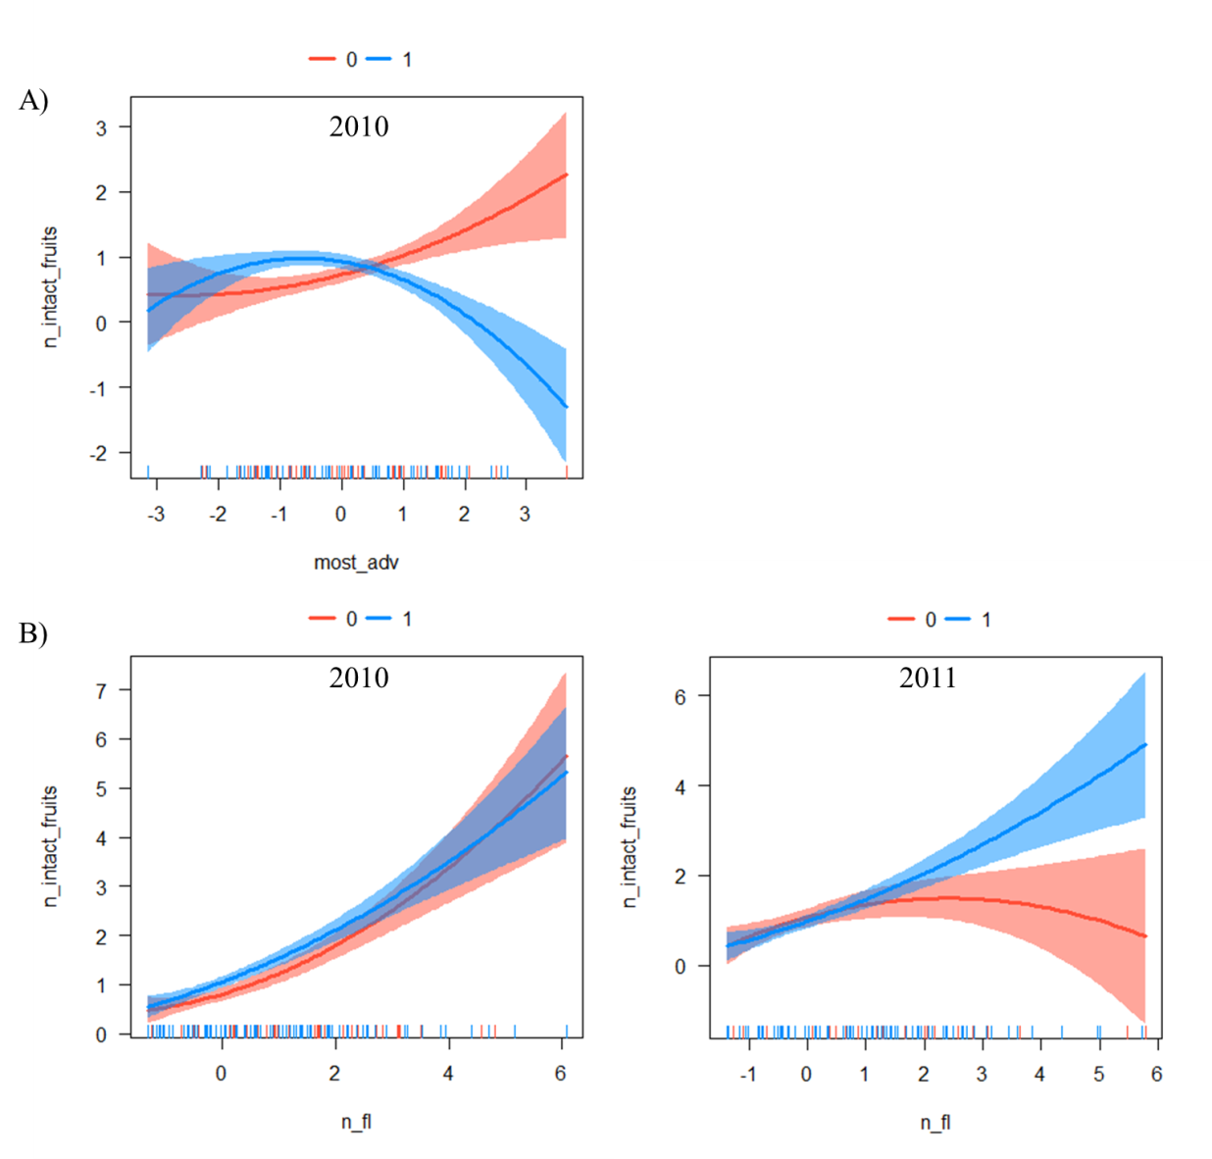

Appendix 4: Linear selection gradients (’s from multiple regressions of relative fitness on standardized reproductive traits) for each population in 2010 and 2011. Boldface indicates significance.

|  |  |  |  |  |  |  |  |  |  |  |  |
| --- | --- | --- | --- | --- | --- | --- | --- | --- | --- | --- | --- |
| Population ID | |  | 2010 | | | |  | 2011 | | | |
| Phenology | Flower  number |  | Shoot  height |  | Phenology | Flower  number |  | Shoot  height |
| With *M. alcon* | |  |  |  | |  |  |  |  |  | |
|  | A |  | -0.173 | **0.747** | | -0.101 |  | -0.129 | **0.766** | **-0.346** | |
|  | B |  | **-0.580** | **0.950** | | 0.186 |  | 0.047 | **0.411** | 0.015 | |
|  | C |  | 0.057 | **0.872** | | -0.068 |  | -0.003 | 0.263 | 0.305 | |
|  | D |  | 0.004 | **0.354** | | 0.222 |  | -0.001 | 0.474 | -0.078 | |
|  | E |  | -0.205 | **0.656** | | 0.125 |  | -0.271 | **1.076** | -0.157 | |
|  | F |  | -0.235 | **0.541** | | -0.040 |  | -0.287 | 0.525 | 0.001 | |
|  | G |  | **-0.355** | **0.436** | | -0.011 |  | 0.215 | 0.222 | **-0.467** | |
|  | H |  | -0.192 | **0.479** | | 0.119 |  | -0.154 | **0.668** | -0.095 | |
|  | I |  | **-0.469** | -0.095 | | 0.250 |  | **-0.473** | 0.000 | -0.418 | |
|  | J |  | 0.131 | 0.163 | | **0.360** |  | 0.073 | 0.137 | 0.114 | |
|  | K |  | 0.030 | **0.707** | | -0.008 |  | -0.077 | **1.380** | -0.374 | |
| Without *M. alcon* | |  |  |  | |  |  |  |  |  | |
|  | L |  | 0.115 | 0.096 | | **0.357** |  | **0.368** | **0.247** | 0.156 | |
|  | M |  | **0.197** | -0.005 | | **0.258** |  | **0.234** | **0.247** | 0.121 | |
|  | N |  | **0.520** | **0.830** | | 0.203 |  | - | - | - | |
|  | O |  | 0.059 | **0.573** | | 0.041 |  | - | - | - | |
|  | P |  | 0.197 | **0.482** | | -0.278 |  | - | - | - | |
|  | Q |  | 0.079 | **0.558** | | 0.058 |  | - | - | - | |
|  | R |  | 0.581 | 0.344 | | 0.120 |  | 0.440 | -0.019 | -0.244 | |
|  | S |  | 0.155 | **0.952** | | 0.104 |  | 0.315 | 0.053 | **0.723** | |
|  | T |  | 0.038 | **0.827** | | **-0.150** |  | 0.133 | **0.482** | **0.200** | |

Appendix 5: Estimates from logistic regressions of the probability of attack on phenology for each population with *M. alcon* in 2010 and 2011. Boldface indicates significance.

|  |  |  |
| --- | --- | --- |
| Population ID | 2010 | 2011 |
| A | 0.449 | **1.359** |
| B | **0.511** | **0.801** |
| C | **1.264** | **0.736** |
| D | -0.328 | **1.034** |
| E | **0.395** | **0.699** |
| F | **0.830** | **0.652** |
| G | **0.481** | **0.511** |
| H | **0.358** | **0.613** |
| I | **0.883** | **1.569** |
| J | **0.659** | **0.775** |
| K | -0.072 | **1.144** |

Appendix 6: Direct, indirect and total effects of reproductive traits on fitness in 2010 and 2011. Boldface indicates significance.

|  |  |  |  |  |  |  |  |
| --- | --- | --- | --- | --- | --- | --- | --- |
| Reproductive trait | 2010 | | |  | 2011 | | |
| Direct | Indirect | Total |  | Direct | Indirect | Total |
| Phenology | - | **-0.041** | **-0.041** |  | - | **-0.046** | **-0.046** |
| Flower number | **0.705** | 0.009 | **0.714** |  | **0.595** | **-0.057** | **0.538** |
| Shoot height | **-0.058** | **-0.030** | **-0.088** |  | **-0.172** | **-0.026** | **-0.198** |

Appendix 7: Effects of traits on interaction intensity for each population with *M. alcon* in 2010 and 2011. Numbers are estimates from multiple regressions of number of eggs on reproductive traits. Boldface indicates significance.

|  |  |  |  |  |  |  |  |
| --- | --- | --- | --- | --- | --- | --- | --- |
| Population ID | 2010 | | |  | 2011 | | |
| Phenology | Flower  number | Shoot  height |  | Phenology | Flower  number | Shoot  height |
| A | 0,181 | 0,223 | 0,031 |  | 1,151 | 0,850 | 0,203 |
| B | 0,052 | **0,205** | 0,182 |  | 0,436 | **1,094** | 0,173 |
| C | **0,299** | -0,071 | **0,309** |  | 0,307 | **1,034** | -0,321 |
| D | -0,016 | 0,022 | -0,039 |  | 0,186 | **0,322** | -0,016 |
| E | 0,156 | 0,196 | 0,023 |  | 0,608 | **1,077** | -0,074 |
| F | **0,988** | **2,558** | -0,370 |  | 1,032 | **3,902** | -0,814 |
| G | 0,211 | **0,916** | -0,197 |  | 0,249 | **2,023** | 0,391 |
| H | **0,935** | **1,570** | -0,298 |  | **2,476** | 1,310 | 0,368 |
| I | **3,302** | **2,813** | -0,304 |  | **4,979** | **13,714** | -1,103 |
| J | **2,172** | **1,797** | 0,217 |  | 1,193 | **6,002** | -0,158 |
| K | 0,063 | -0,290 | 0,460 |  | 0,766 | **2,340** | 1,044 |