SUPPORTING INFORMATION

Appendix S1: Description of the study populations. The colum “*Pa*” indicates if *P. alcon* is present (1) or absent (0). The columns “Mean n eggs” and “Prop. attacked” indicate, respectively, the mean number of eggs per plant and the proportion of plants attacked, in each population where the predator is present. X and Y coordinates are given for the centroid of the population in Swedish grid (RT 90) coordinate system. Populations B and C are two distant locations belonging to the same big population, which extends all around the lake Högsjön (coordinates are given for the centroid of this big population, as coordinates for locations B and C were unavailable).

|  |  |  |  |  |  |  |  |  |  |  |  |  |
| --- | --- | --- | --- | --- | --- | --- | --- | --- | --- | --- | --- | --- |
| Pop. ID | County | Population name | Habitat type | *Pa* | Mean n eggs | |  | Prop. attacked | | X | Y | Area (Ha) |
| 2010 | 2011 |  | 2010 | 2011 |
| A | Ale | Bockemossen | Bog | 1 | 0.51 | 2.17 |  | 0.19 | 0.46 | 6420758 | 1277444 | 10.16 |
| B | Göteborg | Högsjön, Vättlefjäll | Lake shore | 1 | 0.32 | 1.88 |  | 0.15 | 0.51 | 6418804 | 1284149 | 19.88 |
| C | Göteborg | Högsjön, Vättlefjäll | Lake shore | 1 | 0.02 | 0.92 |  | 0.01 | 0.33 | 6418804 | 1284149 | 19.88 |
| D | Göteborg | Orremossen, Vättlefjäll | Bog | 1 | 0.27 | 0.32 |  | 0.09 | 0.12 | 6416407 | 1278600 | 10.30 |
| E | Herrljunga | Remmene skjutfält population 1 | Bog | 1 | 0.94 | 2.16 |  | 0.35 | 0.44 | 6439185 | 1332333 | 0.90 |
| F | Herrljunga | Remmene skjutfält population 2 | Bog | 1 | 2.68 | 3.32 |  | 0.46 | 0.47 | 6438949 | 1332388 | 0.95 |
| G | Herrljunga | Remmene skjutfält population 3 | Bog | 1 | 0.87 | 1.72 |  | 0.27 | 0.31 | 6439135 | 1332460 | 0.49 |
| H | Lerum | Vite mosse | Bog | 1 | 3.22 | 5.4 |  | 0.61 | 0.58 | 6421701 | 1286925 | 2.71 |
| I | Partille | Maderna-Haketjärn | Lake shore, bog | 1 | 4.6 | 12.47 |  | 0.64 | 0.61 | 6404125 | 1282891 | 5.80 |
| J | Vårgårda | Lida | Pasture | 1 | 3.99 | 7.7 |  | 0.57 | 0.67 | 6423501 | 1322251 | 0.92 |
| K | Vårgårda | Tånga hed | Pasture | 1 | 1.18 | 3.24 |  | 0.34 | 0.45 | 6437602 | 1324202 | 5.35 |
| L | Ale | Stora Kroksjön | Lake shore | 0 | - | - |  | - | - | 6432023 | 1291750 | 0.68 |
| M | Borås | Näsudden i Frisjön | Lake shore | 0 | - | - |  | - | - | 6388474 | 1328934 | 0.07 |
| N | Mark | Härsnäs, Härsjön | Lake shore | 0 | - | - |  | - | - | 6387807 | 1300990 | 0.02 |
| O | Svenljunga | Hjortås | Lake shore, meadow | 0 | - | - |  | - | - | 6348447 | 1335103 | 0.13 |
| P | Svenljunga | Tovhult, Kalvsjön | Lake shore, meadow | 0 | - | - |  | - | - | 6344766 | 1333221 | 0.43 |
| Q | Svenljunga | Kalv Camping | Lake shore | 0 | - | - |  | - | - | 6349681 | 1334890 | 0.01 |
| R | Svenljunga | Olshult | Lake shore, meadow | 0 | - | - |  | - | - | 6395122 | 1342387 | 0.65 |
| S | Tranemo | Blåbo, Marjebosjön | Lake shore | 0 | - | - |  | - | - | 6371331 | 1361234 | 2.51 |
| T | Tranemo | Algutstorpasjön | Lake shore | 0 | - | - |  | - | - | 6379112 | 1357106 | 0.13 |

Appendix S2: Selection gradient analyses for three traits, flowering phenology, flower number, and shoot height, of the plant *G. pneumonanthe* in 2010 (N = 2000 plants in 20 populations) and 2011 (N = 1598 plants in 16 populations), using the mean flower developmental stage (rather than the stage of the most advanced flower) as the estimate of phenology. Results are from linear models with Type II sums of squares, including: A) only linear effects, B) linear, quadratic and interaction effects. All models included effects of population × trait interactions. Estimates from a model without interaction terms are given for significant main effects where the population × trait interaction is not significant. Fitness was estimated by the number of intact fruits. Traits were standardized and fitness relativized before analyses.

|  |  |  |  |  |  |  |  |
| --- | --- | --- | --- | --- | --- | --- | --- |
| Source of variation | |  | 2010 |  |  |  | 2011 |
| df | F | Estim |  | df | F |
| A) Linear terms | |  |  |  |  |  |  |
|  | Phenology (early flowering) | 1 | 0.42 |  |  | 1 | 2.45 |
|  | Flower number | 1 | 207.08*** |  |  | 1 | 69.87*** |
|  | Shoot height | 1 | 6.25 * | 0.122 |  | 1 | 0.41 |
|  | Population × Phenology | 19 | 3.10*** |  |  | 15 | 1.63* |
|  | Population × Flower number | 19 | 4.78*** |  |  | 15 | 2.56*** |
|  | Population × Shoot height | 19 | 1.12 |  |  | 15 | 2.63** |
|  |  |  |  |  |  |  |  |
| B) Non-linear terms | |  |  |  |  |  |  |
|  | Phenology 2 | 1 | 0.56 |  |  | 1 | 0.52 |
|  | Flower number 2 | 1 | 1.58 |  |  | 1 | 0.83 |
|  | Shoot height 2 | 1 | 0.57 |  |  | 1 | 0.01 |
|  | Population × Phenology 2 | 19 | 0.63 |  |  | 15 | 0.92 |
|  | Population × Flower number 2 | 19 | 1.81* |  |  | 15 | 2.09 *** |
|  | Population × Shoot height 2 | 19 | 1.06 |  |  | 15 | 0.36 |
|  | Phenology × Flower number | 1 | 1.50 |  |  | 1 | 0.30 |
|  | Phenology × Shoot height | 1 | 1.54 |  |  | 1 | 1.18 |
|  | Flower number × Shoot height | 1 | 1.36 |  |  | 1 | 0.66 |
|  | Population × Phenology × Flower number | 19 | 2.38 *** |  |  | 15 | 2.41** |
|  | Population × Phenology × Shoot height | 19 | 0.80 |  |  | 15 | 0.57 |
|  | Population × Flower number × Shoot height | 19 | 1.03 |  |  | 15 | 2.21 ** |

* p < 0.05; ** p < 0.01; *** p < 0.001

Appendix S3: Linear selection gradients (’s from multiple regressions of relative fitness on standardized reproductive traits) for each population in 2010 and 2011.

|  |  |  |  |  |  |  |  |  |  |  |  |
| --- | --- | --- | --- | --- | --- | --- | --- | --- | --- | --- | --- |
| Population ID | |  | 2010 | | | |  | 2011 | | | |
| Phenology | Flower  number |  | Shoot  height |  | Phenology | Flower  number |  | Shoot  height |
| With *P. alcon* | |  |  |  | |  |  |  |  |  | |
|  | A |  | -0.173 | 0.747*** | | -0.101 |  | -0.129 | 0.766*** | -0.346** | |
|  | B |  | -0.580* | 0.950*** | | 0.186 |  | 0.047 | 0.411* | 0.015 | |
|  | C |  | 0.057 | 0.872*** | | -0.068 |  | -0.003 | 0.263 | 0.305 | |
|  | D |  | 0.004 | 0.354* | | 0.222 |  | -0.001 | 0.474 | -0.078 | |
|  | E |  | -0.205 | 0.656** | | 0.125 |  | -0.271 | 1.076*** | -0.157 | |
|  | F |  | -0.235 | 0.541* | | -0.040 |  | -0.287 | 0.525 | 0.001 | |
|  | G |  | -0.355** | 0.436** | | -0.011 |  | 0.215 | 0.222 | -0.467* | |
|  | H |  | -0.192 | 0.479* | | 0.119 |  | -0.154 | 0.668*** | -0.095 | |
|  | I |  | -0.469** | -0.095 | | 0.250 |  | -0.473* | 0.000 | -0.418 | |
|  | J |  | 0.131 | 0.163 | | 0.360* |  | 0.073 | 0.137 | 0.114 | |
|  | K |  | -0.034 | 0.651*** | | -0.005 |  | -0.077 | 1.380*** | -0.374 | |
| Without *P. alcon* | |  |  |  | |  |  |  |  |  | |
|  | L |  | 0.115 | 0.096 | | 0.357* |  | 0.368** | 0.247* | 0.156 | |
|  | M |  | 0.197* | -0.005 | | 0.258** |  | 0.234** | 0.247** | 0.121 | |
|  | N |  | 0.520*** | 0.830*** | | 0.203 |  | - | - | - | |
|  | O |  | 0.059 | 0.573*** | | 0.041 |  | - | - | - | |
|  | P |  | 0.197 | 0.482** | | -0.278 |  | - | - | - | |
|  | Q |  | 0.079 | 0.558*** | | 0.058 |  | - | - | - | |
|  | R |  | 0.581 | 0.344 | | 0.120 |  | 0.440 | -0.019 | -0.244 | |
|  | S |  | 0.155 | 0.952*** | | 0.104 |  | 0.315 | 0.053 | 0.723* | |
|  | T |  | 0.038 | 0.827*** | | -0.150* |  | 0.133 | 0.482*** | 0.200* | |

* p < 0.05; ** p < 0.01; *** p < 0.001

Appendix S4: Among-population variation on the effect of *G. pneumonanthe* traits on predation by *P. alcon*.

Figure S4.1: Partial regression plots showing among-population variation on the effect of *G. pneumonanthe* flowering phenology on A) the probability of attack (logistic regressions, Population x Phenology interaction was not significant) and B) the number of eggs of *P. alcon* (linear regressions, Population x Phenology interaction was significant) in 2010 and 2011. Each regression line is labelled with the code of the corresponding population (N = 10 in 2010 and N = 11 in 2011).

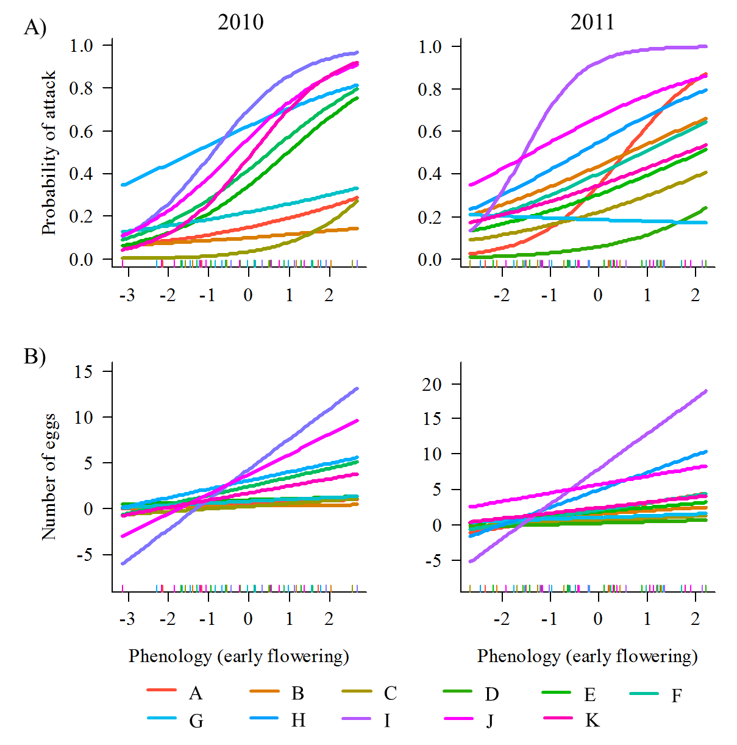

Figure S4.2: Partial regression plots showing among-population variation on the effect of *G. pneumonanthe* flower number on A) the probability of attack (logistic regressions, Population x Flower number interaction was significant in 2010 and not significant in 2011) and B) the number of eggs of *P. alcon* (linear regressions, Population x Flower number interaction was significant) in 2010 and 2011. Each regression line is labelled with the code of the corresponding population (N = 10 in 2010 and N = 11 in 2011).

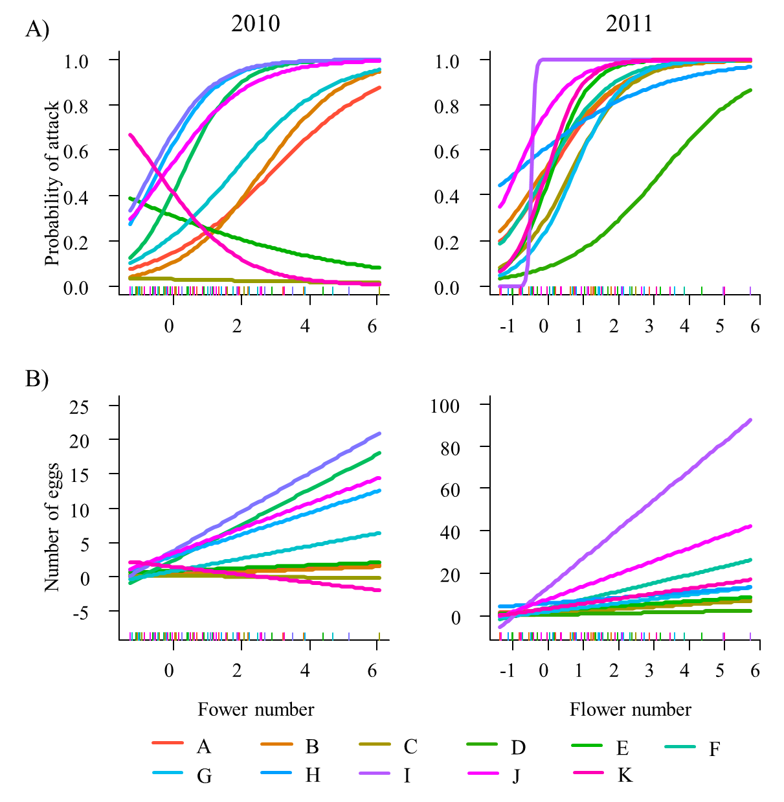

Figure S4.3: Partial regression plots showing among-population variation on the effect of *G. pneumonanthe* shoot height on A) the probability of attack (logistic regressions, Population x Shoot height interaction was not significant in 2010 and significant in 2011) and B) the number of eggs of *P. alcon* (linear regressions, Population x Shoot height interaction was not significant) in 2010 and 2011. Each regression line is labelled with the code of the corresponding population (N = 10 in 2010 and N = 11 in 2011).

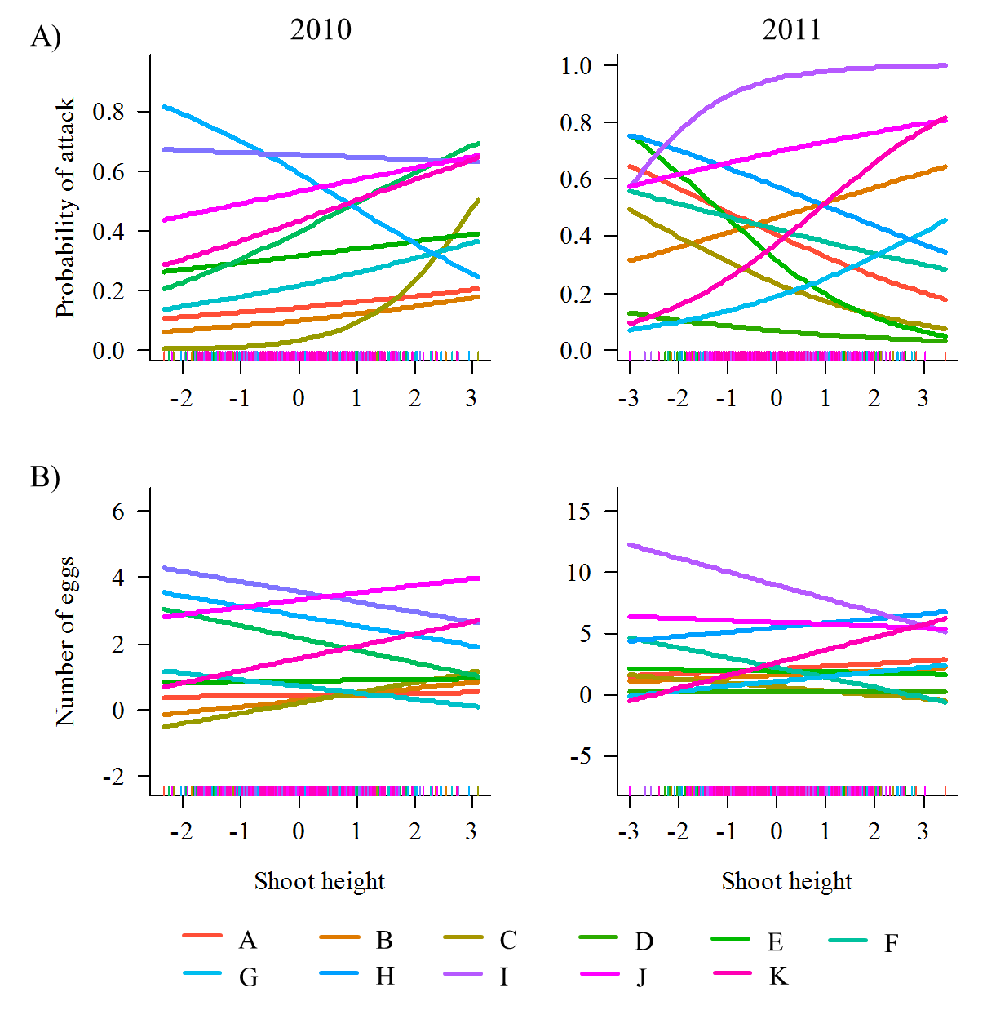

Appendix S5: Path analyses performed to assess the causal effects of phenology and other reproductive traits on fitness

We used path analysis (Grace, 2006) to examine the direct and indirect (predator-mediated) causal effects of phenology and other reproductive traits on fitness in the subset of populations with the predator (excluding population D in 2010). We built two saturated models. The first (model_attack) included direct effects of phenology, flower number and shoot height on number of intact fruits, effects of these traits on the probability of attack, and the effect of *P. alcon* attack on number of intact fruits. The second model (model_eggs) had the same structure, but interaction intensity (number of eggs) was used instead of probability of attack. Correlations between the reproductive traits were included in both models. The adequacy of the hypotheses of our causal models to our data (given by a non-significant 2 value) was not a major issue, as our aim was to compare the relationships depicted in these models among populations (cf. Rey *et al.*, 2006). To test for among-population variation in selection on flowering phenology, we used multigroup analysis (Grace, 2006). This analysis evaluates if the parameters in the model differ between groups (i.e. populations in our case). We first evaluated the most restrictive hypothesis of equality of all path coefficients between populations, and then we imposed equality constraints on individual paths and examined the effect of these constraints on overall model fit (Tables S2.1 and S2.2). Those constraints for which the imposition of the equality assumption causes a significant decrease in the chi-square value indicate path coefficients that are significantly different between groups. We then fitted the path models in each population separately (Tables S2.3 and S2.4) because the multigroup analysis showed that they differed statistically. As data departed from multivariate normality (results not shown), we calculated bootstrap parameter estimates and test statistics for patch coefficients, based on 5000 bootstrap samples. As we were specifically interested in spatial variation in selective scenarios for flowering phenology, path coefficients for direct and indirect effects of phenology on fitness are shown in Table S2.5.

Table S5.1: Multigroup analysis for the model with probability of attack (model_attack) in both years. 2 and P for the models with different paths constrained to be equal are shown. A significant 2 (P<0.05) indicates that the path coefficient differs significantly among populations.

| Paths constrained to be equal | 2010 | |  | 2011 | |
| --- | --- | --- | --- | --- | --- |
| 2 | P |  | 2 | P |
| All | 348.82 | <0.001 |  | 335.92 | <0.001 |
| Attack → Number of intact fruits | 18.10 | 0.034 |  | 62.39 | <0.001 |
| Phenology → Number of intact fruits | 10.93 | 0.280 |  | 5.23 | 0.875 |
| Phenology → Attack | 14.10 | 0.119 |  | 20.45 | 0.025 |
| Shoot height → Attack | 7.94 | 0.540 |  | 23.90 | 0.008 |
| Shoot height → Number of intact fruits | 8.39 | 0.495 |  | 20.88 | 0.022 |
| Flower number → Attack | 43.83 | <0.001 |  | 20.01 | 0.029 |
| Flower number → Number of intact fruits | 110.35 | <0.001 |  | 86.85 | <0.001 |
| Phenology ↔ Flower number | 36.60 | <0.001 |  | 35.85 | <0.001 |
| Phenology ↔ Shoot height | 16.24 | 0.062 |  | 33.44 | <0.001 |
| Shoot height ↔ Flower number | 34.58 | <0.001 |  | 31.05 | 0.001 |

Table S5.2: Multigroup analysis for the model with number of eggs (model_eggs) in both years. 2 and P for the models with different paths constrained to be equal are shown. A significant 2 (P<0.05) indicates that the path coefficient differs significantly among populations.

| Paths constrained to be equal | 2010 | |  | 2011 | |
| --- | --- | --- | --- | --- | --- |
| 2 | P |  | 2 | P |
| All | 480.19 | <0.001 |  | 558.46 | <0.001 |
| Number of eggs → Number of intact fruits | 51.54 | <0.001 |  | 105.35 | <0.001 |
| Phenology → Number of intact fruits | 10.03 | 0.348 |  | 8.38 | 0.592 |
| Phenology → Number of eggs | 53.40 | <0.001 |  | 28.68 | 0.001 |
| Shoot height → Number of eggs | 9.56 | 0.388 |  | 9.37 | 0.497 |
| Shoot height → Number of intact fruits | 9.66 | 0.378 |  | 17.37 | 0.067 |
| Flower number → Number of eggs | 85.05 | <0.001 |  | 134.70 | <0.001 |
| Flower number → Number of intact fruits | 110.19 | <0.001 |  | 80.19 | <0.001 |
| Phenology ↔ Flower number | 36.60 | <0.001 |  | 35.85 | <0.001 |
| Phenology ↔ Shoot height | 16.24 | 0.062 |  | 33.44 | <0.001 |
| Shoot height ↔ Flower number | 34.58 | <0.001 |  | 31.05 | 0.001 |

Table S5.3: Path models for model_attack fitted for each population and year. Solid lines indicate significant (P<0.05, black lines) or marginally significant (P<0.1, grey lines) paths, based on 5000 bootstrap samples. Dashed lines indicate non-significant paths. Standardized coefficients are shown.

|  |  |  |
| --- | --- | --- |
| Pop. | 2010 | 2011 |
| A |  |  |
| B |  |  |
| C |  |  |
| D |  |  |
| E |  |  |
| F |  |  |
| G |  |  |
| H |  |  |
| I |  |  |
| J |  |  |
| K |  |  |

Table S5.4: Path models for model_eggs fitted for each population and year. Solid lines indicate significant (P<0.05, black lines) or marginally significant (P<0.1, grey lines) paths, based on 5000 bootstrap samples. Dashed lines indicate non-significant paths. Standardized coefficients are shown.

|  |  |  |
| --- | --- | --- |
| Pop. | 2010 | 2011 |
| A |  |  |
| B |  |  |
| C |  |  |
| D |  |  |
| E |  |  |
| F |  |  |
| G |  |  |
| H |  |  |
| I |  |  |
| J |  |  |
| K |  |  |

Table S5.5: Standardized path coefficients for direct and indirect effects of phenology on fitness, obtained from fitting the saturated models (model_attack and model_eggs) to each population. Phen🡪Fruits: effect of phenology on number of intact fruits, Phen🡪Attack: effect of phenology on probability of attack, Attack🡪Fruits: effect of probability of attack on number of intact fruits, Phen🡪Eggs: effect of phenology on number of eggs, Eggs🡪Fruits: effect of number of eggs on number of intact fruits.

|  |  |  |  |  |  |  |  |  |  |  |  |  |  |  |  |  |  |
| --- | --- | --- | --- | --- | --- | --- | --- | --- | --- | --- | --- | --- | --- | --- | --- | --- | --- |
| Pop. | model_attack | | | | | | | |  | model_eggs | | | | | | | |
| Phen🡪Fruits | |  | Phen🡪Attack | |  | Attack🡪Fruits | |  | Phen🡪Fruits | |  | Phen🡪Eggs | |  | Eggs🡪Fruits | |
| 2010 | 2011 |  | 2010 | 2011 |  | 2010 | 2011 |  | 2010 | 2011 |  | 2010 | 2011 |  | 2010 | 2011 |
| A | -0.13 | -0.06 |  | 0.08 | 0.39*** |  | -0.17 | -0.20 • |  | -0.12 | -0.05 |  | 0.15 | 0.31** |  | -0.21* | -0.30** |
| B | -0.24* | 0.12 |  | 0.02 | 0.16 |  | -0.29** | -0.52*** |  | -0.23* | 0.10 |  | 0.06 | 0.16 |  | -0.27** | -0.40*** |
| C | 0.07 | 0.01 |  | 0.25* | 0.12 |  | -0.10 | -0.08 |  | 0.08 | 0.01 |  | 0.28* | 0.17 |  | -0.10 | -0.10 |
| D | - | -0.06 |  | - | 0.22 • |  | - | 0.26* |  | - | -0.02 |  | - | 0.17 |  | - | 0.13 |
| E | -0.15 | -0.10 |  | 0.30* | 0.18 • |  | -0.01 | -0.16 |  | -0.13 | -0.09 |  | 0.10 | 0.18 • |  | -0.15 • | -0.22* |
| F | -0.11 | -0.09 |  | 0.21* | 0.19 |  | -0.21 • | -0.26* |  | -0.05 | -0.10 |  | 0.23* | 0.17 • |  | -0.49*** | -0.23 • |
| G | -0.33** | 0.14 |  | 0.08 | 0.00 |  | -0.02 | -0.25* |  | -0.31** | 0.15 |  | 0.12 | 0.07 |  | -0.14 | -0.22 • |
| H | -0.09 | 0.01 |  | 0.15 | 0.24* |  | -0.22* | -0.55*** |  | -0.08 | 0.10 |  | 0.23* | 0.38*** |  | -0.20 • | -0.58*** |
| I | -0.25* | 0.06 |  | 0.34*** | 0.49*** |  | -0.18 • | -0.62*** |  | -0.26* | -0.17 |  | 0.46*** | 0.25*** |  | -0.12 | -0.30* |
| J | 0.07 | 0.05 |  | 0.29** | 0.23* |  | 0.13 | 0.02 |  | 0.03 | 0.07 |  | 0.40*** | 0.13 • |  | 0.19 • | -0.15 |
| K | 0.02 | 0.06 |  | 0.39** | 0.27* |  | -0.18** | -0.37*** |  | 0.02 | 0.06 |  | 0.26* | 0.14 |  | -0.28*** | -0.73*** |

• p<0.1;* p < 0.05; ** p < 0.01; *** p < 0.001