TITLE (provisional): Selection on flowering time in *Gentiana pneumonanthe* is mediated by seed predators and dependent on the community context

Valdés, Alicia* and Ehrlén, Johan

Department of Ecology, Environment and Plant Sciences, Stockholm University, SE-106 91 Stockholm, Sweden

* Corresponding author. E-mail: [alicia.valdes@](mailto:alicia.valdes@)su.se

INTRODUCTION

Timing of reproduction in plants affects their fitness by influencing interactions both with the physical environment and with other organisms. Thus, both abiotic (e.g. temperature, water availability) and biotic factors (i.e. animal interactors, (Elzinga *et al.*, 2007) may condition natural selection in phenological traits. Flower-visiting animals such as pollinators (mutualists) and predispersal seed predators (antagonists) can both determine the evolution of flowering phenologies, exerting different and sometimes opposing selective forces (Brody, 1997; Strauss & Irwin, 2004). Phenotypic selection on floral traits by pollinators is positively related to the degree of pollen limitation (Totland, 2001), and pollinator preference for certain floral traits does not always translate into higher fitness. However, preference of a certain phenotype by seed predators is most likely to decrease the fitness of that particular phenotype (Parachnowitsch & Caruso, 2008). Nowadays, there is weak empirical support for pollinator-mediated selection on flowering time (Ehrlén, 2015), but a growing evidence for predispersal seed predators acting as selective agents on several plant traits (Kolb *et al.*, 2007). The latter have been shown to exert phenotypic selection on flowering time (Ehrlén & Münzbergová, 2009) and in other reproductive traits as flower number (Leimu *et al.*, 2002) or inflorescence height (Kolb & Ehrlén, 2010). When assessing selection in flowering time, it is important to consider that plant phenology might be correlated with other traits also subject to natural selection (Lande & Arnold, 1983). Earlier flowering plants may have more available resources and thus be able to grow higher and produce more flowers than later-flowering plants (Ison & Wagenius, 2014), leading to a decrease in fitness over the season which is due to an indirect effect of phenology.

Spatiotemporal variation in selection intensity on a given trait may result in selection mosaics (Thompson, 2005), and lead to different coevolutionary trajectories of plants and their animal interactors. The relationship between plant reproductive traits and predispersal seed predation is susceptible to vary among populations and years (Kolb *et al.*, 2007), and might contribute to the existence of geographic mosaics of coevolution between plants and their seed predators (Benkman, 1999; Rey *et al.*, 2006). Seed predators might thus vary in their importance as selection agents, due to variations in their abundance, in interaction intensity (predation rates), and in the direction and strength of predator preferences regarding reproductive traits. Variation in phenotypic selection by seed predators might also be related to the context: the environment where the interaction occurs has been acknowledged to affect coevolutionary dynamics (Kolb & Ehrlén, 2010; König *et al.*, 2014; von Euler *et al.*, 2014), but the relations with other community members (i.e. the community context, Brandt & Foitzik, 2004; Strauss & Irwin, 2004; Siepielski & Benkman, 2007) might also influence interactions and thus modify selection.

Large Blue butterflies (*Maculinea* spp.) are predispersal predators of specific host plants during their first larval instars, and their oviposition patterns are closely related to the plant phenological state (Thomas & Elmes, 2001; Van Dyck & Regniers, 2010) and to other reproductive traits (e.g. number of flowers, height of the shoots, Czekes *et al.*, 2014). *Maculinea* larvae need a second host to complete their development, and they are parasites of ant nests during later instars (Als *et al.*, 2004). In this case, the community context in terms of the abundance of the second host (*Myrmica* ants) might indirectly affect phenotypic selection on host plant traits by modifying interaction intensities, as the distribution and abundance of the butterfly could be related to ant abundance.

In this study, we assess how phenotypic selection on flowering time in the perennial herb *Gentiana pneumonanthe* is mediated by the interaction with its specialist predispersal seed predator, the butterfly *Maculinea alcon*, and how this interaction depends on the community context where it occurs. Specifically, we seek to answer two main questions:

1) Is there phenotypic selection on flowering phenology in *G. pneumonanthe*? Is this selection mediated by the interaction with the predispersal seed predator (*M. alcon*)?

2) Are *M. alcon* presence and seed predation intensity related to the community context in terms of abundance of their second host (*Myrmica* ants)?

MATERIALS AND METHODS

**Study system and study area**

The marsh gentian (*Gentiana pneumonanthe* L.) is a rare perennial herb that may reach 45 cm in height (Simmonds, 1946) and inhabits open habitats as wet heathlands and grasslands. Although it appears in some other places in Europe, it is red-listed as vulnerable in Sweden. It flowers in July and August in SW Sweden and is pollinated by bumblebees. *G. pneumonanthe* is the primary host of the Alcon Blue butterfly (*Maculinea alcon*), a specialist predispersal seed predator which lays its eggs on young gentian buds during its flight period (July and August, Appelqvist *et al.*, 2007). The caterpillars consume a large fraction of developing seeds in some populations. Fourth-instar caterpillars drop to the ground and are then picked up by their second host: *Myrmica* ants (probably *M. ruginodis* in our study area, Appelqvist *et al.*, 2007). Caterpillars mimic the surface chemistry of the ant brood (Nash *et al.*, 2008), and this makes ants carry them to their nest, where they spend the rest of their larval period as parasites (Mouquet *et al.*, 2005). Contrary to the majority of *Maculinea* species, which prey on ant brood, *M. alcon* is a “cuckoo” species (Als *et al.*, 2004), whose larvae are fed primarily on regurgitations from ant workers, trophic eggs and prey items.

This study was carried out in 20 populations of *G. pneumonanthe* located in the county of Västra Götaland in SW Sweden (see Appendix 1 for details). The populations are mainly located in moist heathlands and often surrounded by forests, roads or urbanized areas. *M. alcon* was present in 11 of the study populations and absent from 9.

**Data collection**

We collected data on reproductive traits, plant fitness and interaction intensity in 100 marked individuals in each of the study populations during 2010 and 2011. For each individual, we measured shoot height, phenological state, number of flowers and number of *M. alcon* eggs in late July – early August (all this measures were carried out on the median shoot of each plant). Populations were visited 1 or 2 times during this period. If 2 visits were performed, height of shoots and phenological state were assessed on the first visit, while number of flowers was calculated as the maximum count. Phenology, in terms of the developmental stages of flowers, was estimated by counting the number of buds and flowers in each of six developmental stages: a) small bud (the sepals covering the bud completely), b) medium-sized bud (from the time the bud begins to protrude outside the sepals until it grows over the sepals) c) large bud (the bud becomes elongated and rather high, *M. alcon* eggs usually start appearing) d) not fully blooming flower (from the time the bud starts changing into blue until it becomes a solid blue, tightly twisted bud) e) blooming flower (from the time the bud starts to open, when the petals start to spin up, to a fully opened flower) and f) wilted flower (merged and started to wither). We then calculated two different measures of phenology. A phenological index (PI) was calculated for each individual as PI = 1[a/(nfl)] + 2[b/(nfl)] + 3[c/(nfl)] + 4[d/(nfl)] + 5[e/(nfl)] + 6[f/(nfl)], with nfl = total number of flowers and buds. Besides, the state of the most advanced bud was recorded based on the abovementioned categories, assigning numbers 1-6 respectively to categories a-f.

Populations were visited again between 1 and 5 times during the period from late August to mid-October (except for 4 of the populations in 2011). In each of these visits, number of eggs and number of intact fruits were counted. The maximum number of eggs and the final number of intact fruits (i.e. not damaged by the butterfly) were used respectively as an estimate of interaction intensity and as an estimate of plant fitness.

Ant abundance was measured in each of the 20 study populations using ant counts on sugar cubes. In 2010, a 20-m transect was established through each population, and a sugar cube was placed every meter (i.e. 20 sugar cubes per population). In 2010, two 20-m parallel transects or one 40-m transect were established, placing thus 40 sugar cubes per population. The number of *Myrmica* sp. ants in each of the cubes was counted after 30 minutes. We then calculated the average number of ants per sugar cube in each population and year, and used the highest of both yearly values as a measure of ant abundance for each population.

**Statistical analyses**

Analyses were performed separately for 2010 and 2011. As no information on fruit production was available for 4 of the populations in 2011, they were not considered in the analyses for this year.

To evaluate if there was phenotypic selection on flowering phenology, and whether this selection was related to the antagonistic interaction and varied among populations, we performed selection gradient analyses (Lande & Arnold, 1983) by regressing relative fitness on standardized phenological values, together with other reproductive traits (flower number and shoot height). Within each population, absolute fitness (number of intact fruits) was relativized to have a mean of one (by diving it by the mean number of intact fruits), and reproductive traits (phenology, flower number and shoot height) were standardized to have a mean of zero and a standard deviation of one (by subtracting the mean and dividing by the standard deviation). We performed these analyses in two steps. In a first step, we tested if predator presence influenced phenotypic selection. For this, we created a dummy variable “Predator”, coded as 0 (in populations without *M. alcon*) and 1 (in populations with *M. alcon*), and we fitted a linear model with Type II sums of squares, using standardized reproductive traits and their interactions with “Predator” as predictor variables, and relative fitness as response variable. We tested for directional selection (linear terms), but also for correlational selection (examining the effects of interaction terms in a model also including the linear terms) and non-linear selection (examining the effect of quadratic terms in a model also including the linear terms). In a second step, we tested for among-population differences in phenotypic selection that were independent of predator presence in the population. For this, we split our dataset in two subsets according to the dummy variable “Predator”, and we fitted an identical linear model with Type II sums of squares to each of the subsets. This model included standardized reproductive traits and their interactions with population as predictor variables, and relative fitness as response variable. We also tested for correlational and non-linear selection in these models.

As both measures of phenology (PI and state of the most advanced bud) were strongly correlated (r = 0.86), we tested separate models including either one or another. Their performance was very similar in all models, so we only show analyses using the state of the most advanced bud, hereafter referred to as “phenology” variable (with higher values indicating earlier flowering).

Within each population, we estimated linear selection gradients (’s) for phenology from multiple regressions of relative fitness on standardized reproductive traits. To assess the differences in linear selection on phenology between populations with and without the predator, we compared linear selection gradients for phenology between these two groups of populations using one-way ANOVAs.

To investigate among-population variation on the relationship between the occurrence of predation or its intensity and reproductive traits (i.e. differences in predator preferences), we regressed both the probability of attack (dummy variable coded as 0 when number of eggs = 0, and 1 when number of eggs > 0) and the number of eggs on reproductive traits, population and their interactions. We also conducted models separately for each population to obtain parameter estimates of the relationships between reproductive traits and probability of attack and interaction intensity for each population. We excluded data from population D in 2010 from these analyses because predation intensity was extremely low (only 1 plant with 2 eggs) and we believe this could bias the results.

We examined the direct and indirect (predator-mediated) causal effects of phenology and other reproductive traits on fitness using path analysis (Grace, 2006). We specifically examined the direct effects of phenology, flower number and shoot height on number of intact fruits, the effects of these traits on the probability of attack by *M. alcon* (or predation intensity, measured as number of eggs), and the effect of the attack by *M. alcon* (or predation intensity) on number of intact fruits. We also included correlations between the reproductive traits in the path model. We constructed a saturated model including all the hypothetic direct and indirect causal links between traits, probability of attack (or predation intensity) and fitness. We tested for differences between populations in the patch coefficients by means of multigroup analysis in Amos16.0 (Arbukle, 2007). We excluded data from population D in 2010 from these analyses too. We imposed equality constraints on individual paths and examined the effect of these constraints on overall model fit (Grace, 2006). Those constraints for which the imposition of the equality assumption causes a significant decrease in the chi-square value indicate significantly different path coefficients. After performing the multigroup comparison, we fitted the path models in each population separately because they differed statistically. To do this, we considered possible alternatives to the saturated model by constructing nested models sharing the same causal structure, using a stepwise specification search in Amos. We then chose the most parsimonious model for each population and year on the basis of Akaike Information Criterion (AIC). The fit of these models to the data was assessed using a maximum likelihood 2 value, with non-significant values indicating a good fit between the model and the data. To avoid the effects of deviations from multivariate normality, significance tests were based on the Satorra-Bentler robust correction (Satorra & Bentler, 1994) performed with the *lavaan* package (Rosseel, 2012) in R.

To see if the second host of *M. alcon* can condition phenotypic selection by increasing: a) the probability of presence of the predator or b) the intensity of the interaction, we performed a) a logistic regression of butterfly presence on log-transformed ant abundance, using the 20 study populations, and b) per-year linear regressions of the mean number of eggs per plant and the proportion of plants with *M. alcon* eggs on log-transformed ant-abundance, using the 11 populations where the butterfly was present.

All analyses except the path models were conducted in R 3.1.2 (R Core Team, 2014).

RESULTS

We found evidence for linear (directional) selection (model A in Table 1) on flowering phenology, flower number and shoot height in both study years, and in several cases selection was influenced by the presence of the predator. Linear selection on flowering phenology differed between populations with and without predator, the predator x phenology interaction was significant both in 2010 and 2011. Partial regression plots revealed that relative fitness increased with late flowering in populations with the predator, and with early flowering in populations without the predator (Figure 1). Linear selection on flower number and shoot height was not related to predation in 2010, with relative fitness increasing in plants with more flowers and higher shoots, but it differed between populations with and without predator in 2011.

We also found some evidence of correlational selection (model B in Table 1), as some trait interactions showed significant effects. In 2010, plants flowering late had a higher advantage of having high shoots than plants flowering early, and plants with higher number of flowers and higher shoots had a higher fitness. Also in 2010, the interaction between phenology and flower number depended on predation (Appendix 2): in populations with the predator there is selection for late-flowering plants with high number of flowers, while in populations without the predator there is selection for early-flowering plants with high number of flowers. On the other hand, in 2011, the interactions between phenology and shoot height and flower number and shoot height depended also on predation (Appendix 2). In populations with the predator, early-flowering plants with low shoots and late-flowering plants with high shoots had higher fitness, as well as plants with high shoots and high number of flowers. In populations without the predator, there was selection for early-flowering plants with high shoots, and for plants with a high number of flowers and low shoots.

Our models also revealed the presence of non-linear selection (model C in Table 1). In 2010, we found a significant non-linear effect of phenology on fitness that was related to predation (see partial regression plot on Appendix 3), while no evidence of non-linear selection on flowering phenology was found in 2011. There was also significant non-linear selection for flower number in 2010, while in 2011 this effect depended on predation (see partial regression plots in Appendix 3).

We also found among-population differences in phenotypic selection that were independent of predator presence in the population (Table 2).

Phenotypic selection on flowering phenology differed between populations where the predator was absent and present in both study years (Fig. 2). In populations where the predator was absent, there was selection for earlier flowering (mean ± 95% CI of selection gradients, 2010: 0.20 ± 0.15, 2011: 0.30 ± 0.17), while in populations where the predator was present there was selection for later flowering (mean ± 95% CI of selection gradients, 2010: -0.17 ± 0.14, 2011: -0.10 ± 0.11). Values of selection gradients for each population and year are detailed in Appendix 4.

In both study years, early-flowering increased the probability of being attacked by the predator, and this effect was constant between populations (Table 3, Fig. 3A). In 2010, there were differences between populations in the relationship between probability of attack and flower number, while in 2011 plants with higher number of flowers had a higher probability of being attacked in all populations. In 2011, there were differences between populations in the relationship between probability of attack and shoot height. There were also differences between populations in the effects of phenology and flower number on predation intensity (number of eggs, Table 3, Fig. 3B) in both years studied.

The most parsimonious path models (Fig. 4) indicated that flowering phenology does not have a direct effect on fitness of *G. pneumonanthe*, although it has an indirect effect mediated by interaction with its seed predator, as earlier flowering increases the probability of attack by *M. alcon* (see Appendix 5 for relationships between probability of attack and phenology in all populations/years), and attacked plants produce less fruits in both years. Flower number has a positive direct effect on fitness in both years and an indirect negative effect in 2011, as plants producing more flowers have a higher probability of being attacked in this year (although the total effect of flower number on fruit number is positive in both years, see Appendix 6). Shoot height has both direct and indirect negative effects on fitness in both years: tall shoots produce less fruits and also have a higher probability of being attacked. There were significant positive correlations between the three traits included in the model.

The probability of presence of *M. alcon* was higher in populations with higher abundance of *Myrmica* ants (Fig. 5A). Although there were populations with high ant abundance where *M. alcon* was absent, in populations where it was present ant abundance was generally high. Conversely, neither the mean number of eggs per plant (Fig. 5B) nor the proportion of plants with *M. alcon* eggs (Fig. 5C) showed any relationship with ant abundance in any of the two years.

DISCUSSION

Our results evidence the existence of phenotypic selection on flowering phenology in *G. pneumonanthe*. This selection is variable between populations and is mediated by the interaction with *M. alcon*, which promotes selection for later flowering in the populations where it is present. This is due to earlier flowering increasing the probability of attack by the predator, which in turn causes a decrease in fitness. Other reproductive traits as number of flowers and shoot height show also direct and indirect (predator-mediated) effects on fitness. Predator preferences for reproductive traits vary in intensity between populations, but not in direction. *M. alcon* presence is related to the community context in terms of the abundance of its second host.

**Phenotypic selection on flowering time and other reproductive traits**

We have shown that in the perennial herb *G. pneumonanthe*, seed predator preference for early-flowering plants drives phenotypic selection for late flowering, as early-flowering plants decrease their fitness as a result of the antagonistic interaction. Several studies have shown that females of *Maculinea* sp. choose plants for oviposition on the basis of their bud phenology, and prefer laying eggs on slightly immature buds, increasing time available for brood feeding and development (Thomas & Elmes, 2001; Patricelli *et al.*, 2011). Our results add up to this evidence and show that the probability of being attacked by the predator and the intensity of the antagonistic interaction are higher in plants flowering early in the season (i.e. plants that were in a more advanced phenological state at the time of evaluation). This might be due to an overlapping between the “optimal” phenological state for oviposition in these plants and the moment of higher activity of *M. alcon*, as it has been stated that butterflies flying early in the season (during the first one third of the flight period) deposit higher number of eggs than those flying later (Arnaldo *et al.*, 2014). Attacked plants show significant decreases in fitness, as the caterpillars damage flowers and seeds (Thomas, 1995).

We did not found any significant direct effect of phenology on fruit production in populations with the predator, which means that flowering time seems to affect fitness not directly but only through its effect on the seed predator. However, in populations without the predator there is also evidence for phenotypic selection in flowering time, selecting in this case for early flowering. This is consistent with the trend shown by Munguía-Rosas *et al.* (2011), who suggested that selection generally favors early flowering plants. However, we believe that the increase in fitness with early flowering in these populations is not due to a causal relationship between flowering time and fitness, but is the result of indirect selection on other correlated reproductive traits (Ehrlén, 2015), as early-flowering plants have higher shoots and produce more flowers.

We also found evidence for phenotypic selection on shoot height. In 2010, plants with higher shoots were positively selected and there were no differences in selection between populations with and without predator. In 2011, there was selection for lower shoots in populations with the predator and for higher shoots in populations without the predator. This agrees with recent studies on oviposition patterns (Czekes *et al.*, 2014; Wynhoff *et al.*, 2014), which state that butterflies prefer to lay eggs on tall shoots, as this indicates better plant quality and hence more resources available for larval development. However, plants with higher shoots will also be able to produce more flowers, and this can explain why they are positively selected in 2010 and in populations without predator in 2011, as the effect of flower number on fitness might overcome that of shoot height.

Phenotypic selection on flower number was variable among populations, but these differences were not related to the presence of the predator. In populations with the predator, *M. alcon* showed a preference for plants with higher number of flowers in one of the study years, but not in the other. The visibility of food plants for butterflies might be determined by both its height and the size of its floral display (Nowicki *et al.*, 2005), although the importance of the second factor seems to vary between years.

**Differences in predator preferences between populations**

Seed predators generally prefer early-flowering plants with high number of flowers, although there are differences between populations regarding the strength of this preference (i.e. the strength of the relationship between interaction intensity and reproductive traits). These differences lead to variations in selection intensity. For example, in populations where early-flowering plants receive many more eggs than late-flowering plants (e.g. population I in Fig. 3), phenotypic selection on flowering time will be very strong, as late-flowering plants will have much higher fitness. However, in populations where the difference in egg load between early- and late-flowering plants is not very high (e.g. population E in Fig. 3), phenotypic selection on flowering time will be much weaker. If this spatial variation in phenotypic selection is consistent in time, it could lead to selection mosaics and local adaptation (Thompson, 2005) and promote different evolutionary trajectories in different populations.

**Dependence on the community context**

Our results also show that phenotypic selection on flowering phenology in *G. pneumonanthe* is indirectly dependent on the community context. The presence of *M. alcon* is more probable in sites with a high abundance of *Myrmica* ants, as the butterfly needs them to complete its life cycle. Therefore, the plant-seed predator interaction can only take place and affect phenotypic selection in these sites. However, in populations where the butterfly is present, the intensity of seed predation on *G. pneumonanthe* is not related to ant abundance. This suggests that the second host is crucial for the antagonistic interaction to happen, but does not determine its magnitude, at least at the population scale studied. The butterfly’s dependence on ants for choosing an oviposition site at a local scale (i.e. a plant within the population) is somehow controversial, as some studies have found an ant-related oviposition behavior in these species (van Dyck *et al.*, 2000; Wynhoff *et al.*, 2014), while others have not (Nowicki *et al.*, 2005; Fürst & Nash, 2010). We believe that further studies relating interaction intensity to ant abundance at the scale of individual plants could help to clarify to what extent the community context can determine the intensity of antagonistic-mediated selection on flowering phenology.

**Concluding remarks and future directions**

Interactions with animals and their spatiotemporal variation are an important potential driver of natural selection and evolutionary change in plant traits (Thompson, 2005). Flowering time is a key plant trait in the current scenario of global warming, where many plants are known to be advancing their phenologies (Cleland *et al.*, 2007). In this study, we have demonstrated that seed predators are important selective agents that could determine evolution on flowering time in *G. pneumonanthe*. Moreover, predator-mediated selection favors later flowering, meaning that the selection exerted by seed predators goes on the opposite direction than the phenological shifts expected as a response to changing environmental conditions. However, evolutionary change will only occur if 1) the observed phenotypic selection is maintained in time and 2) there is sufficient genetic variance in flowering time to allow a selection response (Putterill *et al.*, 2004). Therefore, longer studies that also investigate the heritability of phenological traits could broaden our knowledge about antagonist-driven evolution of flowering time in this plant species. Studies that also focus on climatic conditions would help to find out how evolution of flowering time will respond to the opposed selection forces exerted by seed predators and global warming. Regarding the community context, we have demonstrated that ant abundance determines the presence of the predator at the population level, but further research is needed to assess if the plant-seed predator interaction (and therefore also phenotypic selection on flowering time) responds to the second host at a more local scale within each population.

ACKNOWLEDGEMENTS

We acknowledge Susanne Govella, Anna Herrström and Jessica Oremus for field data collection. Funding from VR to JE… AV was funded by the “Clarín” postdoctoral program (FICYT, Gobierno del Principado de Asturias, Spain, and Marie Curie-Cofund Actions, EU).

REFERENCES

Als, T.D., Vila, R., Kandul, N.P., Nash, D.R., Yen, S.-H., Hsu, Y.-F., Mignault, A.A., Boomsma, J.J. & Pierce, N.E. (2004) The evolution of alternative parasitic life histories in large blue butterflies. *Nature*, **432**, 386–390.

Appelqvist, T., Bengtsson, O., Sverige & Naturvårdsverket (2007) *Åtgärdsprogram för alkonblåvinge och klockgentiana 2007-2011: Maculinea alcon och Gentiana pneumonanthe : hotkategori: sårbara (vu)*, Naturvårdsverket, Stockholm.

Arbukle, J.L. (2007) *AMOS 16 Users Guide*,.

Arnaldo, P.S., Gonzalez, D., Oliveira, I., Langevelde, F. van & Wynhoff, I. (2014) Influence of host plant phenology and oviposition date on the oviposition pattern and offspring performance of the butterfly Phengaris alcon. *Journal of Insect Conservation*, **18**, 1115–1122.

Benkman, C.W. (1999) The selection mosaic and diversifying coevolution between crossbills and Lodgepole pine. *The American Naturalist*, **153**, S75–S91.

Brandt, M. & Foitzik, S. (2004) Community context and specialization influence coevolution between a slavemaking ant and its hosts. *Ecology*, **85**, 2997–3009.

Brody, A.K. (1997) Effects of pollinators, herbivores, and seed predators on flowering phenology. *Ecology*, **78**, 1624–1631.

Cleland, E.E., Chuine, I., Menzel, A., Mooney, H.A. & Schwartz, M.D. (2007) Shifting plant phenology in response to global change. *Trends in Ecology & Evolution*, **22**, 357–365.

Czekes, Z., Markó, B., Nash, D.R., Ferencz, M., Lázár, B. & Rákosy, L. (2014) Differences in oviposition strategies between two ecotypes of the endangered myrmecophilous butterfly Maculinea alcon (Lepidoptera: Lycaenidae) under unique syntopic conditions. *Insect Conservation and Diversity*, **7**, 122–131.

Van Dyck, H., Oostermeijer, J.G.B., Talloen, W., Feenstra, V., Hidde, A. van der & Wynhoff, I. (2000) Does the presence of ant nests matter for oviposition to a specialized myrmecophilous Maculinea butterfly? *Proceedings of the Royal Society of London B: Biological Sciences*, **267**, 861–866.

Van Dyck, H. & Regniers, S. (2010) Egg spreading in the ant-parasitic butterfly, Maculinea alcon: from individual behaviour to egg distribution pattern. *Animal Behaviour*, **80**, 621–627.

Ehrlén, J. (2015) Selection on flowering time in a life-cycle context. *Oikos*, **124**, 92–101.

Ehrlén, J. & Münzbergová, Z. (2009) Timing of flowering: opposed selection on different fitness components and trait covariation. *The American Naturalist*, **173**, 819–830.

Elzinga, J.A., Atlan, A., Biere, A., Gigord, L., Weis, A.E. & Bernasconi, G. (2007) Time after time: flowering phenology and biotic interactions. *Trends in Ecology & Evolution*, **22**, 432–439.

Von Euler, T., Ågren, J. & Ehrlén, J. (2014) Environmental context influences both the intensity of seed predation and plant demographic sensitivity to attack. *Ecology*, **95**, 495–504.

Fürst, M.A. & Nash, D.R. (2010) Host ant independent oviposition in the parasitic butterfly Maculinea alcon. *Biology Letters*, **6**, 174–176.

Grace, J.B. (2006) *Structural equation modeling and natural systems*, Cambridge University Press, Cambridge, UK ; New York.

Ison, J.L. & Wagenius, S. (2014) Both flowering time and distance to conspecific plants affect reproduction in Echinacea angustifolia, a common prairie perennial. *Journal of Ecology*, **102**, 920–929.

Kolb, A. & Ehrlén, J. (2010) Environmental context drives seed predator-mediated selection on a floral display trait. *Evolutionary Ecology*, **24**, 433–445.

Kolb, A., Ehrlén, J. & Eriksson, O. (2007) Ecological and evolutionary consequences of spatial and temporal variation in pre-dispersal seed predation. *Perspectives in Plant Ecology, Evolution and Systematics*, **9**, 79–100.

König, M.A.E., Wiklund, C. & Ehrlén, J. (2014) Context-dependent resistance against butterfly herbivory in a polyploid herb. *Oecologia*, **174**, 1265–1272.

Lande, R. & Arnold, S.J. (1983) The measurement of selection on correlated characters. *Evolution*, **37**, 1210.

Leimu, R., Syrjänen, K., Ehrlén, J. & Lehtilä, K. (2002) Pre-dispersal seed predation in Primula veris: among-population variation in damage intensity and selection on flower number. *Oecologia*, **133**, 510–516.

Mouquet, N., Belrose, V., Thomas, J.A., Elmes, G.W. & Clarke, R.T. (2005) Conserving community modules: a case study of the endangered lycaenid butterfly Maculinea alcon. *Ecology*, **86**, 3160–3173.

Munguía-Rosas, M.A., Ollerton, J., Parra-Tabla, V. & De-Nova, J.A. (2011) Meta-analysis of phenotypic selection on flowering phenology suggests that early flowering plants are favoured. *Ecology Letters*, **14**, 511–521.

Nash, D.R., Als, T.D., Maile, R., Jones, G.R. & Boomsma, J.J. (2008) A mosaic of chemical coevolution in a Large Blue butterfly. *Science*, **319**, 88–90.

Nowicki, P., Witek, M., Skorka, P. & Woyciechowski, M. (2005) Oviposition patterns in the myrmecophilous butterfly Maculinea alcon Denis & Schiffermueller(Lepidoptera: Lycaenidae) in relation to characteristics of foodplants and presence of ant hosts. *Polish Journal of Ecology*, **53**, 409–417.

Parachnowitsch, A.L. & Caruso, C.M. (2008) Predispersal seed herbivores, not pollinators, exert selection on floral traits via female fitness. *Ecology*, **89**, 1802–1810.

Patricelli, D., Barbero, F., La Morgia, V., Casacci, L.P., Witek, M., Balletto, E. & Bonelli, S. (2011) To lay or not to lay: oviposition of Maculinea arion in relation to Myrmica ant presence and host plant phenology. *Animal Behaviour*, **82**, 791–799.

Putterill, J., Laurie, R. & Macknight, R. (2004) It’s time to flower: the genetic control of flowering time. *BioEssays*, **26**, 363–373.

R Core Team (2014) *R: A language and environment for statistical computing. R Foundation for Statistical Computing, Vienna, Austria. URL http://www.R-project.org/.*,.

Rey, P.J., Herrera, C.M., Guitián, J., Cerdá, X., Sanchez-Lafuente, A.M., Medrano, M. & Garrido, J.L. (2006) The geographic mosaic in predispersal interactions and selection on Helleborus foetidus (Ranunculaceae). *Journal of Evolutionary Biology*, **19**, 21–34.

Rosseel, Y. (2012) lavaan: An R package for structural equation modeling. *Journal of Statistical Software*, **48**, 1–36.

Satorra, A. & Bentler, P.M. (1994) *Corrections to test statistics and standard errors in covariance structure analysis.* *In von Eye, A. and Clogg, C.C. (eds) Latent variables analyses: Applications for developmental research*, pp. 399–419. SAGE Publications.

Siepielski, A.M. & Benkman, C.W. (2007) Selection by a predispersal seed predator constrains the evolution of avian seed dispersal in pines. *Functional Ecology*, **21**, 611–618.

Simmonds, N.W. (1946) Gentiana pneumonanthe L. *Journal of Ecology*, **33**, 295–307.

Stinchcombe, J.R., Agrawal, A.F., Hohenlohe, P.A., Arnold, S.J. & Blows, M.W. (2008) Estimating nonlinear selection gradients using quadratic regression coefficients: double or nothing? *Evolution*, **62**, 2435–2440.

Strauss, S.Y. & Irwin, R.E. (2004) Ecological and evolutionary consequences of multispecies plant-animal interactions. *Annual Review of Ecology, Evolution, and Systematics*, **35**, 435–466.

Thomas, J.A. (1995) *The ecology and conservation of Maculinea arion and other European species of large blue butterfly*. *Ecology and Conservation of Butterflies* (ed. by A.S. Pullin), pp. 180–197. Springer Netherlands.

Thomas, J.A. & Elmes, G.W. (2001) Food–plant niche selection rather than the presence of ant nests explains oviposition patterns in the myrmecophilous butterfly genus Maculinea. *Proceedings of the Royal Society of London B: Biological Sciences*, **268**, 471–477.

Thompson, J.N. (2005) *The geographic mosaic of coevolution*, 1 edition. University Of Chicago Press, Chicago.

Totland, Ø. (2001) Environment-dependent pollen limitation and selection on floral traits in an alpine species. *Ecology*, **82**, 2233–2244.

Wynhoff, I., Bakker, R.B., Oteman, B., Arnaldo, P.S. & van Langevelde, F. (2014) Phengaris (Maculinea) alcon butterflies deposit their eggs on tall plants with many large buds in the vicinity of Myrmica ants. *Insect Conservation and Diversity*, n/a–n/a.

TABLES

Table 1: Effects of standardized traits (flowering phenology, flower number and shoot height), predator presence and their interactions on relative fitness (number of intact fruits) of *G. pneumonanthe* in 2010 (N = 2064 plants in N =20 populations) and 2011 (N = 1598 plants in N = 16 populations). Results are from linear models with Type II sums of squares, including: A) only linear effects, B) linear effects and interactions and C) linear and quadratic effects. Estimates (from a model without interaction terms in each case) are given for significant main effects where the Predation x trait interaction is not significant. Quadratic regression coefficients were doubled to properly estimate stabilizing/disruptive selection (Stinchcombe et al., 2008). Boldface indicates significance.

|  |  |  |  |  |  |  |
| --- | --- | --- | --- | --- | --- | --- |
| Source of variation | | df | 2010 | |  | 2011 |
| F | Estim |  | F |
| A) Linear terms | |  |  |  |  |  |
|  | Phenology (early flowering) | 1 | 0.03 |  |  | 1.52 |
|  | Flower number | 1 | **194.89** | 0.494 |  | **59.27** |
|  | Shoot height | 1 | **10.37** | 0.128 |  | 0.10 |
|  | Predator | 1 | 0.12 |  |  | 0.00 |
|  | Predator x Phenology | 1 | **31.03** |  |  | **13.29** |
|  | Predator x Flower number | 1 | 0.00 |  |  | **7.79** |
|  | Predator x Shoot height | 1 | 0.00 |  |  | **9.60** |
|  |  |  |  |  |  |  |
| B) Interaction terms | |  |  |  |  |  |
|  | Phenology x Flower number | 1 | **3.90** |  |  | 0.38 |
|  | Phenology x Shoot height | 1 | **5.21** | -0.092 |  | 1.35 |
|  | Flower number x Shoot height | 1 | **7.27** | 0.093 |  | **3.97** |
|  | Predator x Phenology x Flower number | 1 | **11.35** |  |  | 0.00 |
|  | Predator x Phenology x Shoot height | 1 | 0.79 |  |  | **4.35** |
|  | Predator x Flower number x Shoot height | 1 | 0.13 |  |  | **4.92** |
|  |  |  |  |  |  |  |
| C) Quadratic terms | |  |  |  |  |  |
|  | Phenology 2 | 1 | **3.90** |  |  | 0.77 |
|  | Flower number 2 | 1 | **8.42** | 0.117 |  | 0.01 |
|  | Shoot height 2 | 1 | 1.35 |  |  | 1.73 |
|  | Predator x Phenology 2 | 1 | **11.86** |  |  | 2.26 |
|  | Predator x Flower number 2 | 1 | 0.65 |  |  | **4.91** |
|  | Predator x Shoot height 2 | 1 | 0.90 |  |  | 0.09 |

Table 2: Effects of standardized traits (flowering phenology, flower number and shoot height) and their interactions with population on relative fitness (number of intact fruits) of *G. pneumonanthe* in populations with and without *M. alcon* in 2010 and 2011 (Npop = number of populations and Npl = number of plants shown in each case). Results are from linear models with Type II sums of squares (see Table 1 legend for details on models A, B and C). Boldface indicates significance.

|  |  |  |  |  |  |  |  |  |  |  |  |  |  |  |  |  |
| --- | --- | --- | --- | --- | --- | --- | --- | --- | --- | --- | --- | --- | --- | --- | --- | --- |
| Source of variation | | Populations with *M.alcon* | | | | | | |  | Populations without *M.alcon* | | | | | | |
| 2010  Npop = 11; Npl = 1164 | | |  | 2011  Npop = 11; Npl = 1099 | | |  | 2010  Npop = 9; Npl = 900 | | |  | 2011  Npop = 5; Npl = 499 | | |
| df | F | Estim |  | df | F | Estim |  | df | F | Estim |  | df | F | Estim |
| A) Linear terms | |  |  |  |  |  |  |  |  |  |  |  |  |  |  |  |
|  | Phenology (early flowering) | 1 | **13.23** |  |  | 1 | 3.26 |  |  | 1 | **18.13** | 0.218 |  | 1 | **14.57** | 0.296 |
|  | Flower number | 1 | **106.25** |  |  | 1 | **52.24** |  |  | 1 | **93.98** |  |  | 1 | **5.67** | 0.224 |
|  | Shoot height | 1 | **5.38** | 0.109 |  | 1 | **5.53** | -0.126 |  | 1 | 2.38 |  |  | 1 | **4.53** |  |
|  | Population x Phenology | 10 | **2.58** |  |  | 10 | 1.10 |  |  | 8 | 1.59 |  |  | 4 | 0.44 |  |
|  | Population x Flower number | 10 | **3.95** |  |  | 10 | **3.09** |  |  | 8 | **4.68** |  |  | 4 | 1.04 |  |
|  | Population x Shoot height | 10 | 0.90 |  |  | 10 | 1.27 |  |  | 8 | 1.79 |  |  | 4 | **3.34** |  |
|  |  |  |  |  |  |  |  |  |  |  |  |  |  |  |  |  |
| B) Interaction terms | |  |  |  |  |  |  |  |  |  |  |  |  |  |  |  |
|  | Phenology x Flower number | 1 | 1.43 |  |  | 1 | 0.01 |  |  | 1 | **12.54** |  |  | 1 | 0.39 |  |
|  | Phenology x Shoot height | 1 | 2.85 |  |  | 1 | **9.09** | -0.142 |  | 1 | 0.45 |  |  | 1 | 1.67 |  |
|  | Flower number x Shoot height | 1 | **10.43** |  |  | 1 | **11.14** |  |  | 1 | 0.16 |  |  | 1 | 1.20 |  |
|  | Population x Phenology x Flower number | 10 | 1.23 |  |  | 10 | 1.28 |  |  | 8 | **3.77** |  |  | 4 | **2.90** |  |
|  | Population x Phenology x Shoot height | 10 | 1.33 |  |  | 10 | 1.43 |  |  | 8 | 0.77 |  |  | 4 | 1.81 |  |
|  | Population x Flower number x Shoot height | 10 | **2.08** |  |  | 10 | **1.91** |  |  | 8 | 1.75 |  |  | 4 | 2.20 |  |
|  |  |  |  |  |  |  |  |  |  |  |  |  |  |  |  |  |
| C) Quadratic terms | |  |  |  |  |  |  |  |  |  |  |  |  |  |  |  |
|  | Phenology 2 | 1 | **6.66** | -0.249 |  | 1 | 0.67 |  |  | 1 | 0.44 |  |  | 1 | 0.27 |  |
|  | Flower number 2 | 1 | 3.13 |  |  | 1 | **9.30** |  |  | 1 | 2.12 |  |  | 1 | 3.43 |  |
|  | Shoot height 2 | 1 | 0.09 |  |  | 1 | 1.64 |  |  | 1 | 0.23 |  |  | 1 | 0.07 |  |
|  | Population x Phenology 2 | 10 | 1.12 |  |  | 10 | 0.70 |  |  | 8 | 1.67 |  |  | 4 | 1.30 |  |
|  | Population x Flower number 2 | 10 | **3.01** |  |  | 10 | **3.33** |  |  | 8 | **1.96** |  |  | 4 | 1.69 |  |
|  | Population x Shoot height 2 | 10 | 1.06 |  |  | 10 | 1.64 |  |  | 8 | 1.79 |  |  | 4 | **2.51** |  |

Table 3: Effects of population, phenology, flower number and shoot height of *G. pneumonanthe* on attack by *M. alcon* and number of eggs in 10 populations in 2010 (N = 1064 plants) and 11 populations in 2011 (N = 1099 plants). 2 values are shown for logistic regressions, and F values for linear regressions. Estimates (from a model without interaction terms) are given for significant main effects where the interaction with population is not significant Boldface indicates significance.

|  |  |  |  |  |  |  |  |  |  |  |  |  |  |  |
| --- | --- | --- | --- | --- | --- | --- | --- | --- | --- | --- | --- | --- | --- | --- |
| Source of variation |  | Response: attack | | | | | | |  | Response: number of eggs | | | | |
| 2010 | | | |  | 2011 | | |  | 2010 | |  | 2011 | |
| df | | 2 | Estim |  | df | 2 | Estim |  | df | F |  | df | F |
| Phenology (early flowering) | 1 | | **24.45** | 0.341 |  | 1 | **39.00** | 0.545 |  | 1 | **68.11** |  | 1 | **46.87** |
| Flower number | 1 | | **26.37** |  |  | 1 | **81.15** | 0.794 |  | 1 | **75.57** |  | 1 | **240.98** |
| Shoot height | 1 | | 3.79 |  |  | 1 | 0.04 |  |  | 1 | 0.04 |  | 1 | 0.03 |
| Population | 9 | | **200.01** |  |  | 10 | **138.77** |  |  | 9 | **34.24** |  | 10 | **46.00** |
| Population x Phenology | 9 | | 13.54 |  |  | 10 | 16.65 |  |  | 9 | **11.71** |  | 10 | **5.55** |
| Population x Flower number | 9 | | **29.56** |  |  | 10 | 14.11 |  |  | 9 | **9.62** |  | 10 | **33.61** |
| Population x Shoot height | 9 | | 12.67 |  |  | 10 | **18.38** |  |  | 9 | 0.71 |  | 10 | 0.72 |

FIGURE LEGENDS

Figure 1: Partial regression plots showing the relationship between relative fitness and phenology, while keeping the other traits constant, in populations with and without the predator and in both study years. Shaded areas represent confidence intervals.

Figure 2: Differences in linear selection gradients for phenology between populations where the predator was present (*M. alcon* =1, N = 11) and absent (*M. alcon* = 0, N = 9) in 2010 and 2011. P-values from one-way ANOVAs are shown.

Figure 3: Path models showing the direct and indirect effects (mediated by the interaction with *M. alcon*) of reproductive traits on fitness of *G. pneumonanthe* in 2010 and 2011. Values are standardized partial regression coefficients and correlation coefficients, with asterisks indicating significance. 2, p and CFI (Comparative Fit Index) for each model are shown.

Figure 4: Partial regression plots showing among-population variation on the effect of *G. pneumonanthe* flowering phenology on A) the probability of attack (logistic regressions, Population x Phenology interaction was not significant) and B) the number of eggs of *M. alcon* (linear regressions, Population x Phenology interaction was significant) in 2010 and 2011. Each regression line is labelled with the code of the corresponding population (N = 10 in 2010 and N = 11 in 2011).

Figure 5: Effects of abundance of the second host (log-transformed maximum *Myrmica* abundance for both years) on A) *M. alcon* presence (p from logistic regression fit is shown, N = 20 populations), B) Mean number of eggs per plant, and C) Proportion of plants with *M. alcon* eggs. In B) and C), N = 11 populations where the predator was present, symbol color indicates the study year for interaction intensity measures (black = 2010 and grey = 2011).

Figure 1

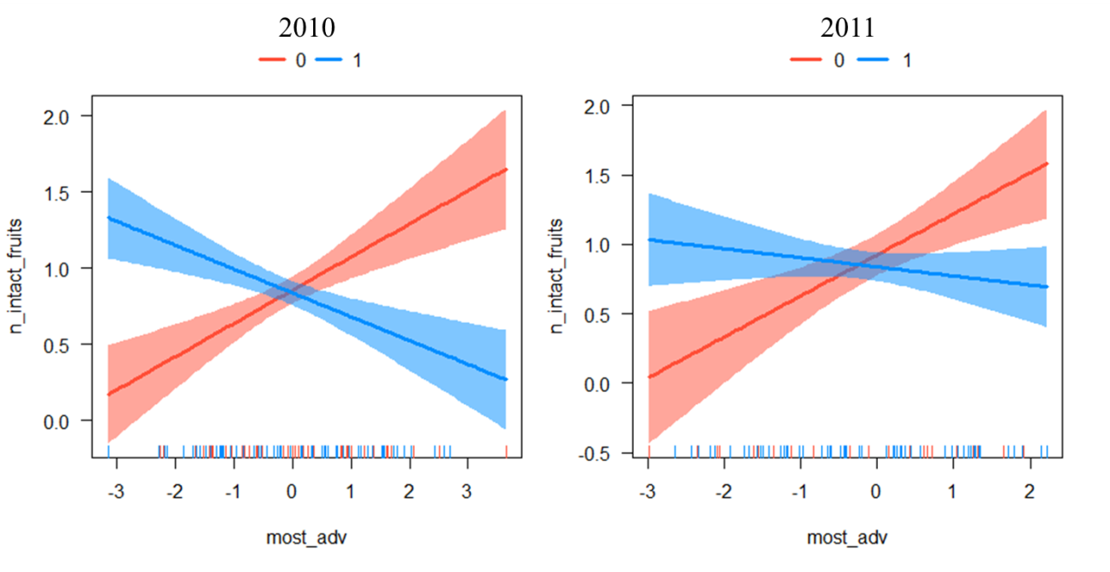

Figure 2

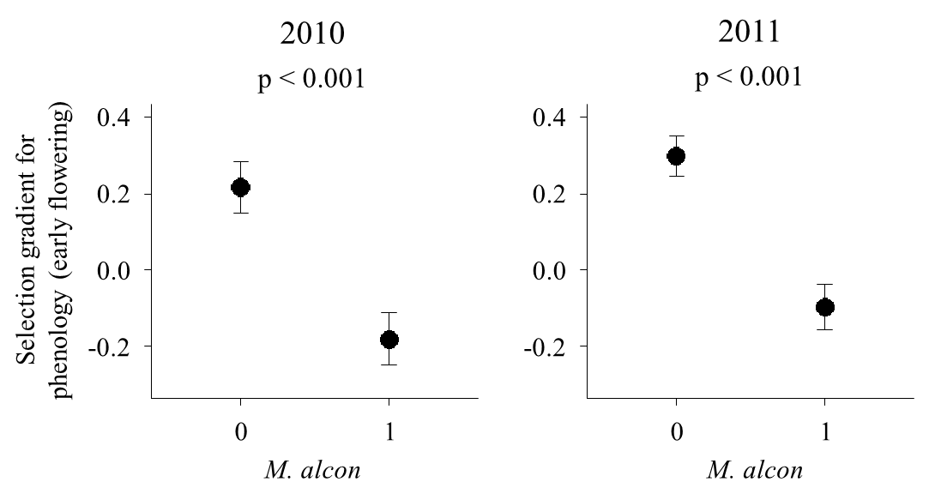

Figure 3

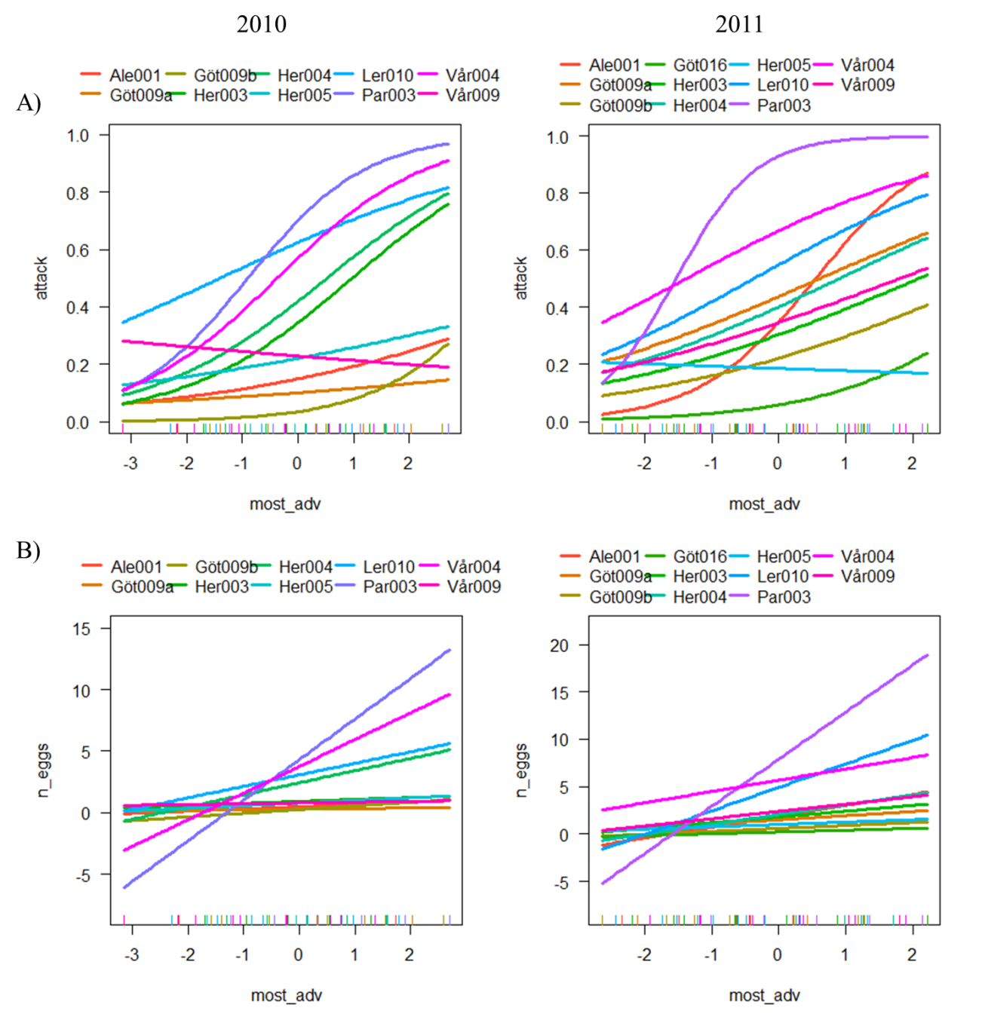

Figure 4

Figure 5

