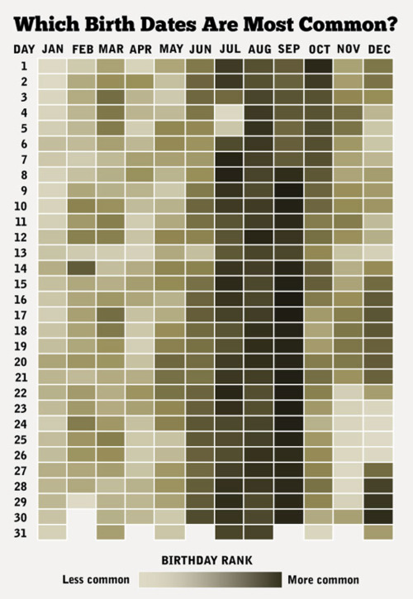

Source: <http://www.brainpickings.org/index.php/2013/10/08/best-american-infographics-david-byrne/>

What makes this a good visualization:

* Quickly draws your eye to the point of the visualization – that birthdates in June through September are most common.
* Simple, but also aesthetically interesting without being distracting.
* Clear labels and key.
* Easy to compare between different dates.

**Bad Visualization**

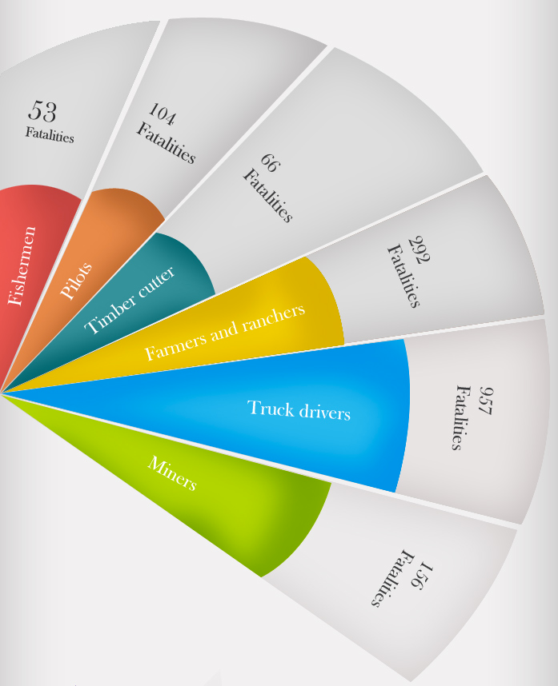This visualization does not accurately compare the number of fatalities for each profession. In fact, it is not readily apparent that this is a comparison from the start. Even once it is clear what is being compared, the colored sections are not scaled in a way as to show the large differences among each category.

Source: <http://gizmodo.com/8-horrible-data-visualizations-that-make-no-sense-1228022038>

While this redesigned visualization is not visibly remarkable, it simply and concisely displays the data, allowing for the viewer to quickly understand both what is being compared and the drastic differences in value across categories.