Kirk Jackson, Ali Tai, Matt Long

Comp 150: Visualization

Assignment 5: Part A & B

November 24, 2014

Hypotheses

1. Displaying a larger bar chart will increase accuracy of two elements being compared, compared to a smaller bar chart.
2. Displaying a larger pie chart will increase accuracy of two elements being compared, compared to a smaller pie chart.

Confidence Interval Calculation Method

The code begins with the initialization of variables representing the population mean value, standard deviation, sample size, z value for $α/2$ (**z <- qnorm(.975)** ), the array of sample upper confidence levels (**ucl**), the array of sample lower confidence levels (**lcl**), and the array of sample means (**x**). The code then enters a loop which populates the lower confidence level array by calculating $\overline{x}-z_{\frac{α}{2}}\frac{σ}{\sqrt{n}}$ where $\overline{x}$ is the sample mean, $z_{α/2}$ is the aforementioned **z**, $σ$ is the standard deviation, and $n$ is the sample size (**lcl[i] <-(x[i]) - z*sig/sqrt(n)**).This loop populates the upper confidence level in a similar manner (using + instead of -). The following section of the code plots, on the output graph, horizontal lines which represent the confidence interval of a particular sample (**lines(c(lcl[i],ucl[i]),c(i,i))**), and points on each of those which represent the mean of a particular sample (**points(x[i],i,pch=16,cex=.5,)**).

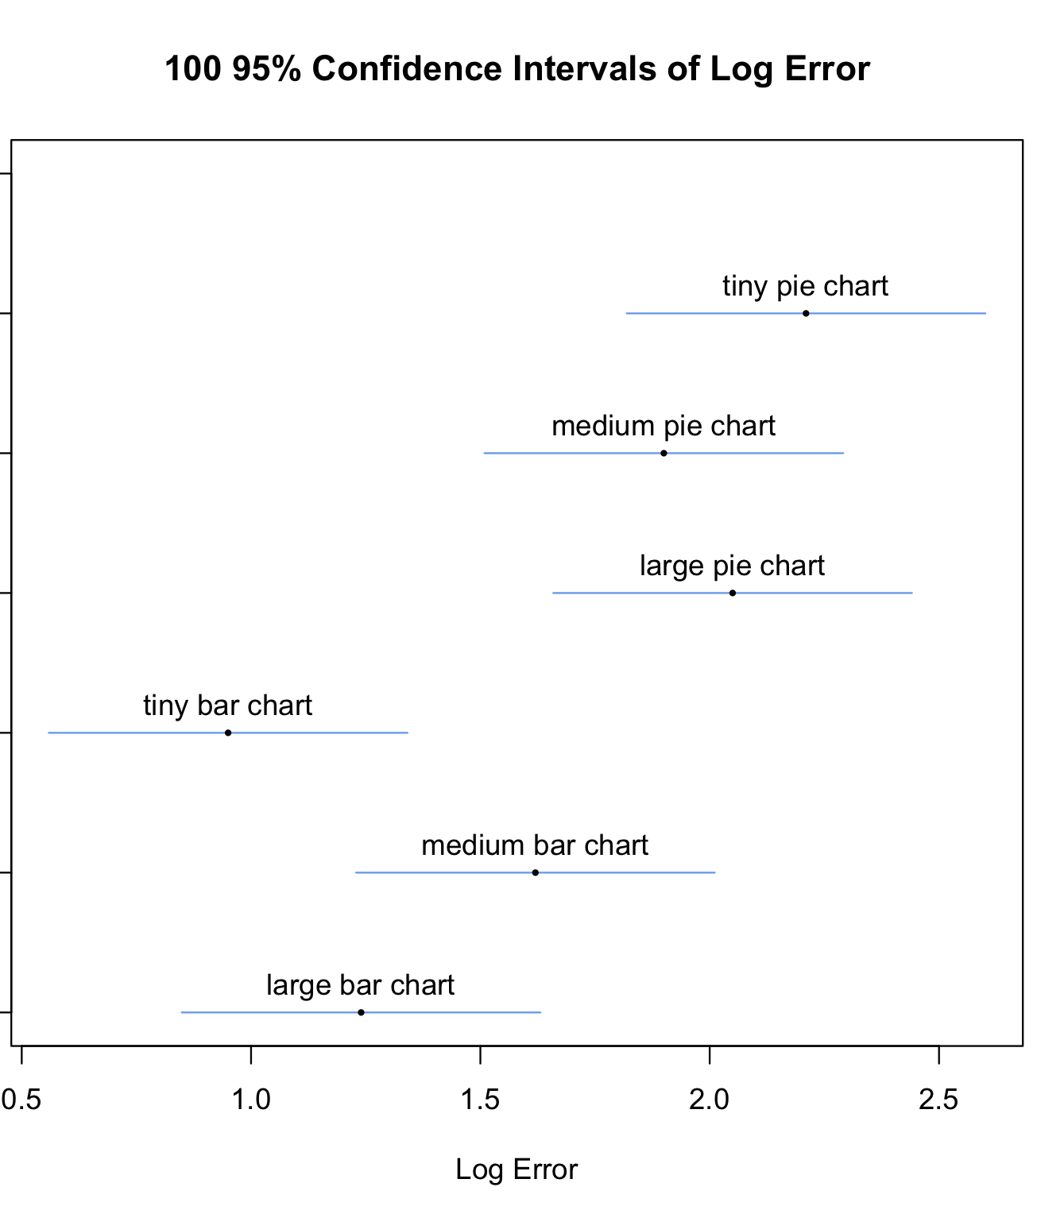

Error Analysis

The 95% confidence intervals of do not seem to show a significant correlation between error and the size of the charts. As can be seen in the graph, the medium pie chart confidence interval estimates less error compared to the tiny and large versions, while the medium bar chart confidence interval estimates much more.

On the other hand, this plot seems to show a correlation between the chart types and error.

Normal Distribution

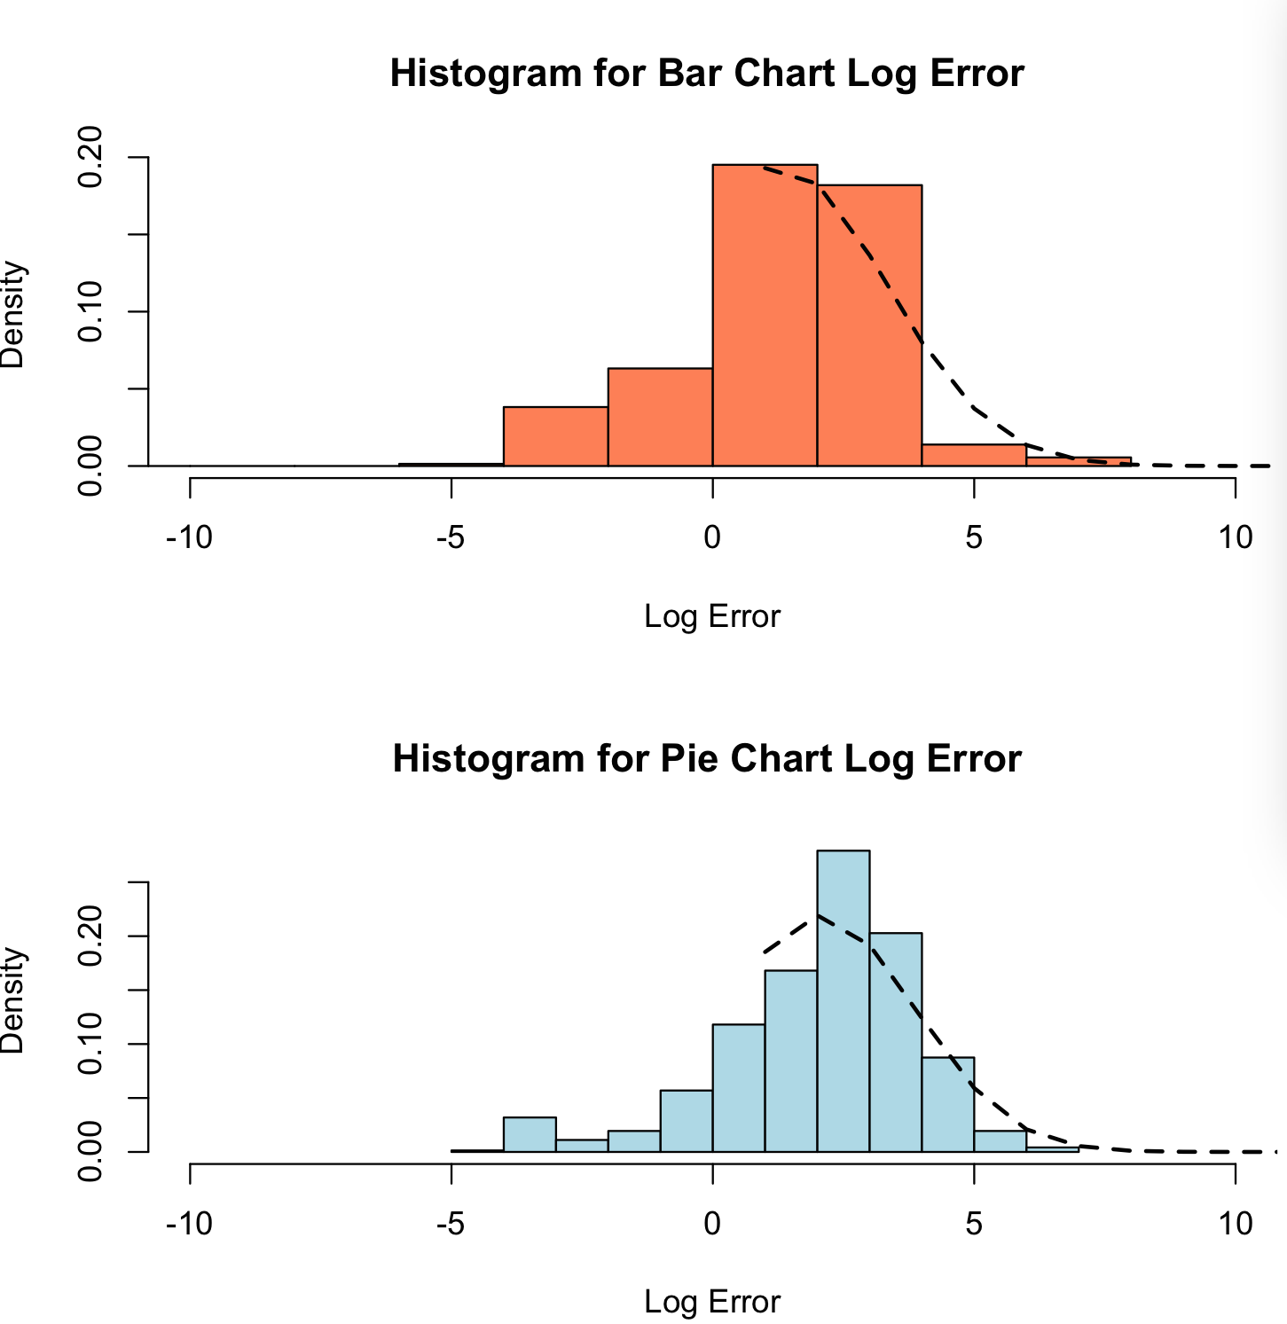

The dotted line drawn on top of the histogram indicates the shape of normally distributed data. These graphs are similar enough to the curve that they can be called normally distributed.

Examples of Conditions

