*Description*

This is a simple CRM Web Application. The front-end is written in HTML, CSS, and

JavaScript and jQuery (Ajax included). Back-end is written is in VB.NET. As database, MS SQL is used.

*Project*

When you start the project, it automatically brings Main.aspx page. Main.aspx is basically

a login page. It is asking you to login with Username and Password. If your records are in the database, you are logged in, otherwise you will get an error "Login failed. Please try again!".

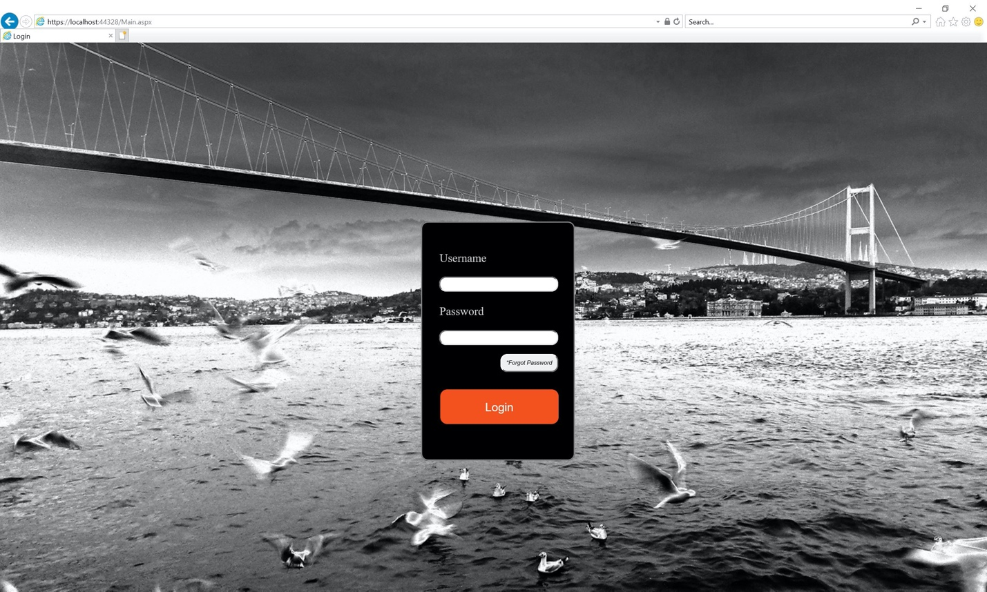

Since the login information are provided by the owner of the application, you will not be able to make your own registration. If you are already registered, but forgot your password, you can click on the button that says "\*Forgot Password". This button will send you to ForgotPassword.aspx.

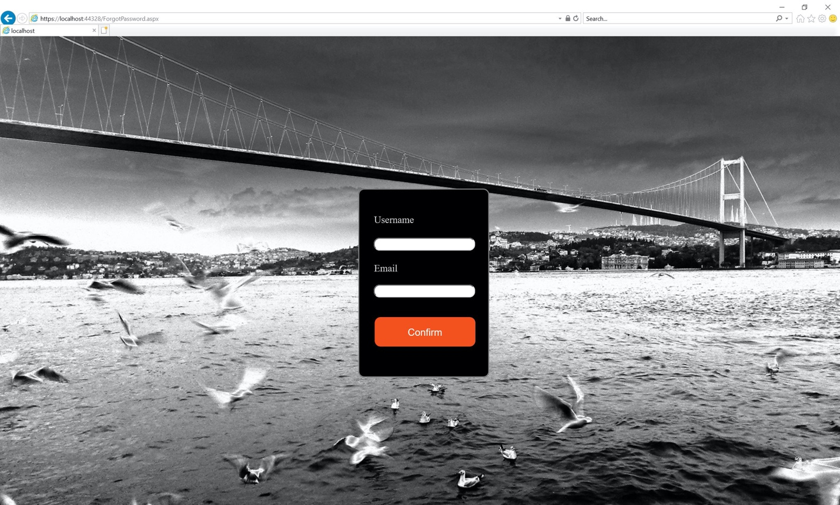

If you enter your username and email information wrong, you will get an error, says "You cannot create a new password! Check your username and/or email and try again...". Otherwise you will be sent to CreatePassword.aspx, and you will be able to create your new password. Then it will send you to Main.aspx again, and you can now log in with your new password.

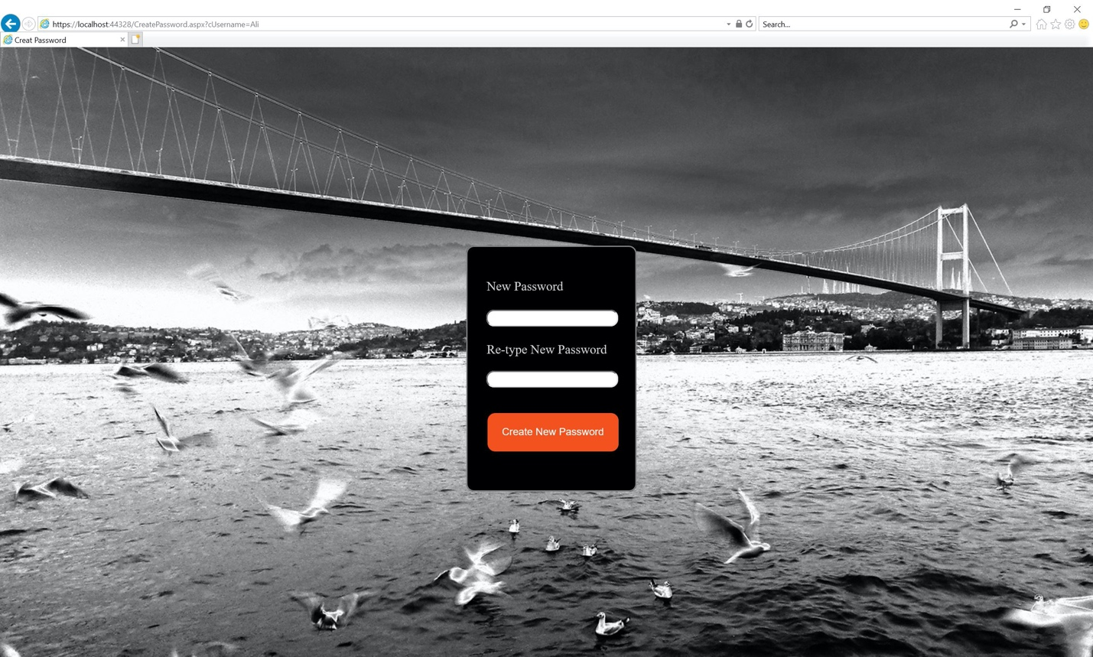

After you logged in, you’ll be sent to Menu.aspx. This page is where all your customer information is kept. There are 2 menus which are located on the left- and right-hand side. Left one is static and the right one is dynamic. On the right menu you can sign out with clicking on "Sign Out" and that will take you back to Main.aspx.

On the middle of the page, you will see jqGrid name is "Customer List" where you can do all your actions about your customers. Table consist of *ID, First Name, Last name, Company, Address, City, Country, Zip Code* fields. You can add, edit, delete customer, refresh the grid, and filter all the fields. Customer information is also held in the database.

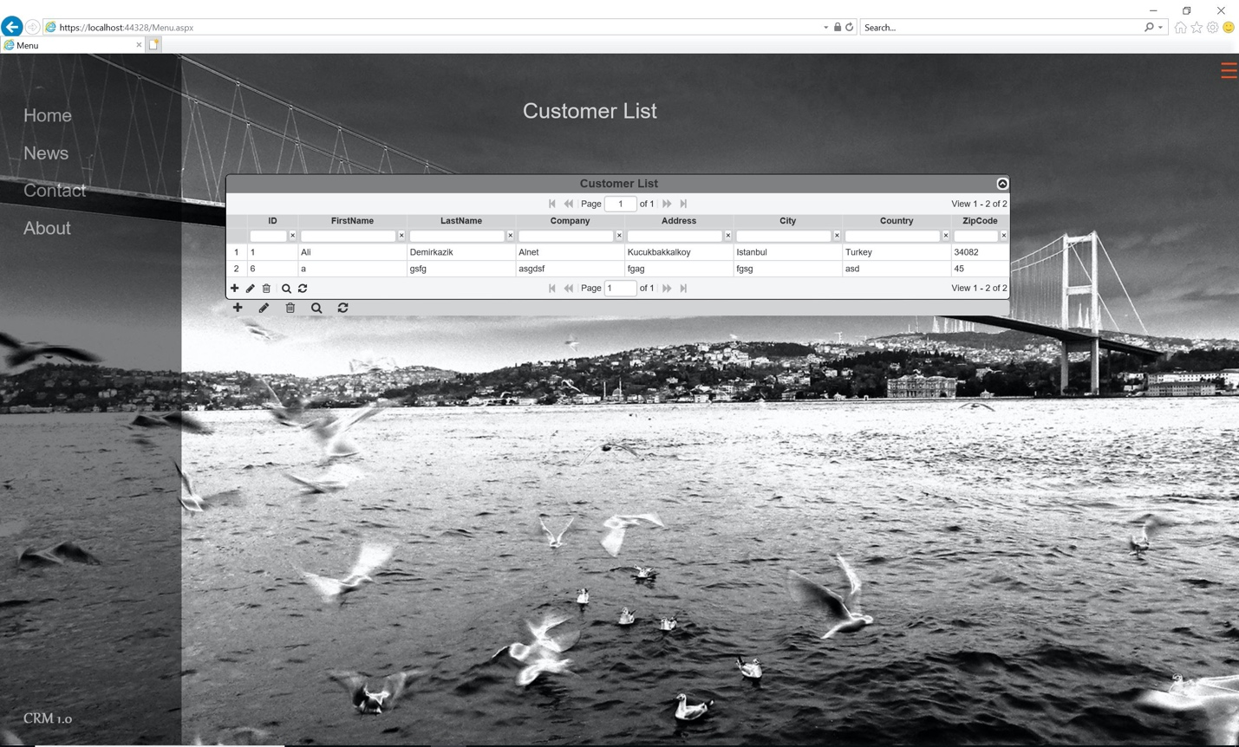

Add Record Screen

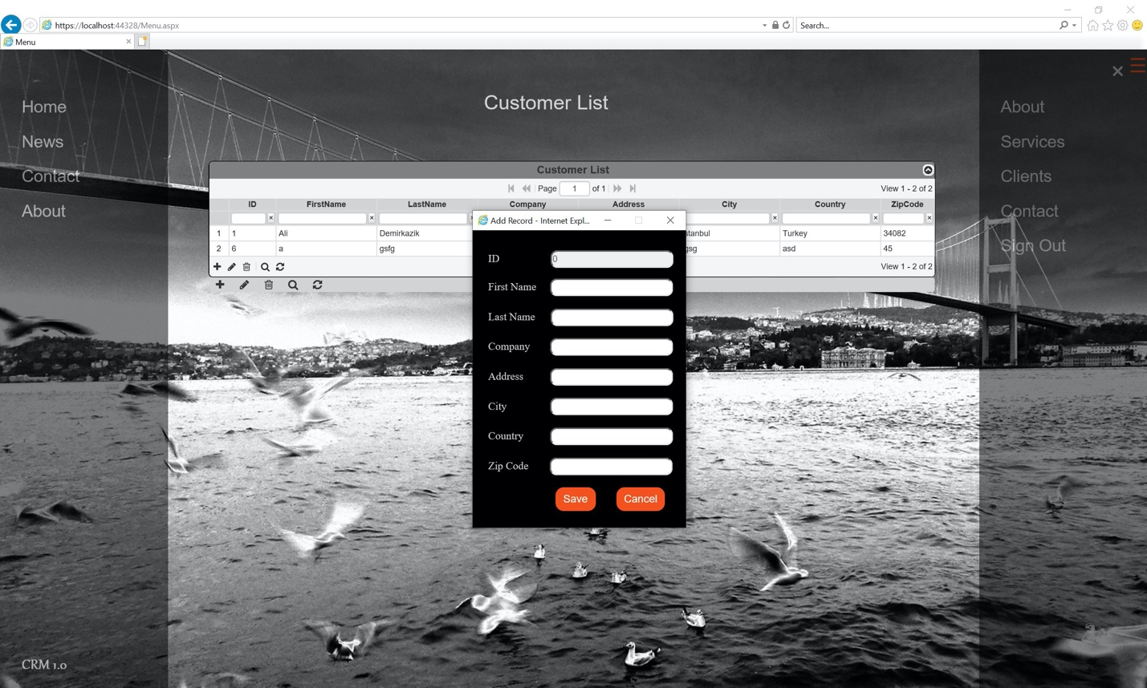

Edit Record Screen

