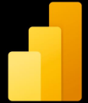Microsoft Power BI Mohammad Ghaheri
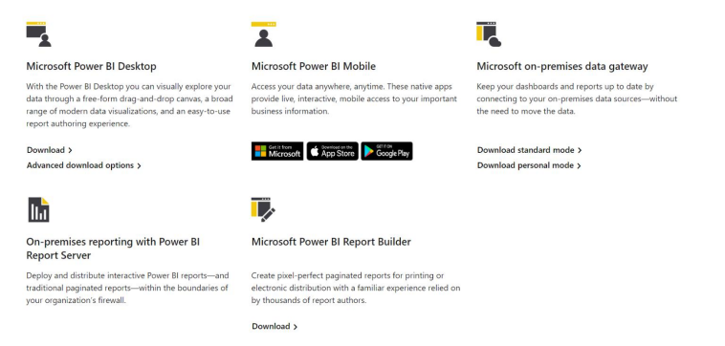
Converting Data into Insights
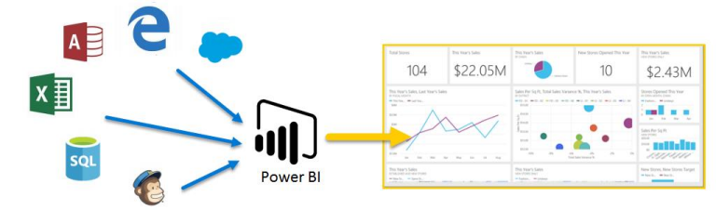
Power BI Desktop vs
Power BI Desktop Report Server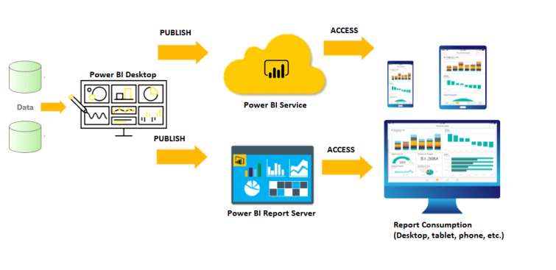
Dashboards
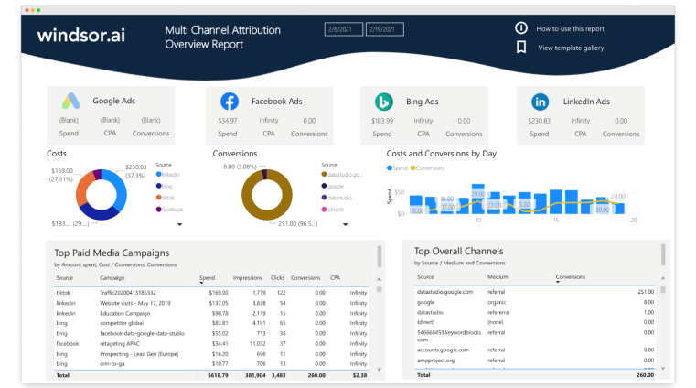
Course Index
• What is Power BI
• Power BI installation
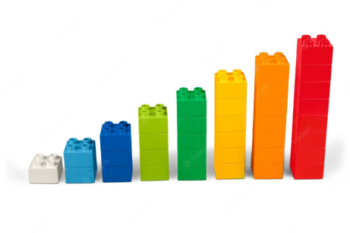
• My first dashboard in Power BI
• Get data in Power BI
• Clean, transform, and load data in Power BI • Design a data model in Power BI
• Work with Power BI visuals
Course Index
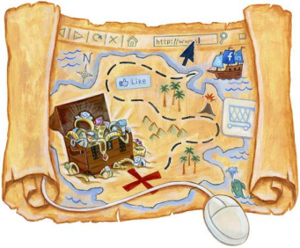
• Shamsi dates & dates dimension in Power Bi • Introduction to creating measures using DAX in Power BI • Create a data-driven story with Power BI reports • Create dashboards in Power BI
• Perform analytics in Power BI
• Power BI advanced topics
Install Power BI
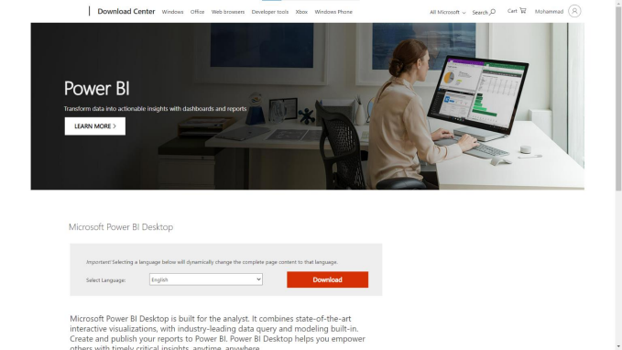
Power BI Desktop
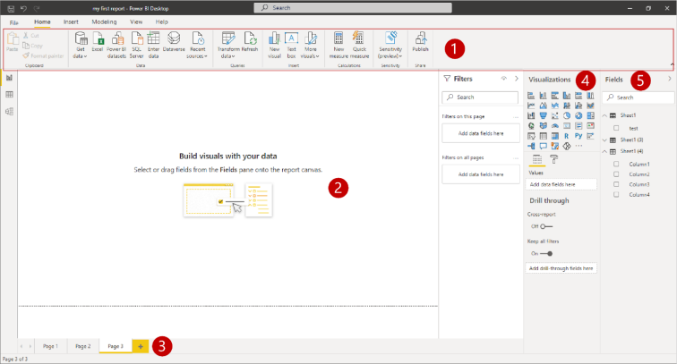
Power BI Desktop
1. Ribbon
2.Report view, or canvas
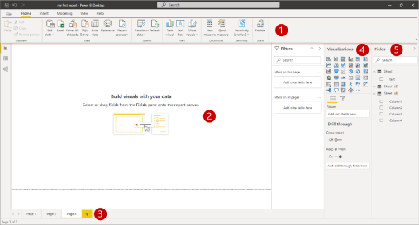
3.Pages tab
4.Visualizations pane
5.Fields pane
My First Dashboard
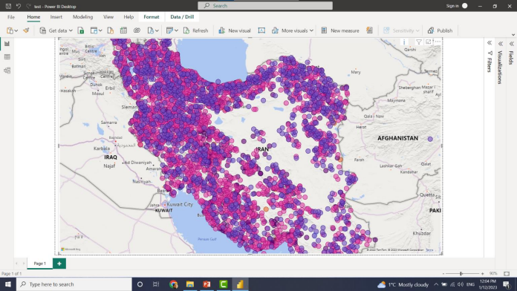
Our RoadMap

Clean &
Transform
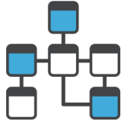Making Visuals
Getting Data

_{Data} Design a Data Model
1st Step
Getting Data
Get data in Power BI
• Identify and connect to a data source
• Get data from a file, such as Microsoft Excel
• Get data from a relational database, such as Microsoft SQL Server • Get data online
• Select a storage mode
Get data in Power BI
Get data in Power BI
CSV File
4
Get data in Power BI
XML File
Get data in Power BI
JSON File
Get data in Power BI
Get data from files
Get data in Power BI
Get data from relational data sources
Get data in Power BI
Relational Database
Movies
Get data in Power BI SQL Query
• https://www.w3schools.com/sql/
Install SQL Server & SSMS
Install Adventure Works DB
Get data in Power BI
Get data from relational data sources
Get data in Power BI
Get data from online services
Get data in Power BI
Select a storage mode
Our RoadMap
Clean &
Transform
Making Visuals
Getting Data
_{Data} Design a Data Model
2nd Step
Clean &
Transform Data
Data Transforming
Power Query
Append Tables
Merge Tables
Our RoadMap Clean &
Making Visuals
Getting Data
^{Transform Data}Design a Data Model
3rd Step
Design a
Data Model
Data Modeling
Good Model Advantages • Data exploration is faster. • Aggregations are simpler to build.
• Reports are more accurate.
• Writing reports takes less time.
• Reports are easier to maintain in the future.
Star schemas
• Fact tables
contain observational or event data values
• Dimension tables contain the details
about the data in fact tables
Star schemas
• Fact tables
contain observational or event data values
• Dimension tables contain the details
about the data in fact tables
Star schemas
• Fact tables
contain observational or event data values
• Dimension tables contain the details
about the data in fact tables
Hierarchies
Hierarchies
Parent-child hierarchy
Path = PATH(Employee[Employee ID], Employee[Manager ID])
Define data granularity
Define data granularity
TotalSales = SUM(Sales[Total Sales])
BudgetAmount = SUM (Budget[BudgetAmount])
Define data granularity
TotalSales = SUM(Sales[Total Sales])
BudgetAmount = SUM (Budget[BudgetAmount])
Work with relationships and cardinality
Our RoadMap Clean &
Making Visuals
Getting Data
^{Transform Data}Design a Data Model
4th Step
Making
Visuals
Work with Power BI visuals
Selecting and changing visuals
Bar and Column charts
Bar and Column charts
y
x
Table & Matrix visuals
Line and Area charts
Pie chart, donut chart, and Treemaps
Combo Charts
KPI & Card Visuals
Filters & Slicers
Map Visuals
Filled Map
Format
Importing Custom Visuals
Importing Custom Visuals
Desktop & Mobile Layout View
Our RoadMap Clean &
Making Visuals
Getting Data
^{Transform Data}Design a Data Model
Course Index
• What is Power BI
• Power BI installation
• My first dashboard in Power BI
• Get data in Power BI
• Clean, transform, and load data in Power BI • Design a data model in Power BI
• Work with Power BI visuals
Course Index
• Shamsi dates & dates dimension in Power Bi • Introduction to creating measures using DAX in Power BI • Create a data-driven story with Power BI reports • Create dashboards in Power BI
• Perform analytics in Power BI
• Power BI advanced topics
Shamsi dates & Dates dimension
Course Index
• Shamsi dates & dates dimension in Power Bi • Introduction to creating measures using DAX in Power BI • Create a data-driven story with Power BI reports • Create dashboards in Power BI
• Perform analytics in Power BI
• Power BI advanced topics
DAX
• Build quick measures.
• Create calculated columns.
• Use DAX to build measures.
• Discover how context affects DAX measures. • Use the CALCULATE function to manipulate filters. • Implement time intelligence by using DAX.
Create a quick measure •
Create calculated columns
Create a measure
Understand context
Use the Calculate function
Use relationships effectively
Work with time intelligence
Course Index
• Shamsi dates & dates dimension in Power Bi • Introduction to creating measures using DAX in Power BI
• Create a data-driven story with Power BI reports • Create dashboards in Power BI
• Perform analytics in Power BI
• Power BI advanced topics

