**PUCIT University Portal**

**Mobile Computing ASSIGNMENT 1**

Submitted to:

Sir Haq Nawaz

Submitted by:

ALI SALEEM

(BITF19M011)

Date: November 30, 2022.



PUCIT, University of the Punjab, Lahore.

**Git and Github**

Initializing project, git and making repository:

Create a folder, named ‘loginPage’. Create login page with HTML and CSS language. Folder structure should look like this.

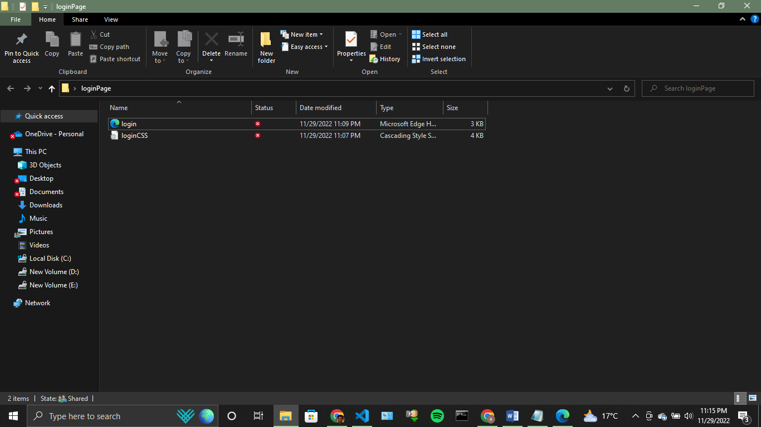

Currently, login page looks like this.

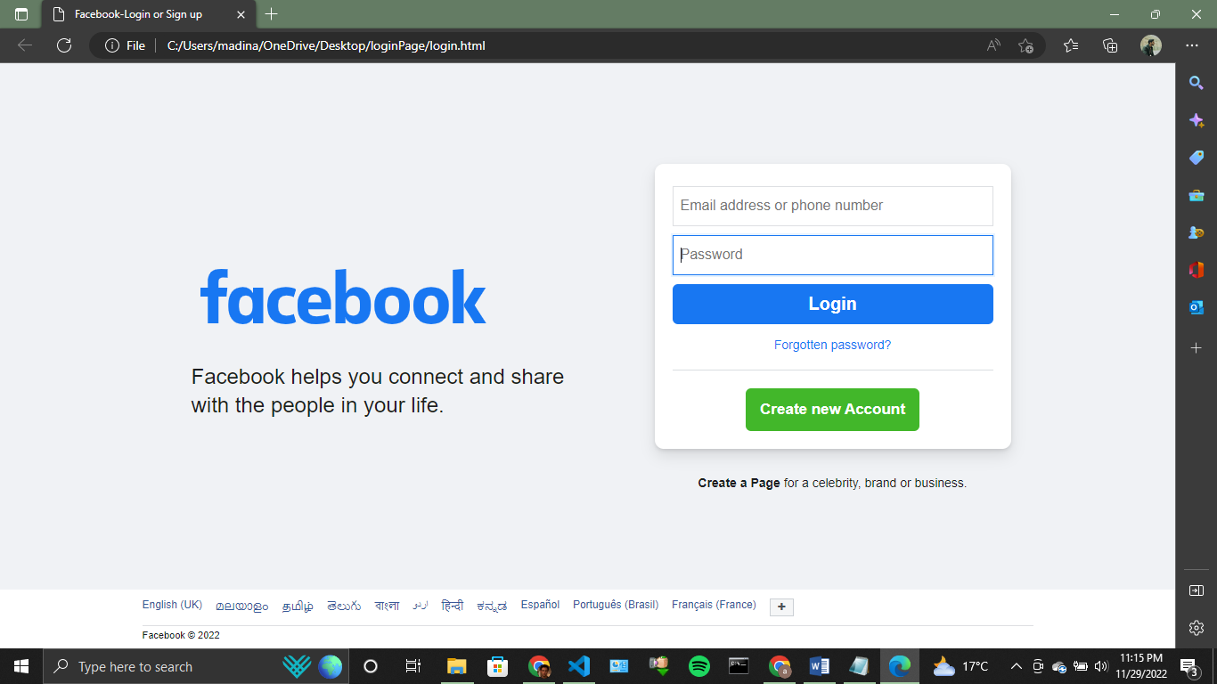

Open command prompt, and open the current ‘loginPage’ folder by using CD command on command prompt.

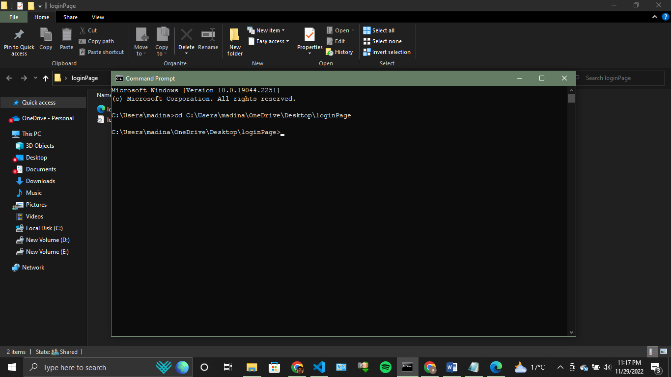

Initialize git by using ‘git init’ command. This command initializes your git for this particular folder. Git is basically a version control system used to keep different versions of your project.

Now lets make repository on github with name ‘loginPageRepo’.

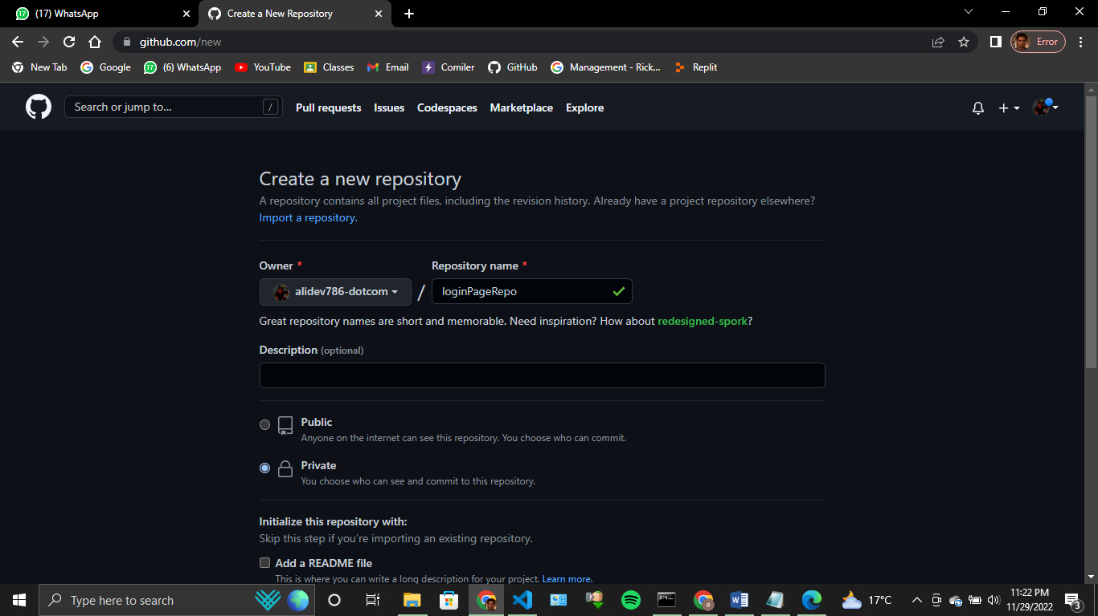

Now lets go back to working directory. For example, we want to keep this current version of our project, before making any changes to it. For that purpose, we need to save this version of project. Before saving this current version, we need to add this current version to ‘Stagging Area’, by using command ‘git add filename’. If you want to add all files in your this version, we can use ‘git add .’ .

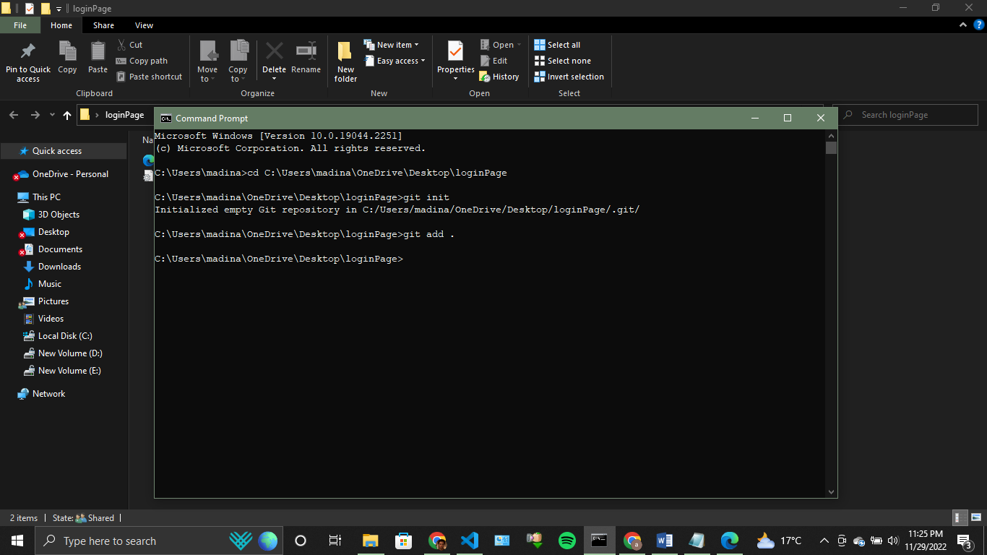

Now after saving all files to stagging area, we need to make a commit which finally saves the current version of our project.

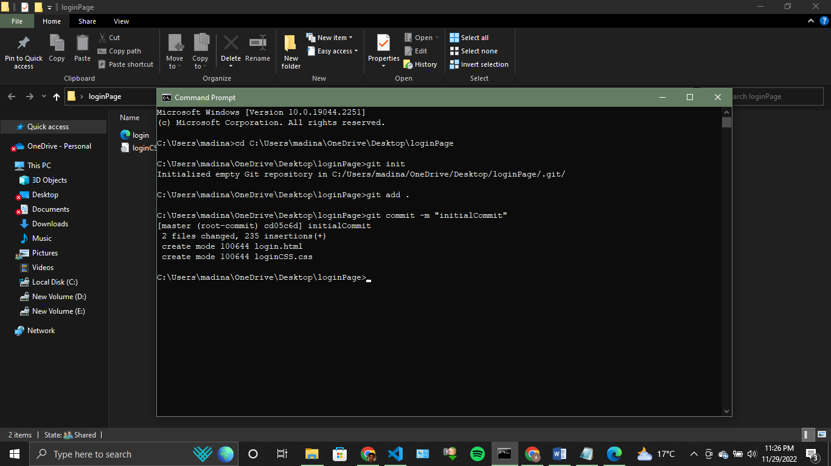

Now your current version is saved with commit name ‘initialCommit’.

Now lets suppose, we want to add one more input field to our html page, i.e, security question. It looks like this after adding this text field.

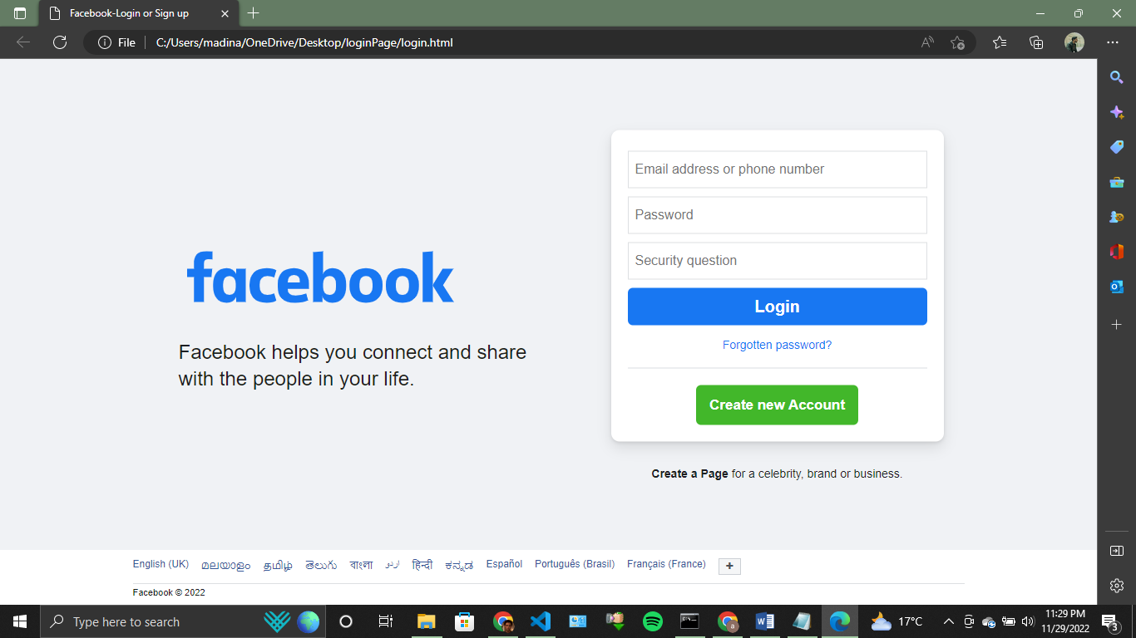

Now we have changed the previous version. Now if we use command ‘git status’, we can check status of our project either there are any changes in our previous version or not.

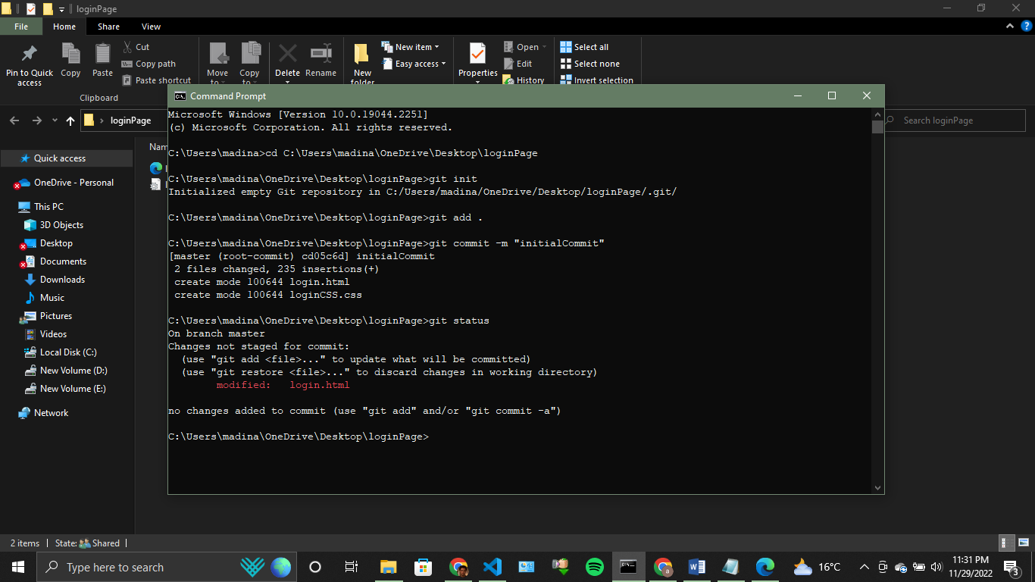

Red line ‘login.html’ shows that there is change in the file ‘login.html’ and it displays that these changes are not stored in any commit. Now lets save this version with name ‘second commit’.

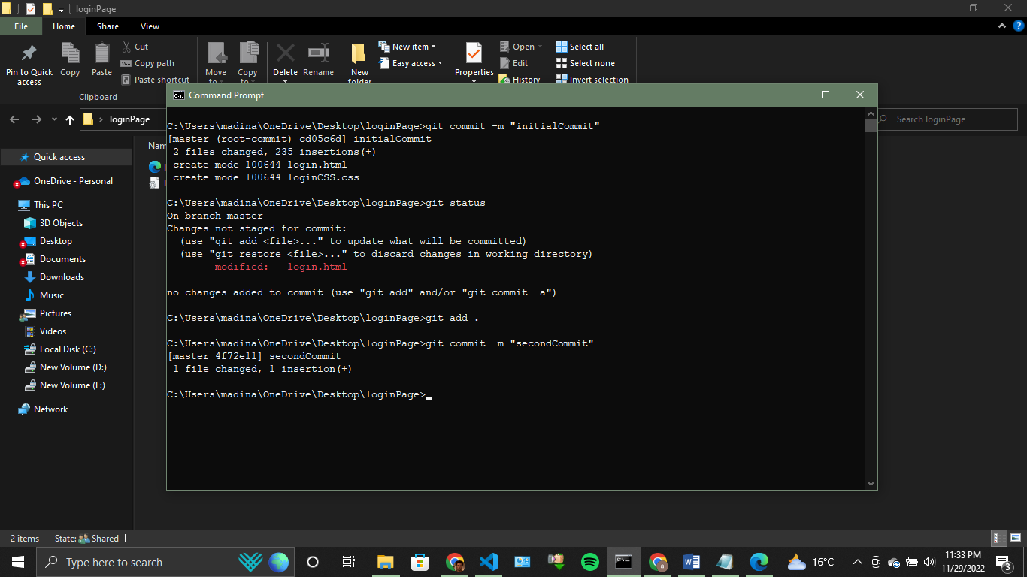

Now, after adding the second commit, lets check the status of the project. This is how it looks like.

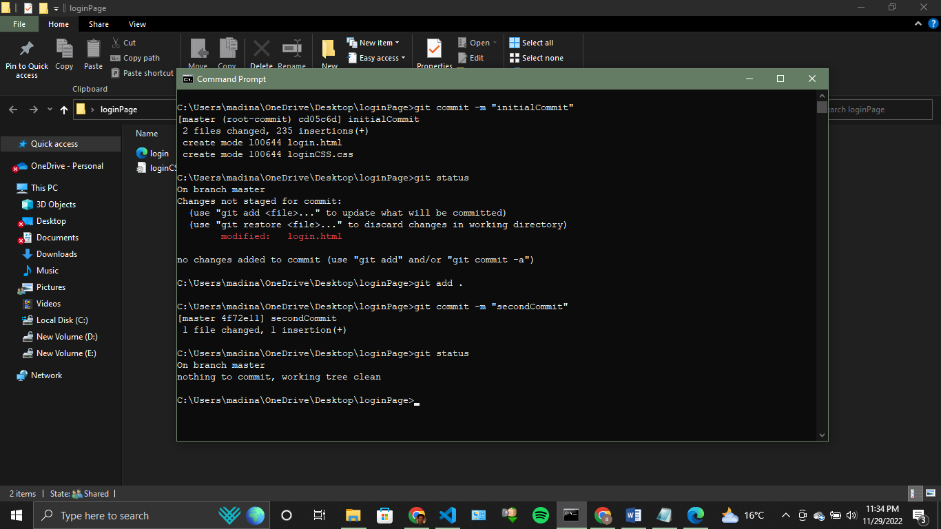

It shows that there is nothing changed and your current version is already saved.

Also, ‘git log’ command gives information about all the commits made since now in this current branch.

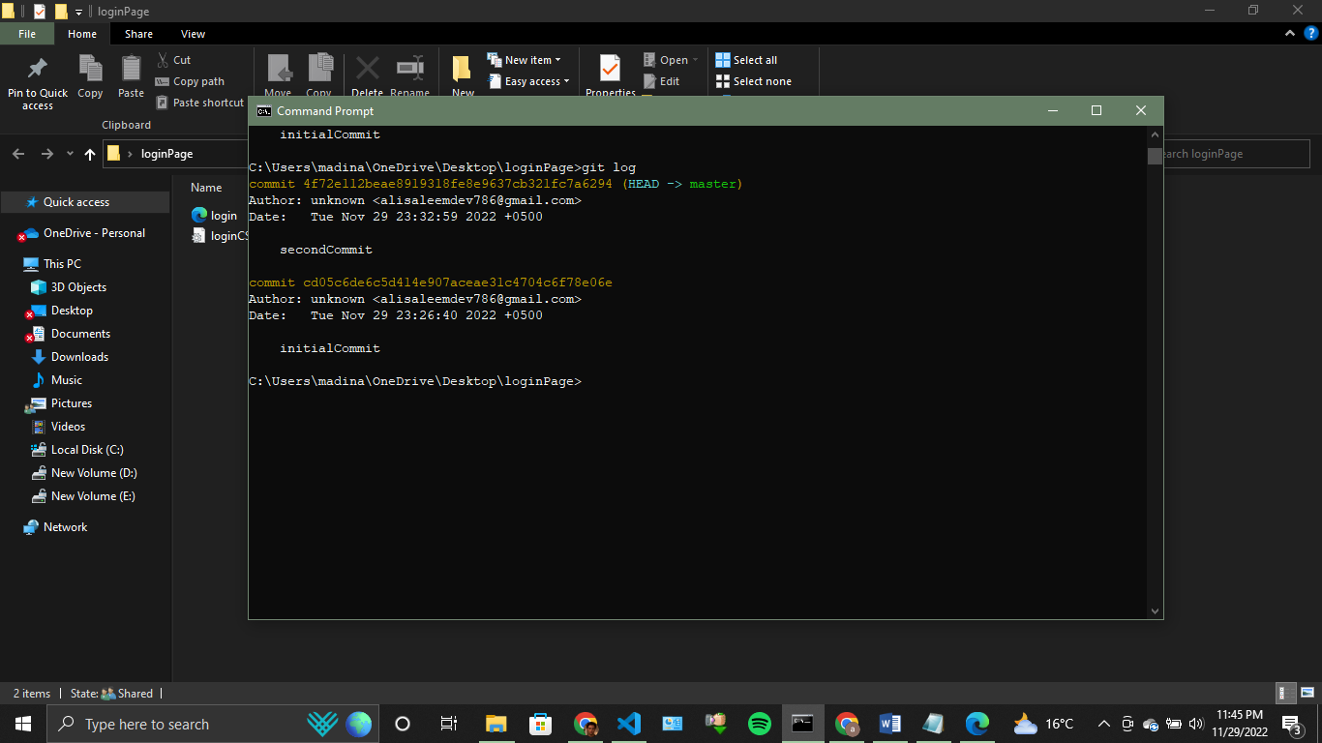

Git Branching

Branching is used in git, when we want to save the current whole project, and wants to add some new feature. We keep on working on new feature in new branch, and when we are done with this feature, we can merge this new branch to old branch, and all the code is good to go.

‘git branch’ command gives idea about current and all branched in your project.

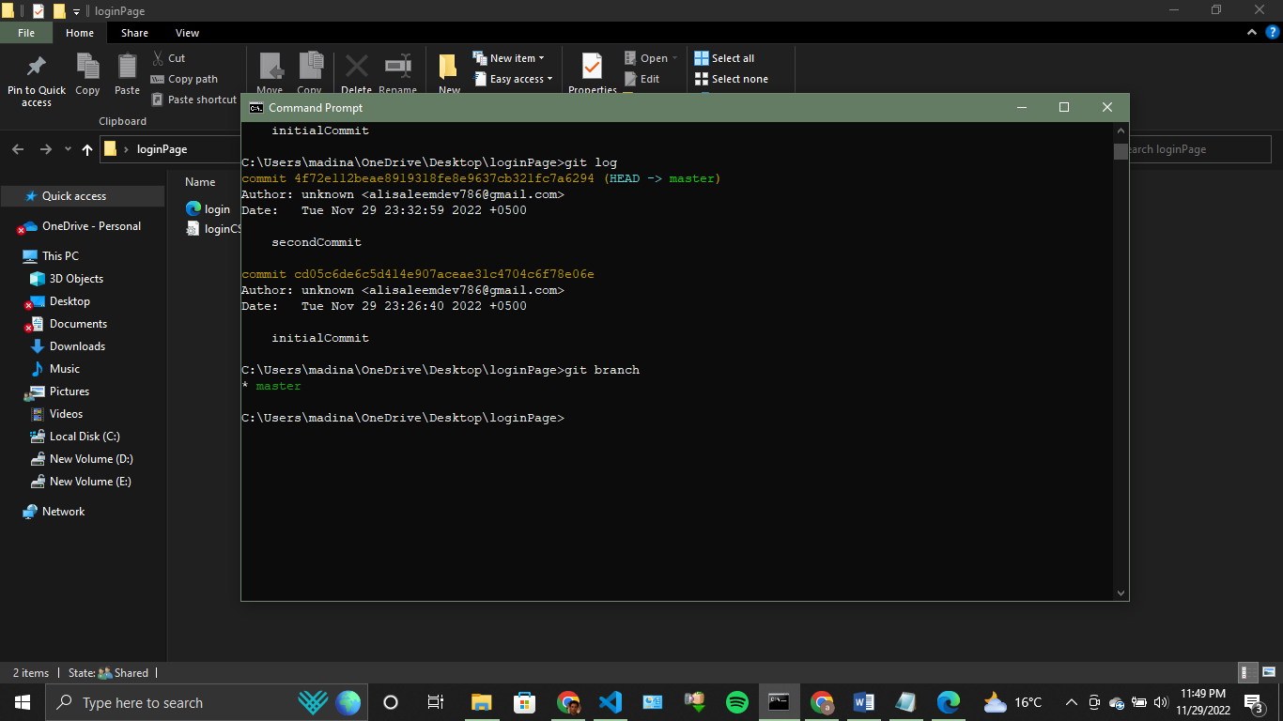

As you can see, currently there is only 1 branch in our project, i.e, master branch.

Noe for example, I need to add 1 more feature to my page which is login by google. Just below ‘Create New Account’ button, I want to add 1 more button with text ‘Login with google’. Now I have doubt, adding this feature can destroy my old work. So I am creating a new branch with name ‘newFeature’.

We can create new branch by using this command ‘git checkout –b branch_name’.

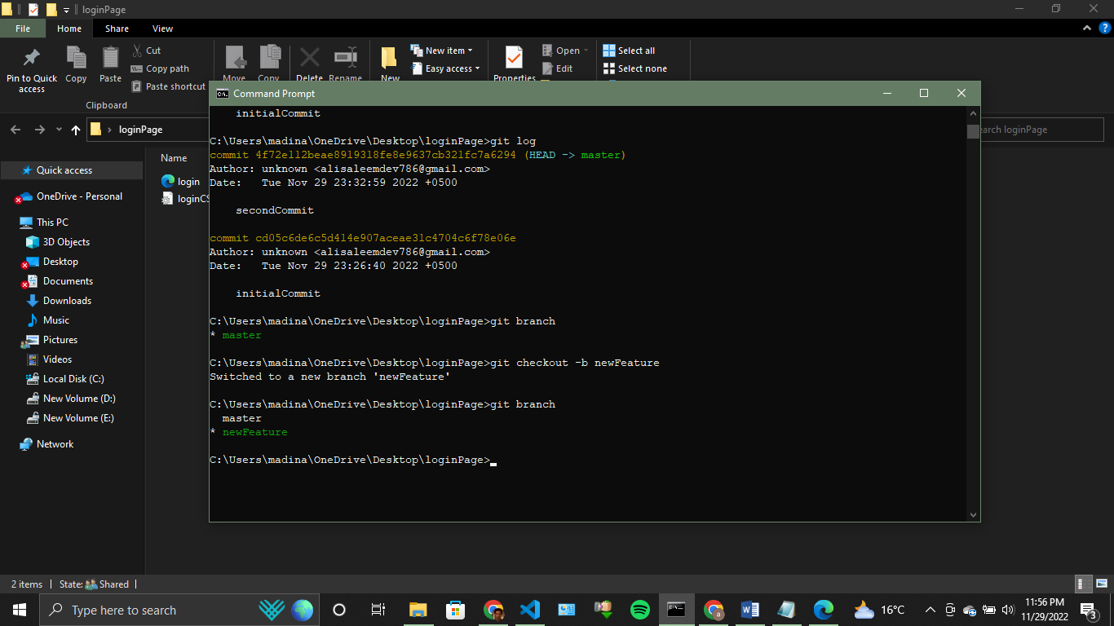

It can be seen that new branch with name ‘newFeature’ has been created and current branch is now newFeature.

This new branch contains all the old work already.

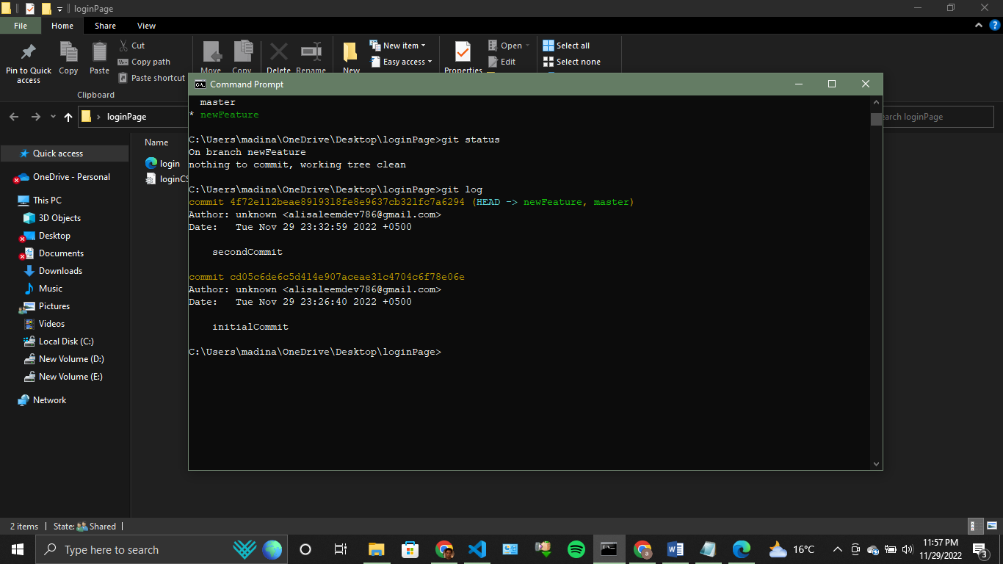

Now lets add the button login with google.

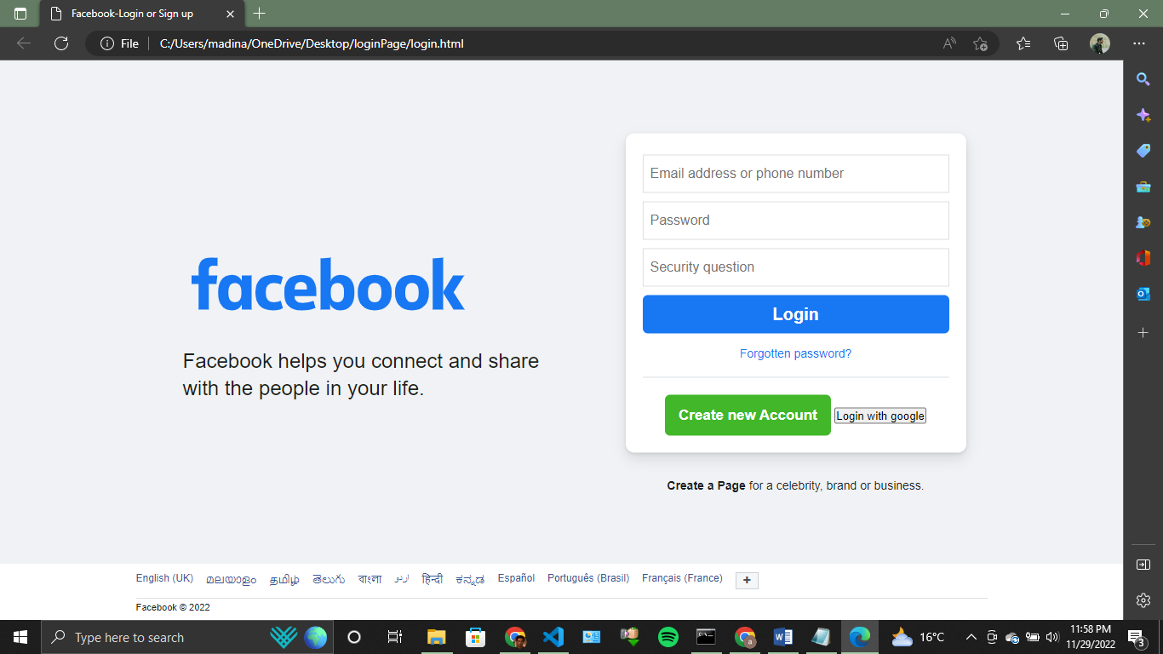

It can be seen that button has been added but this button does not contain any css. So , for now lets commit the current version.

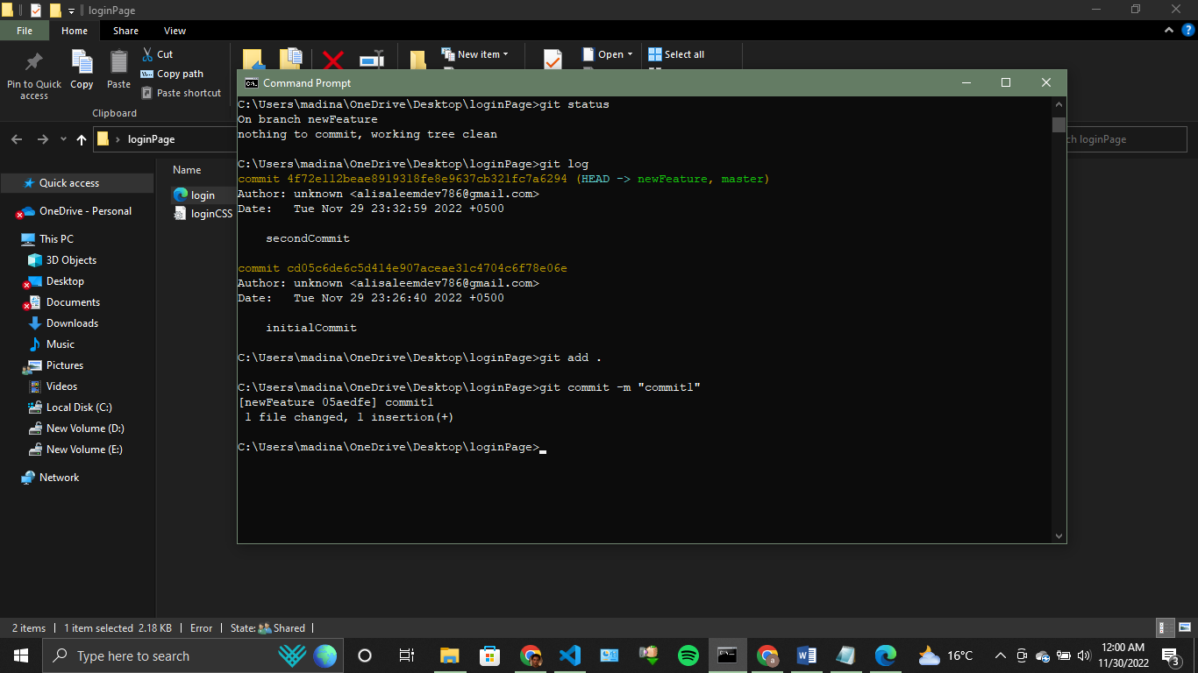

Now lets apply css to this button and save commit this change as well.

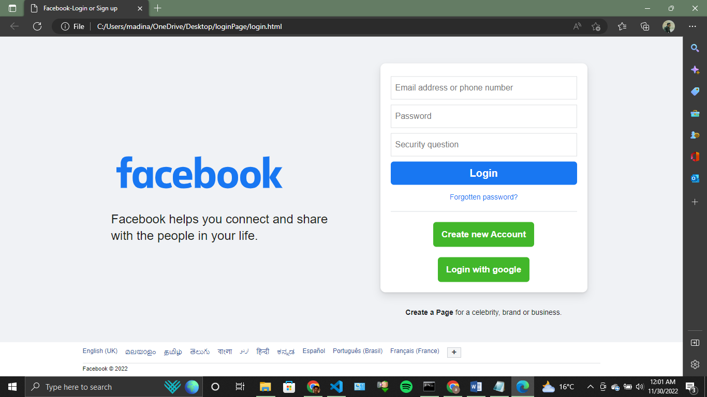

Lets commit this change too as ‘commit2’.

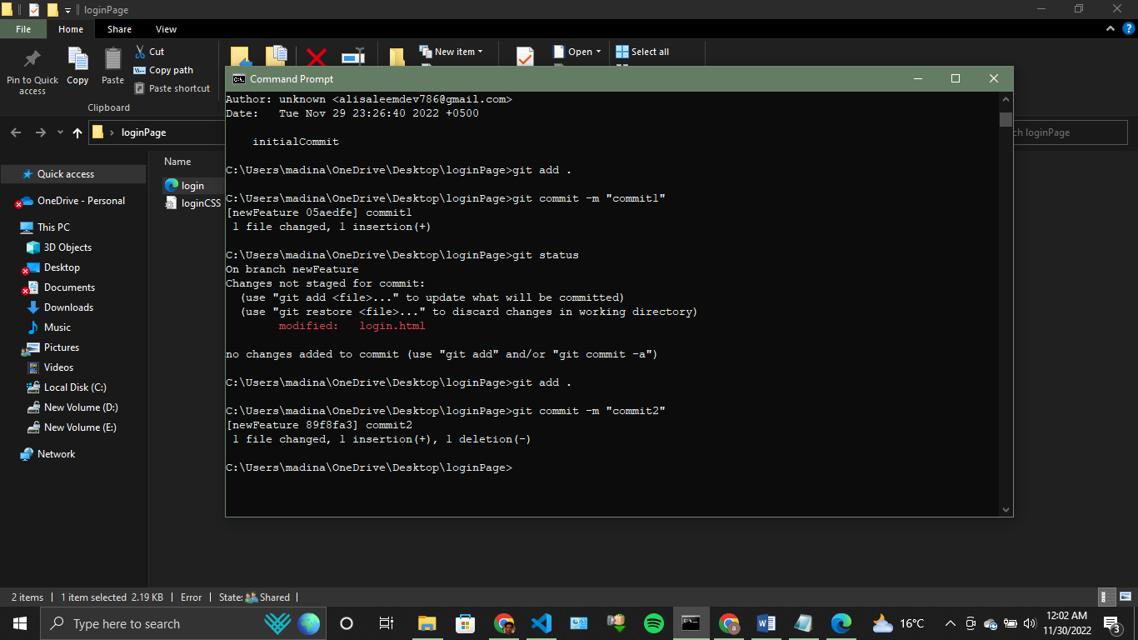

Merging the branch

Now since new feature has been added, I want to merge this new branch ‘newFeature’ to old branch ‘master’. For this purpose, we can use ‘git merge branch_name’ command.

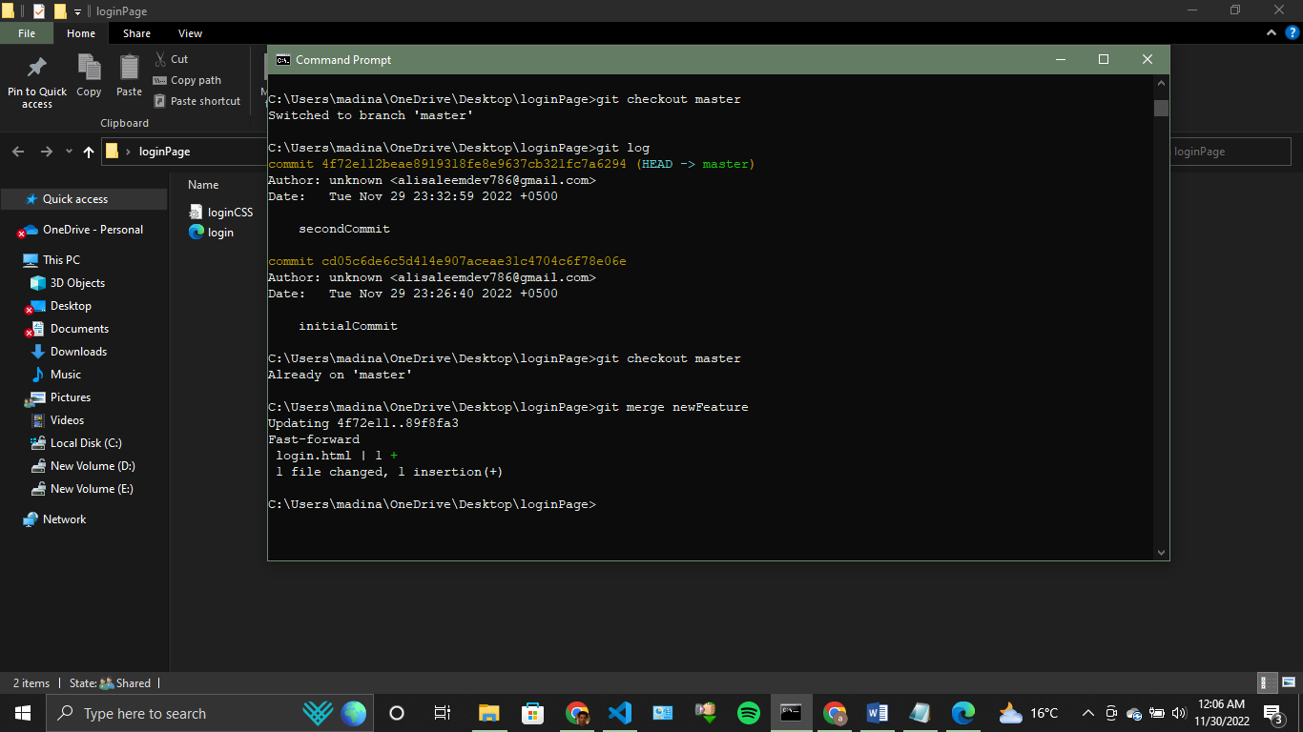

Now, ‘newFeature’ branch has been merged into master branch. Now if we check master branch log, we can see that master branch now contains all the 4 commits. It contains 2 commits from ‘newFeature’ branch as well.

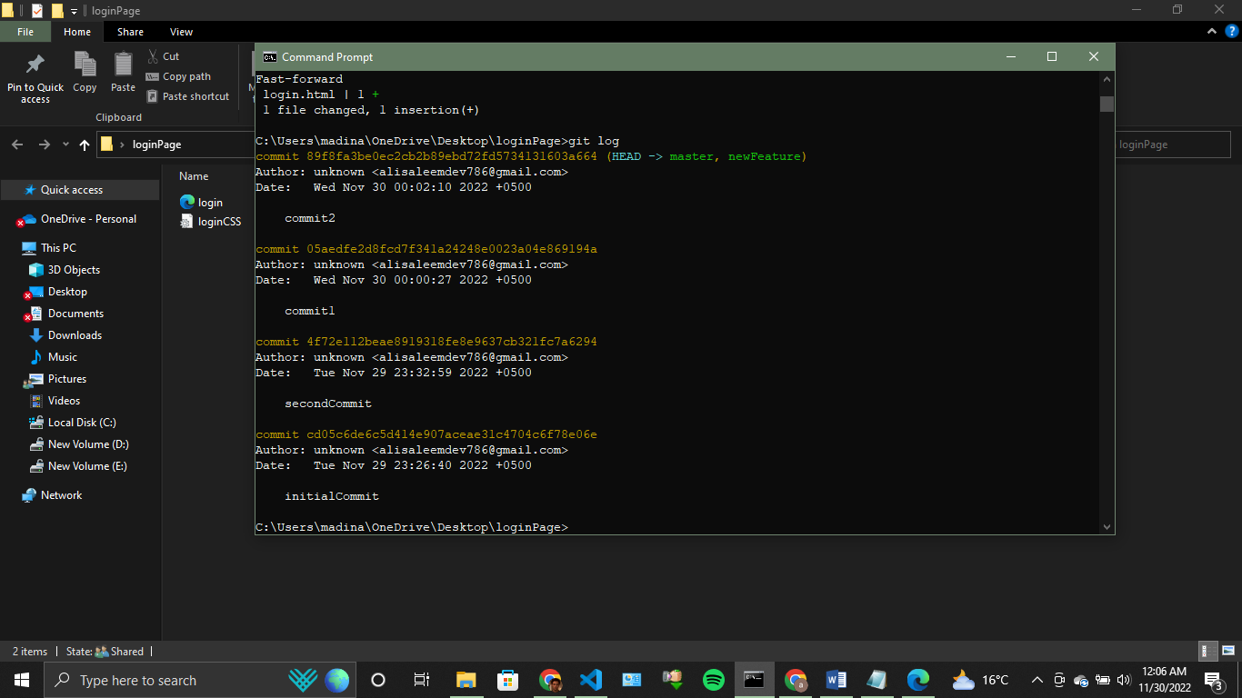

Pusing into remote repository

Now lets suppose, I want to push my all code into my remote repository. For this purpose, we can use ‘git push command’.

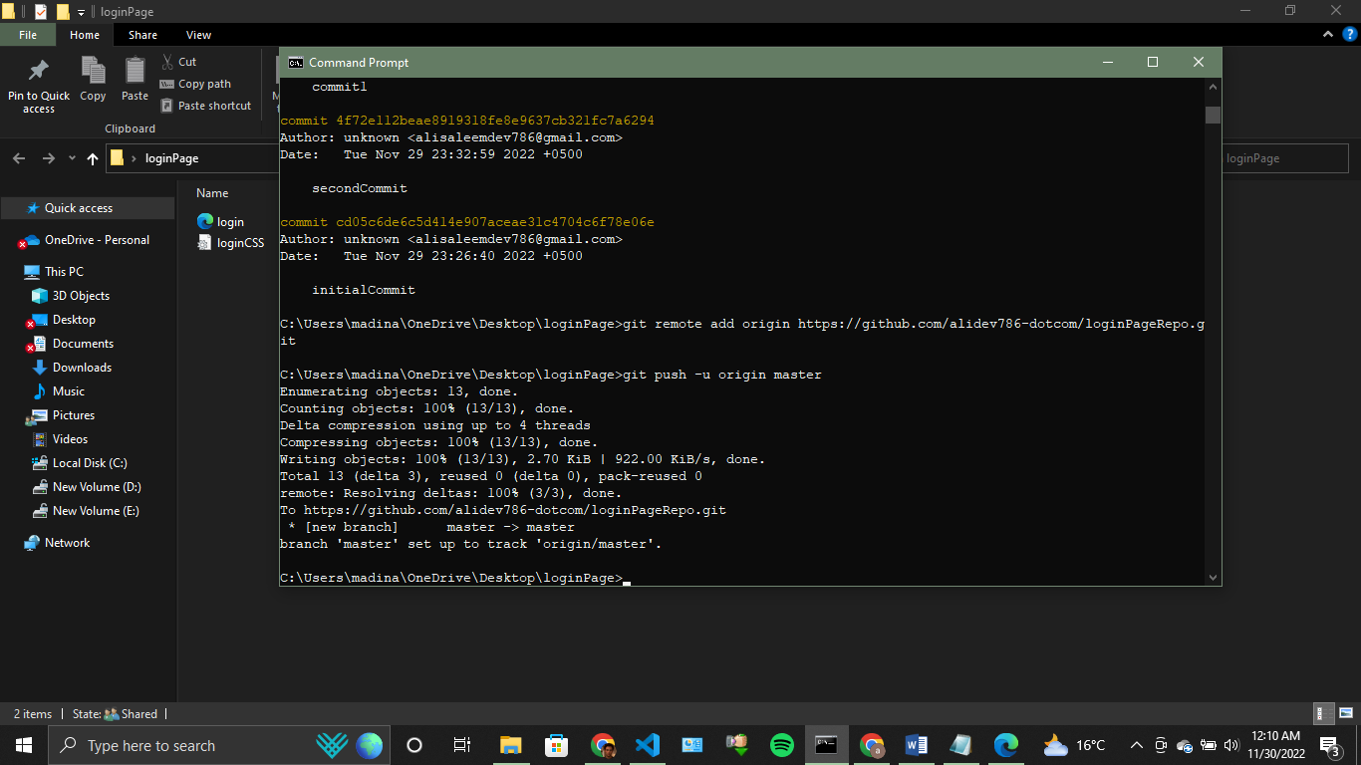

It can be seen that, first we add origin of our remote repository, and after setting origin, we simply push our code to given repository.

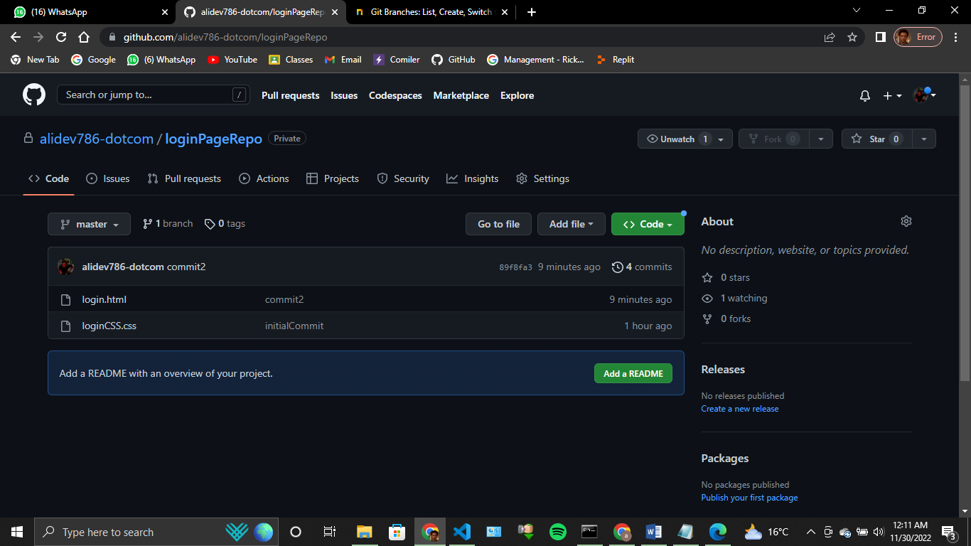

Now we can see that our project has been pushed to remote respository with 4 commits which we done while working on our project.

Git Clone

Now lets suppose I am some other user, and I want to have this ‘loginPageRepo’ in my system. It can be done using git clone command.

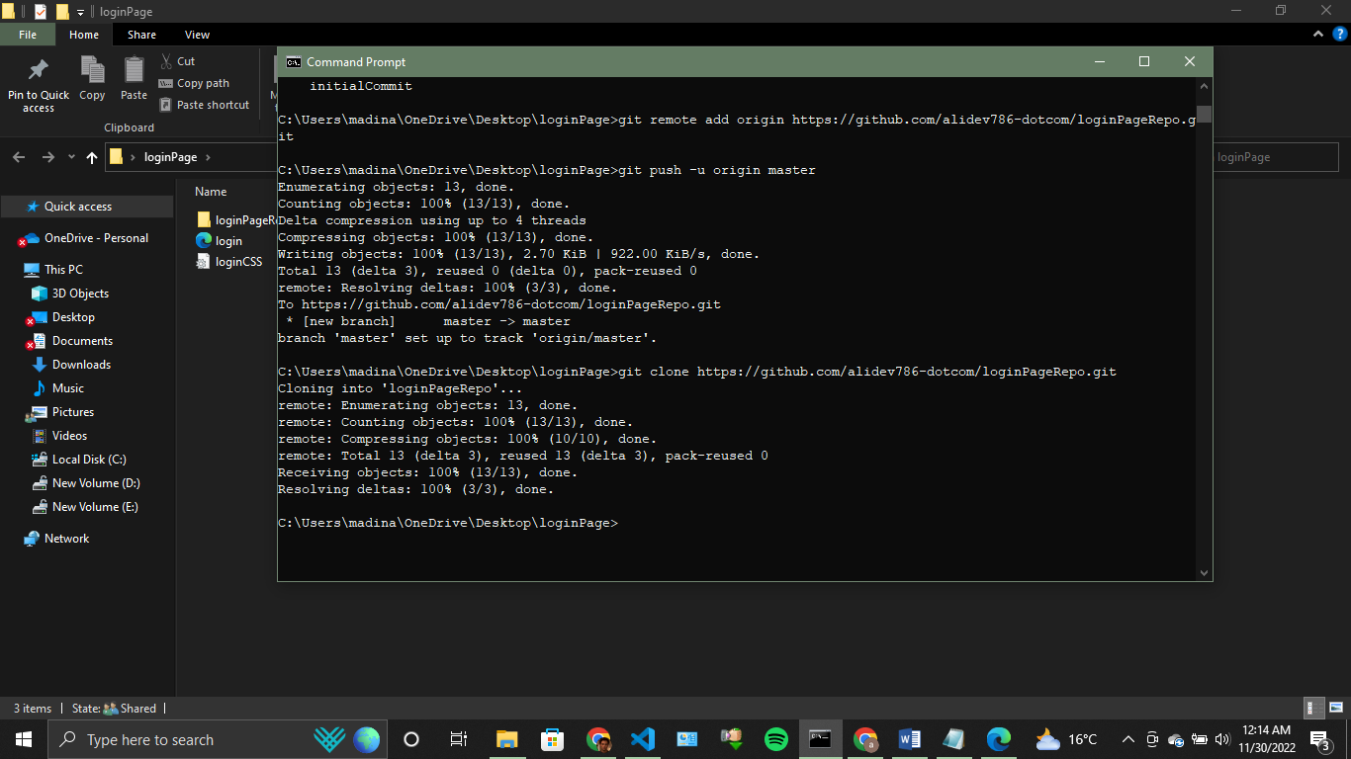

It can be seen that git has been cloned. Complete folder from github repository has been downloaded to my current directory.