
N . C . B . A . & . E
F i n a l Y e a r P r o j e c t R e p o r t

TrackGo
Railway & Bus Ticket Reservation System
with AI-Powered Travel Recommendations
T E A M M E M B E R S
Muhammad Asad Aslam ([Roll No.]) | Group Leader
[Member 2 Name] ([Roll No.])
[Member 3 Name] ([Roll No.])
S U B M I T T E D T O
Miss Hira Faisal
Table of Contents

1 Introduction 3
1.1 Background 3
1.2 Motivation 3
1.3 Problem Definition 4
2 Problem Statement 5
3 Objectives of the Project 6
4 Proposed Solution 7
4.4 Use Case Diagram 8
4.5 Context Diagram (DFD Level 0) 8
4.6 Data Flow Diagram Level 1 9
5 System Architecture 11
6 Functional Requirements 14
7 Non-Functional Requirements 16
8 Database Design 18
9 Implementation Details 21
9.4 Activity Diagrams 22
9.5 Code Snippets 25
10 System Testing / Test Cases 27
11 Future Enhancements 29
12 Security Measures 30
13 Project Limitations 31
14 Conclusion 32
15 References 33
16 Appendices 34

1. Introduction

1.1 Background
Anyone who has travelled between cities in Pakistan knows the routine. You either go to the railway station or bus terminal a day early to buy a ticket, call a booking agent, or open three or four different websites to compare departure times and fares. Pakistan Railways has its own online portal, and the larger bus companies such as Daewoo Express and Faisal Movers each have their own websites and apps. None of these talk to each other, so a passenger who simply wants to know "what is the best way to get from Lahore to Karachi on Friday?" has to do the comparison by hand.
TrackGo is our attempt to put this into one place. It is a web-based reservation system where a passenger can search train and bus schedules together, look at a live seat map, book one or more seats and cancel them later if plans change. On the other side, an administrator manages the routes, vehicles and schedules that the passengers see.
What makes the project more than a plain booking site is the recommendation feature. A separate AI service, written in Python, looks at past booking data and tells the passenger how crowded a route is likely to be on a given date, which time window is usually the quietest, and which day of the week tends to be the cheapest. The web application itself is built with React on the frontend and Node.js/Express with MongoDB on the backend.

1.2 Motivation
The idea came from our own experience of booking tickets for trips home during Eid and semester breaks. A few specific things pushed us towards this project:
- Too many separate platforms: Trains and buses are sold on different websites with different accounts, so comparing them takes a lot of time.
- Overbooking and double-booking: Counter-based and phone bookings depend on someone updating a register correctly. When two people ask for the same seat at the same moment, mistakes happen.
- No idea about crowd levels: Passengers usually find out a train is packed only after boarding it. Operators have this information in their booking data, but it is never shown to the traveller.
- Manual work for operators: Smaller operators still keep routes, vehicles and timetables in spreadsheets or paper registers, which makes changes slow and error-prone.
We also wanted a project that would let us work across a full stack: a REST API, a modern frontend, a NoSQL database and a small machine-learning service that has to cooperate with the rest of the system.

1.3 Problem Definition
After looking at how tickets are currently booked, we narrowed the problem down to the following points:
- There is no single platform where a passenger can search and book both train and bus seats.
- Existing small-scale systems do not protect against two users booking the same seat at the same time.
- Passengers have no data-driven way to know how busy a route will be or when tickets are cheaper.
- Administrators lack a simple panel for managing routes, vehicles and schedules, and for seeing all bookings in one view.
- Many small booking sites store passwords and user data carelessly, with little protection against brute-force logins.
Proposed Solution: Build TrackGo, a web application that combines schedule search, seat-level booking with conflict protection, booking history and cancellation, an admin panel for managing transport data, and an AI service that recommends the best time and day to travel.

2. Problem Statement
Inter-city travellers in Pakistan currently have no single online platform where they can search, compare and book both railway and bus seats. Information is split across operator-specific websites, and none of them tell the passenger in advance how crowded a departure is likely to be or which day offers the lowest fare. On the operator side, schedules and seat availability are often handled manually, which leads to overbooking and inconsistent records.
A useful solution therefore needs to do more than just show a timetable. It has to keep seat availability correct even when many people book at the same time, it has to give administrators an easy way to keep the data up to date, and it should turn the booking history that already exists into advice that actually helps the passenger.
In short, there is a need for a platform that provides:
- One search screen for both train and bus schedules, filtered by source, destination, date and vehicle type.
- Seat selection on a visual seat map, with a guarantee that one seat can never be sold twice.
- A clear booking history for each passenger, with the option to cancel and release seats.
- An admin panel to create and maintain routes, vehicles and schedules, and to monitor all bookings.
- AI-based travel recommendations (crowd level, best time window and cheapest day) for any route and date.
- Proper security: hashed passwords, token-based sessions, role-based access and rate limiting on login.

3. Objectives of the Project

3.1 General Objectives
- Develop a web-based ticket reservation platform for both railway and bus travel.
- Make the booking process quick and reliable, without the possibility of double-booked seats.
- Give administrators full control over the transport data shown to passengers.
- Use historical booking data to give passengers practical travel advice.

3.2 Specific Objectives
- Allow passengers to register, log in and manage their profile using JWT-based authentication.
- Implement schedule search by source, destination, date and vehicle type, with sorting by time or price.
- Build a seat selection page that draws the seat grid from the vehicle's capacity and shows booked seats.
- Use an atomic MongoDB update so that a seat is only booked if it is still free at the moment of writing.
- Let passengers view their bookings and cancel them, returning the seats to the schedule.
- Provide an admin dashboard with separate tabs for routes, vehicles, schedules and bookings.
- Block the deletion of routes, vehicles and schedules that are still in use.
- Build a FastAPI service that predicts crowd level, best travel time and cheapest day using a Neural Network, a Decision Tree and a rule-based model.
- Protect the API with bcrypt password hashing, helmet headers, CORS restrictions, input validation and rate limiting.

4. Proposed Solution

4.1 Overview
TrackGo is made up of three separate parts that communicate over HTTP. The React frontend is what passengers and the admin see in the browser. The Express backend exposes a REST API, checks every request and stores data in MongoDB. The AI service, built with FastAPI in Python, is called by the backend whenever a passenger asks for travel recommendations.
We deliberately kept the AI service as its own process instead of placing it inside the Node.js backend. Python has far better machine-learning libraries, while Node.js is comfortable handling many small API requests. Keeping them apart also means that if the AI service is slow or switched off, booking still works. The backend simply treats the AI service like any external API: it waits for a maximum of ten seconds and then returns a fallback answer or a clear error.

4.2 Features
- Registration and Login: Passengers sign up with name, email, phone number and password. Logging in returns a JWT that is sent with every protected request.
- Unified Search: One form searches both buses and trains. Results can be filtered by vehicle type (All / Bus / Train) and sorted by departure time or price.
- Seat Selection: A seat grid is generated from the vehicle's capacity. Booked seats are greyed out, and the total price updates as seats are selected.
- Conflict-free Booking: Seat availability is checked and updated in a single database operation, so two users cannot end up with the same seat.
- My Bookings: Passengers see all their past and upcoming bookings and can cancel a booking, which frees the seats again.
- AI Recommendations: For a chosen route and date, the system shows a colour-coded crowd level with a percentage, the best time window, the cheapest day with its price, a confidence score and a short explanation.
- Admin Dashboard: Four tabs (Routes, Vehicles, Schedules, Bookings), each with a table and a create/edit dialog.

4.3 Benefits
- Passengers can compare train and bus options in one place instead of visiting several websites.
- Overbooking is prevented at the database level, not just in the user interface.
- Travellers can plan around crowded days and pick cheaper ones.
- Operators keep their routes and timetables in one admin panel instead of spreadsheets.
- Each part of the system can be updated or restarted without affecting the others.

4.4 Use Case Diagram
The use case diagram shows the two human actors, Passenger and Admin, and the AI service as an external system actor. Both human actors must log in first. The passenger's use cases are centred on finding and booking a seat, while the admin's use cases are about maintaining the data that passengers search through.
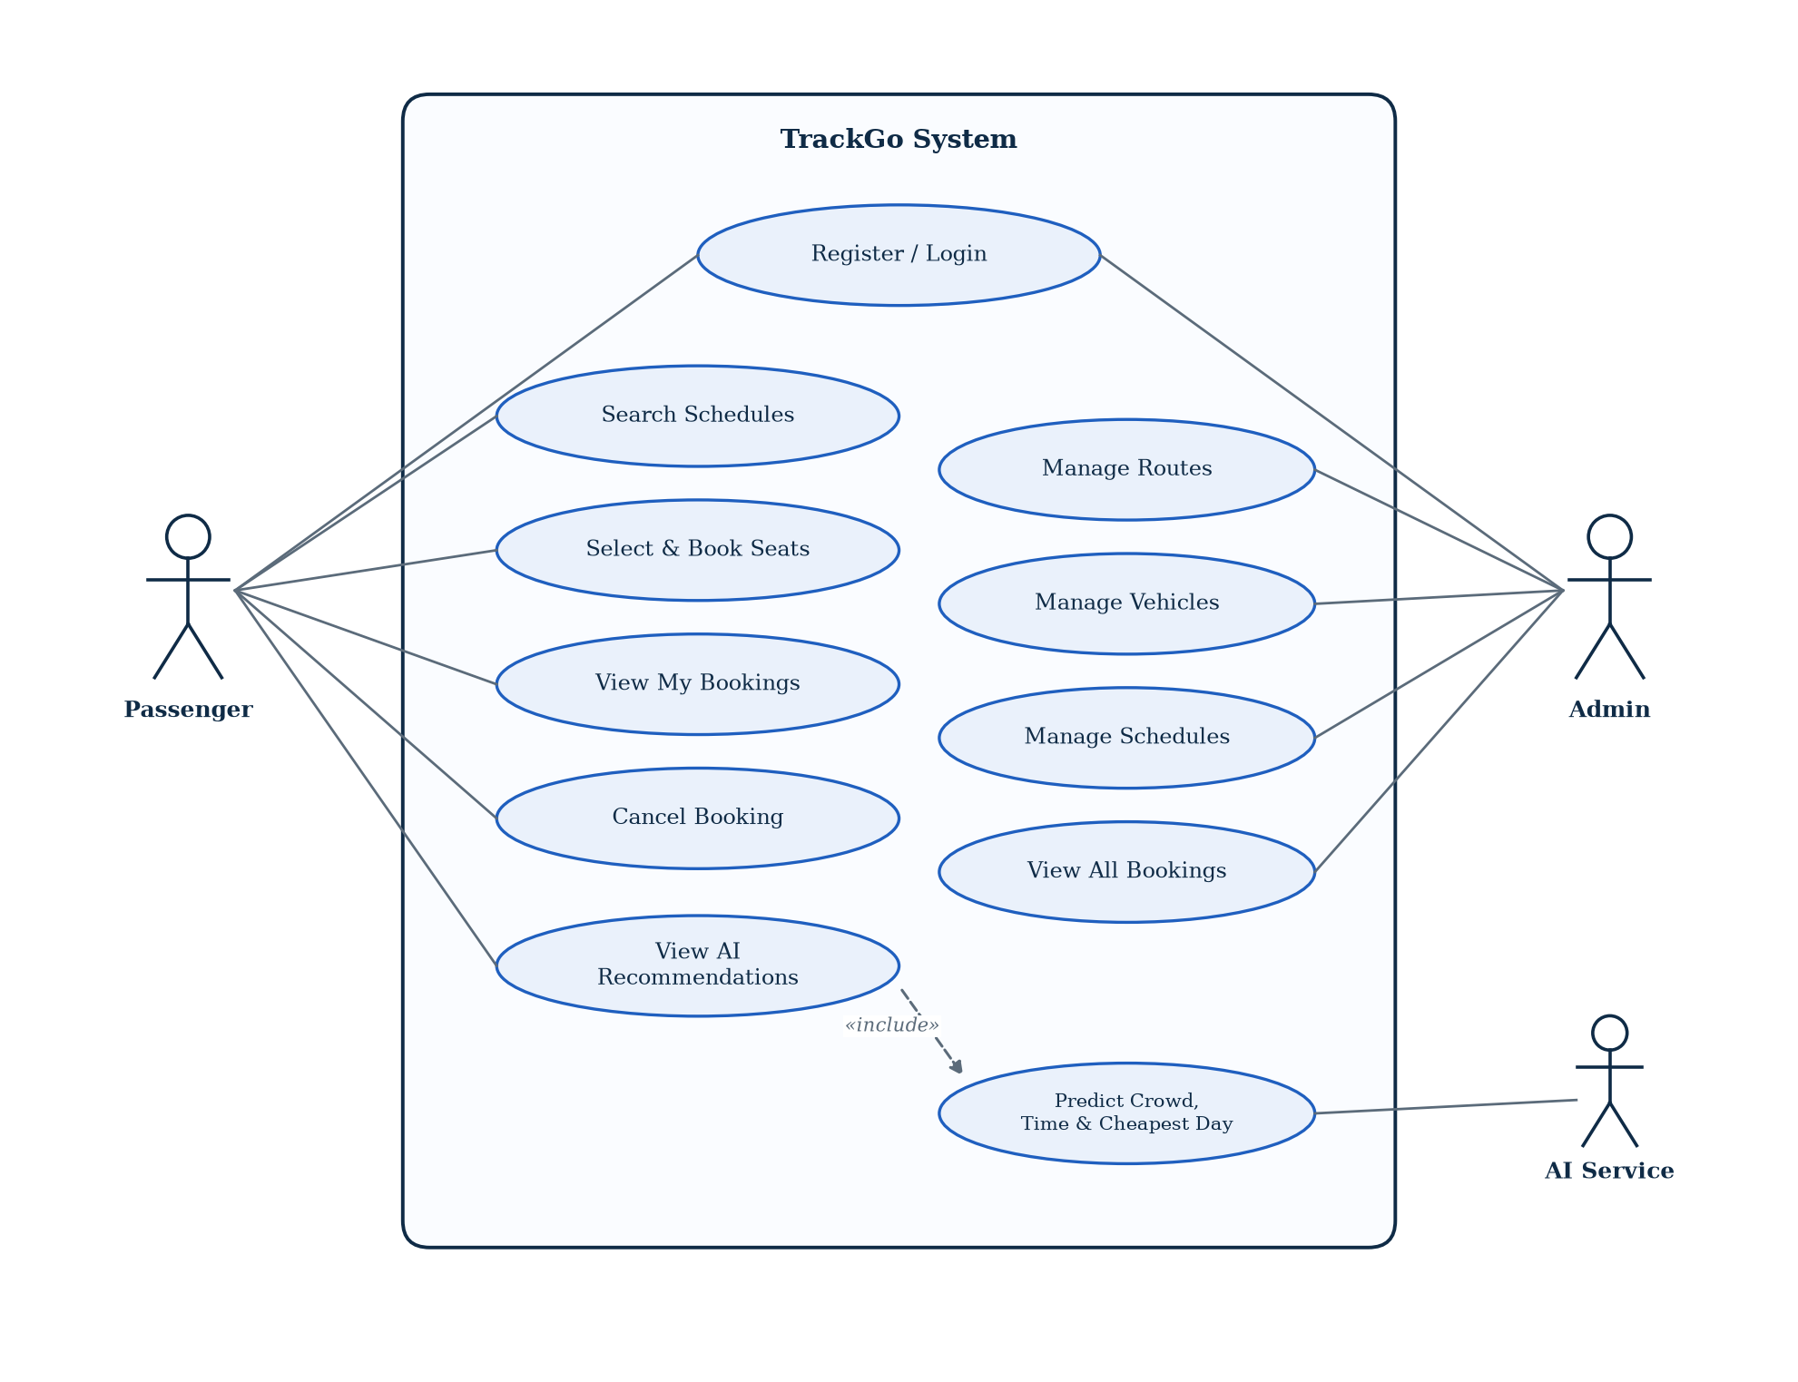
Figure 4.1: Use case diagram of TrackGo

4.5 Context Diagram (DFD Level 0)
At Level 0 the whole of TrackGo is treated as a single process. The diagram shows the four external entities it exchanges data with and the main data flowing in each direction.
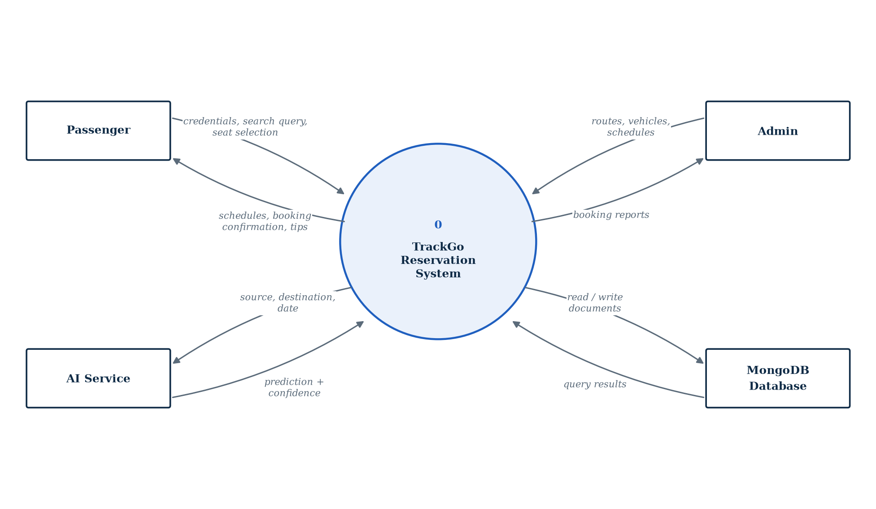
Figure 4.2: Context diagram (DFD Level 0)

4.6 Data Flow Diagram Level 1
The Level 1 DFD breaks the system into five main processes: Authenticate User, Search Schedules, Book/Cancel Seats, Manage Transport Data and Get AI Recommendation. It also shows the four data stores (Users, Routes/Vehicles, Schedules and Bookings) that these processes read from and write to.
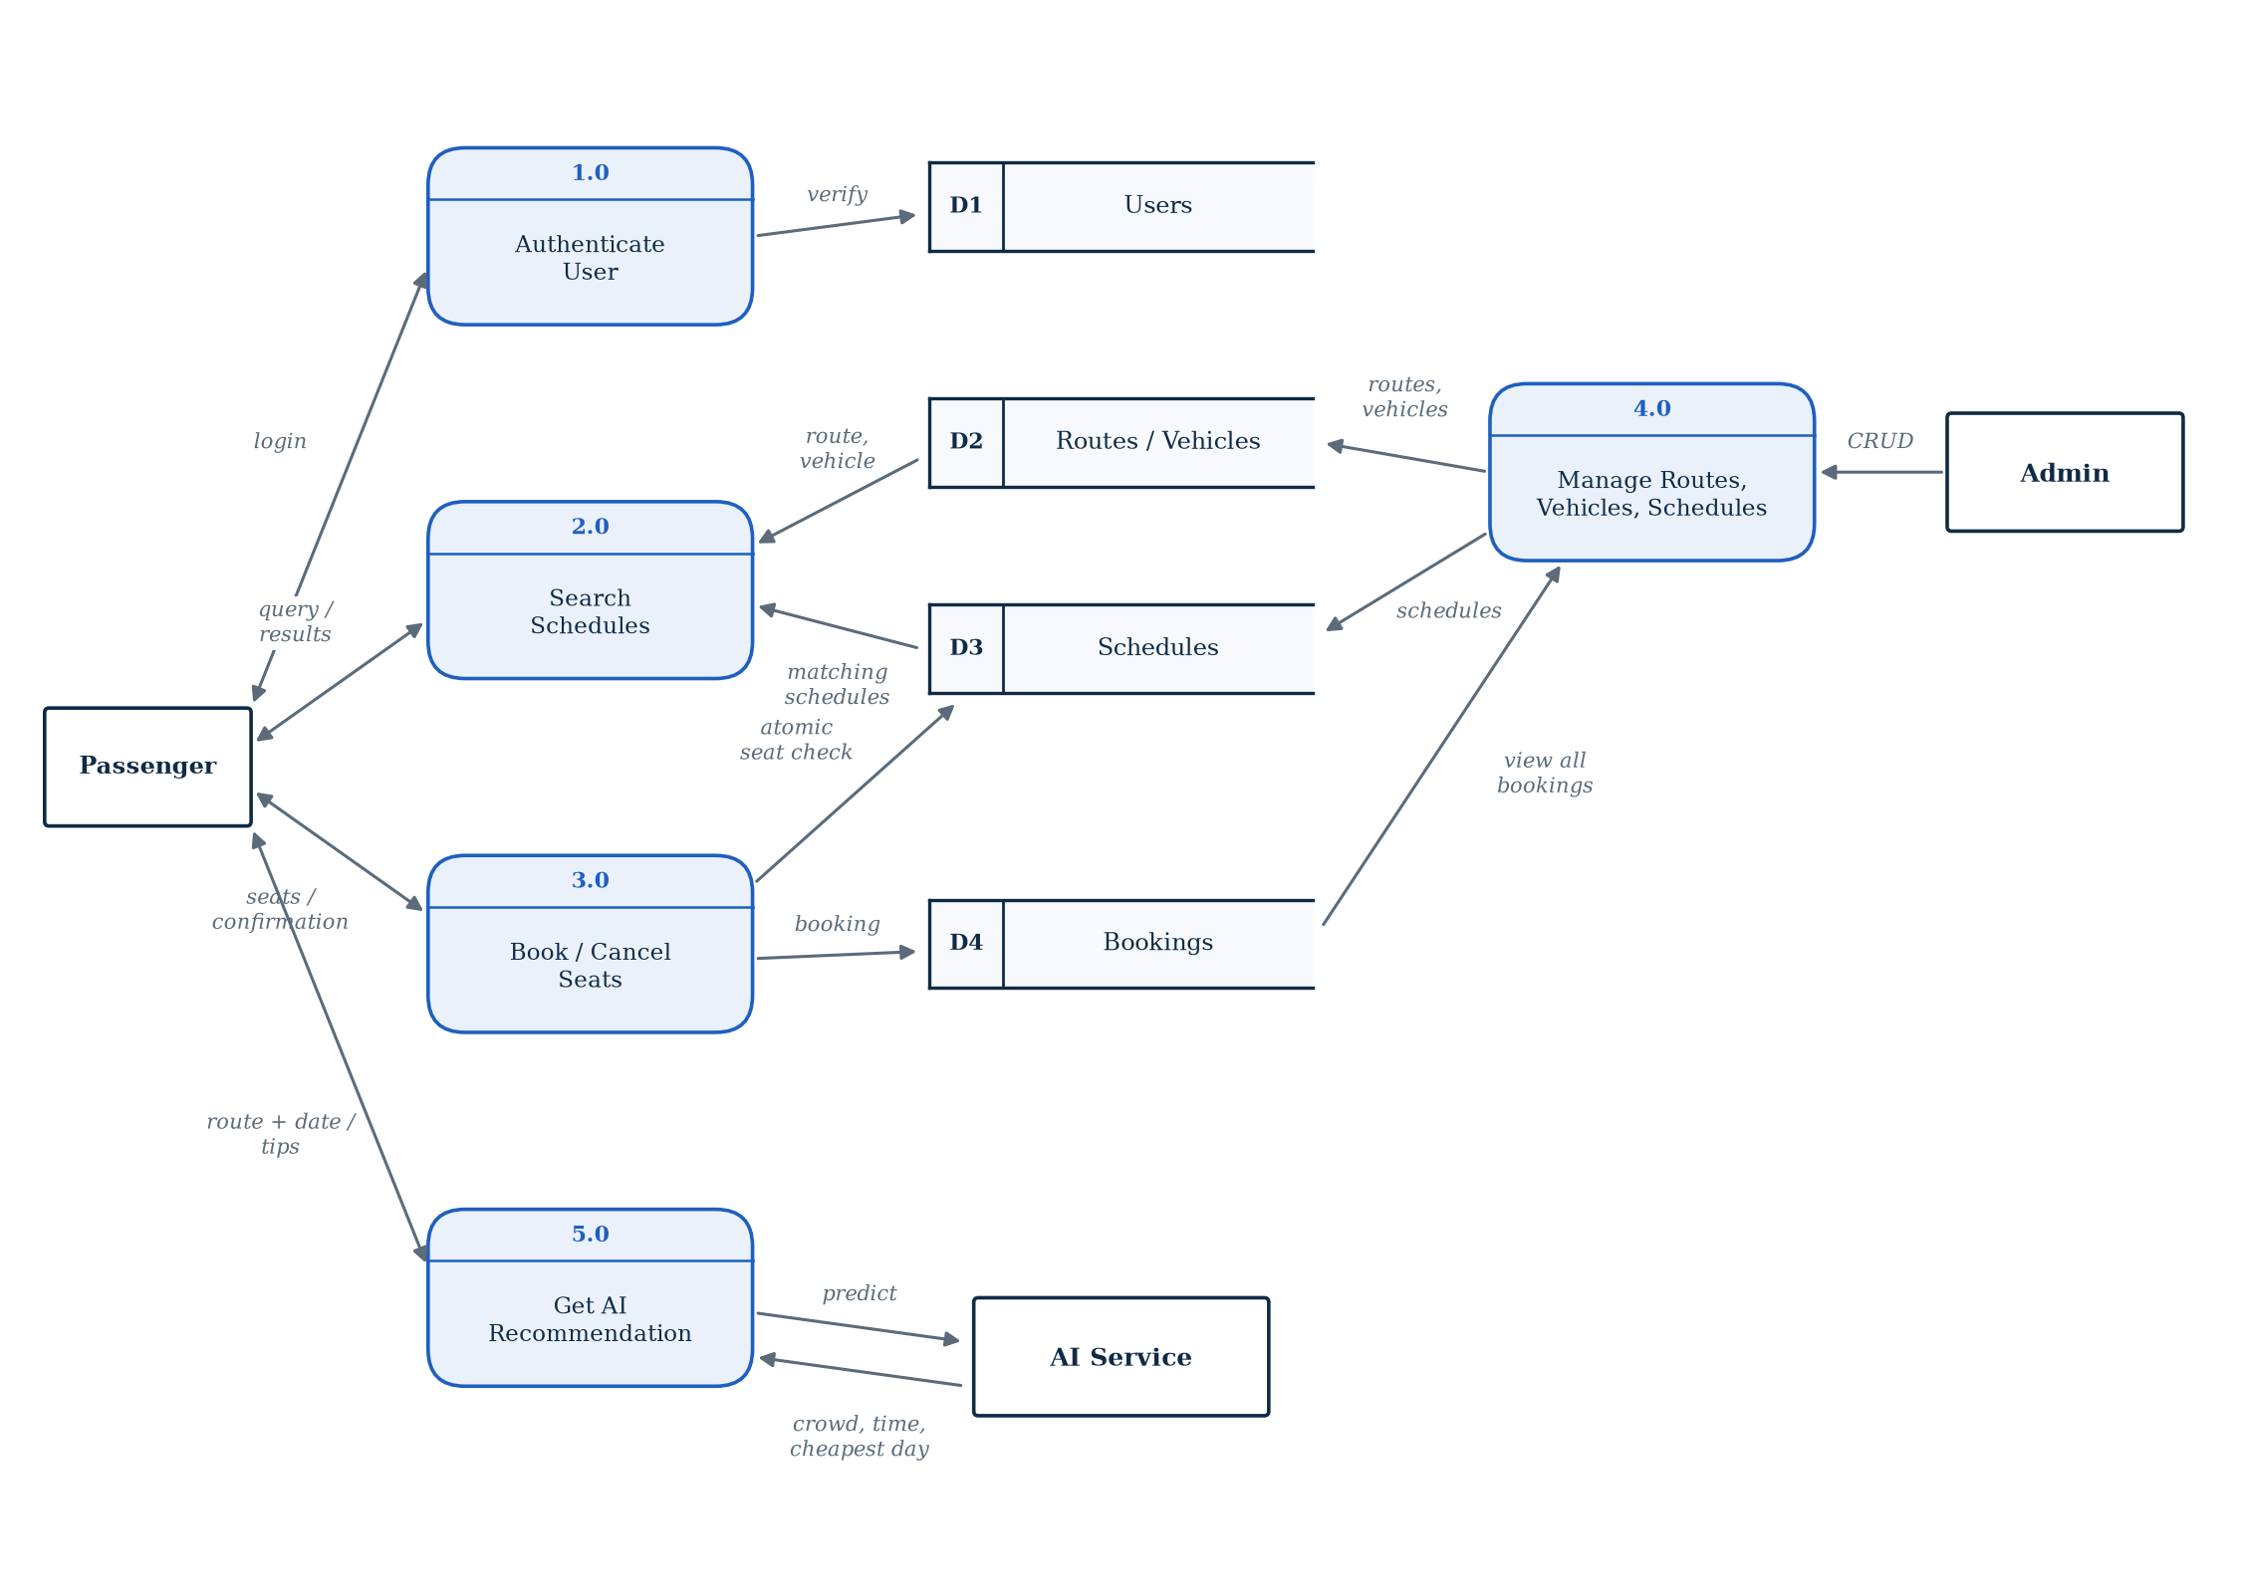
Figure 4.3: Data flow diagram Level 1

5. System Architecture

5.1 Technology Stack
The project follows a three-tier design with an extra service for predictions. The main technologies used in each part are listed below.
- React 18 + Vite: Single-page frontend with fast development builds. React Router 6 handles navigation between pages.
- Material UI 5: Ready-made components (cards, tabs, dialogs, tables) that keep the interface consistent and responsive.
- Axios, React Hook Form and Yup: Axios sends API requests with the JWT attached; React Hook Form and Yup validate forms before anything is sent.
- Node.js + Express 4: The REST API. Controllers are grouped into user, booking, admin and recommendation modules.
- MongoDB Atlas + Mongoose 8: A cloud-hosted document database. Mongoose models enforce field types, validation rules and unique indexes.
- Security packages: jsonwebtoken, bcryptjs, helmet, cors, express-rate-limit and express-validator.
- Python + FastAPI: The AI service, using TensorFlow/Keras for the neural network, scikit-learn for the decision tree, and pandas for data handling.

5.2 Data Flow
- User action: The passenger or admin performs an action in the React app, for example searching for a route or confirming seats.
- API request: The frontend calls the Express API (/api/users, /api/bookings, /api/admin or /api/recommendations) and sends the JWT in the Authorization header.
- Validation and authorisation: Middleware verifies the token, checks the user's role where needed and validates the request body.
- Database operation: The controller reads or writes MongoDB through Mongoose and returns a JSON response.
- AI call (recommendations only): The backend forwards the route and date to the AI service's /predict endpoint and passes the prediction back to the frontend.

5.3 Diagrams
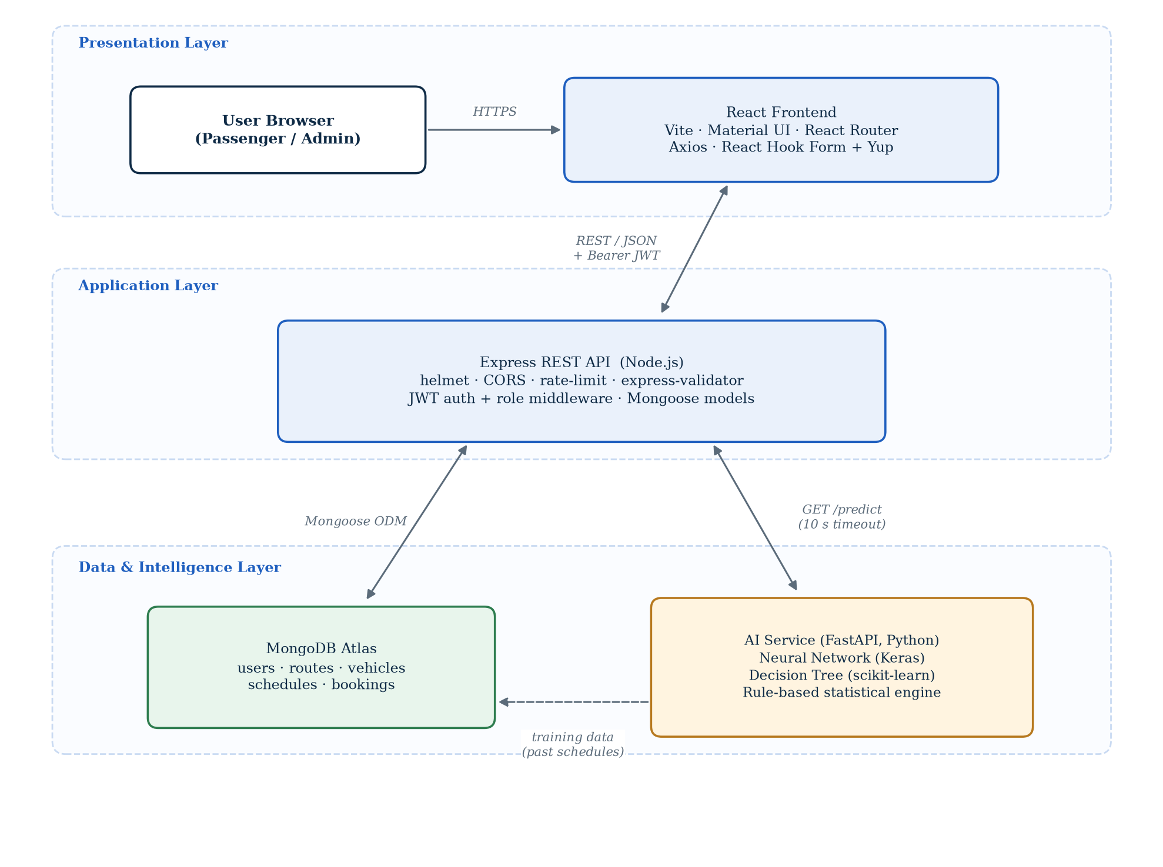
Figure 5.1: High-level system architecture
The sequence diagram below follows a single booking request from the moment the passenger clicks Confirm. The important step is the atomic findOneAndUpdate call, which only succeeds if none of the chosen seats are already in the schedule's bookedSeats list.
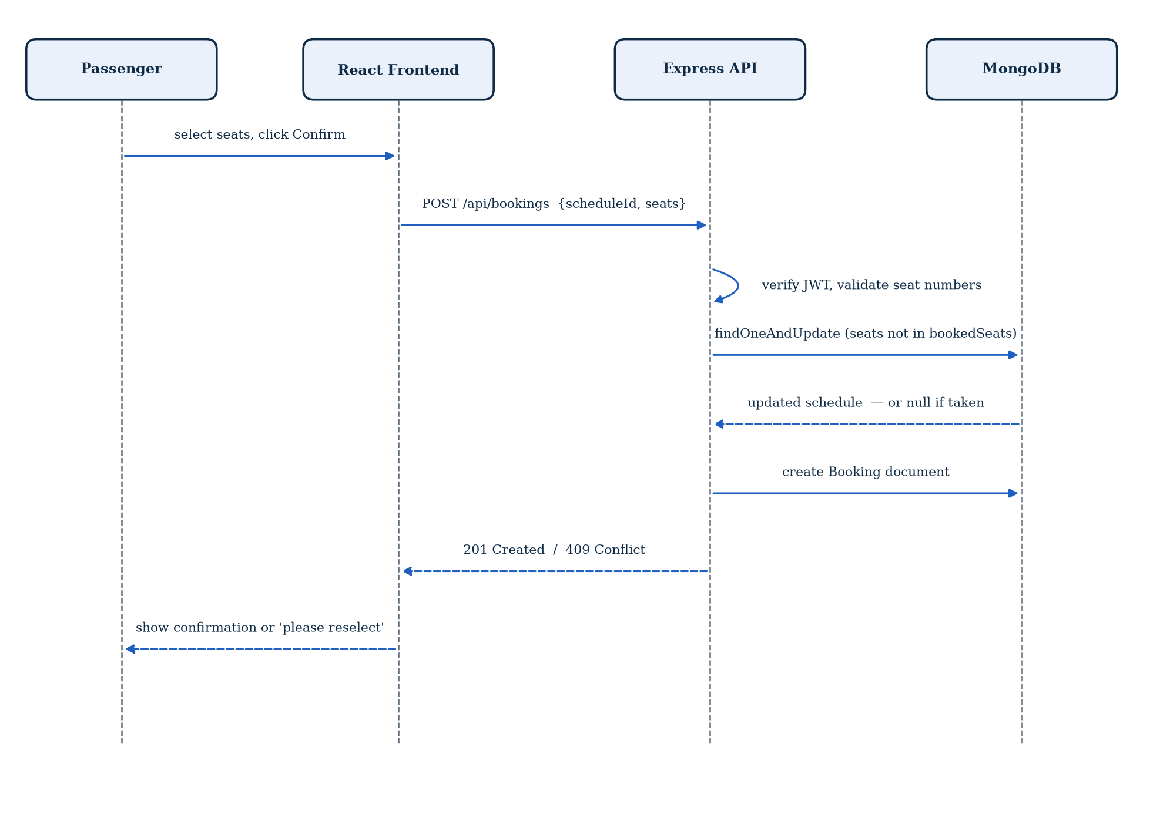
Figure 5.2: Sequence diagram for booking a seat

6. Functional Requirements
Functional requirements describe what the system must do. They are grouped below by the type of user who mainly needs them.

6.1 Passenger (User) Requirements
- Register an account with name, email, password and an 11-digit phone number.
- Log in and stay logged in using a JWT stored on the client.
- View and update their own profile.
- Search schedules by source, destination, date and vehicle type.
- Select one or more seats on a schedule and confirm the booking.
- View a list of their bookings and cancel a booking.
- Request AI recommendations for any route and date.

6.2 Admin Requirements
- Create, view, update and delete routes (source and destination).
- Create, view, update and delete vehicles (type, capacity and registration number).
- Create, view, update and delete schedules (route, vehicle, date, departure, arrival and price).
- View all bookings made by all passengers.
- Be prevented from deleting data that is still referenced by schedules or active bookings.

6.3 System Requirements
- Authenticate every protected request with a valid JWT and reject expired or missing tokens.
- Restrict all /api/admin routes to users whose role is admin.
- Validate all incoming data before it reaches the database.
- Guarantee that no seat on a schedule can be booked twice.
- Return a fallback or a clear error message if the AI service is unavailable.

6.4 Functional Requirements Table
ID | Functional Area | Description
FR-01 | Passenger | Register a new account; duplicate emails are rejected.
FR-02 | Passenger | Log in with email and password and receive a JWT.
FR-03 | Passenger | View and update personal profile details.
FR-04 | Passenger | Search schedules by route, date and vehicle type.
FR-05 | Passenger | Select seats from a seat map and confirm a booking.
FR-06 | Passenger | View own booking history.
FR-07 | Passenger | Cancel a booking and release its seats.
FR-08 | Passenger | View AI recommendations for a route and date.
FR-09 | Admin | Manage routes (create, list, update, delete).
FR-10 | Admin | Manage vehicles (create, list, update, delete).
FR-11 | Admin | Manage schedules (create, list, update, delete).
FR-12 | Admin | View all bookings in the system.
FR-13 | System | Restrict admin endpoints to the admin role.
FR-14 | System | Prevent double-booking with an atomic seat check.
FR-15 | System | Fall back gracefully when the AI service does not respond.
Table 6.1: Functional requirements

7. Non-Functional Requirements
Non-functional requirements describe how well the system should work rather than what it does.

7.1 Performance
- Search and booking requests should normally complete within two seconds.
- The AI service call has a ten-second timeout so a slow prediction never blocks the page indefinitely.
- Vite production builds keep the frontend bundle small for faster first load.

7.2 Security
- Passwords are hashed with bcrypt and never stored or returned in plain text.
- Login and register are limited to 10 requests per 15 minutes per IP; the rest of the API to 300 requests per 15 minutes.
- helmet adds standard security headers, and CORS only allows the configured frontend URL.

7.3 Reliability
- The backend checks required environment variables at startup and stops with a clear message if any are missing.
- Errors are handled by a central error handler and returned in the same JSON format every time.
- If the AI models fail or are not confident enough, the AI service still answers using the rule-based engine.

7.4 Scalability
- MongoDB Atlas can be scaled independently of the application servers.
- The AI service runs as a separate process and can be moved to its own machine if prediction traffic grows.
- The backend is stateless (JWT-based), so more instances can be added behind a load balancer.

7.5 Usability
- Material UI components give a clean, responsive layout on desktop and mobile screens.
- Toast messages confirm every successful action and explain every error.
- Seats are colour-coded (available, selected, booked) so the seat map is easy to read.
Non-Functional Requirements Summary
ID | Requirement Type | Description
NFR-01 | Performance | Normal API responses should take under two seconds.
NFR-02 | Security | bcrypt hashing, JWT sessions, helmet headers and rate limiting.
NFR-03 | Reliability | Fail fast on missing configuration; consistent JSON errors.
NFR-04 | Availability | Booking continues to work even if the AI service is down.
NFR-05 | Scalability | Stateless API; database and AI service scale separately.
NFR-06 | Usability | Responsive layout with clear feedback on every action.
NFR-07 | Maintainability | Frontend, backend and AI service are separate codebases.
NFR-08 | Data Integrity | Unique indexes and validation rules on every model.
NFR-09 | Compatibility | Works on current versions of Chrome, Firefox, Edge and Safari.
Table 7.1: Non-functional requirements

8. Database Design
TrackGo uses MongoDB, a document database. Each record is stored as a JSON-like document, and documents of the same kind are grouped into a collection. Although MongoDB does not force relationships like a SQL database does, we linked documents using ObjectId references and used Mongoose to enforce types, required fields and unique indexes.

8.1 Collections Overview
Collection | Description
users | Passenger and admin accounts: name, email, hashed password, phone number and role.
routes | A source and destination pair, stored in uppercase so that "Lahore" and "LAHORE" match.
vehicles | A train or bus with its seating capacity and a unique registration number.
schedules | A trip: which vehicle runs which route, on what date and time, at what price, and which seats are already booked.
bookings | A passenger's reservation: the schedule, seat numbers, total price and status.
Table 8.1: MongoDB collections

8.2 Collection Schemas
users collection:
{
"_id": "ObjectId",
"name": "string (required)",
"email": "string (unique, lowercase)",
"passwordHash": "string (bcrypt)",
"phone": "string, 11 digits starting with 0",
"role": "user | admin (default: user)",
"createdAt": "Date"
}

schedules collection:
{
"_id": "ObjectId",
"routeId": "ObjectId -> routes",
"vehicleId": "ObjectId -> vehicles",
"date": "Date",
"departureTime": "string (HH:mm)",
"arrivalTime": "string (HH:mm)",
"price": "number (>= 0)",
"bookedSeats": [ "number" ]
}

bookings collection:
{
"_id": "ObjectId",
"userId": "ObjectId -> users",
"scheduleId": "ObjectId -> schedules",
"seats": [ "number" ], // at least one seat
"totalPrice": "number (>= 0)",
"status": "confirmed | cancelled | pending",
"bookingDate": "Date"
}

routes and vehicles collections:
routes: { "_id", "source": "STRING", "destination": "STRING", "createdAt" }
vehicles: { "_id", "type": "train | bus", "capacity": "10 - 500",
"registrationNumber": "STRING (unique)", "createdAt" }

8.3 Relationships
- User to Booking: One-to-Many. A passenger can make many bookings, but each booking belongs to one passenger.
- Schedule to Booking: One-to-Many. Many bookings can be made on the same schedule, each holding different seats.
- Route to Schedule: One-to-Many. The same route (for example Lahore to Karachi) can have many scheduled trips.
- Vehicle to Schedule: One-to-Many. One vehicle can run many trips on different dates and times.
A few validation rules were worth adding at the database level, so that bad data is stopped even if the frontend misses it:
- Route.source and Route.destination cannot be the same, and each pair is unique.
- Vehicle.capacity must be between 10 and 500, and registrationNumber is unique.
- Schedule has a compound unique index on route, vehicle, date and departure time, so the same trip cannot be added twice.
- User.phone must match the pattern ^0[0-9]{10}$.

8.4 ERD Diagram
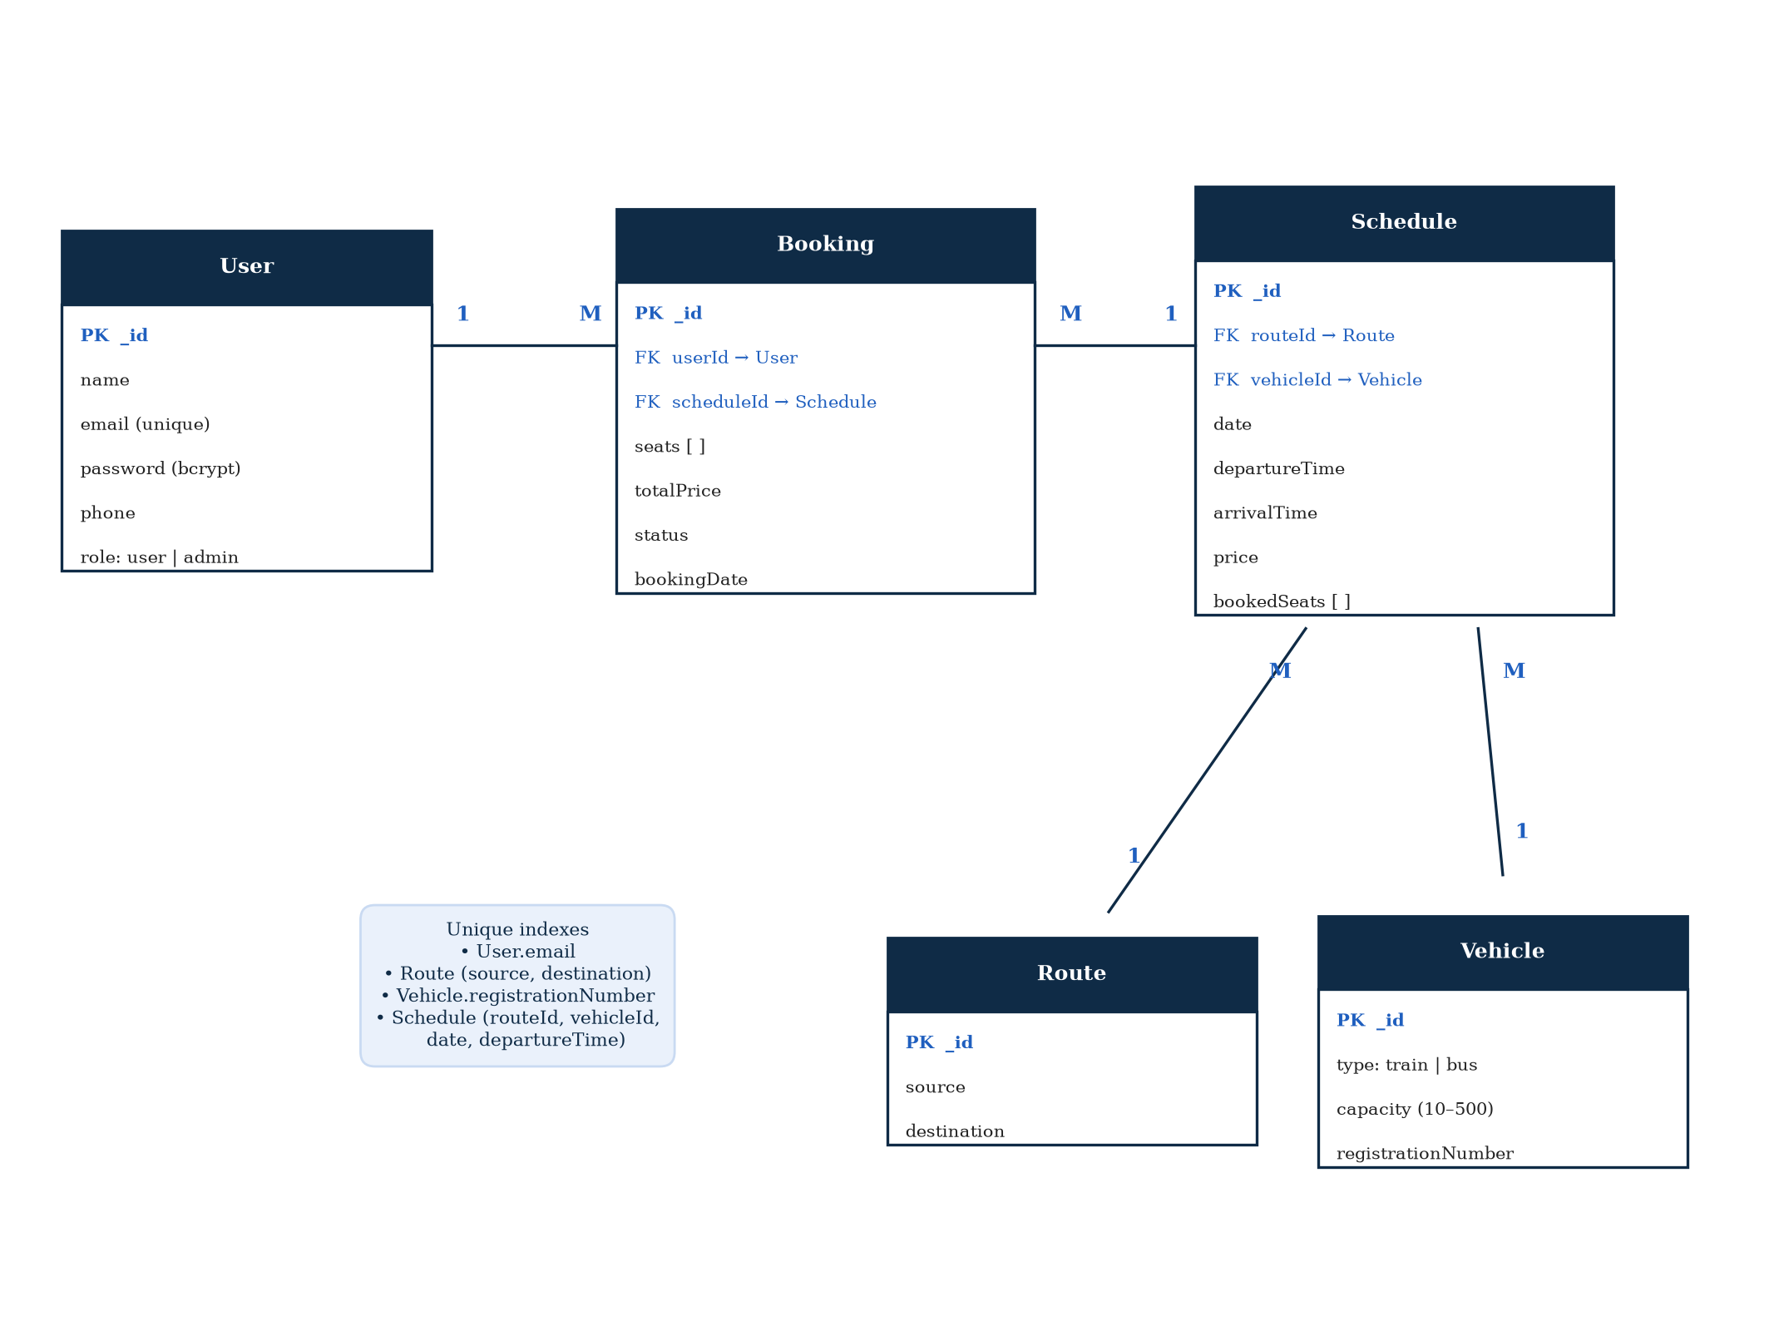
Figure 8.1: Entity relationship diagram

9. Implementation Details

9.1 Backend Modules
- User module (userController.js): registration, login, issuing the JWT, and reading or updating the profile.
- Booking module (bookingController.js): schedule search, fetching one schedule with available seats, creating a booking with the atomic seat check, listing a user's bookings and cancelling a booking.
- Admin module (adminController.js): create, list, update and delete for routes, vehicles and schedules, plus a list of all bookings. Deletes are blocked if a route or vehicle is still used by a schedule, or a schedule still has active bookings.
- Recommendation module (recommendationController.js): forwards the request to the AI service with a ten-second timeout and handles the case where the service is offline.
- Middleware: auth.js verifies the JWT, role.js restricts routes to given roles, and validate.js runs express-validator rules.

9.2 Frontend Pages
Page | Purpose
Landing Page | Public introduction to TrackGo with links to log in or register.
Login / Register | Forms validated with React Hook Form and Yup; the JWT is saved after login.
Dashboard | Search form for source, destination, date and vehicle type.
Search Results | Schedule cards with All / Bus / Train tabs and sorting by time or price.
Seat Selection | Seat grid built from vehicle capacity, with a running total before confirming.
My Bookings | List of the passenger's bookings with a cancel option.
Recommendations | Crowd-level bar, best time, cheapest day, confidence and explanations.
Admin Dashboard | Routes, Vehicles, Schedules and Bookings tabs, each with its own dialog.
Table 9.1: Main frontend pages

9.3 AI Recommendation Module
The AI service is a FastAPI application with a single main endpoint, GET /predict, which takes a source, destination and date. Before the service can answer, models are trained with train.py. By default training uses 2,000 synthetic historical records. If a MongoDB connection string is set, real schedules whose travel date has already passed are blended in, and once there are 50 or more real records they become the main source of training data.
When a request arrives, the service first runs the rule-based engine, which works out the best time window and the cheapest day from historical patterns. It then tries to improve the crowd prediction:
- The Neural Network (a Keras multi-layer perceptron) is tried first. If its confidence is at least 0.60, its result is used and the method is reported as nn+rule-based.
- Otherwise the Decision Tree (scikit-learn) is tried. If its confidence is at least 0.55, the method becomes dt+rule-based.
- If neither model is confident enough, the rule-based crowd estimate is kept.
Finally, an explainer turns the numbers into short sentences, so the passenger is told why a day is considered busy or cheap. The response always includes the method used and a confidence value, which keeps the prediction transparent.
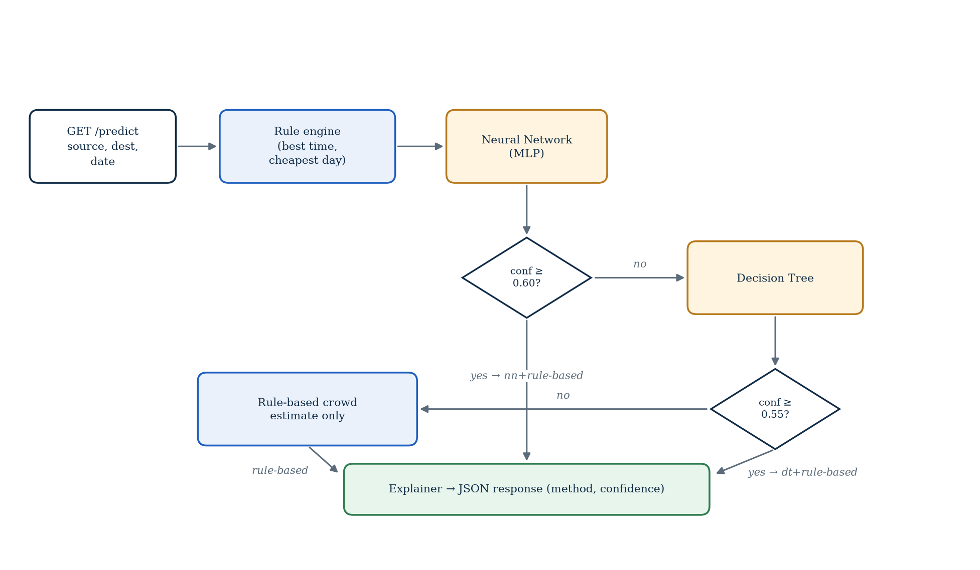
Figure 9.1: AI prediction pipeline

9.4 Activity Diagrams
The following activity diagrams model the three most important workflows in the system.

9.4.1 Registration and Login
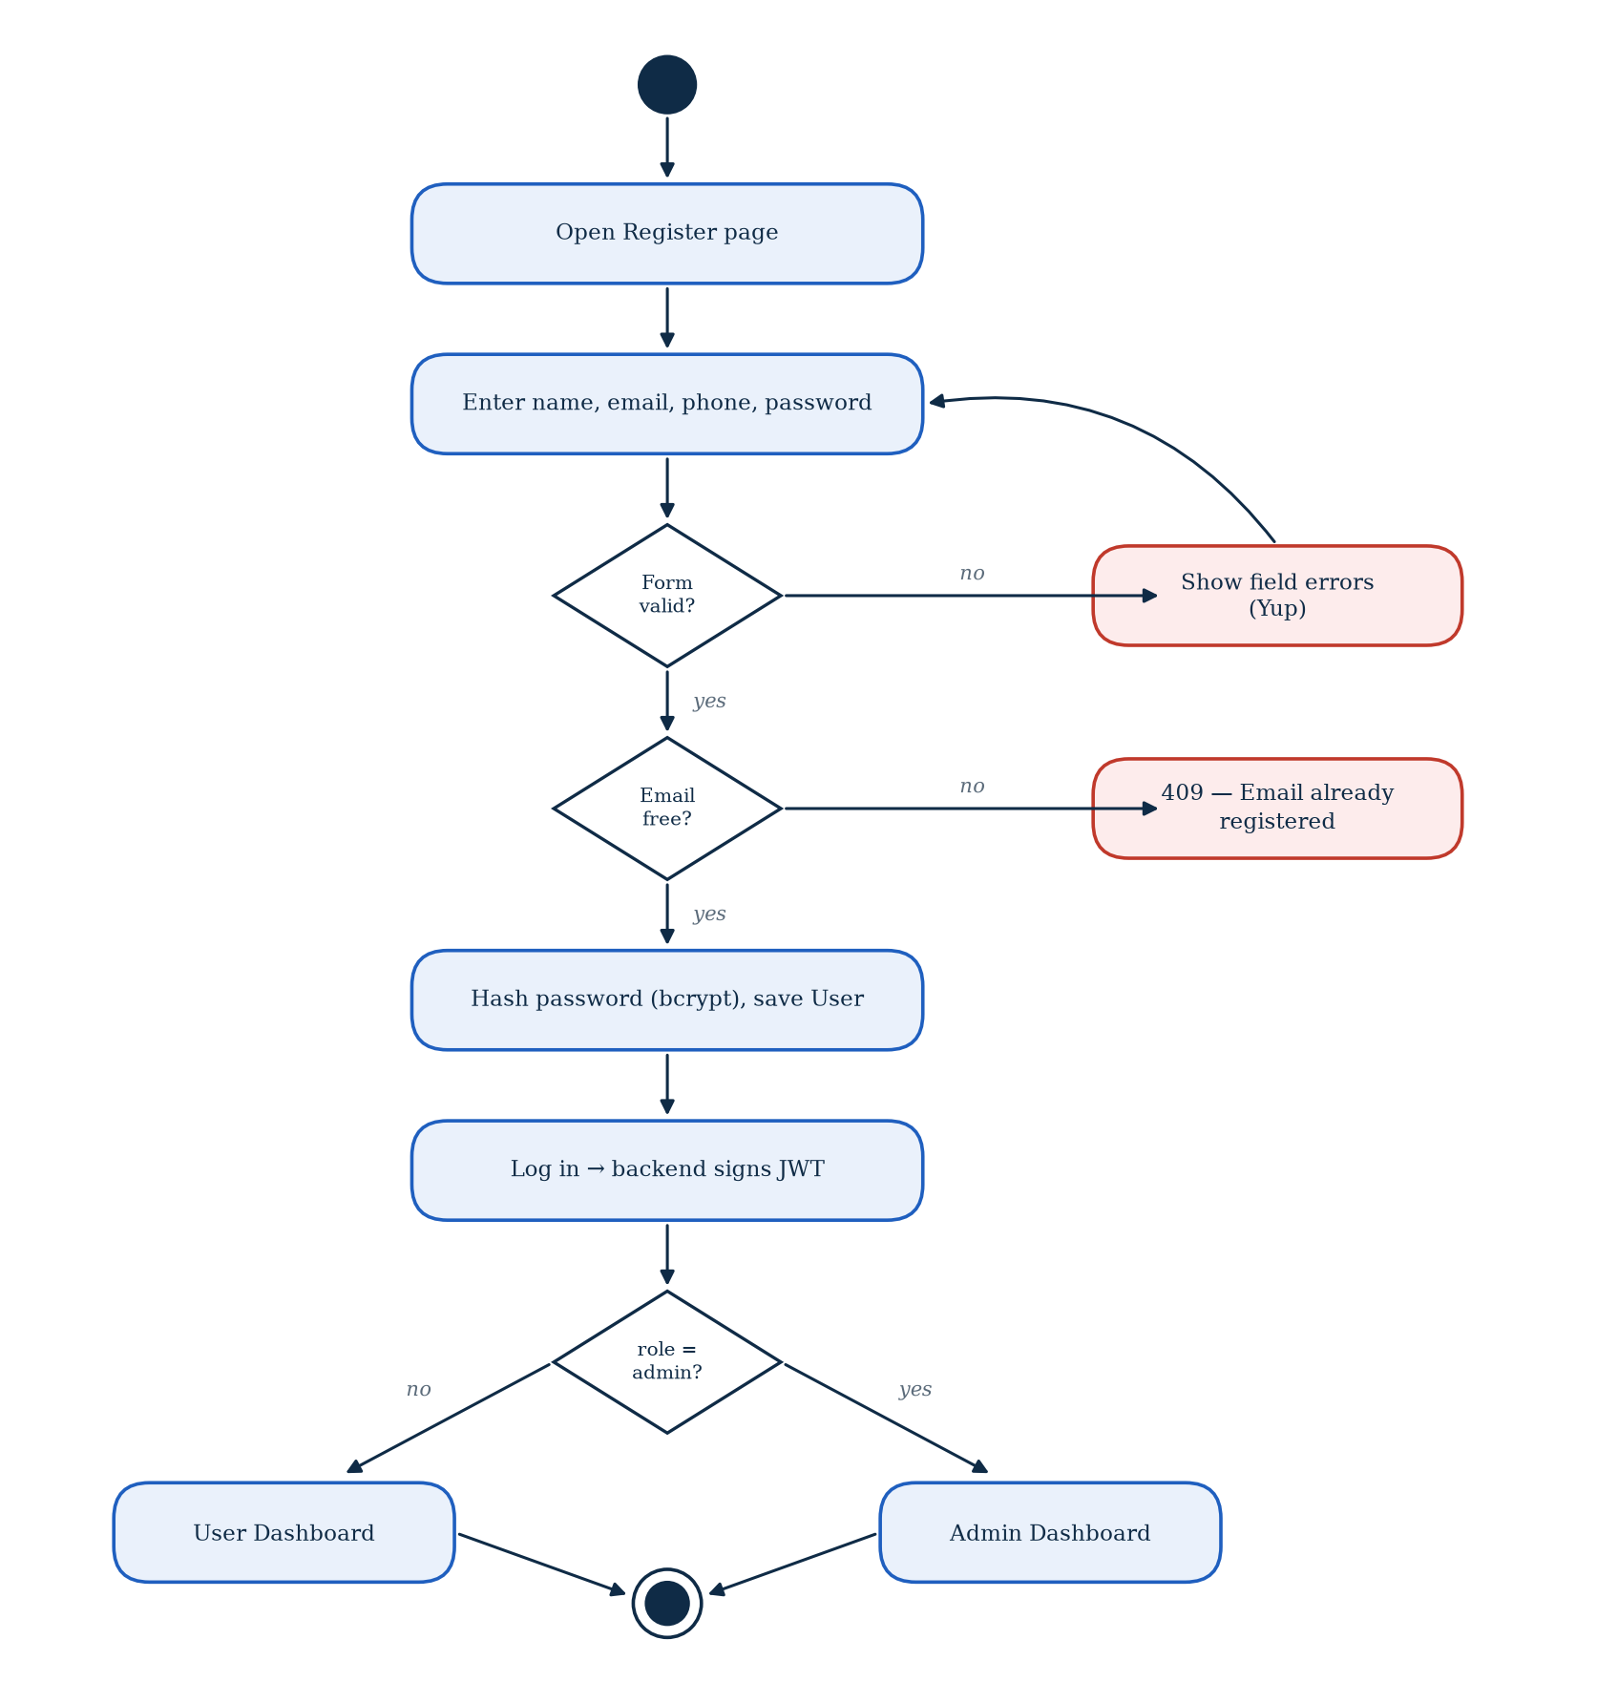
Figure 9.2: Activity diagram for registration and login

9.4.2 Searching and Booking Seats
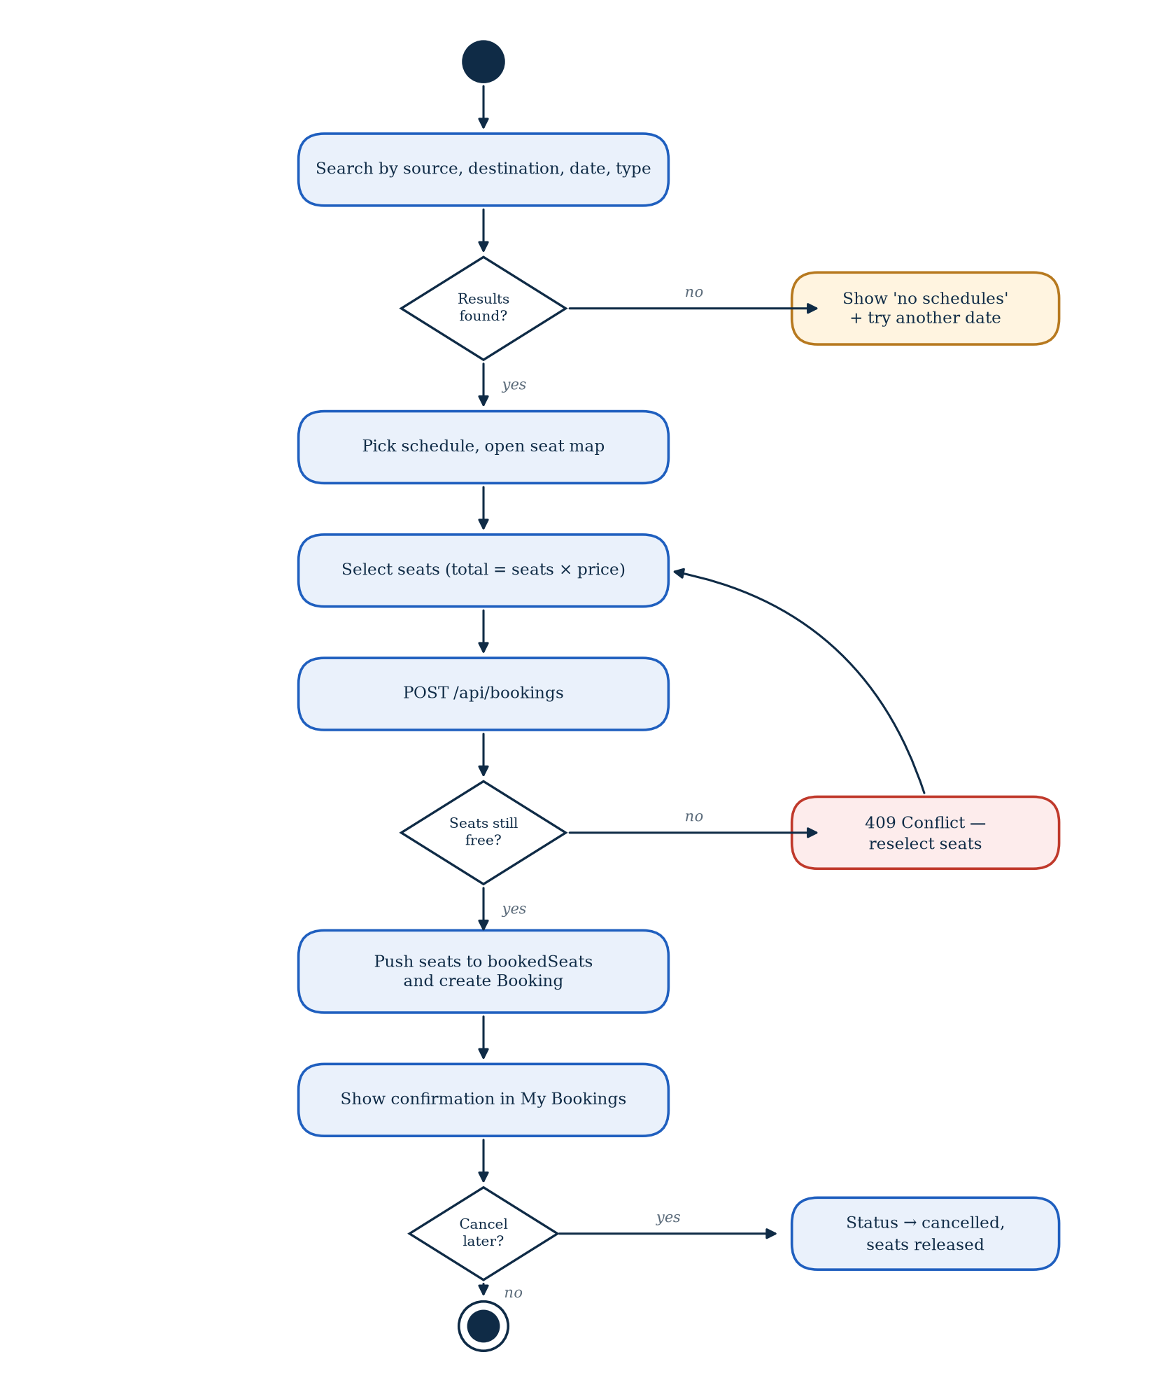
Figure 9.3: Activity diagram for searching and booking seats

9.4.3 Admin Data Management
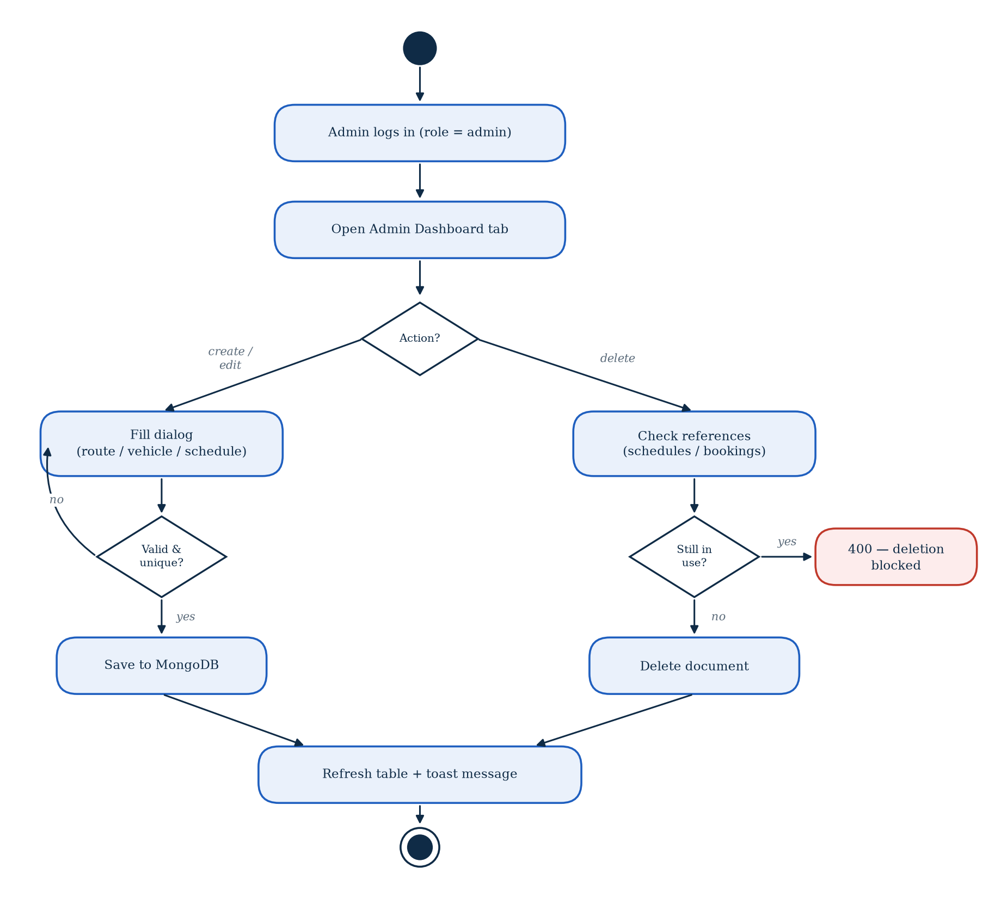
Figure 9.4: Activity diagram for admin data management

9.5 Code Snippets
A few short pieces of code are included here because they show the most important design decisions in the project.
Atomic seat booking (controllers/bookingController.js):
const updatedSchedule = await Schedule.findOneAndUpdate(
{
_id: scheduleId,
bookedSeats: { $not: { $elemMatch: { $in: seats } } }
},
{
$push: { bookedSeats: { $each: seats } }
},
{ new: true }
);

if (!updatedSchedule) {
return res.status(409).json({
success: false,
message: 'One or more seats are already booked. Please reselect.'
});
}

The filter only matches the schedule if none of the requested seats are already booked, and the update adds them in the same step. If two passengers press Confirm at the same moment, MongoDB applies one update first and the second one finds no matching document, so it receives a 409 response instead of a duplicate seat.
Role-based access middleware (middleware/role.js):
const requireRole = (...roles) => {
return (req, res, next) => {
if (!roles.includes(req.user?.role)) {
return next(createError(403, 'Insufficient permissions'));
}
next();
};
};

// usage in routes/adminRoutes.js
router.get('/routes', auth, requireRole('admin'), getRoutes);

Choosing between the models (ai-service/main.py):
if models["nn"] is not None:
nn_result = predict_nn(models["nn"], models["nn_scaler"],
models["nn_encoders"], features)
if nn_result["confidence"] >= 0.60:
final_crowd = nn_result["crowd_level"]
method = "nn+rule-based"

if method == "rule-based" and models["dt"] is not None:
dt_result = predict_dt(models["dt"], models["dt_encoders"], features)
if dt_result["confidence"] >= 0.55:
final_crowd = dt_result["crowd_level"]
method = "dt+rule-based"

10. System Testing / Test Cases
Testing was carried out throughout development rather than only at the end. The main goals were:
- To confirm that each module meets its functional requirements.
- To make sure a passenger can never reach admin features, and that protected routes reject missing or invalid tokens.
- To confirm that the same seat cannot be booked twice, even when requests arrive together.
- To check that the system behaves sensibly when the AI service is slow or switched off.

10.1 Unit Testing
The AI service has an automated pytest suite in tests/test_ai.py. It covers data generation and preprocessing, the rule engine, the decision tree and neural network predictors, the explainer and the shape of the /predict response. In the latest run all 12 tests passed. On the backend, utility functions and Mongoose validation rules (phone format, capacity range, source not equal to destination) were checked individually while they were being written.

10.2 Integration Testing
Integration testing focused on the points where modules meet. Using Postman, we checked that a booking request correctly updates both the schedule and the bookings collection, that cancelling a booking returns the seats to the schedule, that deleting a route with existing schedules is refused, and that the recommendation endpoint returns the AI service's answer when it is running and the fallback response when it is not.

10.3 System Testing
Finally the complete application was tested end to end in the browser. We registered new passengers, searched different routes, booked and cancelled seats, and used the admin dashboard to add and edit data. To test double-booking, two browser windows logged in as different users selected the same seat and pressed Confirm at the same time; only one booking was accepted.
Test Cases
ID | Module | Test Scenario | Expected Result | Status
TC-01 | Auth | Register with a new email | 201 Created, account saved | Pass
TC-02 | Auth | Register with an existing email | 409 Conflict, "Email already registered" | Pass
TC-03 | Auth | Login with correct credentials | 200 OK, JWT returned | Pass
TC-04 | Auth | Login with wrong password | 401 Unauthorized | Pass
TC-05 | Access | Passenger calls an /api/admin route | 403 Insufficient permissions | Pass
TC-06 | Booking | Book free seats | 201 Created, seats marked booked | Pass
TC-07 | Booking | Book a seat already taken | 409 Conflict, no partial booking | Pass
TC-08 | Booking | Book seat number above capacity | 400 Bad Request, invalid seat | Pass
TC-09 | Booking | Cancel a confirmed booking | Status cancelled, seats released | Pass
TC-10 | Admin | Create route with same source and destination | 400 Bad Request | Pass
TC-11 | Admin | Delete a route used by a schedule | 400 Bad Request, deletion blocked | Pass
TC-12 | AI | Request recommendation with AI service running | Prediction with method and confidence | Pass
TC-13 | AI | Request recommendation with AI service stopped | Fallback estimates with a note | Pass
TC-14 | Security | 11th login attempt within 15 minutes | 429 Too Many Requests | Pass
Table 10.1: System test cases
Tools used:
- Postman: sending requests to every API endpoint and checking status codes and responses.
- pytest: automated tests for the AI service.
- Browser developer tools: inspecting network requests, console errors and responsive layouts.
- MongoDB Atlas dashboard: checking that documents were created, updated and deleted correctly.

11. Future Enhancements
- Online payments: integrate a local payment gateway (for example JazzCash or Easypaisa) so bookings are paid for at the time of booking.
- Notifications: send email or SMS confirmations when a booking is made or cancelled.
- Multiple operators: allow each transport company to have its own admin account and manage only its own fleet.
- E-tickets: generate a downloadable ticket with a QR code that can be scanned at boarding.
- Mobile app: build a progressive web app or a React Native app for travellers on the move.
- Automated backend tests: add Jest and Supertest suites so every API change is tested automatically.
- Better predictions: retrain the models regularly as more real booking data is collected, and add features such as public holidays and weather.

12. Security Measures
Because TrackGo stores personal information and handles bookings, security was considered from the start rather than added at the end.
- Password hashing: passwords are hashed with bcrypt before saving, so even the database administrator cannot read them.
- JWT authentication: after login, the server issues a signed token with an expiry time. Every protected route checks this token first.
- Role-based access control: the requireRole('admin') middleware protects every admin endpoint, returning 403 for normal users.
- Input validation: express-validator and Mongoose validation rules reject malformed or unexpected data before it is saved.
- Rate limiting: login and register are limited to 10 attempts per 15 minutes per IP, which slows down brute-force attacks. The wider API is limited to 300 requests per 15 minutes.
- Security headers: helmet sets headers that help protect against common attacks such as clickjacking and MIME sniffing.
- CORS policy: the backend only accepts browser requests from the configured frontend address.
- Secrets in environment files: the JWT secret and database credentials are kept in .env files that are not committed to version control.

13. Project Limitations
We are happy with what TrackGo does today, but there are some limitations we are aware of:
- There is no payment step yet. A booking is confirmed without any money changing hands.
- The system assumes one operator managed by a single admin role.
- The AI models were trained mostly on synthetic data, since real booking history was limited during development. Accuracy should improve as more real data is collected.
- Backend testing was mostly manual through Postman; only the AI service has an automated test suite.
- Confirmation emails and SMS messages are not sent yet.
- The system needs an internet connection and does not work offline.

14. Conclusion
TrackGo brings train and bus booking together in a single web application. A passenger can search both kinds of transport on one screen, pick seats on a seat map, book and cancel trips, and get advice on when to travel. Administrators get a clear dashboard to manage routes, vehicles and schedules without touching the database directly.
The part of the project we learnt the most from was making booking safe under concurrent requests. Moving the seat check into a single atomic MongoDB update solved the double-booking problem far more cleanly than any check done in the application code. Building the AI service as a separate Python application also taught us how to make two different technologies work together, and how to design a system that keeps working when one of its parts fails.
The core features of the project are complete and working end to end. Payment integration, notifications and support for multiple operators are the natural next steps, and the modular design of the system should make these straightforward to add.

15. References
- React documentation. https://react.dev
- Vite documentation. https://vitejs.dev
- Material UI documentation. https://mui.com/material-ui/
- Express.js documentation. https://expressjs.com
- MongoDB documentation. https://www.mongodb.com/docs/
- Mongoose documentation. https://mongoosejs.com/docs/
- FastAPI documentation. https://fastapi.tiangolo.com
- scikit-learn: Decision Trees. https://scikit-learn.org/stable/modules/tree.html
- TensorFlow / Keras documentation. https://www.tensorflow.org/guide/keras
- M. Jones, J. Bradley and N. Sakimura, "JSON Web Token (JWT)", RFC 7519, IETF, 2015.
- OWASP Top Ten Web Application Security Risks. https://owasp.org/www-project-top-ten/
- Pakistan Railways official website. https://www.pakrail.gov.pk

16. Appendices

16.1 API Endpoint Reference
Method | Endpoint | Access | Description
POST | /api/users/register | Public | Register a new passenger
POST | /api/users/login | Public | Log in and receive a JWT
GET | /api/users/profile | User | Get own profile
PUT | /api/users/profile | User | Update own profile
GET | /api/bookings/search | Public | Search schedules
GET | /api/bookings/schedule/:id | User | Get one schedule with available seats
POST | /api/bookings | User | Create a booking
GET | /api/bookings/my | User | List own bookings
PUT | /api/bookings/:id/cancel | User | Cancel a booking
POST / GET | /api/admin/routes | Admin | Create or list routes
PUT / DELETE | /api/admin/routes/:id | Admin | Update or delete a route
POST / GET | /api/admin/vehicles | Admin | Create or list vehicles
PUT / DELETE | /api/admin/vehicles/:id | Admin | Update or delete a vehicle
POST / GET | /api/admin/schedules | Admin | Create or list schedules
PUT / DELETE | /api/admin/schedules/:id | Admin | Update or delete a schedule
GET | /api/admin/bookings | Admin | List all bookings
GET | /api/recommendations | User | Get AI travel recommendations
Table 16.1: REST API endpoints

16.2 Role and Permission Matrix
Permission | Guest | Passenger | Admin
Search schedules | Yes | Yes | Yes
Book and cancel seats | No | Yes | Yes
View own bookings | No | Yes | Yes
View AI recommendations | No | Yes | Yes
Manage routes, vehicles, schedules | No | No | Yes
View all bookings | No | No | Yes
Table 16.2: Permissions by role

16.3 Environment Configuration
The application is configured through environment variables. Only the variable names are listed here; actual values such as the JWT secret and the database password are kept private.
Variable | Used By | Purpose
PORT | Backend / AI | Port the server listens on (5000 / 8000)
MONGO_URI | Backend / AI | MongoDB connection string
JWT_SECRET | Backend | Key used to sign tokens
JWT_EXPIRES_IN | Backend | Token lifetime, for example 7d
FRONTEND_URL | Backend | Allowed CORS origin
AI_SERVICE_URL | Backend | Base URL of the AI service
MODEL_PATH | AI | Folder where trained models are saved
Table 16.3: Environment variables

