# Face Recognition

In our project, Firstly, face recognition will be used to identify the epileptic patient and to record its activities. Secondly, to discriminate between the patient and any other person including the caretaker, face detection and recognition will be used. This will make sure that the activities which are recorded are of the patient only, not of any other person.

**Note: Consent will be taken from the patient**

**Liveness Detection**

# Dataset Collection

The dataset of the patient will be collected under different situations such as:

* Different Lightning Conditions
* Different Angles
* Different Poses
* Different Facial Expression
* If the person wears glasses and have beard, that will also be considered.

Data of the patient will be labeled manually.

Number of pictures of patients:

# Selecting Model & Training

Model can be selected from the following:

* Single Shot MultiBox Detector (SSD)7
* You Only Look Once (YOLO)
* Faster R-CNN
* FaceNet
* Deep Face

## Data Division:

Data will be split into training, testing and validation sets.

## Data Augmentation

Data will be augmented:

* Rotating ( -20 to +20 degrees)
* Brightness Adjustments
* Scaling (Image ka size increase or decrease, this is because it will work from the distance)
* Flipping (for different camera angles)
* Cropping face only for better results and to avoid random objects.

## Model Hyper parameter tuning

Model can be fine tuned by using different learning rates and batch size.

## Camera Type

* Webcams
* IP Cameras (RGB)

## Camera Placement

* Camera should be placed at eye level to detect more accurately.
* To minimize the distortions, the camera should capture the frontal view of patient’s face.
* Place the camera where the lightning conditions are very good.

## Lightning Conditions

* No shadows should be involved.
* The environment should be well lit

## Field of View

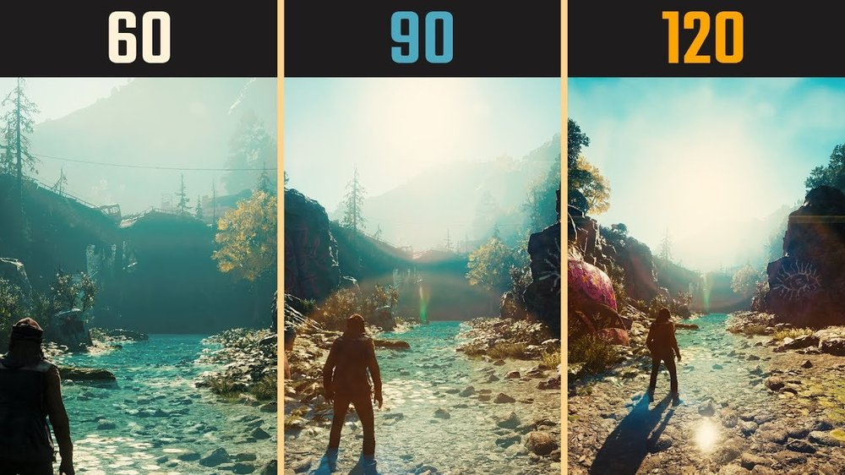

# Face De-identification

## Anonymization

## Face Blurring & Pixelation

<https://www.nist.gov/system/files/documents/2020/08/06/09_tuesday_shenoy_arunashenoy_ibpc2014.pdf>

In face blurring, face is identified, and located, then we define the region of interest in which the face was detected, then the face blur filter is applied and is merged with the original one so that the original one will be hidden.