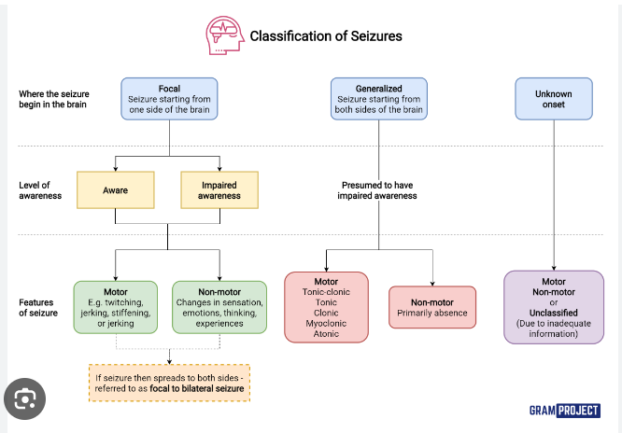

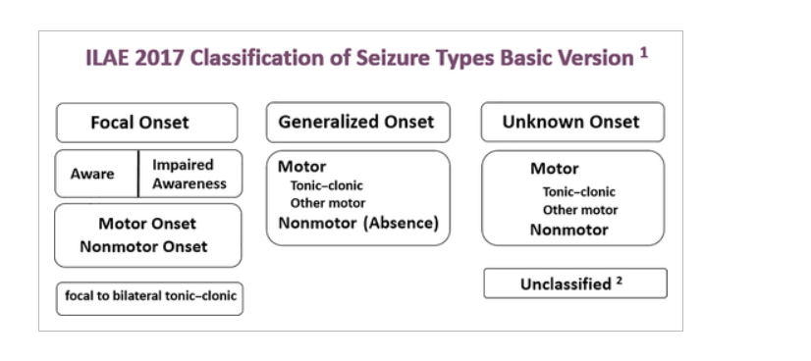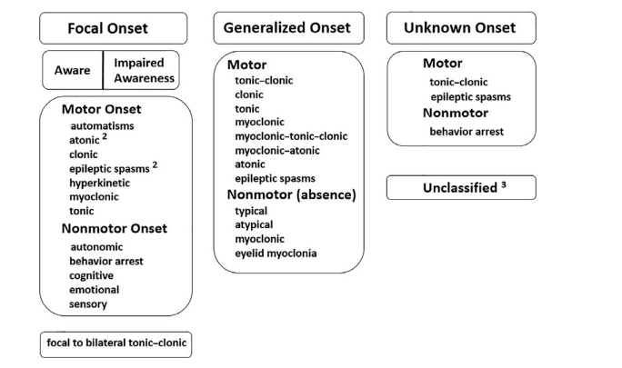

* Simple focal seizure
  + Nothing happens.
  + Only a simple jerk
  + Muscle pull
* Complex focal seizure
  + A person loses his consciousness.
  + He doesn’t know what is around him
  + He will not remember what happened during seizure
* Tonic Seizure
  + If a person is standing and suddenly fall
  + Body will be twisted a little bit
* Atonic seizures
  + HE will become yellowish
  + Loses his consiciousness
  + Falls down(often frontwards)
* Absence Seizures
  + Can occur many times
  + It will not be visible
  + It will be finished automatically, even people cannot consider it around the person
* Myoclonic Seizures
  + Jerks in any part of the body
  + Including hands or foot
* Tonic Clonic Seizures
  + Most popular seizure
  + The body will be stiffened
  + A person falls down
  + Saliva from mouth
  + Shaking of hands or legs
  + Neck stiffens
* Secondary generalized seizure