**List of pending development of BIGM Website**

|  |  |  |  |
| --- | --- | --- | --- |
| **Sl** |  | **Development work** |  |
| **1** |  | **Top Right Menu Dynamic** | **Gallery spelling mistakes** |
|  | A | **Contact Us**  Frontend Task  A Contact Us Page/Form need to be create on frontend so that anyone can contact with following information.  Message and contact person information will be stored in database.   * A database table (contact_us) need to be create for this   Admin Panel Task  Admin will be able to see these contact us from admin panel.   * This From will be under a menu named Contact Us   + Frontend Menu > Contact Us * fields will be ( Full Name, Email, Phone, Subject, Message, Submission Date ) * marks r mandatory * load this data table according to Submission Date (DESC order Last on First) on admin panel side | frontend form |
|  | B | **Location**  Frontend Task   * A page/form need to be create on frontend to link with this menu to show Address & Google Location.   Admin Panel Task   * A form also need to be create on admin panel under a menu named Location.   + Frontend Menu > Location * Admin will be able to input address (under CK Editor) and embed google map location * **Click Here to see how it will be** | frontend look |
|  | C | **Gallery**  Frontend Task   * Upon click on Gallery it will take to a page name Picture Gallery and Video Gallery * Upon click on it will take to Picture Gallery or Video Gallery page * Use form end navigation so that user can go back to before page.   Admin Panel Task   * Create two separate form for Picture Gallery and Video Gallery under   Frontend Menu > Picture Gallery  Frontend Menu > Video Gallery   * Picture Gallery   Gallery will be event wise.  There can be more than one image in one event.  Fields: Event Name/Title, Event Description, Publish Date, Images + (to add multiple image)   * Video Gallery   Fields: Event Name/Title, Event Description, Publish Date, Link for Embedded video from youtube. | sample but it will be not like this |
| **2** |  | **Top Left Menu Dynamic** |  |
|  | A | **News & Event**  Frontend Task   * Upon click on News & Event it will be link with following section on same page, Just set book mark to same page.   Admin Panel Task   * Menu will move to   Frontend Menu > News|Events|Notice   * Filter option for News Event & Notice so that admin can search by News or Events or Notice |  |
|  | B | **Career**  Frontend Task   * A Page need to be create for Career/Job Circular which will be control from admin panel. * User will be able to see all Latest Career/Job Circular like below  |  |  |  |  |  | | --- | --- | --- | --- | --- | | **Sl** | **Job Title** | **Date of Publish** | **Last Date to Apply** | **Details** | | 1 | Driver | dd.mm.yyyy | dd.mm.yyyy | [**View**](http://www.bigm.edu.bd/career/job_title_job_id) | | 2 | Office Support Staff / Classroom Attendant | dd.mm.yyyy | dd.mm.yyyy | [**View**](http://www.bigm.edu.bd/career/job_title_job_id) | | 3 | BIGM: Vacancy Announcement | dd.mm.yyyy | dd.mm.yyyy | [**View**](http://www.bigm.edu.bd/career/job_title_job_id) | | 4 |  | dd.mm.yyyy | dd.mm.yyyy | [**View**](http://www.bigm.edu.bd/career/job_title_job_id) |  * Upon click on each link it will be open in new page where details of the job will be displayed like below  |  |  | | --- | --- | | **Job Title** | Office Support Staff / Classroom Attendant | | **Job Post Date** | dd.mm.yyyy | | **Job Description** | Lorem ipsum dolor sit amet, consectetur adipiscing elit.  Nullam eu convallis urna, at vulputate nibh.  Fusce eu viverra ante. Donec eget tristique nibh. Donec lorem lacus, finibus et erat et, vehicula egestas neque. Duis molestie nisi in finibus ultrices. Curabitur tristique, ante nec auctor tincidunt, mauris quam sollicitudin ipsum, sed imperdiet lectus risus ac leo.  Phasellus tellus purus, vulputate rutrum efficitur a, sagittis nec purus. Suspendisse potenti.  Maecenas vel enim suscipit, lacinia augue eget, gravida nunc. | | **Attachment** |  | | **Last Date to Apply** | dd.mm.yyyy |   Admin Panel Task   * A form need to be create so that admin can upload all jobs. * Create a menu under   + Frontend Menu > Career * A database table need to be create for Career/Jobs.   + Fields: Job Title, Description, Publish Start Date, Publish End Date (Last Date of Apply), Circular Attachment | |
|  | C | **Alumni**  Frontend Task  A Page need to be create for Alumni like below.    Admin Panel Task  A form & database need to be create.  Fields: Title, Description under CK Editor  Frontend Menu > Alumni | |
| **3** |  | **News scrollbar need to be create on top of Main Menu Bar** |  |
| **4** |  | **Main menu fixing**   * As the menu name are long that’s why need to be split in next line * Separate page and menu for different Program of Department |  |

**Location**

|  |  |
| --- | --- |
| **Address**  E-33, Sher-E-Bangla Nagar,  Agargaon, Dhaka-1207  PABX: 880 -2- 48116857, 48113589, 48115073 (Ext: 102, 106, 107,114),  Fax: 880-02-48117084 | **Find us on map** |

**2B Career**

Frontend Task

* A Page need to be create for Career/Job Circular which will be control from admin panel.
* User will be able to see all Latest Career/Job Circular like below

|  |  |  |  |  |
| --- | --- | --- | --- | --- |
| **Sl** | **Job Title** | **Date of Publish** | **Last Date to Apply** | **Details** |
| 1 | Driver | dd.mm.yyyy | dd.mm.yyyy | [**View**](http://www.bigm.edu.bd/career/job_title_job_id) |
| 2 | Office Support Staff / Classroom Attendant | dd.mm.yyyy | dd.mm.yyyy | [**View**](http://www.bigm.edu.bd/career/job_title_job_id) |
| 3 | BIGM: Vacancy Announcement | dd.mm.yyyy | dd.mm.yyyy | [**View**](http://www.bigm.edu.bd/career/job_title_job_id) |
| 4 |  | dd.mm.yyyy | dd.mm.yyyy | [**View**](http://www.bigm.edu.bd/career/job_title_job_id) |

* Upon click on each link it will be open in new page where details of the job will be displayed like below

|  |  |
| --- | --- |
| **Job Title** | Office Support Staff / Classroom Attendant |
| **Job Post Date** | dd.mm.yyyy |
| **Job Description** | Lorem ipsum dolor sit amet, consectetur adipiscing elit.  Nullam eu convallis urna, at vulputate nibh.  Fusce eu viverra ante. Donec eget tristique nibh. Donec lorem lacus, finibus et erat et, vehicula egestas neque. Duis molestie nisi in finibus ultrices. Curabitur tristique, ante nec auctor tincidunt, mauris quam sollicitudin ipsum, sed imperdiet lectus risus ac leo.  Phasellus tellus purus, vulputate rutrum efficitur a, sagittis nec purus. Suspendisse potenti.  Maecenas vel enim suscipit, lacinia augue eget, gravida nunc. |
| **Attachment** |  |
| **Last Date to Apply** | dd.mm.yyyy |

Admin Panel Task

* A form need to be create so that admin can upload all jobs.
* Create a menu under
  + Frontend Menu > Career
* A database table need to be create for Career/Jobs.
  + Fields: Job Title, Description, Publish Start Date, Publish End Date (Last Date of Apply), Circular Attachment

**Alumni**

Frontend Task

A Page need to be create for Alumni like below.

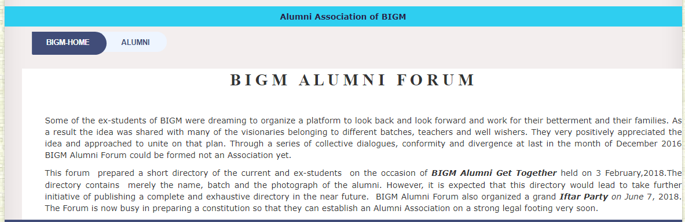

Admin Panel Task

A form & database need to be create.

Fields: Title, Description under CK Editor

Frontend Menu > Alumni

**5. Member Management**

Admin Panel Task

* Create a Menu “Member Management” on root menu
* Create a sub menu “Member Info” under Member Management menu
* Create a form “Member Information” under this menu to Add Edit Delete Member Information
* Check the database tables → **here**

**Member Management > Member Info**

**List of Members**



Search by name **+ Add New Member**

|  |  |  |  |  |  |
| --- | --- | --- | --- | --- | --- |
| **Sl** | **Name** | **Email** | **Phone** | **Picture** | **Action** |
| 1 | Mr. M. Matiul Islam | matiul.islam@bigm.edu.bd | +8801xxxxxxxxxxx |  |  |
| 2 | Dr. A.B. Mirza Azizul Islam | xxxxxxxxxxxxxxxxx@xxxxxx.xxx | +8801xxxxxxxxxxx |  |  |
| 3 | Mr. Abul Maal Abdul Muhith | xxxxxxxxxxxxxxxxx@xxxxxx.xxx | +8801xxxxxxxxxxx |  |  |
| 4 | Dr. Mohammad Abdur Rashid | xxxxxxxxxxxxxxxxx@xxxxxx.xxx | +8801xxxxxxxxxxx |  |  |
| 5 |  |  |  |  |  |
| 6 |  |  |  |  |  |
|  |  |  |  |  |  |



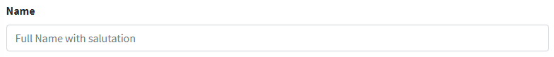**Add New Member**



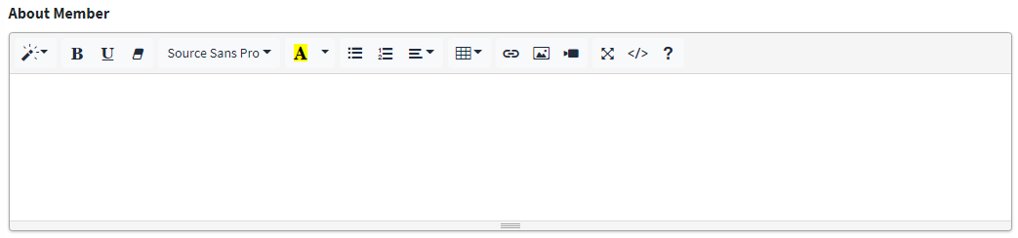

Education

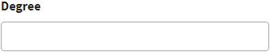 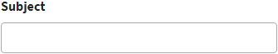 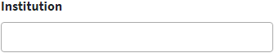

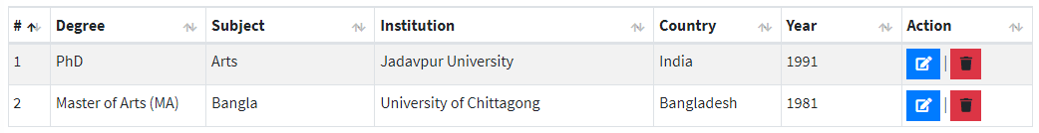 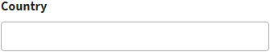 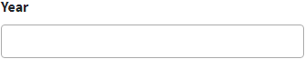

Professional Experience

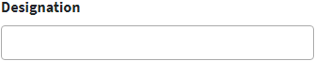

 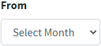 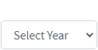 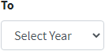 

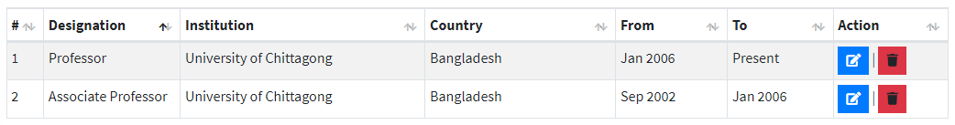



**6. Board of Trustees Management**

Admin Panel Task

* Create a sub menu “Board of Trustees” under “Member Management” menu
* Create a form “Trustees Board Member Information” under this menu to **Add Edit Delete** Member Information
* Check the database tables → **here**

**Member Management > Board of Trustees**

**Trustees Board Member Information**



Search by name **+ Add New Member**

|  |  |  |  |  |
| --- | --- | --- | --- | --- |
| **Sl** | **Name** | **Designation** | **Picture** | **Action** |
| 1 | Mr. M. Matiul Islam |  |  |  |
| 2 | Dr. A.B. Mirza Azizul Islam |  |  |  |
| 3 | Mr. Abul Maal Abdul Muhith |  |  |  |
| 4 | Dr. Mohammad Abdur Rashid |  |  |  |



**Add New Member**

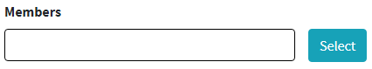

when selecting a member

* pick his name & picture and display on the box
* check that his id already added on BOT table or not
* if exists then show alert that he is already in the list

Member Name will appear here

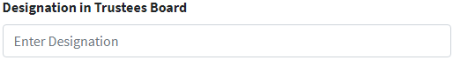





**Edit Member Designation**

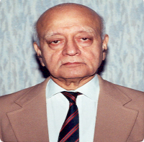

Mr. M. Matiul Islam

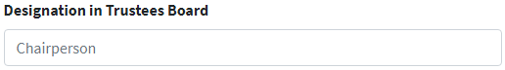



**7. Governing Body**

Admin Panel Task

* Create a sub menu “Governing Body” under “Member Management” menu
* Create a form “Governing Body Member Information” under this menu to **Add Edit Delete** Member Information
* Check the database tables → **here**

IT WILL BE SAME LIKE BOARD OF TRUSTEES

**Tables**

