# Capstone Assignment

## Investing in the Bar Industry in Toronto

## An introduction of the problem.

Toronto is a vibrant city with many diverse cultures and a booming economy. The citizens of Toronto work hard, have busy lives, and look forward to time for socializing and relaxing. The bars in the Toronto are cater to many in its various neighbourhoods. Opening a bar in Toronto can be very risky so due diligence and planning is highly recommended to mitigate the risks. One of the highest value items in the due diligence review is location.

The choice of location will depend on how the bar is to look, what the bar is going to contribute to the community, and the kind of clientele that is expected. Bars in Toronto appear to be more popular in certain neighbourhoods over others. The type of bars also tend to be close to another. This may be due to people preferring alternative choices in the case their first choice is not available, or proximity to their work or residence. The higher value Bar locations may also be located in neighbourhoods of more affluence. We will need to perform some analysis to determine where the best place to open a new bar would be.

## A description of the data and how it will be used to solve the problem.

In order to perform a location due diligence, bars that are of the same type, and grouped by neighbourhood, can be used in an analysis of potential success. Since we need access to as many potential paying customers as possible, the demographic of the neighbourhood must be taken into consideration. The safety of both the customer and the operation of the business can be associated to crime rate in area as well. This means we need to analyze 4 data sources:

1. The types of popular bars currently in the neighbourhoods

2. The population of each neighbourhood

3. The annual income of the residents of the neighbourhood

4. The crime rate in the neighbourhood

This Capstone Assignment will use the Venue information collected by Foursquare in order to determine the popular bars currently in the neighbourhoods. The analysis will also use the Neighbourhood Profiles data available from the City of Toronto Wellbeing Data Catalogue (http://map.toronto.ca/wellbeing/) to analyze the population, affluence and crime rate of each neighbourhood. The crime rate is based on robberies since this is the most important issue with owning a bar in Toronto. The boundaries of the Toronto neighbourhoods will be taken from the City of Toronto Open Data Catalogue - Neighbourhoods (https://www.toronto.ca/city-government/data-research-maps/open-data/open-data-catalogue/#a45bd45a-ede8-730e-1abc-93105b2c439f)

The first step will be to determine the popular bars currently in the neighbourhoods. Then the Wellbeing Data will be used to determine Neighbourhood Profiles. A map of Toronto will be created with the neighbourhoods outlined and overlayed with a color coding based on the Neighbourhood Profiles data. The popular bars will also be marked on the map.

The results will be analyzed and the recommendation(s) for the location of a new bar will be provided in the report conclusion.

## The Methodology

Using the Foursquare API, collected all the popular venues for all the neighborhoods in Toronto. Then, filtered the venues to include bar venues only. Analyzed and grouped each neighborhood by taking the mean of the frequency of occurrence of each bar type. Each neighbourhood along with the top 5 most common venues were determined. The venues for each neighbourhood were arranged and sorted by the top 3. KMeans was applied to create 4 clusters of bar types. Examined the clusters of bar types and classified each. Then, loaded in the Wellbeing information and calculated the overall score with a weighted crime value. Loaded in the Toronto Neighbourhood geo codes and mapped the results.

## Results and Recommendations

The map displays the Neighbourhood perimeters with color coding based on the Wellbeing score and markers for the bar types in the neighbourhoods. The lightest shaded neighbourhoods offer the safest communities with a large affluent population. The darkest (red) neighbourhoods offer the least in safety, population and affluence. Based on the map above, there are some clear options on locations to open a new bar. They are:

1. Lawrence Park and York Mills are of the lightest shaded neighbourhoods (in the Borough of East York) and there are no popular bars currently in that area. An entrepreneur willing to be the first kid in town, with an upscale bar, may do well there.

2. The neighbourhoods of Dovercourt Village and Christie are also of the lightest shaded neighbourhoods. There are seedier type bars and upscale bars in the area so a casual bar or one with live music would do well there.

3. The downtown neighbourhoods have a high population and affluence. Although there are many bars of many types, the Waterfront and Regent Park neighbourhoods do not have any popular bars. This would be a prime location for any type of bar.

Please see the map below (Figure A) for more details.

Figure A: Map of Toronto Neighbourhoods, color coded by Wellbeing and Bar Cluster Markers

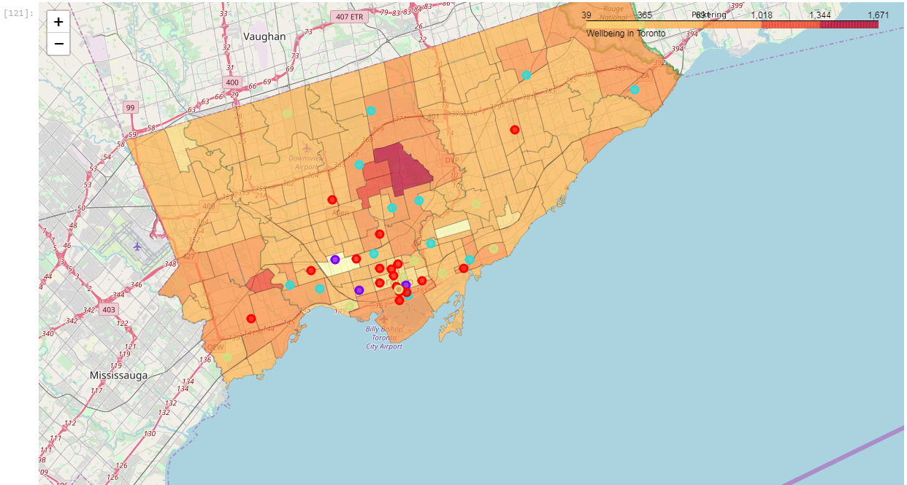

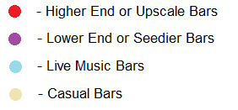

## Conclusion

Toronto is a city with a booming economy and thriving neighbourhoods. Although there are many citizens that could be potential customer, there is already a lot of competition in the bar and entertainment industry. It is very prudent to analyze the neighbourhoods thoroughly for a location before making any investment in this industry. The notebook report generated for this problem was successful in performing the analysis required and identified high value neighbourhoods for bar investments. I highly recommend reviewing the details of this report before investing any capital into a bar in the Toronto area.