|  |
| --- |
|  |
| Neural Network and Fuzzy Systems  (EECE 5860)  Project-1 Report |
| Submitted by – Mohammad Saber  (MUID: 005852837) |
|  |
|  |

Contents

**Problem One: Develop a fuzzy inference system to simulate the camera tracking system** 3

A) Using fuzzy toolbox to generate Fuzzy Inference system: 3

B) Using matlab command line to simulate the camera tracking system: 6

**Problem Two: FCM for clustering analysis of the wine data** 8

A) Data analysis stategy to solve clustering problem: 8

B) Results of analysis of wine Data Clustering: 9

C) Final decision of selecting number of cluster and Dicision 9

Appendix–A : Given Wine data set 12

Appendix–B: patitioning 13-dimentional data into 78 2-dimentional data using matlab code 17

Appendix-C: implementatoin of fuzzy c-means (FCM) algorithm in matlab for Wine clustering 19

Appendix-D: matlab Code for running fcm simulation for 78 combinations within a given range of cluster number 25

Appendix-E: collected data from fcm simulation for cluster number 2, 3, 4 and 5 27

Appendix-F:Graphical representation of fcm simulation for cluster number 2, 3, 4 and 5 35

Appendix-G: MATlab code for finding cluster members 56

References 57

# **Problem One: Develop a fuzzy inference system to simulate the camera tracking system**

## A) Using fuzzy toolbox to generate Fuzzy Inference system:

Two fuzzy inference systems are required to solve the given problem. We can open the fuzzy system toolbox from MATLAB by typing ‘fuzzy’ in MATLAB command line. For first fuzzy inference system we need only one input named *Range* and one output named *Scale* as depicted in Figure 1.

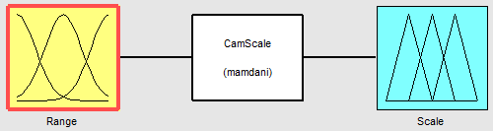

**Figure 1:** Fuzzy inference system to generate scale from input range

Now we have to create membership functions for Range and Scale. We can just click on the input box and output box (Figure 1) to set all membership functions according to the given problem. Figure 2 and 3 shows all membership functions used for this fuzzy inference system.

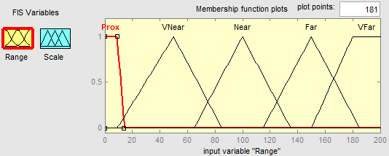

**Figure 2:** Membership functions for input variable “Range”

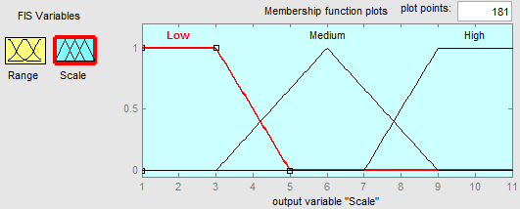

**Figure 3:** Membership functions for output variable “Scale”

Then I have set the following rules by clicking on the middle white box of Figure 1.

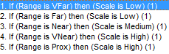

**Figure 4:** Set of rules for first fuzzy inference system

For second fuzzy system we have three inputs and two outputs (Figure 5). One of the inputs of second fuzzy system would be the output first fuzzy system. Thus the input variable “Range” will have same membership functions as output variable of first fuzzy inference system (Figure 3). Two output variables “Pan” and “Tilt” will also have the same membership functions according to the problem specification. Figure 6, 7 and 8 show membership functions for input and output variables required to implement second fuzzy inferences system.

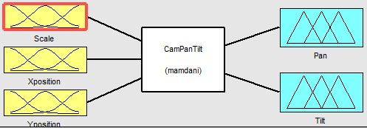  
**Figure 5:** Second fuzzy inference system

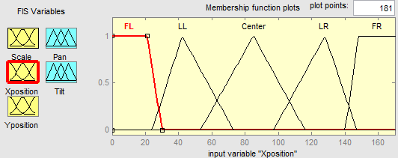

**Figure 6:** Membership functions for input variable “Xposition”

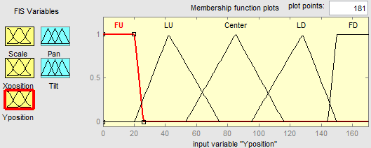

**Figure 7:** Membership functions for input variable “Yposition”

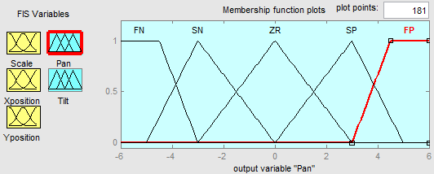

**Figure 8:** Membership functions for output variable “Pan” and “Tilt”

Similarly like first fuzzy inference system, we have to set 30 rules for second fuzzy inference system which are shown in Figure 9.

|  |
| --- |
|  |

**Figure 9:** Set of rules for the second fuzzy inference system

Now, we save these two fuzzy inference systems as “CamScale.fis” and “CamPanTilt.fis” respectively for later use.

## B) Using matlab command line to simulate the camera tracking system:

In part A, we have created two fuzzy inference system using MATLAB GUI. Now, we will simulate this two systems in MATLAB command line. Table 1 shows the given input for the simulation.

|  |  |  |
| --- | --- | --- |
| Range | Xposition | Yposition |
| 100 | 85 | 100 |
| 200 | 150 | 20 |
| 50 | 30 | 53 |
| 101 | 150 | 20 |
| 200 | 0 | 0 |
| 0 | 170 | 170 |
| 100 | 85 | 85 |

**Table 1:** Given input to run simulation for the Camera Tracking System

After giving the first column of Table 1 as input for first fuzzy inference system we will get the following output for the scale variable.

|  |
| --- |
| Scale |
| 6.0000 |
| 2.5295 |
| 9.4705 |
| 6.0000 |
| 2.5295 |
| 9.4705 |
| 6.0000 |

**Table 2:** Output of first fuzzy inference system

Now we will use the result of Table 2 along with second and third column of Table 1 as input of second fuzzy inference system to generate the final output of “Pan” and “Tilt” variables. In MATLAB command line we have used functions *readfis()* and *evalfis()*for reading previously generated *.fis file and running fuzzy inference system simulator respectively. Final outputs of *Pan* and *Tilt* generated by our simulation are shown in Table 3 and 4 respectively.

|  |
| --- |
| function [Pan Tilt] = CameraTracking()  Range = [100; 200; 50; 101; 200; 0; 100];  Horizontal_Pos = [85; 150; 30; 150; 0; 170; 85];  Vertical_Pos = [100; 20; 53; 20; 0; 170; 85];  fis1 = readfis('CamScale');  Scale = evalfis(Range,fis1);  fis2 = readfis('CamPanTilt');  [Pan Tilt] = evalfis([Scale Horizontal_PosVertical_Pos],fis2);  End |

**Figure 10:** MATLAB command line codes to run the simulation of camera tracking system

|  |  |
| --- | --- |
| Pan | |
| 0.0000 | 0.4596 |
| 4.8649 | -4.8649 |
| 0.0000 | 0.0000 |
| 2.6674 | -2.6674 |
| -4.8649 | -4.8649 |
| 2.6674 | 2.6674 |
| 0.0000 | 0.0000 |

**Table 3:** Final result of output variable “Pan”

|  |  |  |
| --- | --- | --- |
| Tilt | | |
| 0 | 0 | 1 |
| 0 | 0 | 1 |
| 0 | 1 | 1 |
| 0 | 0 | 1 |
| 0 | 0 | 1 |
| 1 | 0 | 1 |
| 1 | 0 | 1 |
| 1 | 1 | 1 |
| 1 | 0 | 1 |
| 1 | 0 | 1 |
| 0 | 0 | 1 |
| 0 | 0 | 1 |
| 0 | 1 | 1 |
| 0 | 0 | 1 |
| 0 | 0 | 1 |
| 0 | 1 | 0 |
| 0 | 1 | 0 |
| 0 | 1 | 1 |
| 0 | 1 | 0 |
| 0 | 1 | 0 |
| 1 | 1 | 0 |
| 1 | 1 | 0 |
| 1 | 1 | 1 |
| 1 | 1 | 0 |
| 1 | 1 | 0 |
| 0 | 1 | 0 |
| 0 | 1 | 0 |
| 0 | 1 | 1 |
| 0 | 1 | 0 |
| 0 | 1 | 0 |

**Table 4:** Final result of output variable “Tilt”

# **Problem Two: FCM for clustering analysis of the wine data**

## A) Data analysis stategy to solve clustering problem:

A 13-dimentional data set is given for clustering (Appendix –A). I have tried to analyze 13-dimension data by observing and plotted it using MATLAB. But it’s very difficult or almost impossible to make a decision from that 13-dimensional graph. It’s didn’t make any sense though clusters overlap each other and some point of one cluster was inside the range of another cluster. Later I figure out that we are seeing 2-dimnensionally but our plot is 13-dimention. Thus some points which seems to be inside a given clusteroriginal from another cluster of different dimension. Figure 11 shows the simulation of fuzzy C-means (FCM) algorithm on 13-dimensional data.

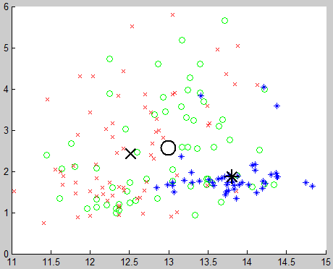

**Figure 11:** Result of running FCM on 13 dimensional data (Cluster size =3)

Then I decided to go for 2-dimensional data at a time. If we try to plot or analyze 2-dimensional data from given 13-dimensional data, then we have 78 combinations (12+11+10+9+8+7+6+5+4+3+2+1 =78) of 2-dimensional data. I have partitioned the original data in 78 pairs using a MATLAB code (Appendix-B). Then try to find out center, radius and standard deviation for all 78 combinations. Then take the average of 156 (78combinations*2clusters) radius and standard deviation for comparison with other results. Similarly I have run the simulation for cluster 3, 4 and 5 and take the average of all cluster radius and standard deviations for future analysis. I have written a MATLAB functions to simulate fuzzy C-means algorithm (Appendix-C) for different cluster size and store the all cluster centers, radius and standard deviation into *.txt files for analysis. It also shows a 2-dimensional graph of clustering operation on given data set. I wrote another MATLAB function to call the simulation of FCM algorithm for all 78 combinations (Appendix-D).

## B) Results of analysis of wine Data Clustering:

After running the simulation and collecting the results I found that average cluster radius for cluster 2, 3, 4 and 5 are 70.15, 49.11, 35.66 and 28.02 unit respectively. When we increase the number of cluster then radius of cluster become smaller which makes sense but we can’t find out any conclusion about how many cluster is good for this data using this information. Again we have standard deviations 208.87, 121.79, 78.83 and 59.25 for cluster number 2, 3, 4 and 5 respectively. This information clearly says that if I go for bigger number of cluster then standard deviation and radius will be further smaller. Thus we can’t make any decision from only standard deviation or radius. We need to find out any second order calculation to make a decision. Table 5 contains the result summary of my findings. Full results are included in Appendix-E.

|  |  |  |  |  |  |
| --- | --- | --- | --- | --- | --- |
| No of Clusters | Average radius | Average STD | Radius*Cluster | STD improve | Real STD improve |
| 2 | 70.15 | 208.87 | 140.31 | - | - |
| 3 | 49.11 | 121.79 | 147.33 | 71.5 % | 21.5 % |
| 4 | 35.66 | 78.83 | 142.63 | 54.5 % | 21.17 % |
| 5 | 28.02 | 59.25 | 140.08 | 33.04 % | 8.04 % |

**Table 5:** Summary of wine data clustering result

## C) Final decision of selecting number of cluster and Dicision

If we observe in the Table 5 carefully, especially second order calculations (last 3 columns), then we can see radius*cluster is bigger (147.33 which is clearly bigger than other chosen number of clusters) for cluster 3. From my observation if we have close cluster centers then radius of clusters will be smaller. Those close clustering are unnecessary clustering and could be merged, and really useful cluster centers are far away from each other. Figure 11 illustrate the above discussion for same data pair.

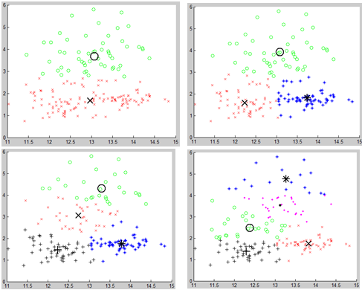

**Figure 11:** Cluster same pair of data using cluster number 2, 3, 4 and 5.

Again, if we consider the standard deviation for every cluster number, then we can see 71.5% improvement from cluster 2 to cluster 3 which is the biggest improvement from comparing other cluster number. But it’s normal if we increase the number of cluster then standard deviation will decrease i.e. improvement may be bias with choosing greater number of cluster. Thus I deduced the ratio of the number of clusters to find real improvement in last column of Table 5. Formula I have used to find real improvement of standard deviation for choosing new number of clusters over pervious number of clusters is given below:

((STD of previous cluster)/(STD of chosen cluster) – (# of chosen cluster)/(# of previous cluster))*100%

For example, if we choose cluster size 3 instead of 2 then our real standard deviation improvement will be ((208.87/121.79)-(3/2))*100% = 21.5 %. In this way, I have calculated all real improvement of standard deviation and found that cluster number 3 is the best among other chosen cluster number. Considering above discussion I think ***three clusters*** would be appropriate for given wind data set. Figure 12 shows sample simulation of cluster number three for some pair of data from 78 pairs. Centers, radii, standard deviations and graphical representation of cluster number 2, 3, 4 and 5 for all 78 pairs are given in Appendix-E and F.

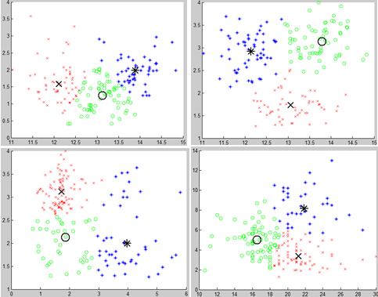

**Figure 12:** Sample simulation on 4 pair among 78 pairs of data set for cluster number 3.

To find the cluster members of each cluster, I have written a MATLAB function which is attached in Appendix – G. The first cluster contains 46 members, second cluster contains 71 members and third cluster contains 61 members. All members from each cluster are given below:

***Cluster 1members:***

1,2,3,4,6,7,8,9,10,11,12,13,14,15,16,17,18,19,23,24,27,28,30,31,32,33,34,35,38,39,42,43,46,47,48,49,50,51,52,53,54,55,56,58,59,74.

Total members = 46.

***Cluster 2 members:***

60,62,64,65,67,68,72,73,76,77,78,80,81,84,85,86,87,88,91,92,93,94,95,98,100,102,103,104,106,107,108,109,111,112,114,115,116,117,118,119,120,122,123,124,125,126,127,128,129,130,132,133,134,138,139,140,141,143,144,147,150,151,152,153,157,161,163,166,171,172,178.

Total members = 71.

***Cluster 3 members:***

5,20,21,22,25,26,29,36,37,40,41,44,45,57,61,63,66,69,70,71,75,79,82,83,89,90,96,97,99,101,105,110,113,121,131,135,136,137,142,145,146,148,149,154,155,156,158,159,160,162,164,165,167,168,169,170,173,174,175,176,177.

Total members = 61.

# Appendix–A : Given Wine data set

|  |  |  |  |  |  |  |  |  |  |  |  |  |
| --- | --- | --- | --- | --- | --- | --- | --- | --- | --- | --- | --- | --- |
| Alcohol | Malic acid | Ash | Alcalinity of ash | Magnesium | Total phenols | Flavanoids | Nonflavanoid phenols | Proanthocyanins | Color intensity | Hue | OD280/OD315 of diluted wines | Proline |
| 14.23 | 1.71 | 2.43 | 15.6 | 127 | 2.8 | 3.06 | 0.28 | 2.29 | 5.64 | 1.04 | 3.92 | 1065 |
| 13.2 | 1.78 | 2.14 | 11.2 | 100 | 2.65 | 2.76 | 0.26 | 1.28 | 4.38 | 1.05 | 3.4 | 1050 |
| 13.16 | 2.36 | 2.67 | 18.6 | 101 | 2.8 | 3.24 | 0.3 | 2.81 | 5.68 | 1.03 | 3.17 | 1185 |
| 14.37 | 1.95 | 2.5 | 16.8 | 113 | 3.85 | 3.49 | 0.24 | 2.18 | 7.8 | 0.86 | 3.45 | 1480 |
| 13.24 | 2.59 | 2.87 | 21 | 118 | 2.8 | 2.69 | 0.39 | 1.82 | 4.32 | 1.04 | 2.93 | 735 |
| 14.2 | 1.76 | 2.45 | 15.2 | 112 | 3.27 | 3.39 | 0.34 | 1.97 | 6.75 | 1.05 | 2.85 | 1450 |
| 14.39 | 1.87 | 2.45 | 14.6 | 96 | 2.5 | 2.52 | 0.3 | 1.98 | 5.25 | 1.02 | 3.58 | 1290 |
| 14.06 | 2.15 | 2.61 | 17.6 | 121 | 2.6 | 2.51 | 0.31 | 1.25 | 5.05 | 1.06 | 3.58 | 1295 |
| 14.83 | 1.64 | 2.17 | 14 | 97 | 2.8 | 2.98 | 0.29 | 1.98 | 5.2 | 1.08 | 2.85 | 1045 |
| 13.86 | 1.35 | 2.27 | 16 | 98 | 2.98 | 3.15 | 0.22 | 1.85 | 7.22 | 1.01 | 3.55 | 1045 |
| 14.1 | 2.16 | 2.3 | 18 | 105 | 2.95 | 3.32 | 0.22 | 2.38 | 5.75 | 1.25 | 3.17 | 1510 |
| 14.12 | 1.48 | 2.32 | 16.8 | 95 | 2.2 | 2.43 | 0.26 | 1.57 | 5 | 1.17 | 2.82 | 1280 |
| 13.75 | 1.73 | 2.41 | 16 | 89 | 2.6 | 2.76 | 0.29 | 1.81 | 5.6 | 1.15 | 2.9 | 1320 |
| 14.75 | 1.73 | 2.39 | 11.4 | 91 | 3.1 | 3.69 | 0.43 | 2.81 | 5.4 | 1.25 | 2.73 | 1150 |
| 14.38 | 1.87 | 2.38 | 12 | 102 | 3.3 | 3.64 | 0.29 | 2.96 | 7.5 | 1.2 | 3 | 1547 |
| 13.63 | 1.81 | 2.7 | 17.2 | 112 | 2.85 | 2.91 | 0.3 | 1.46 | 7.3 | 1.28 | 2.88 | 1310 |
| 14.3 | 1.92 | 2.72 | 20 | 120 | 2.8 | 3.14 | 0.33 | 1.97 | 6.2 | 1.07 | 2.65 | 1280 |
| 13.83 | 1.57 | 2.62 | 20 | 115 | 2.95 | 3.4 | 0.4 | 1.72 | 6.6 | 1.13 | 2.57 | 1130 |
| 14.19 | 1.59 | 2.48 | 16.5 | 108 | 3.3 | 3.93 | 0.32 | 1.86 | 8.7 | 1.23 | 2.82 | 1680 |
| 13.64 | 3.1 | 2.56 | 15.2 | 116 | 2.7 | 3.03 | 0.17 | 1.66 | 5.1 | 0.96 | 3.36 | 845 |
| 14.06 | 1.63 | 2.28 | 16 | 126 | 3 | 3.17 | 0.24 | 2.1 | 5.65 | 1.09 | 3.71 | 780 |
| 12.93 | 3.8 | 2.65 | 18.6 | 102 | 2.41 | 2.41 | 0.25 | 1.98 | 4.5 | 1.03 | 3.52 | 770 |
| 13.71 | 1.86 | 2.36 | 16.6 | 101 | 2.61 | 2.88 | 0.27 | 1.69 | 3.8 | 1.11 | 4 | 1035 |
| 12.85 | 1.6 | 2.52 | 17.8 | 95 | 2.48 | 2.37 | 0.26 | 1.46 | 3.93 | 1.09 | 3.63 | 1015 |
| 13.5 | 1.81 | 2.61 | 20 | 96 | 2.53 | 2.61 | 0.28 | 1.66 | 3.52 | 1.12 | 3.82 | 845 |
| 13.05 | 2.05 | 3.22 | 25 | 124 | 2.63 | 2.68 | 0.47 | 1.92 | 3.58 | 1.13 | 3.2 | 830 |
| 13.39 | 1.77 | 2.62 | 16.1 | 93 | 2.85 | 2.94 | 0.34 | 1.45 | 4.8 | 0.92 | 3.22 | 1195 |
| 13.3 | 1.72 | 2.14 | 17 | 94 | 2.4 | 2.19 | 0.27 | 1.35 | 3.95 | 1.02 | 2.77 | 1285 |
| 13.87 | 1.9 | 2.8 | 19.4 | 107 | 2.95 | 2.97 | 0.37 | 1.76 | 4.5 | 1.25 | 3.4 | 915 |
| 14.02 | 1.68 | 2.21 | 16 | 96 | 2.65 | 2.33 | 0.26 | 1.98 | 4.7 | 1.04 | 3.59 | 1035 |
| 13.73 | 1.5 | 2.7 | 22.5 | 101 | 3 | 3.25 | 0.29 | 2.38 | 5.7 | 1.19 | 2.71 | 1285 |
| 13.58 | 1.66 | 2.36 | 19.1 | 106 | 2.86 | 3.19 | 0.22 | 1.95 | 6.9 | 1.09 | 2.88 | 1515 |
| 13.68 | 1.83 | 2.36 | 17.2 | 104 | 2.42 | 2.69 | 0.42 | 1.97 | 3.84 | 1.23 | 2.87 | 990 |
| 13.76 | 1.53 | 2.7 | 19.5 | 132 | 2.95 | 2.74 | 0.5 | 1.35 | 5.4 | 1.25 | 3 | 1235 |
| 13.51 | 1.8 | 2.65 | 19 | 110 | 2.35 | 2.53 | 0.29 | 1.54 | 4.2 | 1.1 | 2.87 | 1095 |
| 13.48 | 1.81 | 2.41 | 20.5 | 100 | 2.7 | 2.98 | 0.26 | 1.86 | 5.1 | 1.04 | 3.47 | 920 |
| 13.28 | 1.64 | 2.84 | 15.5 | 110 | 2.6 | 2.68 | 0.34 | 1.36 | 4.6 | 1.09 | 2.78 | 880 |
| 13.05 | 1.65 | 2.55 | 18 | 98 | 2.45 | 2.43 | 0.29 | 1.44 | 4.25 | 1.12 | 2.51 | 1105 |
| 13.07 | 1.5 | 2.1 | 15.5 | 98 | 2.4 | 2.64 | 0.28 | 1.37 | 3.7 | 1.18 | 2.69 | 1020 |
| 14.22 | 3.99 | 2.51 | 13.2 | 128 | 3 | 3.04 | 0.2 | 2.08 | 5.1 | 0.89 | 3.53 | 760 |
| 13.56 | 1.71 | 2.31 | 16.2 | 117 | 3.15 | 3.29 | 0.34 | 2.34 | 6.13 | 0.95 | 3.38 | 795 |
| 13.41 | 3.84 | 2.12 | 18.8 | 90 | 2.45 | 2.68 | 0.27 | 1.48 | 4.28 | 0.91 | 3 | 1035 |
| 13.88 | 1.89 | 2.59 | 15 | 101 | 3.25 | 3.56 | 0.17 | 1.7 | 5.43 | 0.88 | 3.56 | 1095 |
| 13.24 | 3.98 | 2.29 | 17.5 | 103 | 2.64 | 2.63 | 0.32 | 1.66 | 4.36 | 0.82 | 3 | 680 |
| 13.05 | 1.77 | 2.1 | 17 | 107 | 3 | 3 | 0.28 | 2.03 | 5.04 | 0.88 | 3.35 | 885 |
| 14.21 | 4.04 | 2.44 | 18.9 | 111 | 2.85 | 2.65 | 0.3 | 1.25 | 5.24 | 0.87 | 3.33 | 1080 |
| 14.38 | 3.59 | 2.28 | 16 | 102 | 3.25 | 3.17 | 0.27 | 2.19 | 4.9 | 1.04 | 3.44 | 1065 |
| 13.9 | 1.68 | 2.12 | 16 | 101 | 3.1 | 3.39 | 0.21 | 2.14 | 6.1 | 0.91 | 3.33 | 985 |
| 14.1 | 2.02 | 2.4 | 18.8 | 103 | 2.75 | 2.92 | 0.32 | 2.38 | 6.2 | 1.07 | 2.75 | 1060 |
| 13.94 | 1.73 | 2.27 | 17.4 | 108 | 2.88 | 3.54 | 0.32 | 2.08 | 8.9 | 1.12 | 3.1 | 1260 |
| 13.05 | 1.73 | 2.04 | 12.4 | 92 | 2.72 | 3.27 | 0.17 | 2.91 | 7.2 | 1.12 | 2.91 | 1150 |
| 13.83 | 1.65 | 2.6 | 17.2 | 94 | 2.45 | 2.99 | 0.22 | 2.29 | 5.6 | 1.24 | 3.37 | 1265 |
| 13.82 | 1.75 | 2.42 | 14 | 111 | 3.88 | 3.74 | 0.32 | 1.87 | 7.05 | 1.01 | 3.26 | 1190 |
| 13.77 | 1.9 | 2.68 | 17.1 | 115 | 3 | 2.79 | 0.39 | 1.68 | 6.3 | 1.13 | 2.93 | 1375 |
| 13.74 | 1.67 | 2.25 | 16.4 | 118 | 2.6 | 2.9 | 0.21 | 1.62 | 5.85 | 0.92 | 3.2 | 1060 |
| 13.56 | 1.73 | 2.46 | 20.5 | 116 | 2.96 | 2.78 | 0.2 | 2.45 | 6.25 | 0.98 | 3.03 | 1120 |
| 14.22 | 1.7 | 2.3 | 16.3 | 118 | 3.2 | 3 | 0.26 | 2.03 | 6.38 | 0.94 | 3.31 | 970 |
| 13.29 | 1.97 | 2.68 | 16.8 | 102 | 3 | 3.23 | 0.31 | 1.66 | 6 | 1.07 | 2.84 | 1270 |
| 13.72 | 1.43 | 2.5 | 16.7 | 108 | 3.4 | 3.67 | 0.19 | 2.04 | 6.8 | 0.89 | 2.87 | 1285 |
| 12.37 | 0.94 | 1.36 | 10.6 | 88 | 1.98 | 0.57 | 0.28 | 0.42 | 1.95 | 1.05 | 1.82 | 520 |
| 12.33 | 1.1 | 2.28 | 16 | 101 | 2.05 | 1.09 | 0.63 | 0.41 | 3.27 | 1.25 | 1.67 | 680 |
| 12.64 | 1.36 | 2.02 | 16.8 | 100 | 2.02 | 1.41 | 0.53 | 0.62 | 5.75 | 0.98 | 1.59 | 450 |
| 13.67 | 1.25 | 1.92 | 18 | 94 | 2.1 | 1.79 | 0.32 | 0.73 | 3.8 | 1.23 | 2.46 | 630 |
| 12.37 | 1.13 | 2.16 | 19 | 87 | 3.5 | 3.1 | 0.19 | 1.87 | 4.45 | 1.22 | 2.87 | 420 |
| 12.17 | 1.45 | 2.53 | 19 | 104 | 1.89 | 1.75 | 0.45 | 1.03 | 2.95 | 1.45 | 2.23 | 355 |
| 12.37 | 1.21 | 2.56 | 18.1 | 98 | 2.42 | 2.65 | 0.37 | 2.08 | 4.6 | 1.19 | 2.3 | 678 |
| 13.11 | 1.01 | 1.7 | 15 | 78 | 2.98 | 3.18 | 0.26 | 2.28 | 5.3 | 1.12 | 3.18 | 502 |
| 12.37 | 1.17 | 1.92 | 19.6 | 78 | 2.11 | 2 | 0.27 | 1.04 | 4.68 | 1.12 | 3.48 | 510 |
| 13.34 | 0.94 | 2.36 | 17 | 110 | 2.53 | 1.3 | 0.55 | 0.42 | 3.17 | 1.02 | 1.93 | 750 |
| 12.21 | 1.19 | 1.75 | 16.8 | 151 | 1.85 | 1.28 | 0.14 | 2.5 | 2.85 | 1.28 | 3.07 | 718 |
| 12.29 | 1.61 | 2.21 | 20.4 | 103 | 1.1 | 1.02 | 0.37 | 1.46 | 3.05 | 0.906 | 1.82 | 870 |
| 13.86 | 1.51 | 2.67 | 25 | 86 | 2.95 | 2.86 | 0.21 | 1.87 | 3.38 | 1.36 | 3.16 | 410 |
| 13.49 | 1.66 | 2.24 | 24 | 87 | 1.88 | 1.84 | 0.27 | 1.03 | 3.74 | 0.98 | 2.78 | 472 |
| 12.99 | 1.67 | 2.6 | 30 | 139 | 3.3 | 2.89 | 0.21 | 1.96 | 3.35 | 1.31 | 3.5 | 985 |
| 11.96 | 1.09 | 2.3 | 21 | 101 | 3.38 | 2.14 | 0.13 | 1.65 | 3.21 | 0.99 | 3.13 | 886 |
| 11.66 | 1.88 | 1.92 | 16 | 97 | 1.61 | 1.57 | 0.34 | 1.15 | 3.8 | 1.23 | 2.14 | 428 |
| 13.03 | 0.9 | 1.71 | 16 | 86 | 1.95 | 2.03 | 0.24 | 1.46 | 4.6 | 1.19 | 2.48 | 392 |
| 11.84 | 2.89 | 2.23 | 18 | 112 | 1.72 | 1.32 | 0.43 | 0.95 | 2.65 | 0.96 | 2.52 | 500 |
| 12.33 | 0.99 | 1.95 | 14.8 | 136 | 1.9 | 1.85 | 0.35 | 2.76 | 3.4 | 1.06 | 2.31 | 750 |
| 12.7 | 3.87 | 2.4 | 23 | 101 | 2.83 | 2.55 | 0.43 | 1.95 | 2.57 | 1.19 | 3.13 | 463 |
| 12 | 0.92 | 2 | 19 | 86 | 2.42 | 2.26 | 0.3 | 1.43 | 2.5 | 1.38 | 3.12 | 278 |
| 12.72 | 1.81 | 2.2 | 18.8 | 86 | 2.2 | 2.53 | 0.26 | 1.77 | 3.9 | 1.16 | 3.14 | 714 |
| 12.08 | 1.13 | 2.51 | 24 | 78 | 2 | 1.58 | 0.4 | 1.4 | 2.2 | 1.31 | 2.72 | 630 |
| 13.05 | 3.86 | 2.32 | 22.5 | 85 | 1.65 | 1.59 | 0.61 | 1.62 | 4.8 | 0.84 | 2.01 | 515 |
| 11.84 | 0.89 | 2.58 | 18 | 94 | 2.2 | 2.21 | 0.22 | 2.35 | 3.05 | 0.79 | 3.08 | 520 |
| 12.67 | 0.98 | 2.24 | 18 | 99 | 2.2 | 1.94 | 0.3 | 1.46 | 2.62 | 1.23 | 3.16 | 450 |
| 12.16 | 1.61 | 2.31 | 22.8 | 90 | 1.78 | 1.69 | 0.43 | 1.56 | 2.45 | 1.33 | 2.26 | 495 |
| 11.65 | 1.67 | 2.62 | 26 | 88 | 1.92 | 1.61 | 0.4 | 1.34 | 2.6 | 1.36 | 3.21 | 562 |
| 11.64 | 2.06 | 2.46 | 21.6 | 84 | 1.95 | 1.69 | 0.48 | 1.35 | 2.8 | 1 | 2.75 | 680 |
| 12.08 | 1.33 | 2.3 | 23.6 | 70 | 2.2 | 1.59 | 0.42 | 1.38 | 1.74 | 1.07 | 3.21 | 625 |
| 12.08 | 1.83 | 2.32 | 18.5 | 81 | 1.6 | 1.5 | 0.52 | 1.64 | 2.4 | 1.08 | 2.27 | 480 |
| 12 | 1.51 | 2.42 | 22 | 86 | 1.45 | 1.25 | 0.5 | 1.63 | 3.6 | 1.05 | 2.65 | 450 |
| 12.69 | 1.53 | 2.26 | 20.7 | 80 | 1.38 | 1.46 | 0.58 | 1.62 | 3.05 | 0.96 | 2.06 | 495 |
| 12.29 | 2.83 | 2.22 | 18 | 88 | 2.45 | 2.25 | 0.25 | 1.99 | 2.15 | 1.15 | 3.3 | 290 |
| 11.62 | 1.99 | 2.28 | 18 | 98 | 3.02 | 2.26 | 0.17 | 1.35 | 3.25 | 1.16 | 2.96 | 345 |
| 12.47 | 1.52 | 2.2 | 19 | 162 | 2.5 | 2.27 | 0.32 | 3.28 | 2.6 | 1.16 | 2.63 | 937 |
| 11.81 | 2.12 | 2.74 | 21.5 | 134 | 1.6 | 0.99 | 0.14 | 1.56 | 2.5 | 0.95 | 2.26 | 625 |
| 12.29 | 1.41 | 1.98 | 16 | 85 | 2.55 | 2.5 | 0.29 | 1.77 | 2.9 | 1.23 | 2.74 | 428 |
| 12.37 | 1.07 | 2.1 | 18.5 | 88 | 3.52 | 3.75 | 0.24 | 1.95 | 4.5 | 1.04 | 2.77 | 660 |
| 12.29 | 3.17 | 2.21 | 18 | 88 | 2.85 | 2.99 | 0.45 | 2.81 | 2.3 | 1.42 | 2.83 | 406 |
| 12.08 | 2.08 | 1.7 | 17.5 | 97 | 2.23 | 2.17 | 0.26 | 1.4 | 3.3 | 1.27 | 2.96 | 710 |
| 12.6 | 1.34 | 1.9 | 18.5 | 88 | 1.45 | 1.36 | 0.29 | 1.35 | 2.45 | 1.04 | 2.77 | 562 |
| 12.34 | 2.45 | 2.46 | 21 | 98 | 2.56 | 2.11 | 0.34 | 1.31 | 2.8 | 0.8 | 3.38 | 438 |
| 11.82 | 1.72 | 1.88 | 19.5 | 86 | 2.5 | 1.64 | 0.37 | 1.42 | 2.06 | 0.94 | 2.44 | 415 |
| 12.51 | 1.73 | 1.98 | 20.5 | 85 | 2.2 | 1.92 | 0.32 | 1.48 | 2.94 | 1.04 | 3.57 | 672 |
| 12.42 | 2.55 | 2.27 | 22 | 90 | 1.68 | 1.84 | 0.66 | 1.42 | 2.7 | 0.86 | 3.3 | 315 |
| 12.25 | 1.73 | 2.12 | 19 | 80 | 1.65 | 2.03 | 0.37 | 1.63 | 3.4 | 1 | 3.17 | 510 |
| 12.72 | 1.75 | 2.28 | 22.5 | 84 | 1.38 | 1.76 | 0.48 | 1.63 | 3.3 | 0.88 | 2.42 | 488 |
| 12.22 | 1.29 | 1.94 | 19 | 92 | 2.36 | 2.04 | 0.39 | 2.08 | 2.7 | 0.86 | 3.02 | 312 |
| 11.61 | 1.35 | 2.7 | 20 | 94 | 2.74 | 2.92 | 0.29 | 2.49 | 2.65 | 0.96 | 3.26 | 680 |
| 11.46 | 3.74 | 1.82 | 19.5 | 107 | 3.18 | 2.58 | 0.24 | 3.58 | 2.9 | 0.75 | 2.81 | 562 |
| 12.52 | 2.43 | 2.17 | 21 | 88 | 2.55 | 2.27 | 0.26 | 1.22 | 2 | 0.9 | 2.78 | 325 |
| 11.76 | 2.68 | 2.92 | 20 | 103 | 1.75 | 2.03 | 0.6 | 1.05 | 3.8 | 1.23 | 2.5 | 607 |
| 11.41 | 0.74 | 2.5 | 21 | 88 | 2.48 | 2.01 | 0.42 | 1.44 | 3.08 | 1.1 | 2.31 | 434 |
| 12.08 | 1.39 | 2.5 | 22.5 | 84 | 2.56 | 2.29 | 0.43 | 1.04 | 2.9 | 0.93 | 3.19 | 385 |
| 11.03 | 1.51 | 2.2 | 21.5 | 85 | 2.46 | 2.17 | 0.52 | 2.01 | 1.9 | 1.71 | 2.87 | 407 |
| 11.82 | 1.47 | 1.99 | 20.8 | 86 | 1.98 | 1.6 | 0.3 | 1.53 | 1.95 | 0.95 | 3.33 | 495 |
| 12.42 | 1.61 | 2.19 | 22.5 | 108 | 2 | 2.09 | 0.34 | 1.61 | 2.06 | 1.06 | 2.96 | 345 |
| 12.77 | 3.43 | 1.98 | 16 | 80 | 1.63 | 1.25 | 0.43 | 0.83 | 3.4 | 0.7 | 2.12 | 372 |
| 12 | 3.43 | 2 | 19 | 87 | 2 | 1.64 | 0.37 | 1.87 | 1.28 | 0.93 | 3.05 | 564 |
| 11.45 | 2.4 | 2.42 | 20 | 96 | 2.9 | 2.79 | 0.32 | 1.83 | 3.25 | 0.8 | 3.39 | 625 |
| 11.56 | 2.05 | 3.23 | 28.5 | 119 | 3.18 | 5.08 | 0.47 | 1.87 | 6 | 0.93 | 3.69 | 465 |
| 12.42 | 4.43 | 2.73 | 26.5 | 102 | 2.2 | 2.13 | 0.43 | 1.71 | 2.08 | 0.92 | 3.12 | 365 |
| 13.05 | 5.8 | 2.13 | 21.5 | 86 | 2.62 | 2.65 | 0.3 | 2.01 | 2.6 | 0.73 | 3.1 | 380 |
| 11.87 | 4.31 | 2.39 | 21 | 82 | 2.86 | 3.03 | 0.21 | 2.91 | 2.8 | 0.75 | 3.64 | 380 |
| 12.07 | 2.16 | 2.17 | 21 | 85 | 2.6 | 2.65 | 0.37 | 1.35 | 2.76 | 0.86 | 3.28 | 378 |
| 12.43 | 1.53 | 2.29 | 21.5 | 86 | 2.74 | 3.15 | 0.39 | 1.77 | 3.94 | 0.69 | 2.84 | 352 |
| 11.79 | 2.13 | 2.78 | 28.5 | 92 | 2.13 | 2.24 | 0.58 | 1.76 | 3 | 0.97 | 2.44 | 466 |
| 12.37 | 1.63 | 2.3 | 24.5 | 88 | 2.22 | 2.45 | 0.4 | 1.9 | 2.12 | 0.89 | 2.78 | 342 |
| 12.04 | 4.3 | 2.38 | 22 | 80 | 2.1 | 1.75 | 0.42 | 1.35 | 2.6 | 0.79 | 2.57 | 580 |
| 12.86 | 1.35 | 2.32 | 18 | 122 | 1.51 | 1.25 | 0.21 | 0.94 | 4.1 | 0.76 | 1.29 | 630 |
| 12.88 | 2.99 | 2.4 | 20 | 104 | 1.3 | 1.22 | 0.24 | 0.83 | 5.4 | 0.74 | 1.42 | 530 |
| 12.81 | 2.31 | 2.4 | 24 | 98 | 1.15 | 1.09 | 0.27 | 0.83 | 5.7 | 0.66 | 1.36 | 560 |
| 12.7 | 3.55 | 2.36 | 21.5 | 106 | 1.7 | 1.2 | 0.17 | 0.84 | 5 | 0.78 | 1.29 | 600 |
| 12.51 | 1.24 | 2.25 | 17.5 | 85 | 2 | 0.58 | 0.6 | 1.25 | 5.45 | 0.75 | 1.51 | 650 |
| 12.6 | 2.46 | 2.2 | 18.5 | 94 | 1.62 | 0.66 | 0.63 | 0.94 | 7.1 | 0.73 | 1.58 | 695 |
| 12.25 | 4.72 | 2.54 | 21 | 89 | 1.38 | 0.47 | 0.53 | 0.8 | 3.85 | 0.75 | 1.27 | 720 |
| 12.53 | 5.51 | 2.64 | 25 | 96 | 1.79 | 0.6 | 0.63 | 1.1 | 5 | 0.82 | 1.69 | 515 |
| 13.49 | 3.59 | 2.19 | 19.5 | 88 | 1.62 | 0.48 | 0.58 | 0.88 | 5.7 | 0.81 | 1.82 | 580 |
| 12.84 | 2.96 | 2.61 | 24 | 101 | 2.32 | 0.6 | 0.53 | 0.81 | 4.92 | 0.89 | 2.15 | 590 |
| 12.93 | 2.81 | 2.7 | 21 | 96 | 1.54 | 0.5 | 0.53 | 0.75 | 4.6 | 0.77 | 2.31 | 600 |
| 13.36 | 2.56 | 2.35 | 20 | 89 | 1.4 | 0.5 | 0.37 | 0.64 | 5.6 | 0.7 | 2.47 | 780 |
| 13.52 | 3.17 | 2.72 | 23.5 | 97 | 1.55 | 0.52 | 0.5 | 0.55 | 4.35 | 0.89 | 2.06 | 520 |
| 13.62 | 4.95 | 2.35 | 20 | 92 | 2 | 0.8 | 0.47 | 1.02 | 4.4 | 0.91 | 2.05 | 550 |
| 12.25 | 3.88 | 2.2 | 18.5 | 112 | 1.38 | 0.78 | 0.29 | 1.14 | 8.21 | 0.65 | 2 | 855 |
| 13.16 | 3.57 | 2.15 | 21 | 102 | 1.5 | 0.55 | 0.43 | 1.3 | 4 | 0.6 | 1.68 | 830 |
| 13.88 | 5.04 | 2.23 | 20 | 80 | 0.98 | 0.34 | 0.4 | 0.68 | 4.9 | 0.58 | 1.33 | 415 |
| 12.87 | 4.61 | 2.48 | 21.5 | 86 | 1.7 | 0.65 | 0.47 | 0.86 | 7.65 | 0.54 | 1.86 | 625 |
| 13.32 | 3.24 | 2.38 | 21.5 | 92 | 1.93 | 0.76 | 0.45 | 1.25 | 8.42 | 0.55 | 1.62 | 650 |
| 13.08 | 3.9 | 2.36 | 21.5 | 113 | 1.41 | 1.39 | 0.34 | 1.14 | 9.4 | 0.57 | 1.33 | 550 |
| 13.5 | 3.12 | 2.62 | 24 | 123 | 1.4 | 1.57 | 0.22 | 1.25 | 8.6 | 0.59 | 1.3 | 500 |
| 12.79 | 2.67 | 2.48 | 22 | 112 | 1.48 | 1.36 | 0.24 | 1.26 | 10.8 | 0.48 | 1.47 | 480 |
| 13.11 | 1.9 | 2.75 | 25.5 | 116 | 2.2 | 1.28 | 0.26 | 1.56 | 7.1 | 0.61 | 1.33 | 425 |
| 13.23 | 3.3 | 2.28 | 18.5 | 98 | 1.8 | 0.83 | 0.61 | 1.87 | 10.52 | 0.56 | 1.51 | 675 |
| 12.58 | 1.29 | 2.1 | 20 | 103 | 1.48 | 0.58 | 0.53 | 1.4 | 7.6 | 0.58 | 1.55 | 640 |
| 13.17 | 5.19 | 2.32 | 22 | 93 | 1.74 | 0.63 | 0.61 | 1.55 | 7.9 | 0.6 | 1.48 | 725 |
| 13.84 | 4.12 | 2.38 | 19.5 | 89 | 1.8 | 0.83 | 0.48 | 1.56 | 9.01 | 0.57 | 1.64 | 480 |
| 12.45 | 3.03 | 2.64 | 27 | 97 | 1.9 | 0.58 | 0.63 | 1.14 | 7.5 | 0.67 | 1.73 | 880 |
| 14.34 | 1.68 | 2.7 | 25 | 98 | 2.8 | 1.31 | 0.53 | 2.7 | 13 | 0.57 | 1.96 | 660 |
| 13.48 | 1.67 | 2.64 | 22.5 | 89 | 2.6 | 1.1 | 0.52 | 2.29 | 11.75 | 0.57 | 1.78 | 620 |
| 12.36 | 3.83 | 2.38 | 21 | 88 | 2.3 | 0.92 | 0.5 | 1.04 | 7.65 | 0.56 | 1.58 | 520 |
| 13.69 | 3.26 | 2.54 | 20 | 107 | 1.83 | 0.56 | 0.5 | 0.8 | 5.88 | 0.96 | 1.82 | 680 |
| 12.85 | 3.27 | 2.58 | 22 | 106 | 1.65 | 0.6 | 0.6 | 0.96 | 5.58 | 0.87 | 2.11 | 570 |
| 12.96 | 3.45 | 2.35 | 18.5 | 106 | 1.39 | 0.7 | 0.4 | 0.94 | 5.28 | 0.68 | 1.75 | 675 |
| 13.78 | 2.76 | 2.3 | 22 | 90 | 1.35 | 0.68 | 0.41 | 1.03 | 9.58 | 0.7 | 1.68 | 615 |
| 13.73 | 4.36 | 2.26 | 22.5 | 88 | 1.28 | 0.47 | 0.52 | 1.15 | 6.62 | 0.78 | 1.75 | 520 |
| 13.45 | 3.7 | 2.6 | 23 | 111 | 1.7 | 0.92 | 0.43 | 1.46 | 10.68 | 0.85 | 1.56 | 695 |
| 12.82 | 3.37 | 2.3 | 19.5 | 88 | 1.48 | 0.66 | 0.4 | 0.97 | 10.26 | 0.72 | 1.75 | 685 |
| 13.58 | 2.58 | 2.69 | 24.5 | 105 | 1.55 | 0.84 | 0.39 | 1.54 | 8.66 | 0.74 | 1.8 | 750 |
| 13.4 | 4.6 | 2.86 | 25 | 112 | 1.98 | 0.96 | 0.27 | 1.11 | 8.5 | 0.67 | 1.92 | 630 |
| 12.2 | 3.03 | 2.32 | 19 | 96 | 1.25 | 0.49 | 0.4 | 0.73 | 5.5 | 0.66 | 1.83 | 510 |
| 12.77 | 2.39 | 2.28 | 19.5 | 86 | 1.39 | 0.51 | 0.48 | 0.64 | 9.899999 | 0.57 | 1.63 | 470 |
| 14.16 | 2.51 | 2.48 | 20 | 91 | 1.68 | 0.7 | 0.44 | 1.24 | 9.7 | 0.62 | 1.71 | 660 |
| 13.71 | 5.65 | 2.45 | 20.5 | 95 | 1.68 | 0.61 | 0.52 | 1.06 | 7.7 | 0.64 | 1.74 | 740 |
| 13.4 | 3.91 | 2.48 | 23 | 102 | 1.8 | 0.75 | 0.43 | 1.41 | 7.3 | 0.7 | 1.56 | 750 |
| 13.27 | 4.28 | 2.26 | 20 | 120 | 1.59 | 0.69 | 0.43 | 1.35 | 10.2 | 0.59 | 1.56 | 835 |
| 13.17 | 2.59 | 2.37 | 20 | 120 | 1.65 | 0.68 | 0.53 | 1.46 | 9.3 | 0.6 | 1.62 | 840 |
| 14.13 | 4.1 | 2.74 | 24.5 | 96 | 2.05 | 0.76 | 0.56 | 1.35 | 9.2 | 0.61 | 1.6 | 560 |

# Appendix–B: patitioning 13-dimentional data into 78 2-dimentional data using matlab code

functionWine_Data( )

clearall;

fcmdata = xlsread('Wine_Data.xls'); % Read Wine_Data.xls file

data1_2 = [fcmdata(:, 1) fcmdata(:, 2)];

data1_3 = [fcmdata(:, 1) fcmdata(:, 3)];

data1_4 = [fcmdata(:, 1) fcmdata(:, 4)];

data1_5 = [fcmdata(:, 1) fcmdata(:, 5)];

data1_6 = [fcmdata(:, 1) fcmdata(:, 6)];

data1_7 = [fcmdata(:, 1) fcmdata(:, 7)];

data1_8 = [fcmdata(:, 1) fcmdata(:, 8)];

data1_9 = [fcmdata(:, 1) fcmdata(:, 9)];

data1_10 = [fcmdata(:, 1) fcmdata(:, 10)];

data1_11 = [fcmdata(:, 1) fcmdata(:, 11)];

data1_12 = [fcmdata(:, 1) fcmdata(:, 12)];

data1_13 = [fcmdata(:, 1) fcmdata(:, 13)];

data2_3 = [fcmdata(:, 2) fcmdata(:, 3)];

data2_4 = [fcmdata(:, 2) fcmdata(:, 4)];

data2_5 = [fcmdata(:, 2) fcmdata(:, 5)];

data2_6 = [fcmdata(:, 2) fcmdata(:, 6)];

data2_7 = [fcmdata(:, 2) fcmdata(:, 7)];

data2_8 = [fcmdata(:, 2) fcmdata(:, 8)];

data2_9 = [fcmdata(:, 2) fcmdata(:, 9)];

data2_10 = [fcmdata(:, 2) fcmdata(:, 10)];

data2_11 = [fcmdata(:, 2) fcmdata(:, 11)];

data2_12 = [fcmdata(:, 2) fcmdata(:, 12)];

data2_13 = [fcmdata(:, 2) fcmdata(:, 13)];

data3_4 = [fcmdata(:, 3) fcmdata(:, 4)];

data3_5 = [fcmdata(:, 3) fcmdata(:, 5)];

data3_6 = [fcmdata(:, 3) fcmdata(:, 6)];

data3_7 = [fcmdata(:, 3) fcmdata(:, 7)];

data3_8 = [fcmdata(:, 3) fcmdata(:, 8)];

data3_9 = [fcmdata(:, 3) fcmdata(:, 9)];

data3_10 = [fcmdata(:, 3) fcmdata(:, 10)];

data3_11 = [fcmdata(:, 3) fcmdata(:, 11)];

data3_12 = [fcmdata(:, 3) fcmdata(:, 12)];

data3_13 = [fcmdata(:, 3) fcmdata(:, 13)];

data4_5 = [fcmdata(:, 4) fcmdata(:, 5)];

data4_6 = [fcmdata(:, 4) fcmdata(:, 6)];

data4_7 = [fcmdata(:, 4) fcmdata(:, 7)];

data4_8 = [fcmdata(:, 4) fcmdata(:, 8)];

data4_9 = [fcmdata(:, 4) fcmdata(:, 9)];

data4_10 = [fcmdata(:, 4) fcmdata(:, 10)];

data4_11 = [fcmdata(:, 4) fcmdata(:, 11)];

data4_12 = [fcmdata(:, 4) fcmdata(:, 12)];

data4_13 = [fcmdata(:, 4) fcmdata(:, 13)];

data5_6 = [fcmdata(:, 5) fcmdata(:, 6)];

data5_7 = [fcmdata(:, 5) fcmdata(:, 7)];

data5_8 = [fcmdata(:, 5) fcmdata(:, 8)];

data5_9 = [fcmdata(:, 5) fcmdata(:, 9)];

data5_10 = [fcmdata(:, 5) fcmdata(:, 10)];

data5_11 = [fcmdata(:, 5) fcmdata(:, 11)];

data5_12 = [fcmdata(:, 5) fcmdata(:, 12)];

data5_13 = [fcmdata(:, 5) fcmdata(:, 13)];

data6_7 = [fcmdata(:, 6) fcmdata(:, 7)];

data6_8 = [fcmdata(:, 6) fcmdata(:, 8)];

data6_9 = [fcmdata(:, 6) fcmdata(:, 9)];

data6_10 = [fcmdata(:, 6) fcmdata(:, 10)];

data6_11 = [fcmdata(:, 6) fcmdata(:, 11)];

data6_12 = [fcmdata(:, 6) fcmdata(:, 12)];

data6_13 = [fcmdata(:, 6) fcmdata(:, 13)];

data7_8 = [fcmdata(:, 7) fcmdata(:, 8)];

data7_9 = [fcmdata(:, 7) fcmdata(:, 9)];

data7_10 = [fcmdata(:, 7) fcmdata(:, 10)];

data7_11 = [fcmdata(:, 7) fcmdata(:, 11)];

data7_12 = [fcmdata(:, 7) fcmdata(:, 12)];

data7_13 = [fcmdata(:, 7) fcmdata(:, 13)];

data8_9 = [fcmdata(:, 8) fcmdata(:, 9)];

data8_10 = [fcmdata(:, 8) fcmdata(:, 10)];

data8_11 = [fcmdata(:, 8) fcmdata(:, 11)];

data8_12 = [fcmdata(:, 8) fcmdata(:, 12)];

data8_13 = [fcmdata(:, 8) fcmdata(:, 13)];

data9_10 = [fcmdata(:, 9) fcmdata(:, 10)];

data9_11 = [fcmdata(:, 9) fcmdata(:, 11)];

data9_12 = [fcmdata(:, 9) fcmdata(:, 12)];

data9_13 = [fcmdata(:, 9) fcmdata(:, 13)];

data10_11 = [fcmdata(:, 10) fcmdata(:, 11)];

data10_12 = [fcmdata(:, 10) fcmdata(:, 12)];

data10_13 = [fcmdata(:, 10) fcmdata(:, 13)];

data11_12 = [fcmdata(:, 11) fcmdata(:, 12)];

data11_13 = [fcmdata(:, 11) fcmdata(:, 13)];

data12_13 = [fcmdata(:, 12) fcmdata(:, 13)];

end

# Appendix-C: implementatoin of fuzzy c-means (FCM) algorithm in matlab for Wine clustering

function [result] = Wine_Clustering(data,nOfc )

[center,U,objFcn] = fcm(data,nOfc);

maxU = max(U);

index1 = find(U(1, :) == maxU);

index2 = find(U(2, :) == maxU);

ifnOfc>=3

index3 = find(U(3, :) == maxU);

end

ifnOfc>=4

index4 = find(U(4, :) == maxU);

end

ifnOfc>=5

index5 = find(U(5, :) == maxU);

end

figure

line(data(index1,1),data(index1,2),'linestyle','none','marker', 'o','color','g');

line(data(index2,1),data(index2,2),'linestyle','none','marker', 'x','color','r');

ifnOfc>=3

line(data(index3,1),data(index3,2),'linestyle','none','marker', '*','color','b');

end

ifnOfc>=4

line(data(index4,1),data(index4,2),'linestyle','none','marker', '+','color','k');

end

ifnOfc>=5

line(data(index5,1),data(index5,2),'linestyle','none','marker', '.','color','m');

end

holdon

plot(center(1,1),center(1,2),'ko','markersize',15,'LineWidth',2)

plot(center(2,1),center(2,2),'kx','markersize',15,'LineWidth',2)

ifnOfc>=3

plot(center(3,1),center(3,2),'k*','markersize',15,'LineWidth',2)

end

ifnOfc>=4

plot(center(4,1),center(4,2),'k+','markersize',15,'LineWidth',2)

end

ifnOfc>=5

plot(center(5,1),center(5,2),'k.','markersize',15,'LineWidth',2)

end

[m1 n1]=size(index1);

[m2 n2]=size(index2);

ifnOfc>=3

[m3 n3]=size(index3);

end

ifnOfc>=4

[m4 n4]=size(index4);

end

ifnOfc>=5

[m5 n5]=size(index5);

end

std1=0;

r1=0;

std2=0;

r2=0;

ifnOfc>=3

std3=0;

r3=0;

end

ifnOfc>=4

std4=0;

r4=0;

end

ifnOfc>=5

std5=0;

r5=0;

end

fori=1:n1

temp=sqrt((data(index1(1, i), 1)-center(1, 1))^2+(data(index1(1, i), 2)-center(1, 2))^2);

if(r1<temp)

r1=temp;

end

std1=std1+temp;

end

fori=1:n2

temp=sqrt((data(index2(1, i), 1)-center(2, 1))^2+(data(index2(1, i), 2)-center(2, 2))^2);

if(r2<temp)

r2=temp;

end

std2=std2+temp;

end

ifnOfc>=3

fori=1:n3

temp=sqrt((data(index3(1, i), 1)-center(3, 1))^2+(data(index3(1, i), 2)-center(3, 2))^2);

if(r3<temp)

r3=temp;

end

std3=std3+temp;

end

end

ifnOfc>=4

fori=1:n4

temp=sqrt((data(index4(1, i), 1)-center(4, 1))^2+(data(index4(1, i), 2)-center(4, 2))^2);

if(r4<temp)

r4=temp;

end

std4=std4+temp;

end

end

ifnOfc>=5

fori=1:n5

temp=sqrt((data(index5(1, i), 1)-center(5, 1))^2+(data(index5(1, i), 2)-center(5, 2))^2);

if(r5<temp)

r5=temp;

end

std5=std5+temp;

end

end

x1=center(1,1);

y1=center(1,2);

std1=std1/sqrt(n1);

x2=center(2,1);

y2=center(2,2);

std2=std2/sqrt(n2);

ifnOfc>=3

x3=center(3,1);

y3=center(3,2);

std3=std3/sqrt(n3);

end

ifnOfc>=4

x4=center(4,1);

y4=center(4,2);

std4=std4/sqrt(n4);

end

ifnOfc>=5

x5=center(5,1);

y5=center(5,2);

std5=std5/sqrt(n5);

end

result = [x1 y1 r1 std1; x2 y2 r2 std2];

ifnOfc>=3

result = [x1 y1 r1 std1; x2 y2 r2 std2; x3 y3 r3 std3];

end

ifnOfc>=4

result = [x1 y1 r1 std1; x2 y2 r2 std2; x3 y3 r3 std3; x4 y4 r4 std4];

end

ifnOfc>=5

result = [x1 y1 r1 std1; x2 y2 r2 std2; x3 y3 r3 std3; x4 y4 r4 std4; x5 y5 r5 std5];

end

ifnOfc==2

fileID=fopen('clus2_c1.txt','a');

fprintf(fileID,'[%4.2f,%4.2f]\n',x1,y1);

fclose(fileID);

fileID=fopen('clus2_c2.txt','a');

fprintf(fileID,'[%4.2f,%4.2f]\n',x2,y2);

fclose(fileID);

fileID=fopen('clus2_r1.txt','a');

fprintf(fileID,'%4.4f\n',r1);

fclose(fileID);

fileID=fopen('clus2_r2.txt','a');

fprintf(fileID,'%4.4f\n',r2);

fclose(fileID);

fileID=fopen('clus2_std1.txt','a');

fprintf(fileID,'%4.4f\n',std1);

fclose(fileID);

fileID=fopen('clus2_std2.txt','a');

fprintf(fileID,'%4.4f\n',std2);

fclose(fileID);

end

ifnOfc==3

fileID=fopen('clus3_c1.txt','a');

fprintf(fileID,'[%4.2f,%4.2f]\n',x1,y1);

fclose(fileID);

fileID=fopen('clus3_c2.txt','a');

fprintf(fileID,'[%4.2f,%4.2f]\n',x2,y2);

fclose(fileID);

fileID=fopen('clus3_c3.txt','a');

fprintf(fileID,'[%4.2f,%4.2f]\n',x3,y3);

fclose(fileID);

fileID=fopen('clus3_r1.txt','a');

fprintf(fileID,'%4.4f\n',r1);

fclose(fileID);

fileID=fopen('clus3_r2.txt','a');

fprintf(fileID,'%4.4f\n',r2);

fclose(fileID);

fileID=fopen('clus3_r3.txt','a');

fprintf(fileID,'%4.4f\n',r3);

fclose(fileID);

fileID=fopen('clus3_std1.txt','a');

fprintf(fileID,'%4.4f\n',std1);

fclose(fileID);

fileID=fopen('clus3_std2.txt','a');

fprintf(fileID,'%4.4f\n',std2);

fclose(fileID);

fileID=fopen('clus3_std3.txt','a');

fprintf(fileID,'%4.4f\n',std3);

fclose(fileID);

end

ifnOfc==4

fileID=fopen('clus4_c1.txt','a');

fprintf(fileID,'[%4.2f,%4.2f]\n',x1,y1);

fclose(fileID);

fileID=fopen('clus4_c2.txt','a');

fprintf(fileID,'[%4.2f,%4.2f]\n',x2,y2);

fclose(fileID);

fileID=fopen('clus4_c3.txt','a');

fprintf(fileID,'[%4.2f,%4.2f]\n',x3,y3);

fclose(fileID);

fileID=fopen('clus4_c4.txt','a');

fprintf(fileID,'[%4.2f,%4.2f]\n',x4,y4);

fclose(fileID);

fileID=fopen('clus4_r1.txt','a');

fprintf(fileID,'%4.4f\n',r1);

fclose(fileID);

fileID=fopen('clus4_r2.txt','a');

fprintf(fileID,'%4.4f\n',r2);

fclose(fileID);

fileID=fopen('clus4_r3.txt','a');

fprintf(fileID,'%4.4f\n',r3);

fclose(fileID);

fileID=fopen('clus4_r4.txt','a');

fprintf(fileID,'%4.4f\n',r4);

fclose(fileID);

fileID=fopen('clus4_std1.txt','a');

fprintf(fileID,'%4.4f\n',std1);

fclose(fileID);

fileID=fopen('clus4_std2.txt','a');

fprintf(fileID,'%4.4f\n',std2);

fclose(fileID);

fileID=fopen('clus4_std3.txt','a');

fprintf(fileID,'%4.4f\n',std3);

fclose(fileID);

fileID=fopen('clus4_std4.txt','a');

fprintf(fileID,'%4.4f\n',std4);

fclose(fileID);

end

ifnOfc==5

fileID=fopen('clus5_c1.txt','a');

fprintf(fileID,'[%4.2f,%4.2f]\n',x1,y1);

fclose(fileID);

fileID=fopen('clus5_c2.txt','a');

fprintf(fileID,'[%4.2f,%4.2f]\n',x2,y2);

fclose(fileID);

fileID=fopen('clus5_c3.txt','a');

fprintf(fileID,'[%4.2f,%4.2f]\n',x3,y3);

fclose(fileID);

fileID=fopen('clus5_c4.txt','a');

fprintf(fileID,'[%4.2f,%4.2f]\n',x4,y4);

fclose(fileID);

fileID=fopen('clus5_c5.txt','a');

fprintf(fileID,'[%4.2f,%4.2f]\n',x5,y5);

fclose(fileID);

fileID=fopen('clus5_r1.txt','a');

fprintf(fileID,'%4.4f\n',r1);

fclose(fileID);

fileID=fopen('clus5_r2.txt','a');

fprintf(fileID,'%4.4f\n',r2);

fclose(fileID);

fileID=fopen('clus5_r3.txt','a');

fprintf(fileID,'%4.4f\n',r3);

fclose(fileID);

fileID=fopen('clus5_r4.txt','a');

fprintf(fileID,'%4.4f\n',r4);

fclose(fileID);

fileID=fopen('clus5_r5.txt','a');

fprintf(fileID,'%4.4f\n',r5);

fclose(fileID);

fileID=fopen('clus5_std1.txt','a');

fprintf(fileID,'%4.4f\n',std1);

fclose(fileID);

fileID=fopen('clus5_std2.txt','a');

fprintf(fileID,'%4.4f\n',std2);

fclose(fileID);

fileID=fopen('clus5_std3.txt','a');

fprintf(fileID,'%4.4f\n',std3);

fclose(fileID);

fileID=fopen('clus5_std4.txt','a');

fprintf(fileID,'%4.4f\n',std4);

fclose(fileID);

fileID=fopen('clus5_std5.txt','a');

fprintf(fileID,'%4.4f\n',std5);

fclose(fileID);

end

end

# Appendix-D: matlab Code for running fcm simulation for 78 combinations within a given range of cluster number

functionRunWineCluster( )

% Wine_Data

fori=2:5

Wine_Clustering(data1_2,i)

Wine_Clustering(data1_3,i)

Wine_Clustering(data1_4,i)

Wine_Clustering(data1_5,i)

Wine_Clustering(data1_6,i)

Wine_Clustering(data1_7,i)

Wine_Clustering(data1_8,i)

Wine_Clustering(data1_9,i)

Wine_Clustering(data1_10,i)

Wine_Clustering(data1_11,i)

Wine_Clustering(data1_12,i)

Wine_Clustering(data1_13,i)

Wine_Clustering(data2_3,i)

Wine_Clustering(data2_4,i)

Wine_Clustering(data2_5,i)

Wine_Clustering(data2_6,i)

Wine_Clustering(data2_7,i)

Wine_Clustering(data2_8,i)

Wine_Clustering(data2_9,i)

Wine_Clustering(data2_10,i)

Wine_Clustering(data2_11,i)

Wine_Clustering(data2_12,i)

Wine_Clustering(data2_13,i)

Wine_Clustering(data3_4,i)

Wine_Clustering(data3_5,i)

Wine_Clustering(data3_6,i)

Wine_Clustering(data3_7,i)

Wine_Clustering(data3_8,i)

Wine_Clustering(data3_9,i)

Wine_Clustering(data3_10,i)

Wine_Clustering(data3_11,i)

Wine_Clustering(data3_12,i)

Wine_Clustering(data3_13,i)

Wine_Clustering(data4_5,i)

Wine_Clustering(data4_6,i)

Wine_Clustering(data4_7,i)

Wine_Clustering(data4_8,i)

Wine_Clustering(data4_9,i)

Wine_Clustering(data4_10,i)

Wine_Clustering(data4_11,i)

Wine_Clustering(data4_12,i)

Wine_Clustering(data4_13,i)

Wine_Clustering(data5_6,i)

Wine_Clustering(data5_7,i)

Wine_Clustering(data5_8,i)

Wine_Clustering(data5_9,i)

Wine_Clustering(data5_10,i)

Wine_Clustering(data5_11,i)

Wine_Clustering(data5_12,i)

Wine_Clustering(data5_13,i)

Wine_Clustering(data6_7,i)

Wine_Clustering(data6_8,i)

Wine_Clustering(data6_9,i)

Wine_Clustering(data6_10,i)

Wine_Clustering(data6_11,i)

Wine_Clustering(data6_12,i)

Wine_Clustering(data6_13,i)

Wine_Clustering(data7_8,i)

Wine_Clustering(data7_9,i)

Wine_Clustering(data7_10,i)

Wine_Clustering(data7_11,i)

Wine_Clustering(data7_12,i)

Wine_Clustering(data7_13,i)

Wine_Clustering(data8_9,i)

Wine_Clustering(data8_10,i)

Wine_Clustering(data8_11,i)

Wine_Clustering(data8_12,i)

Wine_Clustering(data8_13,i)

Wine_Clustering(data9_10,i)

Wine_Clustering(data9_11,i)

Wine_Clustering(data9_12,i)

Wine_Clustering(data9_13,i)

Wine_Clustering(data10_11,i)

Wine_Clustering(data10_12,i)

Wine_Clustering(data10_13,i)

Wine_Clustering(data11_12,i)

Wine_Clustering(data11_13,i)

Wine_Clustering(data12_13,i)

end

end

# Appendix-E: collected data from fcm simulation for cluster number 2, 3, 4 and 5

**Number of Cluster = 2**

|  |  |  |  |  |  |  |  |  |  |
| --- | --- | --- | --- | --- | --- | --- | --- | --- | --- |
| No. | Pair | center 1 | radius 1 | Std 1 | center 2 | radius 2 | std 2 | avg radius | avgstd |
| 1 | [1 2] | [12.97,1.67] | 1.9482 | 9.7999 | [13.07,3.67] | 2.1293 | 6.4399 | 2.03875 | 8.1199 |
| 2 | [1 3] | [12.78,2.28] | 1.2509 | 4.1712 | [13.7,2.45] | 1.1637 | 4.0834 | 1.2073 | 4.1273 |
| 3 | [1 4] | [13.22,17.04] | 6.4995 | 17.5045 | [12.79,7.72] | 7.7223 | 17 | 7.1109 | 17.4349 |
| 4 | [1 5] | [13.33,115.04] | 21.0907 | 68.7442 | [12.83,91.08] | 46.9713 | 61.5752 | 34.031 | 65.1597 |
| 5 | [1 6] | [13.7,2.68] | 1.525 | 6.3753 | [12.4,2] | 1.7134 | 5.629 | 1.6192 | 6.00215 |
| 6 | [1 7] | [13.53,2.91] | 1.9115 | 8.8451 | [12.64,1.3] | 2.9321 | 5.9392 | 2.4218 | 7.39215 |
| 7 | [1 8] | [12.26,0.38] | 1.1346 | 3.6831 | [13.7,0.34] | 1.2412 | 3.4699 | 1.1879 | 3.5765 |
| 8 | [1 9] | [12.32,1.46] | 2.2862 | 5.7704 | [13.67,1.73] | 1.5299 | 5.7787 | 1.90805 | 5.77455 |
| 9 | [1 10] | [13.51,7.59] | 2.468 | 12.6321 | [12.62,3.53] | 5.4772 | 13.2429 | 3.9726 | 12.9375 |
| 10 | [1 11] | [12.27,0.98] | 1.435 | 3.9456 | [13.69,0.95] | 1.1425 | 4.1259 | 1.28875 | 4.03575 |
| 11 | [1 12] | [12.39,2.43] | 1.5851 | 6.1772 | [13.66,2.9] | 1.5777 | 7.7413 | 1.5814 | 6.95925 |
| 12 | [1 13] | [13.7,1150.9] | 293.779 | 1329.7 | [12.7,551.2] | 529.0703 | 1187.18 | 411.42465 | 1258.442 |
| 13 | [2 3] | [1.68,2.35] | 1.2339 | 5 | [3.86,2.39] | 1.9561 | 4.5173 | 1.595 | 4.722 |
| 14 | [2 4] | [1.93,17.06] | 7.7793 | 20.4451 | [2.73,22.29] | 6.5376 | 16.6546 | 7.15845 | 18.54985 |
| 15 | [2 5] | [2.33,115.04] | 21.1068 | 69.5646 | [2.35,91.08] | 46.9695 | 61.9081 | 34.03815 | 65.73635 |
| 16 | [2 6] | [1.66,2.51] | 1.5053 | 6.5659 | [3.74,1.9] | 2.1814 | 6.5878 | 1.84335 | 6.57685 |
| 17 | [2 7] | [13.53,2.91] | 2.7394 | 7.6814 | [12.64,1.3] | 2.5682 | 8.7039 | 2.6538 | 8.19265 |
| 18 | [2 8] | [1.68,0.34] | 1.0836 | 3.9641 | [3.87,0.41] | 1.9298 | 4.3441 | 1.5067 | 4.1541 |
| 19 | [2 9] | [3.81,1.33] | 2.2465 | 6.0074 | [1.68,1.71] | 1.5778 | 6.332 | 1.91215 | 6.1697 |
| 20 | [2 10] | [2.74,7.71] | 5.4004 | 13.9221 | [2.04,3.63] | 3.9011 | 15.5499 | 4.65075 | 14.736 |
| 21 | [2 11] | [3.87,0.77] | 1.9355 | 4.5748 | [1.68,1.04] | 1.1432 | 4.2817 | 1.53935 | 4.42825 |
| 22 | [2 12] | [1.68,2.9] | 2.3368 | 7.4153 | [3.72,2.03] | 1.6399 | 6.3237 | 1.98835 | 6.8695 |
| 23 | [2 13] | [2.5,551.2] | 529.0709 | 1187.1 | [1.9,1150.9] | 293.7784 | 1329.93 | 411.42465 | 1258.516 |
| 24 | [3 4] | [2.46, 22.3] | 7.6949 | 15.799 | [2.29,17.06] | 6.5263 | 15.5077 | 7.1106 | 15.65335 |
| 25 | [3 5] | [2.49,115.05] | 46.9511 | 61.2006 | [2.3,91.09] | 21.0853 | 67.7932 | 34.0182 | 64.4969 |
| 26 | [3 6] | [2.41,2.81] | 1.0655 | 3.5945 | [2.33,1.72] | 1.0083 | 3.3668 | 1.0369 | 3.48065 |
| 27 | [3 7] | [2.35,1.04] | 1.0989 | 4.378 | [2.4,2.85] | 2.3845 | 5.0005 | 1.7417 | 4.68925 |
| 28 | [3 8] | [2.58,0.37] | 0.6598 | 1.703 | [2.17,0.34] | 0.8086 | 1.8199 | 0.7342 | 1.76145 |
| 29 | [3 9] | [2.37,2.07] | 1.2629 | 3.6868 | [2.36,1.19] | 1.6045 | 3.5859 | 1.4337 | 3.63635 |
| 30 | [3 10] | [2.32,3.66] | 5.1044 | 9.8574 | [2.44,7.9] | 2.4039 | 12.2806 | 3.75415 | 11.069 |
| 31 | [3 11] | [2.55,0.92] | 0.7037 | 2.482 | [2.18,1] | 0.8239 | 2.2524 | 0.7638 | 2.3672 |
| 32 | [3 12] | [2.39,1.79] | 1.045 | 4.2364 | [2.36,3.12] | 1.0263 | 2.9214 | 1.03565 | 3.5789 |
| 33 | [3 13] | [2.4,1150.9] | 293.7774 | 1329.63 | [2.3,551.2] | 529.0702 | 1187.09 | 411.4238 | 1258.36 |
| 34 | [4 5] | [19.72,90.92] | 21.2759 | 73.7124 | [19.15,114,61] | 47.3879 | 72.1415 | 34.3319 | 72.92695 |
| 35 | [4 6] | [17.04,2.52] | 7.8152 | 16.7776 | [22.29,2.05] | 6.4618 | 16.5011 | 7.1385 | 16.63935 |
| 36 | [4 7] | [22.24,1.57] | 7.8725 | 18.692 | [17.02,2.47] | 6.6986 | 16.98 | 7.28555 | 17.836 |
| 37 | [4 8] | [22.31,0.41] | 7.6962 | 15.6908 | [17.06,0.32] | 6.4576 | 15.2063 | 7.0769 | 15.44855 |
| 38 | [4 9] | [22.29,1.46] | 7.731 | 16.3626 | [17.04,1.71] | 6.5707 | 16.5085 | 7.15085 | 16.43555 |
| 39 | [4 10] | [17.21,5.09] | 8.6816 | 28.006 | [22.14,4.8] | 7.3137 | 23.2185 | 7.99765 | 25.61225 |
| 40 | [4 11] | [22.3,0.87] | 7.7095 | 15.8526 | [17.05,1.04] | 6.4542 | 15.318 | 7.08185 | 15.5853 |
| 41 | [4 12] | [17.06,2.85] | 6.5417 | 16.5805 | [22.31,2.35] | 7.779 | 17.3583 | 7.16035 | 16.9694 |
| 42 | [4 13] | [17.3,1150.9] | 293.8239 | 1330.5 | [20.5,551.2] | 529.0654 | 1188.56 | 411.44465 | 1259.534 |
| 43 | [5 6] | [115.05,2.48] | 21.086 | 68.1803 | [91.09,2.19] | 46.9475 | 61.6326 | 34.01675 | 64.90645 |
| 44 | [5 7] | [115.05,2.34] | 21.0835 | 69.0635 | [91.08,1.85] | 46.9528 | 62.1752 | 34.01815 | 65.61935 |
| 45 | [5 8] | [91.09,0.38] | 46.9489 | 61.14 | [115.05,0.33] | 21.0858 | 67.7155 | 34.01735 | 64.42775 |
| 46 | [5 9] | [91.09,1.53] | 21.0856 | 68.2196 | [115.05,1.67] | 46.9762 | 61.3446 | 34.0309 | 64.7821 |
| 47 | [5 10] | [115.01,5.97] | 47.11 | 66.2093 | [91.08,4.6] | 21.2729 | 72.2372 | 34.19145 | 69.22325 |
| 48 | [5 11] | [91.09,0.95] | 46.9494 | 61.196 | [115.05,0.95] | 21.0862 | 67.8081 | 34.0178 | 64.50205 |
| 49 | [5 12] | [91.08,2.58] | 46.9608 | 61.6479 | [115.04,2.65] | 21.0893 | 68.3745 | 34.02505 | 65.0112 |
| 50 | [5 13] | [95.7,551.1] | 529.2345 | 1195.14 | [106.2,1150.8] | 294.6086 | 1342.44 | 411.92155 | 1268.79 |
| 51 | [6 7] | [1.73,1.07] | 1.0926 | 5.2502 | [2.79,2.86] | 2.251 | 4.9679 | 1.6718 | 5.10905 |
| 52 | [6 8] | [2.82,0.31] | 0.733 | 2.7214 | [1.7126,0.43] | 1.0607 | 2.781 | 0.89685 | 2.7512 |
| 53 | [6 9] | [1.77,1.2] | 1.6244 | 4.8423 | [2.83,1.99] | 1.0887 | 4.2303 | 1.35655 | 4.5363 |
| 54 | [6 10] | [2.29,3.66] | 2.3972 | 13.5267 | [2.23,7.9] | 5.1324 | 11.4589 | 3.7648 | 12.4928 |
| 55 | [6 11] | [2.81,1.05] | 1.0739 | 3.187 | [1.7,0.84] | 0.7659 | 3.1782 | 0.9199 | 3.1826 |
| 56 | [6 12] | [1.7,1.86] | 1.1756 | 5.0748 | [2.72,3.12] | 1.1087 | 3.9383 | 1.14215 | 4.50655 |
| 57 | [6 13] | [2.1,551.2] | 293.7779 | 1329.66 | [2.8,1150.9] | 529.0703 | 1187.09 | 411.4241 | 1258.377 |
| 58 | [7 8] | [1.03,0.43] | 2.2456 | 4.2992 | [2.84,0.3] | 0.8968 | 3.8904 | 1.5712 | 4.0948 |
| 59 | [7 9] | [2.85,1.93] | 2.2342 | 5.9274 | [1.06,1.18] | 1.5379 | 5.3124 | 1.88605 | 5.6199 |
| 60 | [7 10] | [1.62,7.98] | 3.7357 | 15.2216 | [2.14,3.7] | 5.0286 | 13.3882 | 4.38215 | 14.3049 |
| 61 | [7 11] | [2.83,1.06] | 2.2562 | 4.6534 | [1.01,0.8] | 0.9828 | 4.1082 | 1.6195 | 4.3808 |
| 62 | [7 12] | [2.76,3.11] | 1.2739 | 4.4202 | [0.95,1.84] | 2.3954 | 6.1128 | 1.83465 | 5.2665 |
| 63 | [7 13] | [2.9,1150.9] | 293.7805 | 1329.7 | [1.6,551.2] | 529.071 | 1187.14 | 411.42575 | 1258.42 |
| 64 | [8 9] | [0.4,1.19] | 0.8156 | 3.0462 | [0.31,2.09] | 1.4873 | 2.8445 | 1.15145 | 2.94535 |
| 65 | [8 10] | [0.35,3.67] | 5.0885 | 9.7972 | [0.39,7.91] | 2.3854 | 11.7787 | 3.73695 | 10.78795 |
| 66 | [8 11] | [0.32,1.12] | 0.3119 | 1.4205 | [0.42,0.73] | 0.6278 | 1.4984 | 0.46985 | 1.45945 |
| 67 | [8 12] | [0.45,1.78] | 0.8856 | 3.2473 | [0.31,3.12] | 0.6753 | 2.4238 | 0.78045 | 2.83555 |
| 68 | [8 13] | [0.4,551.2] | 529.0701 | 1187.08 | [0.3,1150.9] | 293.7773 | 1329.62 | 411.4237 | 1258.352 |
| 69 | [9 10] | [1.58,7.87] | 5.2463 | 10.6121 | [1.57,3.66] | 2.3978 | 13.4077 | 3.82205 | 12.0099 |
| 70 | [9 11] | [2.06,1.04] | 0.8529 | 3.4771 | [1.17,0.87] | 1.5483 | 3.3096 | 1.2006 | 3.39335 |
| 71 | [9 12] | [1.86,3.11] | 1.1514 | 3.7191 | [1.14,1.82] | 1.7418 | 5.5218 | 1.4466 | 4.62045 |
| 72 | [9 13] | [1.9,1150.9] | 529.0702 | 1187.2 | [1.4,551.2] | 293.7774 | 1329.67 | 411.4238 | 1258.433 |
| 73 | [10 11] | [3.67,1.03] | 2.3903 | 11.9537 | [7.92,0.8] | 5.0863 | 9.9388 | 3.7383 | 10.94625 |
| 74 | [10 12] | [7.93,2.15] | 2.4048 | 13.6113 | [3.67,2.8] | 5.07 | 11.6265 | 3.7374 | 12.6189 |
| 75 | [10 13] | [5.6,1150.9] | 529.0831 | 1187.25 | [4.8,551.2] | 293.7829 | 1330.5 | 411.433 | 1258.878 |
| 76 | [11 12] | [1.06,3.1] | 0.8977 | 3.6547 | [0.76,1.76] | 0.8392 | 2.6759 | 0.86845 | 3.1653 |
| 77 | [11 13] | [1.1,1150.9] | 293.7773 | 1329.63 | [0.9,551.2] | 529.0701 | 1187.08 | 411.4237 | 1258.356 |
| 78 | [12 13] | [2.4,551.2] | 293.7808 | 1329.7 | [3.1,1150.9] | 529.0703 | 1187.1 | 411.42555 | 1258.399 |

**Number of Cluster = 3**

|  |  |  |  |  |  |  |  |  |  |  |  |  |
| --- | --- | --- | --- | --- | --- | --- | --- | --- | --- | --- | --- | --- |
| No. | Pair | center 1 | radius 1 | Std 1 | center 2 | radius 2 | std 2 | center 3 | radius 3 | std 3 | avg radius | avgstd |
| 1 | [1 2] | [13.08,3.92] | 1.1042 | 3.8054 | [12.23,1.59] | 1.3544 | 4.815 | [13.08,3.92] | 1.8799 | 6.1251 | 1.446167 | 4.915167 |
| 2 | [1 3] | [12.97,2.36] | 1.0757 | 3.0775 | [12.97,2.36] | 0.8686 | 2.4648 | [13.90,2.45] | 0.9717 | 2.6925 | 0.972 | 2.744933 |
| 3 | [1 4] | [13.51,15.94] | 2.4705 | 11.7407 | [13.51,15.94] | 5.4627 | 10 | [12.92,24.10] | 6 | 11 | 4.610467 | 11.06003 |
| 4 | [1 5] | [13.14,102.16] | 39.5325 | 41.8616 | [13.14,102.16] | 9.9236 | 39.1304 | [12.67,86.96] | 16.9712 | 30.1243 | 22.14243 | 37.03877 |
| 5 | [1 6] | [12.14,2.25] | 1.1291 | 3.909 | [12.14,2.25] | 1.286 | 4.3342 | [13.08,1.68] | 1.0793 | 3.5011 | 1.1648 | 3.914767 |
| 6 | [1 7] | [12.17,2.08] | 1.3259 | 4.5381 | [12.17,2.08] | 1.1449 | 4.2079 | [13.75,3.02] | 3.0083 | 4.6297 | 1.826367 | 4.458567 |
| 7 | [1 8] | [12.07,0.37] | 0.5063 | 2.0437 | [12.07,0.37] | 1.0491 | 2.4209 | [13.94,0.33] | 0.8932 | 2.1901 | 0.8162 | 2.218233 |
| 8 | [1 9] | [13.12,1.25] | 1.2559 | 3.4133 | [12.11,1.58] | 2.1013 | 4.3253 | [13.12,1.25] | 1.1531 | 4.0558 | 1.503433 | 3.931467 |
| 9 | [1 10] | [13.43,9.06] | 2.04 | 8.7787 | [12.26,2.89] | 1.6756 | 5.864 | [13.43,9.06] | 4.0437 | 7.1971 | 2.586433 | 7.279933 |
| 10 | [1 11] | [12.06,1.03] | 0.9054 | 2.536 | [12.06,1.03] | 1.2369 | 2.7416 | [13.02,0.85] | 0.5504 | 2.5692 | 0.897567 | 2.6156 |
| 11 | [1 12] | [13.79,3.14] | 1.2977 | 4.296 | [13.06,1.73] | 1.0974 | 3.9596 | [12.14,2.92] | 1.112 | 3.7809 | 1.169033 | 4.012167 |
| 12 | [1 13] | [13.8,1220.89] | 227.7952 | 647.0609 | [13.80,1220.89] | 459.1122 | 966.8322 | [12.52,459.37] | 181.3754 | 582.7196 | 289.4276 | 732.2042 |
| 13 | [2 3] | [1.57,2.32] | 1.5739 | 3 | [2.76,2.45] | 0.8181 | 2.4984 | [1.57,2.32] | 1.1491 | 3.8945 | 1.180367 | 3.159267 |
| 14 | [2 4] | [1.76,16.1] | 6.0179 | 12.3596 | [1.76,16.10] | 5.5579 | 10.7728 | [2.46,19.85] | 3.7262 | 12.9692 | 5.100667 | 12.03387 |
| 15 | [2 5] | [2.35,102.15] | 10.1009 | 39.9837 | [2.34,86.97] | 16.9969 | 31.8473 | [2.21,122.47] | 39.5386 | 42.0468 | 22.21213 | 37.95927 |
| 16 | [2 6] | [3.95,1.9] | 1.152 | 3.6583 | [1.71,1.90] | 1.181 | 4.1795 | [3.95,1.90] | 1.9856 | 5.768 | 1.439533 | 4.535267 |
| 17 | [2 7] | [3.83,1.01] | 2.564 | 6.9864 | [1.80,2.98] | 2.1197 | 4.3316 | [1.65,1.60] | 1.3221 | 4.7445 | 2.001933 | 5.354167 |
| 18 | [2 8] | [4.32,0.41] | 1.4883 | 2.6565 | [1.58,0.33] | 0.8466 | 2.9964 | [2.89,0.42] | 0.7199 | 2.4218 | 1.018267 | 2.691567 |
| 19 | [2 9] | [1.6,1.79] | 1.5173 | 5.3278 | [2.61,1.22] | 1.6828 | 3.2374 | [4.17,1.40] | 2.2252 | 4.2016 | 1.808433 | 4.2556 |
| 20 | [2 10] | [3.19,9.1] | 4.1828 | 8.0497 | [2.22,5.56] | 3.338 | 10.3869 | [1.89,3.06] | 3.9406 | 8.648 | 3.820467 | 9.0282 |
| 21 | [2 11] | [4.31,0.75] | 1.4947 | 2.7834 | [2.86,0.81] | 0.7615 | 2.5237 | [1.58,1.07] | 0.8412 | 3.3561 | 1.032467 | 2.887733 |
| 22 | [2 12] | [1.87,2.13] | 1.1407 | 4.2731 | [3.97,1.99] | 2.1348 | 6.3223 | [1.72,3.12] | 1.4027 | 4.2417 | 1.5594 | 4.9457 |
| 23 | [2 13] | [1.87,1220.89] | 181.3803 | 582.8323 | [1.87,1220.89] | 459.1121 | 966.8331 | [2.56,742.21] | 227.7942 | 647.3596 | 289.4289 | 732.3417 |
| 24 | [3 4] | [2.28,15.97] | 5.7345 | 8.3472 | [2.34,19.87] | 2.1474 | 10.5984 | [2.28,15.97] | 5.452 | 8.8696 | 4.444633 | 9.271733 |
| 25 | [3 5] | [2.53,122.49] | 9.8494 | 38.1604 | [2.53,122.49] | 39.5118 | 41.6356 | [2.25,86.97] | 16.9654 | 29.1691 | 22.10887 | 36.3217 |
| 26 | [3 6] | [2.32,2.41] | 0.726 | 2.3829 | [2.32,2.41] | 1.0506 | 2.4622 | [2.45,3.01] | 0.8656 | 2.3909 | 0.880733 | 2.412 |
| 27 | [3 7] | [2.43,3.08] | 1.0584 | 2.5826 | [2.43,3.08] | 2.1507 | 3.2557 | [2.26,2.03] | 0.7022 | 2.9385 | 1.303767 | 2.9256 |
| 28 | [3 8] | [2.66,0.37] | 0.5781 | 1.2294 | [2.34,0.38] | 0.2898 | 1.3154 | [2.00,0.31] | 0.6441 | 0.9269 | 0.504 | 1.157233 |
| 29 | [3 9] | [2.37,2.37] | 1.1396 | 2.1435 | [2.37,2.37] | 1.3341 | 2.3872 | [2.39,1.63] | 0.8816 | 2.9912 | 1.118433 | 2.5073 |
| 30 | [3 10] | [2.44,9.12] | 1.7683 | 6.2777 | [2.28,2.94] | 1.6848 | 5.3132 | [2.44,9.12] | 3.8871 | 6.4226 | 2.446733 | 6.0045 |
| 31 | [3 11] | [2.6,1.07] | 0.3969 | 1.2694 | [2.60,1.07] | 0.6442 | 1.5714 | [2.12,1.08] | 0.7642 | 1.7385 | 0.601767 | 1.526433 |
| 32 | [3 12] | [2.4,3.35] | 0.6693 | 2.6268 | [2.40,3.35] | 0.8966 | 2.2716 | [2.39,1.68] | 1.0367 | 2.2337 | 0.867533 | 2.377367 |
| 33 | [3 13] | [2.46,1220.89] | 459.1123 | 966.8266 | [2.30,459.37] | 181.3747 | 582.6831 | [2.39,742.21] | 227.7929 | 647.015 | 289.4266 | 732.1749 |
| 34 | [4 5] | [19.31,122.37] | 11.4255 | 48.6884 | [19.31,122.37] | 39.6342 | 47.8703 | [20.17,87.04] | 17.3848 | 38.3807 | 22.81483 | 44.9798 |
| 35 | [4 6] | [15.98,2.69] | 5.4286 | 9.8577 | [19.85,2.14] | 2.2916 | 12.0475 | [24.21,2.06] | 5.9168 | 8.8715 | 4.545667 | 10.2589 |
| 36 | [4 7] | [24.04,1.54] | 6.1115 | 11.1455 | [19.78,1.77] | 2.5738 | 12.7302 | [15.99,2.74] | 5.8115 | 10.6476 | 4.832267 | 11.50777 |
| 37 | [4 8] | [24.26,0.42] | 5.7453 | 8.2206 | [15.97,0.30] | 5.3721 | 8.5145 | [19.86,0.38] | 2.1594 | 10.2919 | 4.4256 | 9.009 |
| 38 | [4 9] | [19.87,1.48] | 5.5664 | 9.8493 | [24.24,1.47] | 5.7846 | 8.8028 | [19.87,1.48] | 2.1899 | 11.65 | 4.513633 | 10.1007 |
| 39 | [4 10] | [16.53,5.01] | 6.6689 | 17.4791 | [21.88,8.18] | 6.9648 | 15.7186 | [21.20,3.39] | 8.7951 | 17.7294 | 7.476267 | 16.9757 |
| 40 | [4 11] | [24.26,0.9] | 5.3781 | 8.6027 | [24.26,0.90] | 5.7558 | 8.3784 | [19.87,0.91] | 2.1767 | 10.595 | 4.436867 | 9.192033 |
| 41 | [4 12] | [24.13,2.3] | 5.994 | 10.9758 | [19.79,2.51] | 2.1644 | 11.3887 | [15.96,2.99] | 5.4906 | 9.9611 | 4.549667 | 10.7752 |
| 42 | [4 13] | [20.78,459.37] | 227.8202 | 647.9809 | [16.97,1220.89] | 459.1098 | 967.107 | [20.78,459.37] | 181.3814 | 584.3848 | 289.4371 | 733.1576 |
| 43 | [5 6] | [86.97,2.12] | 9.891 | 38.9304 | [122.49,2.50] | 39.5115 | 41.975 | [86.97,2.12] | 16.9678 | 29.7511 | 22.12343 | 36.8855 |
| 44 | [5 7] | [102.16,2.12] | 39.4981 | 42.3592 | [102.16,2.12] | 9.932 | 39.967 | [86.96,1.79] | 16.9644 | 30.6494 | 22.1315 | 37.65853 |
| 45 | [5 8] | [102.16,0.35] | 16.9657 | 29.0539 | [102.16,0.35] | 9.8391 | 38.0446 | [122.49,0.31] | 39.5094 | 41.5759 | 22.10473 | 36.2248 |
| 46 | [5 9] | [102.15,1.16] | 39.5518 | 41.7587 | [102.15,1.60] | 9.8678 | 38.7356 | [86.96,1.51] | 16.9628 | 29.6483 | 22.12747 | 36.7142 |
| 47 | [5 10] | [86.85,4.17] | 10.5712 | 39.2493 | [122.15,5.89] | 39.9842 | 48.1849 | [86.85,4.17] | 17.029 | 36.3337 | 22.52813 | 41.25597 |
| 48 | [5 11] | [102.16,0.97] | 9.8507 | 38.133 | [122.49,0.94] | 39.5101 | 41.6126 | [86.97,0.95] | 16.9662 | 29.1684 | 22.109 | 36.30467 |
| 49 | [5 12] | [122.51,2.75] | 9.8882 | 39.156 | [122.51,2.75] | 39.489 | 42.3046 | [86.97,2.56] | 16.9848 | 29.8463 | 22.12067 | 37.1023 |
| 50 | [5 13] | [92.42,459.58] | 181.6942 | 594.3945 | [104.03,742.69] | 227.7341 | 667.7653 | [105.35,1221.03] | 458.9766 | 972.8622 | 289.4683 | 745.0073 |
| 51 | [6 7] | [2.27,2.12] | 1.9919 | 3.2465 | [1.65,0.84] | 0.9897 | 3.255 | [2.27,2.12] | 0.9695 | 3.1559 | 1.317033 | 3.219133 |
| 52 | [6 8] | [2.4,0.34] | 0.4583 | 1.5593 | [3.05,0.29] | 0.8354 | 1.653 | [1.60,0.44] | 0.6166 | 1.9962 | 0.636767 | 1.736167 |
| 53 | [6 9] | [2.97,2.17] | 1.4226 | 3.4647 | [1.63,1.11] | 0.8211 | 3.0687 | [2.43,1.55] | 1.1333 | 2.7967 | 1.125667 | 3.110033 |
| 54 | [6 10] | [2.56,5.5] | 2.1308 | 8.4264 | [2.22,2.97] | 1.7019 | 6.45 | [1.88,9.15] | 3.9624 | 6.7615 | 2.598367 | 7.212633 |
| 55 | [6 11] | [2.36,1.05] | 0.8596 | 1.9828 | [2.35,1.05] | 0.6656 | 2.2639 | [1.58,0.77] | 0.6246 | 1.9997 | 0.7166 | 2.082133 |
| 56 | [6 12] | [1.65,1.73] | 0.9555 | 3.0464 | [2.93,3.21] | 0.9492 | 3.3186 | [2.26,2.87] | 1.0622 | 2.8428 | 0.988967 | 3.069267 |
| 57 | [6 13] | [2.08,459.37] | 181.3741 | 582.7155 | [2.14,742.21] | 227.7974 | 647.0374 | [2.87,1220.89] | 459.1141 | 966.8292 | 289.4285 | 732.194 |
| 58 | [7 8] | [0.77,0.46] | 2.0016 | 2.5564 | [0.77,0.46] | 0.6292 | 2.149 | [2.02,0.35] | 0.6362 | 2.3579 | 1.089 | 2.354433 |
| 59 | [7 9] | [3.1,2.08] | 1.9896 | 3.7938 | [0.80,1.08] | 1.2452 | 3.1796 | [2.10,1.53] | 1.41 | 3.8288 | 1.548267 | 3.600733 |
| 60 | [7 10] | [2.75,5.55] | 4.0137 | 7.7291 | [1.95,3.04] | 2.457 | 7.8006 | [2.75,5.55] | 2.3714 | 9.5362 | 2.947367 | 8.3553 |
| 61 | [7 11] | [2.04,1.06] | 1.9914 | 2.8352 | [2.04,1.06] | 0.6672 | 2.5808 | [0.78,0.73] | 0.7459 | 2.3129 | 1.134833 | 2.5763 |
| 62 | [7 12] | [0.83,1.73] | 0.8565 | 2.9183 | [3.07,3.17] | 2.0733 | 3.6377 | [2.08,2.90] | 0.8688 | 3.6146 | 1.2662 | 3.3902 |
| 63 | [7 13] | [1.63,742.21] | 181.3739 | 582.8325 | [1.63,742.20] | 227.8001 | 647.1095 | [3.03,1220.89] | 459.1158 | 966.8296 | 289.4299 | 732.2572 |
| 64 | [8 9] | [0.35,1.64] | 0.5775 | 1.7223 | [0.29,2.46] | 1.1259 | 1.7895 | [0.35,1.64] | 0.4068 | 2.2618 | 0.7034 | 1.924533 |
| 65 | [8 10] | [0.36,2.94] | 3.8737 | 5.8875 | [0.36,2.94] | 1.6625 | 4.8684 | [0.34,5.48] | 1.8244 | 6.2077 | 2.453533 | 5.654533 |
| 66 | [8 11] | [0.45,0.67] | 0.547 | 0.9456 | [0.45,0.67] | 0.2839 | 0.9673 | [0.32,0.97] | 0.261 | 1.0795 | 0.363967 | 0.997467 |
| 67 | [8 12] | [0.34,2.74] | 0.4834 | 1.737 | [0.34,2.74] | 0.5247 | 1.7317 | [0.29,3.37] | 0.6282 | 1.5157 | 0.545433 | 1.661467 |
| 68 | [8 13] | [0.29,1220.89] | 459.1123 | 966.8254 | [0.39,742.21] | 227.7927 | 647.0083 | [0.39,459.37] | 181.3746 | 582.6675 | 289.4265 | 732.1671 |
| 69 | [9 10] | [1.44,9.08] | 2.1723 | 7.9157 | [1.44,9.08] | 4.1187 | 6.8161 | [1.60,2.95] | 1.984 | 6.5268 | 2.758333 | 7.0862 |
| 70 | [9 11] | [2.42,1.04] | 0.774 | 2.5328 | [0.98,0.79] | 0.7313 | 2.1727 | [2.42,1.04] | 1.1929 | 2.0229 | 0.8994 | 2.2428 |
| 71 | [9 12] | [1.09,1.72] | 0.821 | 3.0528 | [2.15,3.21] | 1.482 | 3.5052 | [1.09,1.72] | 1.1979 | 3.1374 | 1.166967 | 3.2318 |
| 72 | [9 13] | [1.53,742.21] | 227.7947 | 647.0512 | [1.92,1220.89] | 459.1132 | 966.8336 | [1.45,459.37] | 181.3738 | 582.6993 | 289.4272 | 732.1947 |
| 73 | [10 11] | [2.94,1.05] | 1.8468 | 6.1951 | [9.13,0.69] | 3.8692 | 6.2197 | [2.94,1.05] | 1.6685 | 5.1143 | 2.4615 | 5.843033 |
| 74 | [10 12] | [5.5,2.8] | 1.9042 | 6.6138 | [5.50,2.80] | 2.0175 | 8.4568 | [9.11,1.80] | 3.8967 | 7.0453 | 2.606133 | 7.371967 |
| 75 | [10 13] | [4.14,459.38] | 227.7757 | 647.6956 | [5.82,1220.89] | 459.1164 | 966.8852 | [4.14,459.38] | 181.3849 | 583.3462 | 289.4257 | 732.6423 |
| 76 | [11 12] | [1.09,2.73] | 0.633 | 2.0924 | [1.01,3.36] | 0.6449 | 1.8211 | [0.71,1.67] | 0.5414 | 1.8475 | 0.606433 | 1.920333 |
| 77 | [11 13] | [0.89,742.21] | 181.3751 | 582.6729 | [1.08,1220.89] | 459.1123 | 966.8256 | [0.89,742.21] | 227.7926 | 647.0122 | 289.4267 | 732.1702 |
| 78 | [12 13] | [3.07,1220.89] | 227.7955 | 647.0694 | [3.07,1220.89] | 459.1131 | 966.8281 | [2.49,459.37] | 181.3752 | 582.7317 | 289.4279 | 732.2097 |

**Number of Cluster = 4**

|  |  |  |  |  |  |  |  |  |  |  |  |
| --- | --- | --- | --- | --- | --- | --- | --- | --- | --- | --- | --- |
| No. | Pair | center 1 | | radius 1 | Std 1 | center 2 | | radius 2 | | std 2 | |
| 1 | [1 2] | [13.79,1.75] | | 1.0445 | 3.3289 | [13.30,4.31] | | 1.5119 | | 4.2511 | |
| 2 | [1 3] | [12.51,2.22] | | 0.8725 | 2.2221 | [11.87,2.38] | | 0.9055 | | 1.9697 | |
| 3 | [1 4] | [12.96,25.05] | | 4.9515 | 7.1105 | [12.68,21.31] | | 1.8578 | | 8 | |
| 4 | [1 5] | [12.62,86.27] | | 16.2795 | 25.1821 | [12.88,137.04] | | 24.9588 | | 26.9338 | |
| 5 | [1 6] | [13.88,2.91] | | 1.0615 | 3.7742 | [12.36,1.80] | | 0.7928 | | 2.927 | |
| 6 | [1 7] | [13.01,2.67] | | 2.8173 | 3.1184 | [12.09,1.89] | | 1.1641 | | 3.7667 | |
| 7 | [1 8] | [14.05,0.32] | | 0.7808 | 1.7449 | [11.79,0.36] | | 0.7792 | | 1.3432 | |
| 8 | [1 9] | [12.62,1.06] | | 0.9622 | 2.4321 | [13.39,1.44] | | 0.9068 | | 3.0843 | |
| 9 | [1 10] | [13.66,6.36] | | 2.1305 | 6.3329 | [12.15,2.72] | | 1.445 | | 4.664 | |
| 10 | [1 11] | [13.36,0.88] | | 0.5653 | 2.0647 | [14.07,1.03] | | 0.7661 | | 1.988 | |
| 11 | [1 12] | [13.81,3.19] | | 1.0724 | 3.9824 | [13.50,1.79] | | 0.8626 | | 2.0767 | |
| 12 | [1 13] | [13.88,1334.24] | | 345.7636 | 486.912 | [12.88,680.03] | | 164.9686 | | 496.7567 | |
| 13 | [2 3] | [1.34,2.16] | | 0.8974 | 2 | [4.51,2.43] | | 1.3209 | | 2.547 | |
| 14 | [2 4] | [2.90,21.26] | | 2.9097 | 10.8088 | [1.73,15.67] | | 5.1271 | | 8.9525 | |
| 15 | [2 5] | [2.32,99.48] | | 7.0908 | 27.8558 | [2.32,86.29] | | 16.3153 | | 26.9612 | |
| 16 | [2 6] | [1.75,2.88] | | 0.9957 | 3.145 | [1.45,2.03] | | 0.9387 | | 3.0924 | |
| 17 | [2 7] | [4.43,1.07] | | 2.092 | 5.4534 | [1.52,1.73] | | 1.2948 | | 3.8879 | |
| 18 | [2 8] | [4.97,0.47] | | 0.8438 | 1.4069 | [2.41,0.39] | | 0.6617 | | 1.8268 | |
| 19 | [2 9] | [1.68,2.11] | | 1.6443 | 3.0789 | [1.60,1.44] | | 1.2109 | | 3.0031 | |
| 20 | [2 10] | [1.83,5.88] | | 1.9233 | 6.0141 | [1.68,3.00] | | 2.4577 | | 6.5114 | |
| 21 | [2 11] | [3.27,0.80] | | 0.778 | 2.9121 | [4.57,0.73] | | 1.2311 | | 2.1185 | |
| 22 | [2 12] | [4.49,1.99] | | 1.7172 | 4.6313 | [1.79,3.26] | | 1.3134 | | 3.2786 | |
| 23 | [2 13] | [2.00,1025.10] | | 170.1096 | 409.4348 | [1.78,1334.24] | | 345.765 | | 486.9069 | |
| 24 | [3 4] | [2.30,18.55] | | 1.4981 | 4.8516 | [2.26,15.48] | | 4.9648 | | 8.2375 | |
| 25 | [3 5] | [2.23,86.28] | | 16.2783 | 24.24 | [2.52,114.21] | | 9.8198 | | 26.961 | |
| 26 | [3 6] | [2.35,1.53] | | 0.6112 | 1.7808 | [2.44,2.60] | | 0.781 | | 1.8434 | |
| 27 | [3 7] | [2.40,0.70] | | 1.0514 | 1.6973 | [2.24,1.64] | | 0.7583 | | 2.3262 | |
| 28 | [3 8] | [2.37,0.28] | | 0.2274 | 0.7668 | [1.95,0.31] | | 0.5924 | | 0.8213 | |
| 29 | [3 9] | [2.38,1.45] | | 0.6859 | 2.1295 | [2.37,1.94] | | 0.864 | | 1.961 | |
| 30 | [3 10] | [2.43,9.96] | | 3.055 | 3.8848 | [2.40,5.01] | | 1.2869 | | 4.6357 | |
| 31 | [3 11] | [2.67,1.04] | | 0.5726 | 1.2783 | [2.33,1.08] | | 0.6447 | | 1.1389 | |
| 32 | [3 12] | [2.24,2.90] | | 0.6829 | 2.0789 | [2.47,2.34] | | 0.5905 | | 1.7234 | |
| 33 | [3 13] | [2.36,1025.10] | | 170.1028 | 409.3806 | [2.38,680.03] | | 164.9677 | | 496.2743 | |
| 34 | [4 5] | [18.96,113.37] | | 12.2277 | 33.3096 | [19.28,135.28] | | 26.7217 | | 30.9196 | |
| 35 | [4 6] | [25.10,2.15] | | 5.0331 | 6.525 | [18.51,2.29] | | 1.5758 | | 6.5067 | |
| 36 | [4 7] | [18.50,2.18] | | 1.9509 | 8.8135 | [21.21,1.47] | | 2.2007 | | 8.796 | |
| 37 | [4 8] | [25.13,0.41] | | 4.8731 | 5.9511 | [21.35,0.40] | | 1.6529 | | 6.5887 | |
| 38 | [4 9] | [15.47,1.83] | | 5.0744 | 8.5545 | [25.11,1.50] | | 4.914 | | 6.5239 | |
| 39 | [4 10] | [19.02,3.90] | | 2.9983 | 11.9977 | [15.84,5.40] | | 6.2711 | | 12.8542 | |
| 40 | [4 11] | [25.12,0.89] | | 4.8968 | 6.1244 | [21.33,0.85] | | 1.7089 | | 6.782 | |
| 41 | [4 12] | [18.55,2.71] | | 1.8201 | 6.9377 | [21.33,2.35] | | 1.8492 | | 8.2912 | |
| 42 | [4 13] | [17.15,1334.23] | | 345.7682 | 487.0375 | [17.55,1025.11] | | 170.1145 | | 410.1978 | |
| 43 | [5 6] | [99.46,2.34] | | 6.6092 | 26.7551 | [114.20,2.53] | | 9.7957 | | 27.4363 | |
| 44 | [5 7] | [99.45,2.05] | | 6.7122 | 27.6888 | [136.88,2.18] | | 25.1164 | | 26.7498 | |
| 45 | [5 8] | [114.21,0.33] | | 9.7934 | 26.9159 | [86.28,0.39] | | 16.2788 | | 24.0774 | |
| 46 | [5 9] | [114.20,1.61] | | 9.8023 | 27.1357 | [86.27,1.50] | | 16.2747 | | 24.6299 | |
| 47 | [5 10] | [86.13,4.00] | | 16.2899 | 31.2041 | [136.85,3.83] | | 25.1754 | | 26.9107 | |
| 48 | [5 11] | [114.21,0.91] | | 9.7949 | 26.9571 | [99.47,0.97] | | 6.5369 | | 26.2822 | |
| 49 | [5 12] | [114.17,2.61] | | 9.8479 | 27.4159 | [99.46,2.64] | | 6.6751 | | 27.1863 | |
| 50 | [5 13] | [106.63,1025.37] | | 170.4532 | 421.6457 | [100.27,679.88] | | 165.8637 | | 517.2137 | |
| 51 | [6 7] | [1.63,0.70] | | 0.7458 | 2.062 | [3.04,3.23] | | 1.8551 | | 2.5262 | |
| 52 | [6 8] | [2.58,0.32] | | 0.3363 | 1.1633 | [1.49,0.43] | | 0.5071 | | 1.2894 | |
| 53 | [6 9] | [2.87,1.83] | | 1.0129 | 2.4614 | [1.57,1.03] | | 0.7821 | | 2.5584 | |
| 54 | [6 10] | [2.22,2.74] | | 1.4784 | 5.1731 | [2.75,6.54] | | 1.6888 | | 5.4693 | |
| 55 | [6 11] | [3.12,1.05] | | 0.7596 | 1.5964 | [2.02,1.04] | | 0.5528 | | 1.5329 | |
| 56 | [6 12] | [2.44,3.08] | | 0.7954 | 2.6433 | [3.01,3.19] | | 0.9082 | | 2.6829 | |
| 57 | [6 13] | [2.12,440.99] | | 162.9929 | 482.6148 | [2.04,680.03] | | 164.969 | | 496.4133 | |
| 58 | [7 8] | [0.68,0.48] | | 0.4624 | 1.2331 | [1.60,0.39] | | 0.476 | | 1.6794 | |
| 59 | [7 9] | [3.24,2.21] | | 1.8745 | 3.1117 | [0.71,1.04] | | 0.8574 | | 2.6113 | |
| 60 | [7 10] | [2.04,2.89] | | 1.7462 | 6.5407 | [3.06,5.70] | | 2.1401 | | 6.4513 | |
| 61 | [7 11] | [2.55,1.07] | | 0.7457 | 1.8306 | [0.70,0.71] | | 0.4274 | | 1.2848 | |
| 62 | [7 12] | [0.76,1.70] | | 0.8991 | 2.537 | [3.21,3.17] | | 1.9401 | | 2.9511 | |
| 63 | [7 13] | [1.88,440.99] | | 162.9916 | 482.6549 | [3.05,1334.24] | | 345.765 | | 486.9144 | |
| 64 | [8 9] | [0.31,1.96] | | 0.4002 | 1.2523 | [0.31,2.79] | | 0.7923 | | 1.1507 | |
| 65 | [8 10] | [0.36,2.81] | | 1.5339 | 4.2702 | [0.44,9.97] | | 3.0319 | | 3.6079 | |
| 66 | [8 11] | [0.44,0.90] | | 0.2476 | 0.7022 | [0.28,1.03] | | 0.2778 | | 0.6736 | |
| 67 | [8 12] | [0.32,2.88] | | 0.3086 | 1.1085 | [0.45,1.60] | | 0.4233 | | 1.3049 | |
| 68 | [8 13] | [0.28,1025.10] | | 170.103 | 409.3772 | [0.41,680.03] | | 164.9675 | | 496.2492 | |
| 69 | [9 10] | [1.41,9.66] | | 3.5852 | 4.7084 | [1.62,2.75] | | 1.9659 | | 5.332 | |
| 70 | [9 11] | [2.75,1.07] | | 0.8919 | 1.3573 | [1.46,1.00] | | 0.6216 | | 1.9153 | |
| 71 | [9 12] | [1.07,1.68] | | 0.8142 | 2.8361 | [1.79,3.32] | | 0.7838 | | 2.6712 | |
| 72 | [9 13] | [1.44,680.03] | | 164.968 | 496.5995 | [1.90,1334.24] | | 345.7638 | | 486.9131 | |
| 73 | [10 11] | [2.82,1.05] | | 1.5408 | 4.5453 | [9.97,0.65] | | 3.0318 | | 3.8866 | |
| 74 | [10 12] | [6.54,2.64] | | 1.5327 | 5.7868 | [9.62,1.70] | | 3.3921 | | 4.8544 | |
| 75 | [10 13] | [4.00,440.99] | | 162.9944 | 483.0574 | [5.04,1025.10] | | 170.1339 | | 409.5078 | |
| 76 | [11 12] | [1.00,3.42] | | 0.5917 | 1.4599 | [0.67,1.60] | | 0.5831 | | 1.4528 | |
| 77 | [11 13] | [1.11,1334.24] | | 345.7636 | 486.9083 | [0.96,440.99] | | 162.9935 | | 482.583 | |
| 78 | [12 13] | [2.54,440.99] | | 162.993 | 482.6377 | [2.27,680.03] | | 164.9761 | | 496.6422 | |
| No. | Pair | center 3 | radius 3 | | std 3 | | center 4 | | radius 4 | | std 4 | | avg radius | avgstd |
| 1 | [1 2] | [12.74,3.07] | 1.4441 | | 3.8281 | | [12.24,1.46] | | 1.2262 | | 3.7848 | | 1.306675 | 3.798225 |
| 2 | [1 3] | [13.34,2.44] | 0.8299 | | 2.3005 | | [14.06,2.44] | | 0.8189 | | 1.9203 | | 0.8567 | 2.10315 |
| 3 | [1 4] | [13.62,15.56] | 5 | | 10 | | [12.80,18.56] | | 2 | | 7 | | 3.500075 | 8.010125 |
| 4 | [1 5] | [13.42,114.22] | 9.7861 | | 27.363 | | [13.09,99.48] | | 6.5392 | | 27.1601 | | 14.3909 | 26.65975 |
| 5 | [1 6] | [12.15,2.57] | 1.1225 | | 2.7809 | | [13.36,1.76] | | 0.939 | | 2.7167 | | 0.97895 | 3.0497 |
| 6 | [1 7] | [13.14,0.79] | 1.3053 | | 4.0457 | | [13.95,3.11] | | 0.9899 | | 2.8525 | | 1.56915 | 3.445825 |
| 7 | [1 8] | [13.30,0.36] | 0.4352 | | 1.6504 | | [12.47,0.39] | | 0.4297 | | 1.7066 | | 0.606225 | 1.611275 |
| 8 | [1 9] | [13.99,2.07] | 1.2574 | | 2.7324 | | [12.05,1.71] | | 1.9583 | | 3.6628 | | 1.271175 | 2.9779 |
| 9 | [1 10] | [13.21,4.53] | 1.3977 | | 5.1363 | | [13.44,9.57] | | 3.5473 | | 4.9663 | | 2.130125 | 5.274875 |
| 10 | [1 11] | [12.55,0.92] | 0.5655 | | 2.0919 | | [11.86,1.03] | | 1.07 | | 1.6883 | | 0.741725 | 1.958225 |
| 11 | [1 12] | [12.56,1.85] | 0.942 | | 2.6489 | | [12.15,3.02] | | 1.1268 | | 3.3766 | | 1.00095 | 3.02115 |
| 12 | [1 13] | [12.48,440.99] | 162.9936 | | 482.6274 | | [13.60,1025.10] | | 170.109 | | 409.4083 | | 210.9587 | 468.9261 |
| 13 | [2 3] | [1.83,2.48] | 0.8168 | | 2.6606 | | [3.22,2.39] | | 0.795 | | 2.6101 | | 0.957525 | 2.5008 |
| 14 | [2 4] | [2.47,24.92] | 5.14 | | 8.2861 | | [2.04,18.70] | | 2.282 | | 8.3152 | | 3.8647 | 9.09065 |
| 15 | [2 5] | [1.73,137.02] | 24.9775 | | 26.8766 | | [2.39,114.24] | | 9.7691 | | 27.7898 | | 14.53818 | 27.37085 |
| 16 | [2 6] | [4.41,2.00] | 1.5179 | | 4.1427 | | [3.08,1.70] | | 1.1563 | | 2.8722 | | 1.15215 | 3.313075 |
| 17 | [2 7] | [1.77,3.02] | 2.0785 | | 4.1879 | | [3.05,0.91] | | 1.1809 | | 3.0293 | | 1.66155 | 4.139625 |
| 18 | [2 8] | [3.67,0.39] | 0.6661 | | 1.9845 | | [1.53,0.33] | | 0.7973 | | 2.6538 | | 0.742225 | 1.968 |
| 19 | [2 9] | [4.30,1.39] | 2.2569 | | 3.8548 | | [2.99,1.10] | | 0.9063 | | 2.969 | | 1.5046 | 3.22645 |
| 20 | [2 10] | [3.70,4.60] | 2.9037 | | 6.5045 | | [3.17,9.40] | | 3.8978 | | 7.9241 | | 2.795625 | 6.738525 |
| 21 | [2 11] | [1.27,1.08] | 0.6698 | | 1.7465 | | [1.84,1.04] | | 0.7206 | | 2.1531 | | 0.849875 | 2.23255 |
| 22 | [2 12] | [3.13,1.90] | 1.6126 | | 3.4465 | | [1.53,2.53] | | 1.2575 | | 3.6914 | | 1.475175 | 3.76195 |
| 23 | [2 13] | [2.35,440.99] | 162.997 | | 482.736 | | [2.60,680.03] | | 164.9735 | | 497.0243 | | 210.9613 | 469.0255 |
| 24 | [3 4] | [2.39,21.35] | 1.6677 | | 6.7073 | | [2.67,25.14] | | 4.8619 | | 6.0495 | | 3.248125 | 6.461475 |
| 25 | [3 5] | [2.39,136.97] | 25.0322 | | 26.6863 | | [2.40,99.47] | | 6.5325 | | 26.3044 | | 14.4157 | 26.04793 |
| 26 | [3 6] | [2.41,3.12] | 0.827 | | 1.9337 | | [2.24,2.08] | | 0.8829 | | 2.0037 | | 0.775525 | 1.8904 |
| 27 | [3 7] | [2.41,3.26] | 1.9976 | | 2.336 | | [2.40,2.54] | | 0.8357 | | 2.2888 | | 1.16075 | 2.162075 |
| 28 | [3 8] | [2.69,0.37] | 0.551 | | 1.1429 | | [2.32,0.47] | | 0.2279 | | 0.7943 | | 0.399675 | 0.881325 |
| 29 | [3 9] | [2.35,0.91] | 1.0993 | | 1.8385 | | [2.33,2.74] | | 0.9835 | | 1.6134 | | 0.908175 | 1.8856 |
| 30 | [3 10] | [2.27,2.81] | 1.5565 | | 4.853 | | [2.43,7.21] | | 1.3624 | | 3.2418 | | 1.8152 | 4.153825 |
| 31 | [3 11] | [2.36,0.69] | 0.3934 | | 1.1583 | | [1.97,1.07] | | 0.6151 | | 1.089 | | 0.55645 | 1.166125 |
| 32 | [3 12] | [2.37,1.61] | 1.0333 | | 1.6299 | | [2.44,3.41] | | 0.8401 | | 1.9656 | | 0.7867 | 1.84945 |
| 33 | [3 13] | [2.50,1334.24] | 345.7637 | | 486.9087 | | [2.29,440.99] | | 162.9931 | | 482.586 | | 210.9568 | 468.7874 |
| 34 | [4 5] | [20.30,86.26] | 16.5946 | | 32.4985 | | [18.87,99.18] | | 9.6647 | | 38.0528 | | 16.30218 | 33.69513 |
| 35 | [4 6] | [21.31,2.01] | 1.8796 | | 8.0521 | | [15.46,2.75] | | 4.924 | | 8.5887 | | 3.353125 | 7.418125 |
| 36 | [4 7] | [15.50,2.85] | 5.4016 | | 8.7179 | | [24.94,1.58] | | 5.2289 | | 7.4435 | | 3.695525 | 8.442725 |
| 37 | [4 8] | [15.49,0.29] | 4.886 | | 7.9013 | | [18.56,0.35] | | 1.4611 | | 4.5706 | | 3.218275 | 6.252925 |
| 38 | [4 9] | [18.50,1.59] | 2.2241 | | 6.5663 | | [21.29,1.43] | | 1.7885 | | 7.4601 | | 3.50025 | 7.2762 |
| 39 | [4 10] | [21.55,8.76] | 5.5944 | | 13.221 | | [23.03,3.40] | | 6.9693 | | 13.2637 | | 5.458275 | 12.83415 |
| 40 | [4 11] | [15.48,1.05] | 4.8803 | | 7.955 | | [18.54,1.00] | | 1.4487 | | 4.8184 | | 3.233675 | 6.41995 |
| 41 | [4 12] | [15.48,3.04] | 5.0293 | | 8.8383 | | [25.08,2.34] | | 5.0528 | | 7.1339 | | 3.43785 | 7.800275 |
| 42 | [4 13] | [20.74,440.98] | 162.9883 | | 483.7945 | | [20.04,680.02] | | 165.0507 | | 497.8378 | | 210.9804 | 469.7169 |
| 43 | [5 6] | [86.28,2.12] | 16.2754 | | 24.8418 | | [136.96,2.43] | | 25.0442 | | 26.7921 | | 14.43113 | 26.45633 |
| 44 | [5 7] | [114.16,2.40] | 9.8436 | | 27.9313 | | [86.26,1.79] | | 16.2657 | | 25.7663 | | 14.48448 | 27.03405 |
| 45 | [5 8] | [99.47,0.36] | 6.5344 | | 26.2364 | | [136.98,0.27] | | 25.0249 | | 26.6462 | | 14.40788 | 25.96898 |
| 46 | [5 9] | [99.46,1.58] | 6.5806 | | 26.7718 | | [136.96,2.11] | | 25.0629 | | 26.7469 | | 14.43013 | 26.32108 |
| 47 | [5 10] | [114.22,6.57] | 10.2272 | | 29.3793 | | [99.38,5.02] | | 8.0952 | | 31.4595 | | 14.94693 | 29.7384 |
| 48 | [5 11] | [136.97,1.12] | 25.0261 | | 26.6478 | | [86.28,0.96] | | 16.2786 | | 24.2711 | | 14.40913 | 26.03955 |
| 49 | [5 12] | [86.28,2.56] | 16.2909 | | 24.9622 | | [136.90,2.92] | | 25.0984 | | 26.717 | | 14.47808 | 26.57035 |
| 50 | [5 13] | [91.98,440.92] | 163.0274 | | 493.2241 | | [105.88,1334.45] | | 345.5569 | | 492.2419 | | 211.2253 | 481.0814 |
| 51 | [6 7] | [2.54,2.51] | 0.9167 | | 2.129 | | [1.89,1.64] | | 0.9701 | | 2.4229 | | 1.121925 | 2.285025 |
| 52 | [6 8] | [3.13,0.28] | 0.7513 | | 1.3225 | | [2.00,0.41] | | 0.3179 | | 1.1858 | | 0.47815 | 1.24025 |
| 53 | [6 9] | [2.88,2.52] | 1.1057 | | 2.2961 | | [2.15,1.45] | | 1.0956 | | 2.4215 | | 0.999075 | 2.43435 |
| 54 | [6 10] | [2.36,4.71] | 1.5594 | | 6.0926 | | [1.76,9.61] | | 3.5449 | | 4.837 | | 2.067875 | 5.393 |
| 55 | [6 11] | [1.52,0.73] | 0.5563 | | 1.5225 | | [2.59,1.04] | | 0.6863 | | 1.5112 | | 0.63875 | 1.54075 |
| 56 | [6 12] | [1.85,2.38] | 1.0374 | | 2.1635 | | [1.62,1.63] | | 0.7108 | | 2.1717 | | 0.86295 | 2.41535 |
| 57 | [6 13] | [2.89,1334.24] | 345.7638 | | 486.913 | | [2.73,1025.10] | | 170.1085 | | 409.3867 | | 210.9586 | 468.832 |
| 58 | [7 8] | [3.27,0.28] | 1.8217 | | 1.8423 | | [2.53,0.32] | | 0.44 | | 1.5362 | | 0.800025 | 1.57275 |
| 59 | [7 9] | [1.70,1.42] | 1.3341 | | 2.4955 | | [2.62,1.72] | | 1.294 | | 2.5337 | | 1.34 | 2.68805 |
| 60 | [7 10] | [0.96,5.26] | 2.0466 | | 4.6661 | | [0.95,9.40] | | 3.6154 | | 6.836 | | 2.387075 | 6.123525 |
| 61 | [7 11] | [3.28,1.05] | 1.8073 | | 1.9692 | | [1.65,1.01] | | 0.6056 | | 2.2616 | | 0.8965 | 1.83655 |
| 62 | [7 12] | [1.69,2.49] | 0.8457 | | 2.0414 | | [2.45,3.09] | | 0.8181 | | 2.7115 | | 1.12575 | 2.56025 |
| 63 | [7 13] | [1.45,680.03] | 164.9769 | | 496.8145 | | [2.77,1025.10] | | 170.1142 | | 409.3924 | | 210.9619 | 468.9441 |
| 64 | [8 9] | [0.36,1.43] | 0.3233 | | 1.3867 | | [0.44,0.86] | | 0.4836 | | 1.3197 | | 0.49985 | 1.27735 |
| 65 | [8 10] | [0.37,7.23] | 1.3794 | | 3.3329 | | [0.34,5.02] | | 1.0912 | | 4.2605 | | 1.7591 | 3.867875 |
| 66 | [8 11] | [0.44,0.64] | 0.2582 | | 0.8378 | | [0.33,1.24] | | 0.5082 | | 0.7858 | | 0.32295 | 0.74985 |
| 67 | [8 12] | [0.44,2.26] | 0.3146 | | 1.0784 | | [0.28,3.43] | | 0.568 | | 1.3118 | | 0.403625 | 1.2009 |
| 68 | [8 13] | [0.30,1334.24] | 345.7635 | | 486.908 | | [0.38,440.99] | | 162.993 | | 482.577 | | 210.9568 | 468.7779 |
| 69 | [9 10] | [1.49,4.72] | 1.4907 | | 5.6248 | | [1.78,6.68] | | 1.4352 | | 5.1204 | | 2.11925 | 5.1964 |
| 70 | [9 11] | [0.91,0.78] | 0.6895 | | 1.6837 | | [1.95,1.04] | | 0.6732 | | 1.5269 | | 0.71905 | 1.6208 |
| 71 | [9 12] | [1.47,2.71] | 0.8693 | | 2.3035 | | [2.53,2.96] | | 1.2084 | | 2.284 | | 0.918925 | 2.5237 |
| 72 | [9 13] | [1.48,440.99] | 162.9927 | | 482.6011 | | [1.85,1025.10] | | 170.104 | | 409.3926 | | 210.9571 | 468.8766 |
| 73 | [10 11] | [7.22,0.86] | 1.2946 | | 3.3331 | | [5.01,0.98] | | 1.1122 | | 4.3833 | | 1.74485 | 4.037075 |
| 74 | [10 12] | [4.70,2.83] | 1.7779 | | 6.5612 | | [2.75,2.84] | | 1.482 | | 4.9609 | | 2.046175 | 5.540825 |
| 75 | [10 13] | [5.69,680.04] | 164.974 | | 498.6242 | | [6.20,1334.24] | | 345.7719 | | 486.9563 | | 210.9686 | 469.5364 |
| 76 | [11 12] | [1.11,2.88] | 0.6033 | | 1.547 | | [1.00,2.26] | | 0.4509 | | 1.2574 | | 0.55725 | 1.429275 |
| 77 | [11 13] | [1.04,1025.10] | 170.1034 | | 409.3781 | | [0.87,680.03] | | 164.9675 | | 496.2741 | | 210.957 | 468.7859 |
| 78 | [12 13] | [3.15,1025.10] | 170.106 | | 409.3996 | | [3.02,1334.24] | | 345.764 | | 486.9102 | | 210.9598 | 468.8974 |

**Number of Cluster = 5**

|  |  |  |  |  |  |  |  |  |  |  |
| --- | --- | --- | --- | --- | --- | --- | --- | --- | --- | --- |
| No. | Pair | center 1 | radius 1 | Std 1 | center 2 | radius 2 | std 2 | center 3 | radius 3 | std 3 |
| 1 | [1 2] | [13.13,3.53] | 1.2534 | 2.8097 | [13.82,1.74] | 1.0133 | 3.1787 | [12.29,1.38] | 1.2679 | 3.1064 |
| 2 | [1 3] | [12.93,2.37] | 0.862 | 1.8747 | [11.77,2.45] | 0.8083 | 1.7484 | [12.33,2.18] | 0.8231 | 1.6438 |
| 3 | [1 4] | [12.75,18.94] | 1.8747 | 7.9154 | [12.96,25.14] | 4.8585 | 7 | [12.66,21.53] | 2 | 6 |
| 4 | [1 5] | [13.06,95.86] | 5.1507 | 15.4171 | [12.65,140.24] | 21.7631 | 21.504 | [12.55,85.66] | 15.665 | 21.9328 |
| 5 | [1 6] | [14.05,2.97] | 0.9404 | 2.3284 | [12.29,1.81] | 0.7089 | 2.5656 | [13.28,2.64] | 0.7236 | 1.943 |
| 6 | [1 7] | [13.48,0.76] | 1.0431 | 2.1876 | [13.99,3.16] | 0.9254 | 2.7352 | [12.08,2.09] | 1.0575 | 3.1564 |
| 7 | [1 8] | [14.22,0.31] | 0.6147 | 0.84 | [11.71,0.36] | 0.7015 | 1.0847 | [13.62,0.34] | 0.3509 | 1.3008 |
| 8 | [1 9] | [12.39,2.03] | 1.806 | 3.1271 | [12.78,0.94] | 0.8387 | 2.0921 | [13.45,1.44] | 0.8765 | 2.6053 |
| 9 | [1 10] | [13.74,5.62] | 2.2143 | 4.3439 | [13.35,7.51] | 1.4563 | 4.0348 | [12.13,2.67] | 1.391 | 4.2486 |
| 10 | [1 11] | [11.77,1.01] | 1.0185 | 1.3111 | [12.97,0.79] | 0.5157 | 1.6723 | [13.58,0.96] | 0.4869 | 1.6544 |
| 11 | [1 12] | [12.05,2.99] | 1.0314 | 3.1201 | [13.24,3.00] | 0.7362 | 2.3388 | [13.50,1.73] | 0.874 | 1.8582 |
| 12 | [1 13] | [13.15,814.63] | 122.3743 | 318.5531 | [12.44,420.71] | 142.7103 | 444.1256 | [13.89,1342.12] | 337.8835 | 435.9695 |
| 13 | [2 3] | [3.81,2.35] | 0.5867 | 2 | [5.09,2.41] | 0.7688 | 1.4388 | [1.26,2.12] | 0.8255 | 1.7647 |
| 14 | [2 4] | [1.84,12.42] | 2.2862 | 3.6327 | [1.71,16.58] | 2.4454 | 6.636 | [2.12,19.41] | 2.1069 | 8.6675 |
| 15 | [2 5] | [2.29,118.04] | 10.0992 | 21.819 | [2.45,105.03] | 6.1756 | 20.4296 | [1.56,140.28] | 21.7158 | 21.4911 |
| 16 | [2 6] | [3.21,1.69] | 1.1563 | 3.1921 | [1.73,3.05] | 0.8327 | 2.0162 | [1.75,2.52] | 0.8865 | 2.0252 |
| 17 | [2 7] | [2.99,0.79] | 0.9601 | 2.7672 | [1.73,3.01] | 2.0951 | 3.6144 | [4.57,0.74] | 1.0906 | 2.2278 |
| 18 | [2 8] | [1.19,0.33] | 0.4562 | 1.2187 | [1.76,0.32] | 0.4524 | 1.5273 | [3.83,0.38] | 0.5971 | 1.5766 |
| 19 | [2 9] | [1.66,2.25] | 1.6076 | 2.7042 | [3.14,1.06] | 0.9776 | 2.7591 | [1.38,1.30] | 0.9809 | 2.15 |
| 20 | [2 10] | [1.79,5.99] | 1.9508 | 5.7802 | [3.44,2.82] | 2.3673 | 3.9849 | [3.47,5.17] | 2.1701 | 4.4006 |
| 21 | [2 11] | [1.76,1.06] | 0.499 | 1.7865 | [1.20,1.09] | 0.6929 | 1.5416 | [2.71,0.80] | 0.7735 | 1.8078 |
| 22 | [2 12] | [3.30,1.89] | 1.7035 | 4.1391 | [1.84,3.38] | 1.2582 | 2.3222 | [1.62,2.83] | 0.8116 | 2.5225 |
| 23 | [2 13] | [2.26,420.72] | 142.7249 | 444.3159 | [1.78,1342.12] | 337.8825 | 435.9686 | [2.62,814.65] | 122.3504 | 305.9863 |
| 24 | [3 4] | [2.29,16.33] | 1.7397 | 4.7699 | [2.68,25.26] | 4.7441 | 6.2197 | [2.31,19.05] | 1.2693 | 5.3451 |
| 25 | [3 5] | [2.42,104.86] | 6.1405 | 19.1571 | [2.22,85.68] | 15.6815 | 21.0566 | [2.33,140.18] | 21.8246 | 21.4078 |
| 26 | [3 6] | [2.30,1.46] | 0.6777 | 1.3836 | [2.58,2.76] | 0.7726 | 1.7255 | [2.18,2.46] | 0.951 | 1.5213 |
| 27 | [3 7] | [2.49,2.83] | 0.7491 | 1.795 | [2.23,2.21] | 0.7176 | 1.7654 | [2.40,0.67] | 1.0446 | 1.545 |
| 28 | [3 8] | [2.33,0.48] | 0.2373 | 0.6826 | [1.90,0.31] | 0.5458 | 0.6272 | [2.51,0.28] | 0.2697 | 0.6955 |
| 29 | [3 9] | [2.34,2.00] | 0.6996 | 1.5994 | [2.19,1.42] | 0.4902 | 1.4287 | [2.30,2.82] | 0.9004 | 1.3351 |
| 30 | [3 10] | [2.43,7.52] | 1.185 | 2.8945 | [2.42,10.10] | 2.9155 | 3.2673 | [2.42,5.51] | 0.9484 | 2.9756 |
| 31 | [3 11] | [2.32,0.68] | 0.3428 | 0.8441 | [2.61,0.85] | 0.6285 | 0.8987 | [1.94,1.09] | 0.5782 | 0.9012 |
| 32 | [3 12] | [2.36,1.58] | 1.0334 | 1.5403 | [2.52,2.86] | 0.7752 | 1.3802 | [2.45,2.14] | 0.5287 | 1.385 |
| 33 | [3 13] | [2.42,800.35] | 119.6472 | 323.108 | [2.50,1341.35] | 338.6489 | 434.9401 | [2.36,1063.32] | 131.6851 | 280.5719 |
| 34 | [4 5] | [19.71,139.54] | 22.4723 | 26.1345 | [20.41,85.70] | 16.0227 | 29.8266 | [19.22,104.61] | 7.7335 | 25.1587 |
| 35 | [4 6] | [12.24,2.86] | 2.0308 | 3.2788 | [16.38,2.68] | 1.7933 | 5.6137 | [19.08,2.19] | 1.5233 | 6.8681 |
| 36 | [4 7] | [18.97,2.05] | 2.0804 | 7.7994 | [25.05,1.58] | 5.1215 | 7.4789 | [12.53,3.04] | 3.1374 | 3.7566 |
| 37 | [4 8] | [19.07,0.36] | 1.2738 | 4.9735 | [21.65,0.41] | 1.3495 | 4.5574 | [12.14,0.28] | 1.8635 | 2.9843 |
| 38 | [4 9] | [21.63,1.43] | 1.6035 | 5.358 | [16.39,1.75] | 1.8838 | 5.5271 | [25.25,1.51] | 4.7685 | 6.6562 |
| 39 | [4 10] | [18.28,4.18] | 2.9316 | 10.2644 | [24.94,4.21] | 5.1284 | 9.4897 | [21.09,8.97] | 5.6129 | 12.32 |
| 40 | [4 11] | [21.64,0.84] | 1.4057 | 4.7725 | [19.06,0.96] | 1.2679 | 5.3161 | [12.14,1.10] | 1.8644 | 2.9966 |
| 41 | [4 12] | [19.07,2.63] | 1.7098 | 6.9348 | [25.21,2.35] | 4.925 | 7.2461 | [16.40,3.01] | 1.887 | 5.9896 |
| 42 | [4 13] | [17.17,1341.62] | 338.385 | 435.4147 | [19.31,805.38] | 114.6303 | 313.3992 | [20.82,614.84] | 95.3904 | 342.2373 |
| 43 | [5 6] | [117.97,2.55] | 10.0368 | 21.4928 | [95.91,2.24] | 4.9825 | 14.3204 | [85.67,2.12] | 15.6747 | 21.6421 |
| 44 | [5 7] | [117.92,2.50] | 10.0957 | 22.1579 | [95.91,1.87] | 5.2335 | 15.6195 | [104.87,2.18] | 6.3273 | 20.7928 |
| 45 | [5 8] | [85.68,0.39] | 15.6847 | 20.9012 | [95.91,0.38] | 4.9075 | 13.6347 | [117.95,0.32] | 10.0511 | 21.0112 |
| 46 | [5 9] | [140.20,2.21] | 21.8309 | 21.4582 | [104.86,1.63] | 6.1503 | 19.7101 | [117.94,1.69] | 10.0686 | 21.1969 |
| 47 | [5 10] | [95.17,5.11] | 8.3826 | 19.1478 | [103.87,5.21] | 6.4595 | 20.7672 | [139.26,3.50] | 22.7617 | 20.7913 |
| 48 | [5 11] | [104.98,0.98] | 6.0212 | 19.2709 | [140.31,1.16] | 21.6904 | 21.4876 | [95.95,0.94] | 4.9642 | 13.7126 |
| 49 | [5 12] | [95.92,2.60] | 4.9968 | 15.0784 | [85.68,2.59] | 15.6909 | 21.8119 | [104.91,2.55] | 6.1668 | 19.9178 |
| 50 | [5 13] | [105.20,1061.83] | 137.1466 | 293.5173 | [109.38,790.86] | 129.4769 | 334.6036 | [95.69,602.36] | 94.0429 | 403.7972 |
| 51 | [6 7] | [1.63,0.68] | 0.7332 | 1.8407 | [1.81,1.55] | 1.0224 | 2.3681 | [3.28,3.54] | 1.5404 | 1.6208 |
| 52 | [6 8] | [1.46,0.42] | 0.4794 | 1.1699 | [2.88,0.31] | 0.2515 | 0.79 | [3.34,0.25] | 0.5484 | 0.727 |
| 53 | [6 9] | [1.59,0.90] | 0.6758 | 1.778 | [2.99,1.92] | 0.9006 | 1.982 | [1.73,1.47] | 0.6274 | 1.5691 |
| 54 | [6 10] | [2.23,2.62] | 1.3551 | 4.7441 | [1.71,10.06] | 3.1309 | 3.2591 | [2.22,4.19] | 1.4314 | 4.2535 |
| 55 | [6 11] | [2.64,1.03] | 0.4877 | 1.447 | [1.74,0.80] | 0.4456 | 1.0794 | [1.41,0.70] | 0.4459 | 0.8704 |
| 56 | [6 12] | [2.85,3.43] | 1.0007 | 1.9533 | [1.62,1.60] | 0.6976 | 1.9493 | [2.25,2.97] | 0.7041 | 2.097 |
| 57 | [6 13] | [2.22,814.65] | 122.348 | 305.9322 | [2.79,1066.17] | 128.835 | 262.8755 | [2.20,420.72] | 142.7175 | 444.1772 |
| 58 | [7 8] | [3.49,0.28] | 1.5973 | 1.2654 | [1.46,0.39] | 0.4632 | 1.3936 | [2.20,0.32] | 0.3653 | 1.1298 |
| 59 | [7 9] | [2.85,1.84] | 0.8128 | 1.8156 | [3.28,2.31] | 1.8552 | 2.8294 | [0.68,1.02] | 0.864 | 2.239 |
| 60 | [7 10] | [3.17,6.38] | 2.5512 | 4.5645 | [0.76,5.45] | 2.0551 | 4.3315 | [2.62,4.44] | 1.4139 | 4.1628 |
| 61 | [7 11] | [2.80,1.06] | 0.4034 | 1.5333 | [1.45,0.94] | 0.472 | 1.5186 | [2.16,1.07] | 0.6451 | 1.3949 |
| 62 | [7 12] | [2.18,3.04] | 0.8767 | 2.2799 | [3.33,2.94] | 1.9016 | 2.0522 | [0.74,1.69] | 0.9195 | 2.3389 |
| 63 | [7 13] | [2.00,420.70] | 142.7 | 444.2286 | [1.32,621.33] | 92.6796 | 289.6404 | [2.91,1066.16] | 128.8449 | 262.8584 |
| 64 | [8 9] | [0.45,0.82] | 0.4462 | 1.2333 | [0.37,1.34] | 0.3286 | 0.9606 | [0.32,2.86] | 0.7214 | 0.8625 |
| 65 | [8 10] | [0.37,2.59] | 1.3102 | 2.8186 | [0.39,7.55] | 1.1506 | 2.832 | [0.34,5.55] | 0.8319 | 2.5593 |
| 66 | [8 11] | [0.50,0.92] | 0.174 | 0.5564 | [0.29,1.07] | 0.1779 | 0.5262 | [0.33,1.25] | 0.4927 | 0.7409 |
| 67 | [8 12] | [0.31,3.16] | 0.3748 | 0.7986 | [0.27,3.55] | 0.4523 | 0.7375 | [0.45,2.16] | 0.3677 | 0.9206 |
| 68 | [8 13] | [0.41,566.01] | 83.9923 | 307.1318 | [0.37,396.66] | 118.6624 | 297.4696 | [0.39,751.04] | 134.9569 | 413.0292 |
| 69 | [9 10] | [1.62,2.60] | 1.9796 | 4.7678 | [1.43,4.10] | 1.3187 | 3.7117 | [1.52,7.47] | 1.4428 | 3.8208 |
| 70 | [9 11] | [1.52,1.09] | 0.6065 | 1.4039 | [1.31,0.71] | 0.3086 | 0.9928 | [0.82,0.81] | 0.6072 | 1.2947 |
| 71 | [9 12] | [2.61,2.94] | 0.9845 | 1.8719 | [1.54,2.87] | 0.7887 | 2.8535 | [0.85,1.87] | 0.6542 | 1.9953 |
| 72 | [9 13] | [1.89,1342.12] | 337.8816 | 435.9732 | [1.88,1066.17] | 128.8333 | 262.8932 | [1.61,814.67] | 122.3447 | 305.9159 |
| 73 | [10 11] | [7.57,0.80] | 1.2115 | 3.0547 | [2.60,1.05] | 1.3206 | 3.1442 | [10.13,0.64] | 2.8738 | 3.2438 |
| 74 | [10 12] | [10.10,1.65] | 2.9129 | 3.0306 | [7.61,1.93] | 1.739 | 3.9003 | [4.20,2.63] | 1.5644 | 4.8165 |
| 75 | [10 13] | [3.77,420.46] | 142.4668 | 444.8939 | [5.17,1066.02] | 128.9836 | 262.8283 | [5.52,620.82] | 93.1891 | 292.4178 |
| 76 | [11 12] | [1.11,2.78] | 0.6037 | 1.299 | [1.02,3.16] | 0.3615 | 1.0249 | [0.95,2.14] | 0.5572 | 1.3128 |
| 77 | [11 13] | [1.05,1066.15] | 128.8505 | 262.8393 | [0.85,621.31] | 92.6896 | 289.5742 | [1.11,1342.11] | 337.8866 | 435.9623 |
| 78 | [12 13] | [2.61,420.71] | 142.7131 | 444.1175 | [3.01,1342.12] | 337.8828 | 435.9696 | [2.60,814.64] | 122.3622 | 318.5791 |

|  |  |  |  |  |  |  |  |  |  |
| --- | --- | --- | --- | --- | --- | --- | --- | --- | --- |
| No. | Pair | center 4 | radius 4 | std 4 | center 5 | radius 5 | std 5 | avg radius | avgstd |
| 1 | [1 2] | [12.38,2.48] | 1.555 | 3.3486 | [13.27,4.76] | 1.4729 | 3.4402 | 1.3125 | 3.17672 |
| 2 | [1 3] | [13.59,2.49] | 0.5768 | 1.717 | [14.18,2.43] | 0.6944 | 1.124 | 0.75292 | 1.62158 |
| 3 | [1 4] | [13.76,12.38] | 2 | 4 | [13.55,16.39] | 2 | 6 | 2.53348 | 6.21144 |
| 4 | [1 5] | [13.47,117.93] | 10.0988 | 21.5785 | [13.20,104.84] | 6.2402 | 19.8591 | 11.78356 | 20.0583 |
| 5 | [1 6] | [12.02,2.57] | 1.0166 | 2.5912 | [13.29,1.64] | 0.8792 | 2.4048 | 0.85374 | 2.3666 |
| 6 | [1 7] | [13.16,2.74] | 2.8358 | 2.9857 | [12.54,0.97] | 0.8076 | 2.6142 | 1.33388 | 2.73582 |
| 7 | [1 8] | [12.33,0.39] | 0.36 | 1.2059 | [13.00,0.35] | 0.3836 | 1.4184 | 0.48214 | 1.16996 |
| 8 | [1 9] | [14.03,2.08] | 1.0213 | 2.2863 | [11.97,1.46] | 1.0872 | 2.0001 | 1.12594 | 2.42218 |
| 9 | [1 10] | [13.09,4.25] | 1.5351 | 4.0402 | [13.38,10.09] | 3.0693 | 3.826 | 1.9332 | 4.0987 |
| 10 | [1 11] | [14.18,1.02] | 0.6543 | 1.3008 | [12.37,1.02] | 0.4786 | 1.6643 | 0.6308 | 1.52058 |
| 11 | [1 12] | [14.01,3.28] | 0.9259 | 2.4478 | [12.55,1.76] | 0.6959 | 2.2787 | 0.85268 | 2.40872 |
| 12 | [1 13] | [13.74,1066.16] | 128.84 | 262.9182 | [12.76,621.35] | 92.6534 | 289.6523 | 164.8923 | 350.2437 |
| 13 | [2 3] | [2.69,2.46] | 0.5769 | 1.8146 | [1.74,2.44] | 0.847 | 2.4228 | 0.72098 | 1.83934 |
| 14 | [2 4] | [2.36,25.07] | 4.9745 | 8.2956 | [3.20,21.64] | 2.7002 | 8.725 | 2.90264 | 7.19136 |
| 15 | [2 5] | [2.27,96.01] | 5.0425 | 15.9362 | [2.27,85.68] | 15.7123 | 23.6945 | 11.74908 | 20.67408 |
| 16 | [2 6] | [4.49,1.97] | 1.57 | 4.0011 | [1.44,1.88] | 0.9264 | 2.4582 | 1.07438 | 2.73856 |
| 17 | [2 7] | [3.79,2.64] | 2.0064 | 2.5085 | [1.48,1.70] | 1.2521 | 3.9703 | 1.48086 | 3.01764 |
| 18 | [2 8] | [2.74,0.42] | 0.5559 | 1.678 | [5.12,0.48] | 0.7022 | 1.1865 | 0.55276 | 1.43742 |
| 19 | [2 9] | [4.35,1.37] | 2.2884 | 3.9157 | [1.86,1.64] | 0.7547 | 2.0463 | 1.32184 | 2.71506 |
| 20 | [2 10] | [1.55,3.11] | 1.624 | 5.8803 | [3.15,9.51] | 3.7867 | 7.4504 | 2.37978 | 5.49928 |
| 21 | [2 11] | [3.81,0.78] | 0.633 | 1.7659 | [5.10,0.71] | 0.6994 | 1.2045 | 0.65956 | 1.62126 |
| 22 | [2 12] | [1.56,1.94] | 0.949 | 2.3751 | [4.61,1.94] | 1.7284 | 3.7507 | 1.29014 | 3.02192 |
| 23 | [2 13] | [2.60,621.36] | 96.6467 | 300.7791 | [2.01,1066.16] | 128.8355 | 263.0609 | 165.688 | 350.0222 |
| 24 | [3 4] | [2.17,12.17] | 1.85 | 3.1233 | [2.39,21.65] | 1.3704 | 4.6243 | 2.1947 | 4.81646 |
| 25 | [3 5] | [2.56,117.94] | 10.0629 | 21.1793 | [2.39,95.90] | 4.9008 | 13.7879 | 11.72206 | 19.31774 |
| 26 | [3 6] | [2.35,3.22] | 0.6954 | 1.3395 | [2.43,1.87] | 0.5049 | 1.603 | 0.72032 | 1.51458 |
| 27 | [3 7] | [2.31,1.47] | 0.5871 | 1.7548 | [2.39,3.44] | 1.8447 | 1.8116 | 0.98862 | 1.73436 |
| 28 | [3 8] | [2.22,0.28] | 0.1801 | 0.5782 | [2.71,0.42] | 0.5173 | 0.9129 | 0.35004 | 0.69928 |
| 29 | [3 9] | [2.62,1.52] | 0.7227 | 1.5409 | [2.36,0.87] | 1.0932 | 1.4998 | 0.78122 | 1.48078 |
| 30 | [3 10] | [2.26,2.59] | 1.3318 | 3.3278 | [2.35,4.03] | 0.9764 | 3.0549 | 1.47142 | 3.10402 |
| 31 | [3 11] | [2.64,1.16] | 0.5789 | 0.8357 | [2.29,1.07] | 0.6452 | 1.137 | 0.55472 | 0.92334 |
| 32 | [3 12] | [2.13,2.93] | 0.6125 | 1.5776 | [2.44,3.46] | 0.8285 | 1.6542 | 0.75566 | 1.50746 |
| 33 | [3 13] | [2.28,416.07] | 138.0726 | 379.9689 | [2.39,611.18] | 96.1801 | 355.2772 | 164.8468 | 354.7732 |
| 34 | [4 5] | [19.10,117.45] | 12.0869 | 29.4865 | [18.60,95.70] | 8.6001 | 24.3821 | 13.3831 | 26.99768 |
| 35 | [4 6] | [21.64,1.98] | 1.5999 | 5.8663 | [25.24,2.17] | 4.8887 | 6.6591 | 2.3672 | 5.6572 |
| 36 | [4 7] | [21.48,1.45] | 2.066 | 8.0232 | [16.40,2.76] | 1.845 | 6.2383 | 2.85006 | 6.65928 |
| 37 | [4 8] | [25.25,0.41] | 4.7559 | 6.1255 | [16.33,0.30] | 1.7322 | 4.4571 | 2.19498 | 4.61956 |
| 38 | [4 9] | [12.40,2.16] | 2.5053 | 3.8423 | [19.07,1.53] | 2.0973 | 6.7445 | 2.57168 | 5.62562 |
| 39 | [4 10] | [15.63,5.49] | 6.1509 | 11.3199 | [21.05,3.24] | 2.8567 | 7.9116 | 4.5361 | 10.26112 |
| 40 | [4 11] | [16.33,1.06] | 1.7338 | 4.5396 | [25.24,0.89] | 4.7753 | 6.285 | 2.20942 | 4.78196 |
| 41 | [4 12] | [12.29,2.95] | 2.0345 | 3.2069 | [21.64,2.33] | 1.6889 | 6.5754 | 2.44904 | 5.99056 |
| 42 | [4 13] | [16.93,1064.34] | 130.6628 | 281.9129 | [20.73,417.71] | 139.7223 | 399.8607 | 163.7582 | 354.565 |
| 43 | [5 6] | [140.23,2.39] | 21.773 | 21.5819 | [104.91,2.36] | 6.2797 | 19.9053 | 11.74934 | 19.7885 |
| 44 | [5 7] | [140.17,2.07] | 21.8303 | 21.5378 | [85.66,1.80] | 15.6575 | 22.5021 | 11.82886 | 20.52202 |
| 45 | [5 8] | [104.87,0.35] | 6.1258 | 19.1019 | [140.19,0.26] | 21.8145 | 21.3835 | 11.71672 | 19.2065 |
| 46 | [5 9] | [95.91,1.52] | 5.075 | 14.3718 | [85.68,1.49] | 15.6792 | 21.3909 | 11.7608 | 19.62558 |
| 47 | [5 10] | [117.08,6.54] | 11.0101 | 25.7289 | [85.34,3.68] | 15.4659 | 26.8471 | 12.81596 | 22.65646 |
| 48 | [5 11] | [118.04,0.90] | 9.9608 | 21.0777 | [85.69,0.96] | 15.6919 | 21.0899 | 11.6657 | 19.32774 |
| 49 | [5 12] | [140.15,2.87] | 21.8536 | 21.4444 | [117.94,2.69] | 10.0918 | 21.7692 | 11.75998 | 20.00434 |
| 50 | [5 13] | [91.40,411.89] | 133.9956 | 364.6196 | [105.92,1341.31] | 338.6973 | 439.2881 | 166.6719 | 367.1652 |
| 51 | [6 7] | [2.84,2.94] | 0.9655 | 1.726 | [2.42,2.31] | 0.675 | 1.6248 | 0.9873 | 1.83608 |
| 52 | [6 8] | [2.47,0.32] | 0.2894 | 1.0214 | [1.92,0.43] | 0.3434 | 1.0704 | 0.38242 | 0.95574 |
| 53 | [6 9] | [2.46,1.47] | 1.0549 | 2.1549 | [2.85,2.64] | 1.0078 | 2.0186 | 0.8533 | 1.90052 |
| 54 | [6 10] | [2.77,5.65] | 1.7931 | 4.6321 | [2.11,7.60] | 1.7522 | 4.1738 | 1.89254 | 4.21252 |
| 55 | [6 11] | [2.13,1.09] | 0.699 | 1.5445 | [3.15,1.05] | 0.7307 | 1.4289 | 0.56178 | 1.27404 |
| 56 | [6 12] | [2.96,2.90] | 0.9913 | 1.7895 | [1.71,2.22] | 0.9908 | 1.8218 | 0.8769 | 1.92218 |
| 57 | [6 13] | [2.89,1342.12] | 337.8823 | 435.9721 | [1.97,621.36] | 96.6364 | 300.5458 | 165.6838 | 349.9006 |
| 58 | [7 8] | [2.86,0.30] | 0.3354 | 1.2845 | [0.65,0.48] | 0.4802 | 1.0592 | 0.64828 | 1.2265 |
| 59 | [7 9] | [2.24,1.51] | 1.3107 | 2.0362 | [1.52,1.40] | 1.3162 | 2.3528 | 1.23178 | 2.2546 |
| 60 | [7 10] | [0.90,9.56] | 3.4687 | 5.7689 | [1.94,2.70] | 1.568 | 5.0278 | 2.21138 | 4.7711 |
| 61 | [7 11] | [3.42,1.06] | 1.6684 | 1.5085 | [0.66,0.70] | 0.4586 | 1.2677 | 0.7295 | 1.4446 |
| 62 | [7 12] | [2.89,3.33] | 0.6664 | 1.9495 | [1.60,2.33] | 0.8062 | 1.7444 | 1.03408 | 2.07298 |
| 63 | [7 13] | [1.82,814.60] | 122.3959 | 318.616 | [3.04,1342.12] | 337.8856 | 435.9709 | 164.9012 | 350.2629 |
| 64 | [8 9] | [0.35,1.69] | 0.3173 | 1.0008 | [0.29,2.07] | 0.3937 | 1.0213 | 0.44144 | 1.0157 |
| 65 | [8 10] | [0.44,10.12] | 2.8813 | 3.213 | [0.34,4.08] | 0.7699 | 2.6319 | 1.38878 | 2.81096 |
| 66 | [8 11] | [0.47,0.62] | 0.2669 | 0.6105 | [0.27,0.83] | 0.2449 | 0.5472 | 0.27128 | 0.59624 |
| 67 | [8 12] | [0.32,2.78] | 0.3217 | 0.9415 | [0.46,1.59] | 0.4127 | 1.2395 | 0.38584 | 0.92754 |
| 68 | [8 13] | [0.28,1052.62] | 142.3799 | 321.8786 | [0.29,1338.76] | 341.2433 | 431.4585 | 164.247 | 354.1935 |
| 69 | [9 10] | [1.77,5.52] | 1.1682 | 4.5326 | [1.39,10.01] | 3.2668 | 3.6781 | 1.83522 | 4.1022 |
| 70 | [9 11] | [2.80,1.08] | 0.8422 | 1.1587 | [2.00,1.04] | 0.6723 | 1.5828 | 0.60736 | 1.28658 |
| 71 | [9 12] | [1.88,3.37] | 0.6849 | 1.8754 | [1.33,1.63] | 0.9714 | 1.3912 | 0.81674 | 1.99746 |
| 72 | [9 13] | [1.35,621.37] | 96.6333 | 300.5463 | [1.52,420.72] | 142.7225 | 444.0683 | 165.6831 | 349.8794 |
| 73 | [10 11] | [5.56,0.97] | 0.8206 | 2.7432 | [4.08,1.03] | 0.7865 | 2.8221 | 1.4026 | 3.0016 |
| 74 | [10 12] | [5.66,3.03] | 1.6691 | 5.3217 | [2.63,2.89] | 1.3616 | 4.3963 | 1.8494 | 4.29308 |
| 75 | [10 13] | [5.56,813.89] | 123.1465 | 318.9756 | [6.20,1342.08] | 337.9286 | 435.9597 | 165.1429 | 351.0151 |
| 76 | [11 12] | [1.02,3.54] | 0.4707 | 0.945 | [0.66,1.58] | 0.3901 | 1.2123 | 0.47664 | 1.1588 |
| 77 | [11 13] | [0.99,420.69] | 142.6938 | 444.0808 | [0.89,814.58] | 122.4253 | 318.5494 | 164.9092 | 350.2012 |
| 78 | [12 13] | [3.20,1066.16] | 128.8379 | 262.9061 | [2.18,621.35] | 92.6518 | 289.5949 | 164.8896 | 350.2334 |

# Appendix-F:Graphical representation of fcm simulation for cluster number 2, 3, 4 and 5

**Number of Cluster = 2**

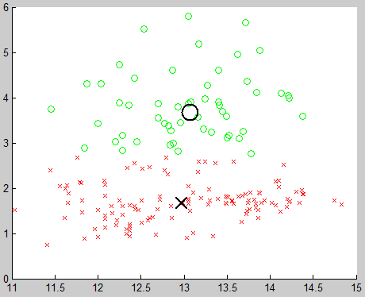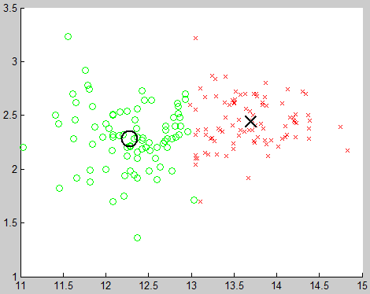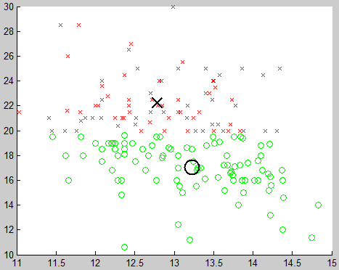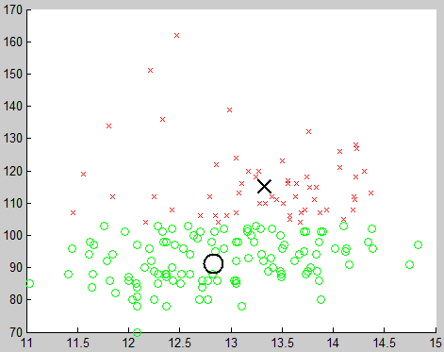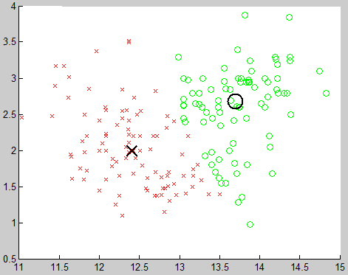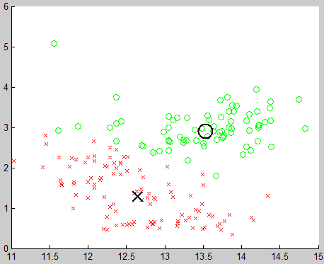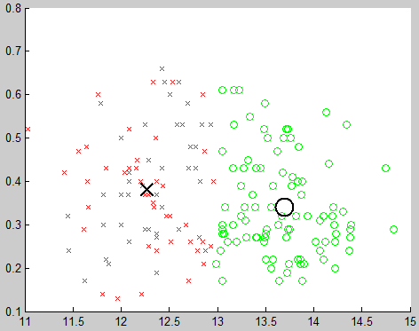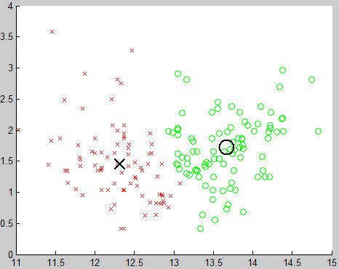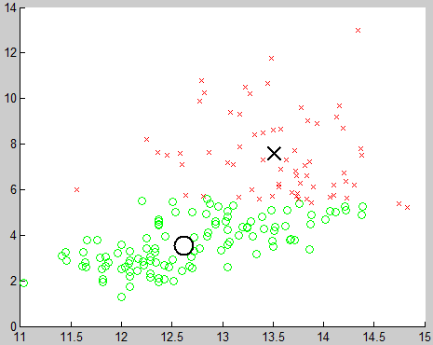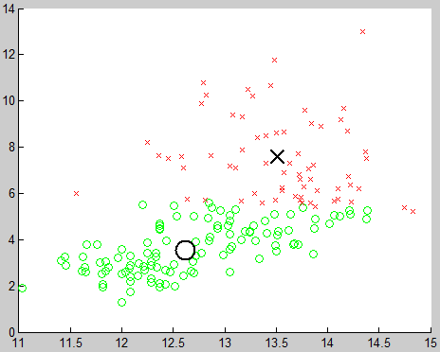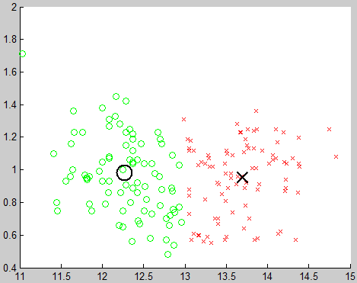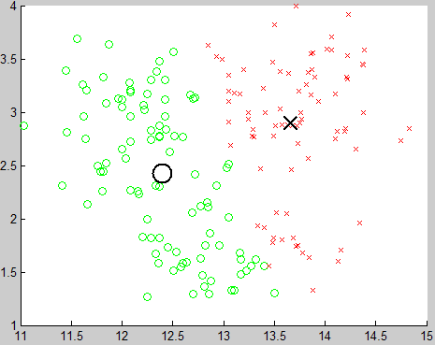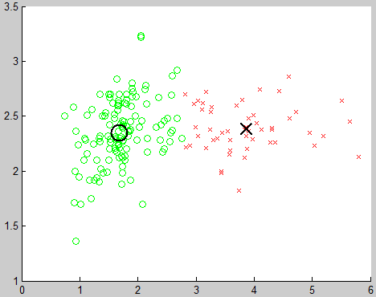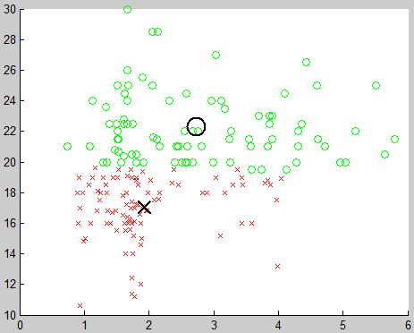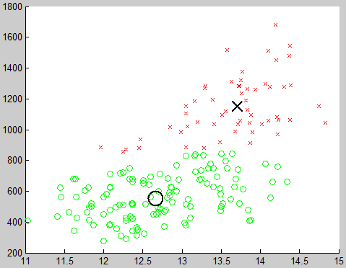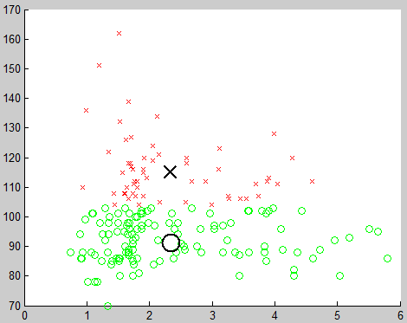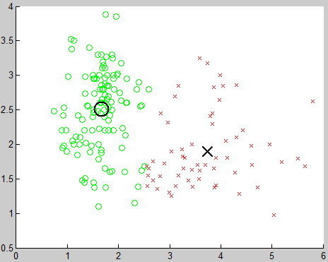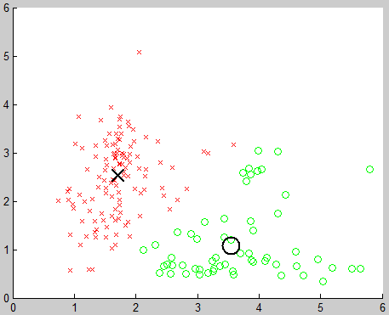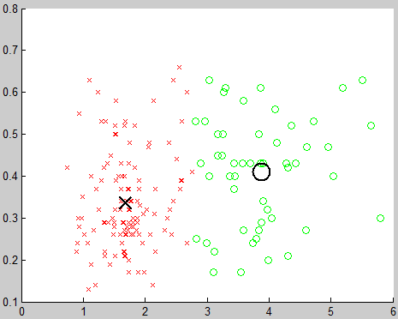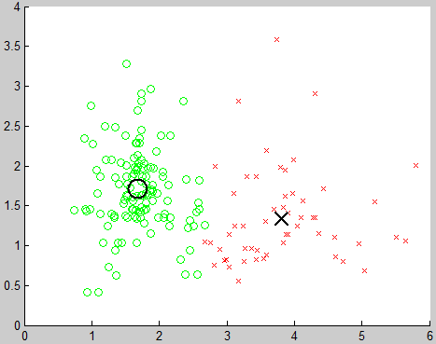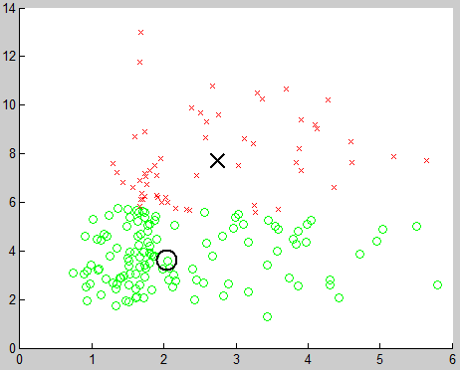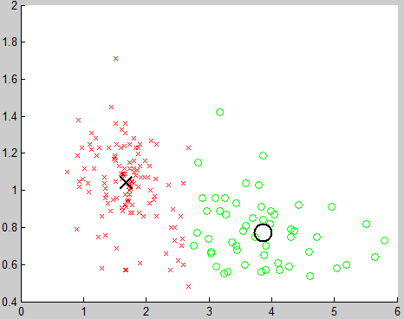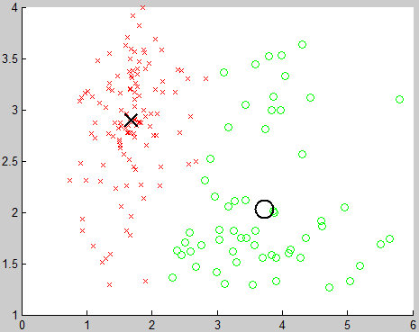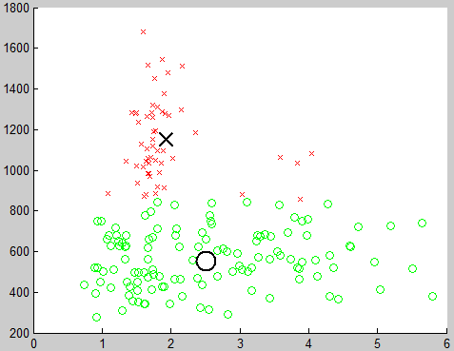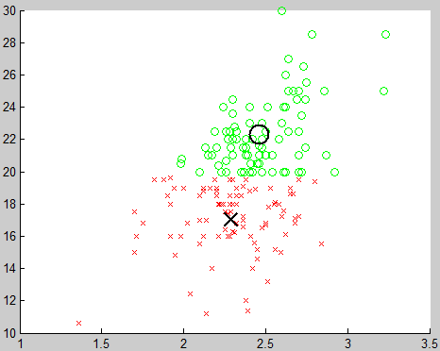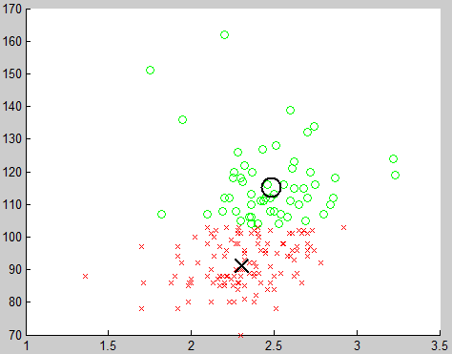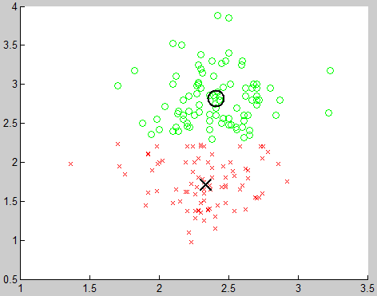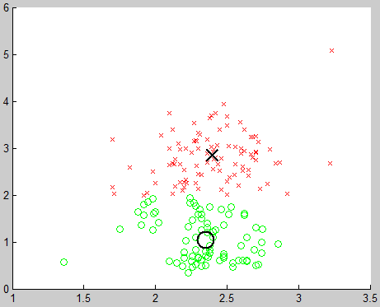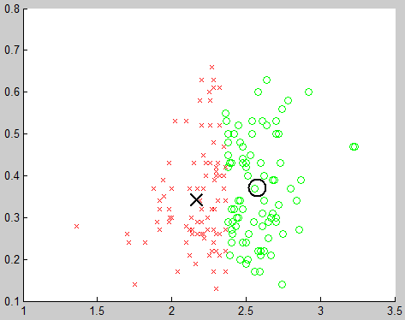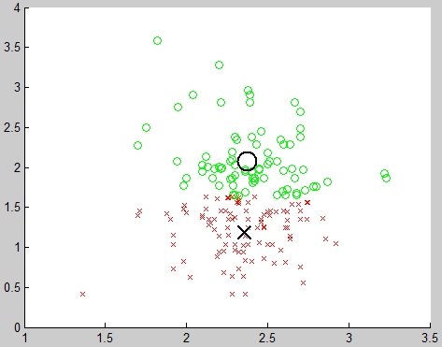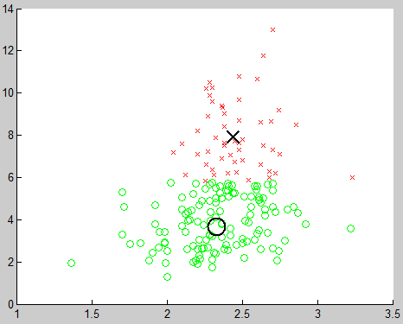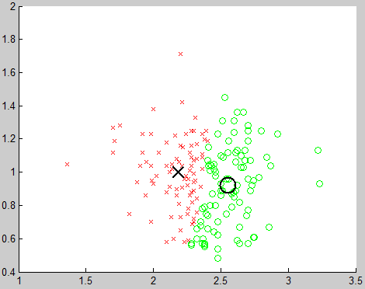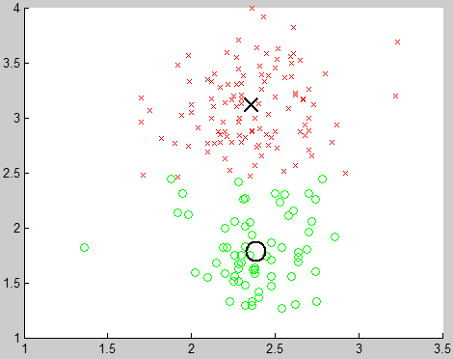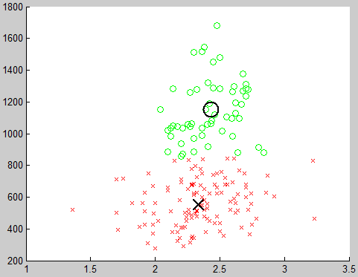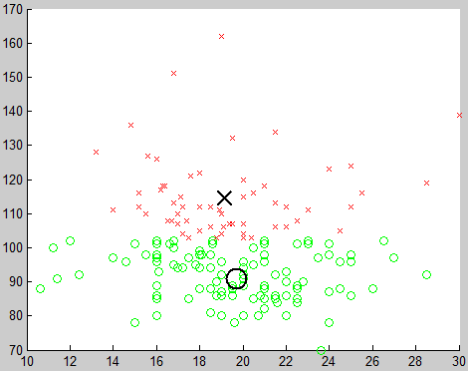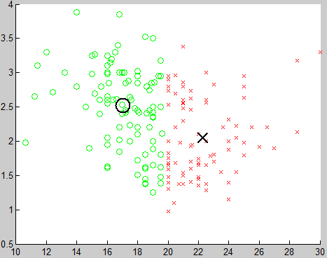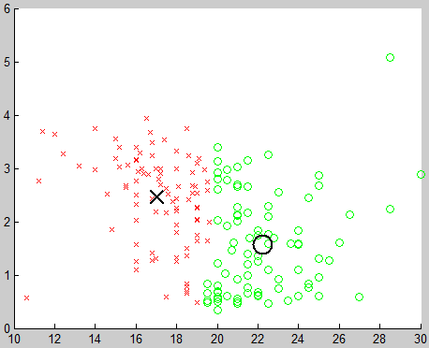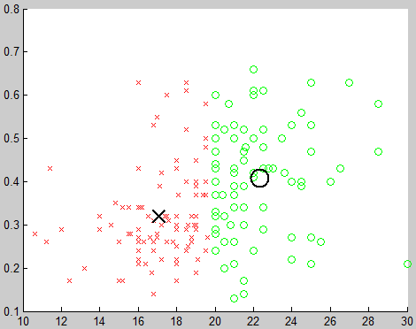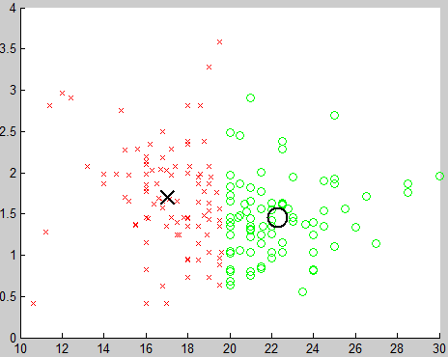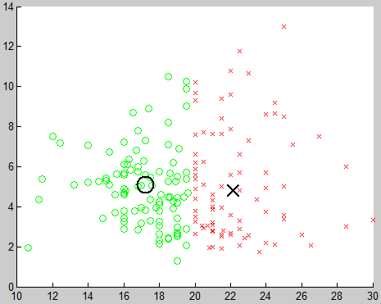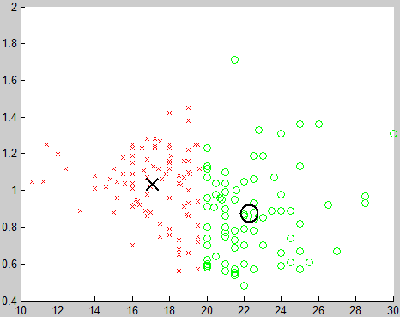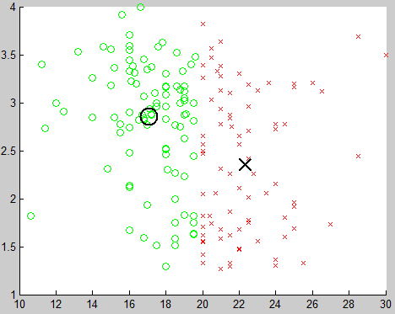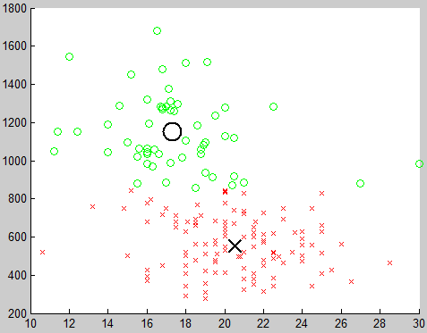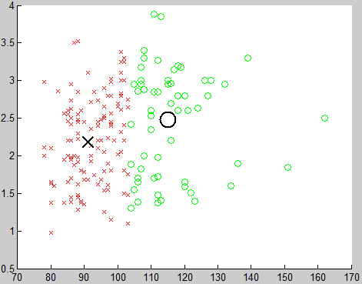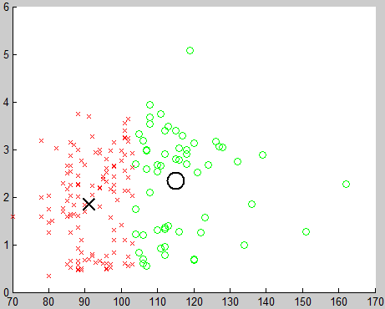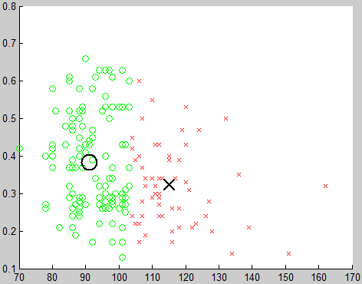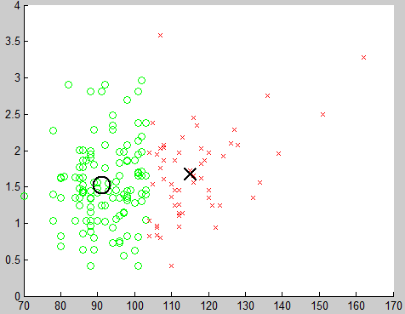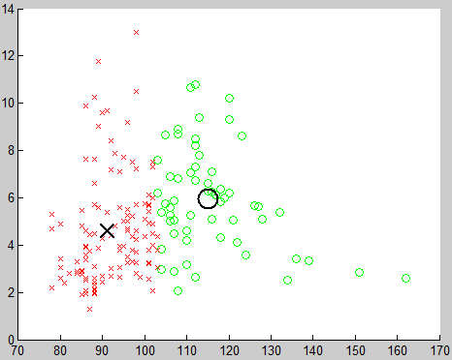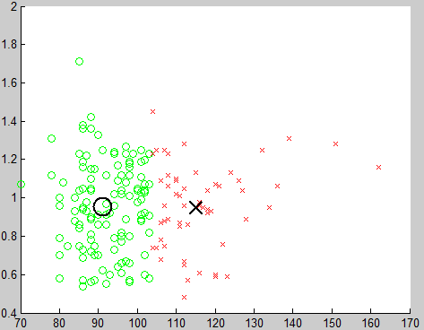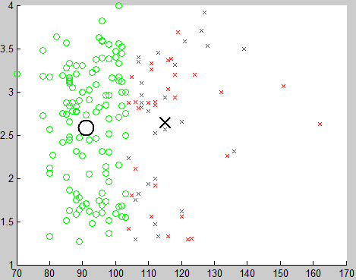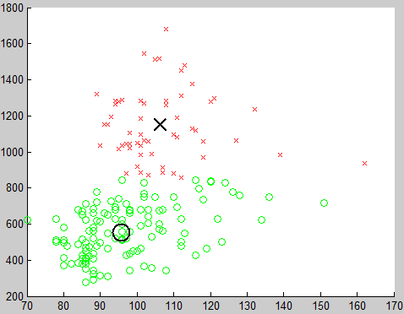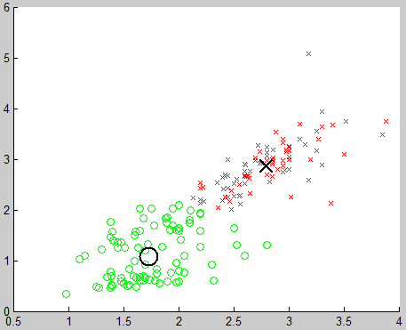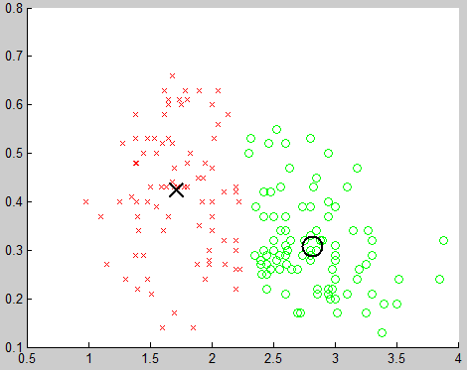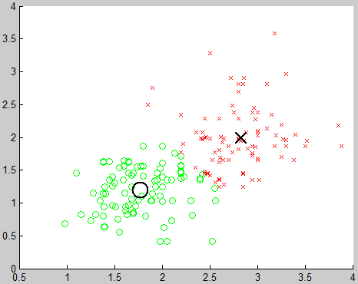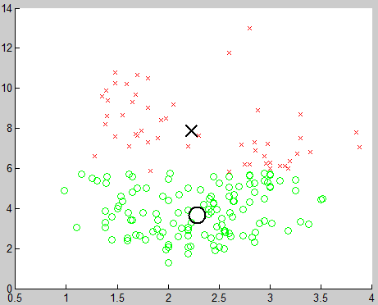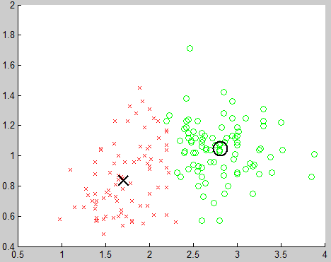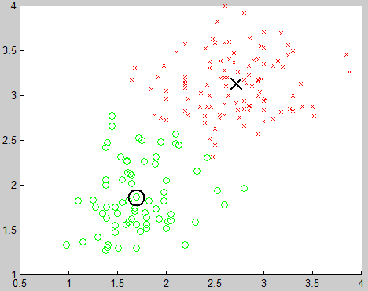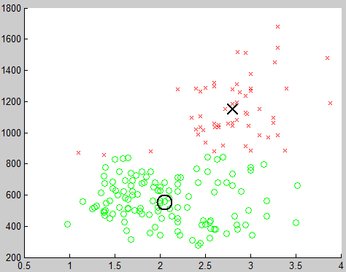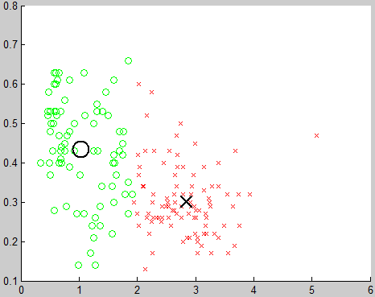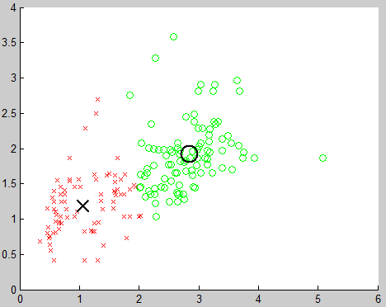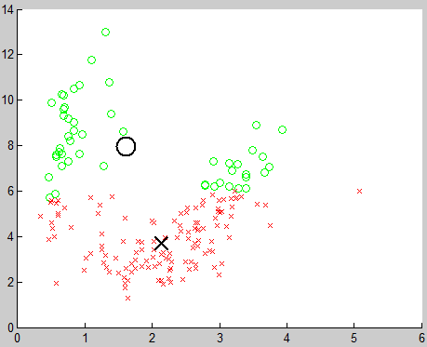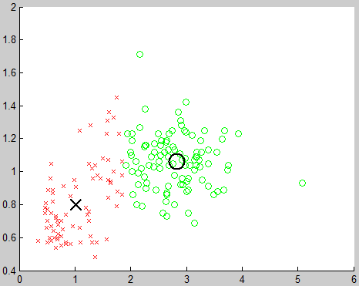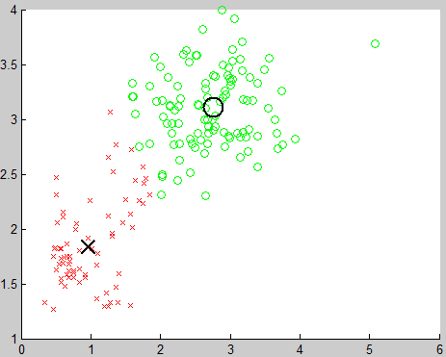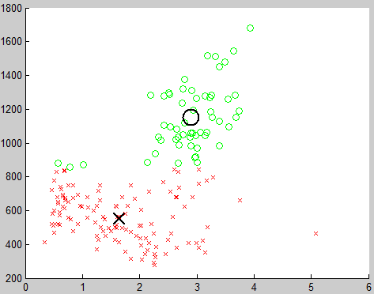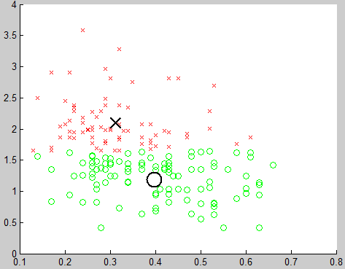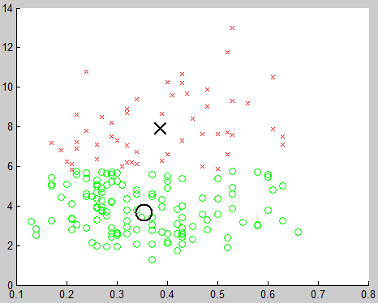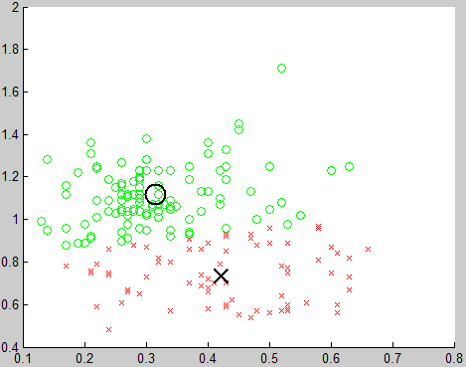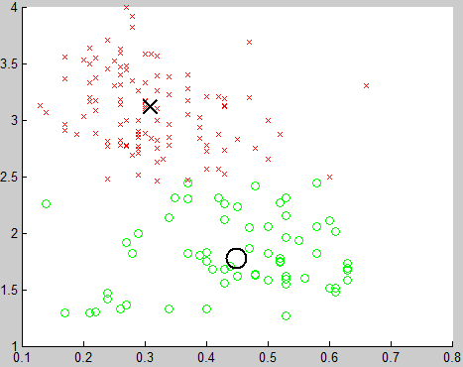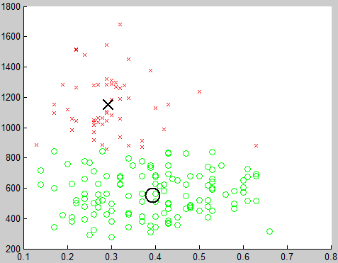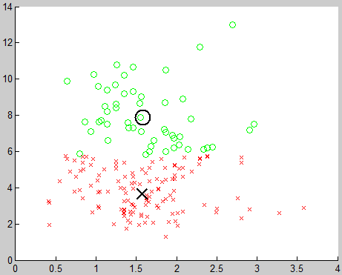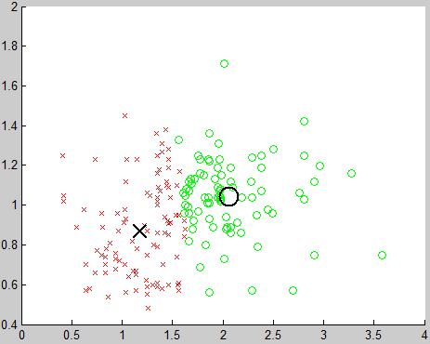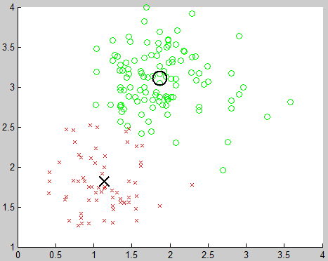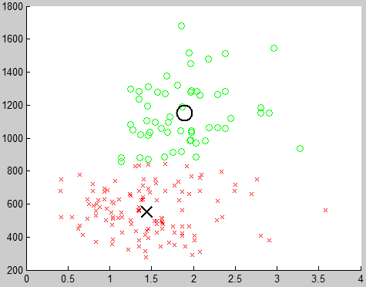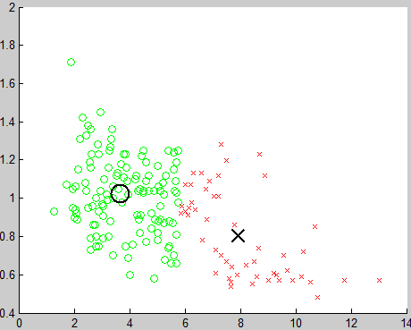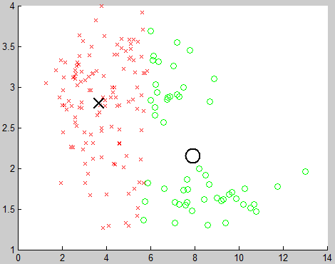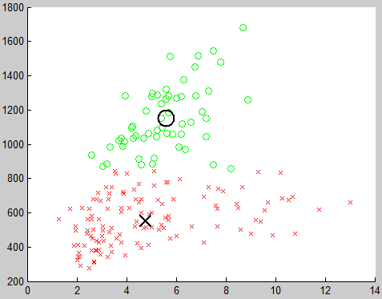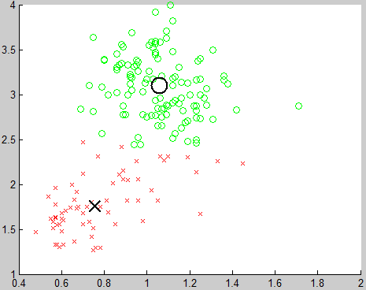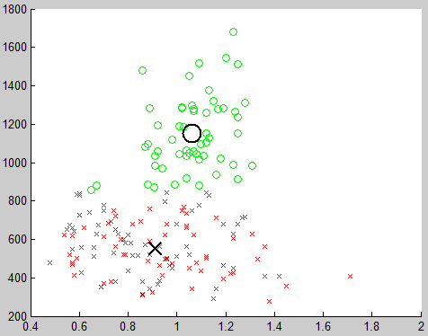

**Number of Cluster = 3**

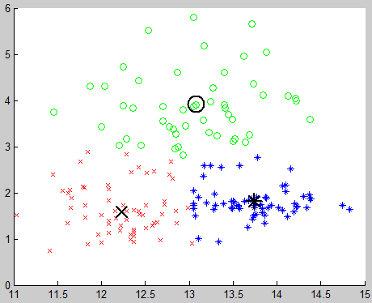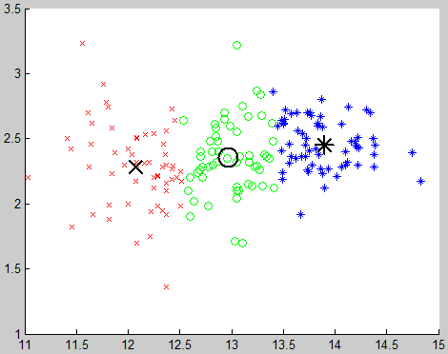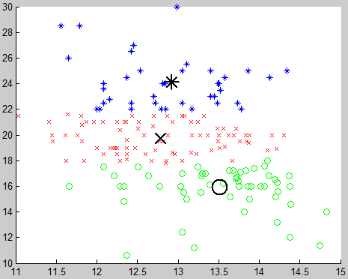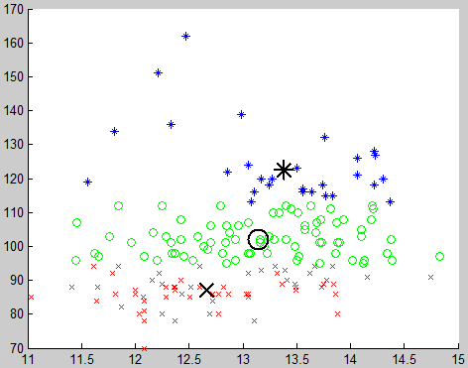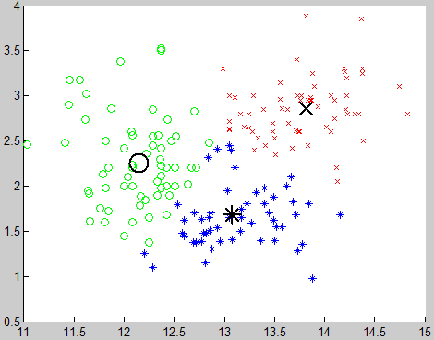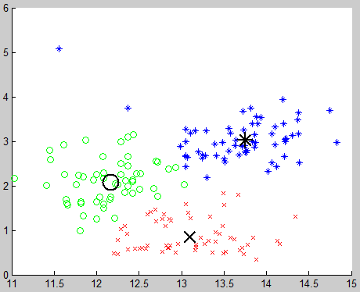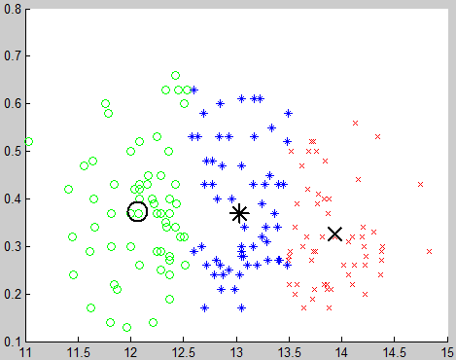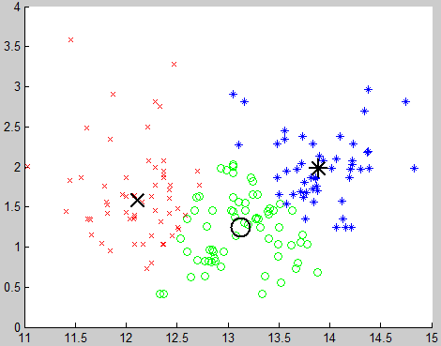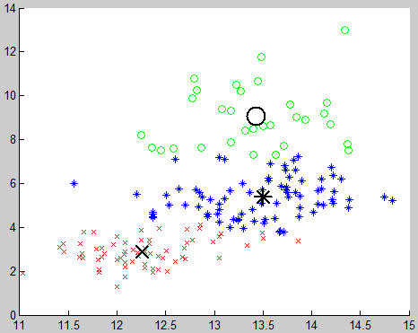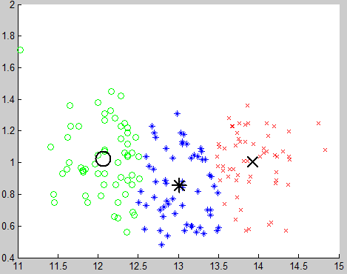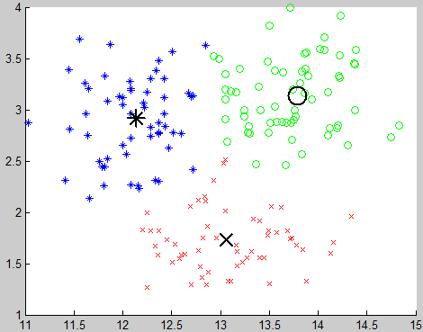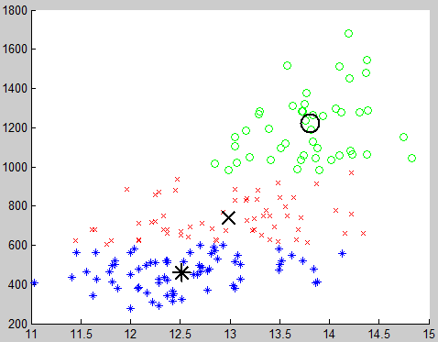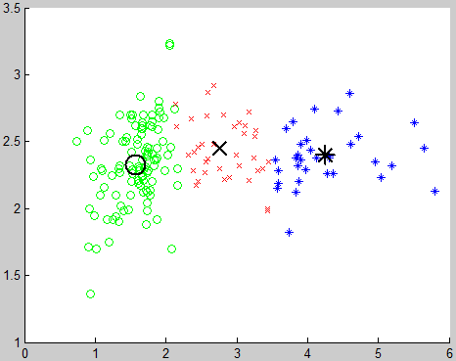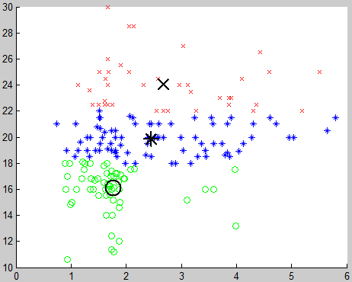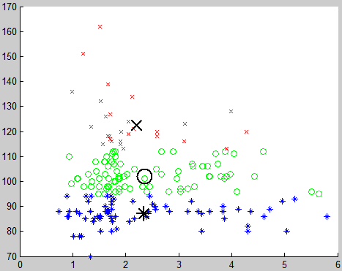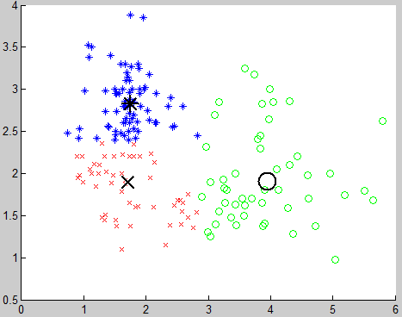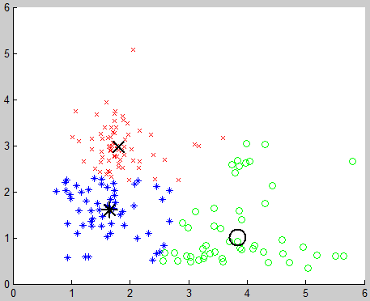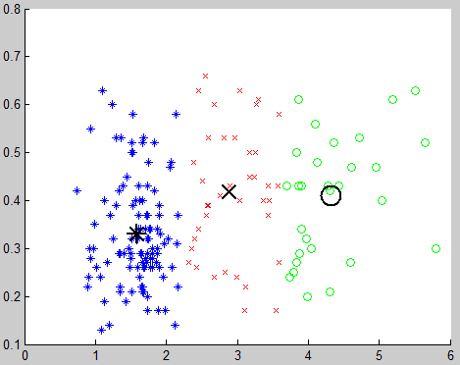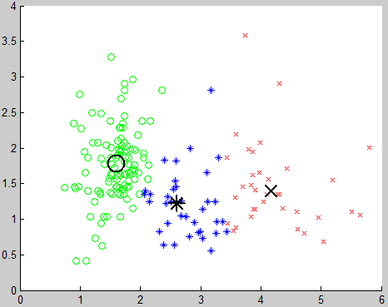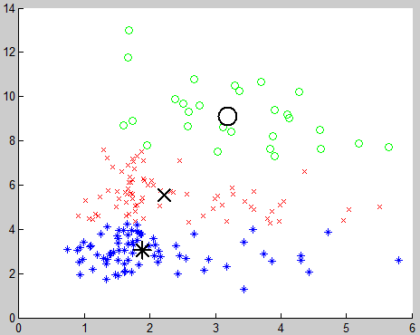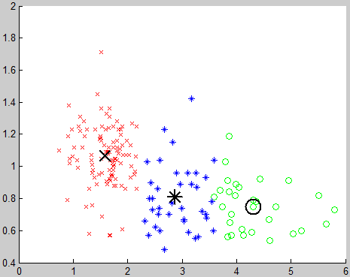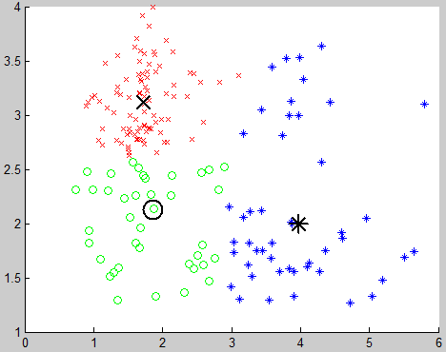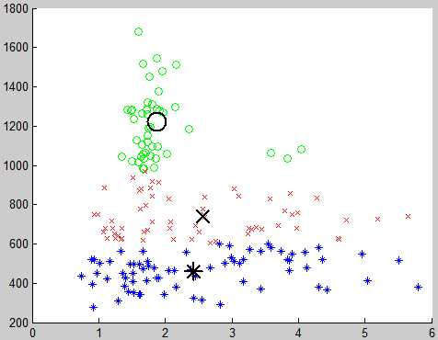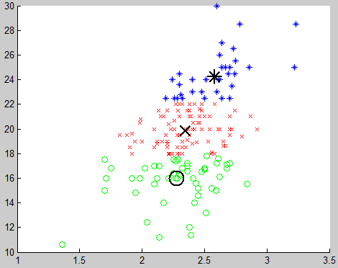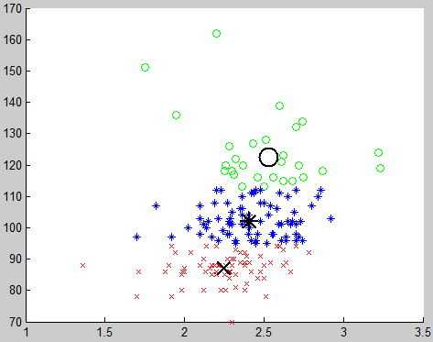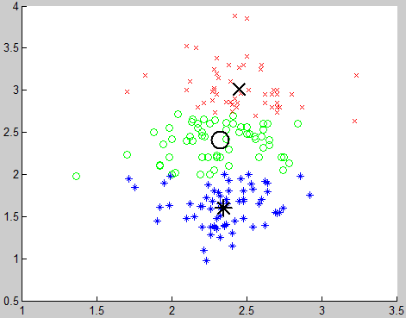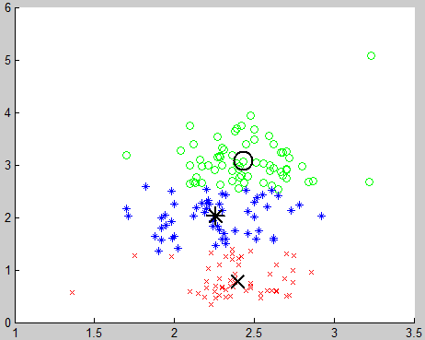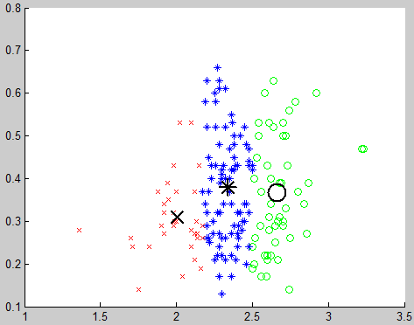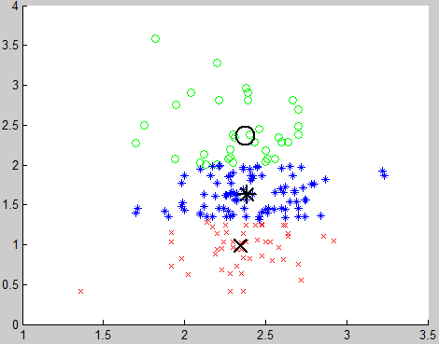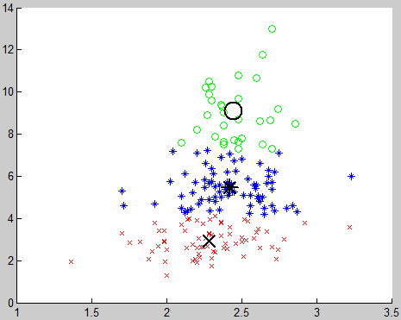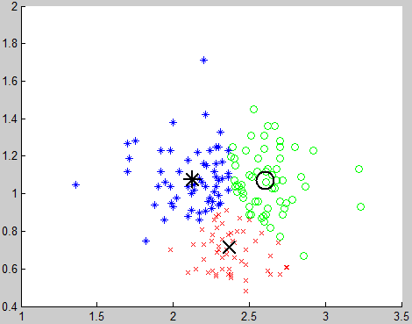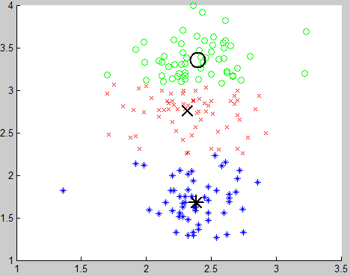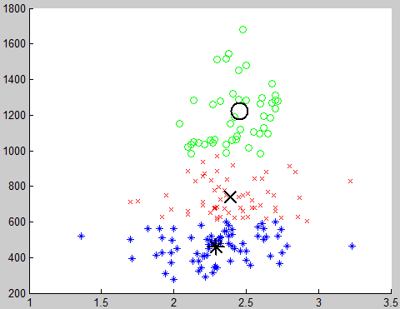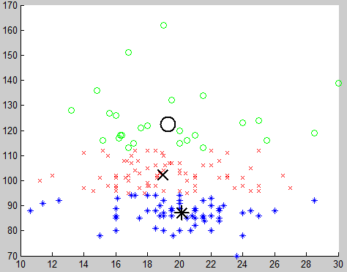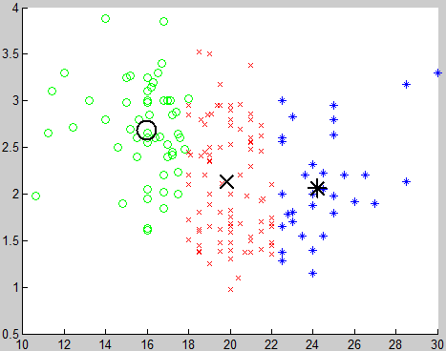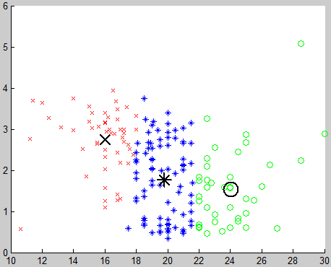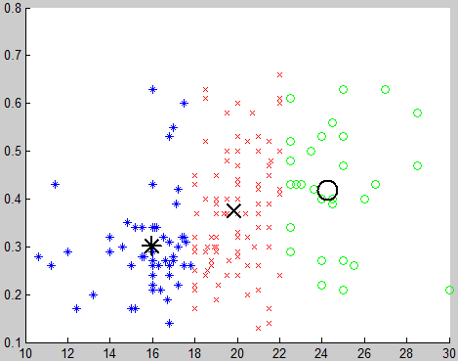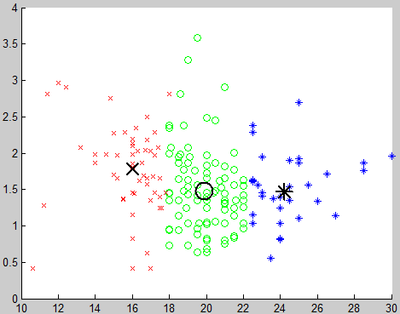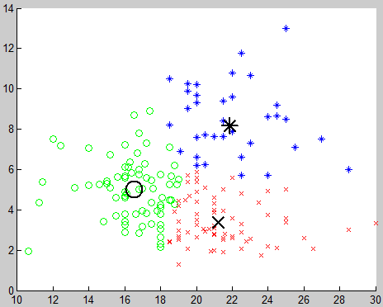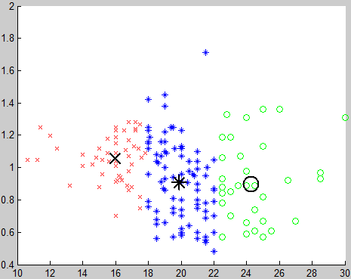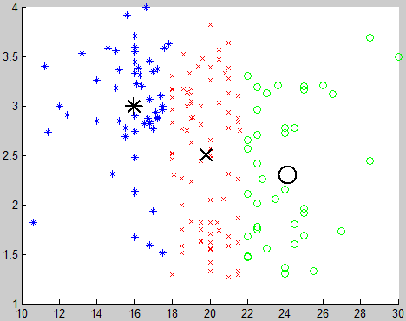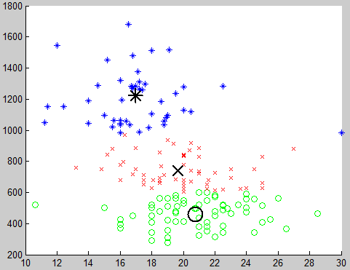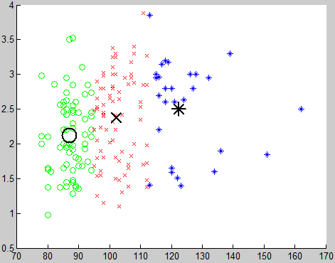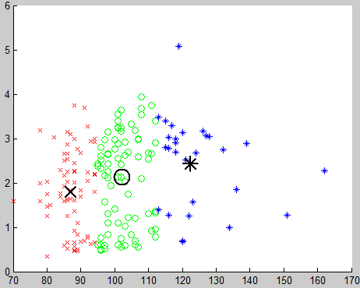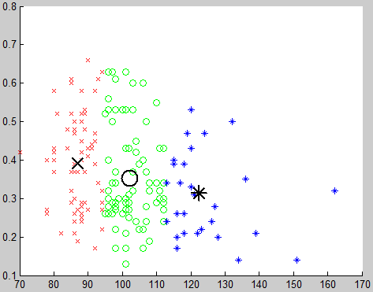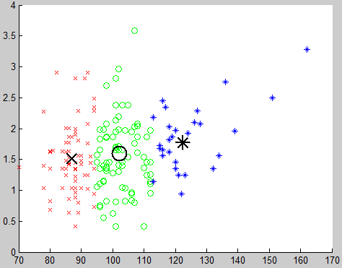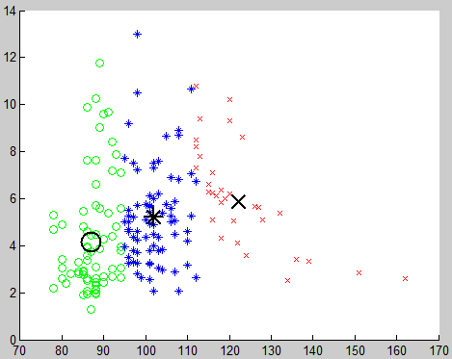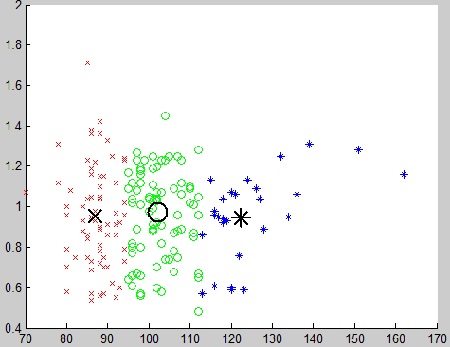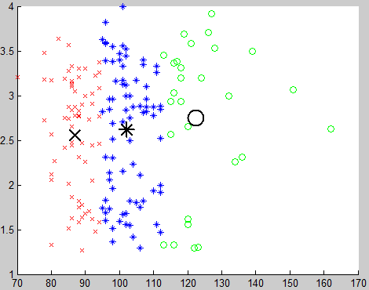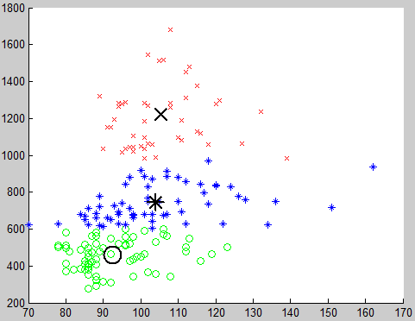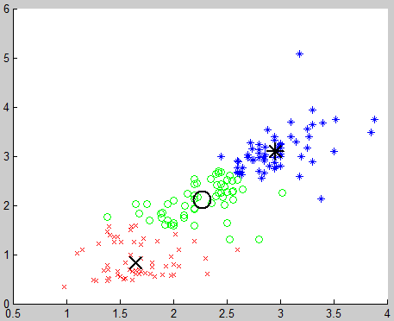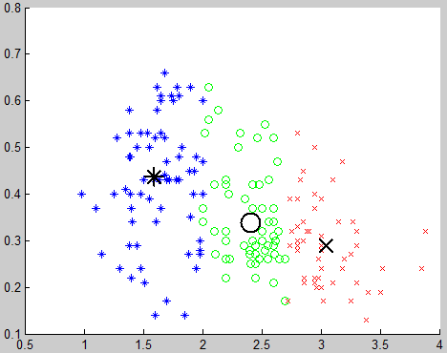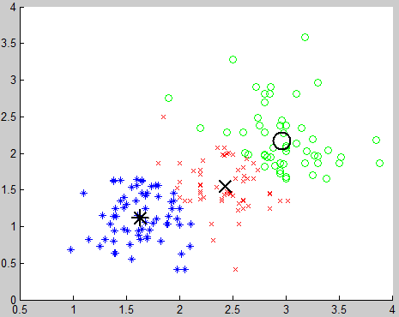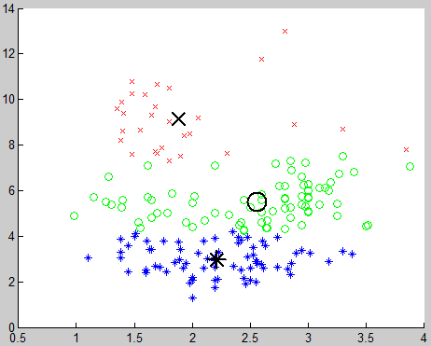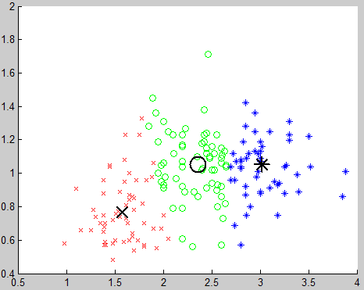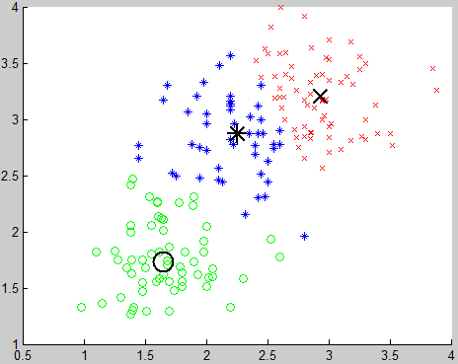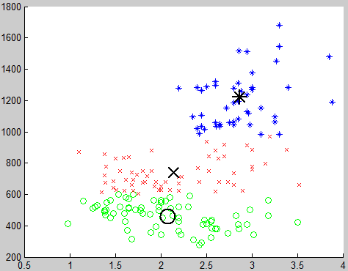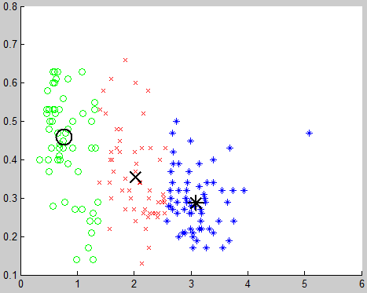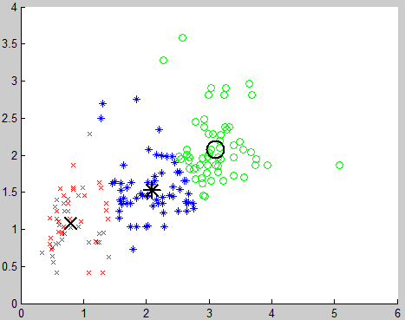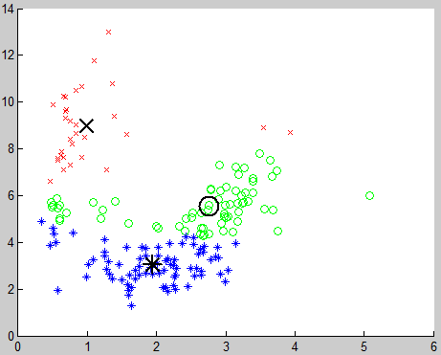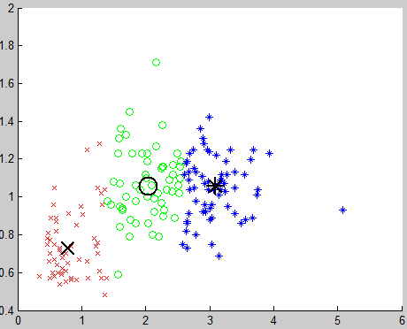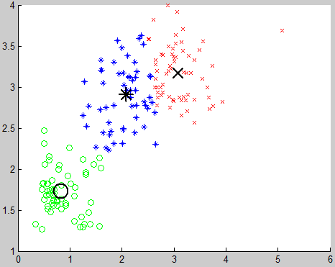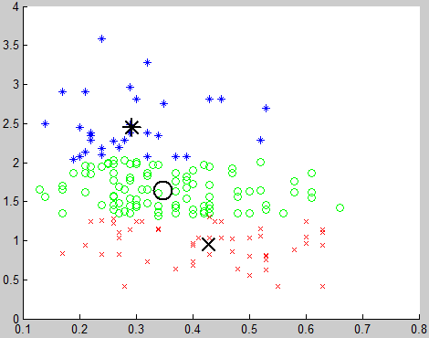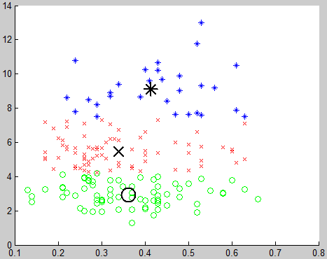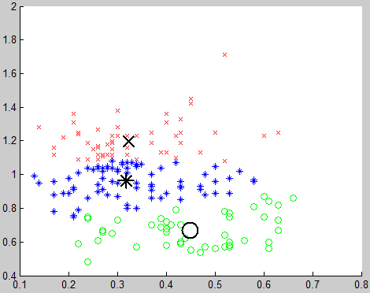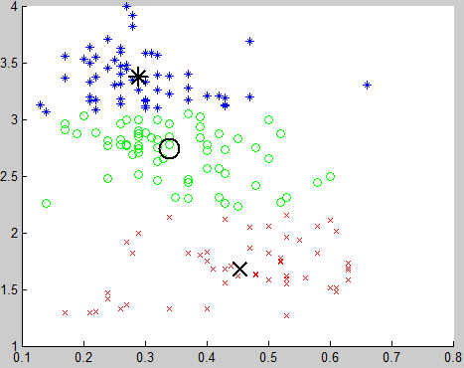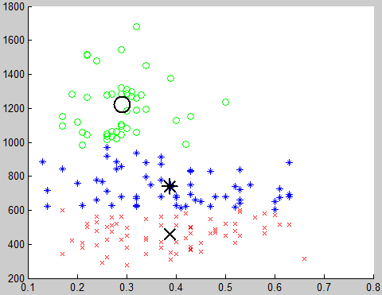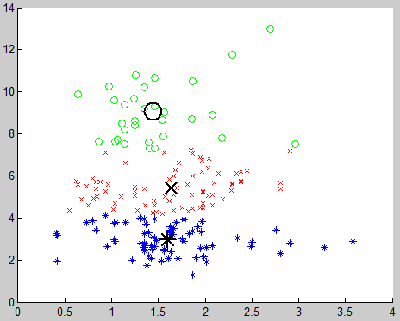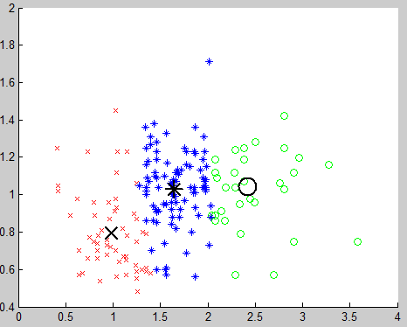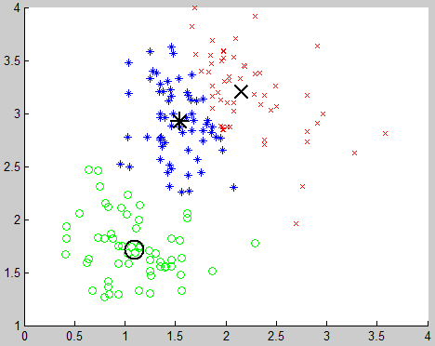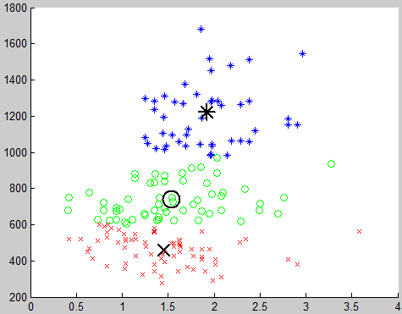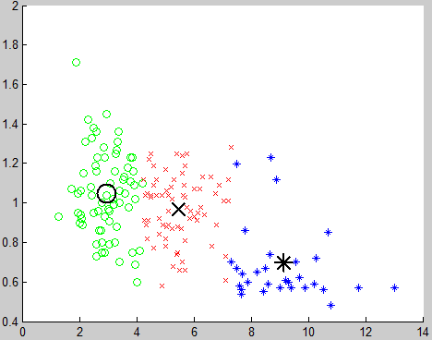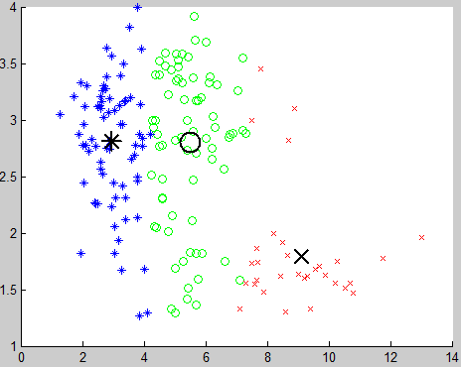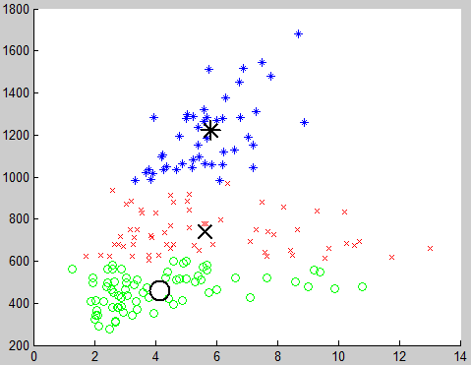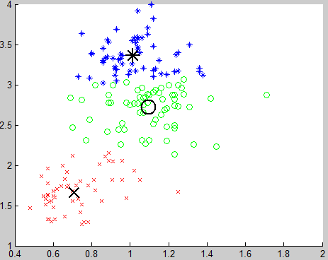

**Number of Cluster = 4**

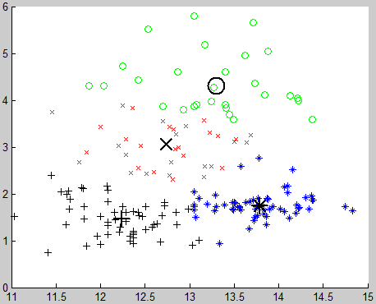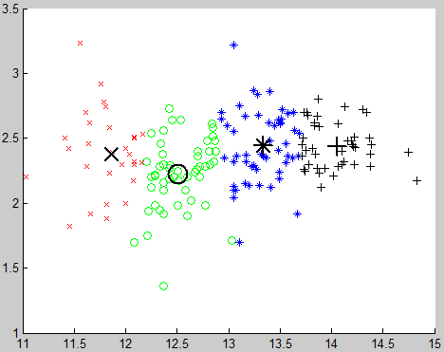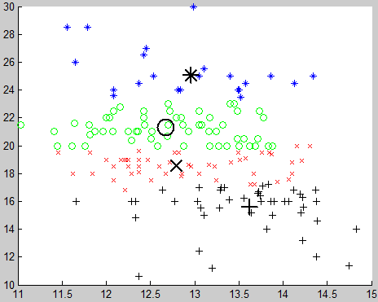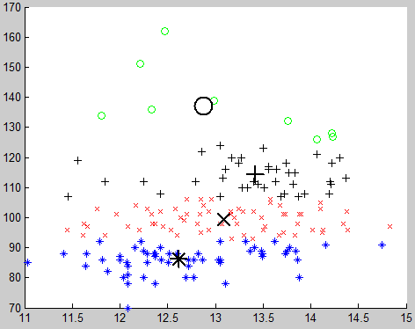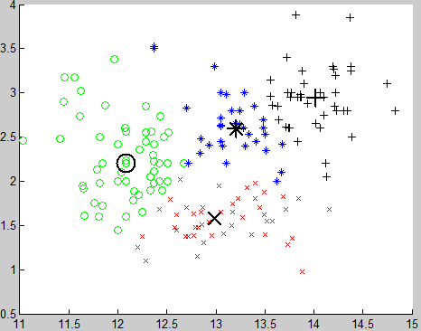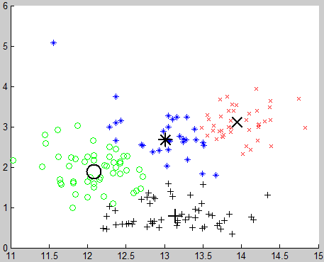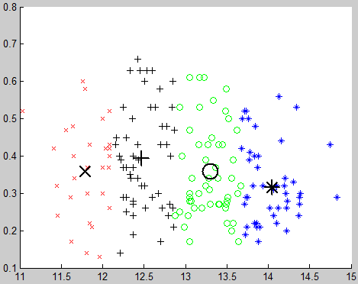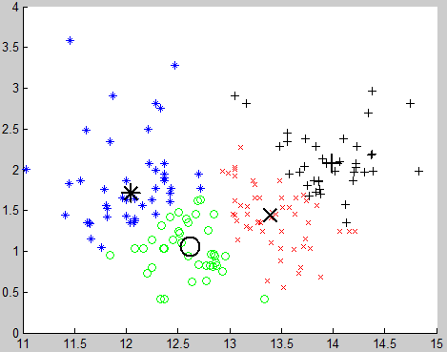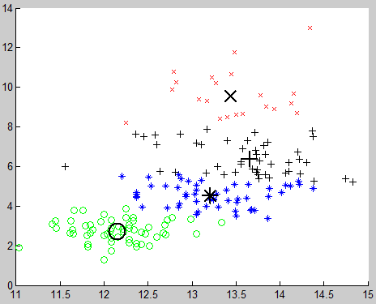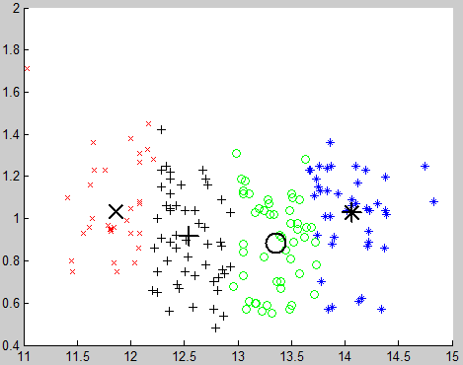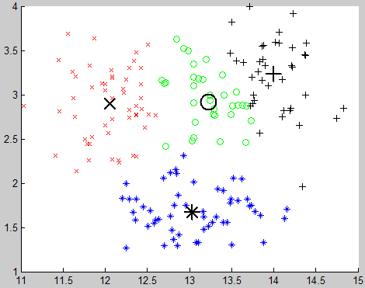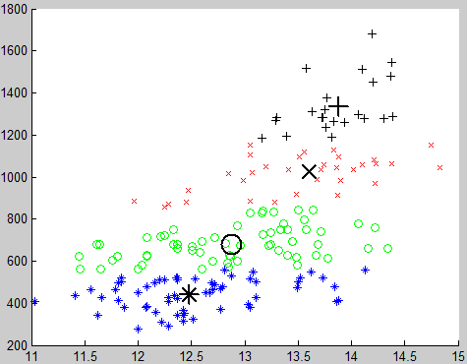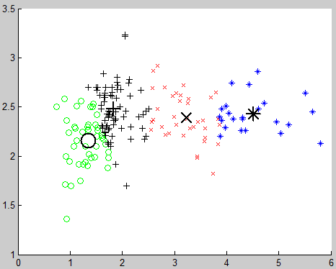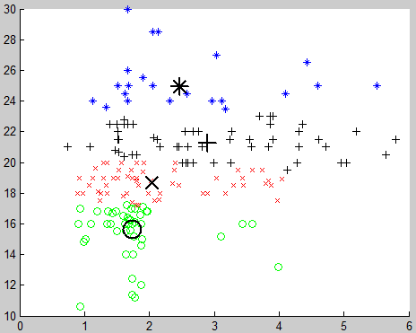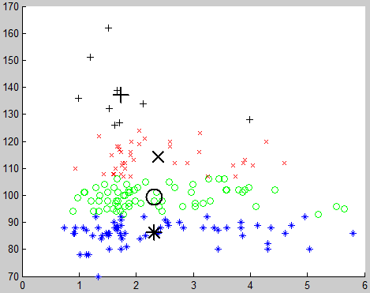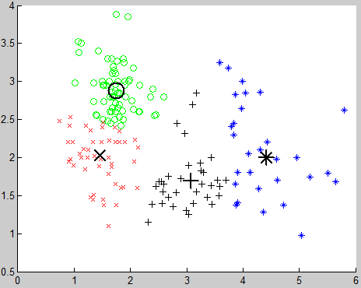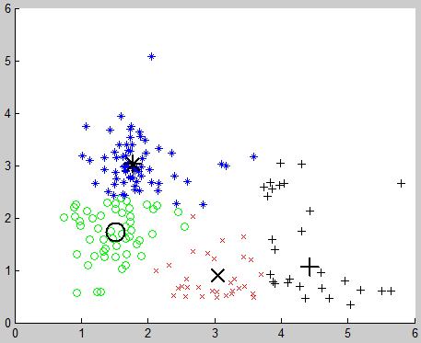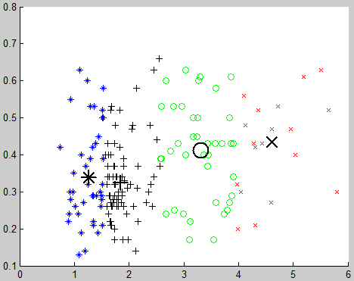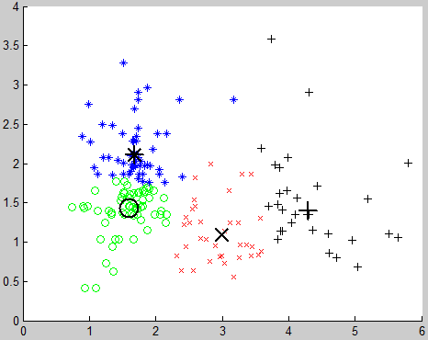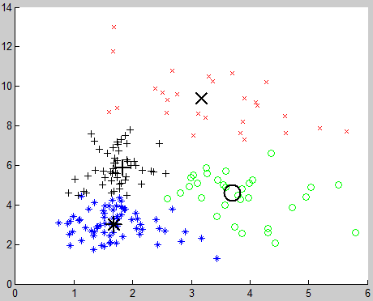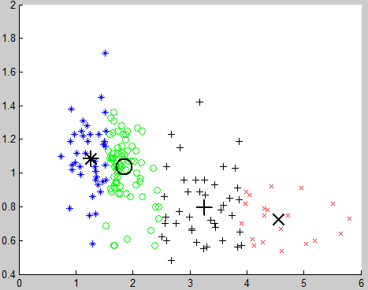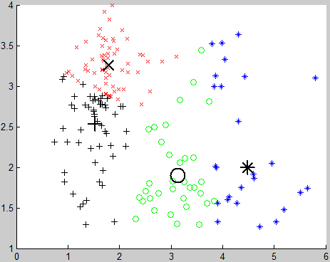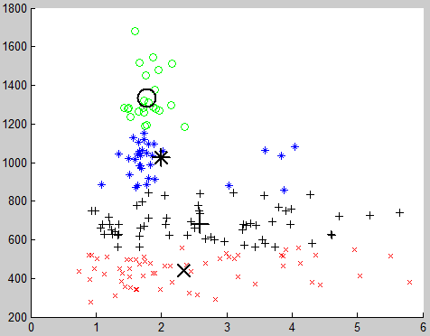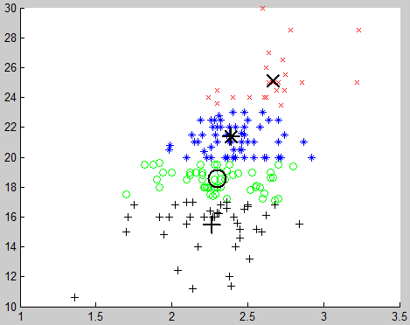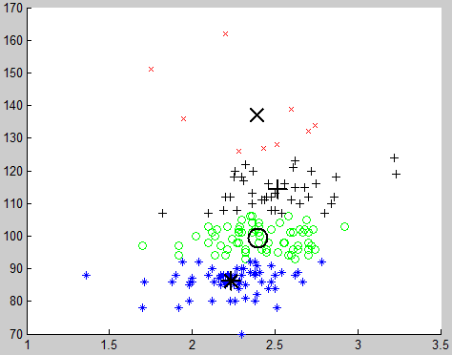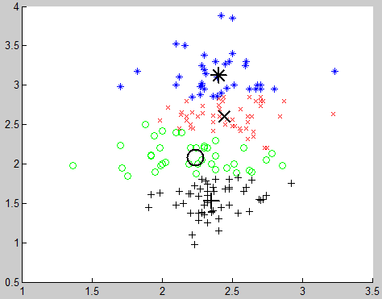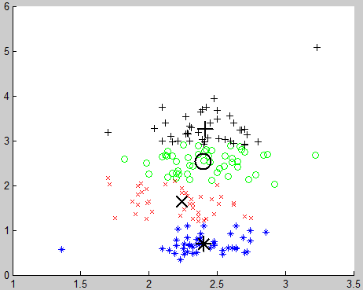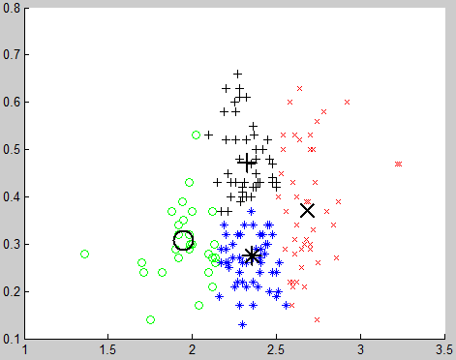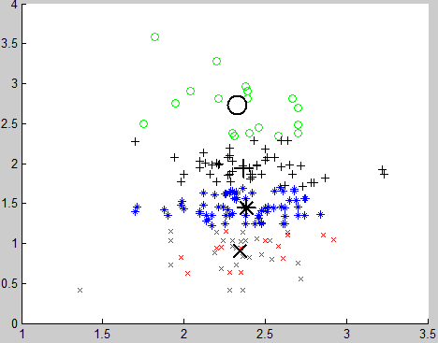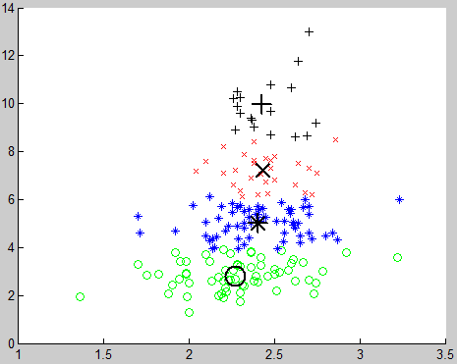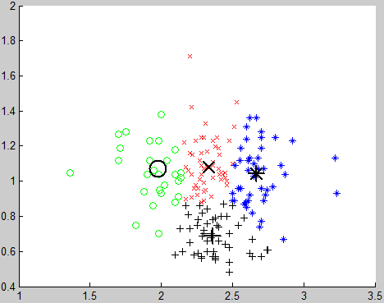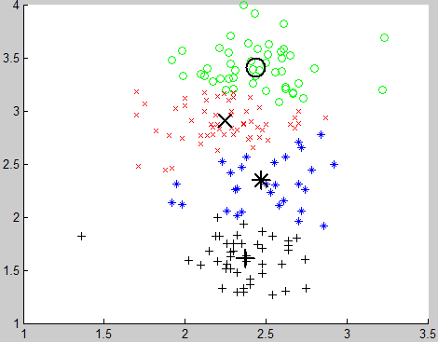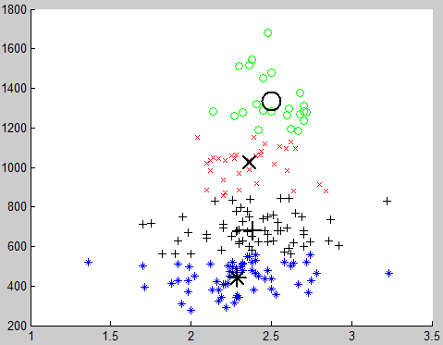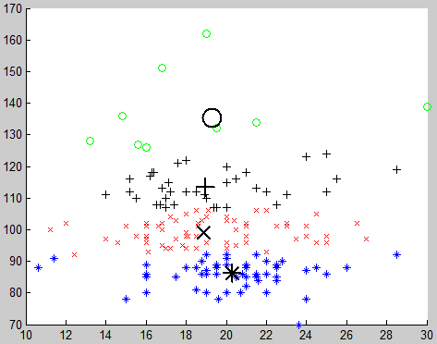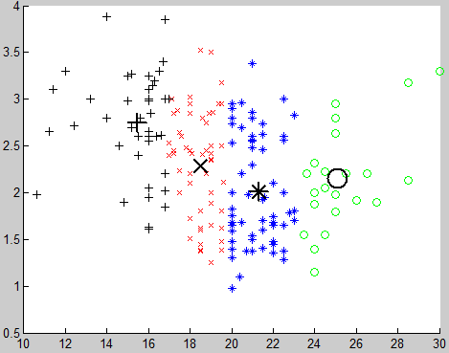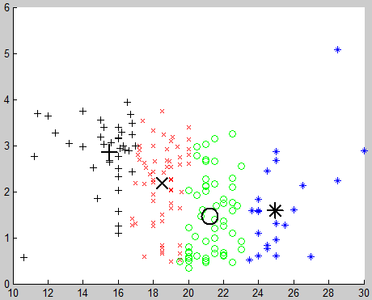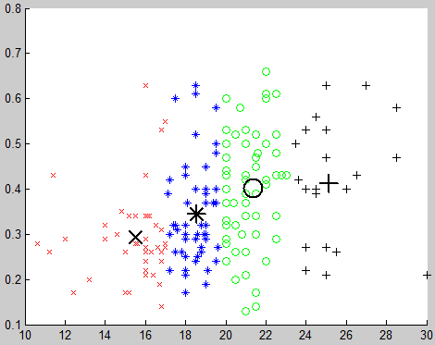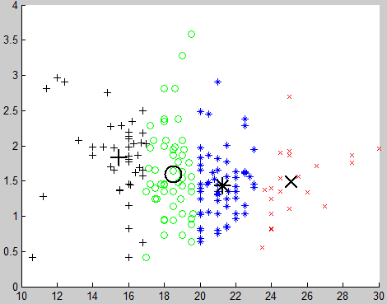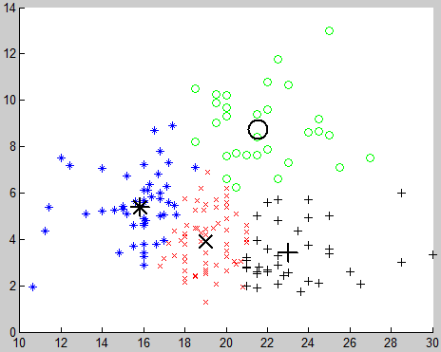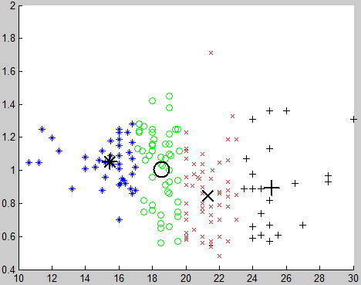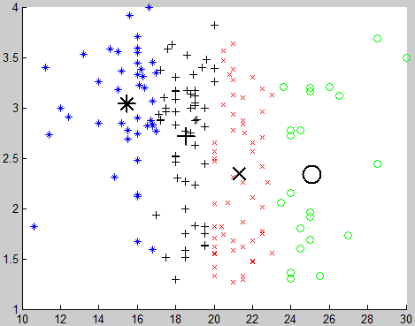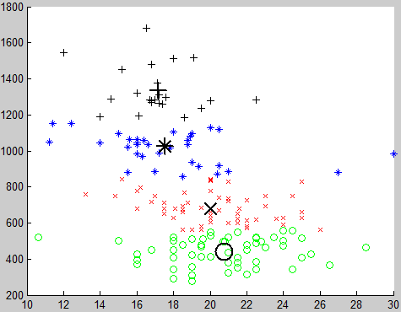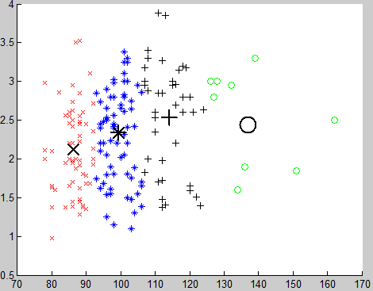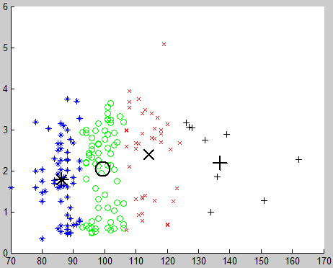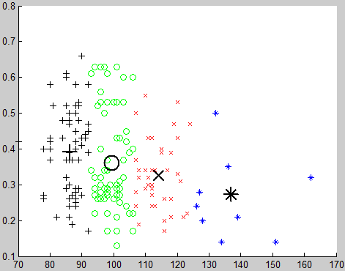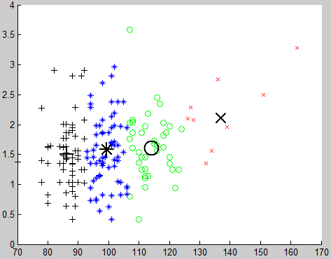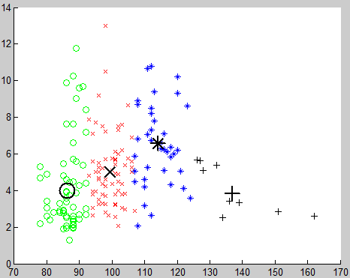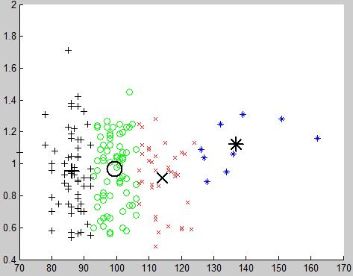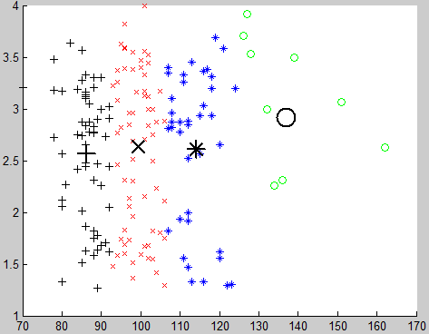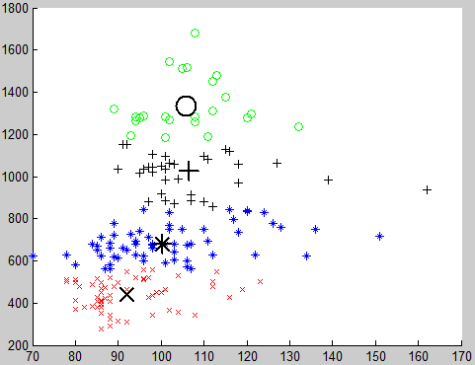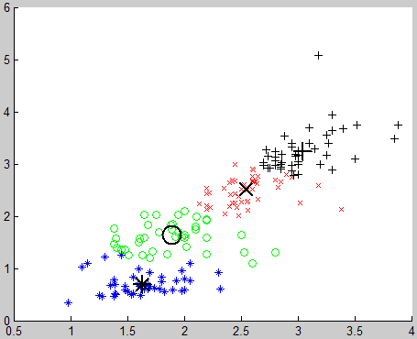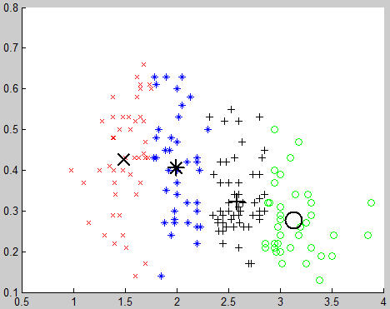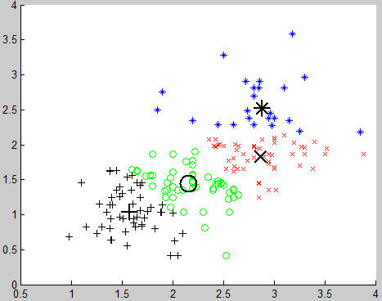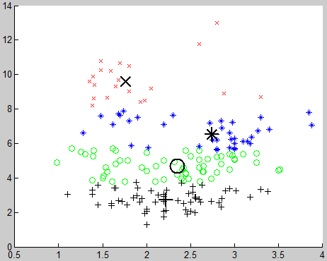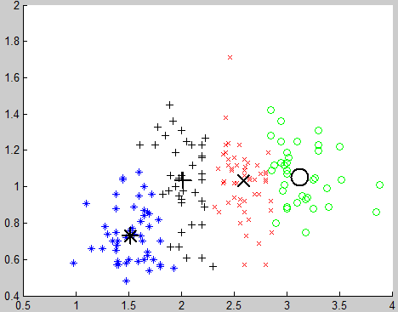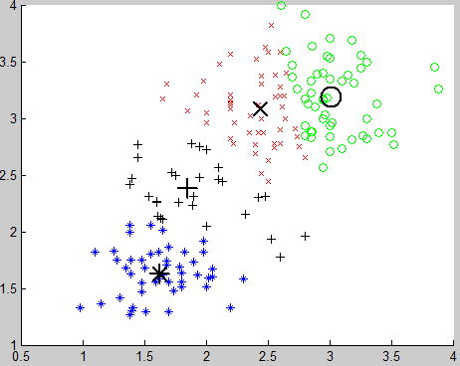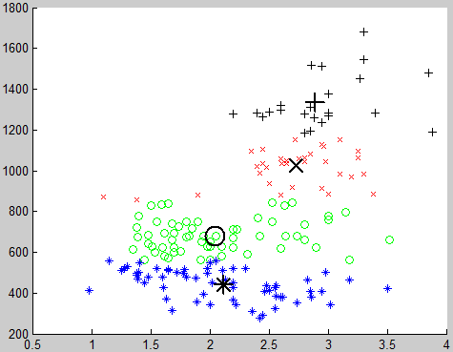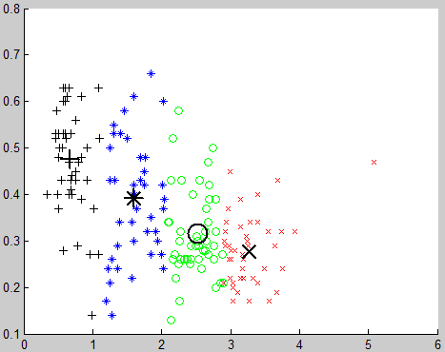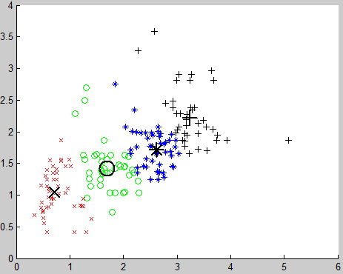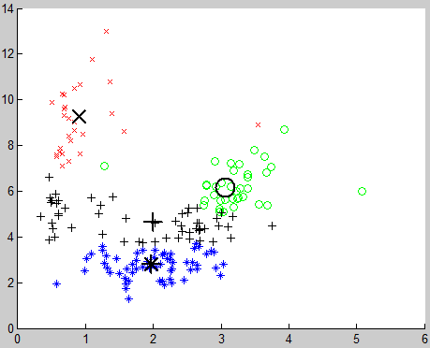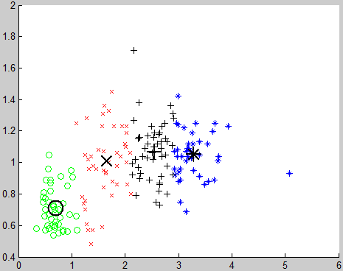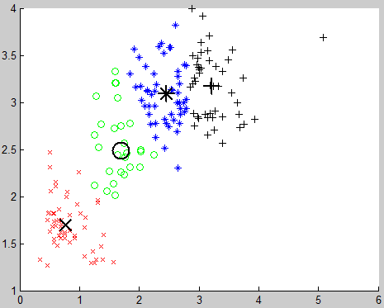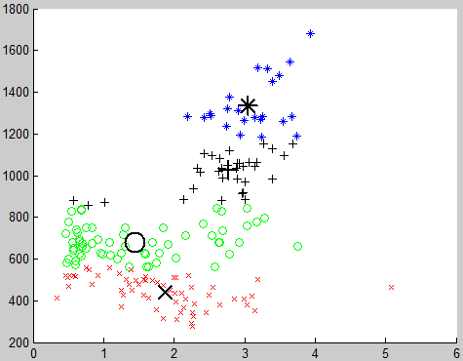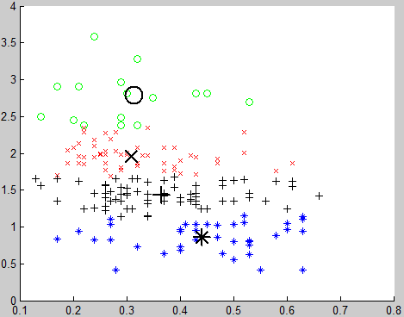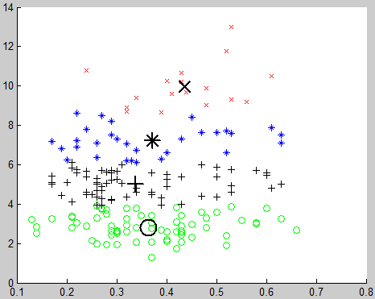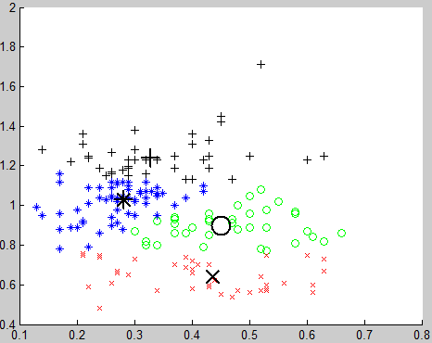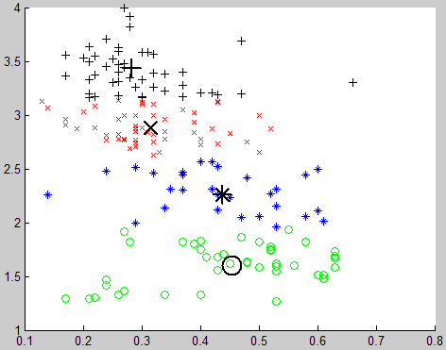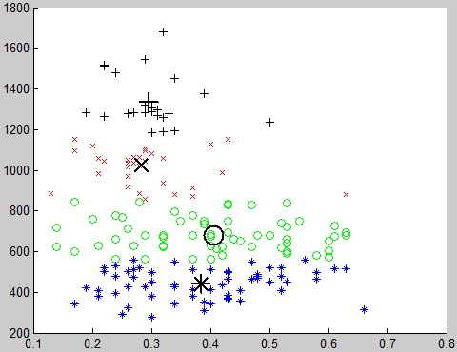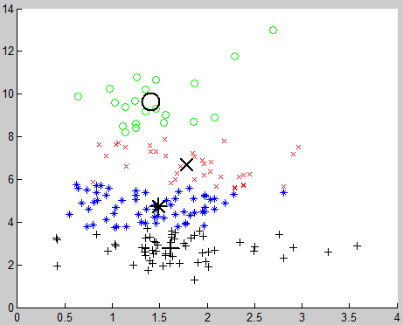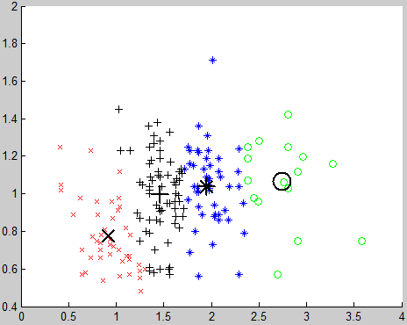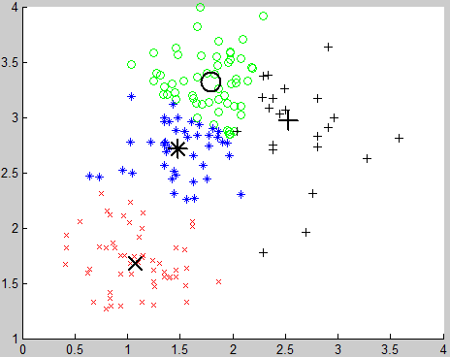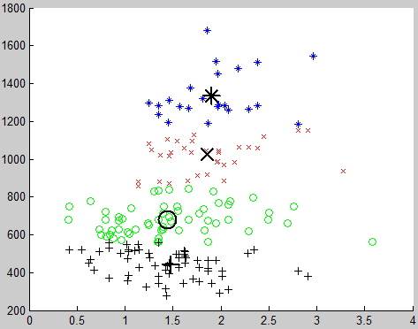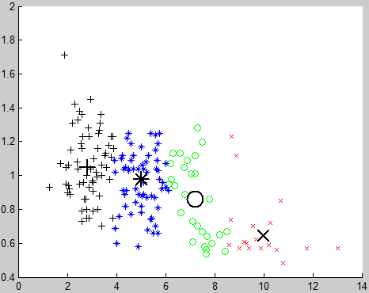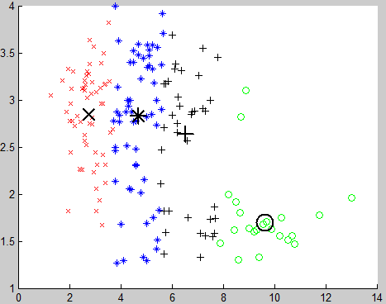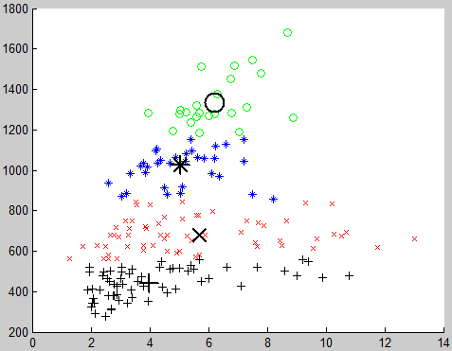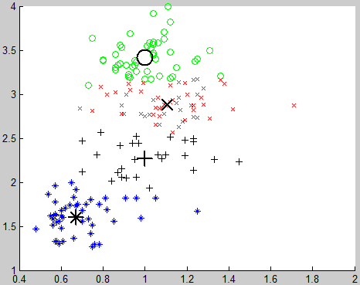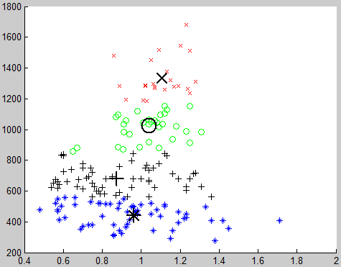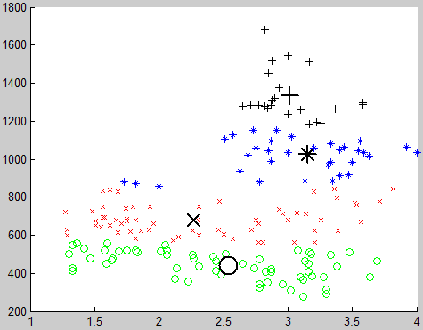

**Number of Cluster = 5**

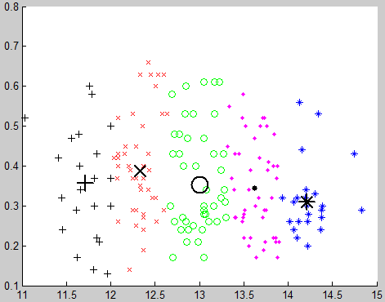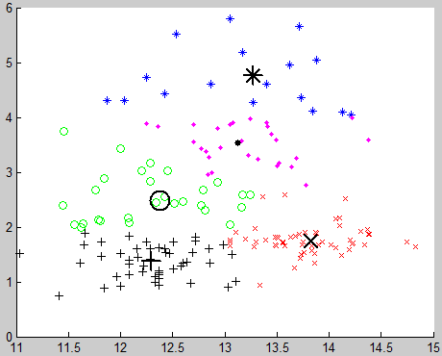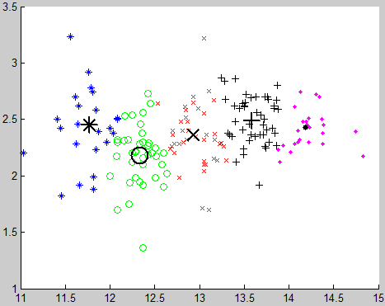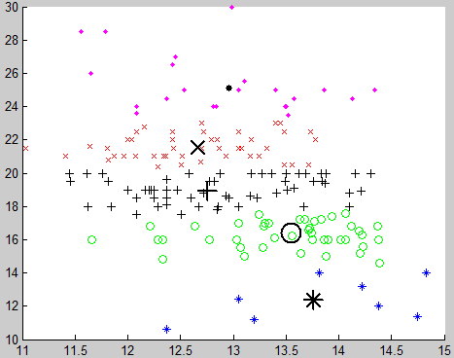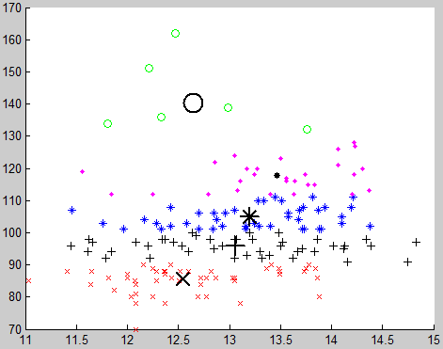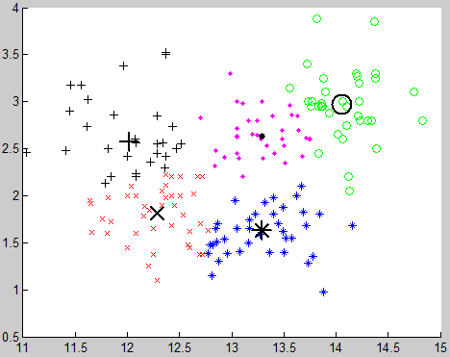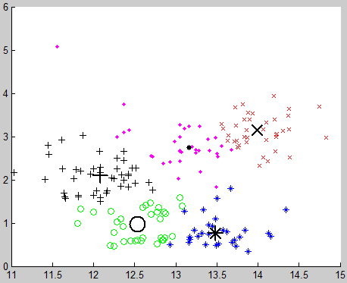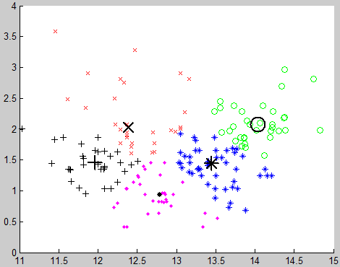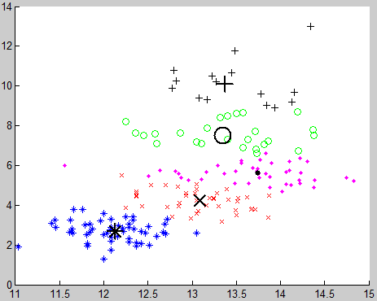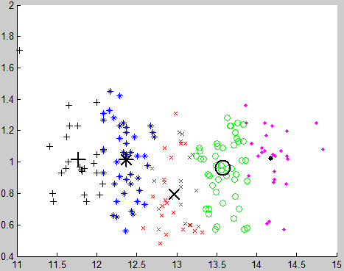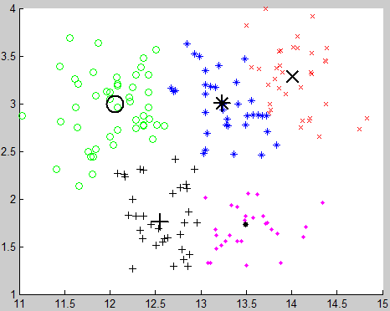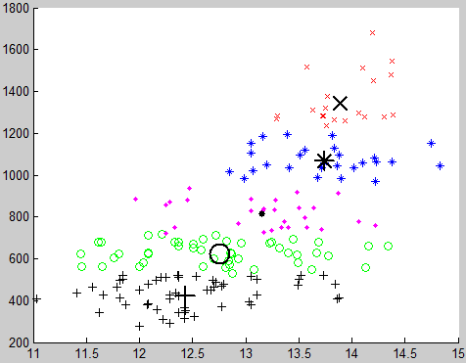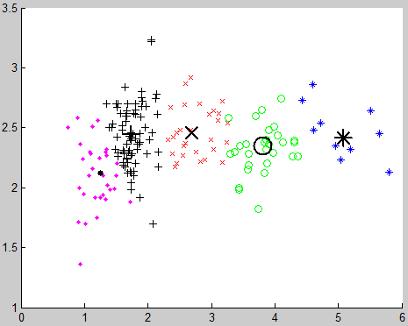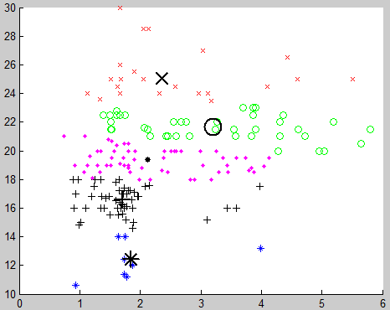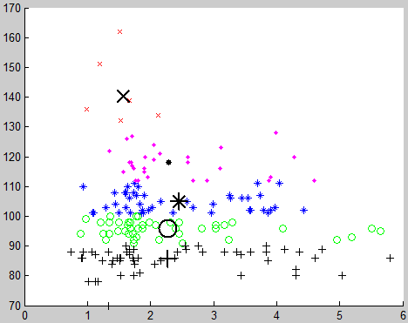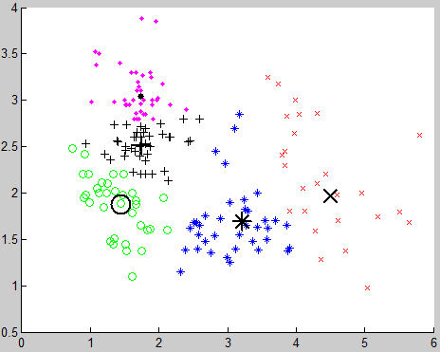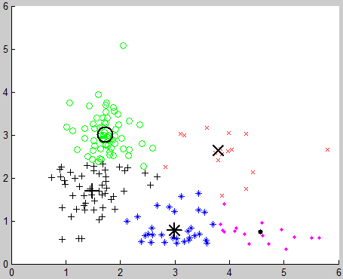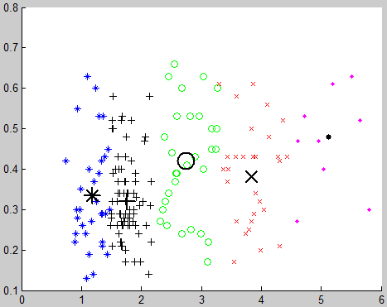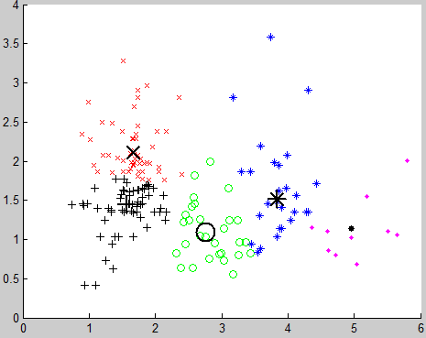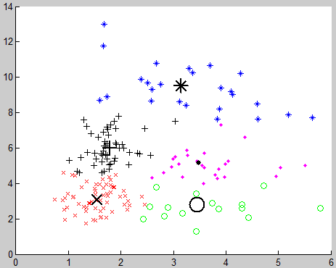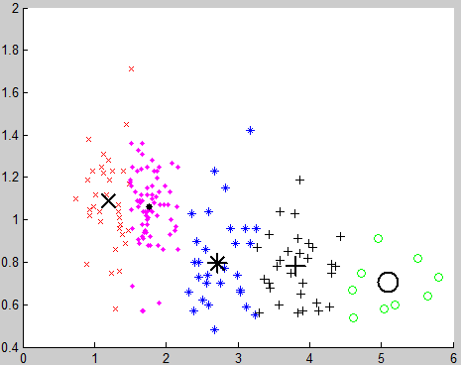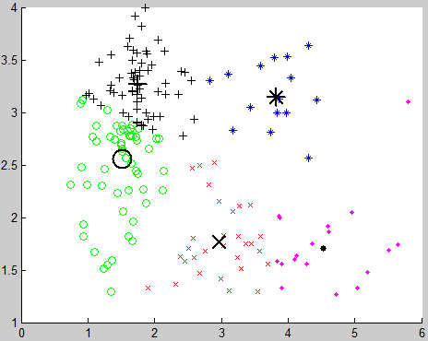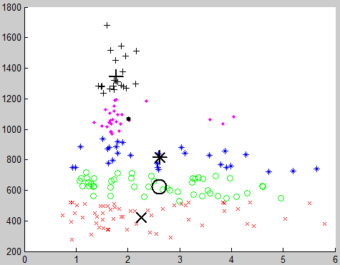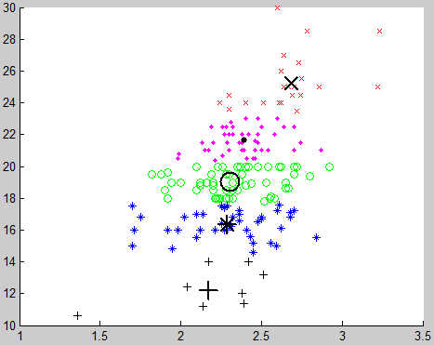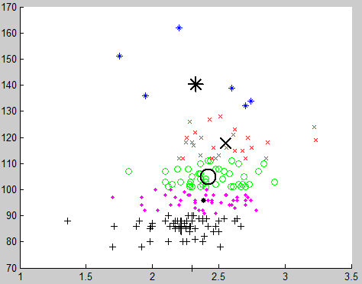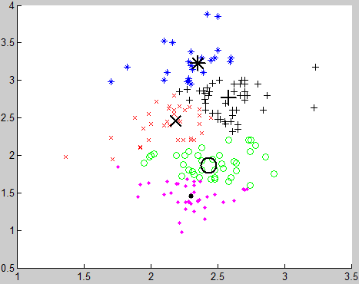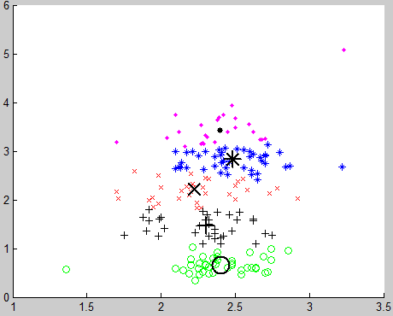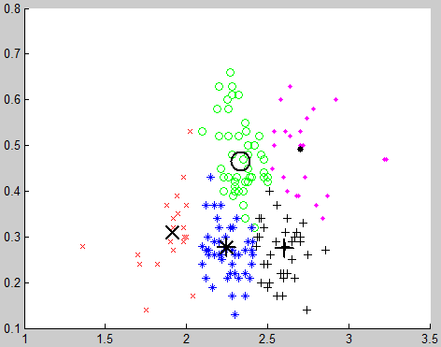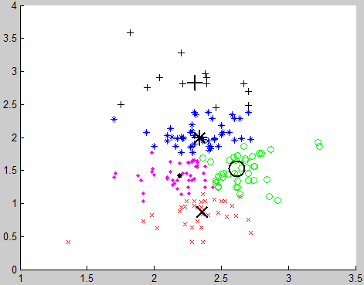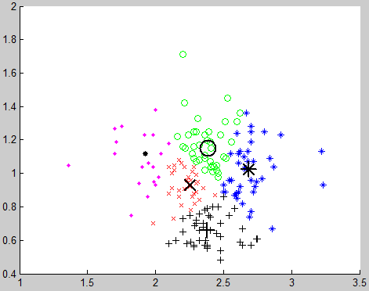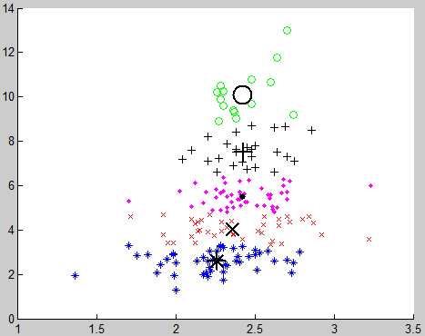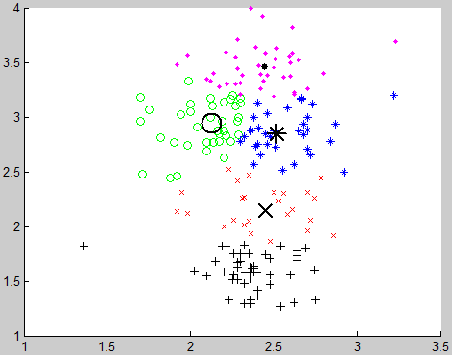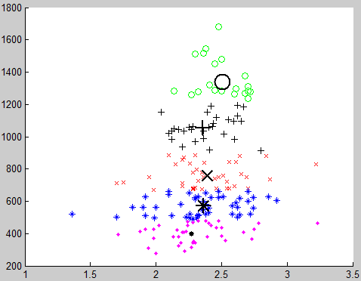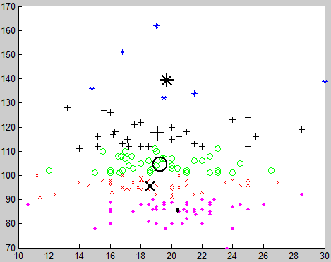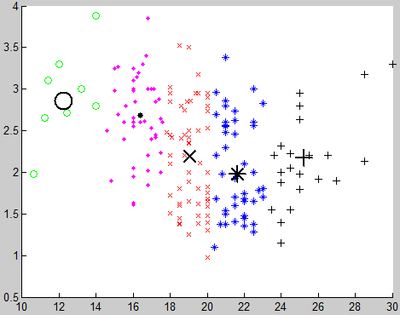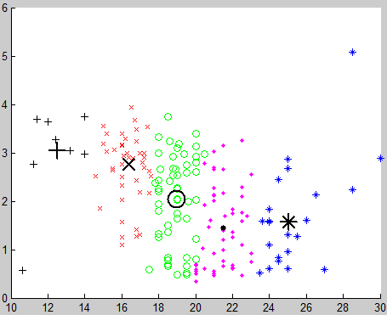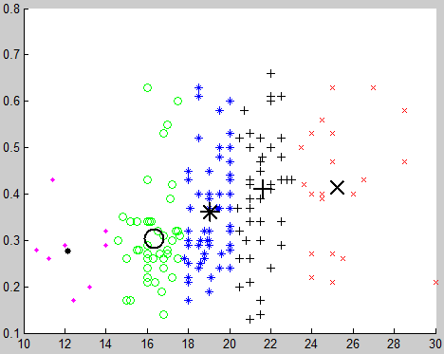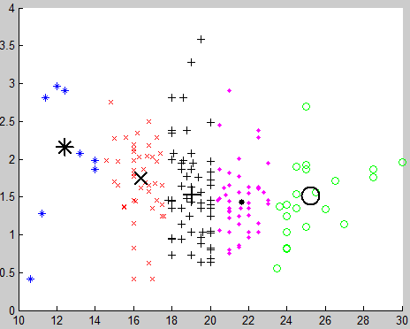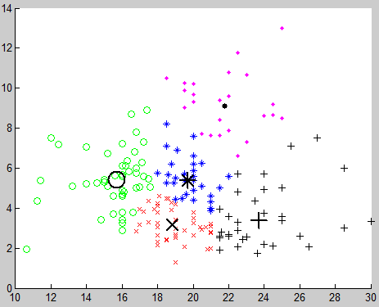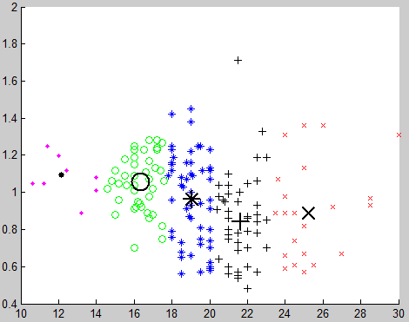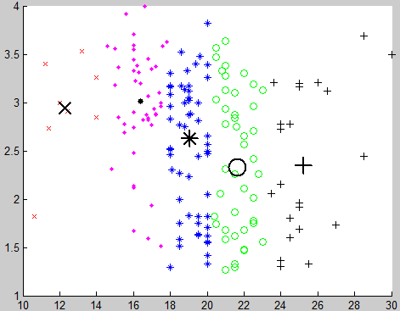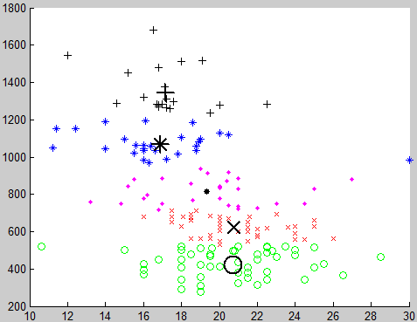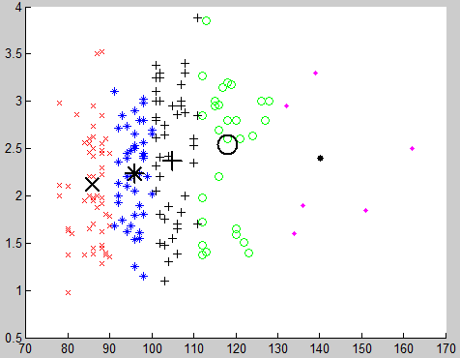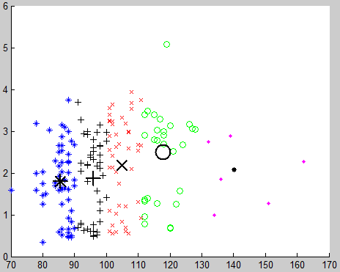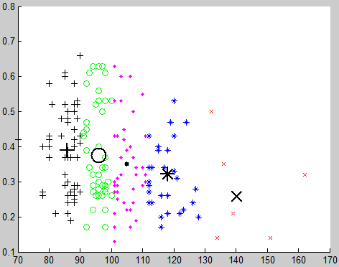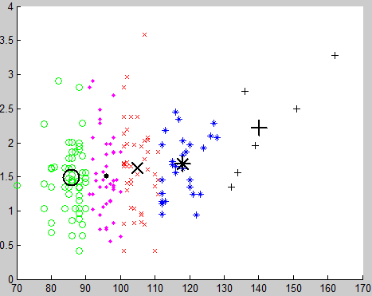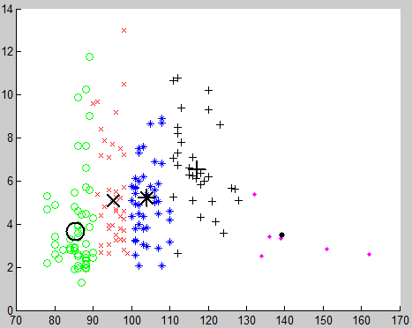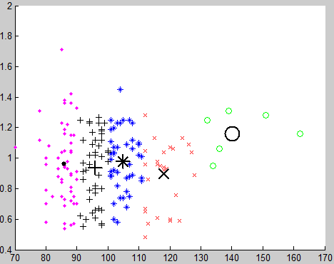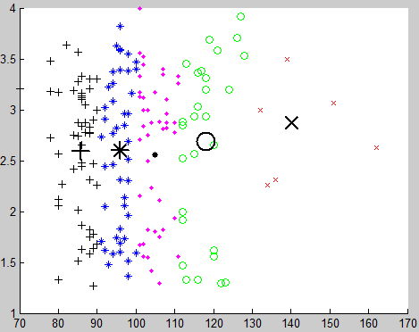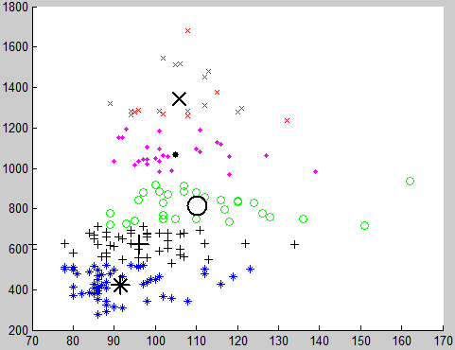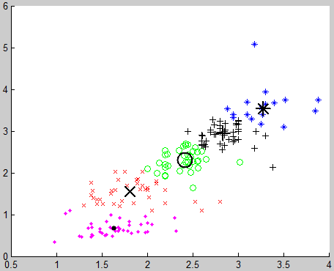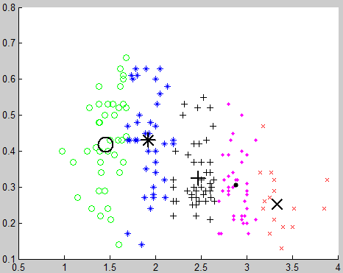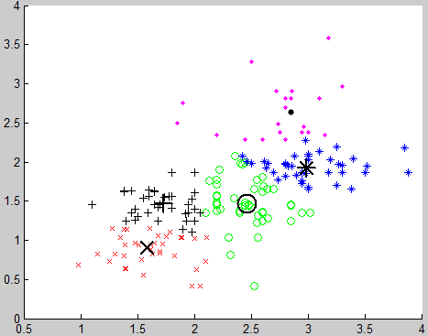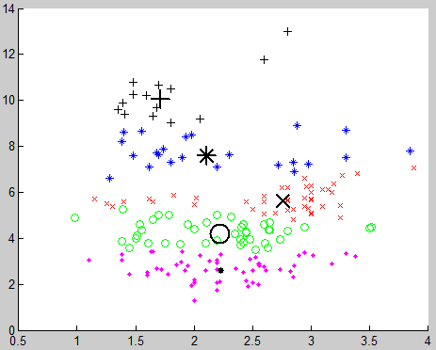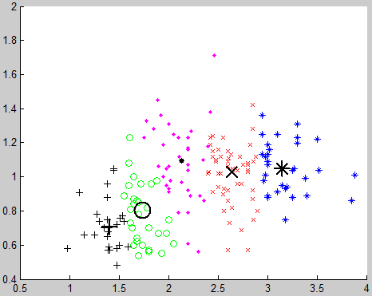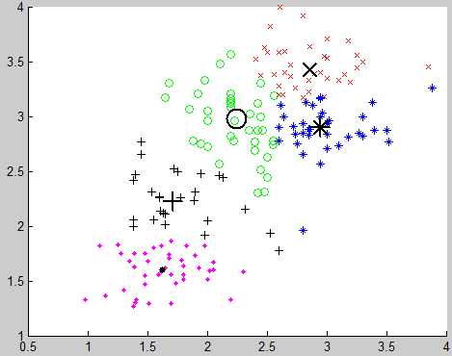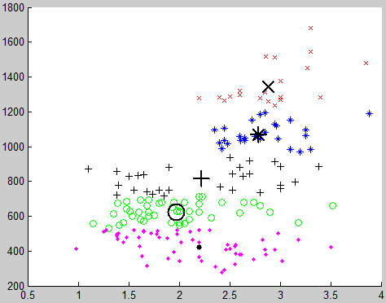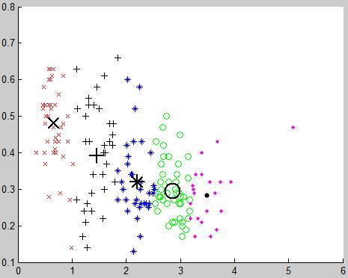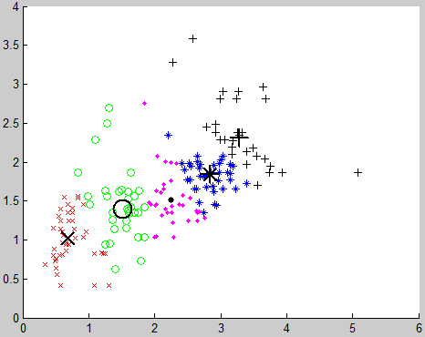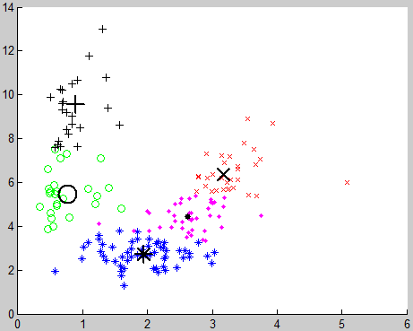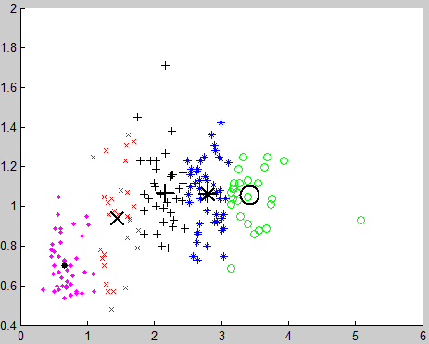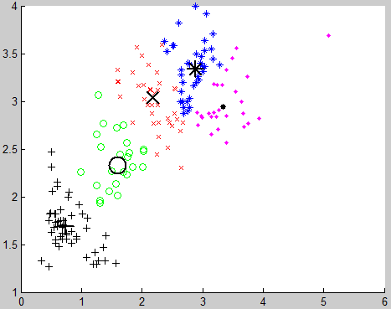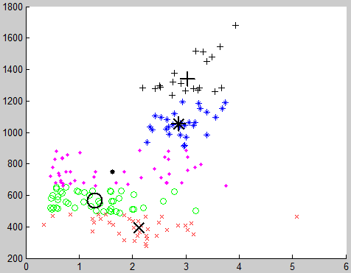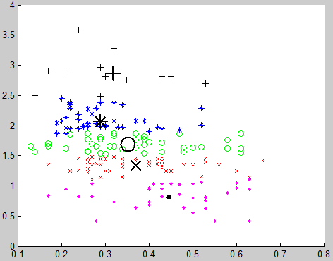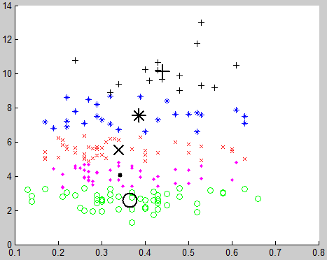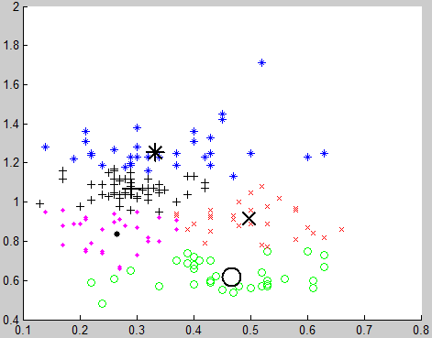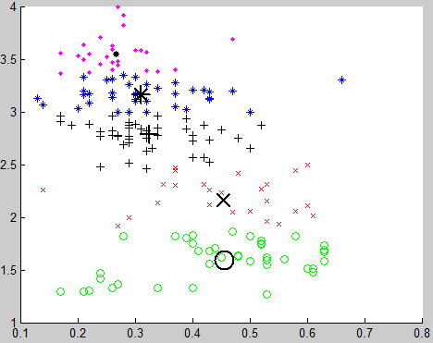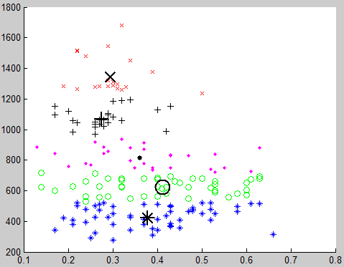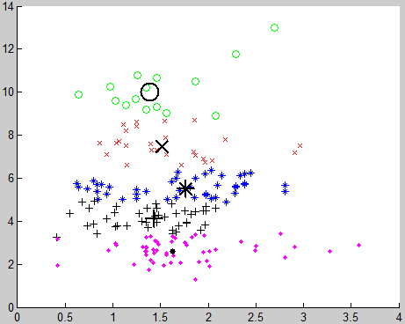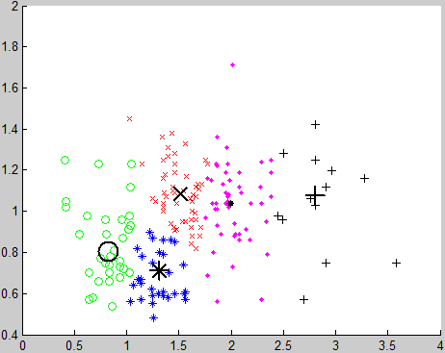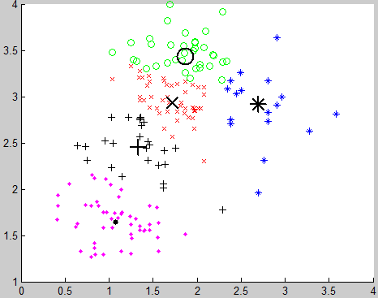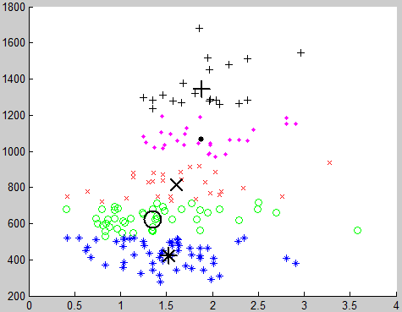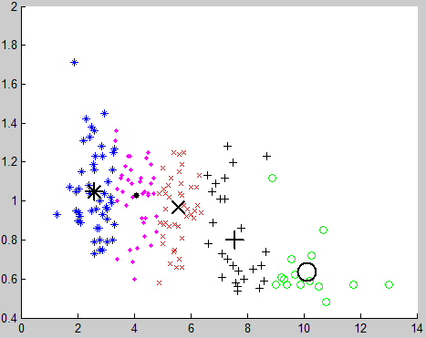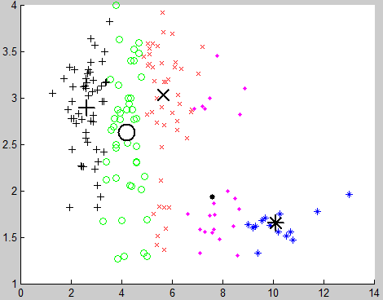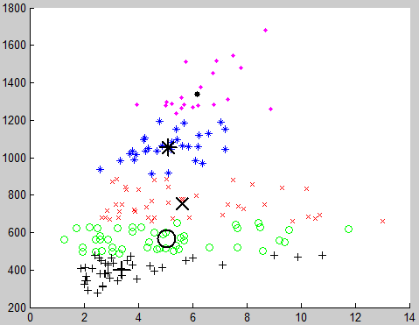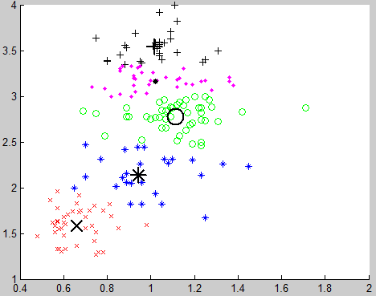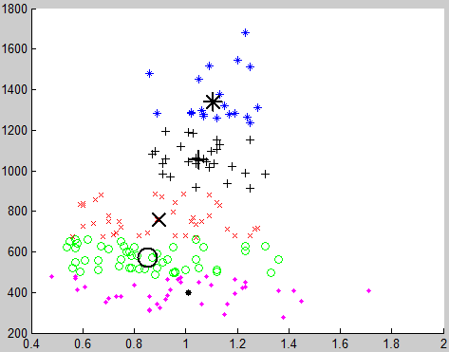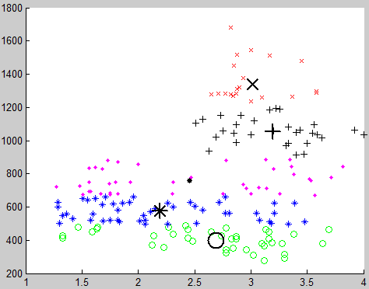

# Appendix-G: MATlab code for finding cluster members

function [result]=FindClusterMembers( data,nOfc )

[center,U,objFcn] = fcm(data,nOfc);

maxU = max(U);

index1 = find(U(1, :) == maxU)

index2 = find(U(2, :) == maxU)

ifnOfc>=3

index3 = find(U(3, :) == maxU)

end

ifnOfc>=4

index4 = find(U(4, :) == maxU);

end

ifnOfc>=5

index5 = find(U(5, :) == maxU);

end

fileID=fopen('cluster1.txt','a');

fprintf(fileID,'%i\n',index1);

fclose(fileID);

fileID=fopen('cluster2.txt','a');

fprintf(fileID,'%i\n',index2);

fclose(fileID);

ifnOfc>=3

fileID=fopen('cluster3.txt','a');

fprintf(fileID,'%i\n',index3);

fclose(fileID);

end

ifnOfc>=4

fileID=fopen('cluster4.txt','a');

fprintf(fileID,'%i\n',index4);

fclose(fileID);

end

ifnOfc>=5

fileID=fopen('cluster5.txt','a');

fprintf(fileID,'%i\n',index5);

fclose(fileID);

end

end

# References

[1] Fuzzy C-Means Clustering, <http://www.mathworks.com/help/fuzzy/fuzzy-clustering.html#FP43419>

[2] Fuzzy C-Means Clustering for Iris Data, <http://www.mathworks.com/help/fuzzy/examples/fuzzy-c-means-clustering-for-iris-data.html>

[3] Fuzzy C-Means (FCM), <http://www.bindichen.co.uk/post/AI/fuzzy-c-means.html>