Group-Based Cross-Validation ile Frekans Formülleri
Linear and symbolic regression performance was evaluated using geometry-grouped five-fold cross-validation. All realizations sharing the same geometry were kept within the same fold, so the reported test performance represents generalization to previously unseen geometry groups within the adopted numerical database.
Geometry group definition: H_m, D0_m, Dtop_m, t_m, B_kaide_m, H_silindir.
The cleaned dataset contains 1146 realizations and 191 unique geometry groups.
Parity plots are based on pooled held-out outer-test predictions and include the ideal 1:1 line and ±20% relative-error bounds. Final equations are re-fitted using the complete dataset only after cross-validated performance evaluation.

f1 Results
Model | Training R² | Test R² | Training MAE | Test MAE | Training RMSE | Test RMSE | Test SMAPE
Linear Regression | 0.8713 ± 0.0056 | 0.8465 ± 0.0410 | 0.1243 ± 0.0047 | 0.1307 ± 0.0101 | 0.1804 ± 0.0044 | 0.1907 ± 0.0175 | 24.95 ± 3.43%
Symbolic Regression (PySR) | 0.9763 ± 0.0096 | 0.9681 ± 0.0352 | 0.0489 ± 0.0094 | 0.0494 ± 0.0085 | 0.0751 ± 0.0170 | 0.0770 ± 0.0243 | 6.39 ± 1.14%

Final full-data equations
The following equations were re-fitted using the complete dataset only after group-based cross-validation. Their predictive performance should be reported using the grouped outer-test results above, not the full-data fit statistics.
f1 = 7.9382304 + 0.026279174*H - 3.6119192*D0 + 0.10987161*Dtop + 0.23220312*t + 1.6992885*B + 0.61929176*sqrtE_rho - 0.21632307*H_D0 - 0.72590959*Dtop_D0 + 0.97865207*t_D0 - 2.3059291*B_D0
f1 = 1171.95236318522*sqrtE_rho*(t + sqrt(D0 - 0.8187234))*(1/H)**1.2772571/H

Grouped outer-test parity plots
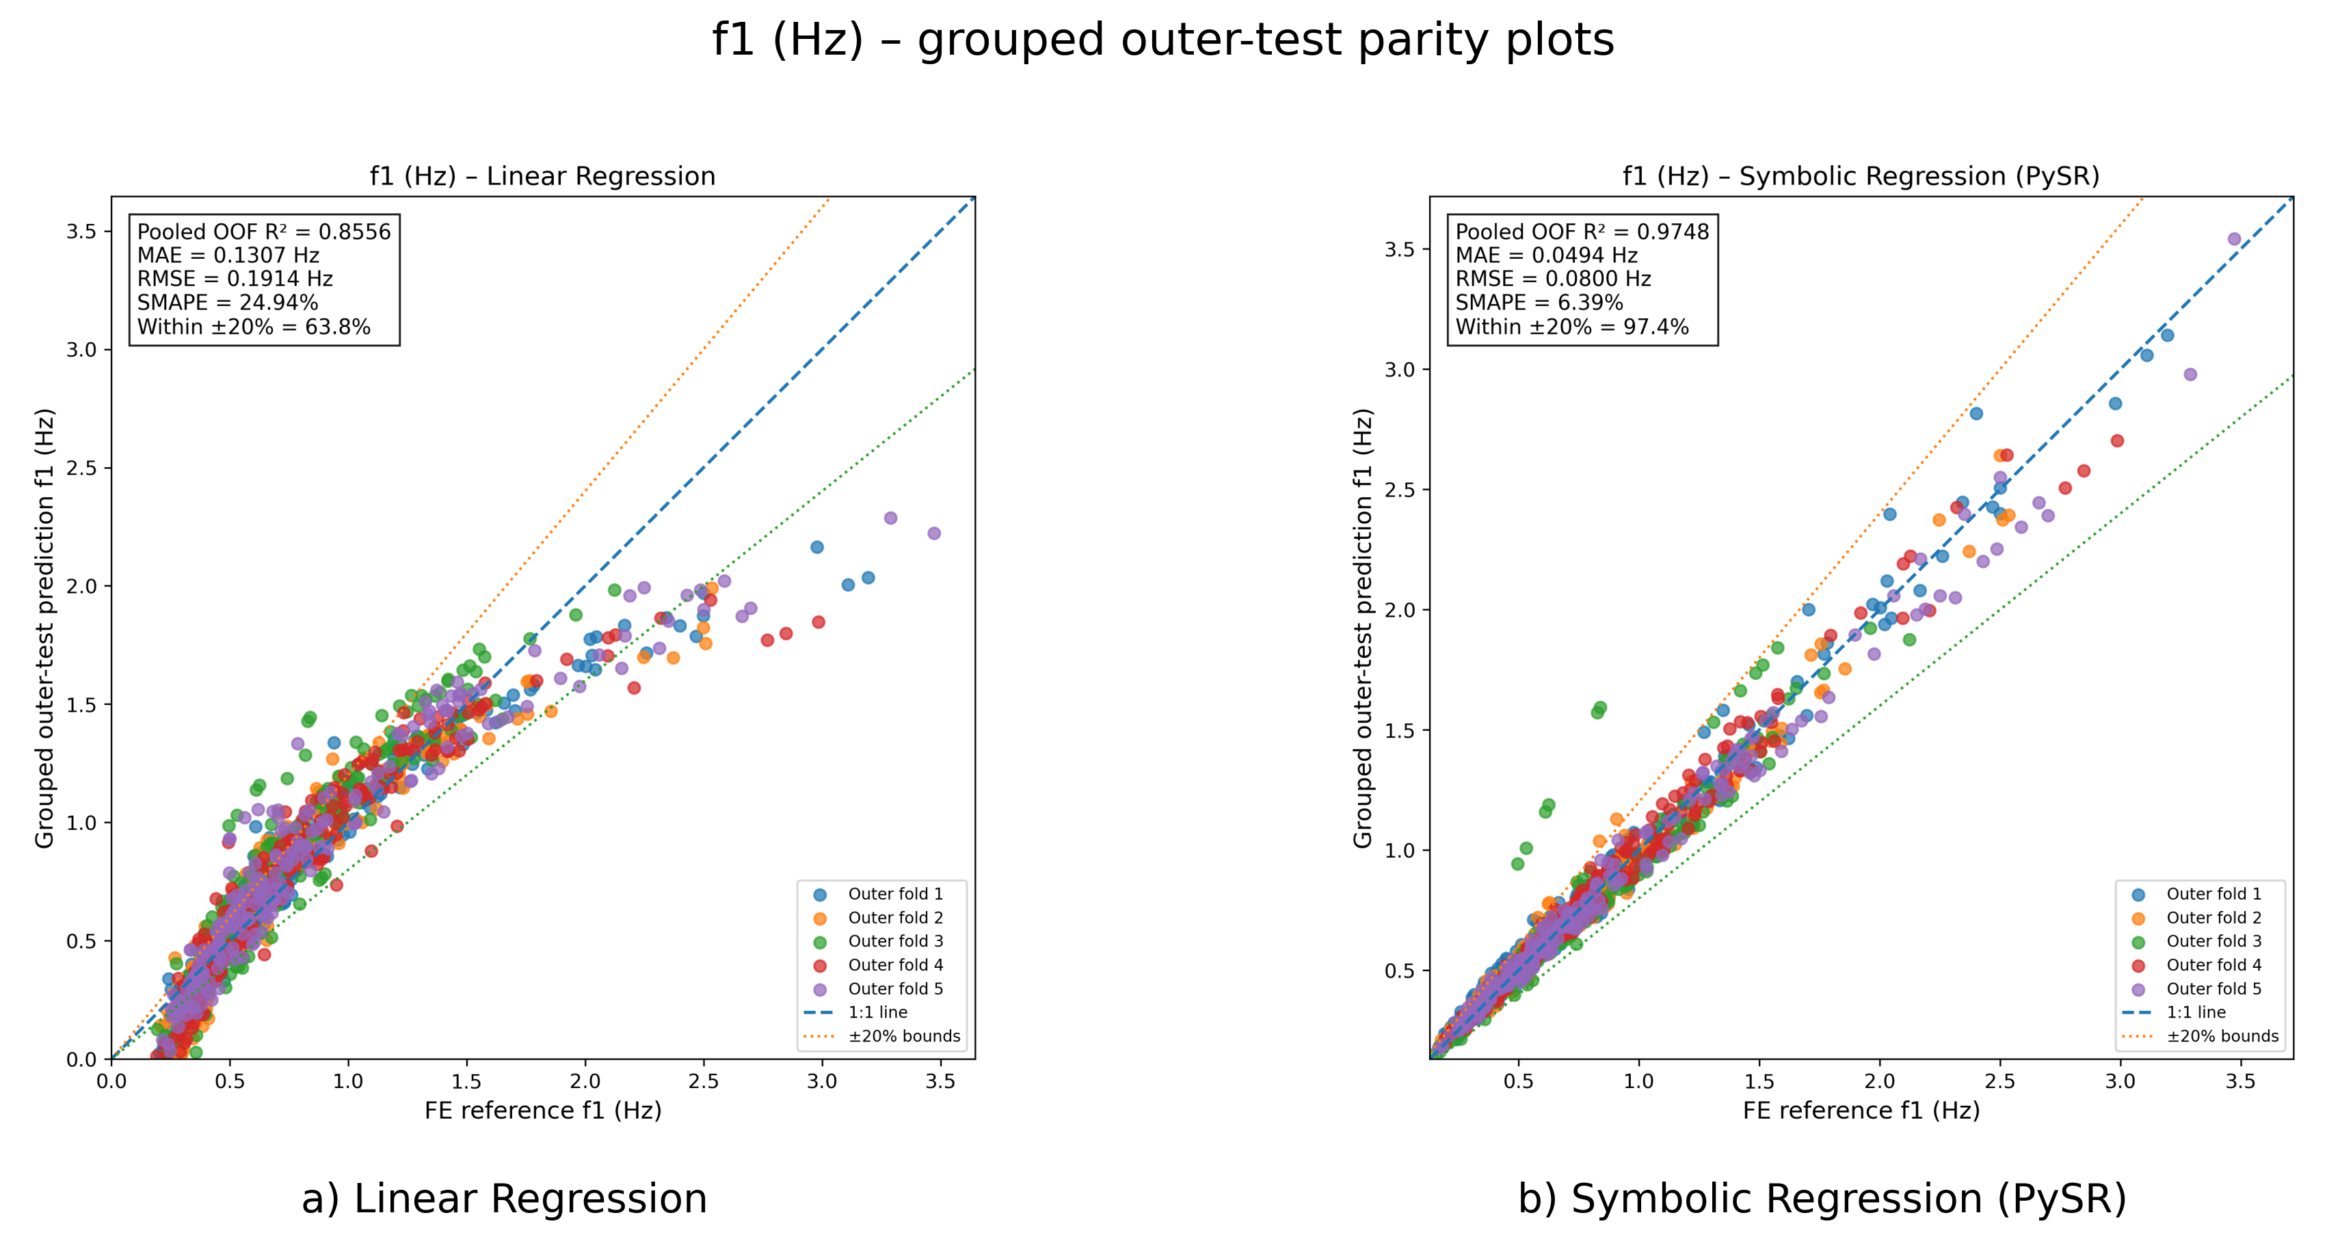

f2 Results
Model | Training R² | Test R² | Training MAE | Test MAE | Training RMSE | Test RMSE | Test SMAPE
Linear Regression | 0.8713 ± 0.0057 | 0.8466 ± 0.0413 | 0.1255 ± 0.0048 | 0.1318 ± 0.0103 | 0.1820 ± 0.0045 | 0.1923 ± 0.0177 | 25.03 ± 3.46%
Symbolic Regression (PySR) | 0.9731 ± 0.0085 | 0.9570 ± 0.0378 | 0.0547 ± 0.0072 | 0.0583 ± 0.0158 | 0.0820 ± 0.0117 | 0.0916 ± 0.0318 | 7.41 ± 2.11%

Final full-data equations
The following equations were re-fitted using the complete dataset only after group-based cross-validation. Their predictive performance should be reported using the grouped outer-test results above, not the full-data fit statistics.
f2 = 8.0240702 + 0.026651692*H - 3.6520142*D0 + 0.10899758*Dtop + 0.26109668*t + 1.7170652*B + 0.62339945*sqrtE_rho - 0.21858068*H_D0 - 0.72299186*Dtop_D0 + 0.85693278*t_D0 - 2.3279806*B_D0
f2 = sqrtE_rho*(D0*(8.660717 - D0)/(H - 11.449657))**1.2869128

Grouped outer-test parity plots
