EdgeRank Algorithm, and The Threat of Invisibility
Said Alaoui Idriss
CSC 3323
Summer 2014

Introduction

Only because you have millions of fans would not guarantee you million people reading your posts on facebook.
Edgerank is an algorithm developed by facebook to limit what is displayed on the top news in the News Feed. News Feed is the list of stories that is displayed from people and pages that you follow on facebook, it includes status updates, photos, videos, links, app activities and likes.
The importance of feature in EdgeRank algorithm lies on rewarding and punishings brands on their effort to deliver contents. If a brand has low EdgeRank value, it would have less popularity among Facebook users, and in consequences the updates would disappear from users knowledge; And brands succeeding in the business of advertising in Facebook, are averaging their Facebook budget by multitudes.
In the following paper, the analysis would not be provided on the implementaton of the algorithm because Facebook engineers Ruchi Sanghvi and Ari Steinberg gave only an overview of how EdgeRank Algorithm works without specifically providing the implementation of the algorithm. However, in the analysis of the algorithm, not only the efficiency of the algorithm should be taken into consideration, but also how it would affects the business plan of the web application. In fact, in the following paper, how would this choice of algoritm affect the user participation in the web application, which would make Facebook grow, and collect as much personal information of users as possible.

What is Edgerank

EdgeRank ranks Edges in the News Feed. It looks at all of the Edges that are connected to the User, then ranks each Edge based on its importance to the User.
An Edge is everything that happen in Facebook, updates, comments, likes, and shares. And any action that is taken in Facebook is an edge.
Edgerank algorithm is represented as the sum of edges , each Edge is made up of Affinity, weight and time decay.

- Affinity is one-way relationship between a User and an Edge. It could be understood on much the User is interacting or participating in the page of the brand. This would be measured by the number of comments, liking, sharing, and even messaging.
- Weight is a value system created by Facebook to increase or decrease the value of certain actions within Facebook. For example, commenting is more involved so it is more valuable than a like.
- Time Decay refers to how long the edge has been alive; the older, the less valuable it is. Time decay is the easiest of the variables to understand. Mathematically, it is 1/(Time Since Action). As an edge ages, it loses value, this would help keeping the News Feed fresh with interesting New content.

These criterias could be understiood or described by the following:
∑ uwd
- ‘u’ represents Affinity score between viewing user and edge creator
- ‘w’ represents Weight for this edge type(status, comment, like, tag, etc)
- ‘d’ represents Time Decay based on how long the edge was created

A Working Example of Edgerank

In figure 1, you can observe a working example of how does the algorithm EdgeRank used by Facebook developers. In fact, considering the Edge which is posting the photo by your brother, knowing that he is your brother, you must have high afinity with the post considering the fact that the News from your brother is highly important for you to know. The value of the weight is precised by Facebook, in this example, the weight of the action of posting a photo on facebook hall is High. And finally, since it was created recently, it is considered as having a high Time Decay. So Your brother posting his photo on the wall is considered as high when taking into account the value of the three criterias, which are: Affinity, weight, and time decay.

How does edgerank affect your reach

Engagement is the key for Facebook Marketing success. In order to maximise your reach for as many follower as possible one should:
- Make sure to always provide good quality content that people will like and engage with it.
- It should include call to actions in the posts that would promote users to like it and post comments.
- Post regularly, and one should avoid posting randomly. Because one would be playing lottery with your Reach, since one do not know when your best followers will be connected.
- Combine all types of posts(text, links, photos, videos….) Because not everyone of your followers likes the same type of content.

Algorithm visibility

Quoting Marshall McLuhan’s (1964), media are ‘extensions of man’, because media is a tool or a medium for humans to see and access with what they can not see and access with their own limitted senses. So the regime of visibility associated with web 2.0 connects to the notion of empowerment, because the web offers people the opportunity to access any information in the world. However, because of the surveillances technologies, it has often been associated with a sense of disempowerement. Disciple and Punish (1977) helps illuminate the ways in which the media participate in configuring the visible. In fact, it engages into controling of what could and should be seen, and what should and could not be seen.
Media industry is constructed around the control of visibility, which means it is working on deciding on what would and would not be seen by the audiance. What could be harmful for the audience to see and perceive would be bannished from the view and only elements that would not cause harm to the society could then be allowed to be viewed. In fact, Media as selection, sorting and framing mechanisms, ultemately points to the fact that media visibilities are never neutral; it is always about making the content meanigful.
As Kincaid (2010) explains, every item that shows up in your News Feed is considered an ‘Object’ (i.e. status update, upload picture). Every interaction with the object is called an edge.
In general, the algorithm is furthermore geared towards highlighting certain types of Edges while downgrading others, considering the working flow of the EdgeRank algorithm. In order for you to like or comment on a friends’s photo or status update, they have to be visible to you in the first place.
The News Feed as we have just seen does not treat individuals equally, it means that the information given about the users through the News Feeds is visible only if the user posting the information has high infinity with the user that posted the information. Also, if it has high weight, and time decay. So, as a user of facebook, you could have only information that facebook judges as important to you but not all the information. The threat that we could resume from here is not that the possibility of constantly being observed, but in fact the possibility of constantly disappearing. There is now a whole industry being built around so called ‘News Feed Optimization’. PR firms all have advice on how to boost a brand’s visibility on Facebook. Similarly, Taylor suggest that: ‘Facebook’s EdgeRank holds all power of visibility’ (2011).
While Affinity, Weight and Time Decay are key components of the algorithm structuring the regime of visibility in News Feed, it is safe to assume that other factors will affect the ranking and selection of Edges as well. What becomes apparent is that algorithms, especially those working at the heart of ‘Big Data’ companies like Facebook and Google, occupy a pecular epistemological position where some components are known while others are necessarily obscured. Algorithm are also fluid, adaptable and mutable. This means that EdgeRank is not something that merely acts upon users from above, but rather that power arises from inter-relationships with users. How EdgeRank will process the data that I provide, therefore fundamentally also depends on me, and my relationships with my ‘friends’. For instance, Top News dynamically updates depending on how many times I visit Facebook. This makes it difficult to make a general claim about the percentage of stories making it to the Top News as the degree of influence the frequency and duration of my visits to Facebook has on the Edge remains unknown.
The Visibility works as a reward rather than punisment, as it was referred by Foucault’s notion of panopticism. Considering numerous observation that I personnaly had with my facebook account, Top News were mostly filled with engagement and interaction, and stories without engagement and interaction were filtered out. Also, Top News display has tailored stories, for example if X commented on Y’s picture, it is followed by X likes Y’s photo. These types of stories that are tailored at the top News are mostly having many other friends of friends, also commenting on the post. So, it means that the post was really popular and interesting for the community.
So, the threat of invisibility on Facebook is quite real. Facebook makes users using the applicatoin responssible for the management of the content. In fact, it is a kind of a Power that consider individuals as objects and as instruments of its exercise. This algorithm that works on computing the user affinity and the weight of the edge, made it possible for users to become the principle of their own content regulation. Foucault identified three techniques: Hierarchical observatoin, normalizing judgement and examinaton.
In Facebook, a useful user is someone that is actively participating in the content, and interact with numerous people. This person is participating in sustaining disciplinary power. In fact, through the threat of invisitbility, inhence users participation in adding contents to facebook wall. When a user failling to participate, would be punished by the algorithm used by facebook because the user does not post frequently and does not have high affinity with other users. It means that Facebook is punishing inactive users. Also, while Facebook is generating many comments and likes on the News Feeds, would provide to users an incentive will to like and comment. As Hoffman explains: ’Disciplinary power judges according to the norm, He depicts the norm as standard of behaviour that allows for the measurement of forms of behaviour as “normal” or “abnormal”’(2011). If Facebook would create an impression that the users are highly participating in the content of the page, it would radically suggest that participation is the norm. Hence, EdgeRank algorithm would make functioning as a disciplinary technique where subjects would accommodate their behavior to correspond to the normal. Because, so to make it to the top news one should be actively interacting with people, and getting stories of updates, liking , and comments from other users would bring up the user to comment and like as others to integrate the group. Also, Facebook enhance popularity, where popularity fosters further popularity. In fact, being popular would enhance the chances to be more visible in Facebook environment. So, EdgeRank algorithm allows space for free participation, where the desirable participation is the visible ones, while participation that are not desirable are not visible to the users.

References

- “What is News Feed?”, https://www.facebook.com/help/210346402339221 , 29 June 2014.
- “What is Edgerank”, http://www.whatisedgerank.com/, 29 June 2014.
- “Edgerank”, http://edgerank.net/, 29 June 2014
- “News Feed FYI: Helping You Find More News to Talk About”, https://newsroom.fb.com/news/2013/12/news-feed-fyi-helping-you-find-more-news-to-talk-about/ , 29 june 2014.
- M. Hoffman, Michel Foucault: Key Concepts, Acumen, Durham NC,2011
- M. McLuhan, Understanding Media: The Extensions of Man. Routledge, London, 1964
- M. Foucault, Discipline and Punish: The Birth of the Prison, Allen Lane, London, 1977.
- T. Bucher, “Want to be on the top? Algorithm power and the threat of invisibility on Facebook”, new media & society, 14, 7, 2012, 1164-1180.
- “Everything you need to know about Facebook’s EdgeRank”, http://thenextweb.com/socialmedia/2011/05/09/everything-you-need-to-know-about-facebook’s-edgerank , 29 june 2014.
- “EdgeRank: The secret sauce that makes Facebook’s news feed tick”. http://techcrunch.com/2010/04/22/facebook-edgerank/, 29 june 2014.

Appendix A

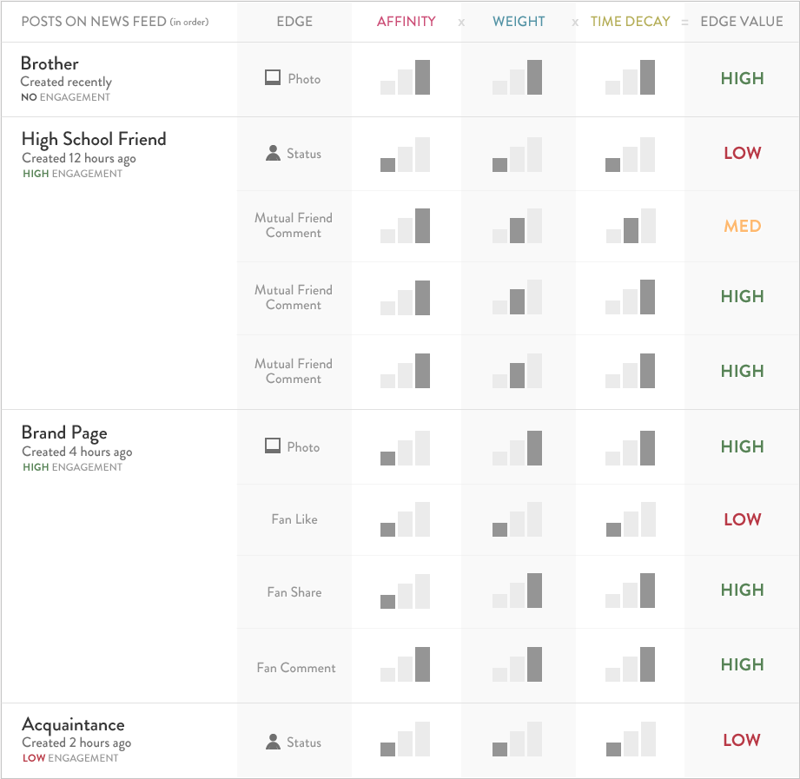

Figure 1. EdgeRank Working Example

