Software Documentation

For

Pong Game

May 2, 2018

Version 1

Prepared by:

Ali El rafei and Omar Farouk

Table of Contents
1 Introduction 3
1.1 Overview 3
1.2 Goals and Objectives 3
1.3 Scope 3
1.4 Definitions 3
2 General Design and Constraints 4
2.1 Pong Game Application Environment 4
2.2 Used Tools 4
2.3 Design Phases 4

3 Game play and updates 7
3.1 the user input 7
3.2 the user output 7
3.3 the upcoming updates 7

Introduction

Overview
The pong game application is desktop application available to windows users, Linux users and Mac users . The application provides an entertainment game, it is a competitive game played by two players, it consists of 2 paddles and a ball,
The ball bounce on the paddle and change its direction and the other paddle do the same, The two players trying to keep hitting the ball before the ball passes there paddles, one player will win when the ball passes the paddle of the other player.

This document provides information on the requirements for the pong game application. Project goals, scope and definitions are given in the introduction. Design constraints and application environment are described in the following section. Non-functional requirements are outlined for later verification. Functional requirements are given to show the system features and expected user interaction.

Goals and Objectives
The main objective of this project is to make an entertainment game to users to allow them enjoy their time.

The Pong game application is expected to:
- Provide graphical animation.
- Provide ease of use.

Scope
The Pong game application provides players with total handling to the paddles and easy handling. When one of the players win it display that the player win the game. The can restart the game, also can pause the game and resume.

Definitions
Paddle –a small bar at the two sides of the game that hit the ball.
walls– the two rectangles at the top and the bottom of the game.
Client – the person or organization for which this Roo Balance application is being built.
player – the person or persons who will actually interact with the PongGame.

2 General Design

2.1 Pong Game Application Environment
The Pong Game application is designed to work on linux OS and Windows OS in the future .
2.2 Used tools
The Game was built using Haskell platform 2010 in addition to Gloss package you can find all you need to know about gloss in this link: https://hackage.haskell.org/package/gloss.
We used Cabal package which stands for (Common Architecture for Building Applications and Libraries ) Cabal provides sandboxing Functionality, allowing packages to installed locally to a directory ,so that a package may be tested and built completely independently of all globally installed packages.
2.2.1 The libraries used by gloss
we used Graphics.Gloss, Graphics.Gloss.Data.ViewPort, Graphics.Gloss.Interface.Pure.Game

2.3 Design Phases
First Phase : we wanted to draw a static pictures on the display which represents our game objects so we used function display which takes (display window background drawing) to display some thing like this figure :
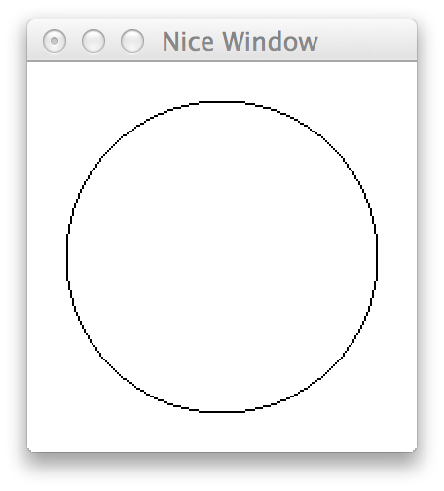

Our game consisted of two paddles two walls and a single ball like shown in the figure bellow :

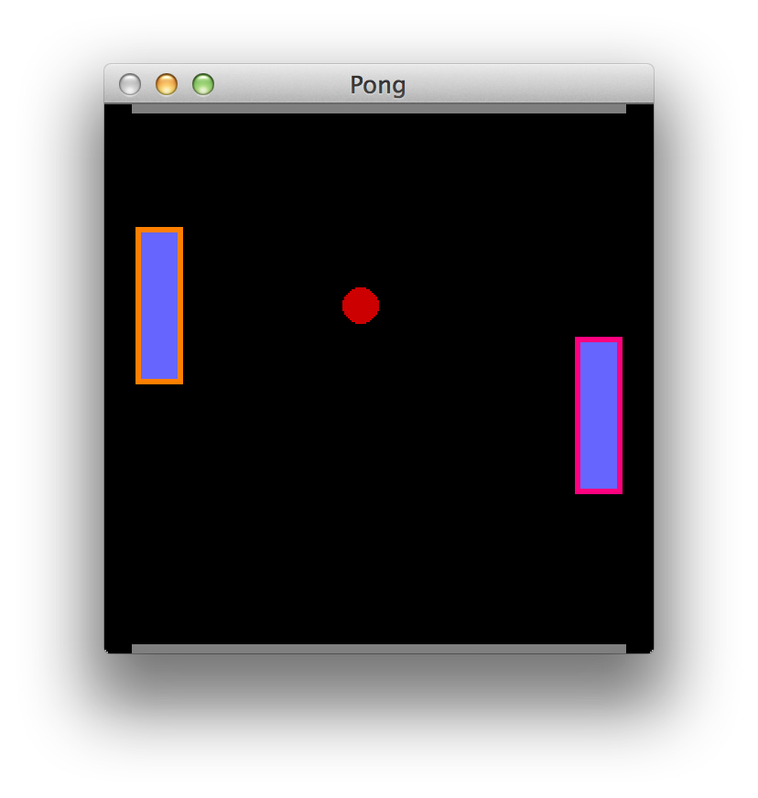

Second Phase : we wanted to change the static objects to a dynamic ones so we had to work on each object independently.
We started with the ball movement , before we implement the ball movement function we needed to make data structure to hold the state of the game and function to initialize the game and another function to convert the game state into picture .

1-Data PongGame
The data structure to hold the state of the game

2-Initial State ::PongGame
The starting state of the game

3-Render :: PongGame→picture
Convert the game state into picture

Third Phase: this phase we upgraded our game from static display to animation the animation do very little . It move the ball but there is no collision logic so we used the animation function in gloss (animate::Display→ color → (Float→picture)→ IO () ) .
MoveBall:this function will update the ball state as it moves by updating the ball velocity and location
moveBall::Float->PongGame->PongGame
we added function frame to the parameter of animate .
Frame::Float→picture

at this point the ball only falls from its current position but there is no logical collision so the next phase we once again update our game to support this kind of animation

Fourth Phase: We could not do much using animate since we have no information about the previous state of the game , so we could not update the state of the game and we could not handle the logical collisions or user inputs so for this point to just make the logical interactions we have used the simulate function .
Run a finite time step simulation in a window
Simulate::Display → How to display the game .
color → Background color
int → number of simulations steps per second of real time
a → the initial game state
(a →picture)→ a function to render the game state to picture
(ViewPort→Float→a→a) a function to step the game once
→ IO()

fps::Int
fps = 60
Number of frames to show per second

main = simulate window background fps initialState render update
function update is used to update the game by moving the ball
update :: ViewPort → Float → PongGame → PongGame
The ViewPort represents the global transformation applied to the displayed picture
the next move we needed to implement collisions so that our game becomes playable . We have two types of collisions side walls and the paddles so we implemented these two functions as follows :

paddleBounce :: PongGame → PongGame
Detect a collision with the paddle . Upon collisions change the velocity of the ball to bounce it off the paddle
wallBounce :: PongGame → PongGame
Detect a collision with one of the side walls . Upon collisions change the velocity of the ball to bounce it off the wall
paddleCollision ::Postion → raduis → bool
Detect a collision with the paddle . Return if a collision take place or not
wallCollision :: Postion → raduis → bool
Detect a collision with the one of the side walls . Return if a collision take place or not

the funniest part when we got our simple formula to actually know when the
ball collied with the paddles and the walls as show in the the following figures :

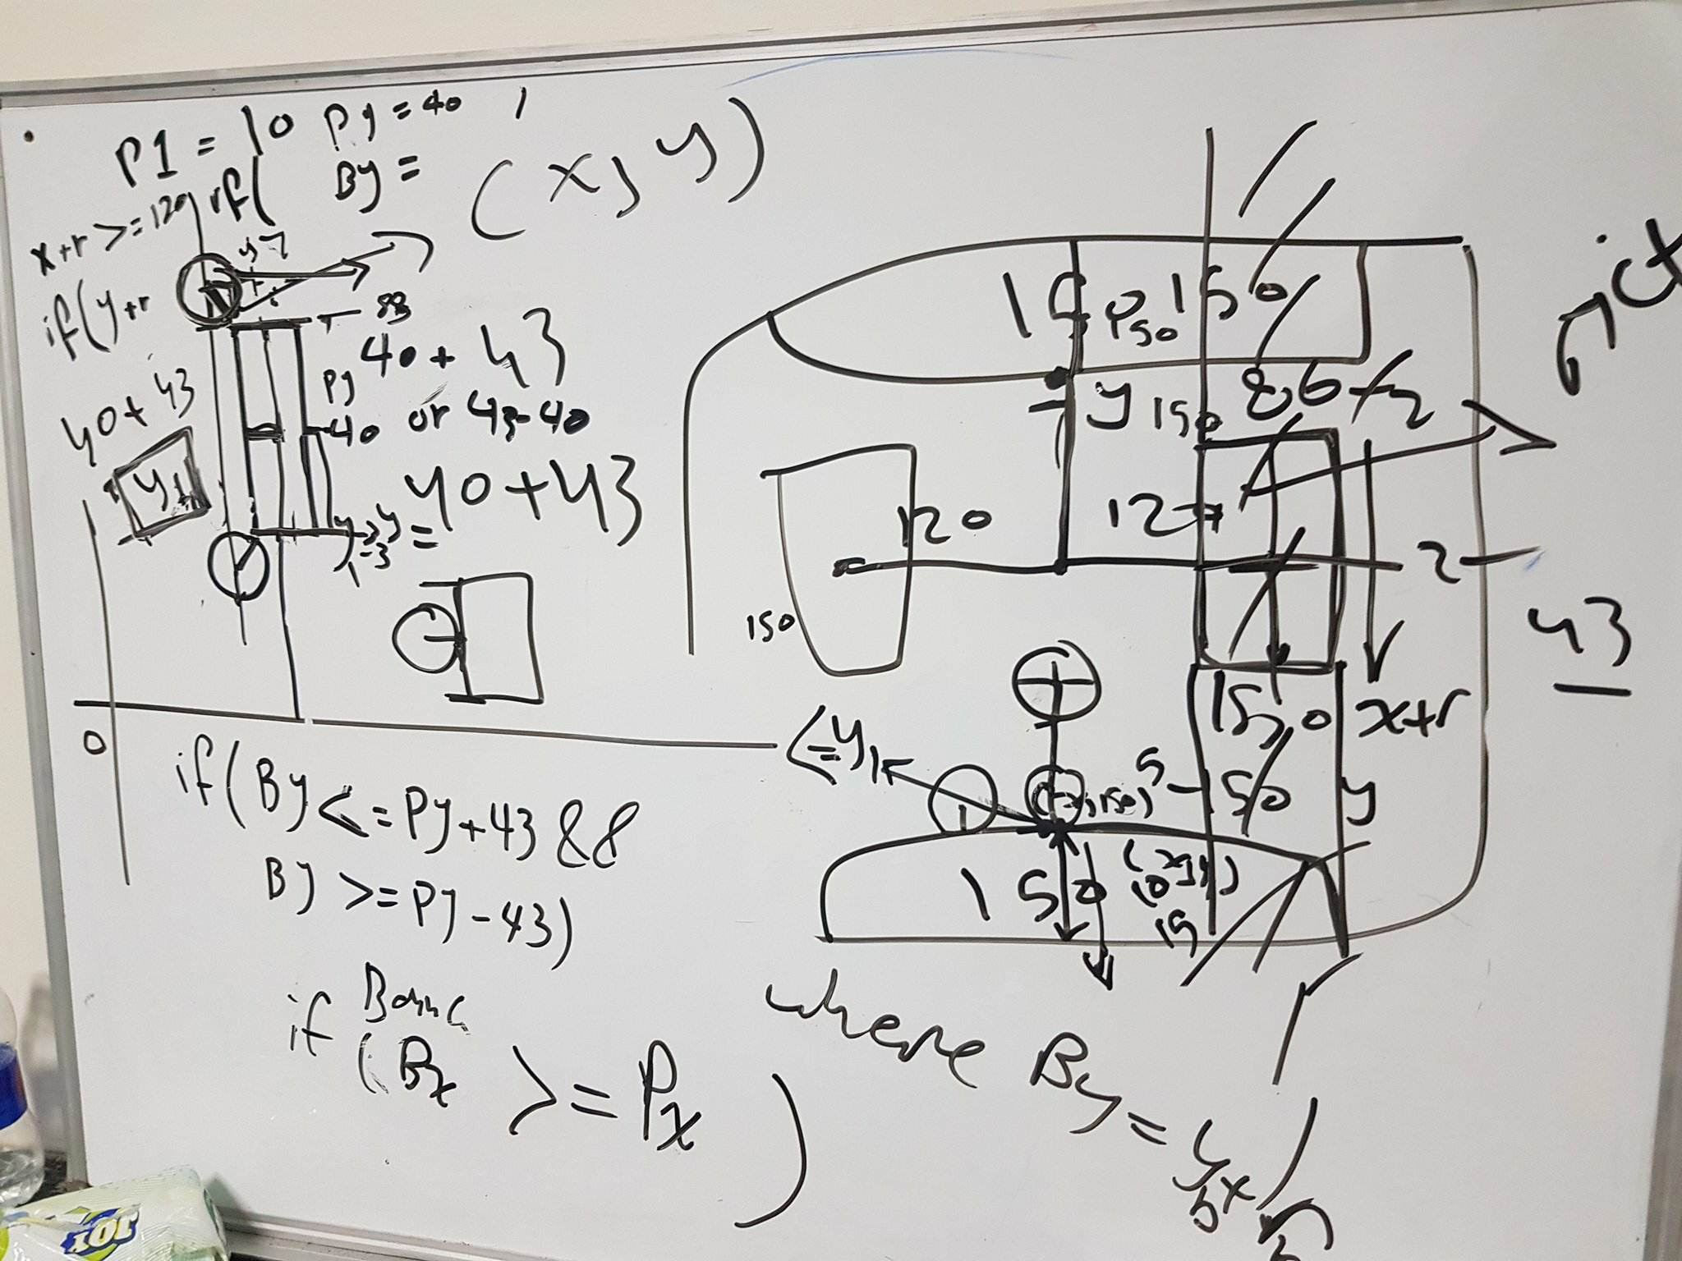

we had to find out the distance between the edge of the ball facing the walls or the edge facing the paddles and calculate the x coordinate and y coordinate to find out if the collision happened or not and if happened redirect the ball Note that the game have some bugs but it is nearly noticeable but it will be fixed in the upcoming versions .

Fifth phase : So far , we have an app that starts the pong game and then plays it forever. However, the players cant move their paddles in this phase we have fix this issue and implemented the user input .
Again we had to update our game by replacing the simulate function by the play function . Play function gave us the ability to have user interactions .
Play :: Display Window to draw game in
→ color Background color
→ Int The number of simulation steps per second
→ a the initial game state.
→ (a→ Picture) A function t render the state to a picture
→ (Event → a → a) A function to handle input events.
→ (Float → a → a) A function to step the world one iteration
→ IO ()

Main = play window background fps initialiState render handlekeys update
HandleKeys :: Event → PongGame → PongGame
Respond to key events
this function works as it goes for pattern matching to check which event had happened so that it apply the response

Last Phase : we added the features to give the game more funny experience
as we add a win flags to indicate who win and we also added some extra keys like restart the game and pause the game in the next version we will include the AI option .
To implement the win flags for the players we had to change the Data structure that holds the state and add a new pictures (PL1Win) and (PL2Win)
and add a change to function (paddleBounce) to add two fields to check the winner . Now the final version of function update looks like :
Update :: Float → PongGame → PongGame
update seconds gm = paddleBounce (moveBall seconds (wallBounce (moveBall seconds gm)))
function paddleBounce now takes the postions of the two flags .
3 Game play and updates
3.1 User Inputs
we have two players as shown in the figure bellow .
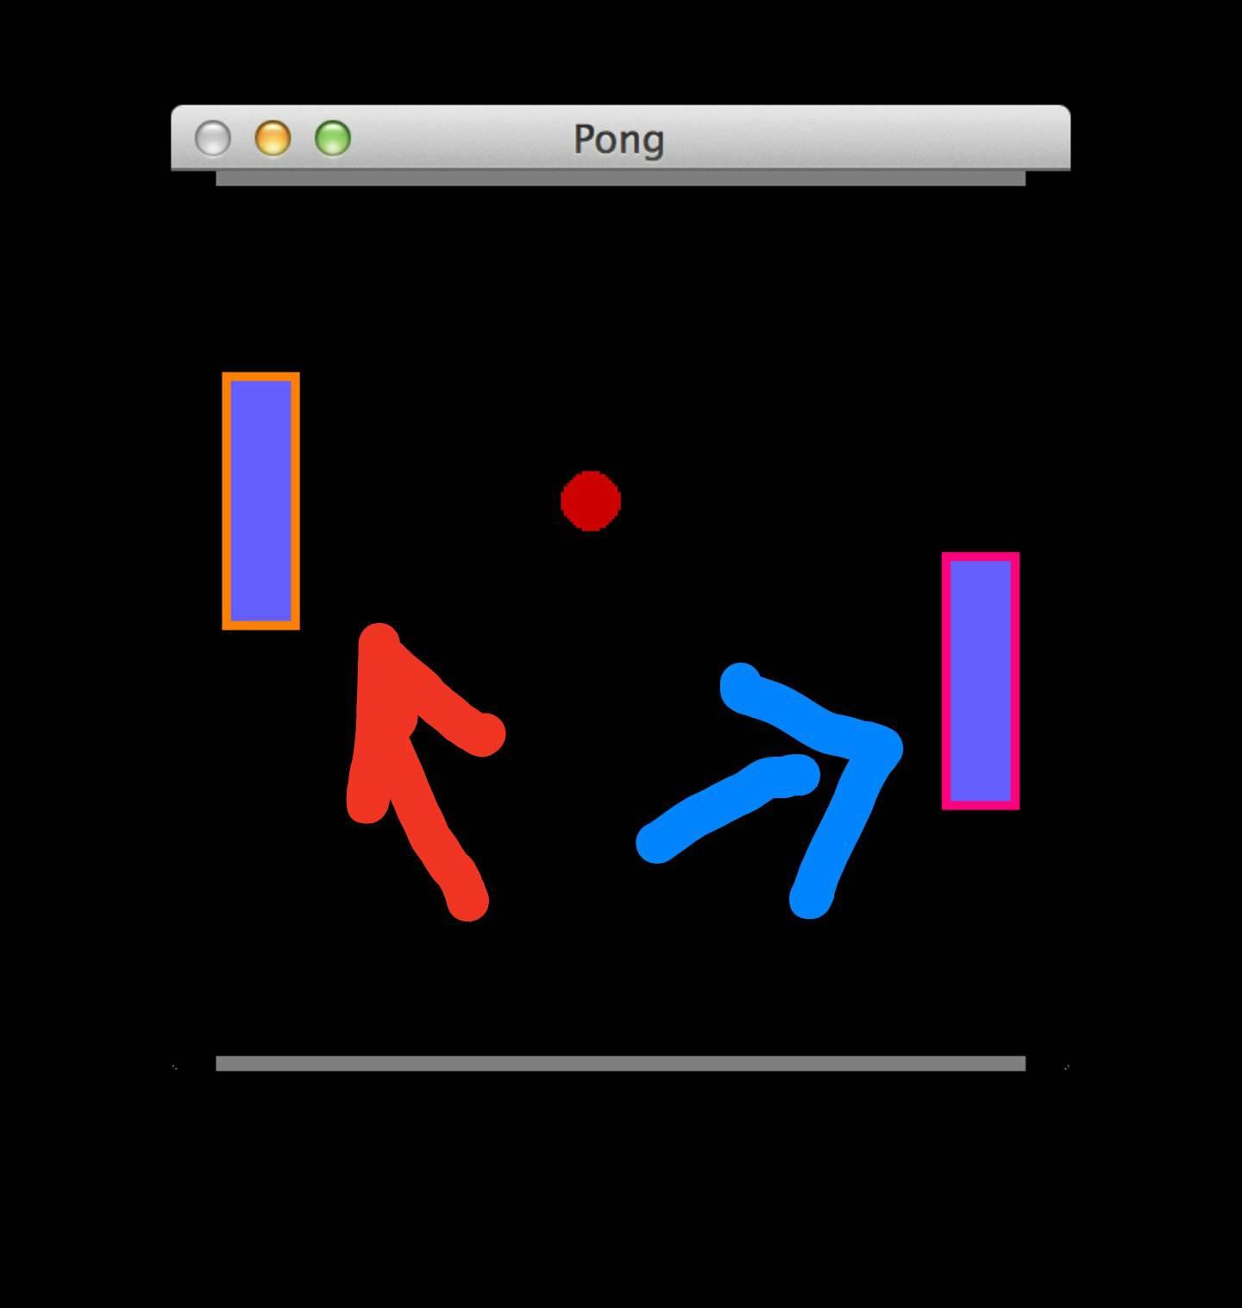

for player 1 :
( p ) key to go up
( l ) key to go down
for player 2 :
( w ) key to go up
( s ) key to go down
to pause the game use ( O ) key
to Restart the game use ( R ) key
to exit the game use ( Esc ) key

3.2 User outputs
if the ball pass the line where player 1 stands player 2 will win as shown in the figure .
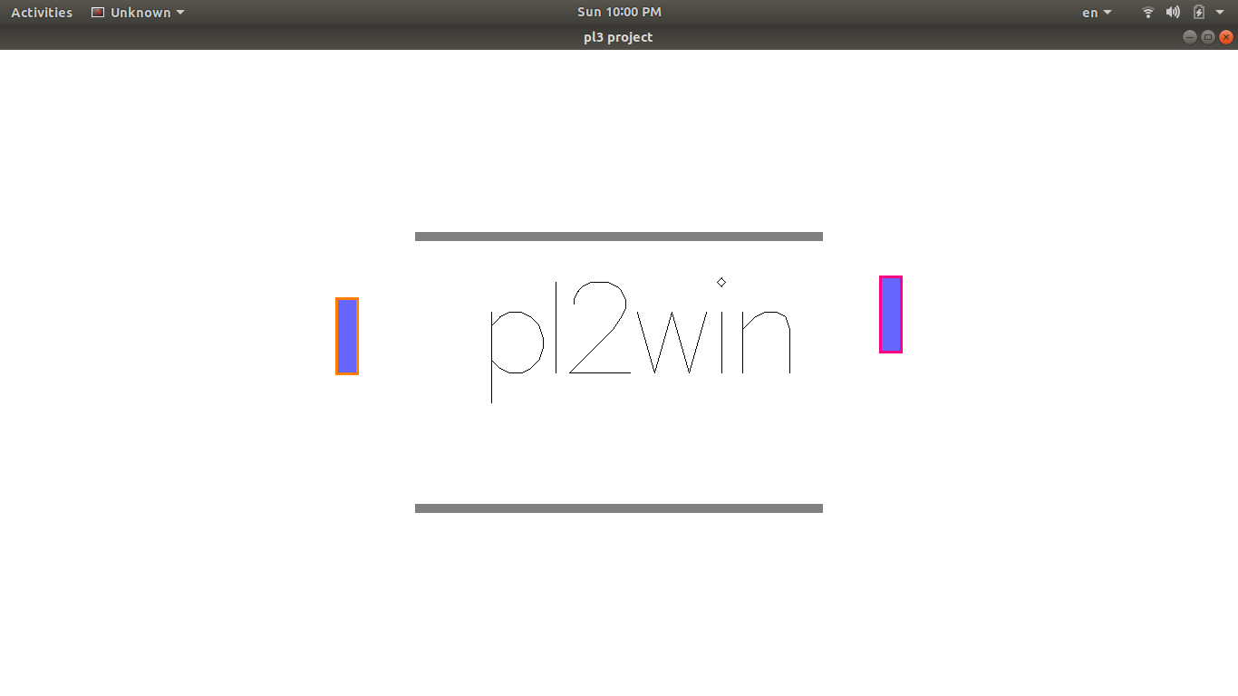

But if the ball pass the line where player 2 stands player 1 will win as shown in the figure .
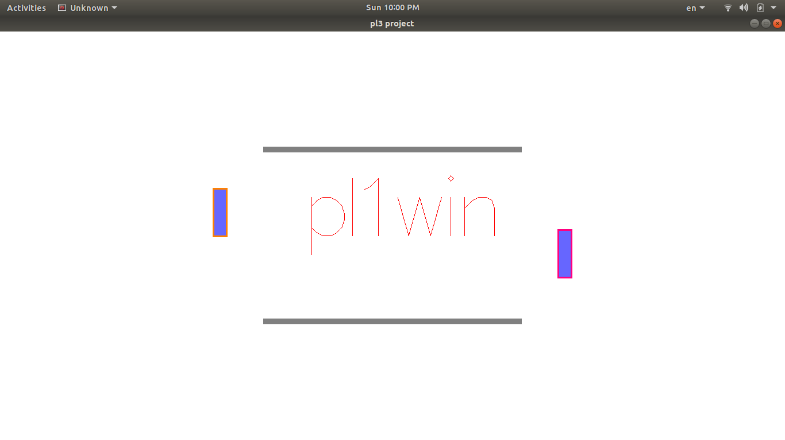
3.3 Upcoming updates
- AI option
- enhanced user interface
- fixing bugs
- more changes to game play

PL3 Project

Team:

1 | علي محمد مختار الرافعي | 20160249
2 | عمر فاروق عبد الواحد ابراهيم | 20160269

