Bit Operations

Generally, as a programmer you don't need to concern yourself about operations at the bit level. You're free to think in bytes, or ints and doubles, or even higher level data types composed of a combination of these. But there are times when you'd like to be able to go to the level of an individual bit.

The byte is the lowest level at which we can access data; there's no "bit" type, and we can't ask for an individual bit. In fact, we can't even perform operations on a single bit -- every bitwise operator will be applied to, at a minimum, an entire byte at a time. This means we'll be considering the whole representation of a number whenever we talk about applying a bitwise operator.

By convention, in C and C++ you can think about binary numbers as starting with the most significant bit to the left.

Bitwise AND
The bitwise AND operator is a single ampersand: &. A handy mnemonic is that the small version of the boolean AND, &&, works on smaller pieces (bits instead of bytes, chars, integers, etc). In essence, a binary AND simply takes the logical AND of the bits in each position of a number in binary form.

#include <stdio.h>

int a, b, c;

int main(void)
{
a = 72;
b = 184;
c = a & b;
printf("%d & %d = %d\n",a,b,c);
return 0;
}
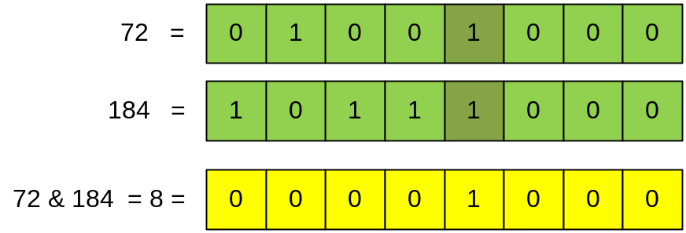

Bitwise OR
Bitwise OR works almost exactly the same way as bitwise AND. The only difference is that only one of the two bits needs to be a 1 for that position's bit in the result to be 1. (If both bits are a 1, the result will also have a 1 in that position.) The symbol is a pipe: |. Again, this is similar to boolean logical operator, which is ||.

#include <stdio.h>

int a, b, c;

int main(void)
{
a = 72;
b = 184;
c = a | b;
printf("%d | %d = %d\n",a,b,c);
return 0;
}
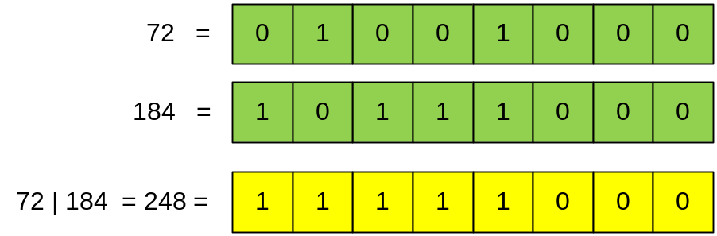

Bitwise Exclusive-Or (XOR)
There is no boolean operator counterpart to bitwise exclusive-or, but there is a simple explanation. The exclusive-or operation takes two inputs and returns a 1 if either one or the other of the inputs is a 1, but not if both are. That is, if both inputs are 1 or both inputs are 0, it returns 0. Bitwise exclusive-or, with the operator of a caret, ^, performs the exclusive-or operation on each pair of bits. Exclusive-or is commonly abbreviated XOR.

#include <stdio.h>

int a, b, c;

int main(void)
{
a = 72;
b = 184;
c = a ^ b;
printf("%d ^ %d = %d\n",a,b,c);
return 0;
}
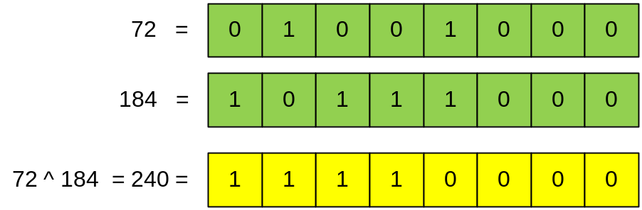

The Bitwise Complement
The bitwise complement operator, the tilde, ~, flips every bit. A useful way to remember this is that the tilde is sometimes called a twiddle, and the bitwise complement twiddles every bit: if you have a 1, it's a 0, and if you have a 0, it's a 1.

#include <stdio.h>

unsigned short int a, b;

int main(void)
{
a = 1023;
b = ~a;
printf("~%d = %d\n",a,b);
return 0;
}

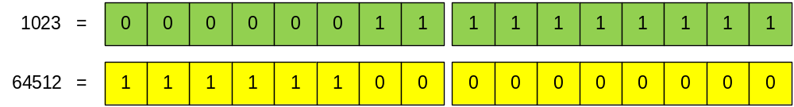

Here is a great way of finding the largest possible value for an unsigned integers:

#include <stdio.h>

unsigned short int a;
unsigned int b;
unsigned long long c;

int main(void)
{
a = ~0;
printf("Greatest unsigned short int = %u\n",a);
b = ~0;
printf("Greatest unsigned int = %u\n",b);
c = ~0;
printf("Greatest unsigned long long = %llu\n",c);
return 0;
}

Working with signed integers:

#include <stdio.h>

short int a, b;

int main(void)
{
a = 5;
b = ~a;
printf("%d %d\n",a,b);
return 0;
}
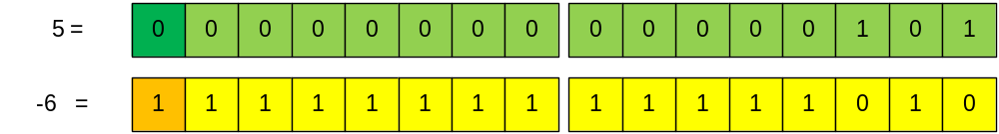

Shift operators
The left-shift operator is the equivalent of moving all the bits of a number a specified number of places to the left:
[variable] << [number of places]
A bitwise left-shift is the equivalent of integer multiplication by 2.

#include <stdio.h>

int a, b;

int main(void)
{
a = 5;
b = 5 << 2;
printf("%d %d\n",a,b);
return 0;
}
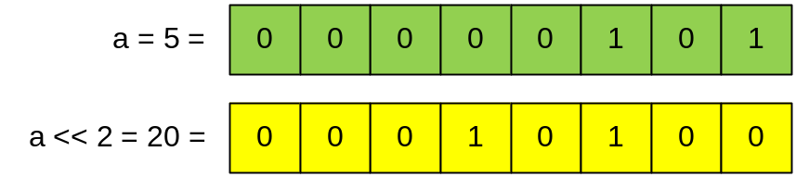

There's a corresponding right-shift operator: >>. A bitwise right-shift is the equivalent of integer division by 2.

Using the left and right shift operators will result in significantly faster code than multiplying by a power of two.

Summary
The Bitwise operators supported by C language are listed in the following table. Assume variable A holds 60 and variable B holds 13, then:

Operator | Description | Example
& | Binary AND Operator copies a bit to the result if it exists in both operands. | (A & B) will give 12 which is 0000 1100
| | Binary OR Operator copies a bit if it exists in either operand. | (A | B) will give 61 which is 0011 1101
^ | Binary XOR Operator copies the bit if it is set in one operand but not both. | (A ^ B) will give 49 which is 0011 0001
~ | Binary Ones Complement Operator is unary and has the effect of 'flipping' bits. | (~A ) will give -61 which is 1100 0011 in 2's complement form due to a signed binary number.
<< | Binary Left Shift Operator. The left operands value is moved left by the number of bits specified by the right operand. | A << 2 will give 240 which is 1111 0000
>> | Binary Right Shift Operator. The left operands value is moved right by the number of bits specified by the right operand. | A >> 2 will give 15 which is 0000 1111

#include <stdio.h>

int main(void)
{
unsigned int a = 60; /* 60 = 0011 1100 */
unsigned int b = 13; /* 13 = 0000 1101 */
int c = 0;

c = a & b; /* 12 = 0000 1100 */
printf("Line 1 - Value of c is %d\n", c );

c = a | b; /* 61 = 0011 1101 */
printf("Line 2 - Value of c is %d\n", c );

c = a ^ b; /* 49 = 0011 0001 */
printf("Line 3 - Value of c is %d\n", c );

c = ~a; /*-61 = 1100 0011 */
printf("Line 4 - Value of c is %d\n", c );

c = a << 2; /* 240 = 1111 0000 */
printf("Line 5 - Value of c is %d\n", c );

c = a >> 2; /* 15 = 0000 1111 */
printf("Line 6 - Value of c is %d\n", c );

return 0;
}

