**Game Design Document**

**Fill up the following document**

1. Write the title of your project.

Street Bicycle Racing Game

1. What is the goal of the game?

The goal of the game is to gain points, keep away from the obstacles

and maintain your limited lives available to win the race.

1. Write a brief story of your game.

Tara has always loved to ride bicycles since childhood. Soon, she

discovers her growing interest in the same field and practices hard to

upgrade her cycling skills. Now, she is all set to participate in the

Street Bicycle Racing Championship, so that she can display her

talent to all and move on to the next level!

1. Which are the playing characters of this game?

* Playing characters are the ones who respond to the user based on the input from the user.
* Cars, monkeys, dinos, wizards, etc., are the playing characters in the game.

|  |  |  |
| --- | --- | --- |
| Number | Character Name | What can this character do? |
| 1 | Cyclist | It can jump up when an obstacle strikes on the way, and can collect the boosters, coins etc. based on the input of the user. |

1. Which are the Non-Playing Characters of this game?

* Non-Playing characters are the ones that don't have an action or behavior when the user interacts with the game.
* Hurdles, stones, bananas, coins, etc., are non-playing characters in the game.

|  |  |  |
| --- | --- | --- |
| Number | Character Name | What can this character do? |
| 1 | Coin | Collecting coins would benefit the user as, on the basis of the total coins collected, it would be decided if the player won or lost. |
| 2 | Energy_booster | Collecting enery_booster would increase the speed of the player. |
| 3 | Life | Limited lives are available initially to the player. Collecting a life would be equivalent to another chance for the player to continue in case of a crash. |
| 4 | Traffic_cone | Acting as a hurdle, if the player bumps on it, speed would decrease along with the loss of a life. |
| 5 | Spikes | Riding on the spikes may result in losing the game directly. |
| 6 | Box | Acting as a hurdle, if the player bumps on it, speed would decrease along with the loss of a life. |
| 7 | Barrier | Bumping into the barriers may either result in losing the game directly or loss of life with decreased speed. |
| 8 | Dustbin | Acting as a hurdle, if the player bumps on it, speed would decrease along with the loss of a life. |

Draw your imagination of this game. What does this game look like?

* Draw the game either on your computer or on paper.
* Add images of the game scenes to show each of the playing and non-playing characters at least once.

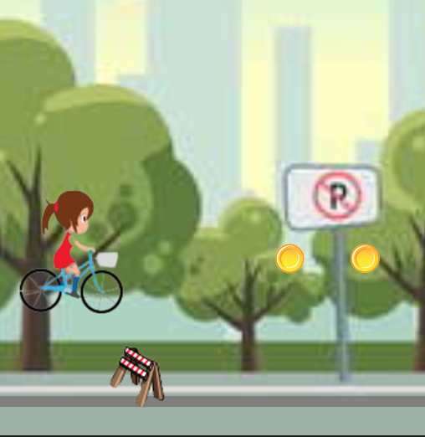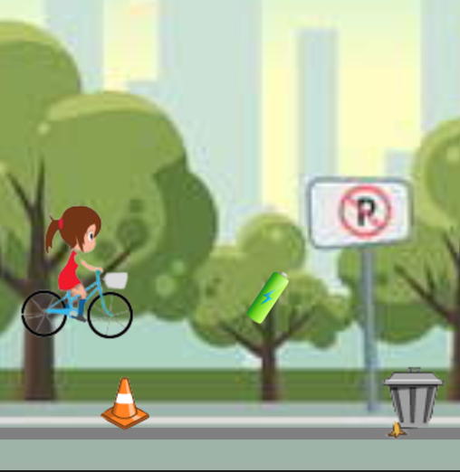

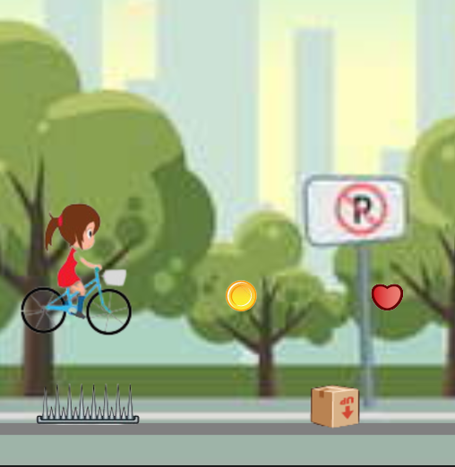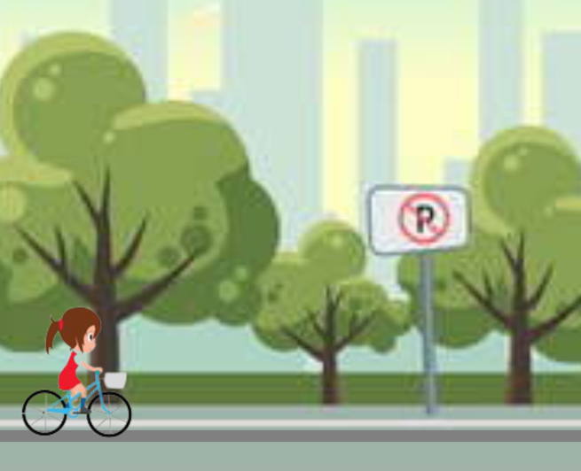

How do you plan to make your game engaging?

Initially, when the game starts, speed of the player would be slow, but

gradually, as all the hurdles start spawning, energy_boosters would be

available to the player to increase the speed. Coins have to be collected in

order to win the game. Limited lives are available to make the game

challenging. If the player bumps into of the hurdles, player would either lose

a life along with decrement of velocity or would directly lose the game.

Keeping in mind all the difficulties, to ease the player, a life would be made

available to the player at regular intervals, to ensure the game balance.