Deconstruction of original game

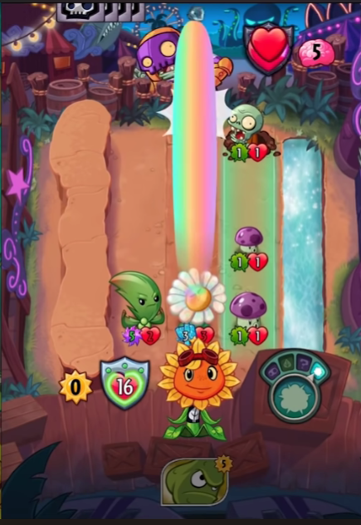

[3D WORLD]

-Fight system-

{raycast to the other layer}

[3D WORLD]

-Placing system- {instances 3D of scriptable objs}

Layer 1

Layer 2

[UI]

-Turn system- {state machine}

[UI]

-Health & Mana system-

{variables}

[UI]

-Hand system-

{instances 2D of scriptable objs}

UML Diagram

