IDCMS Core Framework

Database Comparability

- Each database vendor has their own way structure database and might not be same as Mysql.
- To migrate to other database you must use bellow software.
Porting Microsoft Sql Server : Microsoft Sql Server Assistant For Mysql.
Porting Oracle : Sql Developer.

Porting to Postgress : Enterprise Db Migration Wizard For Mysql

Porting to Db2 : Using xxx software.

- All new creation tables must follow below basic data definition language (DDL).

Field | Type | Extra
tableId | Interger/numeric | Auto increment/sequence
isDefault | Bolean/tinyint
isNew | Bolean/tinyint
isDraft | Bolean/tinyint
isUpdate | Bolean/tinyint
isDelete | Bolean/tinyint
isActive | Bolean/tinyint
isApproved | Bolean/tinyint
By | int
Date | Date
Time | Time

- When creating the data definition language above, don’t’ yet create field date or time, some database cannot understand Mysql definition on Date and Time field. Please create after completion of migration on database created.
- If the client wanted security, please implement foreign key. There are overhead of database query when implement foreign key/composite key. If on update or on delete, programmer must create each function on each table update or delete.

- UTF8- This is capability database accepting special character like Chinese or Japanese. By default on Mysql please put collation utf8_unicode_ci.

- Postgress Database don’t create sequence as oracle sql developer .Have to manually create the sequence.

- Oracle automatically creates a trigger + sequence when creating new table. This is performance risk since it will call 3 function like below. There for should avoid it and just put in the insert query.
- Trigger
- Sequence from dual table
- insert query
- This is not ORM-object relation manager. It just a connection to the database. The more you declare your object into ORM.The more houngry resources your system and most of them got confusable term like singular,plural,many,belongto or whatsoever.No point to tweak if used ORM framework.
- If you import Mysql to Oracle database, it wil default the create table to uppercase. You have to change manually each column name.
E.g
alter table "JOKERS"."RELIGION" rename column "RELIGIONID" to "religionId"
All query must be added to double quote .Quite odd
E.g
Select * from RELIGION WHERE “religionId”=1

- For master and detail format will used additional flag as isDraft and isApproved.When new record the master table will update the isDraft=1 .When Button approved is Clicked,It will change the isDraft =0 and updated the isAppoved =1.

- Don’t use truncate to test date.used instead delete from table name.The reason was foreign key issue.

Basic Structure of System

- Basically any application system has crud functionality.
** CRUD – Create, Read, Update, Delete
- Structure Query Language is dependable on database vendor and might not same at all.
Below is the example on each basic crud on each vendor.

- On a system, sometime we need to check duplicate of the record. Sample as below.

- Business logic prefers put in the php code rather the store procedure. Most company don’t afford to paid high salary database administrator. Much easier to maintain.

** Please use at the leaf menu to generate table to form. After that,then you can edit the file and todo adjustment

- For main form , only accept data as root data .

6 To output the class please using like below. Before using constructor .Eliminated because wanted more cleaner structure.

/**
* Declare object
**/
$religion_obj = new religion();
if(isset($_SESSION['staffId'])){
$religion_obj->staffId = $_SESSION['staffId'];
}
if(isset($_SESSION['vendor'])){
$religion_obj-> vendor = $_SESSION['vendor'];
}
$religion_obj -> execute();

/**
* crud -create,read,update,delete
**/
if(isset($_POST['method'])) {
if(isset($_POST['leafId'])){
$religion_obj-> leafId = $_POST['leafId'];
}
if($_POST['method']=='create') {
$religion_obj->create();
}
if(isset($_POST['filter'])){
$religion_obj->filter = $_POST['filter'];
}
if(isset($_POST['query'])){
$religion_obj->query = $_POST['query'];
}
if(isset($_POST['order'])){
$religion_obj-> order= $_POST['order'];
}
if(isset($_POST['sort_field'])){
$religion_obj-> sort_field= $_POST['sort_field'];
}
if($_POST['method']=='read') {
$religion_obj->read();
}
if(isset($_POST['religionId'])) {
$religion_obj->religionId = $_POST['religionId'];
if($_POST['method']=='save') {
$religion_obj->read();
}
if($_POST['method']=='delete') {
$religion_obj->delete();
}
}
}

if(isset($_GET['method'])) {
if(isset($_GET['leafId'])){
$religion_obj-> leafId = $_GET['leafId'];
}
if(isset($_GET['field'])) {
if($_GET['field']=='staffId') {
$religion_obj->staffId();
}
}
if(isset($_GET['religionDesc'])) {
if(strlen($_GET['religionDesc']) > 0 ) {
$religion_obj->duplicate();
}
}
if(isset($_GET['mode'])){
if($_GET['mode']=='excel') {
$religion_obj->excel();
}
}
}

Apache Server Setting

1. Set server name 127.0.0.1 or Internet Protocol provided instead of localhost or computer ip to reduce server speed to lookup domain at httpd.conf

2.Please paste below code to httpd.conf to increase website performance.
<IfModule mod_deflate.c>

AddOutputFilterByType DEFLATE text/html text/plain text/xml text/css text/javascript
AddOutputFilterByType DEFLATE application/xml application/xhtml+xml application/rss+xml
AddOutputFilterByType DEFLATE application/javascript application/x-javascript
#AddOutputFilterByType DEFLATE application/x-httpd-php

BrowserMatch ^Mozilla/4 gzip-only-text/html
BrowserMatch ^Mozilla/4\.0[678] no-gzip
BrowserMatch \bMSI[E] !no-gzip !gzip-only-text/html

SetEnvIfNoCase Request_URI \.(?:gif|jpe?g|png)$ no-gzip dont-vary
SetEnvIfNoCase Request_URI \.(?:exe|t?gz|zip|bz2|sit|rar)$ no-gzip dont-vary
SetEnvIfNoCase Request_URI \.(?:pdf|doc)$ no-gzip dont-vary
SetEnvIfNoCase Request_URI \.(?:avi|mov|mp3|mp4|rm)$ no-gzip dont-vary

</IfModule>
Header unset Cache-Control
Header unset Last-Modified
Header unset ETag
FileETag None
<FilesMatch "\\.(ico|jpg|jpeg|png|gif|js|css|pdf|flv|swf)$">
ExpiresActive On
ExpiresDefault "access plus 1 year"
</FilesMatch>

Mysql Extra Configuration

1.Please add below extra code to reduce speed domain lookup
skip-name-resolve

Using above setting you will get as below.

1. Above score 97 / 100 on yslow(Yahoo Speed Test Page) and 98/100 pagespeed (Google Speed Test Page).

Output Yslow on above setting

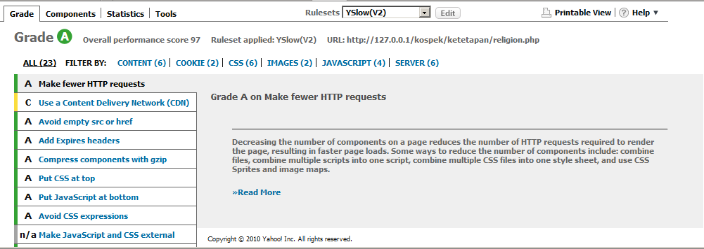

Ouput on Pagespeed.

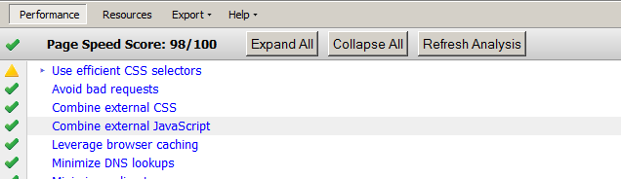

2. Have test using cdn method and its proven unpractical. JavaScript parse not so fast so second server might be error.

Testing Second Web Server : Omni Web Server.

