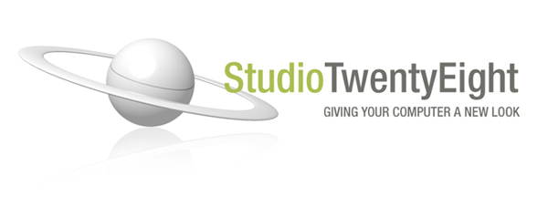
Blueticons for Windows XP

Terms of Use:

These icons are for personal use only. You can’t use these icons on personal website, software, prints, or any other place without permission from StudioTwentyEight. The icons must not be redistributed, sold or exchanged without written permission. You may use these icons as avatars, signatures or display pictures on forums or instant messaging software.
If you want to create an emoticon pack for any software or website contact StudioTwentyEight for permission.

By downloading this file you agree to follow these terms of use.

Information:

The icon set includes 27 icons and PNG images for Windows XP. All icons are from 16x16 to 128x128. PNG images are 256x256.

