**Project w.r.t. teacher**

log in:

Input:

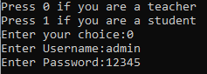

Output:

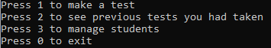

* Make a test:

Input:

Output:

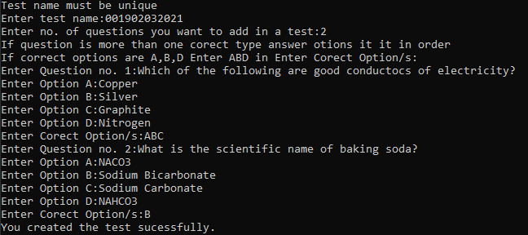

* Test paper table created:

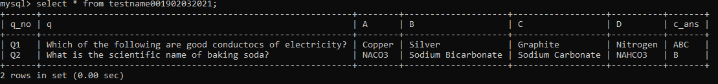

* Test paper updated to existing students table:

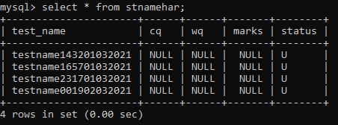

* View past papers:

Input: 

Output:

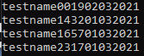

* Manage students:

Input: 

Output:

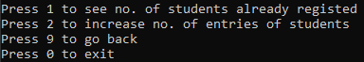

* manages current no. of students:

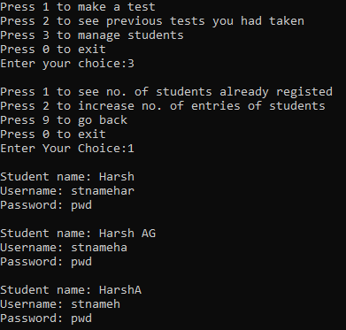

* Entering data of students:

Input:

Output:

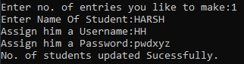

1. Data added to login table:

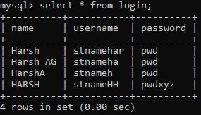

1. Student tables created:

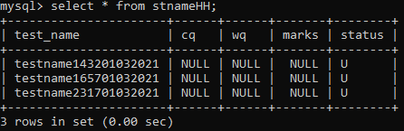

**Project w.r.t. student**

Login:

Input:

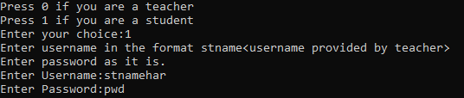

Output:

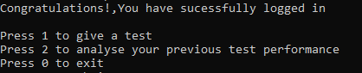

* Student gives a test:

Input: 

Output:

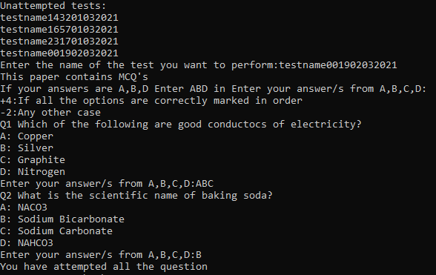

* Data updated in student table:

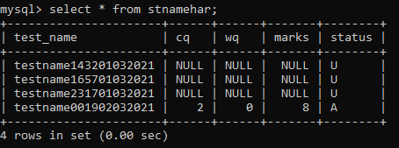

* Student analyzes his performance :

Input: 

Output:

