**Robotiğe Giriş Projesi**

**Danışman ; Doç.Dr. Akif Durdu**

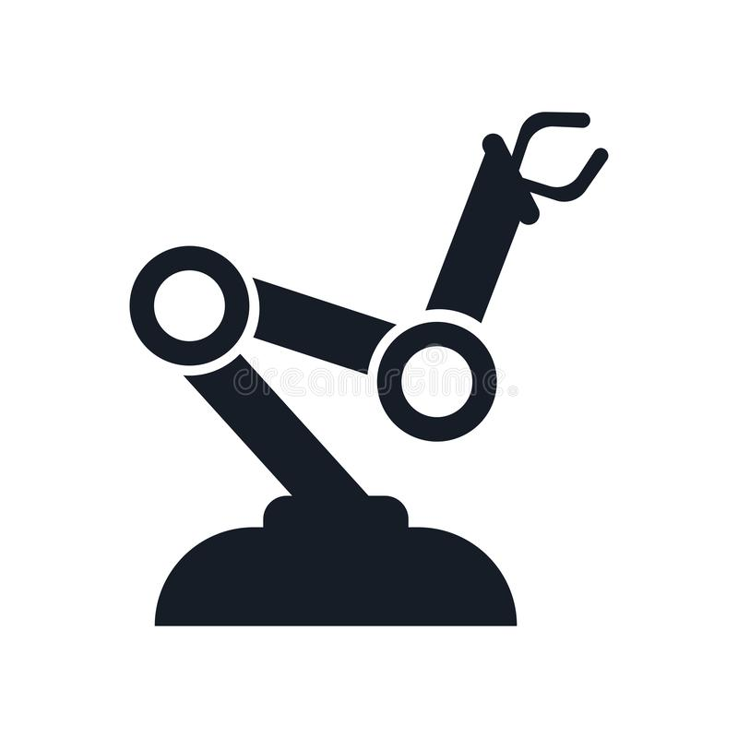

**Hazırlayan; Ali HAN**

**No; 181222089**

**Forward Kinematiği Kod bloğu**

**{**

% --- Executes on button press in btn_forward.

function btn_forward_Callback(hObject, eventdata, handles)

% hObject handle to btn_forward (see GCBO)

% eventdata reserved - to be defined in a future version of MATLAB

% handles structure with handles and user data (see GUIDATA)

Th_1 = str2double(handles.Theta_1.String)*pi/180;

Th_2 = str2double(handles.Theta_2.String)*pi/180;

Th_3 = str2double(handles.Theta_3.String)*pi/180;

L_1 = 20;

L_2 = 50;

L_3 = 40;

L(1) = Link([0 L_1 0 pi/2]);

L(2) = Link([0 0 L_2 0]);

L(3) = Link([0 0 L_3 0]);

Robot = SerialLink(L);

Robot.name = 'Alinin Robotu';

Robot.plot([Th_1 Th_2 Th_3]);

T = Robot.fkine([Th_1 Th_2 Th_3]);

H = T.T();

handles.Pos_X.String = num2str(floor(H(1,4)));

handles.Pos_Y.String = num2str(floor(H(2,4)));

handles.Pos_Z.String = num2str(floor(H(3,4)));

**}**

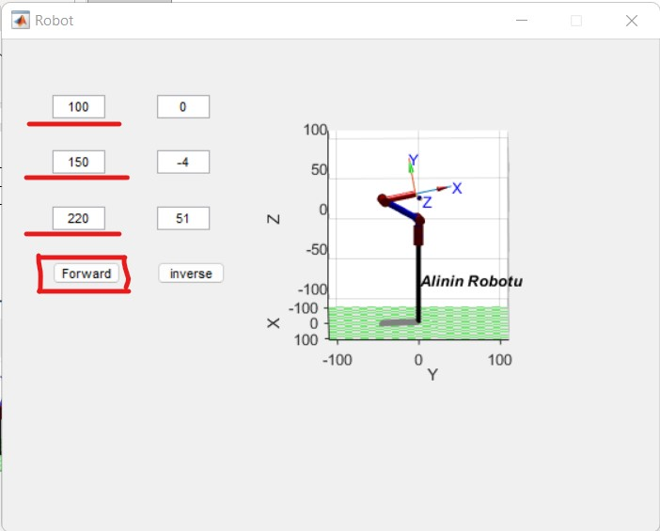 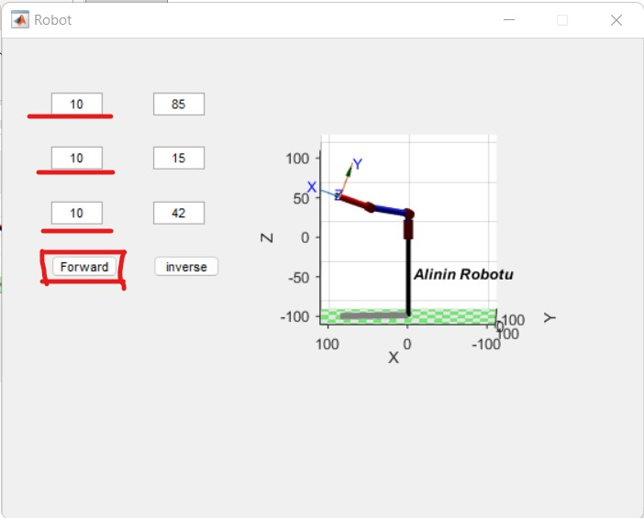

**İnverse Kinematiği Kod Bloğu {**

% --- Executes on button press in btn_inverse.

function btn_inverse_Callback(hObject, eventdata, handles)

% hObject handle to btn_inverse (see GCBO)

% eventdata reserved - to be defined in a future version of MATLAB

% handles structure with handles and user data (see GUIDATA)

PX = str2double(handles.Pos_X.String);

PY = str2double(handles.Pos_Y.String);

PZ = str2double(handles.Pos_Z.String);

L_1 = 20;

L_2 = 50;

L_3 = 40;

L(1) = Link([0 L_1 0 pi/2]);

L(2) = Link([0 0 L_2 0]);

L(3) = Link([0 0 L_3 0]);

Robot = SerialLink(L);

Robot.name = 'Alinin Robotu';

T = [ 1 0 0 PX;

0 1 0 PY;

0 0 1 PZ;

0 0 0 1 ];

J = Robot.ikine(T, [0 0 0],'mask',[1 1 1 0 0 0]) * 180/pi;

disp(J);

handles.Theta_1.String = num2str(floor(J(1)));

handles.Theta_2.String = num2str(floor(J(2)));

handles.Theta_3.String = num2str(floor(J(3)));

Robot.plot(J*pi/180);

**}**

