CATANALYZER
An Evaluation Tool for Understanding Static Positions in Settlers of Catan

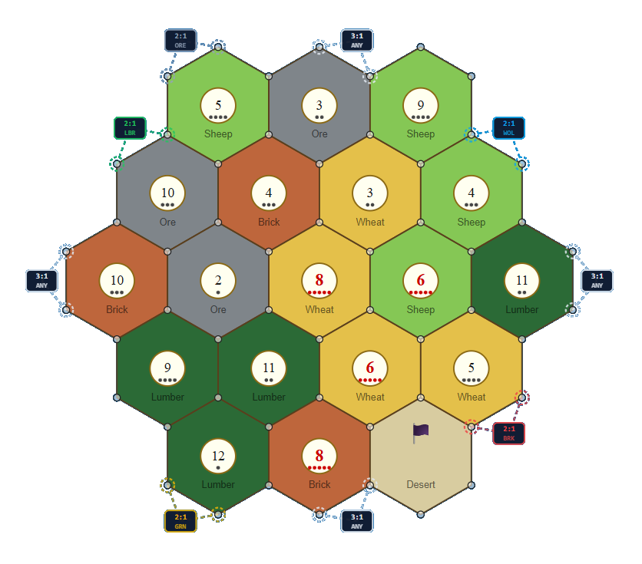

J. J. Olivo / alienproxy / jolivo.xenius.org

Table of Contents
1. Overview 3
2. Max Purchases 3
2.1 What It Measures 3
2.2 Item Cost Table (Cheapest → Most Expensive) 3
2.3 Bank Trading 4
2.4 Algorithm 4
2.5 Interpretation 4
3. Max VP Gain 4
3.1 What It Measures 4
3.2 Item Cost Table (Highest VP → Lowest) 4
3.3 Why Roads Are Excluded 5
3.4 Algorithm 5
3.5 Interpretation 5
4. Comparing the Two Metrics 5
4.1 When They Agree 5
4.2 When They Diverge 5
4.3 The Lopsidedness Problem 5
5. Mathematical Significance 6
5.1 The A × B Product 6
5.2 The VP Floor Proposal 6
5.3 The Geometric Mean √(A × B) 6
5.4 The VP/Count Ratio 6
5.5 Recommendation 6
6. Port Adjustments 7
7. Summary 7
8. Resource Diversification Index (RDI) 7
8.1 Pips: The Common Currency 7
8.2 The Formula 7
8.3 Component A — Portfolio Coverage (C) 8
8.4 Component B — Build-Pair Synergy (S) 8
8.5 Component C — Income Entropy (H) 8
8.6 Grading and Interpretation 8
8.7 Relationship to the Purchasing-Power Metrics 8
9. Summary of All Three Metrics 8

Catanalyzer & Purchasing Power Metrics
Max Purchases · Max VP Gain
Definition, Calculation, and Mathematical Analysis

1. Overview
My name is Jose Jaime Olivo, and my friends call me Jimi. I developed Catanalyzer with the help of AI tools like Claude Code and Google Gemini. I have decades of experience as a software QA analyst, Software Test Engineer, and technical writer. One of my hobbies is designing board games, and related to that, I have an avid interest in Settlers of Catan. You can find me on Catan Universe playing as “Deophage.” And maybe you can join my guild, Catanthropology!
The Catanalyzer tracks each player's cumulative resource earnings turn by turn. Two purchasing-power metrics are computed from these snapshots to give different perspectives on a player's economic position. Neither metric reflects actual in-game spending — resources are never deducted from the simulation. Instead, each metric answers a hypothetical question: "If this player spent all of their accumulated resources right now, what is the best possible outcome?"
Both metrics use the same bank-trading model: a player may trade surplus resources for needed ones at a fixed exchange rate, adjusted downwarAd if they control a port.

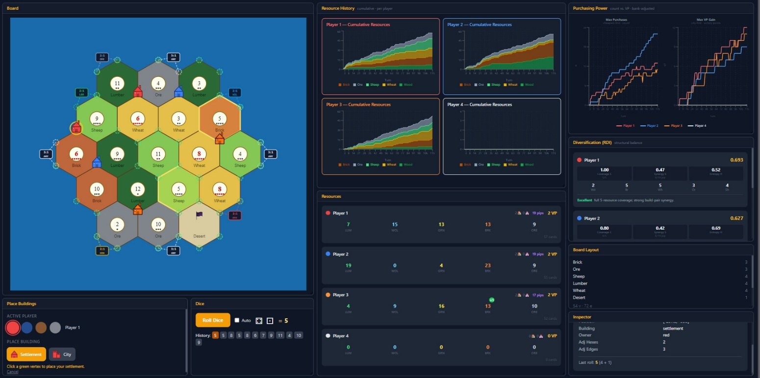
Figure 1: A screenshot of the Catanalyzer in action.

2. Max Purchases

2.1 What It Measures
Max Purchases answers: "How many items can this player buy simultaneously, trading with the bank as needed?" It treats all purchasable items as equal regardless of their strategic worth — one road counts the same as one city. The score is a raw count of transactions.
A high Max Purchases score indicates a large, versatile resource hand capable of many economic transactions. It rewards breadth and volume over strategic specialization.

2.2 Item Cost Table (Cheapest → Most Expensive)
Item | Wood | Brick | Wheat | Sheep | Ore | Total
Road | 1 | 1 | 0 | 0 | 0 | 2
Dev Card | 0 | 0 | 1 | 1 | 1 | 3
Settlement | 1 | 1 | 1 | 1 | 0 | 4
City | 0 | 0 | 2 | 0 | 3 | 5

2.3 Bank Trading
When a player is short of a required resource, they may trade surplus of any other resource at the bank rate. The default rate is 4:1 (give 4 of one type, receive 1 of any type). Port ownership reduces this threshold:
- Generic 3:1 port → any 3 identical resources for 1 of any type
- Specific 2:1 port → 2 of that specific resource for 1 of any type
The simulator tracks port ownership in real time. As soon as a player places a settlement or city on a port vertex, their effective trade rate updates for the affected resource.

2.4 Algorithm
The algorithm is a greedy cheapest-first loop:
resources ← player's current hand score ← 0 loop: for each item (road, dev card, settlement, city): if item is affordable (using bank trades): buy item, deduct cost, score += 1 restart loop from road if nothing was bought this pass: stop
"Affordable" is checked by first covering any shortfall via bank trades, consuming only surplus resources (i.e. those above what the current purchase itself requires). If a shortfall cannot be covered, the item is skipped.

2.5 Interpretation
High score: broad, balanced hand with many tradeable surpluses. Typical for players who collect lumber and brick heavily (roads are very cheap).
Low score: hand concentrated in one or two resources that cannot be efficiently traded into variety.
Key limitation: roads (0 VP) inflate the count. A player with 20 lumber and 20 brick scores extremely high despite having no ability to earn victory points from those resources.

3. Max VP Gain

3.1 What It Measures
Max VP Gain answers: "How many victory points could this player purchase right now, trading with the bank as needed?" It ignores items that give no direct VP and prioritizes the most valuable purchases first.
A high Max VP Gain score indicates a hand capable of converting resources into points efficiently. It rewards wheat and ore accumulation (cities = 2 VP each) over cheap, VP-neutral transactions.

3.2 Item Cost Table (Highest VP → Lowest)
Item | Wood | Brick | Wheat | Sheep | Ore | Total | VP Value
City | 0 | 0 | 2 | 0 | 3 | 5 | 2
Settlement | 1 | 1 | 1 | 1 | 0 | 4 | 1
Dev Card | 0 | 0 | 1 | 1 | 1 | 3 | 1

3.3 Why Roads Are Excluded
Roads cost 1 wood + 1 brick and yield 0 victory points. Including them would cause the algorithm to "spend" resources on transactions that produce no progress toward the metric's objective. Excluding roads ensures that every purchase in this metric contributes positively to the score.

3.4 Algorithm
The algorithm is a greedy highest-value-first loop:
resources ← player's current hand score ← 0 loop: for each item (city, settlement, dev card): if item is affordable (using bank trades): buy item, deduct cost, score += item.VP restart loop from city if nothing was bought this pass: stop

3.5 Interpretation
High score: hand rich in wheat and ore, capable of chaining city purchases (2 VP each). Also benefits from sheep, which enables dev cards and settlements.
Low score: hand dominated by lumber and brick — resources not required by any VP-generating item. These players may score very high on Max Purchases while scoring 0 here.
Key limitation: a player with exactly enough for one city (5 cards: 2 wheat + 3 ore) scores 2 VP, while a player with 12 mixed resources may score only 2–3 VP if diversity is lacking. The metric does not reward card volume, only strategic alignment.

4. Comparing the Two Metrics

4.1 When They Agree
A player with a large, well-diversified hand scores high on both metrics. They have enough cheap resources to chain many purchases (Count) and enough wheat/ore/sheep to convert resources into VP items. This represents the strongest overall economic position in Catan.

4.2 When They Diverge
Divergence reveals strategic specialization:
- High Count, Low VP Gain: lumber/brick specialist. Many roads can be built but no VP items are within reach.
- Low Count, High VP Gain: wheat/ore specialist. Can purchase a city or two but has little transactional breadth.
- Both low: early game or resource drought — hand too small to support any meaningful purchasing.

4.3 The Lopsidedness Problem
The two metrics are computed from the same resource snapshot but use independent greedy passes — they do not share state. A player who simply accumulates more cards of any type will score higher on both, making the metrics positively correlated with total card count as well as with strategic position. Separating the effect of card volume from strategic alignment requires normalization.

5. Mathematical Significance

5.1 The A × B Product
Multiplying A (Count) × B (VP Gain) yields a product that collapses to zero whenever the player has no VP-purchasable items — even if their Count score is very high. A lumber/brick specialist with Count = 15 and VP = 0 scores 0, indistinguishable from a player with no resources at all. This makes the raw product an unreliable combined metric.

5.2 The VP Floor Proposal
One proposed fix is to add a constant floor to VP Gain (e.g. floor = 2, representing the 2 starting VP every Catan player holds). Algebraically:
A × (2 + VP_extra) = 2A + A × VP_extra
This decomposes into two terms. The first (2A) is simply twice the Count metric and adds no new information. The second (A × VP_extra) is the original product, which still collapses to zero for VP_extra = 0. The floor softens but does not eliminate the collapse problem, and it mixes a static game constant (starting VP) with a dynamic resource metric.

5.3 The Geometric Mean √(A × B)
The geometric mean is the mathematically principled way to combine two metrics of different scales. It has two key properties:
- It returns zero only when either metric is exactly zero — the same collapse condition.
- It penalizes lopsidedness: Count = 10, VP = 2 → √20 ≈ 4.5; Count = 5, VP = 4 → √20 ≈ 4.5; Count = 7, VP = 7 → √49 = 7.0. Equal "products" have the same geometric mean regardless of how the balance is distributed.
With a VP floor of 2 applied before the geometric mean:
Score = √(Count × max(2, VP_Gain))
This produces a well-behaved curve: never collapses to zero, rewards balance over specialization, and grows sublinearly (diminishing returns for extreme values on either axis).

5.4 The VP/Count Ratio
VP_Gain ÷ Count measures strategic efficiency: the average VP earned per transaction. A high ratio means the player is converting resources into points with minimal waste. A low ratio means high transactional throughput but low strategic return — busy buying cheap items rather than impactful ones.
This ratio is undefined when Count = 0 (empty hand) and produces zero when VP = 0, making it most useful in mid-to-late game when both metrics are non-zero.

5.5 Recommendation
The two most interpretable derived metrics are:
- Geometric mean √(Count × VP_floored) — combined purchasing power, balanced across both dimensions.
- Ratio VP / Count — strategic efficiency, measuring how well the player is converting economic activity into victory points.
A unified algorithm that uses VP-weighted item costs from the start — buying whichever item maximizes VP-per-resource-spent at each step — would replace both separate metrics with a single, coherent score.

6. Port Adjustments
Both metrics incorporate the player's effective bank trade ratio, updated live as settlements and cities are placed. Port access compresses the trade threshold from 4:1 to 3:1 or 2:1, which directly amplifies both metrics for the affected resources.
Example: a player with a 2:1 Ore port and 10 ore can convert that ore into needed wheat or sheep at half the normal cost, making city purchases (2 wheat + 3 ore) reachable from a more concentrated hand. Both Count and VP Gain scores increase meaningfully for that player relative to the same hand without port access.
Port adjustments propagate automatically — no manual intervention is required in the simulator.

7. Summary
 | Max Purchases | Max VP Gain
Question answered | How many items can I buy? | How many VP can I earn?
Priority order | Cheapest first | Most valuable first
Roads included? | Yes | No (0 VP)
Score unit | Count of purchases | Victory points
Rewards | Breadth, volume | Wheat/ore alignment
Collapses when | Hand is empty | No VP items affordable

The two metrics are complementary. Used together, they reveal whether a player's economic growth is broad (high Count, low VP), strategic (low Count, high VP), or balanced (both high) — each a distinct and meaningful position in a Catan game.

8. Resource Diversification Index (RDI)
The two purchasing-power metrics above read a player’s current hand. The Resource Diversification Index takes a structural view instead: it scores the board position itself — where a player has settled and what those placements can produce over the long run — rather than any single snapshot of cards. It answers: “How healthy and resilient is this player’s resource engine?” RDI is a single number between 0 and 1.

8.1 Pips: The Common Currency
Every input to RDI is measured in pips — the probability dots printed on a number token. A token showing n contributes min(n−1, 13−n) pips, so 6 and 8 are worth 5 pips each while 2 and 12 are worth 1. Pips approximate how often a hex actually pays out. A city collects at double rate, so it contributes double pips (weight ×2) versus a settlement (weight ×1). Desert hexes and hexes with no token contribute nothing and are ignored.
For each player the simulator sums pips two ways: p_r, the pips accruing to each of the five resources (Wood, Brick, Wheat, Ore, Sheep), and p_n, the pips landing on each active dice number. P_total is the sum of all resource pips. The robber roll (7) is excluded, leaving ten active numbers: N = {2, 3, 4, 5, 6, 8, 9, 10, 11, 12}.

8.2 The Formula
RDI is a weighted blend of three components, each normalised to the range 0–1:
RDI = 0.40·C + 0.40·S + 0.20·H
Coverage (C) and Synergy (S) carry equal weight (0.40 each) because breadth and buildability are the two pillars of a workable economy; Entropy (H) is a 0.20 refinement that rewards steady, well-timed income.

8.3 Component A — Portfolio Coverage (C)
Coverage measures how many of the five resources the player produces at all. With U = the count of resources holding at least one pip:
C = U / 5
A player touching all five resources scores C = 1.0; one drawing only two resources scores 0.4. Coverage rewards not being locked out of any resource, which would otherwise force expensive bank trades.

8.4 Component B — Build-Pair Synergy (S)
Coverage alone can be misleading: a scattering of single pips across five resources looks diverse but builds nothing. Synergy measures whether the pips actually pair up into Catan’s buildable recipes. Three complementary pairs are scored by their weaker half (a recipe is gated by whichever input is scarcer):
Build Pair | Resources | Primarily Enables | Synergy Term
Road pair | Wood + Brick | Roads, settlements | min(Wood, Brick)
Scale pair | Wheat + Ore | Cities | min(Wheat, Ore)
Flex pair | Wheat + Sheep | Dev cards, settlements | min(Wheat, Sheep)
The raw synergy is the sum of the three terms, normalised by total pips so the score stays in 0–1:
S_raw = min(Wood, Brick) + min(Wheat, Ore) + min(Wheat, Sheep)
S = S_raw / P_total (S = 0 when P_total = 0)
A high S means most of the player’s income lands in matched pairs ready to spend; a low S means the pips exist but sit stranded in resources that don’t combine into anything.

8.5 Component C — Income Entropy (H)
Entropy measures how evenly a player’s income is spread across the dice. It is the normalised Shannon entropy of the number-pip distribution. With pᵢ = p_n / P_total for each active number:
H = −( Σ pᵢ · ln pᵢ ) / ln(10)
The divisor ln(10) is the maximum possible entropy across the ten active numbers, which rescales H to 0–1. H ≈ 1 means income is spread evenly across many numbers — something almost always trickles in. A low H means income is concentrated on one or two numbers: lucrative when they hit, but “bursty” and prone to long droughts when the robber or a cold streak lands on them.

8.6 Grading and Interpretation
The composite RDI is bucketed into a qualitative grade for quick reading:
RDI Range | Grade | Reading
< 0.35 | Fragile | Narrow, poorly-paired, or bursty engine
0.35 – 0.50 | Developing | Workable but with a clear structural gap
0.50 – 0.65 | Solid | Balanced, buildable, dependable income
≥ 0.65 | Excellent | Broad coverage, strong pairing, steady flow
Alongside the grade the panel surfaces plain-language notes derived from the components: a narrow resource base (U ≤ 2) or full five-resource coverage (U = 5); weak pairing (S < 0.15) or strong build-pair synergy (S ≥ 0.30); and bursty income concentrated on few numbers (H < 0.5) or income well spread across the dice (H ≥ 0.8).

8.7 Relationship to the Purchasing-Power Metrics
RDI is deliberately orthogonal to Max Purchases and Max VP Gain. Those two read the accumulated hand and answer “what can I do right now?”; RDI reads the board and answers “will this engine keep delivering?” A player can post a high Max VP Gain from a lucky hand on a fragile board (low RDI), or show an Excellent RDI early while their hand — and therefore both purchasing metrics — is still empty. Read together, the purchasing-power pair describes the present, and RDI describes the position’s long-run ceiling.

9. Summary of All Three Metrics
The simulator reports three complementary lenses on a player’s economy. The first two are hand-based and momentary; the third is board-based and structural.
Aspect | Max Purchases | Max VP Gain | RDI
Question answered | How many items can I buy? | How many VP can I earn? | How resilient is my engine?
Measured from | Current hand | Current hand | Board placements (pips)
Score range | Count of purchases | Victory points | 0 – 1
Rewards | Breadth, volume | Wheat/ore alignment | Coverage, synergy, even income
Collapses when | Hand is empty | No VP items affordable | No settlements placed
Max Purchases and Max VP Gain capture what a hand can convert into today; RDI captures whether the underlying board will keep that hand replenished tomorrow. A player strong on all three — broad buyable hand, VP-aligned resources, and a high-coverage, well-paired, evenly-spread board — holds the most durable economic position in the game.
The end. More will be added as it’s developed. I hope you enjoy it!
-Jimi

