|  |  |  |  |  |  |  |  |  |  |  |  |  |  |
| --- | --- | --- | --- | --- | --- | --- | --- | --- | --- | --- | --- | --- | --- |
| Hz | 10 | 30 | 50 | 70 | 100 | 300 | 500 | 700 | 1k | 3k | 5k | 7k | 10k |
| mV | 1V | 1V | 1V | 1V | 1V | 1V | 800 | 640 | 480 | 140 | 80 | 60 | 40 |
| dB | 0 | 0 | 0 | 0 | 0 | 0 | -1.9382 | -3.8764 | -6.37518 | -17.0774 | -21.9382 | -24.437 | -27.9588 |

二階被動低通濾波器(10nF)

06050651 蘇峻緯

06050676 陳彥廷

06050083 黃彥辰

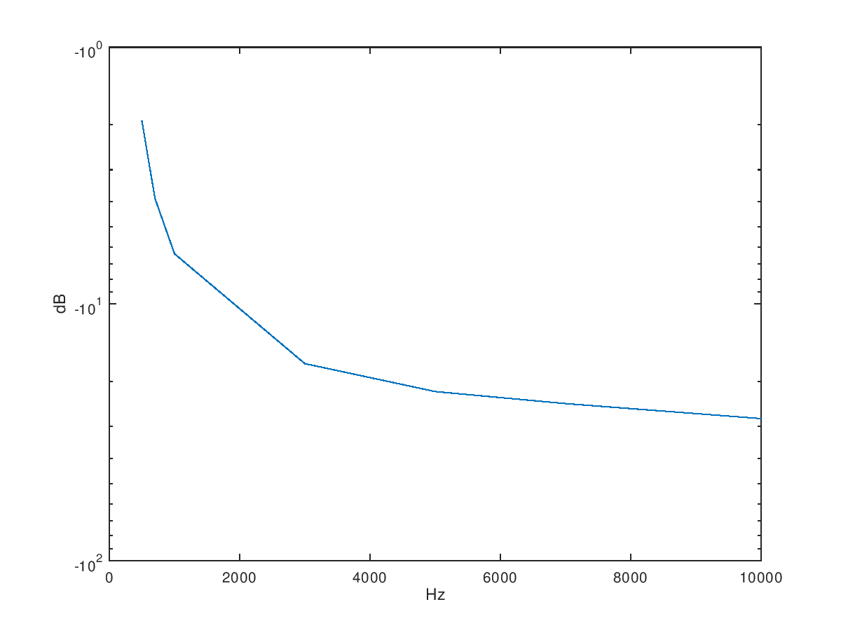

二階被動低通濾波器(3.3nF)

|  |  |  |  |  |  |  |  |  |  |  |  |  |  |
| --- | --- | --- | --- | --- | --- | --- | --- | --- | --- | --- | --- | --- | --- |
| Hz | 10 | 30 | 50 | 70 | 100 | 300 | 500 | 700 | 1k | 3k | 5k | 7k | 10k |
| mV | 1000 | 1200 | 1200 | 1200 | 1200 | 1200 | 1160 | 1080 | 1000 | 500 | 320 | 240 | 140 |
| dB | 0 | 1.58362 | 1.58362 | 1.58362 | 1.58362 | 1.58362 | 1.28916 | 0.66848 | 0 | -6.02060 | -9.89700 | -12.39578 | -17.07744 |

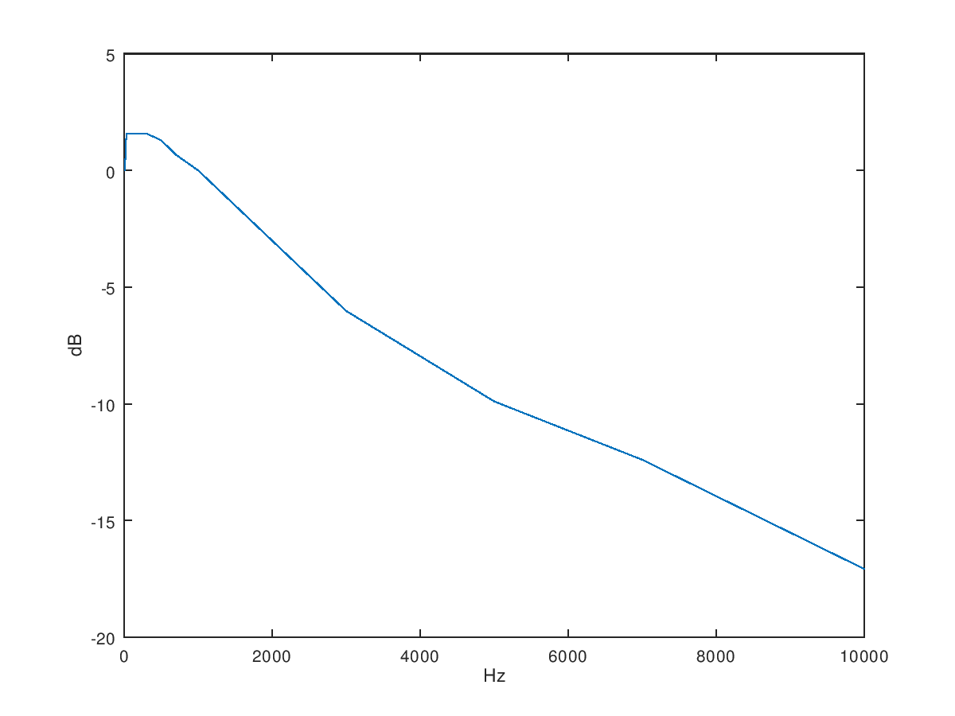

二階被動低通濾波器(3.3nF)

二階被動高通濾波器(2.2nF)

|  |  |  |  |  |  |  |  |  |  |  |  |  |
| --- | --- | --- | --- | --- | --- | --- | --- | --- | --- | --- | --- | --- |
| Hz | 1k | 3k | 5k | 7k | 10k | 30k | 50k | 70k | 100k | 300k | 500k | 1000k |
| mV | 3200 | 16500 | 25000 | 46000 | 58000 | 80000 | 85000 | 86000 | 86000 | 86000 | 86000 | 86000 |
| dB | -29.8970 | -15.6503 | -12.0412 | -6.7448 | -4.7314 | -1.9382 | -1.4116 | -1.3100 | -1.3100 | -1.3100 | -1.3100 | -1.3100 |

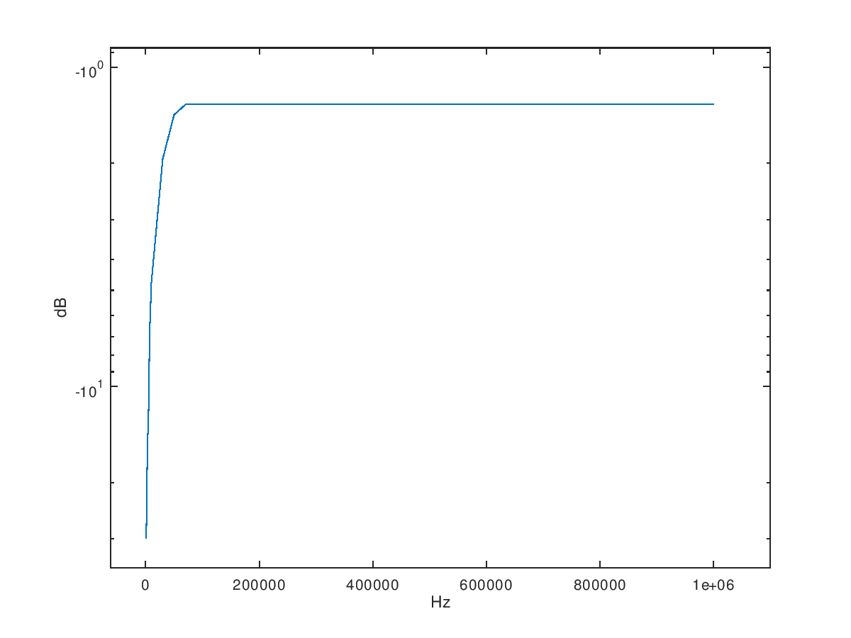

|  |  |  |  |  |  |  |  |  |  |  |  |  |
| --- | --- | --- | --- | --- | --- | --- | --- | --- | --- | --- | --- | --- |
| Hz | 1k | 3k | 5k | 7k | 10k | 30k | 50k | 70k | 100k | 300k | 500k | 1000k |
| mV | 60 | 60 | 100 | 120 | 180 | 320 | 360 | 360 | 380 | 380 | 360 | 340 |
| dB | -24.4370 | -24.4370 | -20.0000 | -18.4164 | -14.8945 | -9.8970 | -8.8739 | -8.8739 | -8.4043 | -8.4043 | -8.8739 | -9.3704 |

二階被動高通濾波器(1nF)

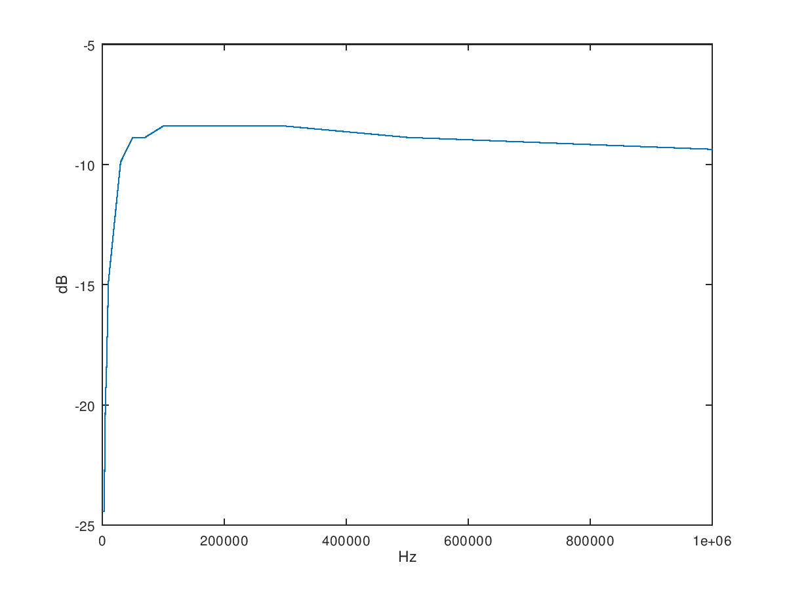

二階被動帶通濾波器(470nF)

|  |  |  |  |  |  |  |  |  |  |  |  |  |  |
| --- | --- | --- | --- | --- | --- | --- | --- | --- | --- | --- | --- | --- | --- |
| Hz | 500 | 700 | 1k | 3k | 5k | 7k | 10k | 30k | 50k | 70k | 100k | 300k | 500k |
| mV | 16 | 16 | 26 | 40 | 54 | 72 | 32 | 20 | 13.6 | 9.6 | 4.8 | 4.8 | 4.8 |
| dB | -35.918 | -35.918 | -31.701 | -27.959 | -25.352 | -22.853 | -29.897 | -33.979 | -37.329 | -40.355 | -46.375 | -46.375 | -46.375 |

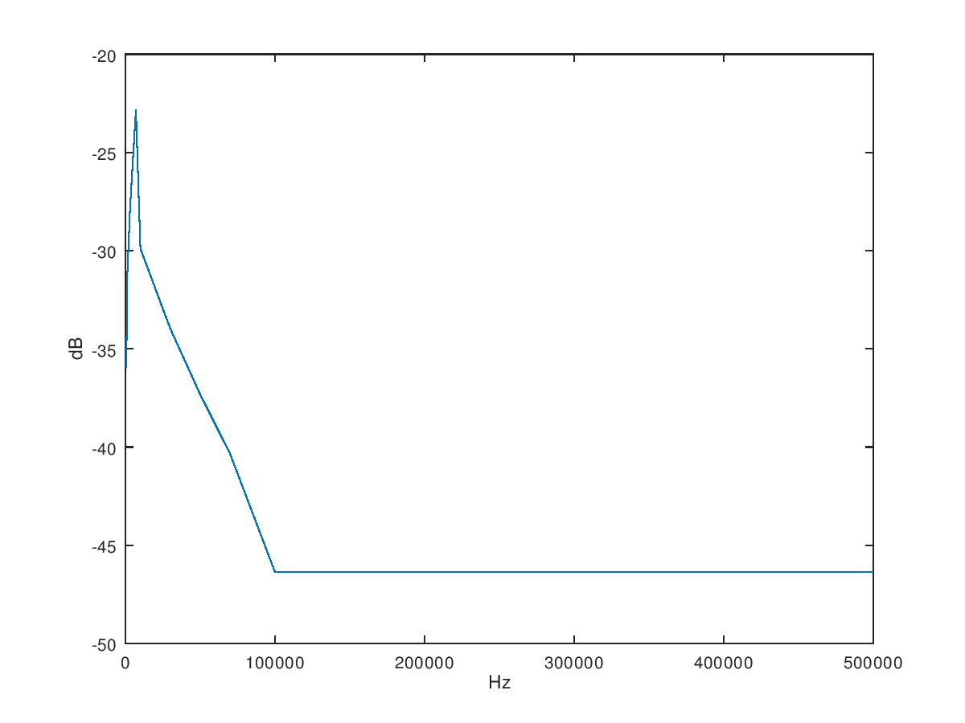

二階被動帶通濾波器(10nF)

|  |  |  |  |  |  |  |  |  |  |  |  |  |  |
| --- | --- | --- | --- | --- | --- | --- | --- | --- | --- | --- | --- | --- | --- |
| Hz | 500 | 700 | 1k | 3k | 5k | 7k | 10k | 30k | 50k | 70k | 100k | 300k | 500k |
| mV | 3.2 | 4 | 4 | 4 | 5.6 | 12 | 17 | 50 | 50 | 50 | 50 | 50 | 50 |
| dB | -49.897 | -47.959 | -47.959 | -47.959 | -45.036 | -38.416 | -35.391 | -26.021 | -26.021 | -26.021 | -26.021 | -26.021 | -26.021 |

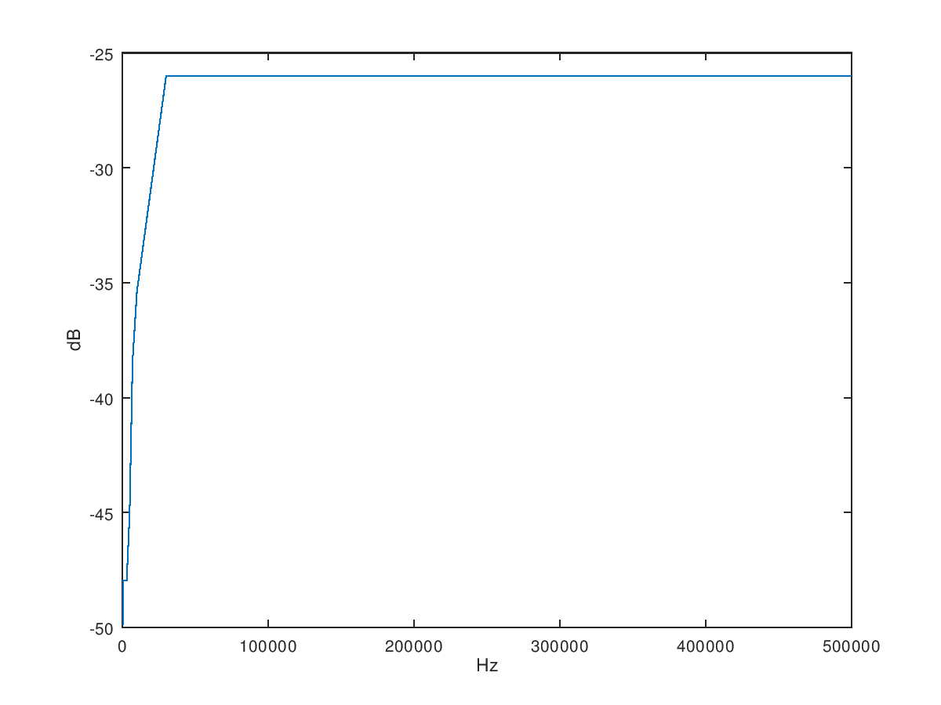

二階主動低通濾波器(10nF)

|  |  |  |  |  |  |  |  |  |  |  |  |  |  |
| --- | --- | --- | --- | --- | --- | --- | --- | --- | --- | --- | --- | --- | --- |
| Hz | 10 | 30 | 50 | 70 | 100 | 300 | 500 | 700 | 1k | 3k | 5k | 7k | 10K |
| mV | 7600 | 9400 | 9600 | 9600 | 9600 | 9600 | 9200 | 8400 | 6400 | 1200 | 600 | 400 | 200 |
| dB | 17.6163 | 19.4626 | 19.6454 | 19.6454 | 19.6454 | 19.6454 | 19.2758 | 18.4856 | 16.1236 | 1.5836 | -4.4370 | -7.9588 | -13.9794 |

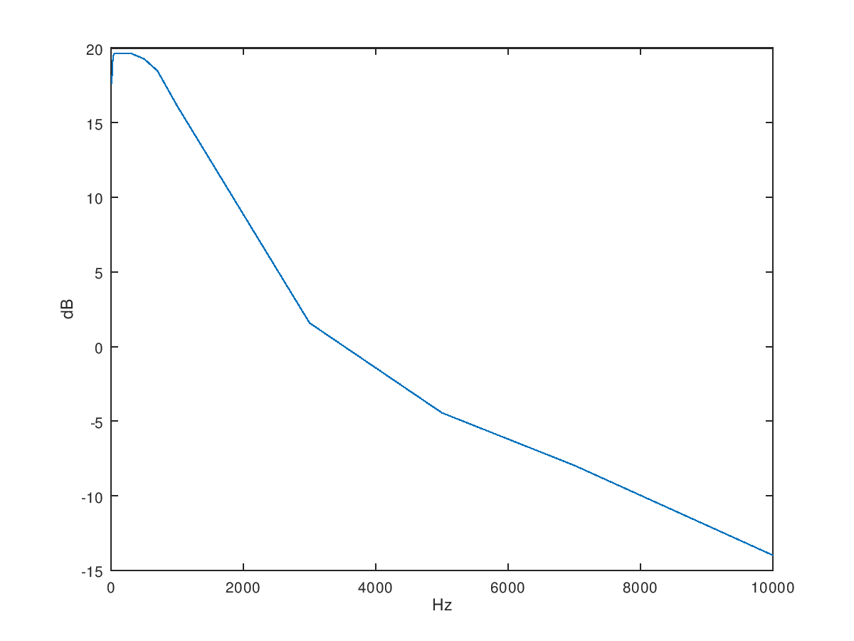

二階主動低通濾波器(3.3nF)

|  |  |  |  |  |  |  |  |  |  |  |  |  |  |
| --- | --- | --- | --- | --- | --- | --- | --- | --- | --- | --- | --- | --- | --- |
| Hz | 10 | 30 | 50 | 70 | 100 | 300 | 500 | 700 | 1k | 3k | 5k | 7k | 10K |
| mV | 8000 | 9400 | 9600 | 9600 | 9600 | 9600 | 9600 | 9400 | 9400 | 7400 | 4600 | 3000 | 1800 |
| dB | 18.0618 | 19.4626 | 19.6454 | 19.6454 | 19.6454 | 19.6454 | 19.6454 | 19.4626 | 19.4626 | 17.3846 | 13.2552 | 9.5424 | 5.1055 |

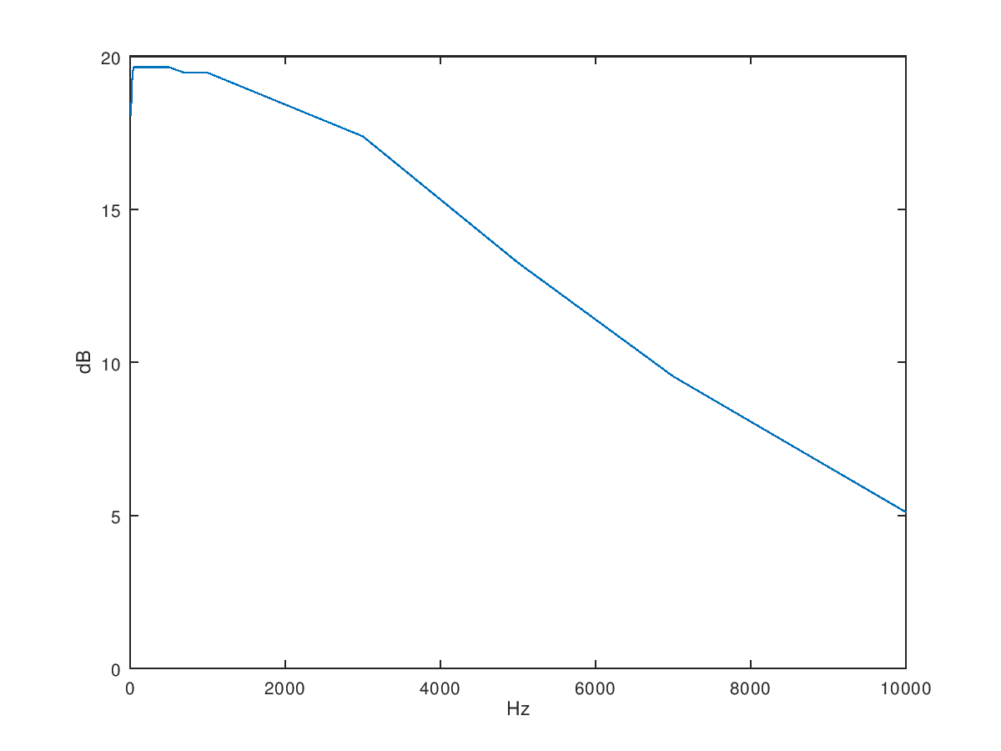

二階主動高通濾波器(2.2nF)

|  |  |  |  |  |  |  |  |  |  |  |  |  |  |
| --- | --- | --- | --- | --- | --- | --- | --- | --- | --- | --- | --- | --- | --- |
| Hz | 70 | 100 | 300 | 500 | 700 | 1k | 3k | 5k | 7k | 10k | 30k | 50k | 100k |
| mV | 80 | 80 | 80 | 80 | 80 | 80 | 380 | 880 | 1020 | 1000 | 900 | 860 | 720 |
| dB | -21.93820 | -21.93820 | -21.93820 | -21.93820 | -21.93820 | -21.93820 | -8.40433 | -1.11035 | 0.17200 | 0.00000 | -0.91515 | -1.31003 | -2.85335 |

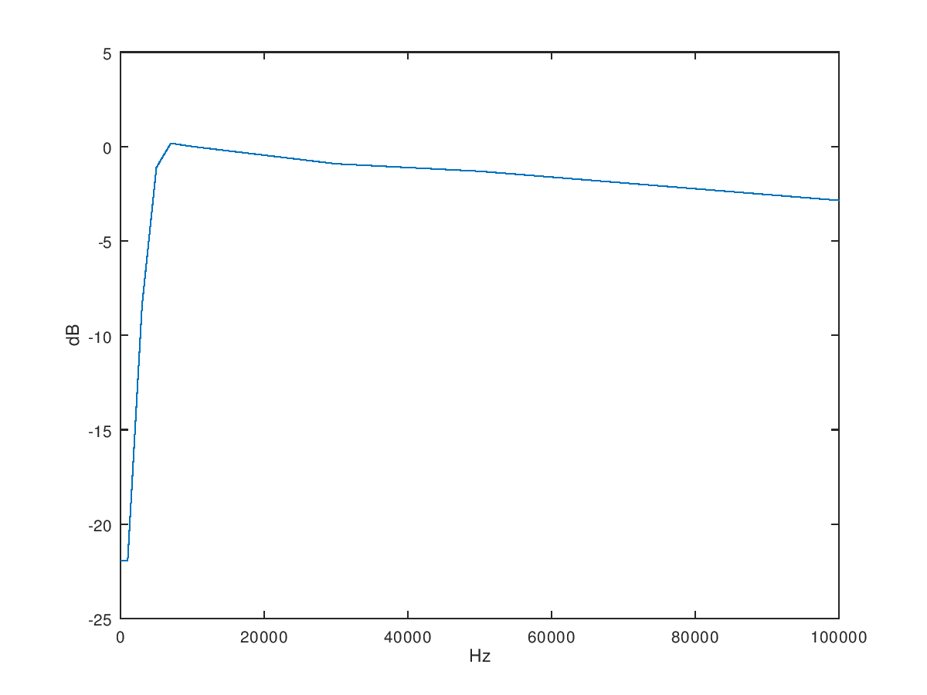

二階主動高通濾波器(3.3nF)

|  |  |  |  |  |  |  |  |  |  |  |  |  |  |
| --- | --- | --- | --- | --- | --- | --- | --- | --- | --- | --- | --- | --- | --- |
| Hz | 70 | 100 | 300 | 500 | 700 | 1k | 3k | 5k | 7k | 10k | 30k | 50k | 100k |
| mV | 60 | 60 | 60 | 60 | 60 | 60 | 120 | 260 | 480 | 900 | 940 | 880 | 720 |
| dB | -24.43697 | -24.43697 | -24.43697 | -24.43697 | -24.43697 | -24.43697 | -18.41638 | -11.70053 | -6.37518 | -0.91515 | -0.53744 | -1.11035 | -2.85335 |

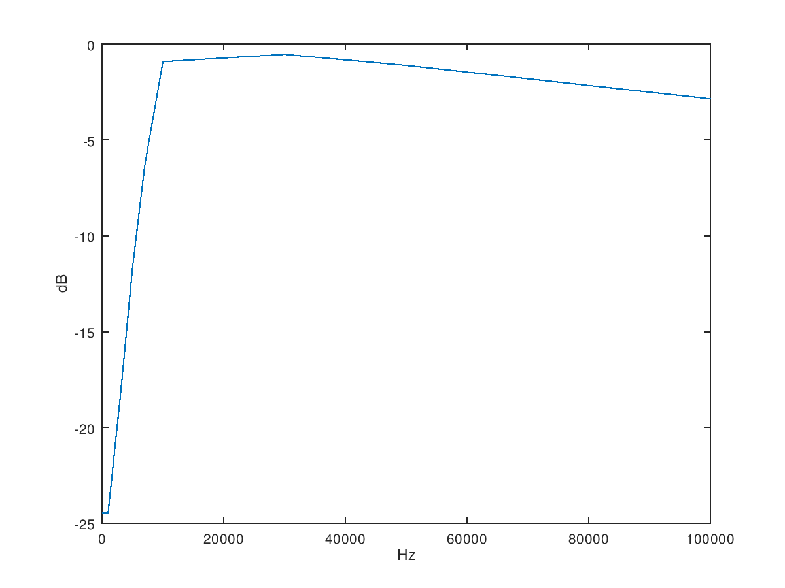

二階主動帶通濾波器(1nF)

|  |  |  |  |  |  |  |  |  |  |  |  |  |
| --- | --- | --- | --- | --- | --- | --- | --- | --- | --- | --- | --- | --- |
| Hz | 1k | 3k | 5k | 7k | 10k | 30k | 50k | 70k | 100k | 300k | 500k | 700k |
| mV | 80 | 180 | 320 | 540 | 2540 | 220 | 140 | 100 | 100 | 60 | 60 | 40 |
| dB | -21.9382 | -14.8945 | -9.8970 | -5.3521 | 8.0967 | -13.1515 | -17.0774 | -20.0000 | -20.0000 | -24.4370 | -24.4370 | -27.9588 |

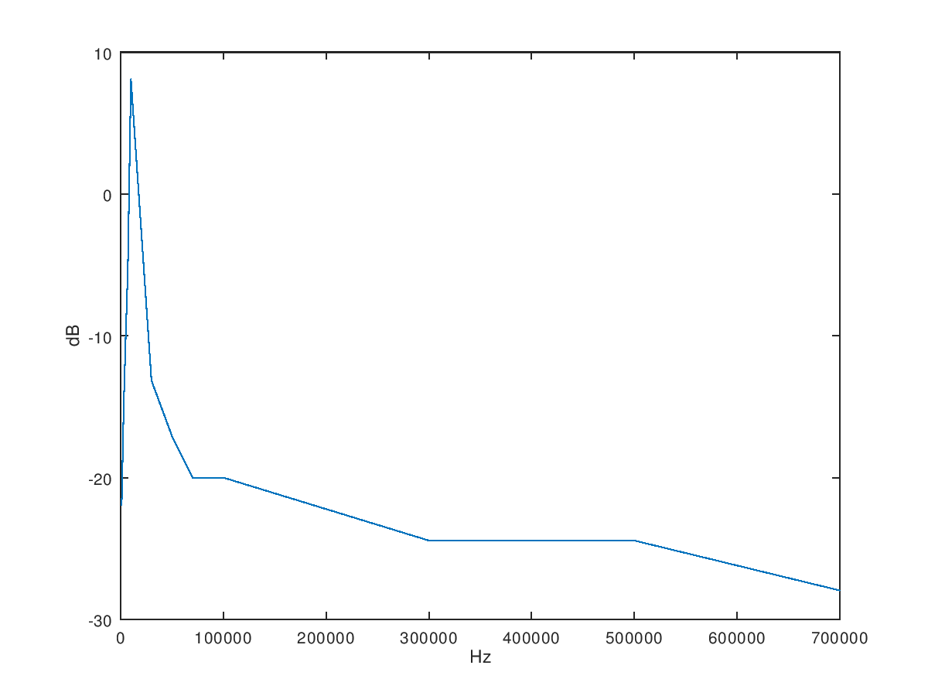

二階主動帶通濾波器(3.3nF)

|  |  |  |  |  |  |  |  |  |  |  |  |  |
| --- | --- | --- | --- | --- | --- | --- | --- | --- | --- | --- | --- | --- |
| Hz | 1k | 3k | 5k | 7k | 10k | 30k | 50k | 70k | 100k | 300k | 500k | 700k |
| mV | 160 | 860 | 740 | 340 | 220 | 100 | 80 | 60 | 60 | 40 | 40 | 40 |
| dB | -15.9176 | -1.3100 | -2.6154 | -9.3704 | -13.1515 | -20.0000 | -21.9382 | -24.4370 | -24.4370 | -27.9588 | -27.9588 | -27.9588 |

