16:332:543
RUTGERS UNIVERSITY
DEPARTMENT OF ELECTRICAL AND COMPUTER ENGINEERING

COMMUNICATION NETWORKS I
FINAL EXAM SOLUTIONS

by
Mesut Ali ERGIN
12/17/2004
1. From The Text (Problem 4.2):

(a)
Rewriting the Eq.(4.5), we have

Using the probability definitions for Q_{a} and Q_{r} from Eq. (4.1) and (4.2), we can re-write the above equation as

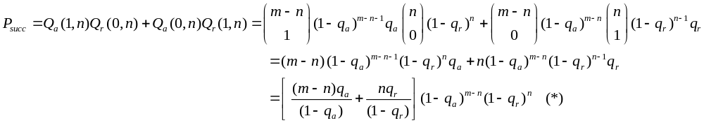

(b)
Assuming 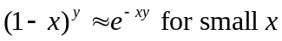 we may write

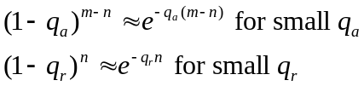

with the same assumption, we may also approximate
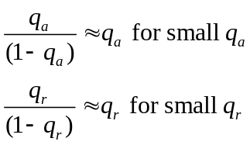

Therefore (*) becomes, (using G(n) definition in the question)

(c)
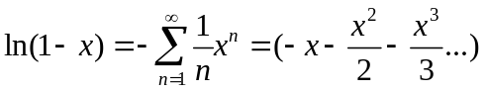 Plugging this expansion into the given equation
We know that . Therefore, if x<<1, then this ratio is close to 1 (due to the
left handside of the above equation).
2. Going Back to TinyOS Again:

- CRC Checking

TinyOS is a light-weight and modular embedded operating system. Basic building block in providing this modularity is TinyOS components. A component of TinyOS may be implementing a command, handling a hardware-oriented event, or posting a task to append a new to-do job to the scheduler list.

Most of the radio communications functionality falls under generic comm module, including CRC checking. Within the generic comm. module, active messaging layer interfaces the radio communication facility to the other components of TinyOS, most of them being sensing related. Categorically, generic comm. homes modules that operate on packet, byte and bit basis.

As long as the radio receiver of TinyOS running hardware feeds demodulated bits from the medium, Radio.rxBit event (coded in SecDedRadioByteSignal.nc) continually tries to detect a preamble/start symbol. After a successful detection of a preamble, receiver is synchronized and consecutive bit receptions follow. After the eighth data bit, Radio.rxBit event posts a task named radioDecodeThread to start decoding of this newly arrived byte. The flow, explained up to here is summarized in the below figure:
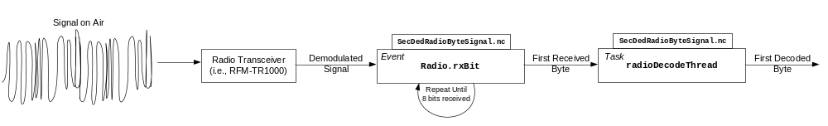

After decoding, this byte-level component signals the ByteComm.rxByteReady event that is responsible from arranging those bytes into a complete packet. After the last byte of the fixed size packet is received, ByteComm.rxByteReady event posts a CRCCheck task, before taking further action on this packet . CRCCheck task, implemented in CRCPacket.nc, essentially realizes the CRC check. It first re-calculates the 16-bit CRC of the arrived packet (discarding the CRC already in the packet) by calling the calcrc() function. The CRC operation in this function is explained in detail in the following paragraph. CRCCheck task then compares the calculated CRC with the one on the packet. If they happen to be the same, CRCCheck task signals a Receive.receive event, in order to get a new TinyOS message handle and copies this healthy packet into the TinyOS message. crc field of this TinyOS message is set to be 1. Otherwise, control is passed back to the ByteComm.rxByteReady event, which then returns failure to indicate a packet discard. This part of the story is illustrated in the following figure:

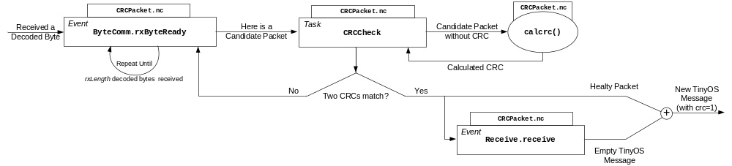

For the detailed operation of CRC routine, we explain the corresponding lines from the source code:

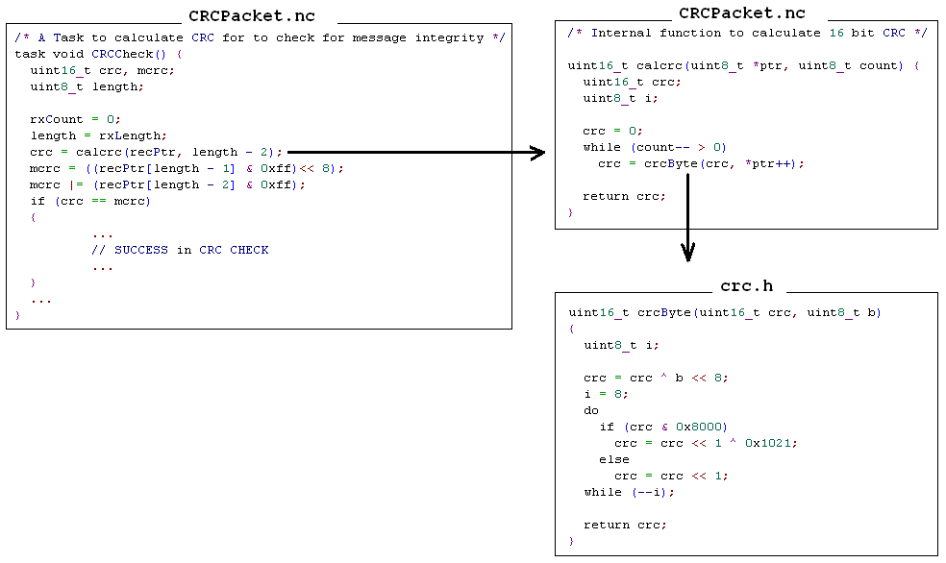

Here, CRCCheck task simply calls calcrc() function, with pointing two bytes less than the original packet length in order to ignore the CRC on the packet. calcrc() function makes (length-2) successive calls to crcByte() function, to construct the final 16-bit CRC. Each call uses the previous return value from crcByte() as a parameter. This realization of CRC is a straightforward division register implementation*. For each of the 8-bit blocks, algorithm works as follows:
Initialize the register with zero (or crc from previous run)
Augment the byte by appending 8 more zero bits to the end of it.
do
shift the register left by one bit, reading the next bit of the
augmented byte into register bit position 0.
if (a 1 bit popped out of the register during the above step)
Register = Register XOR Polynomial
while(more bits in the byte remains)

After the above algorithm terminates, register contains the remainder. Following the first iteration, remainder is always transferred to the algorithm for accumulation. After the last byte is processed, algorithm returns the actual CRC remainder to be used for the overall packet. The generator polynomial used for this CRC calculation is G(x)=x¹⁶+x¹²+x⁵+1, which is the standard generator used for X.25 protocol.

When this calculated CRC is returned back to CRCCheck task, it is simply compared to the one, retrieved out of the packet (mcrc). If they are found to be the same, CRC check terminates successfully.

[*] Ross N. Williams, “A painless guide to CRC error detection algorithms”, http://www.cs.waikato.ac.nz/~312/crc.txt, 1993.

- Framing

TinyOS uses fixed size frames, with the structure given below:

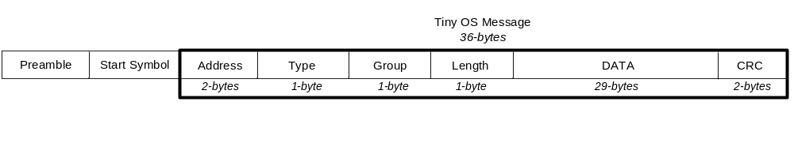
Because of fixed size frames used, receiver exactly knows where to find the end of the frame, eliminating the need to use frame delimiters or special characters. For the start of the frame, however, a synchronization method has been deployed. Through the radio transceiver, SpiByteFifoC component of the transmitter party sends out f0f0f0ff00ff0f00ff0f0f0f pattern as the preamble/start string. Receiver tries to detect this pattern, as explained in the first part of the question. Receiver also synchronizes its internal clock to start receiving the message bits with the help of the last 1 in the start symbol. Since radios of concern use a fixed data rate, timing of the reception can easily be governed via this first synchronization.

- Replacing the CRC

We will now construct a two-dimensional block parity coding scheme for TinyOS. Group of blocks will be composed of single TinyOS messages, each 34-bytes (272-bits) long. Messages allow us to use 2-byte space for parity bits. In order to maximize our schemes error detecting capabilities, we try to use as many of the 16 bit space as possible for parity purposes. However, 16-bit parity bit space allows at most 8x7=56 blocks to be used. Therefore, we can not place one bit into each block with 2-byte space available. For this reason, we create a 3x12 block as illustrated in the figure below:

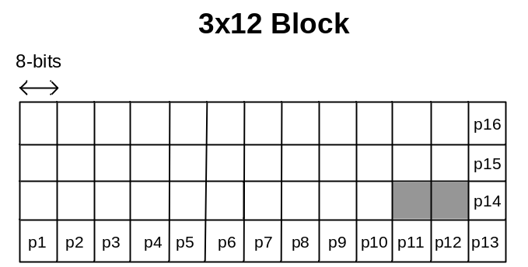

This block structure utilizes all 16-bits of space in the packet. In each block, we place a single representative bit for 8-actual bits (using bytes for the purpose also speeds up the algorithm). Thus we can place 36*8=288 bits into the 3x12 block (ignoring last 2 blocks). The representative bit for a block is simply found by XOR`ing all eight corresponding bits that should go into the same block. No error correction is done in TinyOS, hence, this approach will only degrade the error detection performance if correlated errors occur frequently (within 8-bit blocks). The required changes to the original TinyOS code are given below:
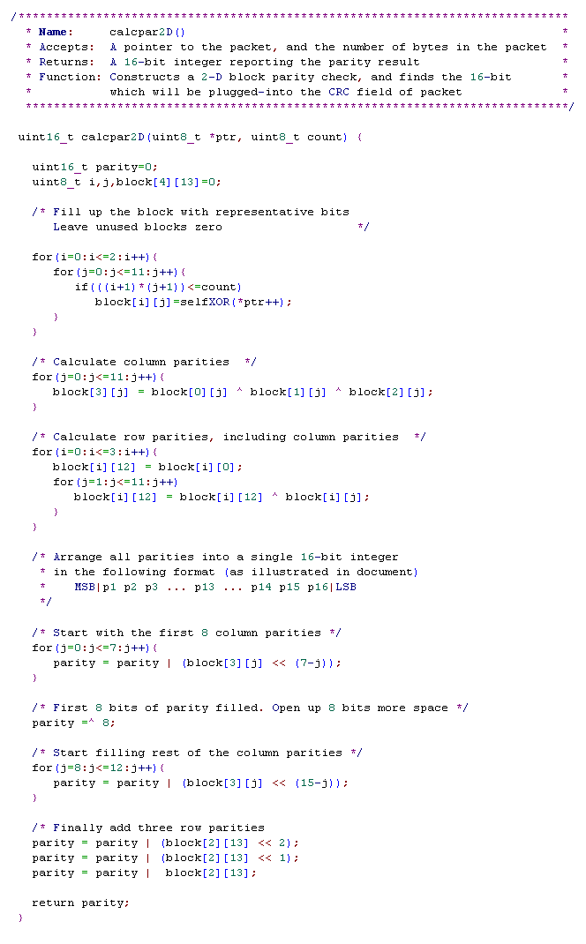
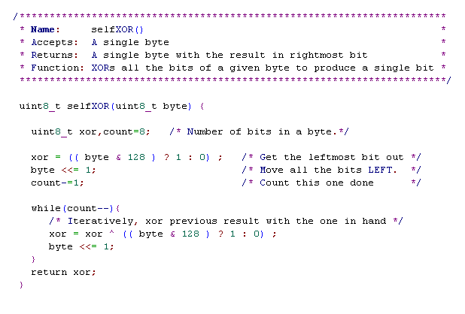
To implement two-dimensional parities, we have added two functions to the current TinyOS source tree, namely calcpar2D(), and selfXOR(). We have inserted these two functions into CRCPacket.nc file. Transition to this method is seemless, in the sense that replacing all calls to the function calcrc()with calcpar2D() is sufficient.

Although the code has been written self-documented, a brief explanation is given here: calcpar2D() mainly constructs a 4x13 block. The actual data to be coded goes into the 3x12 block, and the rest of the block holds parity bits. While constructing the block, all bits of each byte in the packet XOR`ed to generate 1 bit out of 8-bits. selfXOR() function realizes this. The resulting bit is the LSB returned on exit.

Then calcpar2D() continues to fill in the parity bits of the block by first processing columns, and then rows. After this step, we have 16-bytes, LSB of each of them keeping our parity bit. To compile LSB of all those bytes into one byte, the resulting parity, we do necessary shifting and masking operations. Similar to CRC, returned parity variable includes the 16-bit parity calculated from the packet given as parameter.
3. Lost in Loss Models:

(a)
For this loss system, we may briefly say that:

- Population consists of K users
- There are m servers
- Each user is either
- in a call (finishing in some time exponentially distributed with mean 1/μ )
or
- will generate one soon (in some time distributed exponentially with mean 1/ν )
- When his/her call is finished, user goes back and attempt another call in some time with the same exponential distribution with mean 1/μ .

N(t) denotes the number of calls in the system. When there is no call, there are K customers, each with the potential of generating a call with rate ν , totaling Kν. As we have more calls in progress, the amount of potential callers decreases. Service rate, however, increases with the number of calls in progress. More calls in progress means, a higher rate of having any of them completed. Using this intuition, we may draw the state transition diagram as follows ( 0≤n≤m ):

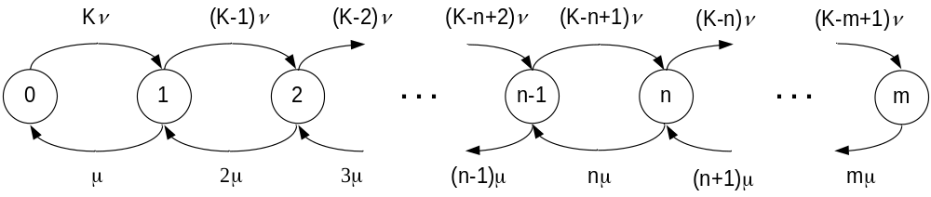

Now, we can directly write steady-state difference equations for this birth-death process using the flow conservation rule. This rule (flow-in being equal to the flow-out) can be exercised using any closed contour on the chain. Therefore;

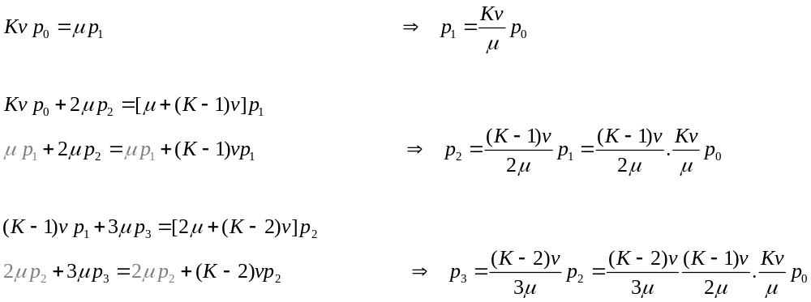
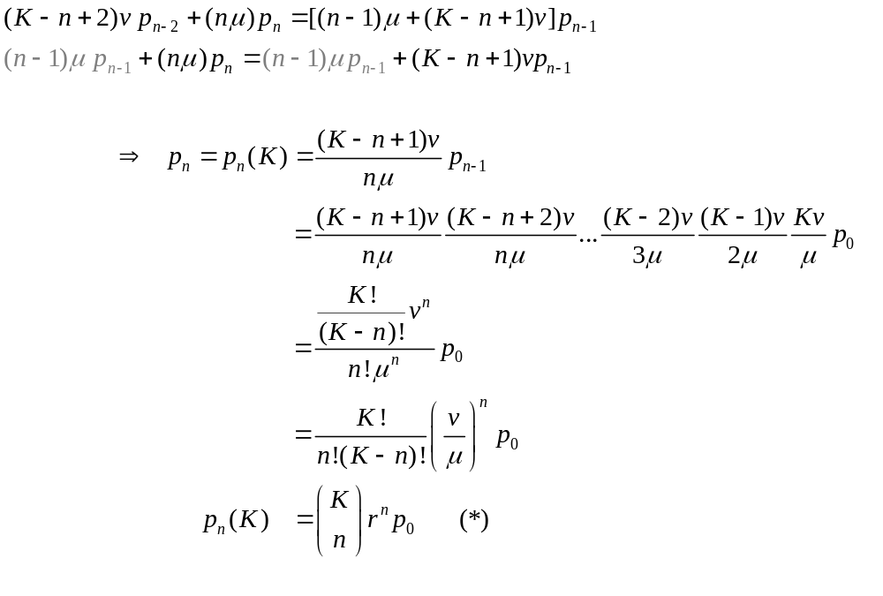
Also, using the fact that all probabilities should add up to one, we have

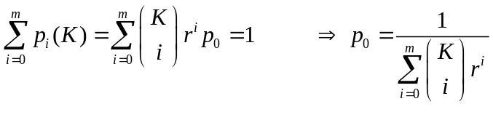
Finally, plugging p₀ back into the (*), we obtain the truncated binomial distribution as:

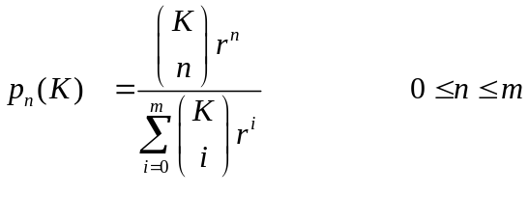

(b)
Engset and Erlang distributions are defined as:

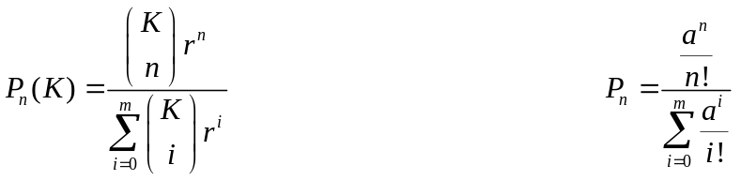

A quick look at the combination C(K,n) as K→∞ reveals the following:
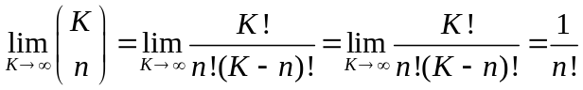

Therefore, as K→∞, Engset distribution becomes:
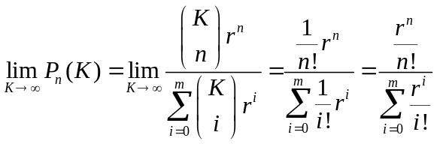 , which is an Erlang distribution with parameter a=r

Following is a MATLAB script and its output, plotting Engset and Erlang distributions with the specified parameters in the question.

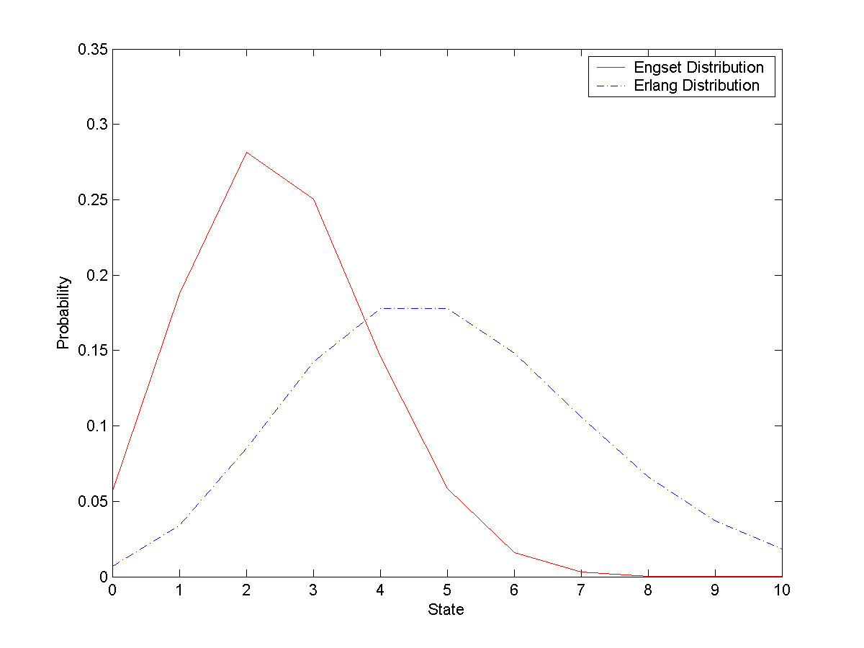
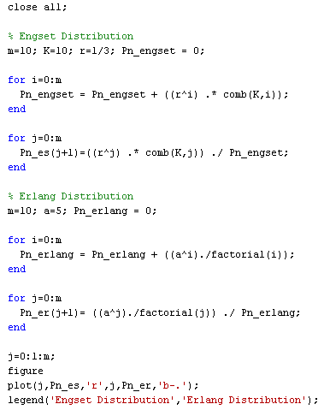

(c)

As given in the hint, let us look at the system over a long interval T and try to find the number of calls that arrive when n servers are busy.

During time T, the average amount of time in which n servers are busy is given by:

E{T_{n}}=T p_{n}(K)

The average amount of calls during this period is found by multiplying E{Tn} with its corresponding state dependent arrival rate (K-n)v ( shown in diagram for solution (a) );

Arrivals during Tn=A_{n}=(K-n)v E{Tn}
In other words, out of all arrivals to the system, A_{n} of them find the system in “n-servers-busy” state. Ratio of these A_{n} arrivals to the all arrivals will give us the distribution of the number of busy servers as we let T→∞

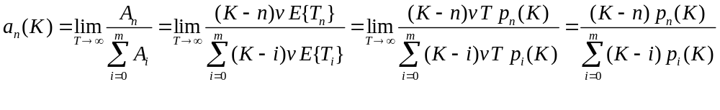

Now, by inserting the steady state distribution equation found in (a), we re-organize the above equation:

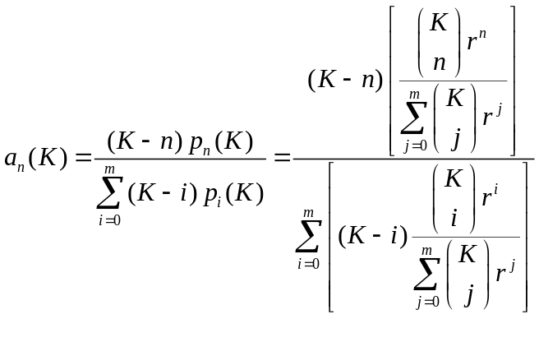
since inner summation in denominator is independent of i, it may be moved out of the summation over i,

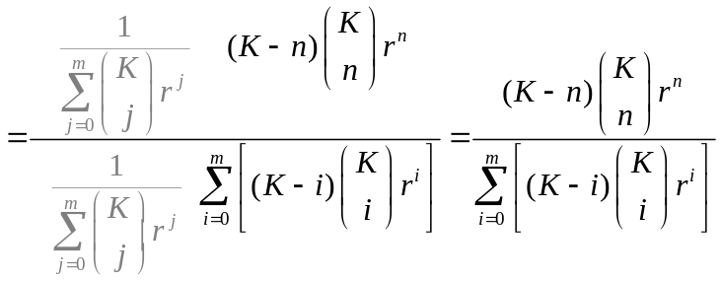

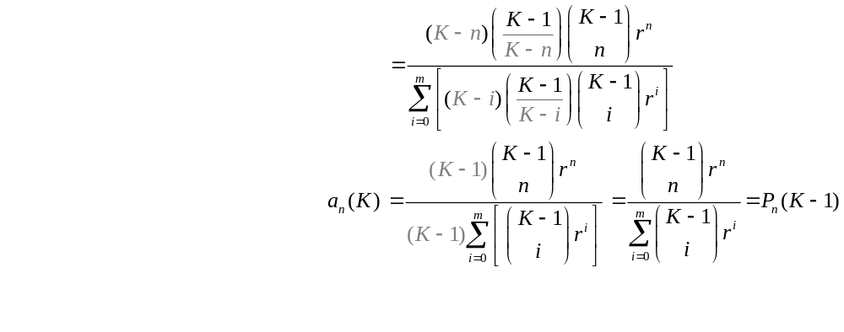Also, by simply removing first terms of combinations out, we finally obtain:

4. Applying Queuing Theory to Traffic Modeling:

(a)
Let us look at a single source, to obtain its statistics. A source moves between Silence and Burst states as explained. Since silence period is exponentially distributed with mean 1/α, the source makes transitions from silent state to the burst state with rate α, on average. The opposite transition is similarly with rate β. Following figure illustrates this.
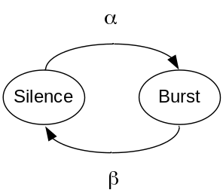
Now, considering N of those sources multiplexed together, we can easily say that, if no sources are active at a given instant (J(t)=0), there are N independent sources each about to start bursting in exponential time with mean 1/α. Therefore, the cumulative effect of having J(t)=1 will be due to rate Nα. As more sources are in active burst state, this rate decreases. Reversibly, probability that any one of the sources will make a transition to silent state increases, as J(t) increases. This constitutes a queue similar discussed in the 3rd question. The Birth-death process is treated as follows:

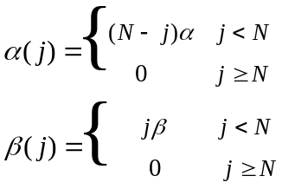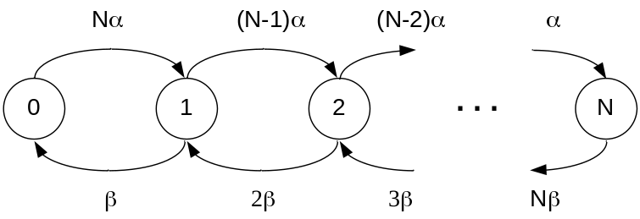

The differential equations, governing p_{j}(t) are;

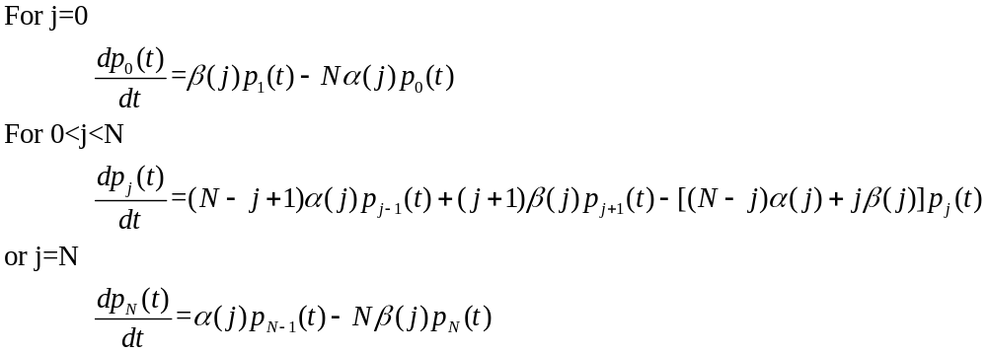

(b) To find the equilibrium state distribution, we look at the system as T→∞, so the differentials tend to go to zero. We then write the global balance equations as

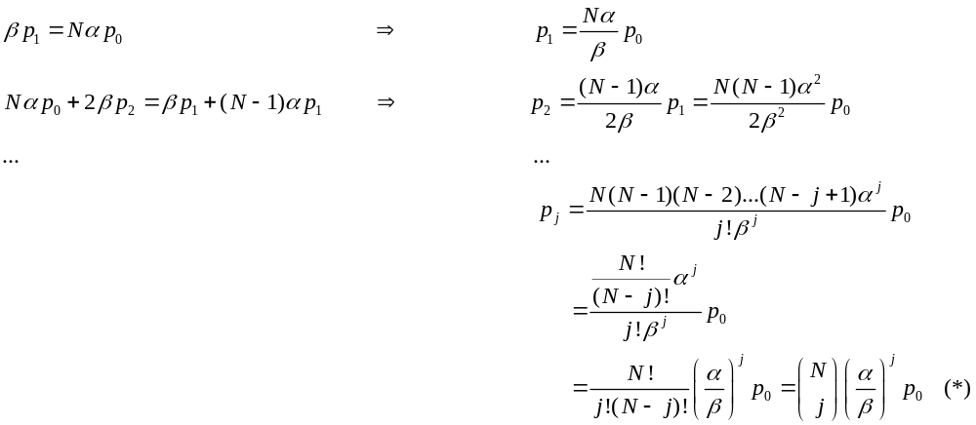

Using the fact that all probabilities should add up to 1, we have

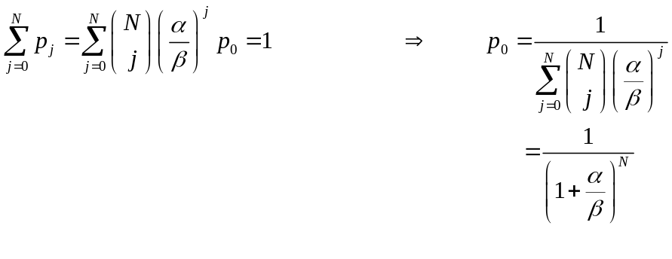
Plugging p₀ back to (*), we obtain the binomial distribution as follows

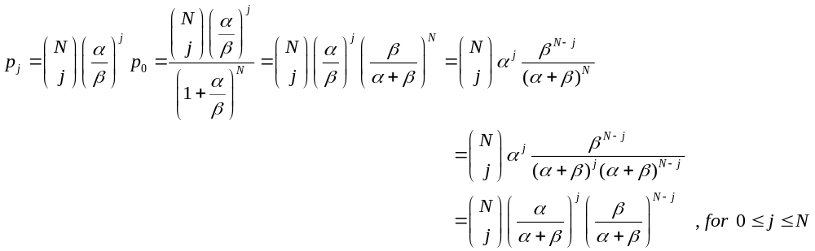

(c) To solve the set of differential equations, given in (a), we need to follow the method of z-transforms:

The time dependent transform is given as 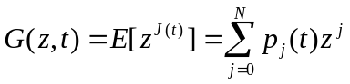

Then we multiply j^{th} differential equation by z^{j} ,and sum over all possible j

Here, using the fact that differentiation is a linear operator, we move first summation inside of differentiation.

Left handside of the equation is missing the term p_{o}(t)z⁰, so adding this term to the both sides of
the equation, and organizing

Unfortunately, after this point, I could not find an elegant way of freeing state dependent rates out of
summations, in order to reach from here to a more generic partial differential equation.

