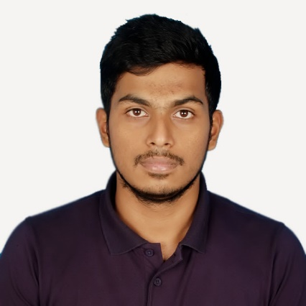Abdullah Al Alif

Mirpur-2, Dhaka, Bangladesh | +8801674 908 356 | alifabdullah26709@gmail.com

# Education

## Bachelor in Computer SCIENCE | matriculated in may, 2014 | American international university- Bangladesh (AIUB)

* **Interested Fields:** Web Technologies, Software Quality Assurance and Testing, Computer Graphics, and Operating Systems.
* **CGPA**: *3.80* on a scale of *4.00* (approx. grad. Date- August 2017)] (having classes only on Monday and Wednesday for only 3 hours)

## Higher secondary certification | 2011 | notre dame college, dhaka

* **Major Discipline**: Science
* **CGPA**: 5.00 on a scale of 5.00

## secondary school certification (english version) | 2009 | Rajuk uttara model school and college

* **Major Discipline:** Science
* **CGPA**: 5.00 on a scale of 5.00

**Skills & Abilities**

## Management

* Organizational skills gathered from club level experiences, i.e. Notre Dame Science Club (NDSC) and AIUB Computer Club (ACC). I also experienced some Military discipline and skills.

## Basic COmputer usage

* Microsoft Word
* Microsoft Excel
* Microsoft PowerPoint
* Windows/Linux/Mac OSX

### **PROFESSIONAL QUALIFICATION & AFFILIATIONS**

* Excellent fluency in English both oral and written
* Matured public speaker and reasonably good presenter
* Able to process all sorts of documentations and writings
* Undertaking premium courses on Udemy and EDX.
* CISCO IT essential certification, CISCO

### **RELATED SKILLS**

* Having good sense of modern mobile-first UI designs
* Creating useful wireframes and mock-ups using Adobe XD for both mobile and web applications
* Prototyping using Prottapp.com which is very similar to Balsamiq
* Using Adobe Illustrator for creating business cards, flyers, typography, and other basic designs
* Pretty good hand with using HTML, CSS3 along with SCSS and frameworks like Bootstrap, Bulma and Semantic UI
* Good with basic JavaScript and JQuery
* Expertise on composing software documentations, user manual, release notes and other business writings
* Regular visitor and follower of Modern UI/UX layouts websites/Blogs like onepagelove.com, uimovement.com, goodui.org etc
* completing UI/UX course from online learning resource Coursera.com and edx.com
* Performing expensive premium courses from Udemy on parallax effect, good UI and one page sites. Also, CSS layouts like flexbox, CSS grids etc. Learning to build responsive sites using adobe muse and web flow too.

## Leadership and Others

* I had an opportunity to serve in *Bangladesh Army* over 1.5 years as an officer cadet. In army, everyone is taught with some basic knowledge and behavior of a leader not only in the case of army only, but also for the entire life, in all aspects
* Have been biased for Mathematics. I achieved special awards in *National Mathematics Olympiad* back in my school
* Well mannered, disciplined and regular in my duties. I never missed a single class in my school and college, thus achieved the *Perfect Attendance Certificate* which is very rare
* Achieved *Dean’s Award* and have been studying in AIUB with Scholarship since beginning. Retaining potential expectation to achieve *Cum Laude*.

**Personal**

**Father’s name**: Md. Abul Bashar Mizi

**Mother’s name**: Roushon Ara Begum

**Date of Birth**: 05 July, 1994

**Sex**: Male

**Marital status**: Single

**Nationality:** Bangladesh

**Address:** 2F-3, Mirpur-2, Dhaka, Bangladesh

**Experience**

Writing is my hobby. So, I used to write articles and contents as a freelancer in my leisure period and still am writing. I don’t have any other major experiences to mention till now.

## Regular project | web technologies, aiub | april, 2017

* I built a simple website named” PC RIG” along with my fellow group-mates.
* I am practicing web design from PSD to html and with various beautiful Front-end frameworks. Currently, I am onto making a portfolio site for myself.
* I am good with writing any sorts of software documentation and technical writings.

## Writer | UvoCorp | February, 2017 to present

* I am a verified full time writer for writing academic assignments and business letters according to clients’ orders. I had to go through formal examination and recruitment process for this job.

## writer | universal Web experts | august 2016 to january 2017

* This is a USA based software company where I used to write and update their site’s contents.