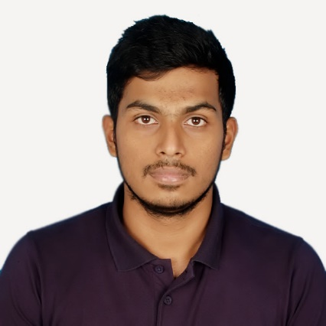Abdullah Al Alif

Mirpur-2, Dhaka, Bangladesh | +8801674 908 356 | alifabdullah26709@gmail.com

# Personal Profile

* Frankly speaking, I wasn’t so called talented to write creative or innovative things in the school’s wall magazine or in any daily’s. But overtime, I noticed that I enjoy writing something, or, to say, my writings get appreciated. This is how I was inspired to read more to produce better writings both academically and professionally.

I really am very much passionate and interested for learning and writing new things. Most importantly, I am gathering more and more knowledge and experiences towards my passion. And I believe, passion is what never lacks interest.

# Education

## Bachelor in Computer SCIENCE | matriculated in may, 2014 | American international university- Bangladesh (AIUB)

* **Related coursework:** Business communication and writing, Software Requirement, Software Engineering (agenda-Documentation)
* **CGPA**: 3.81 on a scale of 4.00 [(approx. grad. Date- August 2017)]

## Higher secondary certification | 2011 | notre dame college, dhaka

* **Major Discipline**: Science
* **CGPA**: 5.00 on a scale of 5.00

## secondary school certification (english version) | 2009 | Rajuk uttara model school and college

* **Major Discipline:** Science
* **CGPA**: 5.00 on a scale of 5.00

# Skills & Abilities

## Management

* Organizational skills gathered from club level experiences, i.e. Notre Dame Science Club (NDSC) and AIUB Computer Club (ACC). I also experienced some Military discipline and skills. Strong abilities to work under pressure and maintaining deadlines.

## COmputer

* Microsoft Word (APA, MLA, Harvard or IEEE formats and all kind of Referencing)
* Microsoft Excel
* Microsoft PowerPoint
* Windows/Linux/Mac OSX
* Latex
* Browsing and Web Research
* HTML, CSS and JavaScript

## Communication

* Able to process all sorts of documentations and writings
* Excellent fluency in both Bengali and English
* Matured public speaker and reasonably good presenter

**Personal**

**Father’s name**: Md. Abul Bashar Mizi

**Mother’s name**: Roushon Ara Begum

**Date of Birth**: 05 July, 1994

**Sex**: Male

**Marital status**: Single

**Nationality:** Bangladesh

**Address:** 2F-3, Mirpur-2, Dhaka, Bangladesh

# Experience

## Writer | UvoCorp, great britain (uk) | February, 2017 to present

* I am a verified full time writer for writing academic assignments and business letters according to clients’ orders. I had to go through formal examination and recruitment process for this job. For more information, please visit: www.uvocorp.com.

## writer | universal Web experts | august 2016 to present

* This is a USA based software company where I write and update their site’s contents.

## Software documentation writing| regular university studies | september 2016 to present

* I have composed the whole Software Requirements and Specifications of our two big projects in University, “Doctor Urgent”, which is an Android based mobile application, and another was about an automated market system.