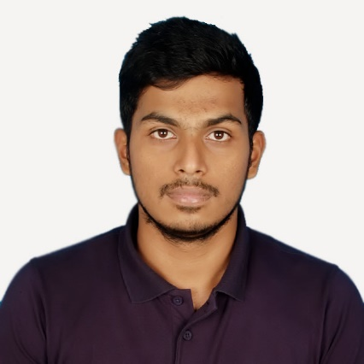Abdullah Al Alif

Mirpur-2, Dhaka, Bangladesh | +8801674 908 356 | alifabdullah26709@gmail.com

# Personal Profile

* Frankly speaking, I wasn’t so called talented to write creative or innovative things in the school’s wall magazine or in any daily’s. But overtime, I noticed that I enjoy writing something, or, to say, my writings get appreciated. This is how I was inspired to read more to produce better writings both academically and professionally. I really am very much passionate and interested for learning and writing new things. Most importantly, I am gathering more and more knowledge and experiences towards my passion. And I believe, passion is what never lacks interest.

Professionally I did not write any Bangla content, but I am from Bangla medium. And I believe I can write flawlessly in Bengali too. Oh yes, I am more of a tech-guy. Any technological contents are always welcomed.

# Education

## Bachelor in Computer SCIENCE | matriculated in may, 2014 | American international university- Bangladesh (AIUB)

* **Related coursework:** Business communication and writing, Software documentation writings.
* **CGPA**: 3.80 on a scale of 4.00 (approx. grad. Date- August 2017)]

## Higher secondary certification | 2011 | notre dame college, dhaka

* **Major Discipline**: Science
* **CGPA**: 5.00 on a scale of 5.00

## secondary school certification | 2009 | Rajuk uttara model school and college

* **Major Discipline:** Science
* **CGPA**: 5.00 on a scale of 5.00

# Skills & Abilities

## Management

* Organizational skills gathered from club level experiences, i.e. Notre Dame Science Club (NDSC) and AIUB Computer Club (ACC). I also experienced some Military discipline and skills.

## COmputer

* Microsoft Word (APA, MLA, Harvard or IEEE formats and all kind of Referencing)
* Microsoft Excel
* Microsoft PowerPoint
* Windows/Linux/Mac OSX
* Latex
* Browsing and Web Research
* HTML, CSS and JavaScript

## Communication

* Able to process all sorts of documentations and writings
* Excellent fluency in both Bengali and English
* Matured public speaker and reasonably good presenter

## Leadership

* I had an opportunity to serve in Bangladesh Army over 1.5 years as a gentleman cadet. In army, everyone is taught with some basic knowledge and behavior of a leader not only in the case of army only, but also for the entire life, in all aspects.

**Personal**

**Father’s name**: Md. Abul Bashar Mizi

**Mother’s name**: Roushon Ara Begum

**Date of Birth**: 05 July, 1994

**Sex**: Male

**Marital status**: Single

**Nationality:** Bangladesh

**Address:** 2F-3, Mirpur-2, Dhaka, Bangladesh

# Experience

## Writer | UvoCorp | February, 2017 to present

* I am a verified full time writer for writing academic assignments and business letters according to clients’ orders. I had to go through formal examination and recruitment process for this job. For more information, please visit: www.uvocorp.com (UK based).

## writer | universal Web experts | august 2016 to present

* This is a USA based software company where I write and update their site’s contents.

## Software projects | regular university studies | september 2016 to present

* I have composed two major software documentations and specifications for project purpose.

## Online certification | UDEmy | on creative, copy and content writings

* I have bought many paid premium courses from Udemy.com on writings and achieved certificates on completion.