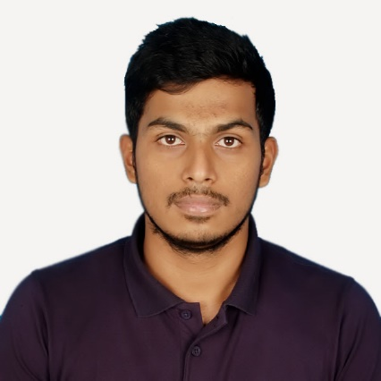Abdullah Al Alif

Mirpur-2, Dhaka, Bangladesh | +8801674 908 356 | alifabdullah26709@gmail.com

# Personal Profile

* Frankly speaking, though being graduating in computer science, I have grown more interests in the theoretical parts, or to say, strategical or management issues rather than core programming. Well, there’s myriad of software engineers in the market, but I believe there are not that much skilled and desirous project managers or business analysts contemporarily.

So I thought it could be a way to strengthen my career along with project management and related stuff. So, I decided to opt for elective courses like *Management Information System, Engineering Managements, Software Project Managements and Requirements Engineering* which are basically the jobs of a business analysts as well as project managers. I really am very interested in Project management and related stuff.

# Education

## Bachelor in Computer SCIENCE | matriculated in may, 2014 | American international university- Bangladesh (AIUB)

* **CGPA**: 3.81 on a scale of 4.00 [9 credits (one course, thesis and internship) left to complete under graduation (approx. grad. Date- August 2017)]

## Higher secondary certification | 2011 | notre dame college, dhaka

* **Major Discipline**: Science
* **CGPA**: 5.00 on a scale of 5.00

## secondary school certification (english version) | 2009 | Rajuk uttara model school and college

* **Major Discipline:** Science
* **CGPA**: 5.00 on a scale of 5.00

# Skills & Abilities

## Management

* Organizational skills gathered from club level experiences, i.e. Notre Dame Science Club (NDSC) and AIUB Computer Club (ACC). I also experienced some Military discipline and skills.

## COmputer

* Microsoft Word (APA, MLA, Harvard or IEEE formats and all kind of Referencing)
* Microsoft Excel
* Microsoft PowerPoint
* Windows/Linux/Mac OSX
* Latex
* Browsing and Web Research
* HTML, CSS and JavaScript

## Communication

* Able to process all sorts of documentations and writings
* Excellent fluency in both Bengali and English
* Matured public speaker and reasonably good presenter

## Leadership

* I had an opportunity to serve in Bangladesh Army over 1.5 years as a gentleman cadet. In army, everyone is taught with some basic knowledge and behavior of a leader not only in the case of army only, but also for the entire life, in all aspects.

**Personal**

**Father’s name**: Md. Abul Bashar Mizi

**Mother’s name**: Roushon Ara Begum

**Date of Birth**: 05 July, 1994

**Sex**: Male

**Marital status**: Single

**Nationality:** Bangladesh

**Address:** 2F-3, Mirpur-2, Dhaka, Bangladesh

# Experience

## Writer | UvoCorp | February, 2017 to present

* I am a verified full time writer for writing academic assignments and business letters according to clients’ orders. I had to go through formal examination and recruitment process for this job. For more information, please visit: www.uvocorp.com.

## writer | universal Web experts | august 2016 to present

* This is a USA based software company where I write and update their site’s contents and documents.

## Software projects | regular university studies | september 2016 to present

* I have composed the whole Software feasibility studies, Requirements and Specifications of our two big projects in University, “Doctor Urgent”, which is an Android based mobile application, and another was about an automated market system.