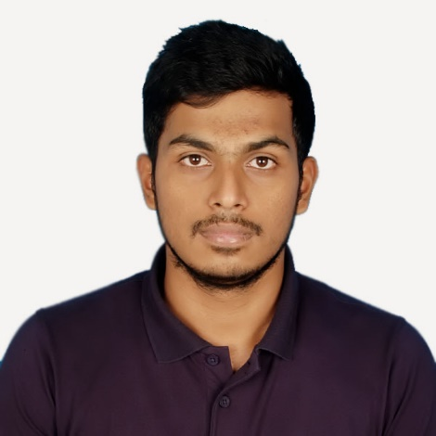

Abdullah Al Alif

Mirpur, Dhaka, Bangladesh

+880 1783 520 360

alifabdullah26709@gmail.com

https://www.linkedin.com/in/alifabdullah/

https://medium.com/@alifabdullah

Education |

**Bachelor of Computer Science and Engineering | American International University- Bangladesh.**

2014 – 2018(February)

CGPA: 3.82 (Achieved Magna Cum Laude)

**Higher Secondary Certification | Notre Dame College**

Passed in 2011

GPA: 5.00

**Secondary School Certificate | Rajuk Uttara Model School and College**

Passed in 2009

GPA: 5.00

Technical Skills |

* Pretty comfortable with JavaScript and its front end framework JQuery
* JavaScript’s web frameworks like ExpressJS with the fastest NodeJS environment
* Real time communication in Node Environment with Socket.io
* REST API mechanisms in NodeJS
* Working with database like MySQL and MongoDB as well as AWS’s mLab along with mongoose package
* Live server like Heroku
* Detailed understanding of web
* Version Controlling with git to GitHub and BitBucket
* Software Quality Testing with Selenium in Java and API testing with POSTMAN
* Real time Charts/Graphs using PowerBI (Business Intelligence), Tableau, CanvasJS, D3JS and ThingSpeak
* Very comfortable with Linux distros as well
* Accustomed to work with front end frameworks like Materialize CSS, Bulma, Beauter, Pure CSS and comparisons
* Fairly good with Python with its data visualization libraries like Numpy, Pandas
* Internet of Things programming with various internet protocols like MQTT and socket
* Hands on experience with Android programming with materialized design
* VueJS, React, detailed JQuery and penetration testing on websites are queued for learning up next
* Prototyping and working with Adobe Muse and XD. A little bit of Adobe Illustrator.
* Good with MS Office.

Projects & Experience |

* Certified IoT engineer (Trained by DataSoft Systems Bangladesh Limited combined with ICT division of Bangladesh Government)
* Software Testing with Selenium Certification (Trained by Lead Soft Bangladesh Limited)
* Web design course with ShikhbeShobai (an e-learning platform)
* Regular university projects
* Self-made projects (random and untracked)
* Software documentation for university project requirements
* Different types of writing experience as hobby
* My dissertation was regarding ethical hacking
* IoT live projects including web dashboard and android app, handed over to DataSoft.

Soft Skills |

* Good oral and written communication skill in both Bengali and English
* IELTS 7 (S-7.5, R-6.5, W-6.5, L-8), Mentioning in case if needed to work with the foreigners
* Management skills from club level experience (AIUB computer club)
* Quick adaptability with new environment and work under pressure
* Sincere and very punctual to meet the deadlines
* Ability to work under pressure
* I am very fast in typing (60 WPM)
* Interested in learning new tools and technology very fast.

Personal |

Father: Md. Abul Bashar Mizi

Mother: Roushan Ara Begum

Nationality: Bangladeshi

Religion: Islam

DOB: 05 July 1994

Marital status: Single

Permanent Residence: Mirpur, Dhaka, Bangladesh.