

AMERICAN INTERNATIONAL UNIVERSITY–BANGLADESH (AIUB)
Dept. of Computer Science
Faculty of Science and Technology
CSC2210: OBJECT ORIENTED PROGRAMMING 2
Spring 2025-2026
Section: [M]2

Project Report On
Project Name [Gym Management System]
Supervised By
Dr. Md. Iftekharul Mobin

Submitted By:
Name | ID
1. M. ALIF HASAN | 24-56407-1
2. RUFAIDAH MAHZABIN | 24-56514-1
3. MAKSUD HAIDER ROMAN | 24-56439-1
4. MD. AHNAF AZAM JAFIN | 24-56396-1
Obtained Marks for CO2 and CO3 (Description given in the following page)
Assessment  Criteria | Not Attended/ Incorrect (0) |  | Inadequate  (1-2) |  | Average  (3) | Good  (4) | Excellent  (5)
Evaluation Criteria (CO2) |  | Total = |  | Evaluation Criteria (CO3) |  |  | Total =
Requirement fulfillment |  |  |  | Organization of the application
Validation |  |  |  | Representation and Integration of Database
Verification |  |  |  | Graphical User Interface

- Project Title

Gym Management System

- Project Description

The Gym Management System is a desktop-based application developed using C# and SQL Server to automate and manage daily gym operations efficiently. The system provides secure login access for different types of users such as Super Admin, Admin (Gym Owner/Staff), and Customers/Members. Each user type has specific functionalities according to their responsibilities.
The system helps manage gym members, memberships, payments, inventory, reviews, offers, and reports through a centralized platform. It reduces manual paperwork, improves accuracy, and increases operational efficiency.

User Roles and Features:

User Type 1: Admin
The Admin manages the overall gym operations, members, payments, products, and reports.
Features
- Add, update, and delete gym members
- Manage membership packages
- Track member attendance
- View customer payment history
- View sales and earnings reports

User Type 2: Member
Members can access gym services, memberships, and personal information through the system.
Features
- Register and log into the system
- View available membership packages
- Purchase memberships or gym products
- Make payments
- View payment history
- Update personal profile information
- Check attendance records

Additional Functionalities
- Secure Login and Authentication System
- Role-Based Access Control
- Search and Filtering Options
- Dashboard for Reports and Statistics
- Database Management using SQL Server
- User-Friendly Interface using Windows Forms
- Data Validation and Error Handling

Objective of the Project

The main objective of this project is to develop an efficient and user-friendly Gym Management System that simplifies gym administration, improves customer service, and manages gym operations digitally through an organized software solution.

- General Requirements

3.1 System Design & Architecture
- The application will follow Object-Oriented Programming (OOP) principles:
  - Encapsulation
  - Inheritance
  - Polymorphism
  - Abstraction
- The system will be developed as a desktop-based application using C# Windows Forms.
- Proper class design will be implemented with multiple user classes such as:
  - Super Admin
  - Admin/Staff
  - Customer/Member
- The application will use separate classes for:
  - Database connection
  - User management
  - Membership management
  - Inventory management
  - Payment and billing management
- Role-based access control will be implemented to provide different functionalities for different users.
- The system architecture will maintain modularity and scalability for future improvements.

3.2 Database Requirements
- The system will use a relational database management system (SQL Server).
- The database will be normalized up to Third Normal Form (3NF) to reduce redundancy and maintain data integrity.
- CRUD operations (Create, Read, Update, Delete) will be implemented for:
  - Members
  - Products
  - Membership packages
  - Payments
  - Reviews
  - Inventory
- A dedicated database connection class will be included for handling database communication.
- The database will contain multiple related tables such as:
  - Users
  - Members
  - Membership Packages
  - Payments
  - Inventory
  - Reviews
  - Offers
- SQL queries and stored procedures may be used where necessary.

3.3 Functional Requirements
- The system will provide a secure login functionality using:
  - User ID
  - Password
- Different dashboards/home pages will be displayed based on user roles.
- All forms within the application will be properly connected and navigable.
- The system will include a search option accessible to all users for searching:
  - Members
  - Products
  - Packages
  - Payment records
- The application will support:
  - Member registration
  - Membership management
  - Attendance tracking
  - Inventory management
  - Billing and payment management
- Customers will be able to:
  - View membership packages
  - Purchase services/products
  - Provide ratings and reviews
- Admins will be able to:
  - Add/update/delete records
  - Monitor inventory
  - Generate reports
  - View earnings and sales history
- The billing system will generate payment records and purchase history.

3.4 User Interface Requirements
- The application will contain multiple forms for different operations.
Examples:
- Login Form
- Registration Form
- Dashboard Form
- Membership Management Form
- Inventory Form
- Payment Form
- Review Form
- Proper form design principles will be followed:
  - Clear layout
  - Organized controls
  - User-friendly navigation
  - Readable fonts and labels
- The desktop UI design will maintain consistency throughout the application.
- Buttons, labels, textboxes, and data grids will be properly aligned and grouped.
- Appropriate colors and themes will be used for better user experience.

3.5 Validation & Error Handling
- Proper form validation will be implemented, including:
  - Required field validation
  - Numeric input validation
  - Password validation
  - Empty field checking
- Error messages will be displayed for invalid inputs.
- Exception handling will be implemented throughout the application using try-catch blocks.
- Database connection errors and invalid operations will be handled gracefully.
- The system will prevent duplicate entries where necessary.

3.6 Programming Practices
- Proper use of properties will be implemented for data encapsulation.
- Appropriate access modifiers will be used:
  - public
  - private
  - protected
- The code will follow modular programming practices.
- Reusable methods and classes will be created to improve maintainability.
- Meaningful naming conventions will be used for:
  - Variables
  - Classes
  - Methods
  - Controls
- Comments and documentation will be added where necessary for readability.

  - Application Type

The project is a management-type desktop application developed using C# and SQL Server.
The system is similar to:
- Gym Management System
- Inventory Management System
- Membership Management System
- Billing and Payment Management System
The application is designed to automate gym operations and improve overall management efficiency.

4 . Diagram

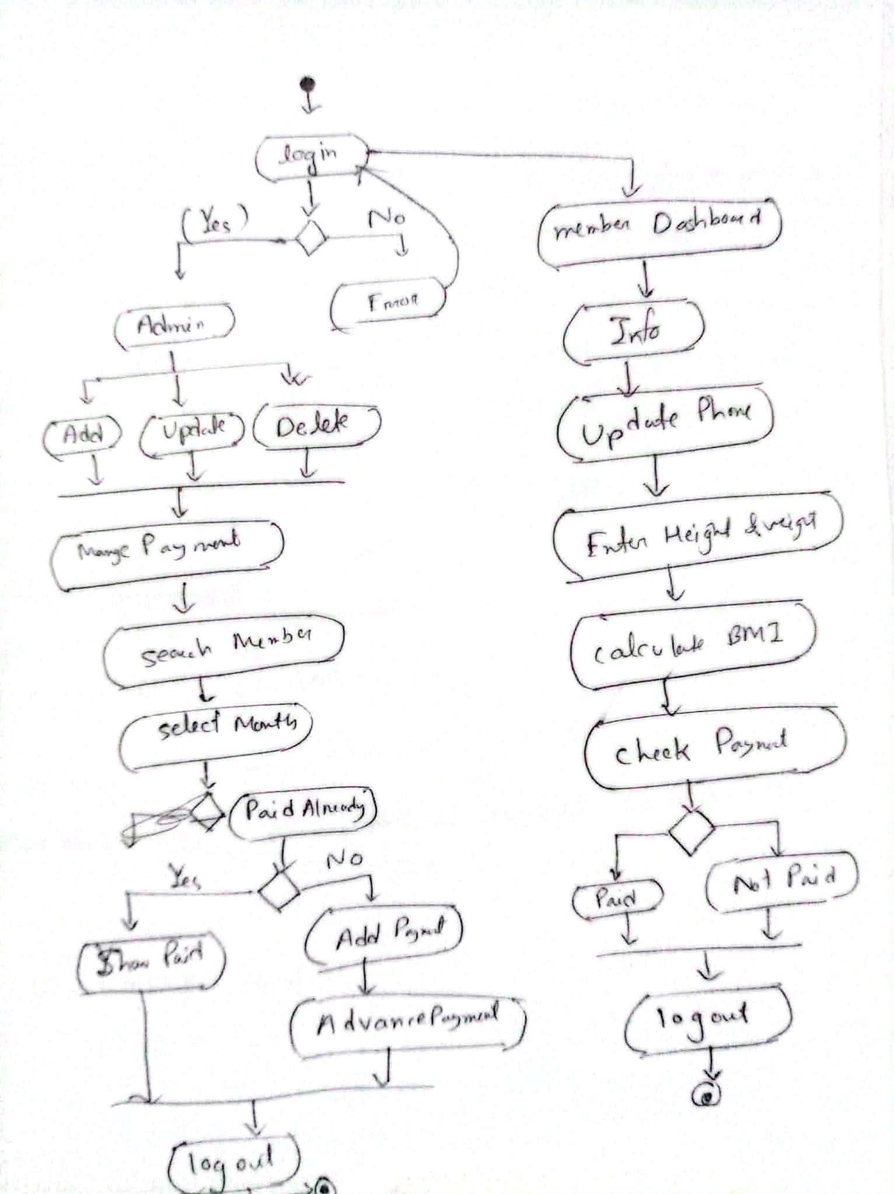

5 . Screenshot:

Registration Design:

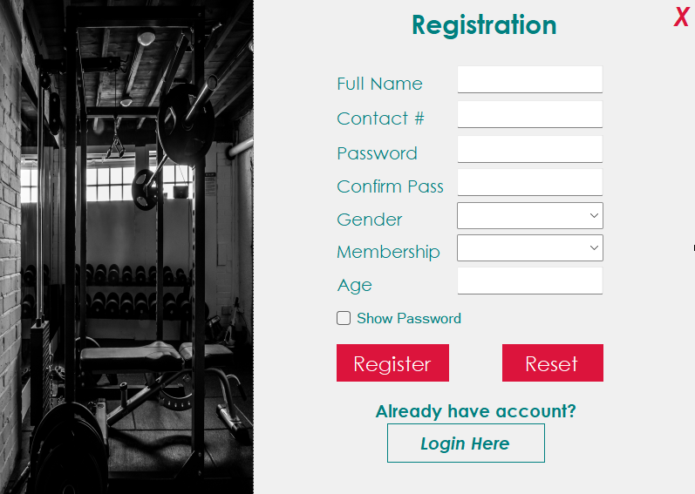

Login Design:

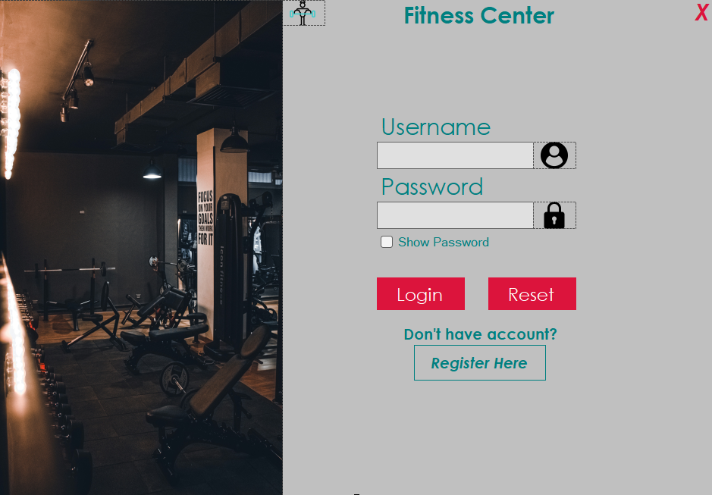

Main Form:

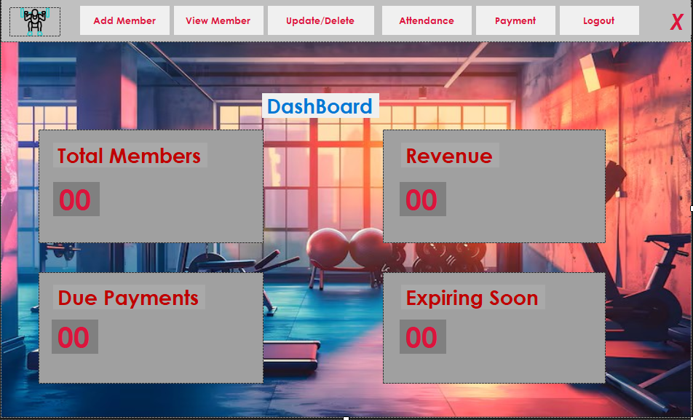

AddMember:

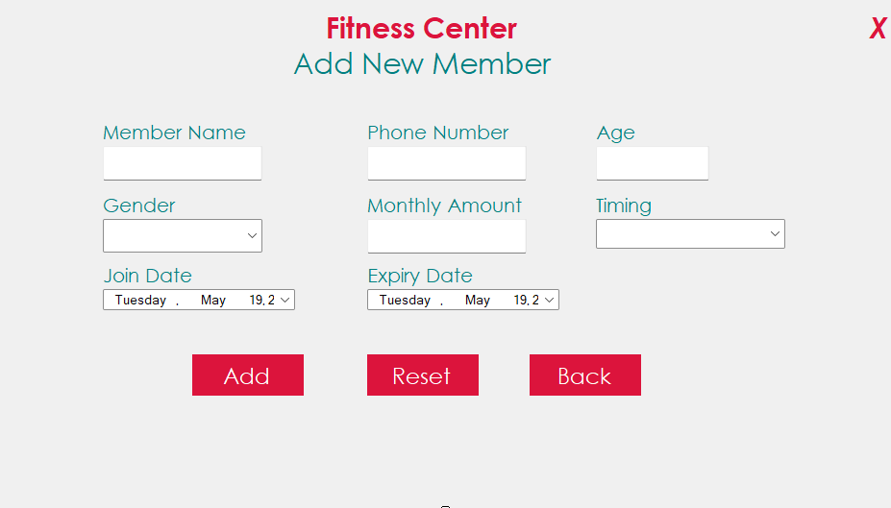

View Member:
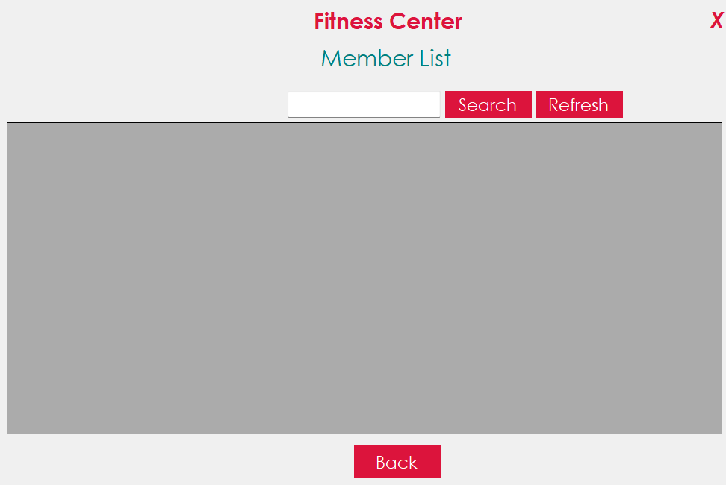

UpdateDelete:

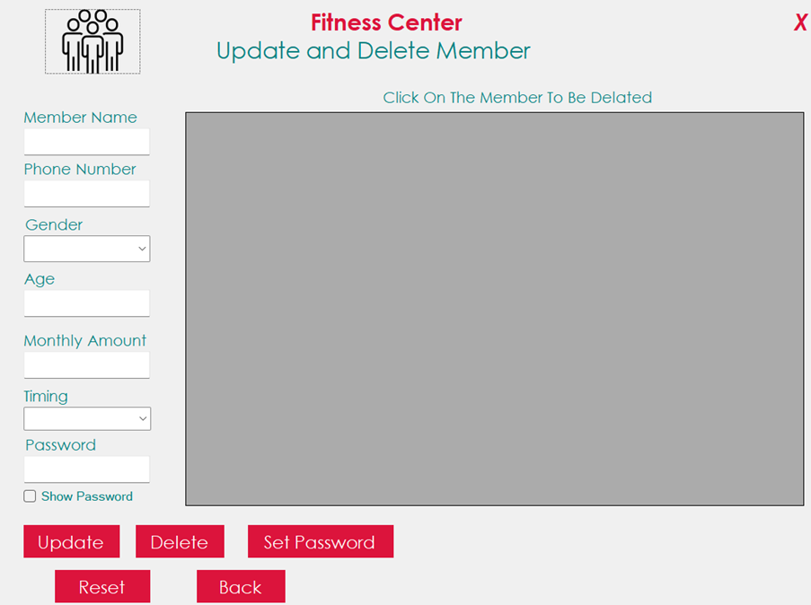

Attendence:

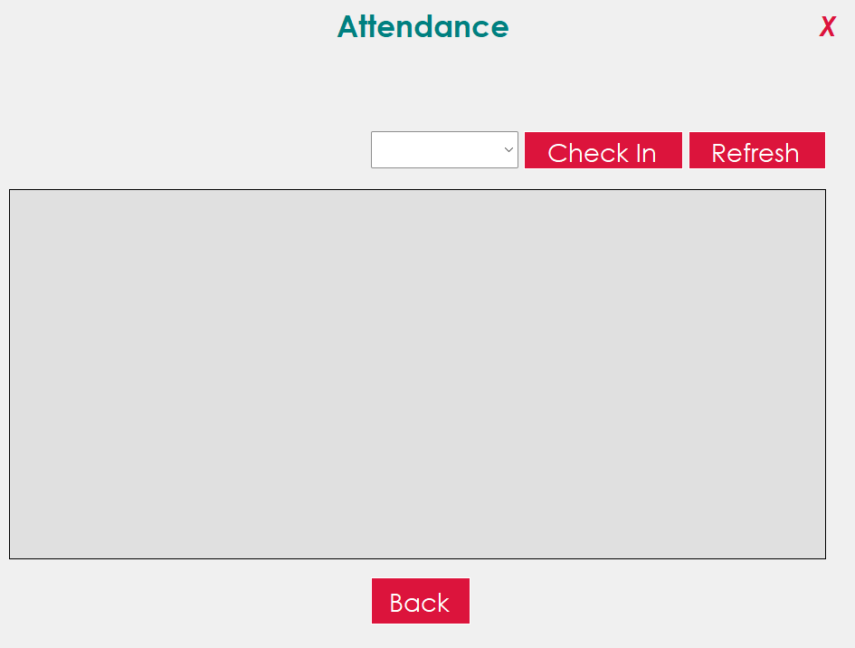

Payment: 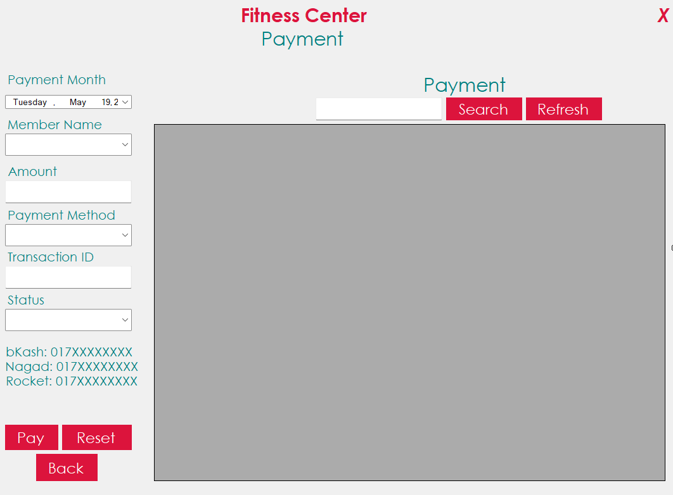
- Conclusion

The Gym Management System is a desktop-based application developed using C# and SQL Server to simplify and automate the daily operations of a gym. The system provides an efficient and user-friendly platform for managing members, memberships, payments, inventory, reviews, and administrative activities.

By implementing Object-Oriented Programming (OOP) concepts, database management, role-based access control, and proper validation techniques, the application ensures security, maintainability, and organized data handling. Different user roles such as Super Admin, Admin, and Customer provide better management and accessibility according to user responsibilities.

The project reduces manual work, improves accuracy, saves time, and enhances overall operational efficiency. It also provides a scalable structure so that additional features and future improvements can be integrated easily.
Overall, the Gym Management System demonstrates the practical implementation of software development concepts and serves as an effective solution for modern gym management and administration.

