Step-1

<https://nodejs.org/en/download/>

step-2

download and install

step-3

node version check

node -v / node

npm version check

npm -v

if any issue check

environment variable

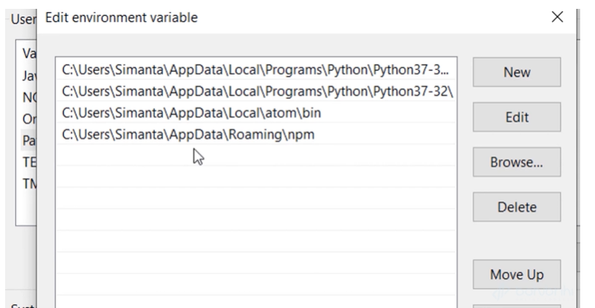

Npm init

Step-4

Run npm date package

= npm install date-formate

let mat = require('date-format');

let time = mat('hh-mm:ss.SSS', new Date());

let date_d = mat('dd-MM-yy', new Date());

console.log(date_d);

For global install/uninstall

Npm uninstall/install module name -g

Npm install typescript -g

That means if you “-g” then it will install globaly

Install – React

1st –

Npm install create-react-app -g

Npm root -g

2nd

Create-react-app application name

React project folder structure

1. Every file should be injected in public/index.html file
2. Every jsx file will be better of include in the app.js file. Then render this file.