**HTML Exercises**

**Ex-1: Heading and paragraph, formatting tag**

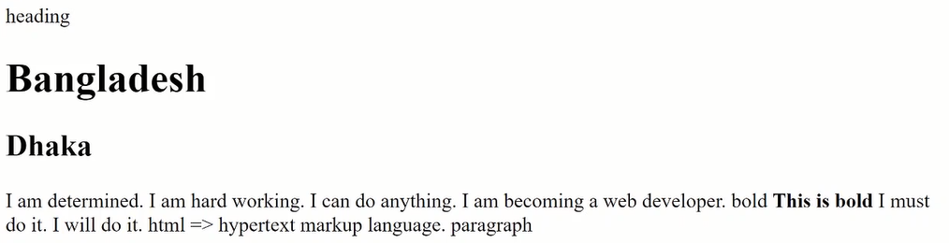

**Ex-2: Hyperlink**

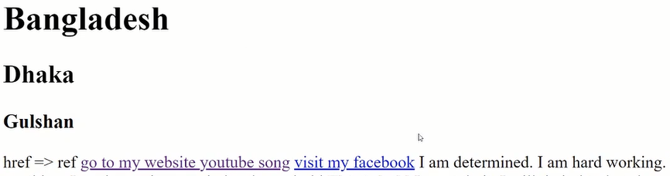

**Ex-3: Image**

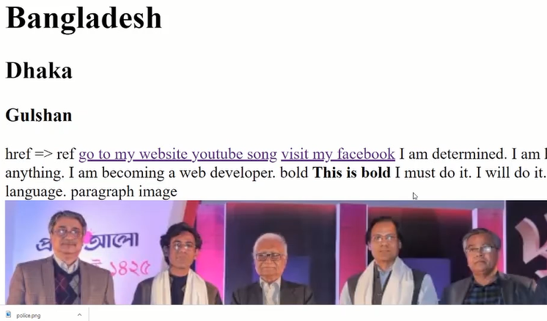

**Ex-4: List**

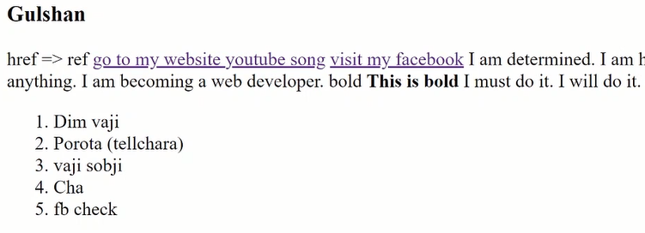

**Ex-5: Table**

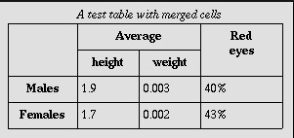

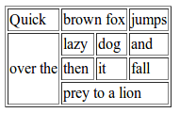

**Ex-6: HTML forms**

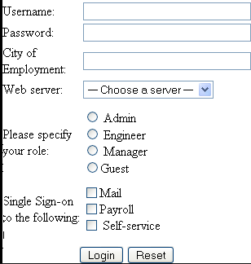

**Ex-7: HTML equations**

