1. Total number of pixels:

5 * 6 * 600 = 18,000 pixels for each image.

16-bit grayscale image -> each pixel takes 2 bytes:

18,000 pixels * 2 bytes/pixels = 36,000 bytes for each image.

Total storage of 1 GB = 1073741824 bytes:

1,073,741,824 bytes / 36,000 bytes/image = 29,826.2 so 29,826 since you need whole numbers for the image amount (can’t store a 1/5th of an image).

Therefore, 29,826 images can be stored.

1. 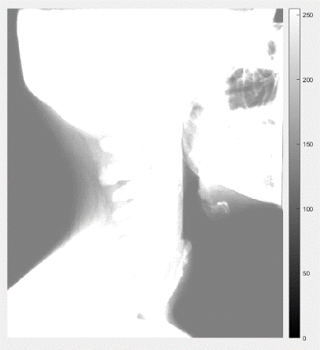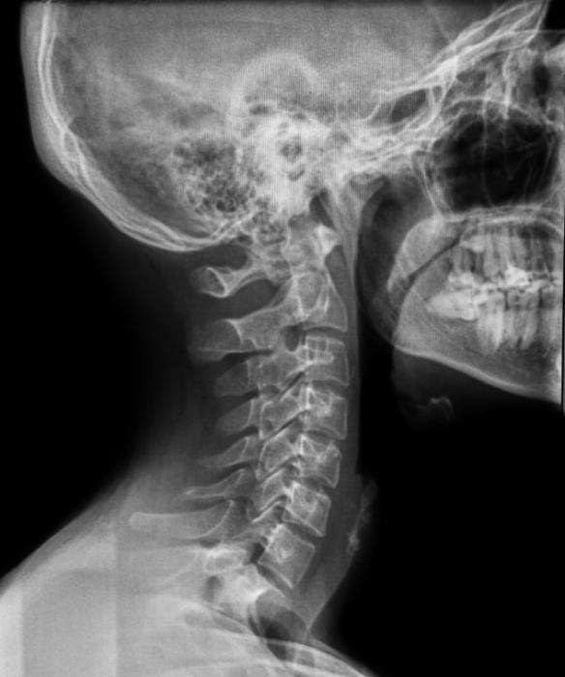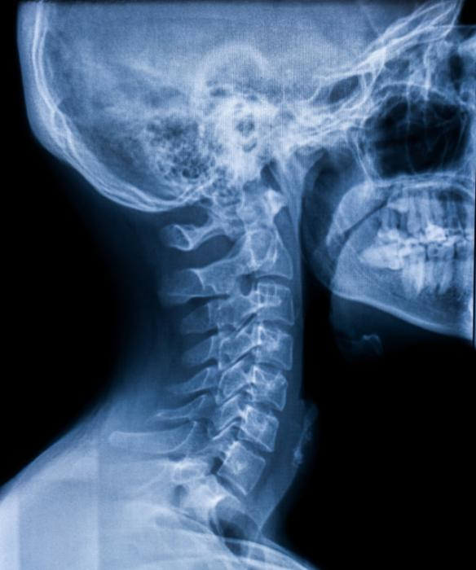Original: Gray: Deteriorated:

a)

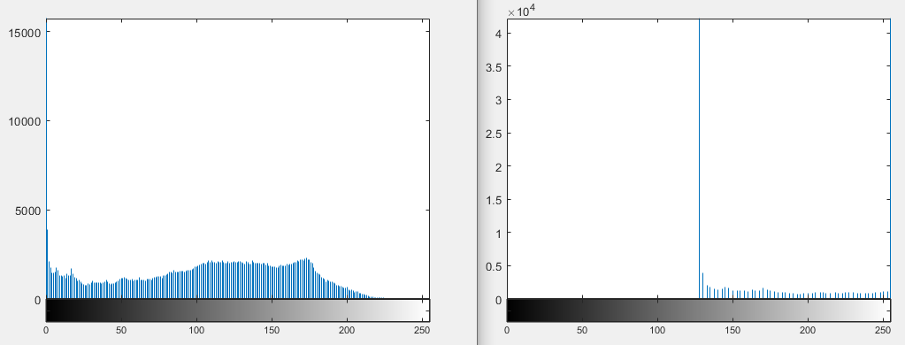Gray: Deteriorated:

Dynamic range is 20*log2(maxv/miv) of our deteriorated image.

20*log2(255/128) = 19.89 is the dynamic range.

b) Histogram Equalization: Image:

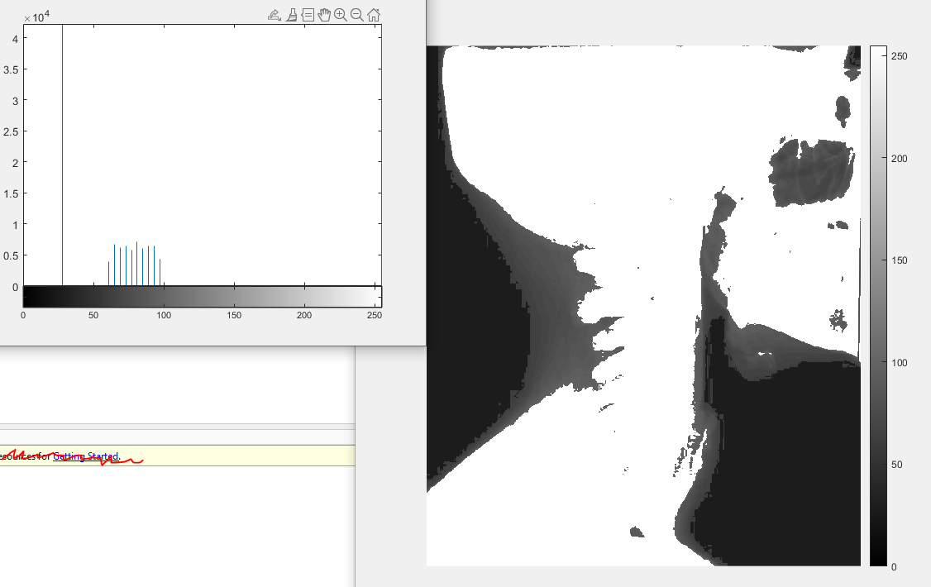

c) In the original image (Gray) the histogram is equally distrusted, i.e. there are relatively a decent amount of pixels for each pixel values trailing off around 200. In the deteriorated image there is low contrast so the histogram is kind of squeezed together between the pixel values of about 125 to 255 providing less contrast and a brighter image overall. However, in the image obtained in b there is very high contrast so the detrition is less even. There are a lot of a dark pixel value (almost 0) and a lot of 255 pixel value (white) and a few gray in between the values of 50 and 100. There is more concentrated intensity at certain points in b and more distributed intensity in the original and in the deteriorated there is a high intensity in the brighter range of pixel values and contrast is low.

1. a) 5x5 = 25 pixels

Each pixel has 8 bits so 35 x 8 = 200 bits.

1 byte = 8 bits so 200 / 8 = 25 bytes.

b)

c)

d) H = -(2/25 * log2(2/25) + 5/25 * log2(5/25) + 11/25 * log2(11/25) + 7/25 * log2(7/25))

= -(0.08 * log2(0.08) + 0.20 * log2(0.20) + 0.44 * log2(0.44) + 0.28 * log2(0.28))

= -(0.08 * -3.644 + 0.20 * -2.322 + 0.44 * -1.1844 + 0.28 * -1.8365)

= -(-0.29152 -0.4644 -0.521136 -0.51422)

=1.791276

=1.79 bit/pixel is the entropy

e)

|  |  |  |  |
| --- | --- | --- | --- |
| **Pixel Value** | **Probabilties** | **Source Reduction** | |
| 1 | 2 |
| 160 | 0.44 1 | 0.44 | 0.56 0 |
| 254 | 0.28 00 | 0.28 00 | 0.44 1 |
| 50 | 0.20 010 | 0.28 01 |  |
| 0 | 0.08 011 |  |  |

|  |  |  |  |
| --- | --- | --- | --- |
| **Pixel Value** | **PDF** | **2-Bit Binary** | **Huffman Code** |
| 0 | 0.08 | 00 | 111 |
| 50 | 0.2 | 01 | 110 |
| 160 | 0.44 | 10 | 0 |
| 254 | 0.28 | 11 | 10 |

Shorter code to pixel value with greater PDF and longer code to pixel value with smaller pdf.

f) Code length is 3, 3, 1, and 2 respectively.

So 3*0.08 + 3*0.2 + 1*0.44 + 2*0.28 = 1.84 bits.

g) Compression ratio: 2:1.84 = 1.09.

h) This is lossless compression because no data is lost after doing this compression.

1.79 bit/pixel (the entropy) < 1.84 bits (average code length) < 2-bit.

Since entropy is less than average code length we have no loss.