1. A) CODE:

x = -2:0.01:2;

y = -2:0.01:2;

[X,Y] = meshgrid(x,y);

h = 1/2\*exp(-pi\*(X.^2 + (Y.^2)/3));

imagesc(x, y, h);

colormap(gray);

colorbar;

xlabel('Distance, x [mm]');

ylabel('Distance, y [mm]');

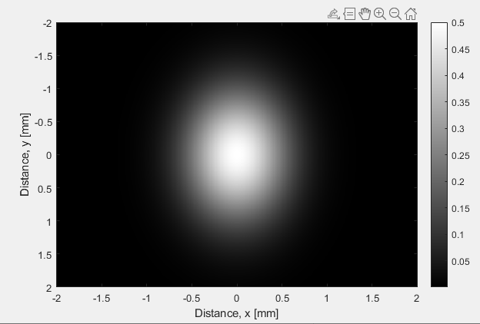

b) We know this:

So, in our case we take out the constant ½ and get two more constants of 1/(2π) and 3/(2π) because of the constants on x and y (1 and 1/3). So, h(u, v) = ½\*1/(2π)\*3/(2π) exp[-π(u2 + v2/3)] = 3/(4π2) exp[-π(u2 + v2/3)].

c) The maximum will be at (0, 0) because when we partially derive h(x, y) with respect to both x and y the equation will be satisfied at 0 for both.

Max of h(x, y) = h(0, 0) = ½ exp[-π(x2 + y2/3)] = ½

So, half maximum = ¼.

Need to solve for x (width) while = ¼

¼ = ½ exp[-π(x2 + y2/3)]

½ = exp[-π(x2 + y2/3)]

Ln(1/2) = -π(x2 + y2/3)

ln(1/2)/-π = x2 + y2/3

This is our equation of a circle (or ellipse rather) where

r = $\sqrt{ln(1/2)/-π}$

FWHM = 2r (diameter of our 2D gaussian) = 2 $\sqrt{ln(1/2)/-π}$\* = 0.93943727923.

So, our full width at half maximum is equal to about 0.94 mm and half maximum is 0.25 mm.

1. A) Non-ionizing radiation has less energy than ionizing radiation. Ionizing radiation removes electrons from atoms or molecules including living tissue. That is why it is dangerous with too much exposure. Ionizing radiation includes higher energy wavelengths like x-rays and gamma rays and non-ionizing radiation includes less energy wavelengths like radio waves, microwaves and the visible light spectrum.

B) In x-ray attenuation mechanism, the x-rays are attenuated while passing through tissue and x-ray photons get absorbed by an atom while removing an electron from an atom. The photon is absorbed by an atom and is more likely to occur with atoms with higher atomic numbers (like bones) and help in the contrast of an x-ray. The main factors affecting attenuation is the incident beam energy, the thickness, and atomic number and density of the material. In summary, the intensity of an x-ray beam decreases the farther it penetrates into matter.

C) The difference in x-ray attenuation is what gives us our contrast. Dense material like bones absorb more x-ray photons than less dense material like tissues. That is why bones appear very white on an x-ray and tissue is darker. Additionally, in order to improve contrast (say a certain material is too dark) we can add a special dye, such as iodine, which is called a contrast medium that allows us to highlight a certain material.

1. A) We can use the equation Id(x) = I0e-ux, as it decreases exponentially as it passes through a material, where x will just be our length of the material. In our case it would be two materials so Id(x) = I­0e-uL/2 + I­0e-uL/2 for both A and B. But since in this case |x| > 1 cm we are only affected by material B so it is just I = I­0e-uL/2 with μ being μB = 1.0/cm.

Id(x) = I0e-1.0cm\*2cm/2 = 0.37I0

b) Now we pass through A and B so:

Id(x) = 2I­0 (e-uL/2 + e-uL/2)

= 2I0 (0.9744)

= 1.95 I0