1. 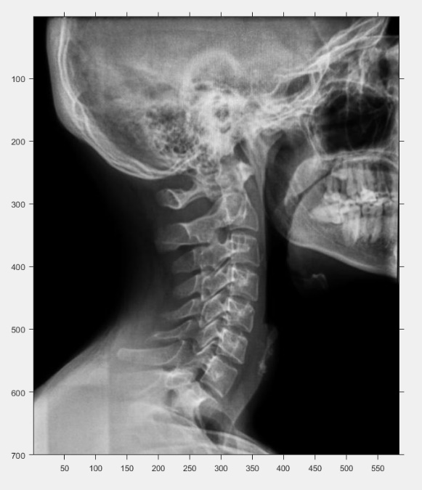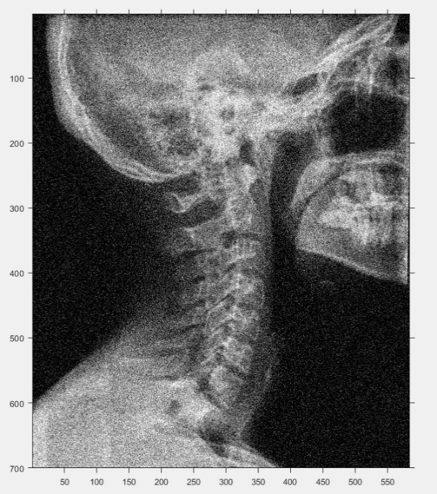 a)

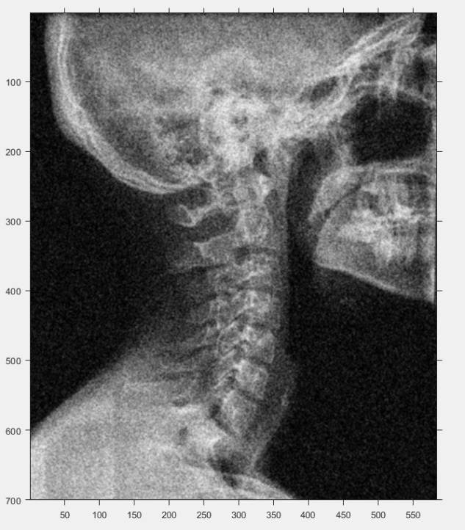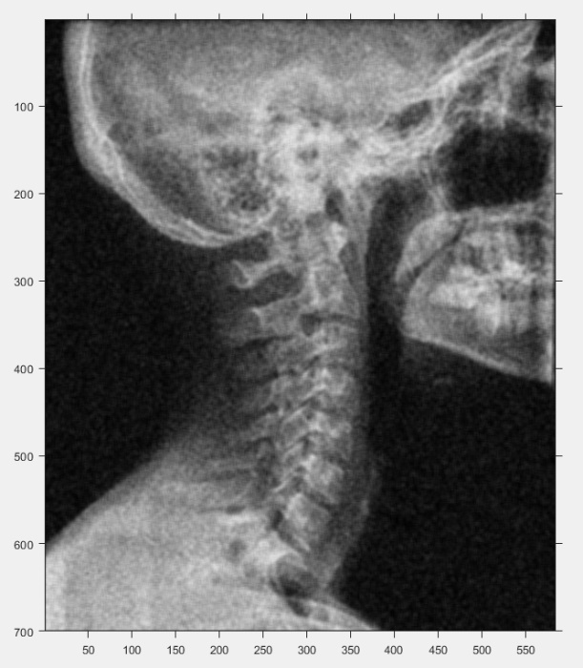b) c)

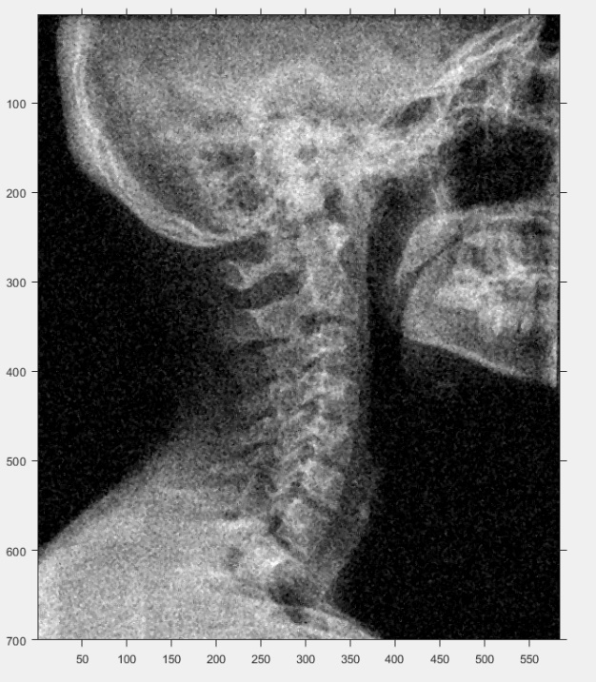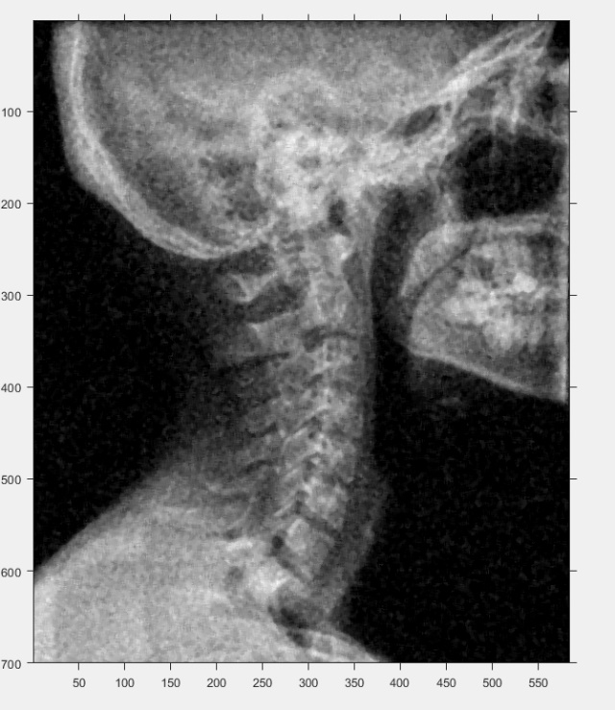d) e)

f) I would choose an averaging mask as they are generally better at reducing gaussian noise while median masks are better for salt-and-pepper noises. We can see this from our images where the resotred images of b and c look better and closer to the original image than d and e. The former using averaging mask. Median masks still left quite a bit of noise.

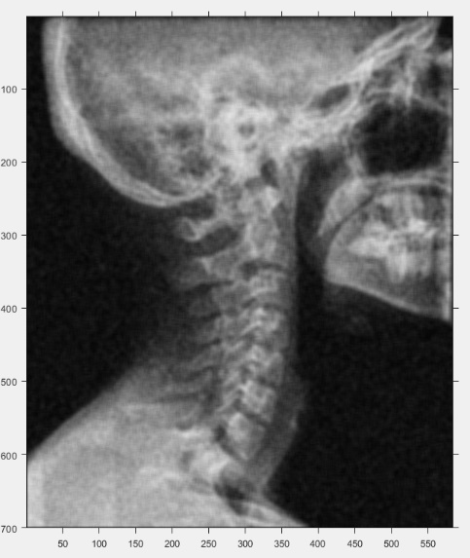g) The following is a resoted image using a 7x7 avergaing mask. It is quite blurry with more fine details being removed.

h) To find the optiomal size we need to find a balance between noise reducation and the preservation of our image details. We can see for the averaging masks, upon visual inspection, in the 3x3 there is still some noise and in the 7x7 there is too much blur and not enough details showing. Therefore, 5x5 provides a nice compromise between the two giving us our optimal size. We can also use mean square error is we want to measue the effectiveness of the filters mathematically of the different filter sizes.

I) White gaussian noise is a type of additive noise where the power spectrum of this noise signal extends to infinity with constant power across al frequencies (hence why it is called white, since white light constitutes all possible frequencies in the electromagnetic spectrum), making the power spectrum flat. This type of noise is gaussian with a zero mean, and it mimics the effect of many random processes that occur in nature. It is additive because it is added to any noise that might be intrinsic to the information system.

**Code For Question 1:**



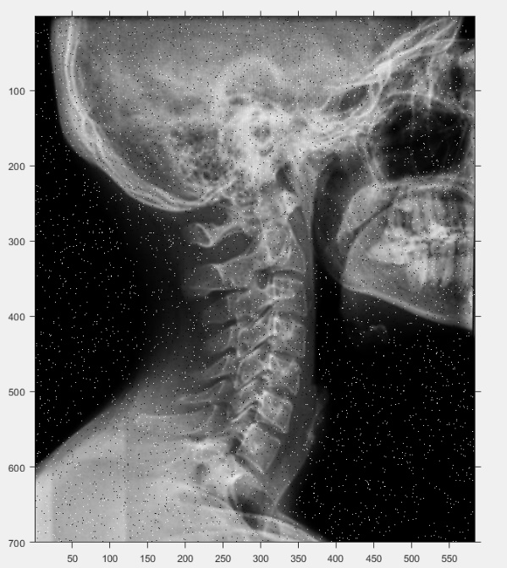

1. 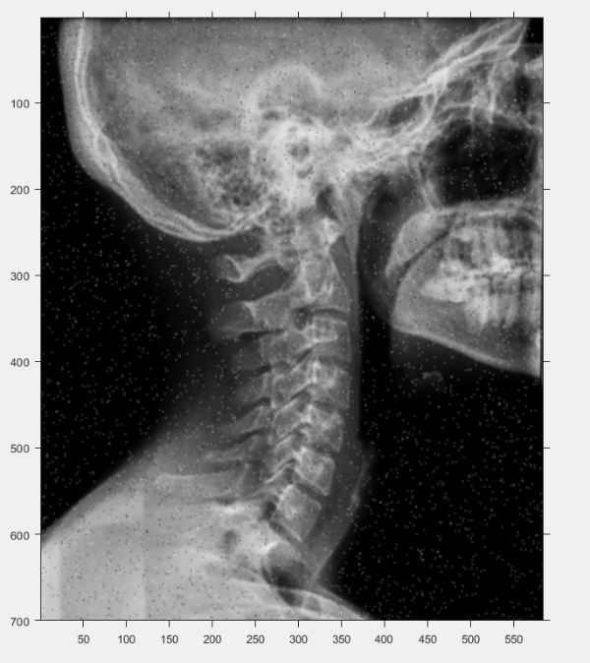A) b)

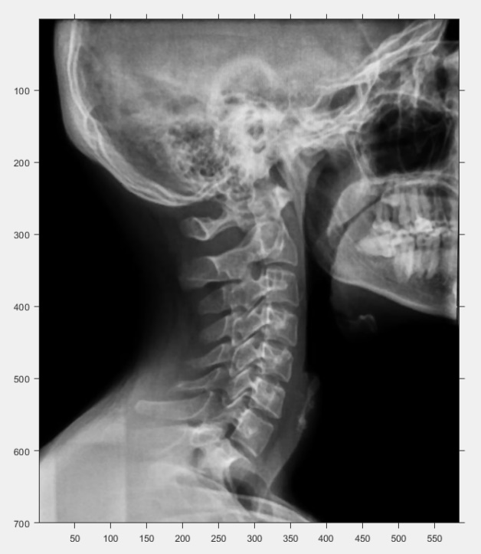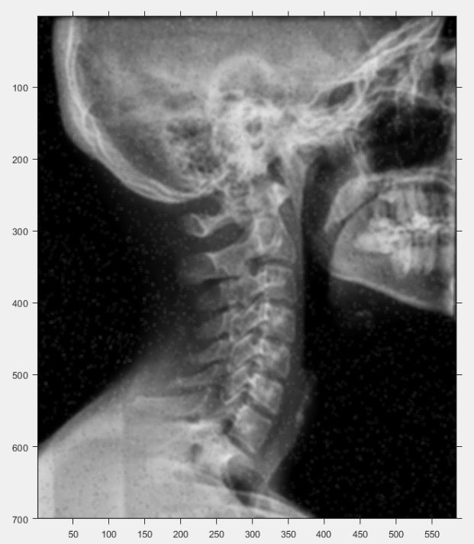c) d)

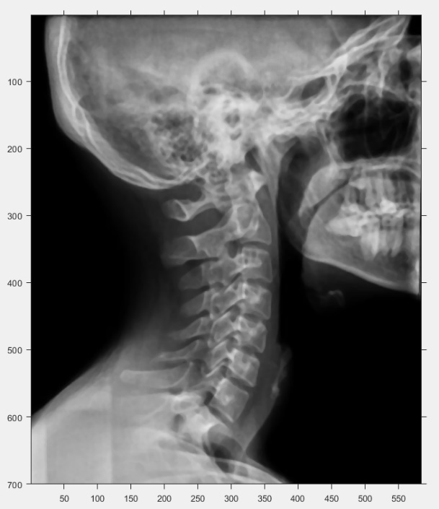e)

f) I would choose a median mask as it is better at getting rid of the salt-and-pepper noises. We can see this from our images of d an e which look much more like the original image than the averaging mask images of b and c. the averaging maks only averaged out those pixels to blend in better but the median mask removed it pretty much compleetly.

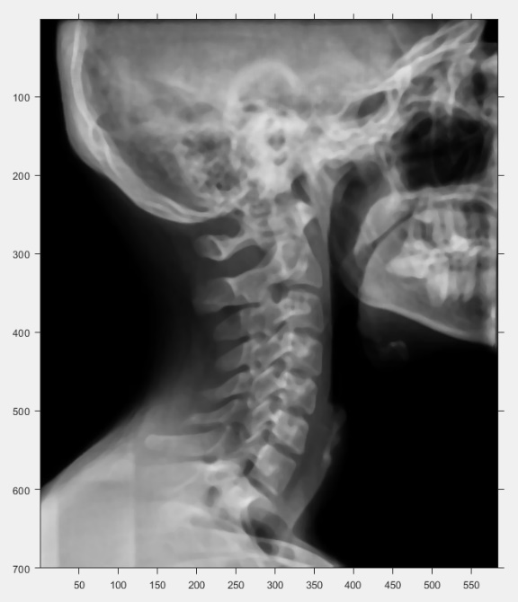g) The following is a 7x7 median mask. It is similar to the 5x5 median mask but it is less like the original image than the 5x5. There is a bit more blur but not too noticeable.

h) To find the optiomal size we need to find a balance between noise reducation and the preservation of our image details. We can see for the median masks, upon visual inspection, in the 3x3 there is still some noise and in the 7x7 there is a bit too much blur and less details showing. Therefore, 5x5 median provides a nice compromise between the two giving us our optimal size. We can also use mean square error is we want to measue the effectiveness of the filters mathematically of the different filter sizes.

j) It is a type of impulse noise where the original value of the pixels is lost and is taken equal to the extremes of the dynamic range (in our case 0, black, or 255, white). These can be caused by malfunctioning pixels in cameras or seneors, faulty memory in transmission noise chanels, etc. These pixels can appear as isolated points or in small clusters giving the effect of salt and pepper sprinkled on the image.

**Code For Question 2:**



1. 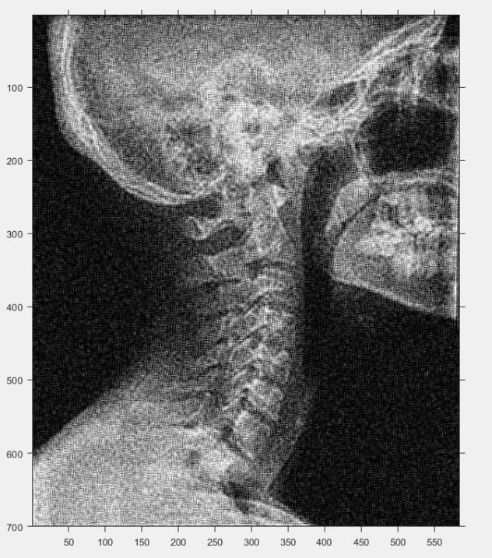k) We would use a Laplacian filter to sharpen the image. I used a filter of -1s around and 8 as a positive centre. We need to add our filtered result to the image this way. The result is the following:

L) Comparing this to the original image it does help remove the blurring from the averaging mask but leaves a very grainy effect left on the image. This could be due to over-sharpening.

**Code For Question 3:**

