Nama : Nino Fachrurozy E.P

NIM : 17051204038

Kelas : TI 2017 A

**Tugas Pengolahan Citra Digital**

* **Histogram**

>> spon = imread('C:\Users\IQBAL\Downloads\spon.png');

>> spon = rgb2gray(spon);

>> imhist(spon);

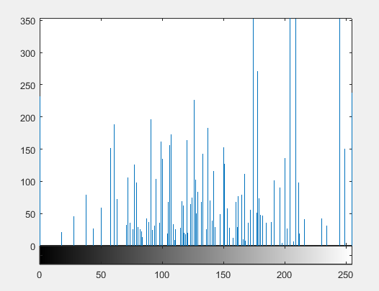

* **Histogram Equalization**

>> sponEq = histeq(spon);

>> imshowpair(spon,sponEq,'montage');

>> figure, imhist(sponEq,64);

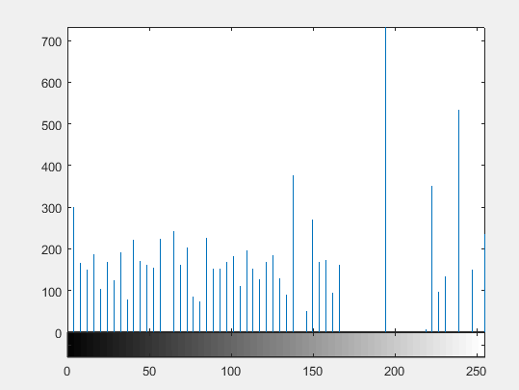





* **Low Passing Filter**

>> fil = fspecial('average', 3);

>> sponLPF = uint8(round(filter2(fil, spon)));

>> imshowpair(spon,sponLPF,'montage');