Sales Forecasting.

Small app to calculate the total cost on the sold products based on available offers.

Prerequisites :

Python should be installed.
sales_forecasting.py file should be available in the path where you are going to execute it.
If dynamic product values are required product_conf.conf configuration file should be available in the conf directory, conf directory should follow execution directory path from app is required to be started.

Way to launch:

Redirect to the directory where the file have been kept.
Suppose :
Inside /opt/sale_forecasting
Then cd /opt/sale_forecasting

Execute python sales_forecasting.py

You will see the below output on terminal/console .

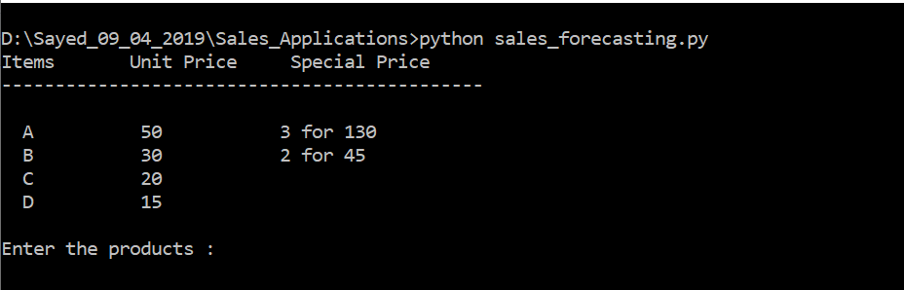

Enter the products :
Example AAABB
Total will be calculated based on applicable offers
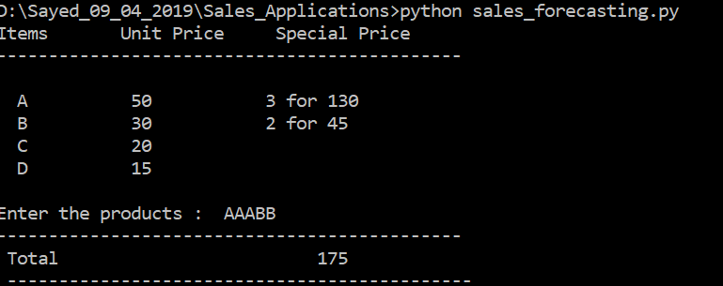

To add more products on the running application can be added in conf file as mentioned followed by conf/product_conf.conf.

Open the file in text editor and follow below steps.

#for adding products add in AVAILABLE_PRODUCTS product_name : price followed by comma
#for adding or updating the offers on products add in OFFERS_ON_PRODUCTS product_name : (quantity , offered_price ) followed by comma

After adding close the file and in launched console press enter 2 times to get the updated products.

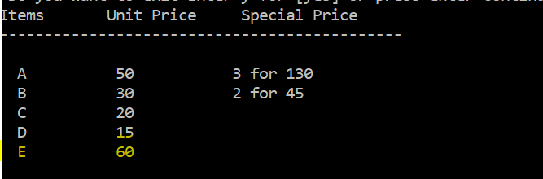

For exiting or closing press enter and then small “y” and enter.

Thanks for your time.

