**Assign Input Variables from terraform.tfvars**

- Create a file named `terraform.tfvars` and define variables

- If the file name is `terraform.tfvars`, ***terraform will auto-load the variables present in this file by overriding the `default` values in `variables.tf`***

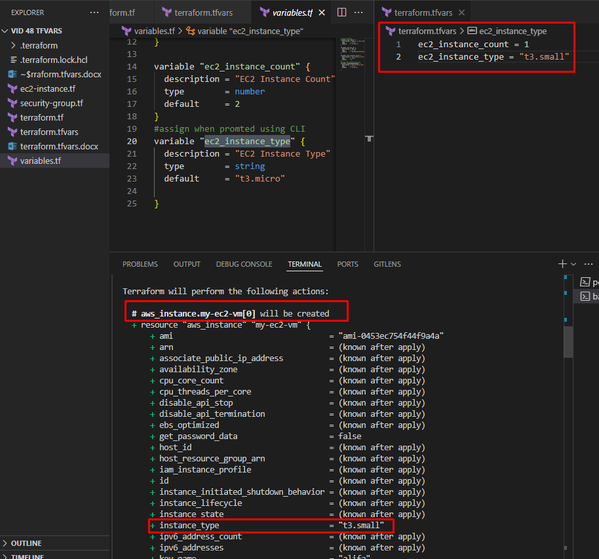

Even though in variables.tf it is mentioned that instance count is 2 and type is t3.micro,

But when applied terraform init we see other configurations like count is 1 and type is t3.small. this is because we created terraform.tfvars file and defined the variables. This is more prioritized. It was auto loaded.