Here in the console a bucket was made.

We store the terraform.tfstate file in s3 bucket.

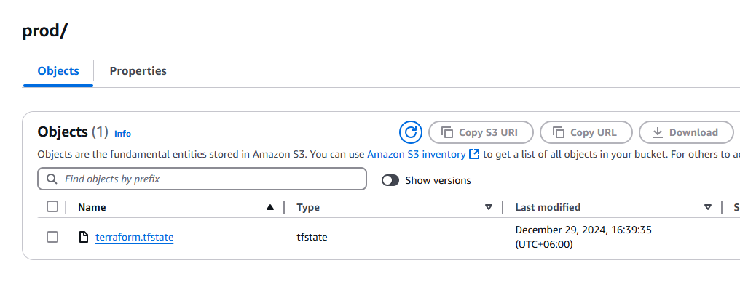

backend "s3" {

bucket = "alifa-bucket-backend"

key = "prod/terraform.tfstate"

region = "us-east-1"

}

In the backend block we gave the name of the bucket that was created in the console and a path was assigned which later on got generated in order to store the file.

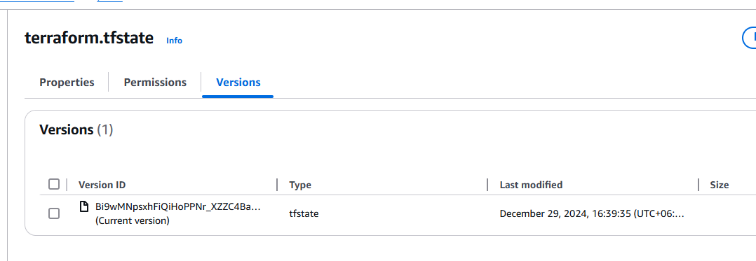

After making changes in the ec2 like changing ec2 instance and then applying, we will get another version of the terraform.tfstate file.

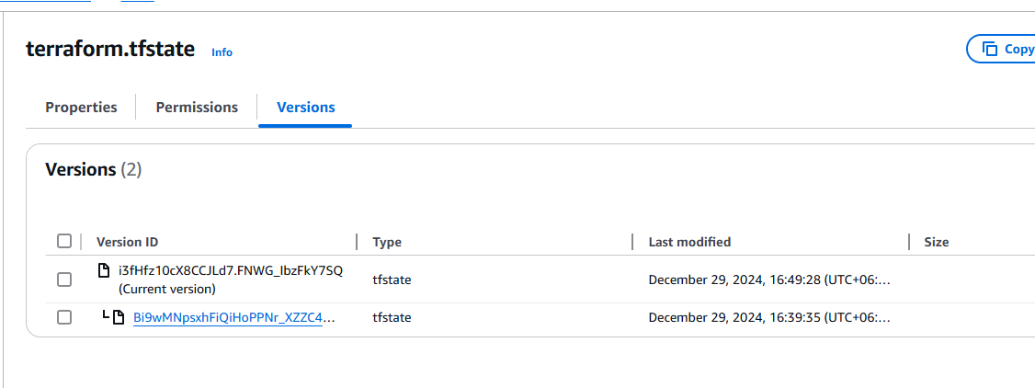

After terraform destroy another file will also be created

