# Lab – 01 Assignment

**Question 03:** Create a Webpage that contains the following List and use all the tags and attributes of HTML Lists.

**Source Code:**

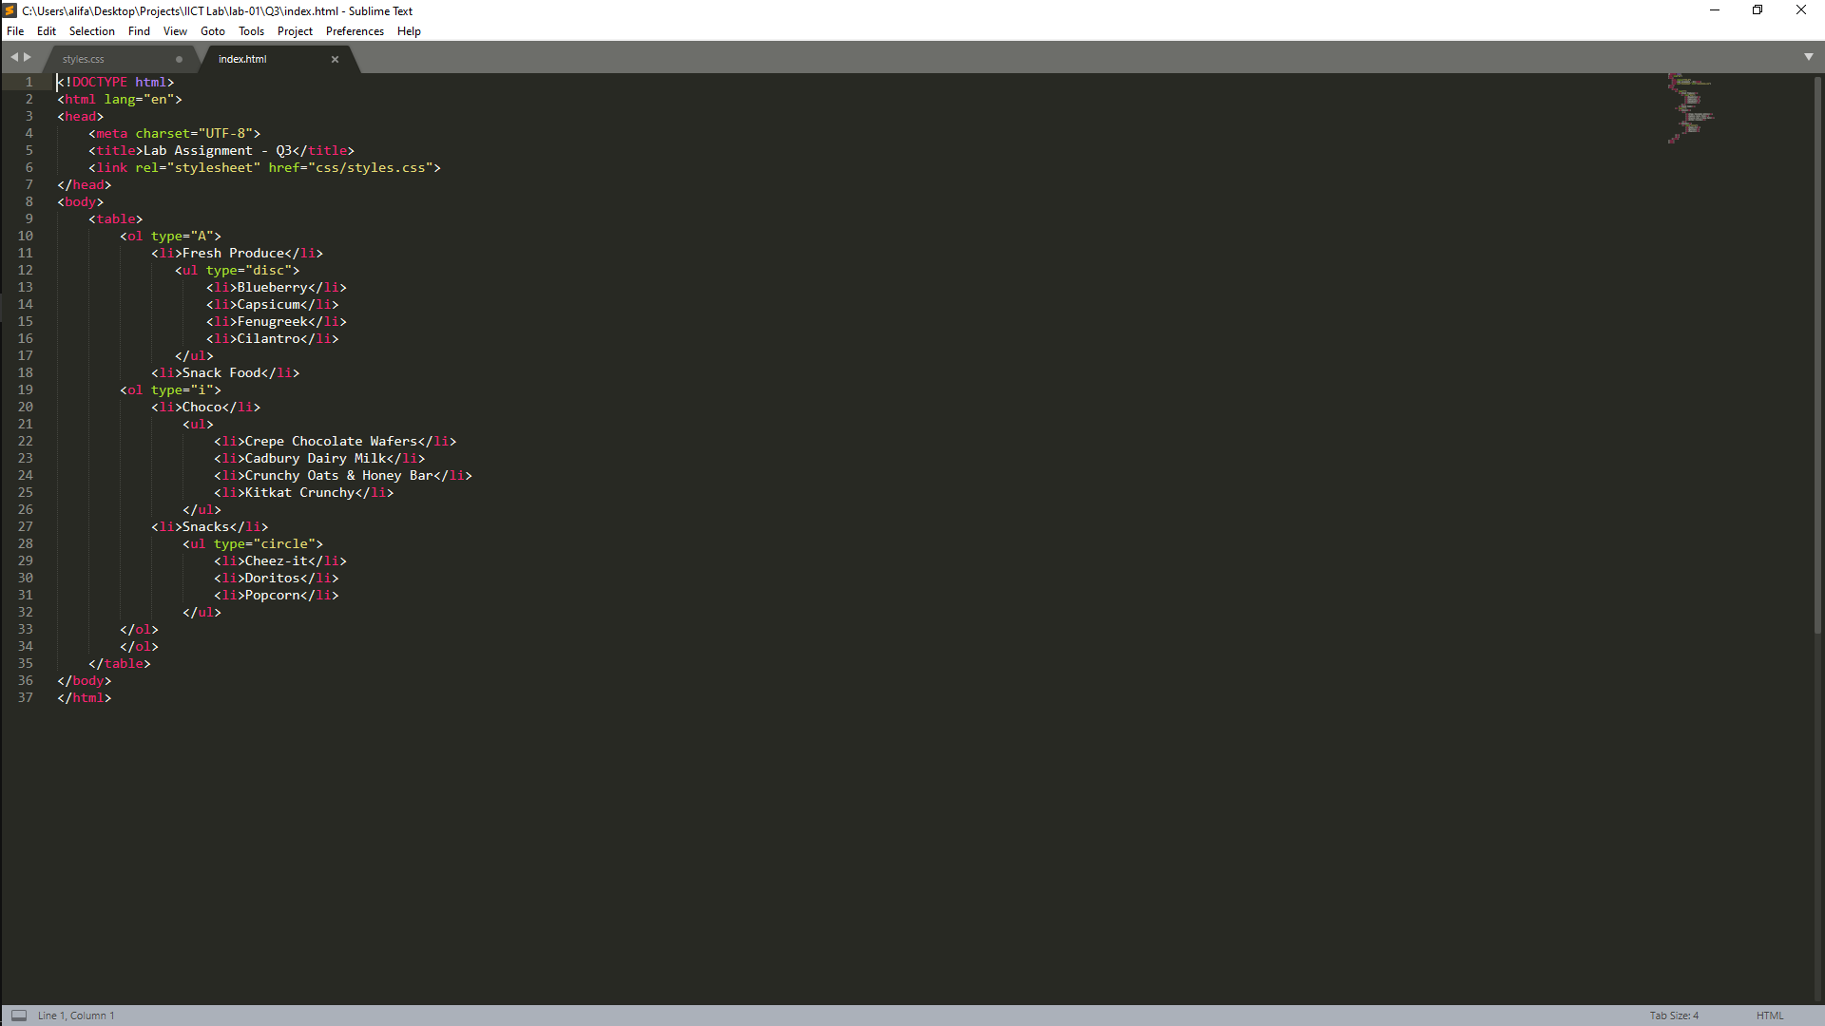

**Output:**

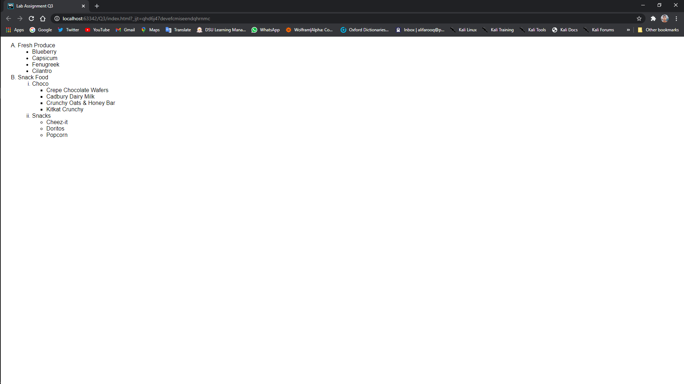

**Question 01:** Create a beautiful Webpage for any Topic of your choice. Use all the tags and attributes mentioned above (except those of Lists and Tables).

**Source Code:**

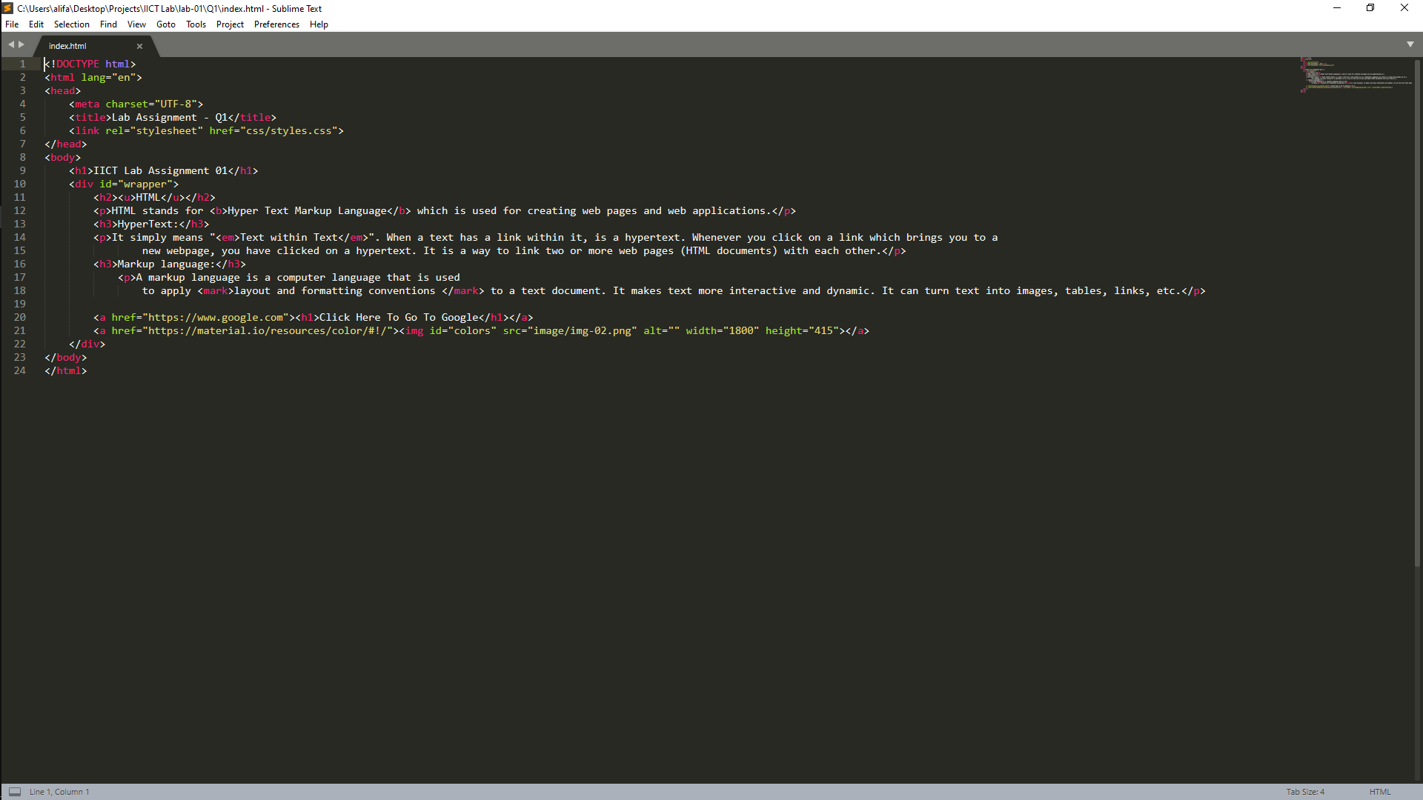

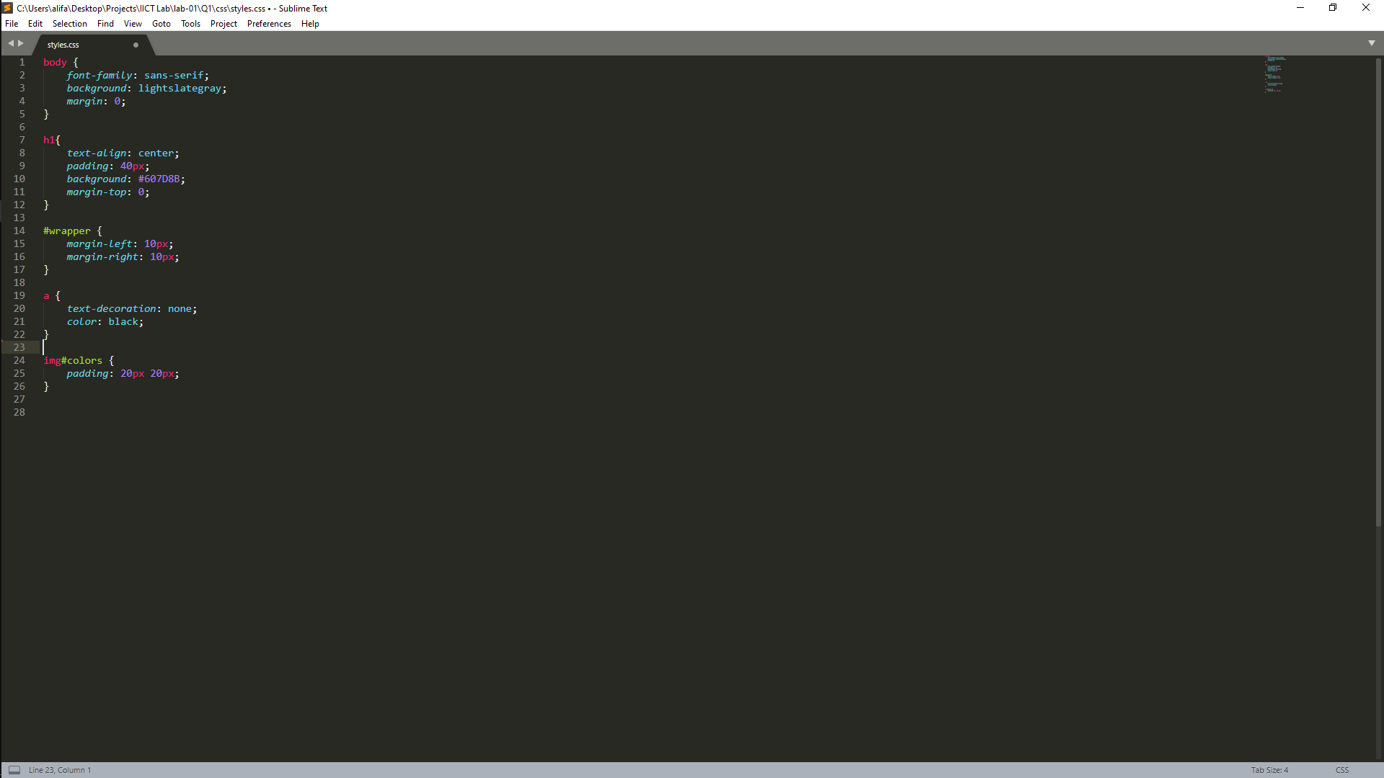

**Output:**

