# Lab 02 – Assignment

**Question 01:** Create a Webpage that contains the following table and use all the tags and attributes of HTML Tables.

**Source Code:**

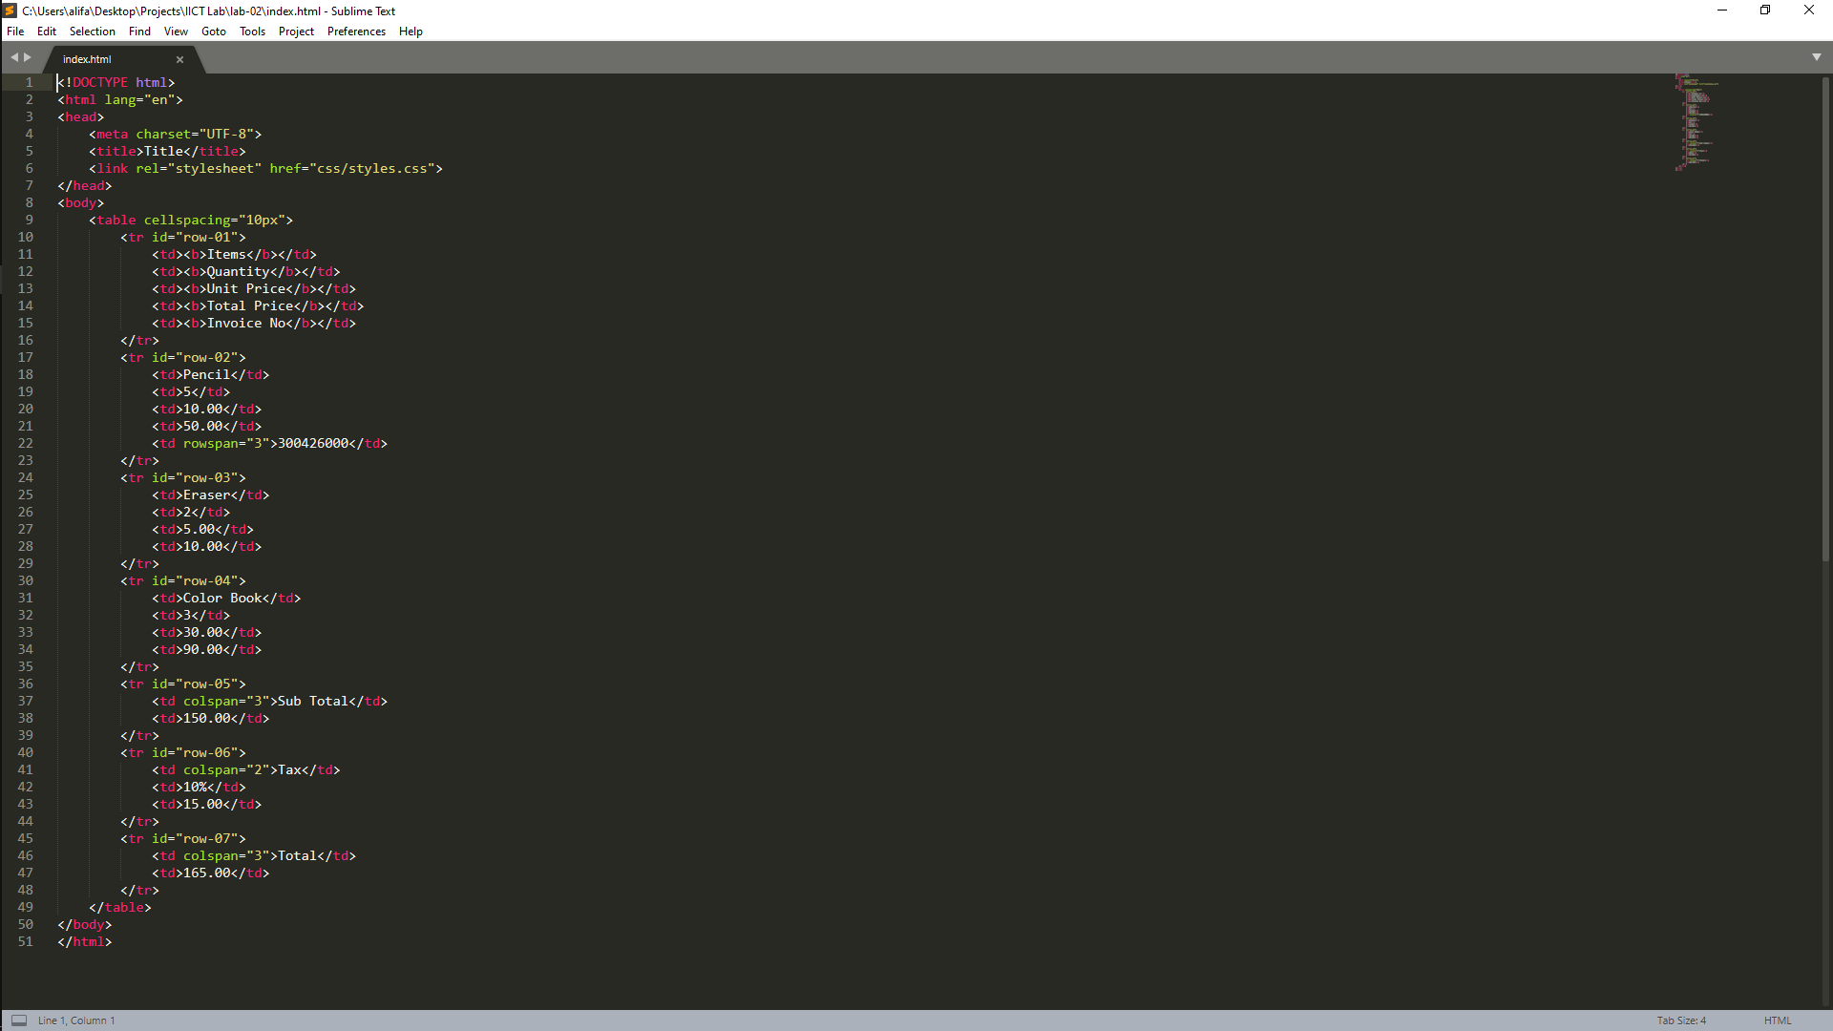

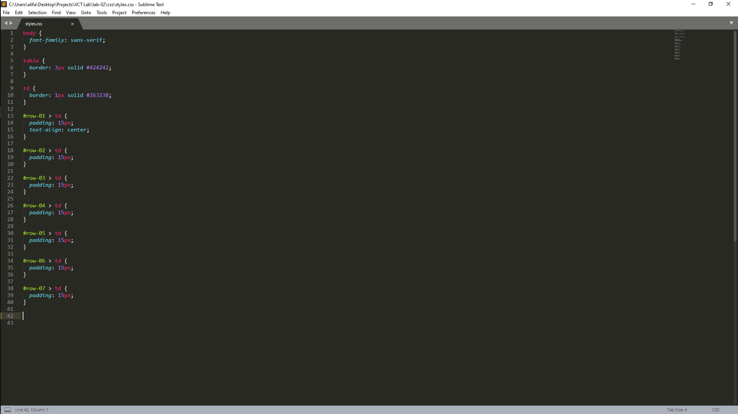

**Output:**

