

**Department of Electrical Engineering**

SUMMER 2023

**Design Project Report**

# HCS12-based power meter and fan speed controlled by Temperature using PWM technique

|  |  |
| --- | --- |
| **Project Advisors: Dr.Belal Sababha** |  |
|  | |

**Team Members**

|  |  |  |  |
| --- | --- | --- | --- |
| **Student Name** | | **Student ID** | |
| **1 Fatema Ali** | | | **20208031** |
| **2 Shatha Alhamad** | | | **20228189** |
|  | |

## Abstract

**This project presents the design and implementation of a power meter and fan speed control system based on the HCS12 microcontroller, utilizing the pulse width modulation (PWM) technique for temperature regulation. The objective of the system is to monitor power consumption accurately and dynamically control the fan speed according to the ambient temperature.**

**The HCS12 microcontroller acts as the central processing unit of the system, responsible for acquiring power measurements and adjusting the fan speed. The power meter module employs suitable current and voltage sensors to monitor the power consumed by the load. The obtained data is processed by the microcontroller and transferred serial and displayed on the screen PC, providing real-time power consumption.**

**In addition to power monitoring, the system incorporates temperature sensing using a temperature sensor. The microcontroller reads the temperature value and calculates the desired fan speed based on a pre-defined temperature-fan speed relationship. PWM signals are generated by the microcontroller to drive the fan, enabling precise control of its speed. As the temperature changes, the microcontroller adjusts the duty cycle of the PWM signal accordingly, resulting in an automatic and responsive fan speed adjustment.**

**The HCS12 microcontroller provides a versatile platform for the implementation of this system, offering sufficient processing power, input/output capabilities, and communication interfaces. The system demonstrates the ability to accurately measure power consumption and efficiently control the fan speed based on the ambient temperature.**

**Experimental results indicate that the power meter provides accurate power measurements, allowing users to monitor and manage their energy consumption effectively. The fan speed control mechanism responds promptly to temperature changes, maintaining a comfortable environment while minimizing energy usage.**

**The proposed HCS12 microcontroller-based power meter and fan speed control system with PWM technique offers an effective solution for energy management and temperature regulation. Its versatility, accuracy, and responsiveness make it suitable for a wide range of applications, including residential, commercial, and industrial environments.**

### **1. Introduction**

With the increasing demand for energy efficiency and environmental sustainability, there is a growing need for advanced control systems that can monitor and regulate power consumption in various applications. In this context, the integration of microcontrollers has proven to be highly effective, offering a versatile and powerful solution for controlling and monitoring devices. This paper presents a design and implementation of a power meter and fan speed control system based on the HCS12 microcontroller, incorporating temperature regulation using the pulse width modulation (PWM) technique. Furthermore, the system enables data transfer to a personal computer (PC) via serial communication.

The HCS12 microcontroller serves as the core component of the system, providing the necessary processing capabilities and interfacing functionalities. By utilizing suitable current and voltage sensors, the microcontroller accurately measures the power consumption of the load. This information is then processed and displayed on an PC screen in real-time, allowing users to monitor their energy usage.

In addition to power monitoring, the system incorporates temperature sensing through a temperature sensor. The microcontroller continuously reads the temperature value and adjusts the fan speed accordingly. PWM signals are generated by the microcontroller to control the fan's speed, ensuring precise regulation. As the ambient temperature changes, the microcontroller dynamically adjusts the duty cycle of the PWM signal, resulting in an automatic and responsive fan speed adjustment.

To enhance the system's functionality, a serial communication interface is implemented to establish a connection between the microcontroller and a PC. This enables the transfer of data from the power meter and fan speed control system to the PC for further analysis, storage, or visualization. Serial communication provides a reliable and efficient means of exchanging data between the microcontroller and the PC, facilitating the integration of the system into larger energy management systems or enabling remote monitoring and control.

The proposed HCS12 microcontroller-based power meter and fan speed control system, with temperature regulation using PWM technique and serial communication to a PC, offers a comprehensive energy monitoring and management solution. By combining power measurement, fan speed control, and data transfer capabilities, the system enables users to monitor their power consumption, optimize energy usage, and create a comfortable environment. This system can find applications in various settings, such as residential buildings, offices, industrial facilities, and more, contributing to energy efficiency and sustainability goals.

By leveraging the capabilities of the HCS12 microcontroller, this project aims to contribute to energy efficiency goals and provide a scalable platform for implementing intelligent power management systems in various settings, including residential, commercial, and industrial environments

**1.** **Previous Work**

Title 1: Smart sensory energy metering

Introduction:

SSEM (Smart Sensory Energy Metering) is an electronic device that records consumption of electric energy and allows customers to program how and when their home uses energy.

Block diagram:

Home Server

(

Data Storage

)

User Device

AC current

sensor node 3

AC voltage

and current

sensor

Ethernet

shield

Arduino unio

AC current

sensor adapter

AC current

sensor node 2

Electrical

panel

AC current

sensor node 1

Functionality:

In this project they use A/C current sensor, AC current adapter, Sensor Controller (Arduino mega), Ethernet shield, Voltage and Current sensor and server as showing in figures 1 As its show in the diagram where each hardware will be.And with the electrical panel which contain several circuits switch each switch control of some part of the home that use electric current, they connected each switch with the sensor and will allow as to read the current that move in that wire that come out from the switch to a room, the AC current sensor will be install inside the electric panel and connect the sensor with wire.The sensor will be connected to the adapter shield by wire, each AC current sensor has it won channel that provided by AC current sensor adapter.The Ac current sensor adapter shield will be connected to the sensor controller by small pins “male pins “come from the adapter shield connect to the female pins on the sensor controller node.The sensor controller node will be programmed to convert the analog value that came from sensor to digital, the sensor controller will be connect to the Ethernet shield by long wire or it can be connect by the small pin that are been on adapter shield.The Ethernet shield will be connected to the sensor node, at same time the Ethernet will be connect to the laptop or PC that are work as home server. The home server will include to part server and client the server is web server include the web control, receiving the data that are collect it to the webserver database , the database c be design by MySQL and connect it to the webserver , the databases will have many thing such as cost of the electric usage , time of electric usage , number of room , the value of the current .The user device “Client “it is a web page will be make it be the HTML and JQuree the client will be able to choose many option from the webpage such as select the limit of cost and time and for each room that connect to the system, there will be an application for the user using just to showing the electric usage on live time, and receiving the message when there is high electric usage. The hole part will be connected to each other and work as one system.

Title 2: IOT Based Smart Energy Meter for Efficient Energy Utilization in Smart Grid Introduction:

Smart grid plays an important role in our current society and in our networks. Smart meters play a vital role. Smart meter provides immediate monitoring of reliable status, automatic information collection, user interaction and energy control. It also provides a double flow of information between consumers and suppliers, provides better control and efficiency. It also provides real-time consumption information and provides power control. As long as the customer's maximum load demand exceeds the maximum value, the electricity supply to customers will be separated with the help of an intelligent power meter. In an ideal environment with normal workload conditions, the smart meter has a service life of 5 to 6 years. In this project, the use age of the smart meter with IOT technology is introduced. The IOT-based power meter system consists mainly of three main parts, which are remote control, Wi-Fi and theft detection part. When there is an error or theft, the theft detection sensor detects the error response and the circuit according to the information it receives. The console plays a key role in the system to ensure that all components work well. Therefore, Internet of things can improve the performance and efficiency of the smart grid mainly in the three phases.

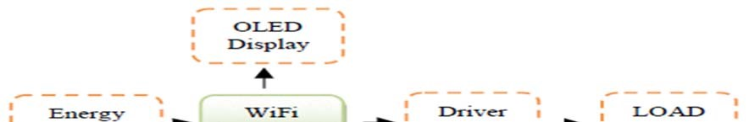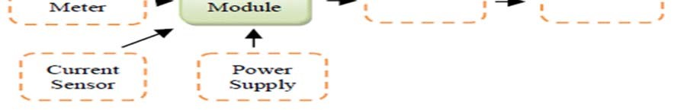

Block Diagram:

Figure 3:IOT Based Smart Energy Meter for Efficient Energy Utilization in Smart Grid.

Functionality:

The proposed system is cost effective and compact. Therefore, the premium becomes much easier. In this proposed system, the power meter is connected to the microcontroller through an opt coupler. The OLED screen is also connected to the system. In the controller circuit, ULN2003 is used to drive the relay to change loads. The current sensor is also equipped to determine energy theft. Figure 3 illustrates the

functional block diagram of the proposed intelligent monitoring system. The main functional unit of this system is discussed. The Wi-Fi module is used here and is programmable with an 80 MHz microcontroller. Then, the OLED screen used here that does not require backlight. You can illuminate the screen with high resolution. Then, the optical coupler detects the calibrated lamp of the energy meter and sends its output to a microcontroller. The optocoupler mainly produces infrared light and a semiconductor image sensor is used to detect the emitted infrared radiation. The Wi-Fi module is programmed using the Arduino IDE software to calculate the pulse of the power meter. The optocoupler pulse sensor and sends the data obtained to the cloud by microcontroller. The lamp blinks 3200 times in one unit. The LED flashing of the energy consumed in the units is calculated with the unit cost. Monitoring is carried out at each interval. The system also provides power theft with the current sensor connected to the system.

Therefore, the system does not imply providing a less human error.

.

Title 3: Design and Implementation of the Smart Meter in Vehicle to Grid Introduction:

Today, EV is an important area for researchers due to its attractive properties of reducing the use of gasoline and greenhouse gas emissions compared to conventional compounds. In this paper, the authors described that electrical vehicles achieve this by using a larger capacity battery pack that can be recharged using the power provided by the power grid. If the diesel generator of the electrical vehicles is considered, there should be a bi-directional smart meter that not only measures the charged car but also measures the energy saved in the network. The smart meter is the interface between electric cars and the network. It has two special functions compared to the traditional meter. The smart meter has a bidirectional scale and a bidirectional connection compared to a conventional meter. You can judge the direction of the energy consumption of a system by the different phase between the current and voltage wave in the mains. You can calculate the energy consumption or import power of the car. Basically, the smart meter is the interface between the network and the electric car. You can achieve a change of address between the electric vehicle and the network through GPRS. In this document, they provide a detailed description of the hardware and software.

Block diagram:

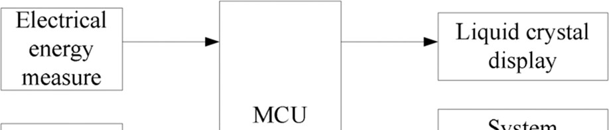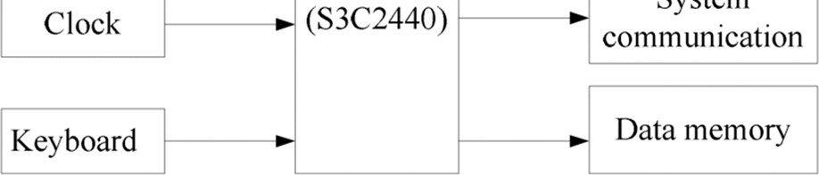

Figure 4:Design and Implementation of the Smart Meter in Vehicle to Grid Functionality:

The smart meter consists of a microprocessor controller (MCU) and an external interface circuit, which includes the measurement of electrical energy, clock, keyboard, LCD screen, system connections and data memory. The integrated circuit measures

various parameters of the electrical signal, such as active, reactive and visual energy, peak values, signal duration, temperature, etc. After the measurement, the signal is transferred to the MCU, which is primarily responsible for the process here. This circuit designed in this document has an input for current sampling and an input for measuring voltage. Then, Samsung IC is designed for mobile devices and general applications with a compact solution, low consumption and high performance. Its low power and simple and stable design are especially suitable for cost and energy sensitive applications. It is based on a new bus architecture known as Advanced Microcomputer Engineering. Then the communication module is the core part of the system. The system uses two main communication methods: RS485 and GPRS connections. To solve data in large quantities, save the function in case of power failure and other problems, the smart meter designed with 2M*32-bit flash memory. The data and program preservation requirements can be saved, without loss of data in case of power failure, and ensuring the speed meter reading. It has unlimited meter reading and writing functions, and is low in power consumption.

Title 4: Smart Metering and Functionalities of Smart Meters in Smart Grid- a Review Introduction:

The Smart grid application may be a possible solution to meet the growing demand for energy use and the increased use of smart meters. The intelligent measurement application and various algorithms also have the ability to make defects in the energy, isolation and recovery system with high precision. There are many equipment and energy measurement solutions available to address and control energy usage problems. The capabilities and functions of smart meters are currently used commercially by several comprehensive utilities. One of the objectives of this article is to identify and review the functionality and functionality of commercially implemented smart meters. Smart meters are powerful digital displays and capabilities to record how much energy is consumed and when this information is automatically transferred to the meter's data management system (MDMS) for further processing and storage. To maintain interoperability between different smart meter providers and MDMS solution providers, data collection and storage standards and data communication standards must be followed. The other objective of this article is to review the literature on intelligent metadata data structures, information flow, measurement data management solutions and

data use. To capture the rapid development and deployment of smart meters when trying to identify emerging opportunities, this document provides an overview of smart meters and the functions of smart meters in the smart grid and associated systems.

Block Diagram:

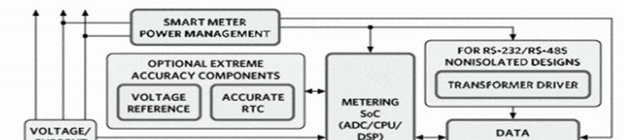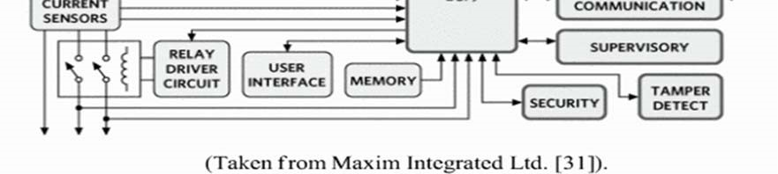

Figure 5:smart metering and functionalities of smart meters in smart grid- a review block

diagram Functionality:

Smart meters include a range of hardware, software and calibration systems. Metrics, security and communications are essential elements of smart meters. The Figure 5 shows a block diagram of an intelligent scale showing the building blocks of an integrated solution for intelligent measurement. An intelligent meter system may include: accurate real-time clock (RTC), data communication module, chip measurement system (SoC), security module, power management system, monitoring unit, tamper detection, power adapter and voltage reference (VREF). The Smart Device Center is based on an SOC processor, which includes the architecture to support measurements. The analog front end of the meter consists of digital converters that support differential inputs. The integrated gain phase provides gains for low production sensors. The hardware multiplier (HW) can be used on the SOC chip to further accelerate the intensive operations of mathematics while calculating energy. On the other hand, the program supports the calculation of several parameters. RMS current and voltage, active and reactive energy, power factor and frequency are the main parameters calculated during energy measurements. The measured and calculated data are stored by the smart meter and transmitted according to the different standards required by public utilities.

Title 5: Implementation of Smart Meter Working as IEEE1888-6LoWPAN Gateway for the Building Energy Management Systems Introduction:

When building the power management system, Smart Meter (SM) plays an important role in helping users feel active and determine energy consumption. As a result, multiple efforts have been made to improve the function of this device in order to contribute to the reduction of energy consumption towards a green economy and sustainable development. In addition to SM, other protocols have been developed to achieve intelligent, convenient and safe management and control between buildings or building blocks. With the growing growth of devices connected to the Internet, the Internet of things, the integration of millions of devices into the Internet IPv4 is not the best option. Therefore, IPv6 is designed to solve this problem. IPv6 allows more Internetbased devices. IPv6 is more complex than IPv4; therefore, devices usually consume more energy. Based on previous concerns, the low power IPv6 protocol was developed for the wireless personal area network to reduce consumption.

Block diagram:

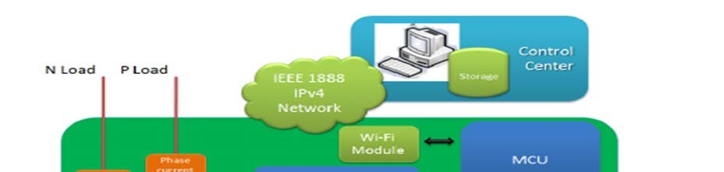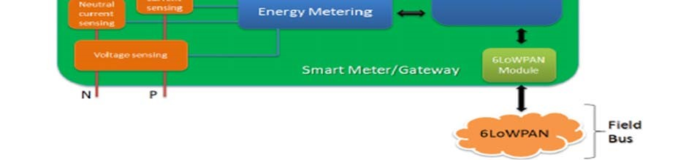

Figure 6:Implementation of Smart Meter Working as IEEE1888-6LoWPAN Gateway for

the Building Energy Management Systems

Functionality:

The form represents the system architecture, including SM, which acts as a GW to transfer data from an FB network to storage in the control center through a Wi-Fi connection. Communication with small sensors or actuators that use the FB is a built-in FB Internet device that packages IEEE packages and communicates with storage and applications via Wi-Fi. The microcontroller acts like the SM CPU and is connected to measure the IC power using the SPI connection. The combined power processor was used to calculate the amount of electricity from the specified AC voltage and current. The SM Wi-Fi module is used to transmit electricity consumption and FB data to control the center using the standard IEEE protocol. It provides wireless connectivity with complete and independent IP, but communicates with the CPU through a simple USART port. Therefore, a module is designed in a small form, which consumes very little energy. The FB network has some client nodes that integrate small temperature sensors and can transfer temperature data to the server node connected to the MCU through a USART connection.

Title 6: Implementation of Smart Meter Introduction:

In our actual project, we are going to implement a smart meter that will compute the power consumption. Once it is done, then next it will communicate with the control office over the internet. Also, it will have the capability to disable some of the loads based on the current electricity price and demand. Basically, our project is majorly based on a system in which we can save the unused power from the system. Like if we talk about the metering then it will first measure the used power of the system and transfer the whole data to the nearest office for the billing. And as this device is called smart so it has a smart option like it can disable the load if the demand is increasing from the main supply.

Block Diagram:

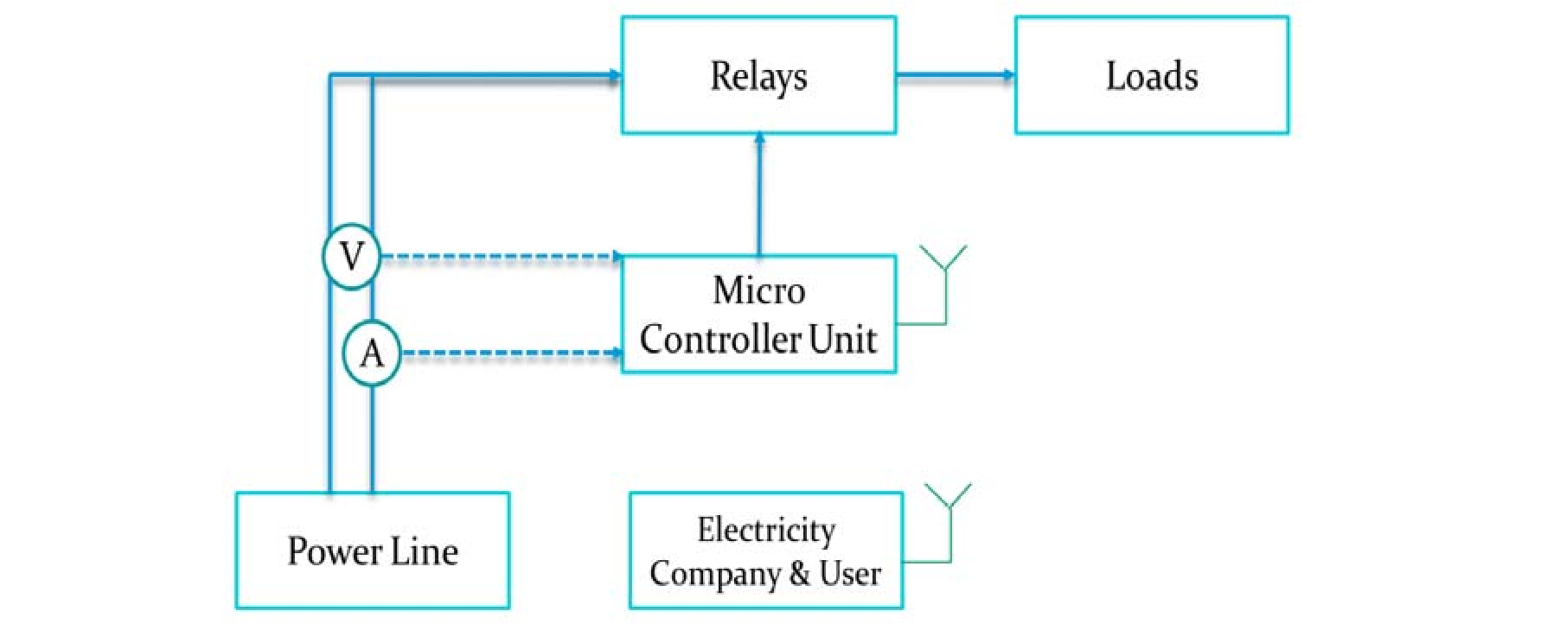

Figure 7: Implementation of Smart Meter Functionality:

Basically, smart meter has a simple flow diagram as shown in figure 7. First, we will connect two measuring meters. The voltage and current entering the system will be measured to compute the consumed power through a microcontroller. Then, using these measurements and the current electricity price, the bill will be calculated. Meanwhile the user will be updated with the current price and bill. In addition, the price will increase during peak times to encourage users to reduce their consumption. However, if the user didn’t comply, some of the uncritical loads will be switched off. So, this is how our circuit will flow on hardware like our first major part will be the measurement system and then it will transfer the recorded data to microcontroller which will calculate the required bill according to the recent tariff. Basically, the tariff prices go changing in peak and normal duty hours. So, this is the main simple smart meter and the upper discussed cases are the practical applications of this project.

**Comparative Study**

|  |  |  |  |  |  |  |
| --- | --- | --- | --- | --- | --- | --- |
| **Projects** | **1** | **2** | **3** | **4** | **5** | **Our project** |
| **Smart meter** | Yes | Yes | Yes | Yes | Yes | Yes |
| **Communication GSM, Wi-Fi** | Internet shield | Wi-Fi | RS-485  GPRS | GSM | Wi-Fi | Wi-Fi |
| **Billing** | Yes | No | Yes | No | No | Yes |
| **Energy consumption monitoring** | Yes | Yes | Yes | No | Yes | Yes |

Table1: a comparative study

1. **System Design**

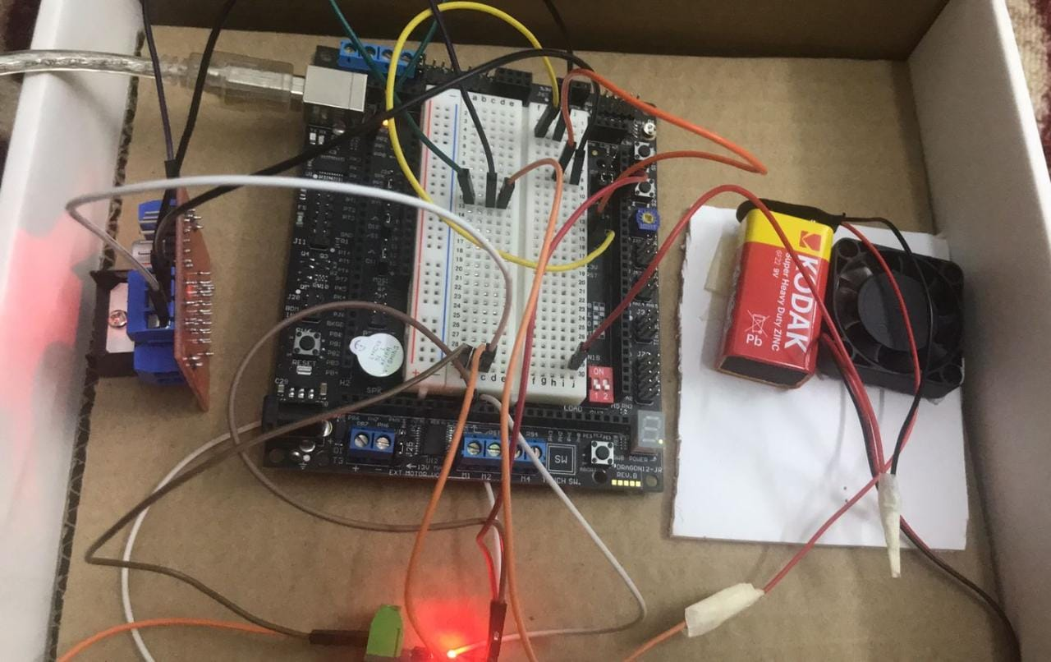

the expected results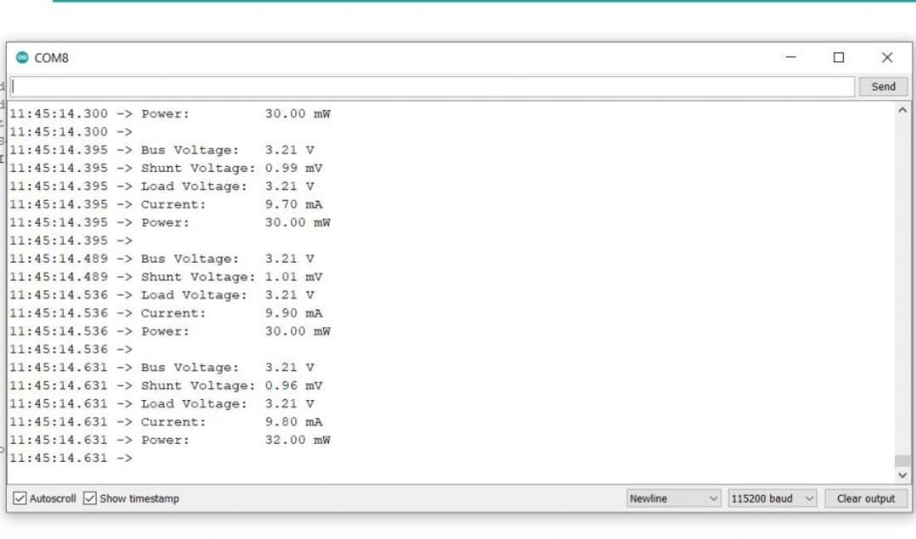

Our results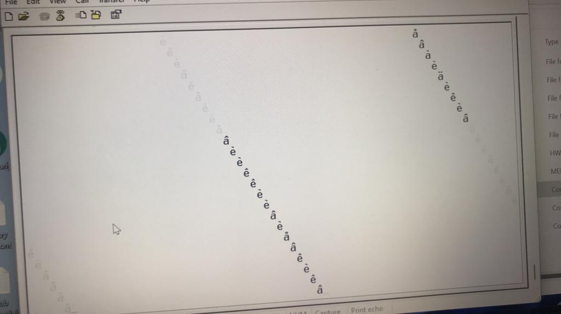

Components: -

* Microcontroller: HCS12
* temperature sensor) build in HCS12)
* Current sensor ACS712
* Serial Cable
* Battery DC
* Load (fan)
* Wires
* H-Bridge

### 

Implementation Process: -

* Making sure that the HCS12 can measure the voltage of the system.
* Measuring current from a system.
* Build a code that computes the power and energy consumed.
* Applying the dynamic pricing concept and bill calculation. .
* Display the information on PC screen.
* Develop the loads
* Calibrate the system and compare it to other products.

The expected work in the future regarding the prototype is adding more than one load. We can see in the video that we have only one load which is fan but our plan to have more than one and put them in a designed box to make it look organized.

#### 3. Problems and recommendations

* Some components are not available in the lab, and when buying them from a specialized store, it took a lot of time.
* Temperature sensor and some pins which build in on HCS12 board are not working.
* The lack of voltage sensor availability, so forced us to do a particular circuit substitute for it, this is inaccurate.

**Recommendations:**

Thoroughly understand the HCS12 microcontroller: Familiarize yourself with the architecture, features, and capabilities of the HCS12 microcontroller. This will enable you to make full use of its functionality and optimize its performance.

Plan and design the system architecture: Clearly define the requirements of the project and design the system architecture accordingly. Determine the necessary components, such as current and voltage sensors, temperature sensor, fan, LCD display, and serial communication module, and ensure their compatibility with the HCS12 microcontroller.

Select appropriate sensors and peripherals: Carefully choose sensors and peripherals that are compatible with the HCS12 microcontroller and suit the project requirements. Ensure that the sensors provide accurate and reliable readings, and that the peripherals have the necessary interfaces and functionalities for seamless integration with the microcontroller.

Calibrate and validate sensor readings: Calibrate the sensor readings to ensure accurate measurements. Perform validation tests and comparisons with known standards to verify the accuracy and reliability of the measurements.

## 4.Code

#include <hidef.h> /* common defines and macros */

#include "derivative.h" /* derivative-specific definitions */

void PLL_init(void);

void myDelay(void);

void ATD0_init(void);

unsigned char ATD0_read(unsigned char);

void motor0_init(void);

void motor0_speed(unsigned char);

void SCI0_init(void);

void SCI0_Tx(unsigned char);

void main(void) {

/* put your own code here */

unsigned char myTempReading, myTempVoltage,myCurrentReading ,myCurrentVoltage,outsideTemp,actualCurrent,dcfanvoltage,consumed_power,speed,first_digit_power,second_digit_power,first_digit_temp,second_digit_temp,actualcurrentmA;

PLL_init();

SCI0_init();

ATD0_init();

motor0_init();

motor0_speed(0);

EnableInterrupts;

for(;;) {

myTempReading = ATD0_read(5);// the reading between 0-255

myTempVoltage = (myTempReading*5000)/255; // myVoltage = (myReading/255)*5 (math is correct, but integer math will result in zeros all the time except when the reading is 255;

outsideTemp=myTempVoltage/10;

speed= ATD0_read(5); // vary the duty by reading the onboard POT

speed = (speed *235)/255; //scale the 0-255 reading to 0-235 (motor speed limit, see calculations below)

motor0_speed(speed);

if(outsideTemp>18){

//increase the speed of fan pwm

motor0_speed(10);

} else{

motor0_speed(0);

//decrease the speed of fan pwm

}

myCurrentReading=ATD0_read(6);

myCurrentVoltage=(myCurrentReading*5000)/255;

actualCurrent=(myCurrentVoltage-2500)/66;

actualcurrentmA=actualCurrent*1000;

dcfanvoltage=12000 ;

consumed_power=actualCurrent*dcfanvoltage ;

first_digit_power=consumed_power/10;

second_digit_power=consumed_power%10;

SCI0_Tx(first_digit_power+0x30);

SCI0_Tx(second_digit_power+0x30);

SCI0_Tx('\n');

first_digit_temp=outsideTemp/10;

second_digit_temp=outsideTemp%10 ;

SCI0_Tx(first_digit_temp+0x30+' '+second_digit_temp+0x30);

SCI0_Tx('\n');

_FEED_COP(); /* feeds the dog */

} /* loop forever */

/* please make sure that you never leave main */

}

void PLL_init(void){

SYNR = 2;

REFDV = 0; // at 8MHz Osc --> 48MHz PLL

PLLCTL = 0x60;// ON, Auto

while(!(CRGFLG & 0x08));//wait the lock BIT TO SET

CLKSEL = CLKSEL | 0x80; // select the PLL clk

}

void myDelay(void){

unsigned char j;

unsigned int k;

for(j=0;j<15;j++){

for(k=0; k<20000; k++){

j=j;

k=k;

}

}

}

void ATD0_init(void){

ATD0CTL2 = 0xC0; //Power up, Fast Flag Clear

myDelay();

ATD0CTL3 = 0x20; //two conversion, non FIFO

ATD0CTL4 = 0x85; // 8-bit conversiton, 2 AD clocks for stage 2, 2MHz at 24MHz E clk

}

unsigned char ATD0_read(unsigned char channelNo){

ATD0CTL5 = 0xB0 | channelNo;//right justification, unsigned, single sequence, single channel

while(!(ATD0STAT0 & 0x80));

if(channelNo==5){

return ATD0DR1L ;

}

if(channelNo==6){

return ATD0DR2L;

}

}

void SCI0_init(void){

SCI0BDL = 156;

SCI0BDH = 0; // 9600bps @ 24MHz E clk

SCI0CR1 = 0; // No Loop, 8 data bits, no parity

SCI0CR2 = 0x0C; // Enable Tx, Rx

}

void SCI0_Tx(unsigned char myByte){

while(!(SCI0SR1 & 0x80));

SCI0DRL = myByte;

}

void motor0_init(void){ //PWM0

PWMCLK=0x01; // select SA

PWMPOL=0x01; // Start high (1 polirity)// we are using a nMOS

PWMPRCLK=0x07; //prescale the E-clock by 128 --> 24M/128 = 187.5 Khz

PWMSCLA=0x04;// prescale A by 8 (4*2) to get SA --> 187.5KHz/8 = 23.43KHz

PWMCTL=0x0C; // select 8-bit mode and disable PWM in wait and freeze modes

//i.e each count will take this amount of time: (1/24MHz)*128*8 = 42.666 microseconds

PWMPER0=235; // this will get us 10.02 ms period (10.02 ms =235 counts * 42.666 micro Second per count)

PWMDTY0=235/2; // 50% duty cycle (initially)

PWMCNT0=0x00;

PWME=0x01; //enable PWM0 (connect your motor to PP0 i.e pin # 4)

}

void motor0_speed(unsigned char myspeed){

PWMDTY0 = myspeed;

}

### **5. Conclusion**

The HCS12 microcontroller-based power meter and fan speed control system, incorporating temperature regulation using the PWM technique and serial communication to a PC, provides a robust and efficient energy monitoring, control, and optimization solution. The project successfully demonstrates the capabilities of the HCS12 microcontroller in accurately measuring power consumption, dynamically adjusting fan speed based on temperature, and enabling data transfer to a PC for further analysis and management.

The temperature regulation feature enhances energy efficiency by automatically adjusting the fan speed based on ambient temperature. The PWM technique implemented by the microcontroller enables precise control over the fan's speed, creating a comfortable environment while minimizing energy consumption. As the temperature changes, the system dynamically adapts the duty cycle of the PWM signal, ensuring optimal cooling without unnecessary energy expenditure.

The integration of serial communication between the microcontroller and a PC allows for seamless data transfer and further analysis. This enables users to monitor and manage power consumption remotely, integrate the system into larger energy management systems, and generate comprehensive reports for energy optimization.

Overall, the HCS12 microcontroller-based power meter and fan speed control system with temperature regulation using PWM technique and serial communication to a PC offers a comprehensive solution for energy management. Its accuracy, responsiveness, and versatility make it suitable for a wide range of applications in residential, commercial, and industrial settings. By providing real-time power monitoring, intelligent fan speed control, and data transfer capabilities, the system contributes to energy efficiency goals and enables users to make informed decisions for sustainable energy consumption.

**Links**

* <https://youtu.be/Te0iMLOqt6I>
* <https://github.com/alifatem/embded/upload/main>