

**Faculty of Arts and Sciences**

**Department of Computer Science**

CMPS 253 – Software Engineering

Spring 2019, M. Bdeir

**Software Project Management Plan**

For the Group Term Project:

**[The Thrifters]**



*Team Members:*

[Ali Fayad]

[Ali Jaber]

[Anis Amer]

[Hussein Banjak]

[Mohamad Chehade]

[Walid Allaw]

**Revision History**

|  |  |  |  |
| --- | --- | --- | --- |
| **Version** | **Date** | **Update Comments** | **Author / Updated By** |
| 1.0 | 3/18/2016 | Initial Document. | Mahmoud Bdeir |
| 1.1 | 3/21/2016 | Added section 3.2, renamed 11.2, changes to the cover page. | Mahmoud Bdeir |
| 1.2 | 2/24/2017 | Edited based on lessons learned from Spring 2016. | Mahmoud Bdeir |
| 1.3 | 3/8/2017 | Removed some sections, re-ordered others. | Mahmoud Bdeir |
| 1.4 | 4/13/2018 | Added ‘About You’ section | Mahmoud Bdeir |
| 1.5 | 3/20/2019 | Minor edits | Mahmoud Bdeir |
| 1.6 | 4/8/2019 | Submitted spmp first draft | The Thrifters |
| 1.7.1 | 4/09/2019 | Successful first combined app - Simplistic approach | The Thrifters |
| 1.7.2 | 4/10/2019 | Animated transaction log | The Thrifters |
| 1.7.3 | 4/10/2019 | Animated Category log | The Thrifters |
| 1.7.4 | 4/10/2019 | Animated Wallet log | The Thrifters |
| 1.7.5 | 4/11/2019 | Progress bar now changes color based on percentage of spent funds | The Thrifters |
| 1.7. 6 | 4/12/2019 | Calendar fix | The Thrifters |
| 1.7. 7 | 4/15/2019 | Successful Google Assistant integration | The Thrifters |
| 1.7. 8 | 4/16/2019 | Animated page traversal | The Thrifters |
| 1.7. 9 | 4/25/2019 | Successful Siri Integration | The Thrifters |
| 1.8 | 4/30/2019 | Finalized Spmp | The Thrifters |
| 1.9 | 5/01/2019 | Finalized presentation | The Thrifters |

Table of Contents

1. Document Specifications and Conventions 5

2. Introduction 5

2.1. Project Overview 5

2.2. Customer or Market Needs 5

2.3. Business Objectives and Success Criteria 5

3. Vision 6

3.1. Vision Statement 6

3.2. Story-Telling Diagram 6

3.3. Selected Features 6

4. Scope 7

4.1. Scope of Initial Release 7

4.2. Scope of Subsequent Releases 7

4.3. Limitations and Exclusions 7

5. Business Context 7

5.1. Stakeholder Profiles 8

5.2. Operating Environment 10

5.3. Business Opportunity 11

5.4. Complete Product Features 11

6. Deliverables 11

7. Milestones 12

8. Requirements 12

9. Project Organization 22

9.1. Process Model 23

9.2. Organizational Structure & Project Responsibilities 23

9.3. Organizational Boundaries and Interfaces 23

10. Managerial Process 23

10.1. Management Objectives and Priorities 23

10.2. Assumptions, Dependencies, and Constraints 23

10.3. Project Risks 24

10.3.1. Risk Table 24

10.3.2. Discussion of Risks to be managed 26

10.3.3. RMMM Plan for each risk 27

10.3.3.1. Risk Mitigation 27

10.3.3.1. Risk Monitoring 27

10.3.3.2. Risk Management 27

10.4. Change Management and Control 28

10.5. Monitoring and Controlling Mechanism 28

10.6. Weekly Progress Reports 28

11. Technical Process 30

11.1. Methods, Tools, and Techniques 31

11.2. System Modeling 31

11.2.1. Context models 31

11.2.1.1. Technical Interfaces 31

11.2.2. Interaction models 31

11.2.3. Structural models 32

11.2.4. Behavioral models 33

11.3. Software Documentation 34

11.3.1. Database Model 34

11.3.2. Data Dictionary 34

12. Work Packages, Schedule, and Budget 35

12.1. Work Packages (WBS) 35

12.2. Sprint Schedule 36

12.3. Budget 36

13. Project Resources 36

14. About You 37

14.1. About Me 37

14.2. Lessons Learned From Working in a Team 37

# Document Specifications and Conventions

# Introduction

## Project Overview

In general, very few people pre-plan their spending according to a thoroughly detailed budget, this mainly, might be, due to the cumbersomeness of the task at hand, meaning that it wastes precious time that could have been better invested elsewhere, makes it necessary for a person to always have a pen, paper, and calculator at hand, and involves a lot of scratching and rewriting, which would require keeping track of countless sheets of paper and make things very messy. Our team believes that modern problems need modern solutions, the days of paper and pen are gone; we need to make use of the available technological advancement to solve this problem. Therefore, we decide to develop a mobile application that completes this task in an easy, automated, and time efficient way. We know that many software was already developed to target this problem, but our application stands out by providing the ability to use voice commands, this is in addition to the simplicity that directly addresses what the user needs.

As a result, we developed Thrifty; a mobile money management application that can be accessed through voice commands. The user should specify the category name and the wallet which, is the budget in our case, then the app makes sure that the user stays within the limit of his/her budget by showing graphs and sending notifications. Furthermore, users can keep track of purchase logs (time, price, and wallet purchased from). This is achieved through displaying the logs of a specific day (chosen by user) in the app.

## Customer or Market Needs

Based on our daily experience, and observing people struggle financially, before the end of each month; we believe that our app could do wonders for people, especially university students who might need to monitor their spending. These students are already stressed enough from keeping a high gpa and providing deliverables within their corresponding deadlines, and therefore, do not need extra pressure from writing down everything they purchase on paper, organizing them, safely storing them, and doing the required calculations… Additionally, they might neither have the time nor the experience to manage their payments according to a budget. Our main target market are university students for reasons mentioned previously, however anyone wanting to save their time and effort can use the app, as these reasons can be reproduced for anyone – time is money. We want our users spending less time money managing, and more time doing what they love and generally being more productive. Moreover, our software provides a competitive edge over others in the market through its free availability and the integration of Siri and Google Assistant.

## Business Objectives and Success Criteria

The main objective of the software is to solve the struggle faced by people in managing their financial assets. Also, we aim to reduce the effort and time needed to use this application by the integration of voice commands.

Some business objectives:

* This application works well after many test cases.
* Related documentation is produced.
* The additional graphs and statistics are provided.
* The application is efficiently controllable through voice commands.

Some of the success criteria include:

* Proper advertising of the application (marketing).
* Making the use free of charge and getting revenue from ads.
* Concise and simple interface for direct and easy use.

# Vision

## Vision Statement

This application helps the user in managing his/her payments in an easy and simple way. It provides him/her with accessibility through voice commands and automatically logs their transactions to the corresponding date. Furthermore, it allows the user to keep track of his/her economic situation on a daily, weekly, and monthly basis.

## Story-Telling Diagram

Thrifty

(auto generate of the timestamp)

User

Category name, wallet, price of the item

* Add, edit, delete, display category
* Add, edit, delete, display wallet
* Display, add, delete transaction
* Display graphs and statistics about the economic state (of corresponding date)
* Generate notifications that alert the user in case of: addition/failure of transaction, wallet, or category , exceeding wallet limit or budget limit
* View graphs

## Selected Features

1. This application allows easy money management; “thrifting”.
2. The user can access this application through voice command.
3. This application provides graphs about financial expenditure.
4. This application alerts the user in case of exceeding the limit.
5. This application assures a simple and user-friendly UI.

# Scope

## Scope of Initial Release

The initial scope of our application is the Lebanese market. We will initially target students in universities, where we believe our application is vital, this is in addition to the general population of Lebanon (Lebanese and non-Lebanese individuals). At this stage, our budget prevents the worldwide spread of the application, or even a regional middle-east launch.

## Scope of Subsequent Releases

The subsequent Releases are going to target the largest possible audience. We will use social media platforms to market our application (Facebook, Instagram, etc…). We will also use ads to improve our budget and acquire the ability of spreading our application in different regions and on a more regional scale. In our subsequent releases, we are going to introduce support for different languages such as French, Arabic, Iranian, and Spanish (etc). Furthermore, our team will have to update our application based on user feedback, and what might be useful to improve the efficiency of our software and improving user interface.

## Limitations and Exclusions

As mentioned before, the main limitation is the ability to spread our software to a broader audience. This aside, no technical limitations were faced, except for voice commands, that required heavy researching, especially for Siri.

# Business Context

## Stakeholder Profiles

|  |  |
| --- | --- |
| * Date: |  |

|  |  |  |
| --- | --- | --- |
| Stakeholder: Client (Mr. Bdeir) | Ref. No.: 01 | Date: 25/03/2019 |

|  |  |
| --- | --- |
| Why are you engaging this stakeholder? | This stakeholder is the course professor and therefore is the one who will – among others- mainly evaluate our project |

|  |  |  |  |  |  |  |  |
| --- | --- | --- | --- | --- | --- | --- | --- |
| Power  (rate the control or resources this stakeholder can use to promote or oppose the project objectives) |  | High | Medium | Low or None |  | OVERALL SCORE (tick one) | |
| Economic assets | x |  |  | High/Med | Low/No |
| Authority | x |  |  | ++ |  |
| Ability to coerce/force |  | x |  |  | |
| Prestige/status | x |  |  |
| Social ties/connections | x |  |  |
| Info/communication control | x |  |  |
| Knowledge and skills | x |  |  |

|  |  |  |  |  |  |  |  |
| --- | --- | --- | --- | --- | --- | --- | --- |
| Interests  (rate the net gains or losses for the stakeholder arising from the project) | Potential gains for stakeholder: | | Premium software which solves problem at hand | | | | |
| Potential losses for stakeholder: | | Inferior software which would have wasted stakeholder time and effort | | | | |
|  | | | | | | |
| High Net Gains or Losses | Medium Net Gains or Losses | | Low or Neutral |  | OVERALL SCORE (tick one) | |
| ++ or -- |  | |  | High/Med | Low/No |
| ++ |  |

|  |  |  |  |  |  |  |  |
| --- | --- | --- | --- | --- | --- | --- | --- |
| Legitimacy  (rate the degree to which other parties recognise the three Rs of the stakeholder) |  | High | Medium | Low or None |  | OVERALL SCORE (tick one) | |
| Rights | X |  |  | High/Med | Low/No |
| Responsibilities | X |  |  | ++ |  |
| Resolve | x |  |  |  | |

|  |  |  |  |  |  |  |  |
| --- | --- | --- | --- | --- | --- | --- | --- |
| CLIP Descriptor and Engagement Type  (circle CLIP code for the stakeholder, based on overall score for each category [e.g. PL]) | PIL  Dominant | PI  Forceful | PL  Influential | P  Dormant | L  Concerned | IL  Vulnerable | I  Marginal |
| Suggested engagement types (circle all appropriate) | | | | | | |
| Involve  Collaborate  Empower | Inform  Consult  Involve | Consult  Involve  Collaborate | Inform  Consult | Involve  Collaborate  Empower | Collaborate  Empower | Collaborate  Empower |

|  |  |  |
| --- | --- | --- |
| Stakeholder: Developer (team members) | Ref. No.: 02 | Date: 25/03/2019 |

|  |  |
| --- | --- |
| Why are you engaging this stakeholder? | This stakeholder are team colleagues |

|  |  |  |  |  |  |  |  |
| --- | --- | --- | --- | --- | --- | --- | --- |
| Power  (rate the control or resources this stakeholder can use to promote or oppose the project objectives) |  | High | Medium | Low or None |  | OVERALL SCORE (tick one) | |
| Economic assets |  |  | x | High/Med | Low/No |
| Authority |  | x |  | + |  |
| Ability to coerce/force |  | x |  |  | |
| Prestige/status | x |  |  |
| Social ties/connections |  | x |  |
| Info/communication control | x |  |  |
| Knowledge and skills |  | x |  |

|  |  |  |  |  |  |  |  |
| --- | --- | --- | --- | --- | --- | --- | --- |
| Interests  (rate the net gains or losses for the stakeholder arising from the project) | Potential gains for stakeholder: | | Developing new skills and social ties | | | | |
| Potential losses for stakeholder: | | Getting a bad grade on course | | | | |
|  | | | | | | |
| High Net Gains or Losses | Medium Net Gains or Losses | | Low or Neutral |  | OVERALL SCORE (tick one) | |
| ++ |  | |  | High/Med | Low/No |
| + |  |

|  |  |  |  |  |  |  |  |
| --- | --- | --- | --- | --- | --- | --- | --- |
| Legitimacy  (rate the degree to which other parties recognise the three Rs of the stakeholder) |  | High | Medium | Low or None |  | OVERALL SCORE (tick one) | |
| Rights | X |  |  | High/Med | Low/No |
| Responsibilities | X |  |  | ++ |  |
| Resolve | x |  |  |  | |

|  |  |  |  |  |  |  |  |
| --- | --- | --- | --- | --- | --- | --- | --- |
| CLIP Descriptor and Engagement Type  (circle CLIP code for the stakeholder, based on overall score for each category [e.g. PL]) | PIL  Dominant | PI  Forceful | PL  Influential | P  Dormant | L  Concerned | IL  Vulnerable | I  Marginal |
| Suggested engagement types (circle all appropriate) | | | | | | |
| Involve  Collaborate  Empower | Inform  Consult  Involve | Consult  Involve  Collaborate | Inform  Consult | Involve  Collaborate  Empower | Collaborate  Empower | Collaborate  Empower |

|  |  |  |
| --- | --- | --- |
| Stakeholder: User | Ref. No.: 03 | Date: 25/03/2019 |

|  |  |
| --- | --- |
| Why are you engaging this stakeholder? | The user of thrifty will need to keep logs of his/her spending habits |

|  |  |  |  |  |  |  |  |
| --- | --- | --- | --- | --- | --- | --- | --- |
| Power  (rate the control or resources this stakeholder can use to promote or oppose the project objectives) |  | High | Medium | Low or None |  | OVERALL SCORE (tick one) | |
| Economic assets |  |  | X | High/Med | Low/No |
| Authority |  |  | X |  | + |
| Ability to coerce/force |  | X |  |  | |
| Prestige/status | X |  |  |
| Social ties/connections |  |  | X |
| Info/communication control |  |  | X |
| Knowledge and skills |  |  | X |

|  |  |  |  |  |  |  |  |
| --- | --- | --- | --- | --- | --- | --- | --- |
| Interests  (rate the net gains or losses for the stakeholder arising from the project) | Potential gains for stakeholder: | | Gain access to Thrifty which will give a solution to money management problem | | | | |
| Potential losses for stakeholder: | | Thrifty is non-functional and therefore user will not get solution delivered | | | | |
|  | | | | | | |
| High Net Gains or Losses | Medium Net Gains or Losses | | Low or Neutral |  | OVERALL SCORE (tick one) | |
|  | + | |  | High/Med | Low/No |
| + |  |

|  |  |  |  |  |  |  |  |
| --- | --- | --- | --- | --- | --- | --- | --- |
| Legitimacy  (rate the degree to which other parties recognise the three Rs of the stakeholder) |  | High | Medium | Low or None |  | OVERALL SCORE (tick one) | |
| Rights |  |  | X | High/Med | Low/No |
| Responsibilities |  |  | X |  | + |
| Resolve |  |  | X |  | |

|  |  |  |  |  |  |  |  |
| --- | --- | --- | --- | --- | --- | --- | --- |
| CLIP Descriptor and Engagement Type  (circle CLIP code for the stakeholder, based on overall score for each category [e.g. PL]) | PIL  Dominant | PI  Forceful | PL  Influential | P  Dormant | L  Concerned | IL  Vulnerable | I  Marginal |
| Suggested engagement types (circle all appropriate) | | | | | | |
| Involve  Collaborate  Empower | Inform  Consult  Involve | Consult  Involve  Collaborate | Inform  Consult | Involve  Collaborate  Empower | Collaborate  Empower | Collaborate  Empower |

## Operating Environment

The software should operate whenever/wherever the user requests. Consequently, the software doesn’t need an internet connection, hence a connection to the internet might not be available everywhere. Additionally, the application is suitable for individuals, families, and even small enterprises. Our team believes that this application will be of much value for university students, especially those who live alone and must manage their spending carefully.

## Business Opportunity

The software can generate profit in three different ways. Firstly, through a partnership with advertising companies, where these companies provide ads to be displayed to the user through the software, especially since users are buying products from their corresponding local markets, in exchange for an agreed upon portion of revenue for every ad viewed. Secondly, through monetization by setting a purchase price for a premium version of the software that provides additional services. Thirdly, profit can be generated through ownership, by an interested company or party that wishes to buy the software at an agreed upon price.

## Complete Product Features

|  |  |  |
| --- | --- | --- |
| TP ID | Feature | Value |
| 1521 | Voice command | Must have |
| 1526 | Viewing transactions (of specific date) | Must have |
| 1527 | Adding Categories | Must have |
| 1528 | Give notifications/warnings | Must have |
| 1531 | Graphs and statistics | Must have |
| 1532 | Multiple wallets | Must have |
| 1533 | Calendar | Must have |
| 1538 | Humanize Thrifty | Nice to have |
| 1655 | Progress bar | Good to have |
| 3835 | Customizable user experience | Nice to have |

# Deliverables

|  |  |  |  |
| --- | --- | --- | --- |
| **ID** | **Date** | **Deliverable** | **Responsible Party** |
| 1 | April 13 | Vision and Scope Document | Ali Fayad - Ali Jaber -Anis Amer - Walid Allaw |
| 2 | March 10 | User Stories | Ali Fayad |
| 3 | March 2 | Screen Mockups | Hussein Banjak |
| 4 | March 26 | Prototype 1 | Whole team |
| 5 | May 3 | Detailed Design Document | Ali Fayad - Ali Jaber -Anis Amer - Walid Allaw |
| 6 | April 3 | Draft SPMP | Ali Fayad - Ali Jaber -Anis Amer - Walid Allaw |
| 7 | April 10 | UAT Test Cases | Ali Fayad – Ali Jaber |
| 8 | May 4 | Known Issues | Hussein Banjak |
| 9 | May 4 | Release Notes | Hussein Banjak |
| 10 | May 4 | Compiled and Deliverable Machine Code (Binaries) | Ali Jaber |
| 11 | May 4 | Source Code | Ali Jaber |
| 12 | May 4 | SPMP (print an MS Word file) | Ali Fayad |
| 13 | May 4 | Deployment (Demo of the Software) | Ali Fayad |

# Milestones

|  |  |  |
| --- | --- | --- |
| **ID** | **Date** | **Milestone** |
| 1 | March 26 | Prototype 1 |
| 2 | April 06 | Implementation Complete |
| 3 | April 10 | Technical Preview (Alpha Testing Complete) |
| 4 | April 13 | Code Freeze |
| 5 | April 20 | Release Candidate (Beta Testing Complete) |
| 6 | April 23 | RTM Ready |
| 7 | April 27 | Deployment Complete |

# Requirements

8.1. Use Case Diagrams

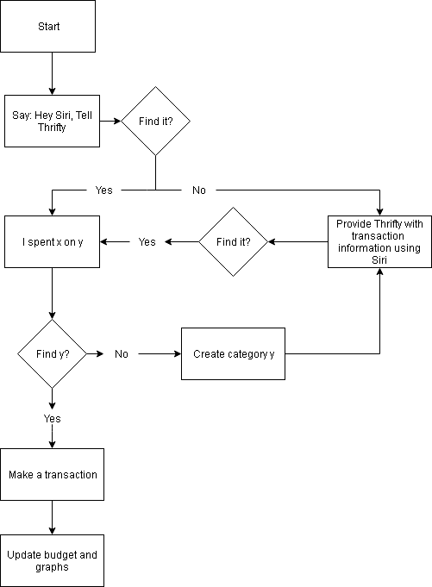

8.2. Screen Mockups

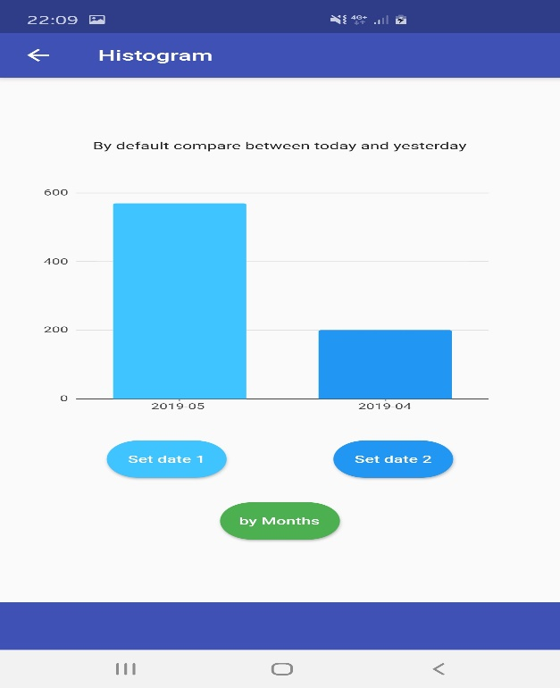 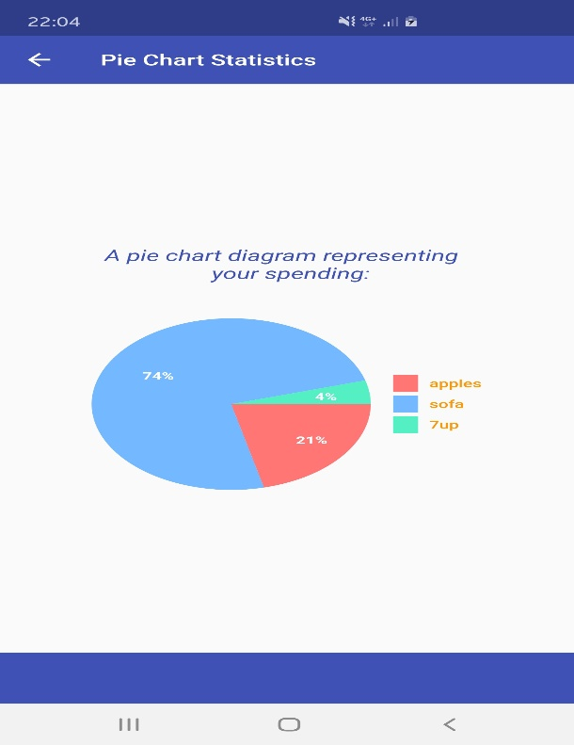 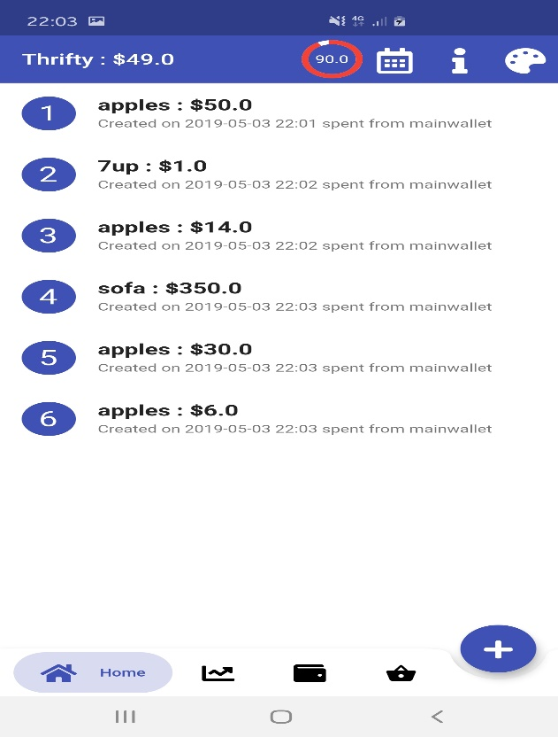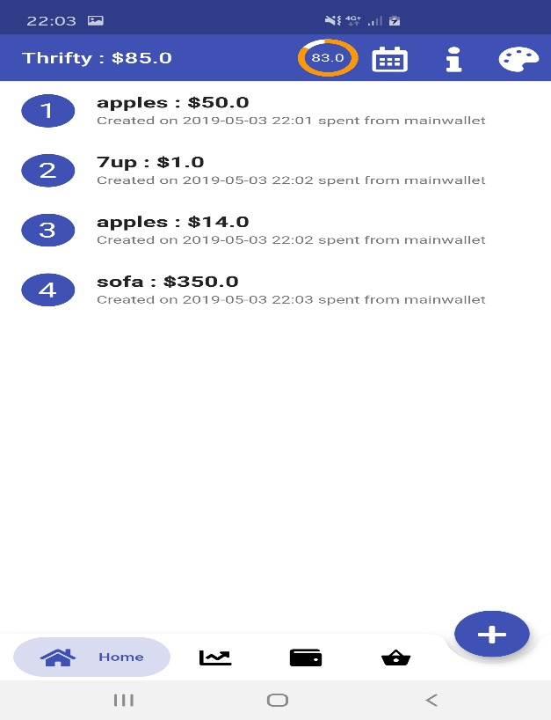 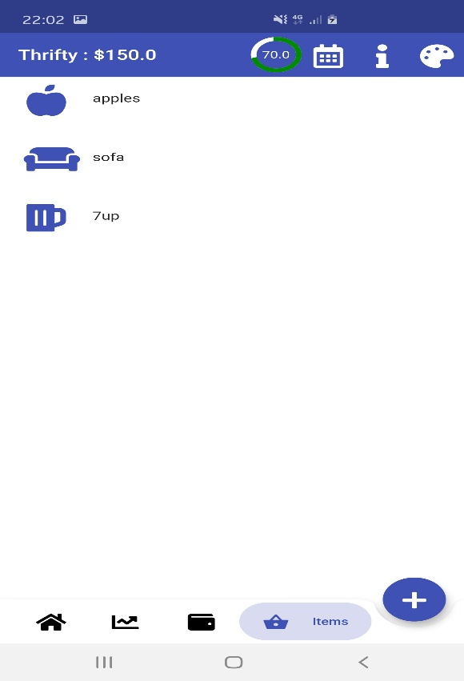 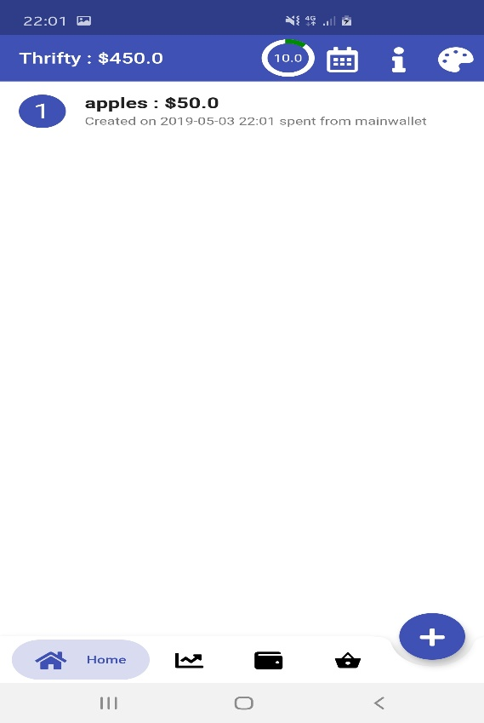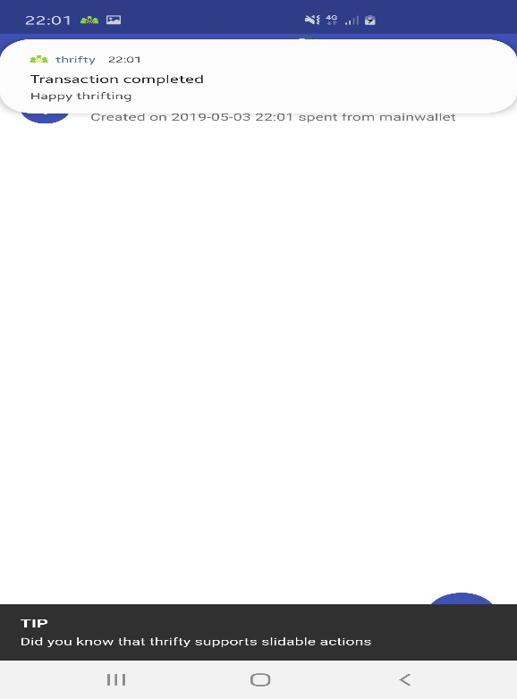 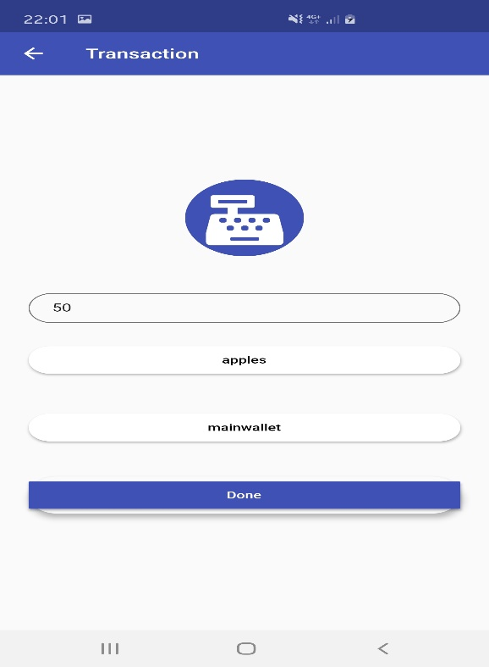 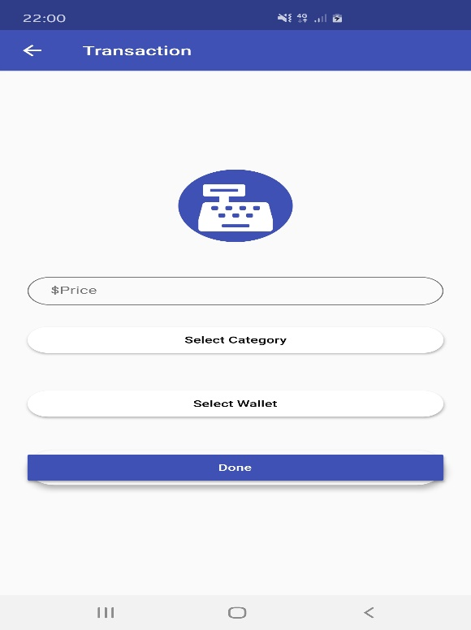 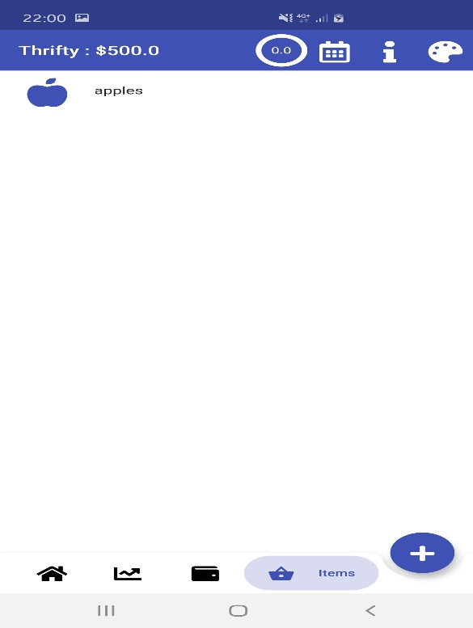 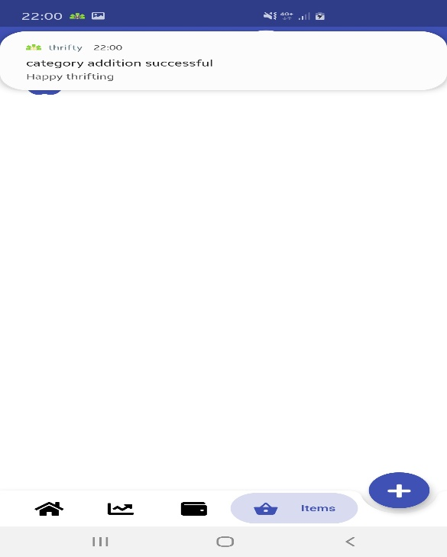 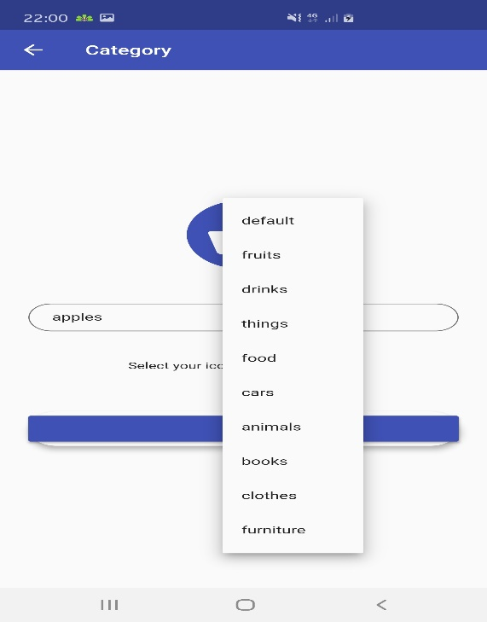 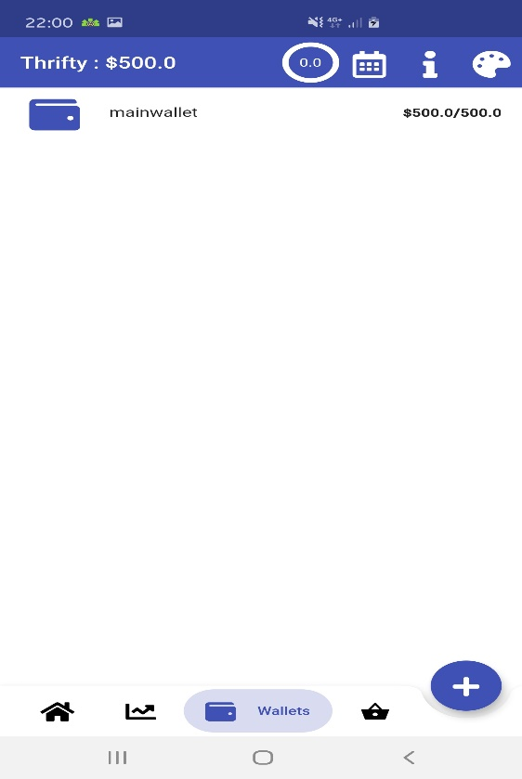 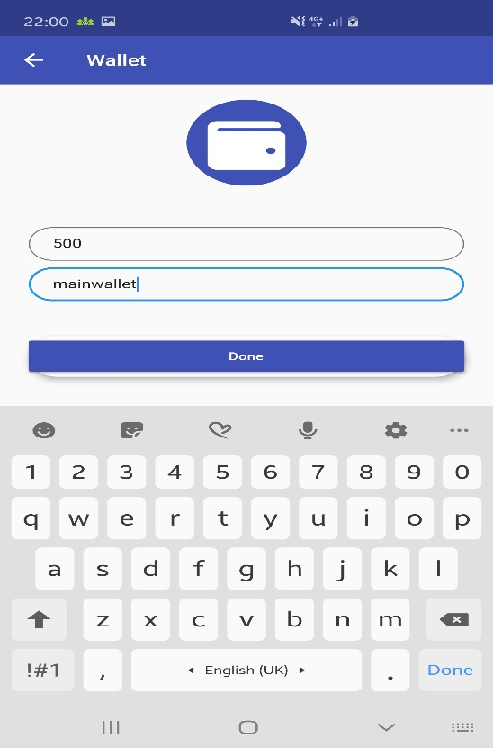 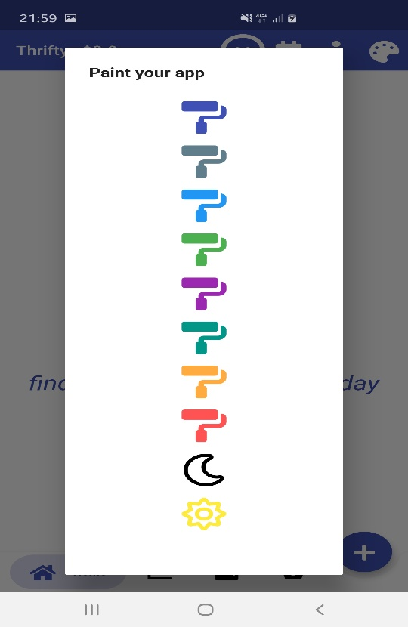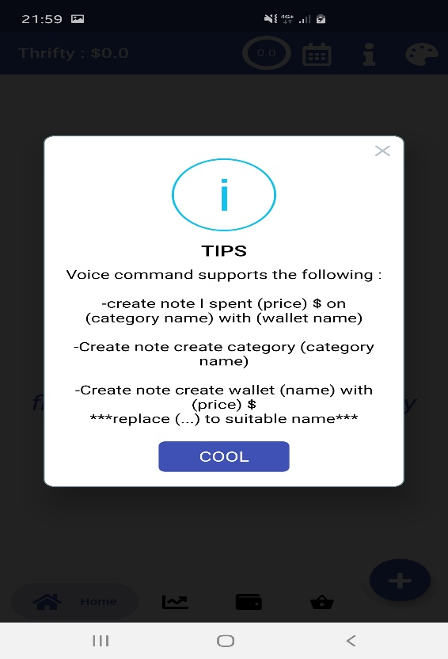 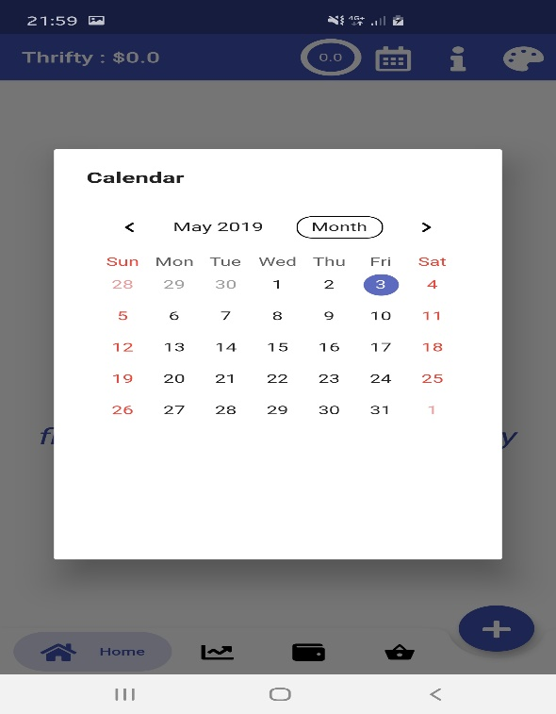 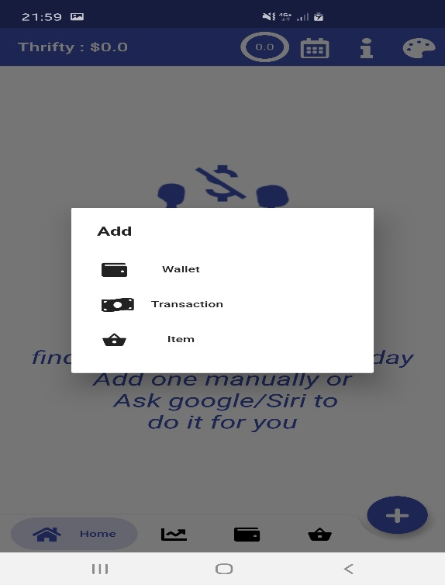 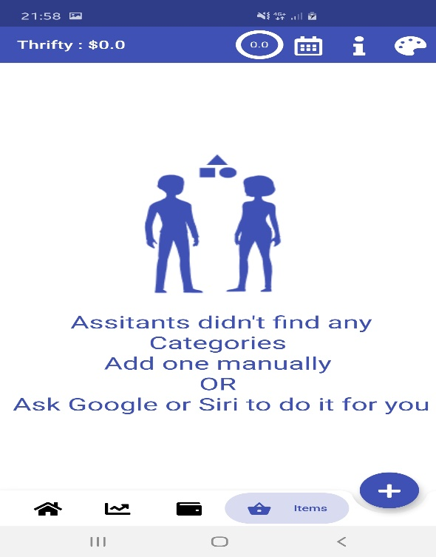 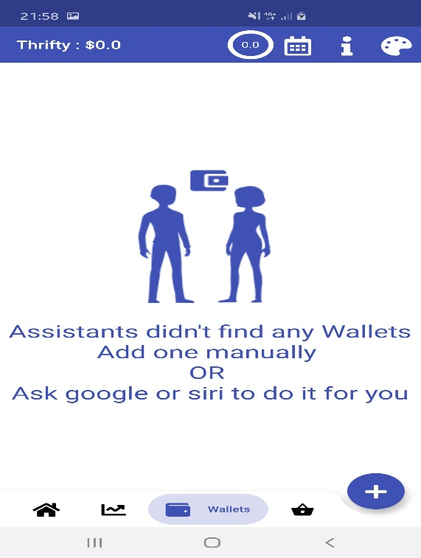 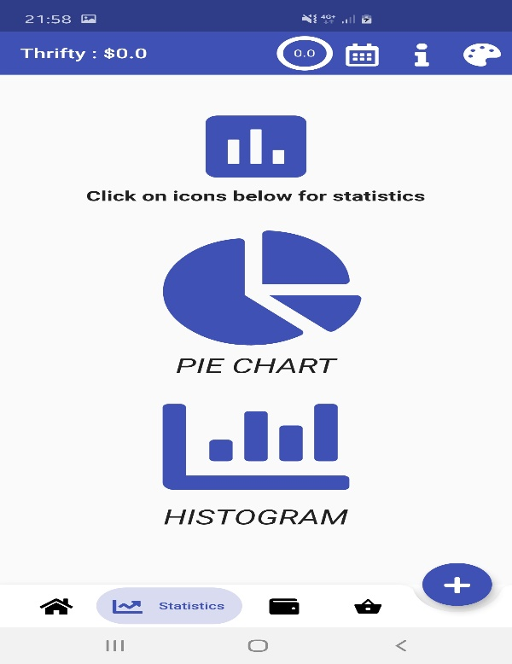 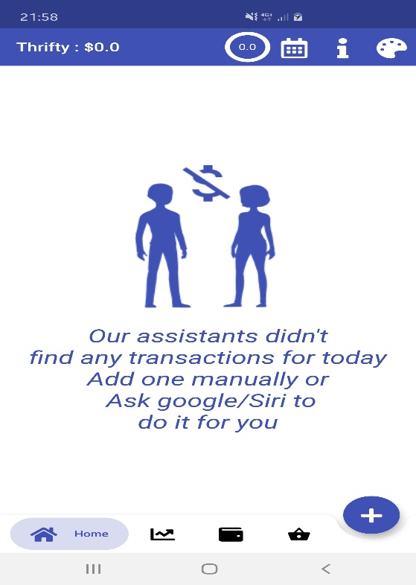 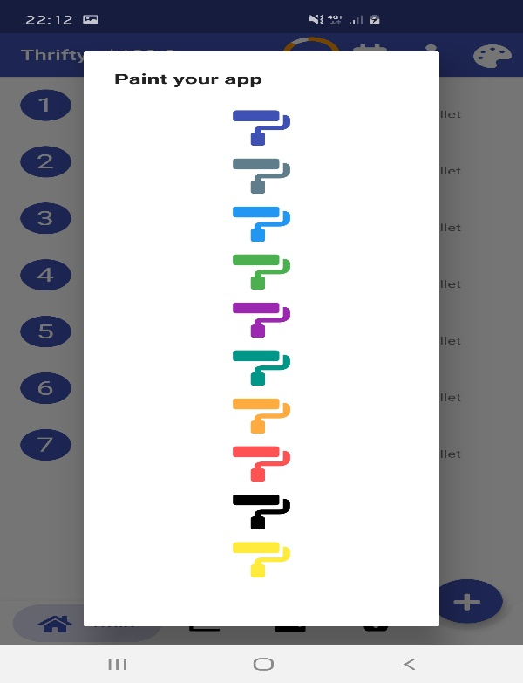 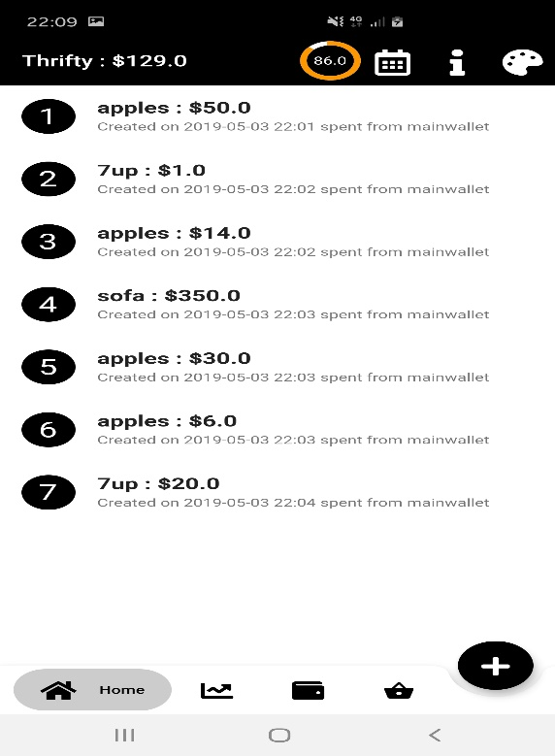 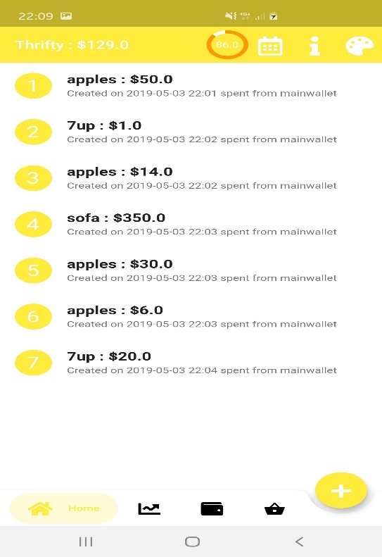 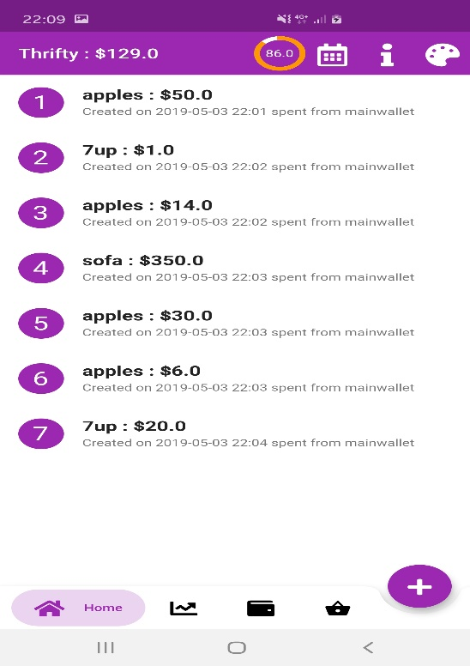 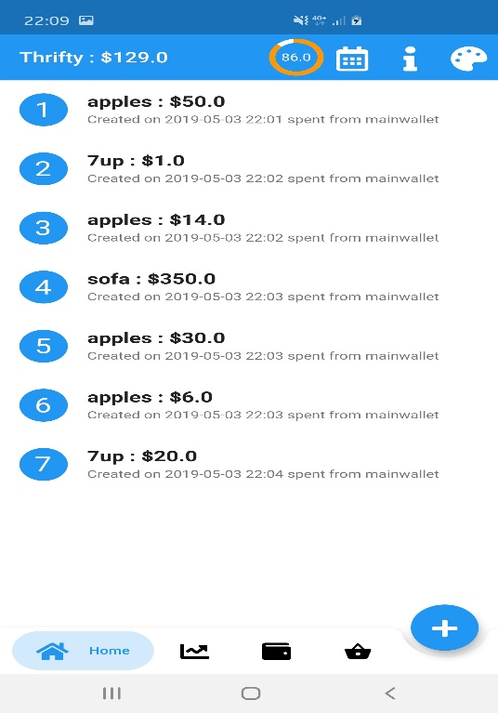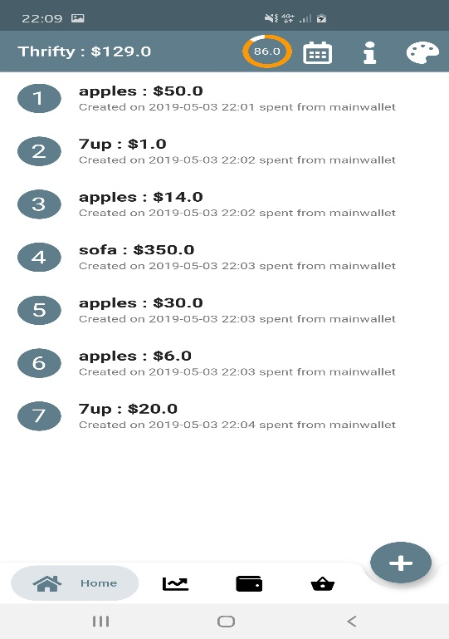 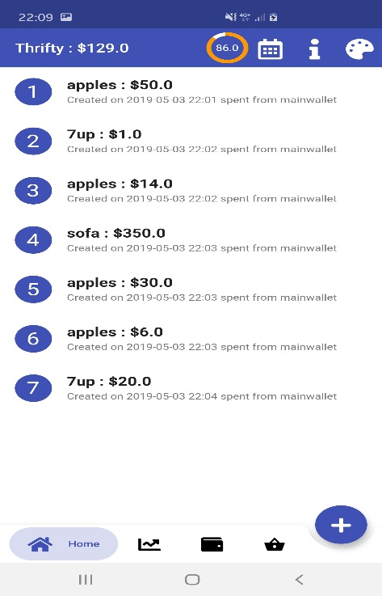 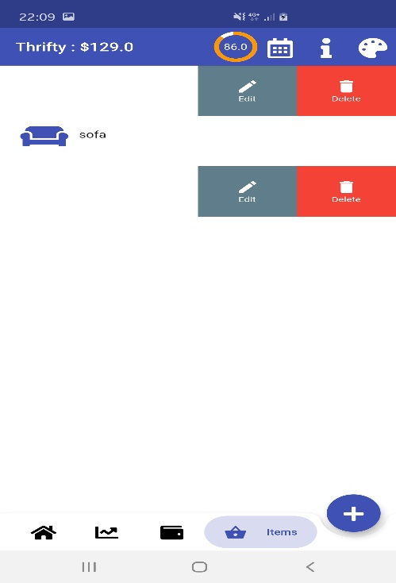 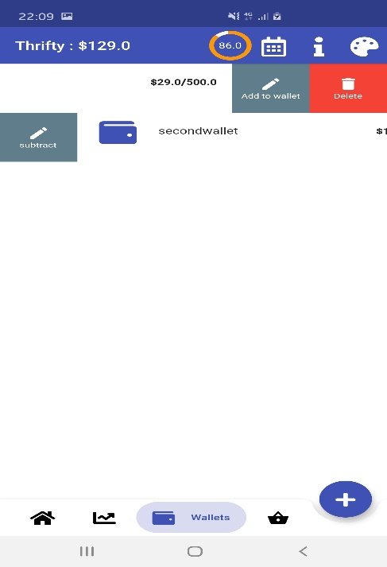 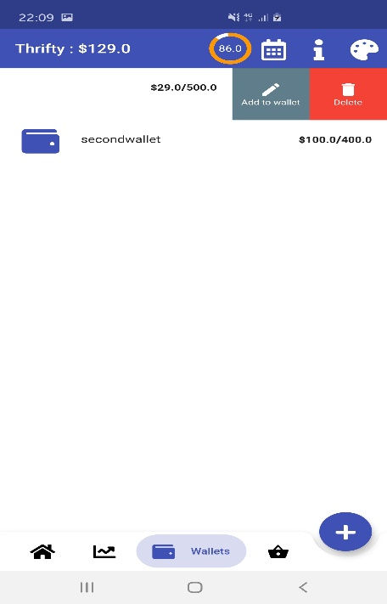 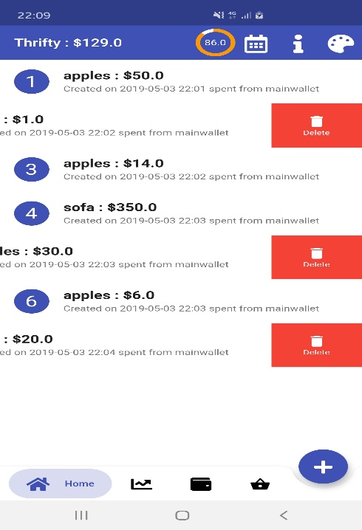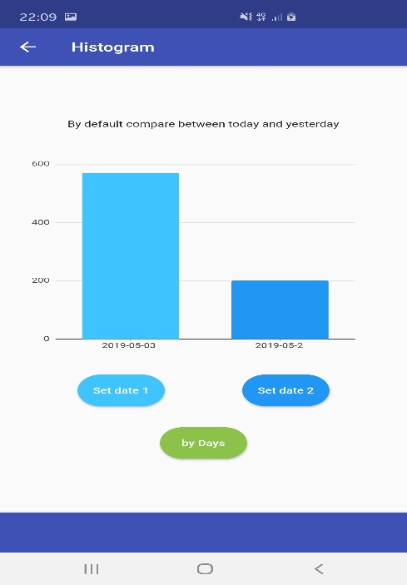

8.3. User Stories

#1524: As a user, I want to plan a general budget over a set period, using wallets

#1525: As a user, I want to be able to use voice commands

#1526: As a user, I want to view my transactions (for any chosen date)

#1527: As a user, I want to add my own categories and tailor it to my personal needs.

#1528: As a user, I want the application to give a warning when approaching budget limit or after addition of transaction, wallet, category.

#1531: As a user, I want to display statistics using graphs and pie charts

#1532: As a user, I want to add multiple wallets for specific categories of payments

#1533: As a user, I want to have access to a calendar

#1534: As a user, I want the app to save certain categories and quickly add them - not re-enter them every time - for recurring expenditures.

#1538: As a user, I want the app to be humanized, i.e some sort of contact (jokes or health alerts) between Thrifty and user

#1655: As a user, I want a progress bar to display how much spent of budget

#3835: As a user, I want to be able to make the app theme feel personalized to my individual taste.

8.4. Non-Functional Requirements

- The system should store information in the database without loss

- The system should pop up notifications in less than 2 seconds after the user’s action

# Project Organization

## Process Model

The main methodology followed for the project is the Agile methodology, where requirements, and consequently solutions, evolve through constant collaboration between self-organizing, cross-functional, and empowered teams. This methodology’s main advantage is that it allows developers to fully understand the client’s vision. This is achieved through frequent delivery of high-quality working software, then re-evaluating it and modifying accordingly based on the client’s feedback. Agile’s main objective is maximizing customer satisfaction. In particular, the Scrum Agile methodology was chosen based on the fact that we are a team of six members. These 6 members where then split into 3 teams of 2, where each team was responsible for a certain set of related tasks. Additionally, and thanks to this methodology, we were able to efficiently and seamlessly adapt to changing customer demands, ensuring the client’s competitive edge.

## Organizational Structure & Project Responsibilities

|  |  |  |
| --- | --- | --- |
| **ID** | **Task** | **Assigned Member** |
| **1** | **SPOC** | **Hussein Banjak** |
| **2** | **Requirements** | **All team members** |
| **3** | **Database** | **Ali Jaber, Mohamad Chehadeh, Walid Allaw** |
| **4** | **Code** | **Ali Fayad, Anis Amer, Hussein Banjak** |
| **5** | **Testing** | **All team members** |
| **6** | **SPMP** | **Ali Jaber, Ali Fayad, Anis Amer, Mohamad Chehadeh, Walid Allaw** |
| **7** | **Presentation** | **All Team members** |

## Organizational Boundaries and Interfaces

Our team was at Constant communication with both Professor Bdeir and our team’s GA Sohaib El Jundi, both through face to face meetings, and through Slack. Within the team, communication was established through 3 times per week SCRUM meetings after the 253 lectures, a 6 member WhatsApp group, and a Sprint planning retrospective meetings.

# Managerial Process

## Management Objectives and Priorities

|  |  |  |  |
| --- | --- | --- | --- |
|  | Constrained | Optimized | Accepted |
| Scope |  | X |  |
| Schedule | X |  |  |
| Cost |  |  | X |

## Assumptions, Dependencies, and Constraints

* + 1. Project assumptions:
* Users are assumed to have basic financial planning skills
* Users are assumed to know how to read simple graphs and charts
* Users are expected to have an email account

10.2.2 Project dependencies:

* The application depends on Siri and google assistant to enable the user to make use of voice commands

## Project Risks

## Risk Table

|  |  |  |  |  |  |  |  |  |  |  |
| --- | --- | --- | --- | --- | --- | --- | --- | --- | --- | --- |
| **Risk Id** | | **Description** | | **Category** | | **Probability** | | **Impact Value** | | **Risk Exposure** |
| 01 | | Time Shortage | | DE | | Medium | | (2) | | 0 |
| 02 | | Undiscovered bugs might cause the application to malfunction | | BU | | Medium | | (2) | | 0 |
| 03 | | Problems in notifications | | TB | | Very low | | (3) | | 0 |
| 04 | | Problems in voice command | | TB/SS | | High | | (1) | | 0 |
| **Legend** | | | |  | |  | |
| **Risk Category**  PS: Product Size  BU: Business Impact  CC: Customer Characteristics  PD: Process Definition  DE: Development Environment  TB: Technology to be Built  SS: Staff Size and Experience | | **Impact Value:**  1: Catastrophic  2: Critical  3: Marginal  4: Negligible | |  | |  | |

|  |  |  |  |  |  |  |  |  |
| --- | --- | --- | --- | --- | --- | --- | --- | --- |
| **Risk Information Sheet** | | | | | | | | |
| Risk ID | Date | Probability | | | Impact | | | |
| 01 | 25/3/2019 | Medium | | | Critical | | | |
| Description | | | | | | | | |
| Might run out of time, causing an under-developed implementation of the software, this is due to two reasons mainly, the first being the heavy researching required for voice commands. In addition, workload from other courses have placed our team on a tight schedule | | | | | | | | |
| Refinement / Context | | | | | | | | |
| Put our software as top priority over other course workloads, as other courses are time consuming | | | | | | | | |
| Mitigation / Monitoring | | |  |  | |  |  |  |
| Our team is currently on schedule | | | | | | | | |
| Management / Contingency Plan / Trigger | | | | | | | | |
| Manage our time efficiently, and increase software development time. | | | | | | | | |
| Current Status | | | | | | | | |
| Currently on schedule and in good position | | | | | | | | |
| Originator | | Assigned | | | | | | |
| Walid Allaw | | All team members | | | | | | |

|  |  |  |  |  |  |  |  |  |
| --- | --- | --- | --- | --- | --- | --- | --- | --- |
| **Risk Information Sheet** | | | | | | | | |
| Risk ID | Date | Probability | | | Impact | | | |
| 02 | 01/04/2019 | Medium | | | Critical | | | |
| Description | | | | | | | | |
| No software is bug free, especially if developed by first time developers, even though it is highly unlikely that users will find a bug that makes the app nonfunctional. | | | | | | | | |
| Refinement / Context | | | | | | | | |
| Bugs that affect the general quality of our software might arise post release | | | | | | | | |
| Mitigation / Monitoring | | |  |  | |  |  |  |
| Continue testing with a mentality of finding bugs, as this improves software quality | | | | | | | | |
| Management / Contingency Plan / Trigger | | | | | | | | |
| Locate bugs and fix as fast as possible | | | | | | | | |
| Current Status | | | | | | | | |
| Many bugs have been discovered and fixed | | | | | | | | |
| Originator | | Assigned | | | | | | |
| Ali Fayad | | Ali Fayad, Ali Jaber | | | | | | |

|  |  |  |  |  |  |  |  |  |
| --- | --- | --- | --- | --- | --- | --- | --- | --- |
| **Risk Information Sheet** | | | | | | | | |
| Risk ID | Date | Probability | | | Impact | | | |
| 03 | 07/04/2019 | Medium | | | Marginal | | | |
| Description  Might face problems in notification call and display, as we have multiple notification types. | | | | | | | | |
| Refinement / Context | | | | | | | | |
| Always release new updates that address notifications, based on user feedback | | | | | | | | |
| Mitigation / Monitoring | | |  |  | |  |  |  |
| Notifications are continuously being tested and are functional as planned | | | | | | | | |
| Management / Contingency Plan / Trigger | | | | | | | | |
| Thoroughly test notification display at corresponding notification trigger | | | | | | | | |
| Current Status | | | | | | | | |
| Notifications are currently functional and optimal | | | | | | | | |
| Originator | | Assigned | | | | | | |
| Anis amer | | Mohamad Chehadeh | | | | | | |

|  |  |  |  |  |  |  |  |  |
| --- | --- | --- | --- | --- | --- | --- | --- | --- |
| **Risk Information Sheet** | | | | | | | | |
| Risk ID | Date | Probability | | | Impact | | | |
| 04 | 10/04/2019 | High | | | Catastrophic | | | |
| Description  As new developers on a newly released framework, integration of voice commands is high risk high reward gamble. Specifically, not being able to establish connection between flutter and xcode | | | | | | | | |
| Refinement / Context | | | | | | | | |
| Voice command integration might not be possible as no libraries have been found on flutter framework | | | | | | | | |
| Mitigation / Monitoring | | |  |  | |  |  |  |
| Continuously test voice command integration | | | | | | | | |
| Management / Contingency Plan / Trigger | | | | | | | | |
| Rigorously research voice command integration for both Google Assistant and Siri | | | | | | | | |
| Current Status | | | | | | | | |
| Voice commands currently functional and optimal for both Siri and Google Assistant | | | | | | | | |
| Originator | | Assigned | | | | | | |
| Hussein Banjak | | Hussein Banjak/Mohamad Chehadeh | | | | | | |

## Discussion of Risks to be managed

* Time constraint: As a new team of amateur developers working together and developing mobile applications for the first time, we were at times faced with time shortages. Our team members underestimated the time needed for research and coding, this is alongside the pressure from other courses, we found ourselves at times, even if not very frequent, late on our deliverable’s deadlines.
* Undiscovered bugs: No code is bug-free, put this alongside the fact that 5 of our team members have never developed mobile applications before, we get an environment that’s asking for bugs to breed.
* Problem of notifications: No code is bug- free.
* Voice Commands: In addition to the fact that flutter is a newly developed framework, our team faced major difficulties in finding voice command libraries, researching voice commands and integrating them to flutter, and especially in adding certain functionality to Siri.

## RMMM Plan for each risk

## Risk Mitigation

* Time shortage: At every meeting, team members are re-structuring their schedules and organizing their time in a more efficient manner taking advantage of the pragmatic nature of Agile Scrum.
* Undiscovered bugs: make sure to systematically and rigorously test for bugs maintaining an objective, set to find bugs, and fix their mentality.
* Problems in notifications: Even if this risk has a very low probability, rigorously test this function.
* Voice commands: The team must do more comprehensive research on integrating voice commands, mainly on Siri and Google Assist. If this fails, get guidelines from more knowledgeable individuals (professors, TAs, etc..)

## Risk Monitoring

* Time Shortage: Regular meetings are held in the same procedural manner, at the same time. Furthermore, heavy rigorous research is being done by sub-team related to voice commands
* Undiscovered bugs: Discovered bugs have been dealt with, all team members are testing different components of software
* Problems in notifications: All notifications are currently functional in appropriate location
* Voice commands: Google Assistant and Siri integration is flawless, both are functional and allow user to use intended functions

## Risk Management

* Time shortage: team members will increase their work hours and take direct actions to maximize the work done
* Bugs: Check and revisit the code to fix persistent bugs
* Notifications: Code will be regularly maintained to make sure notifications work
* Voice commands: If any error occurs, easy to read code, which implements separation of concerns, will be revised in an effort to patch the issue

## Change Management and Control

Meetings were held on a weekly basis. Work was divided into sub-teams. Each team held one task to complete during a period of one weak.

In case of any changes, team members are all notified and should decide on a strategy to resolve occurring problems.

## Monitoring and Controlling Mechanism

Codes are shared among the group members. Target Process will be used to deal with deadlines and keep track of progress. Meetings will be held regularly with the client to ensure all-round satisfaction.

## Weekly Progress Reports

1. Progress report #1 (March 25)- The Thrifters

Dear Dr. Bdeir,

What was accomplished last: 1.user interface 2. database 3. notifications 4. graph 5. pie-chart 6. calendar

Planned to be accomplished next week: Combine codes to be able to test the app

There are no problems so far.

Thank you,

Thrifters

1. Progress report #2 (April 1)- The Thrifters

Dear Mr. Bdeir,

What was accomplished:

1. Successfully combined notifications with thrifty app, displaying notifications when categories or wallets are added, and when transactions are made (app icon is displayed with notification)

2. Successfully combined the calendar with the thrifty app, allowing user to choose particular dates

3. Successfully combined graphs and pie charts into thrifty, displaying category statistics for current day by default for pie chart, and spending statistics for current day and the one before for histogram, the user can also display both sets of data for different dates

4. Implemented a simplistic UI, display categories of chosen date as a basic list in background of main page, additionally a basic add category, wallets, and transactions page was implemented

What we plan on doing next week:

Improve UI design into a more premium one

1. Progress report #3 (April 8)- The Thrifters

Dear Mr. Bdeir,

What was accomplished:

1. Category, wallets, and transactions lists are now animated (drawer like), with index or appropriate icon, drawers open revealing delete or edit buttons

2. Replaced bottom nav bar with a more premium animated looking one, which now allows the transition between pages from the bottom bar rather than having simplistic boxy buttons

3. Implemented a progress bar which displays the percentage total amount of spending from total budget in the top app bar

What we plan on doing next week:

Google assistant voice commands research and integration (if time permitting)

Notes:

No problems have been faced so far

1. Progress report #4 (April 15)- The Thrifters

Dear Mr. Bdeir,

What was accomplished:

1. Part of the team worked on heavy researching for Google Assistant integration (the how) into thrifty app, and successfully implemented add transactions, category, and wallet functions using "create note" function in Google Assistant

2. The other part was testing the work already previously done (bottom up integration testing)

What we plan on doing next week:

Research Siri integration into thrifty app

Notes:

The research was very rigid but yielded good results, as integration was successful

1. Progress report #5 (April 22)- The Thrifters

Dear Mr. Bdeir,

What was accomplished:

1. Part of the team worked on heavy researching for Siri integration (the how) into thrifty app,

2. The other part was testing the work already previously done, in addition to google assistant (bottom up integration testing)

What we plan on doing next week:

Implement add category, transaction, wallet functions through Siri voice command and finalize application (make sure quality is number 1)

Notes:

* 100$ were needed to obtain developer id so that we can access Siri's development kit
* Additionally, the research was very rigid but yielded good results

1. Progress report #6 (April 29)- The Thrifters

Dear Mr. Bdeir,

What was accomplished:

1. Siri Integration is done

2. Finalize SPMP

3. Finalize Presentation

4. Fixed bugs:

* balance update without pressing done
* switch monthly and weekly displays in calendar
* User can  no longer create transaction without existing category when using voice commands
* User can no longer create nameless category (Jeser Khaldeh pattern)
* User can no longer use negative values for transactions (Jeser Khaldeh pattern)
* Category list updates after deleting category
* Progress bar changes from green to orange and red colors

Notes:

Thrifty was a very informative and valuable app development experience

# Technical Process

## Methods, Tools, and Techniques

Target process: Used to keep track of our work on a weekly basis and also our requirements and user stories.

Word: Edit spmp and our weekly reports

Powerpoint: Will be used in the preparation of the presentation

Slack: used for communication among group members and TA’s, alongside the professor.

## System Modeling

## Context models

## Technical Interfaces

## Interaction models

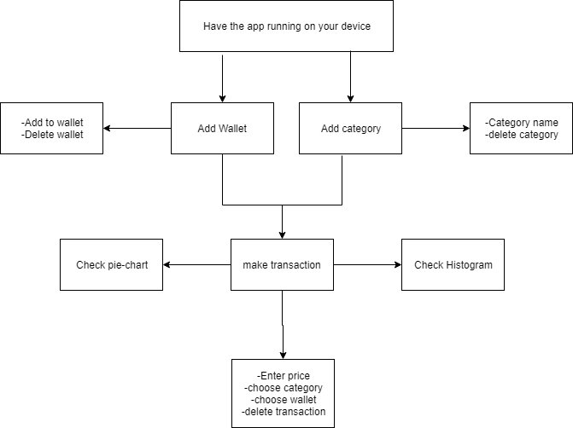

## Structural models

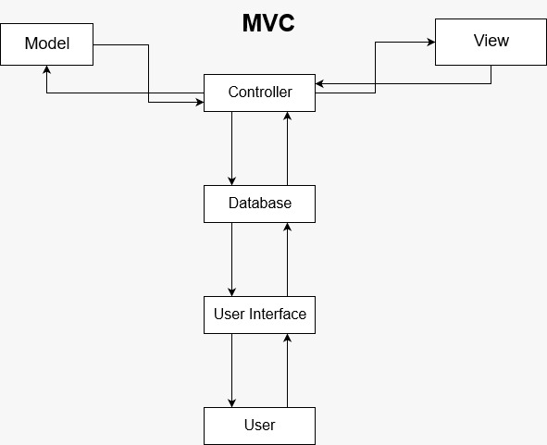

## Behavioral models

Front End

Database

Back end

Get input from user

Parse information and apply operations

Save data into database

Display data back

## Software Documentation

## Database ModelDatabaseModel

## Data Dictionary

|  |  |  |  |  |
| --- | --- | --- | --- | --- |
| Table | Attributes | Datatype | isNull | type |
| WALLET | Wallet_name  budget | Varchar(100)  float | No  No | PK  - |
| Category | Category_name | Varchar(100) | No | PK |
| Transaction | Date  Category_name  Wallet_name  Price | Text  Text  Float | No  No  No  No | PK  FK  FK  - |

# Work Packages, Schedule, and Budget

## Work Packages (WBS)

## Sprint Schedule

|  |  |  |
| --- | --- | --- |
| **Sprint** | **Time Period** | **Description of The Potentially Shippable Product** |
| 1 | 15 days | By the end of this sprint, we will have implemented our local  data-base and tested it (CRUD operations). |
| 2 | 12 days | At the end of this sprint, we will have done with the user interface. |
| 3 | 13 days | At the end of this sprint, the remaining requirements  should be done, like getting the user input from Siri and Google Assistant. |
| 4 | 12 days | By the end of this sprint, we should have started testing our application  to fix any problems found, in addition to optimization. |

## Budget

100$ for apple developer id

# Project Resources

13.2.1. People

Team members:

* + Ali Fayad
  + Ali Jaber
  + Anis Amer
  + Hussein Banjak
  + Mohamad Chehade
  + Professor: Mr. Mahmoud Bdeir
* TA: Sohaib Al-Jundi
  + Walid Allaw

1. 2.2. Hardware and Software

Hardware:

* + Personal laptops

Software:

* + Target Process
  + Slack
* Draw.io
  + Flutter Framework
  + Adobe Photoshop CS6

1. 2.3. Special Resources

None Required.

1. 2.4. Reference Materials

None Referenced.

# About You

## About Me

Ali Fayad:

I am Ali Fayad, a 2nd-year cmps student. I am very interested in philosophy, mainly logic, epistemology, and metaphysics, which are three very interrelated fields of philosophy. Mainly, metaphysics uses logic and epistemology to understand the fundamental nature of existence and being using apriori knowledge – the opposite of empiricism and experimenting. Metaphysics gives a more fundamental understanding of being and is more abstracted and generalized than applied sciences. I entered AUB as a cmps premed but stopped doing premed after being exposed to the logic behind computer science, which happened to occur as I started developing an interest in metaphysics. I am motivated by gaining more knowledge, for as long as the technical limitations allow.

In the future, some friends and I are planning a startup computer science company which would provide various solutions for the community’s different needs. I am interested in all fields of computer science, but particularly software engineering and machine learning. Additionally, I see myself working alongside friend-colleagues in our own startup company. The fact that we have known each other for a very long tie would dramatically increase team collaboration and focus on finding solutions for problems.

Ali Jaber:

A computer science student at AUB. My main interest in the field of computer science is Programming. I enjoy programming classes more than the theoretical part of this field. I like to code and create my own programs just to test and always build up from scratches. I found that self-teaching is an effective way to acquire experience and the ability to solve problems in the upcoming future.

I’m thinking of completing my master’s degree in this field, work in a company that develops applications, and software and maybe an instructor in the university.

Anis Amer:

I am Anis Amer, a computer science student at AUB. I am interested in developing mobile applications, and my motivation comes from making human life easier. I am a hard worker, and I seek to acquire knowledge in order to be up to date with this exponential growth of technology.

My future plan is to have my own startup. Besides, my motivation comes from fulfilling human needs in societies where life becomes easier. However, in 5 years, I want to work with a company because I want and experience that helps me, later, work on my startup. Moreover, I would like to be introducing computer science to schools in my region because I see this as an essential need.

Hussein Banjak:

I am majoring in computer science at AUB. I have first picked up programming at the university which then turned into a second hobby mainly due to its problem-solving criteria. Always being up to challenge, I gradually got more into inquiry and knowledge seeking. This, in turn, pushed me into working hard pursuing my goals which also played a big role in improving my academic level. After acquiring my bachelor's degree, I plan to either apply for graduate studies or work in the software industry.

Well, in five years, I’d like to be seen as someone with deep expertise in the software sector. I’m also really excited to take the lead on some projects while gaining more skills and experience.

Mohamad Chehade:

I am a computer science student at AUB. After entering AUB, I discovered that programming is my passion. Therefore, I would always look for programming challenges no matter the difficulty, which made me a knowledgeable individual in programming. Lastly, due to my love for Cmps, I always put in extra effort to make sure that the project quality is up to my standards. All in all, I plan to either apply for graduate studies in the US or work in the software industry.

Walid Allaw:

I am Walid Allaw, a junior cmps student. I had the chance to get a full scholarship and came to AUB in order to complete my education. First, I aimed to be an engineer, but since I was a French-educated student, I needed to complete one year at university preparatory program to improve my linguistic skills. This prevented me from being an engineer, so I chose to major in Computer Science, although I didn’t have experience in this field. Since my first day in this major, I started to be passionate with what I do, and I did whatever I needed to be better. Now, I am very satisfied about what I do; I feel that I am in the right way to learn more about software engineering and computer science in general.

I am planning soon to apply to an internship; I will take this software as an additional opportunity to improve my CV beside the technical skills which I already learned. For the future, my main plan is to learn because every day we have something new. In addition, definitely I will search for a job in this field most probably in a company or a bank.

## Lessons Learned From Working in a Team

* Every software project needs enough communication and patience to work successfully

• The work should be well divided among team members because being a lone wolf hinders development for everyone

• For successful app development, the group must take advantage of the group’s collective knowledge, because individuals are limited to their own experiences, therefore sharing provides members with a broader spectrum of ideas and diversifies options

• Learned new programming languages that were challenging but fun to integrate.

• Every team member should respect the others’ work even if they have failed in order to maintain their motivation to complete the work at hand

• Deadlines aren’t a stress creator if all team members face them hand by hand

• Peer review is the best strategy to deliver the best version of the work

• Face to face meetings can help to exchange ideas between the team members and the investors (managers) without any confusion, and work directly on fixing some problems

• Never expect successful work without sacrificing a major part of your time for it