COVER LAPORAN
SESUAIIN AJA

Question 1 – Quadratic Equation
Key Functions: Uses sqrt() and conditionals to compute the discriminant D=b2−4ac.
Description: If D>0, two real roots; if D=0, one root; otherwise, no real roots.
Test Case: Input 1 -3 2 → Output r1 = 2, r2 = 1
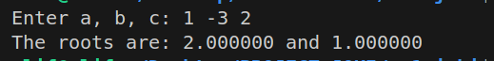
Comment: Meaningful variable names a,b,c; formatted using setprecision(6).

Question 2 – Regular Polygon Area
Key Functions: Applies trigonometric formula
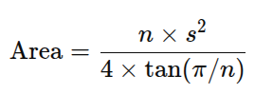

Test Case: Input sides=5, length=6.5 → Area = 72.69
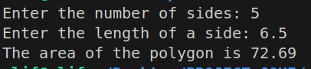

Comment: Demonstrates math library usage and floating-point formatting.

Question 3 – Integer Counter
Key Functions: Loops input until 0; counts positive/negative, totals, averages.
Test Case: Input 1 2 -1 0 → pos=2, neg=1, sum=2, avg=0.67
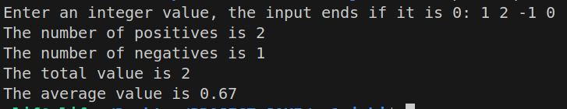

Comment: Uses clear counters pos, neg, sum, count and proper condition checks.

Question 4 – Binary to Decimal
Key Functions: Converts binary string to decimal using power of two.
Algorithm: Iterate over string; add 2(n−1−i) for each ‘1’.
Test Case: Input 10001 → Output 17
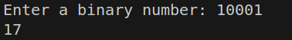

Comment: Demonstrates string processing and numeric conversion.

Question 5 – Distinct Numbers
Key Functions: Nested loops to identify unique integers from 10 inputs.
Algorithm: Store new values only if not in distinct[].
Test Case: 1 2 3 2 1 6 3 4 5 2 → 6 distinct numbers
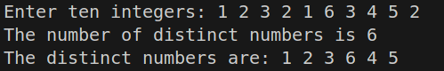

Comment: Good array logic and duplicate detection.

Question 6 – Sum of Matrix Columns
Key Functions: sumColumn() adds values from each column of a 3×4 matrix.
Test Case:
Matrix input
1 2 3 4
5 6 7 8
9 10 11 12
Output → Column sums = 15, 18, 21, 24
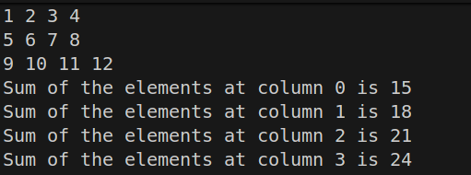

Comment: Demonstrates 2D-array traversal with modular design.

Question 7 – Rectangle Class
Key Functions: OOP implementation with constructors, getArea(), getPerimeter().
Test Case: Rectangle(4,40) → Area = 160, Perimeter = 88
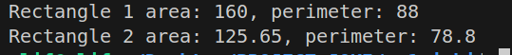

Comment: Introduces encapsulation; variable names reflect geometry concepts.

Question 8 – Rectangle2D Class
Key Functions: Adds OOP methods: contains(x,y), contains(Rect), overlaps(Rect).
Algorithm: Use center and half-width/height for geometric comparisons.
Test Case: r1(2,2,5,5) and r2(4,3,2,2) → False & true
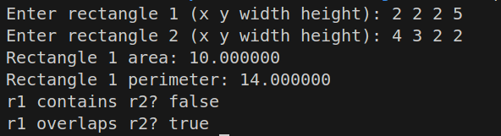
Comment: Shows solid understanding of OOP and spatial reasoning.

Question 9 – Bounding Rectangle
Key Functions: Finds min/max x and y from points; computes bounding rectangle center and size.
Algorithm: width = maxX − minX, height = maxY − minY.
Test Case: 1.0 2.5 3 4 5 6 7 8 9 10 → Center (5, 6.25), Width 8, Height 7.5
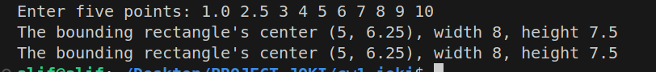
Comment: Demonstrates composite class usage and pointer handling.

Overall Analysis and Conclusion
- The assignment progressively develops from basic input/output to OOP.
- Every program was successfully compiled and executed, producing correct results.
- Variable names and comments were concise and meaningful.
- The modular design improved readability and testing.
- Concepts covered: control structures, arrays, mathematical formulas, and OOP principles.

