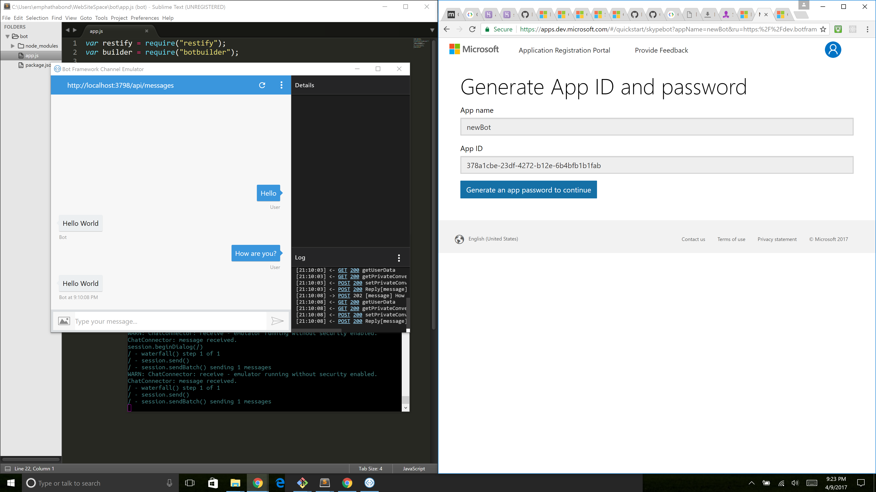

newBot

ID:

378a1cbe-23df-4272-b12e-6b4bfb1b1fab

PW:

X6dhXNnwtRo6AXhhQLkc8Rn