**Front End**

* Home
* About
* Contact
* List of Campaign

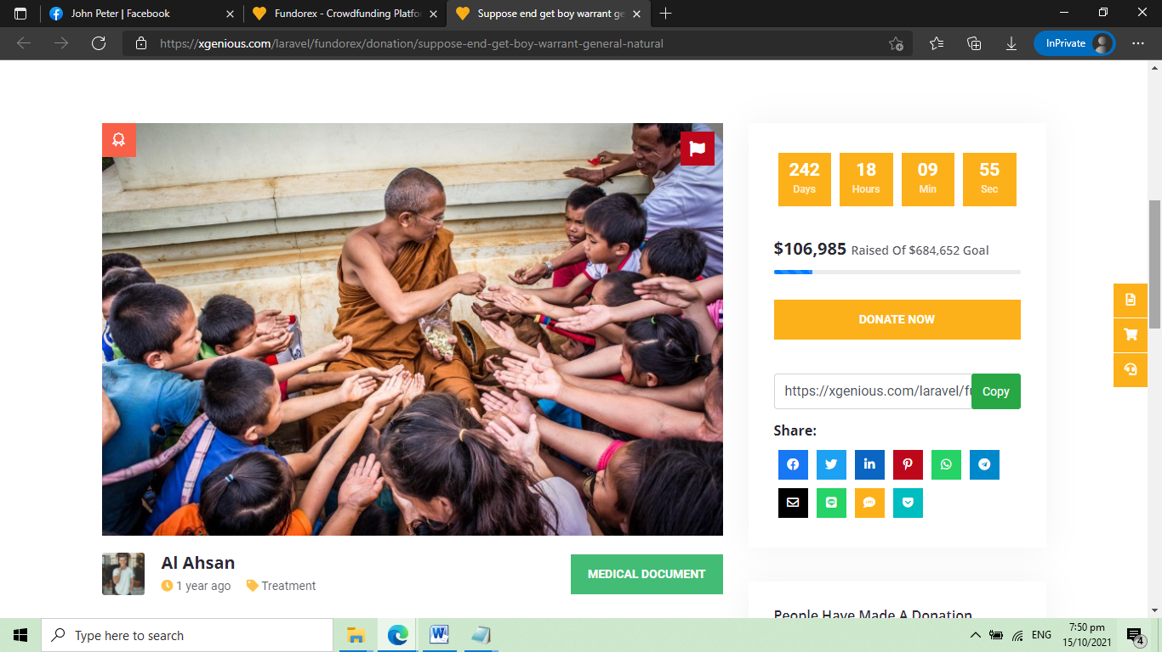

Sample: https://xgenious.com/laravel/fundorex/

**Login Form**

**Admin Dashboard**

* Total User
* Total Events
* Total Campaign
* Total Members

**Member Information**

* Name
* Email
* Complete Address
* Profile Image
* Proof of Identity – upload document
* Username
* Password
* Account Status – active, inactive

**Campaign Category**

* Category name
* Description

**Campaign List** – admin can only view, approve and disapprove

* Category
* Campaign Name
* Description
* Target Amount
* Deadline
* Upload Campaign Banner
* Status – approve, disapprove

**Campaign Gallery**

* Campaign Name
* Upload Image
* Description

**Donation Information** – admin can only view, approve and disapprove

* Campaign name
* Donated By
* Amount
* Date
* Status – approved, declined

**Withdraw Logs**

* Campaign name
* Total Amount
* Date of Approval
* Requested By
* Status – pending, withdrawn
* Remarks

**Report – Raised per Month**

**User Management**

* Username
* Password
* Complete Name
* Email
* Profile Picture

**Member Dashboard**

* Number of Campaign
* Total Donations

**Campaign List** – create and update campaign

* Category
* Campaign Name
* Description
* Target Amount
* Deadline
* Upload Campaign Banner
* Status – approve, disapprove, pending

**Campaign Gallery**

* Campaign Name
* Upload Image
* Description

**Donation Information** – table only

* Campaign name
* Donated By
* Amount
* Date

**Request to Withdraw**

* Campaign name
* Total Amount
* Date of Approval
* Status – pending, withdrawn
* Remarks

**Profile**

* Name
* Email
* Complete Address
* Profile Image
* Proof of Identity – upload document
* Username
* Password