Lab 2: Agile Backlog Creation & Sprint Simulation in Jira
Urban Rooftop Gardening Co-op App | Problem Statement #65
Name: Sadikot Alifiya Mustafabhai | SRN: PES1UG25CS841
SE Lab | Semester 5 | PES University | September 2026
1. Epics Created in Jira
Epic | Description | Traces To | Priority | Story Pts
Epic 1: Rooftop Plot Registration & Approval | Enable Co-op Gardeners to register rooftop plots and Community Leaders to approve them before they go active. | FR-002 | High | 8
Epic 2: Crop Planting & Harvest Tracking | Enable gardeners to log crop planting data and receive system-computed harvest windows and yield estimates. | FR-001 | High | 8
Epic 3: Surplus Produce Trading | Enable gardeners to list, reserve, and settle trades for surplus produce with other co-op members. | FR-003, FR-004 | High | 13
Epic 4: Soil Maintenance Knowledge Sharing | Enable gardeners to share and discover moderated soil-maintenance tips. | FR-005 | Medium | 5
Epic 5: Platform Performance & Accessibility | Ensure the platform performs reliably (real-time trade board) and is accessible to first-time, mixed-ability users. | NFR-001, NFR-002 | High / Medium | 13

2. User Stories with Story Points
Story | As a… | I want to… | So that… | Pts | Priority
Story 1.1: Register Rooftop Plot | Co-op Gardener | Register my rooftop plot with building address, area, sunlight hours and soil type | I can start using the platform for my garden | 5 | High
Story 1.2: Approve Plot Registration | Community Leader | Review and approve pending plot registrations | Only verified plots become active | 3 | High
Story 2.1: Log Crop Planting | Co-op Gardener | Log the planting date, crop type and plot ID for a crop | The system can estimate my harvest window and yield | 5 | High
Story 2.2: Receive Harvest Alert | Co-op Gardener | Receive an alert when my crop reaches its predicted harvest window | I can harvest my crop at the right time | 3 | Medium
Story 3.1: List Surplus Produce | Co-op Gardener | Publish a surplus-produce listing with crop, quantity, availability and exchange mode | Other members can trade for my extra produce | 5 | High
Story 3.2: Reserve and Settle a Trade | Co-op Gardener | Reserve a surplus listing and complete payment or barter confirmation | I receive produce with a trade receipt | 8 | High
Story 4.1: Post a Soil Tip | Co-op Gardener | Post a soil-maintenance tip tagged by soil type and crop | I can share knowledge with other members | 3 | Medium
Story 4.2: Search Soil Tips | Co-op Gardener | Search and filter approved soil tips by tag | I quickly find advice relevant to my crop | 2 | Medium
Story 5.1: Real-Time Trade Board Updates | Co-op Gardener | The trade board refreshes within 2 seconds when a listing changes | I always see accurate produce availability | 8 | High
Story 5.2: Accessible Plot Registration | First-time Gardener | Complete plot registration in under 3 minutes on an accessible screen | I can join the co-op regardless of technical ability | 5 | Medium
TOTAL |  |  |  | 47

3. Sprint Plan
Sprint | Stories | Points | Duration | Focus
Sprint 1 | Story 1.1, 1.2, 2.1, 2.2 | 16 pts | 1 Week | Core Registration & Crop Tracking
Sprint 2 | Story 3.1, 3.2, 4.1, 4.2 | 18 pts | 1 Week | Trading & Knowledge Sharing
Backlog / Sprint 3 | Story 5.1, 5.2 | 13 pts | Sprint 3 | Performance & Accessibility

4. Jira Screenshots
4.1 Full Backlog — Epics, User Stories & Story Points
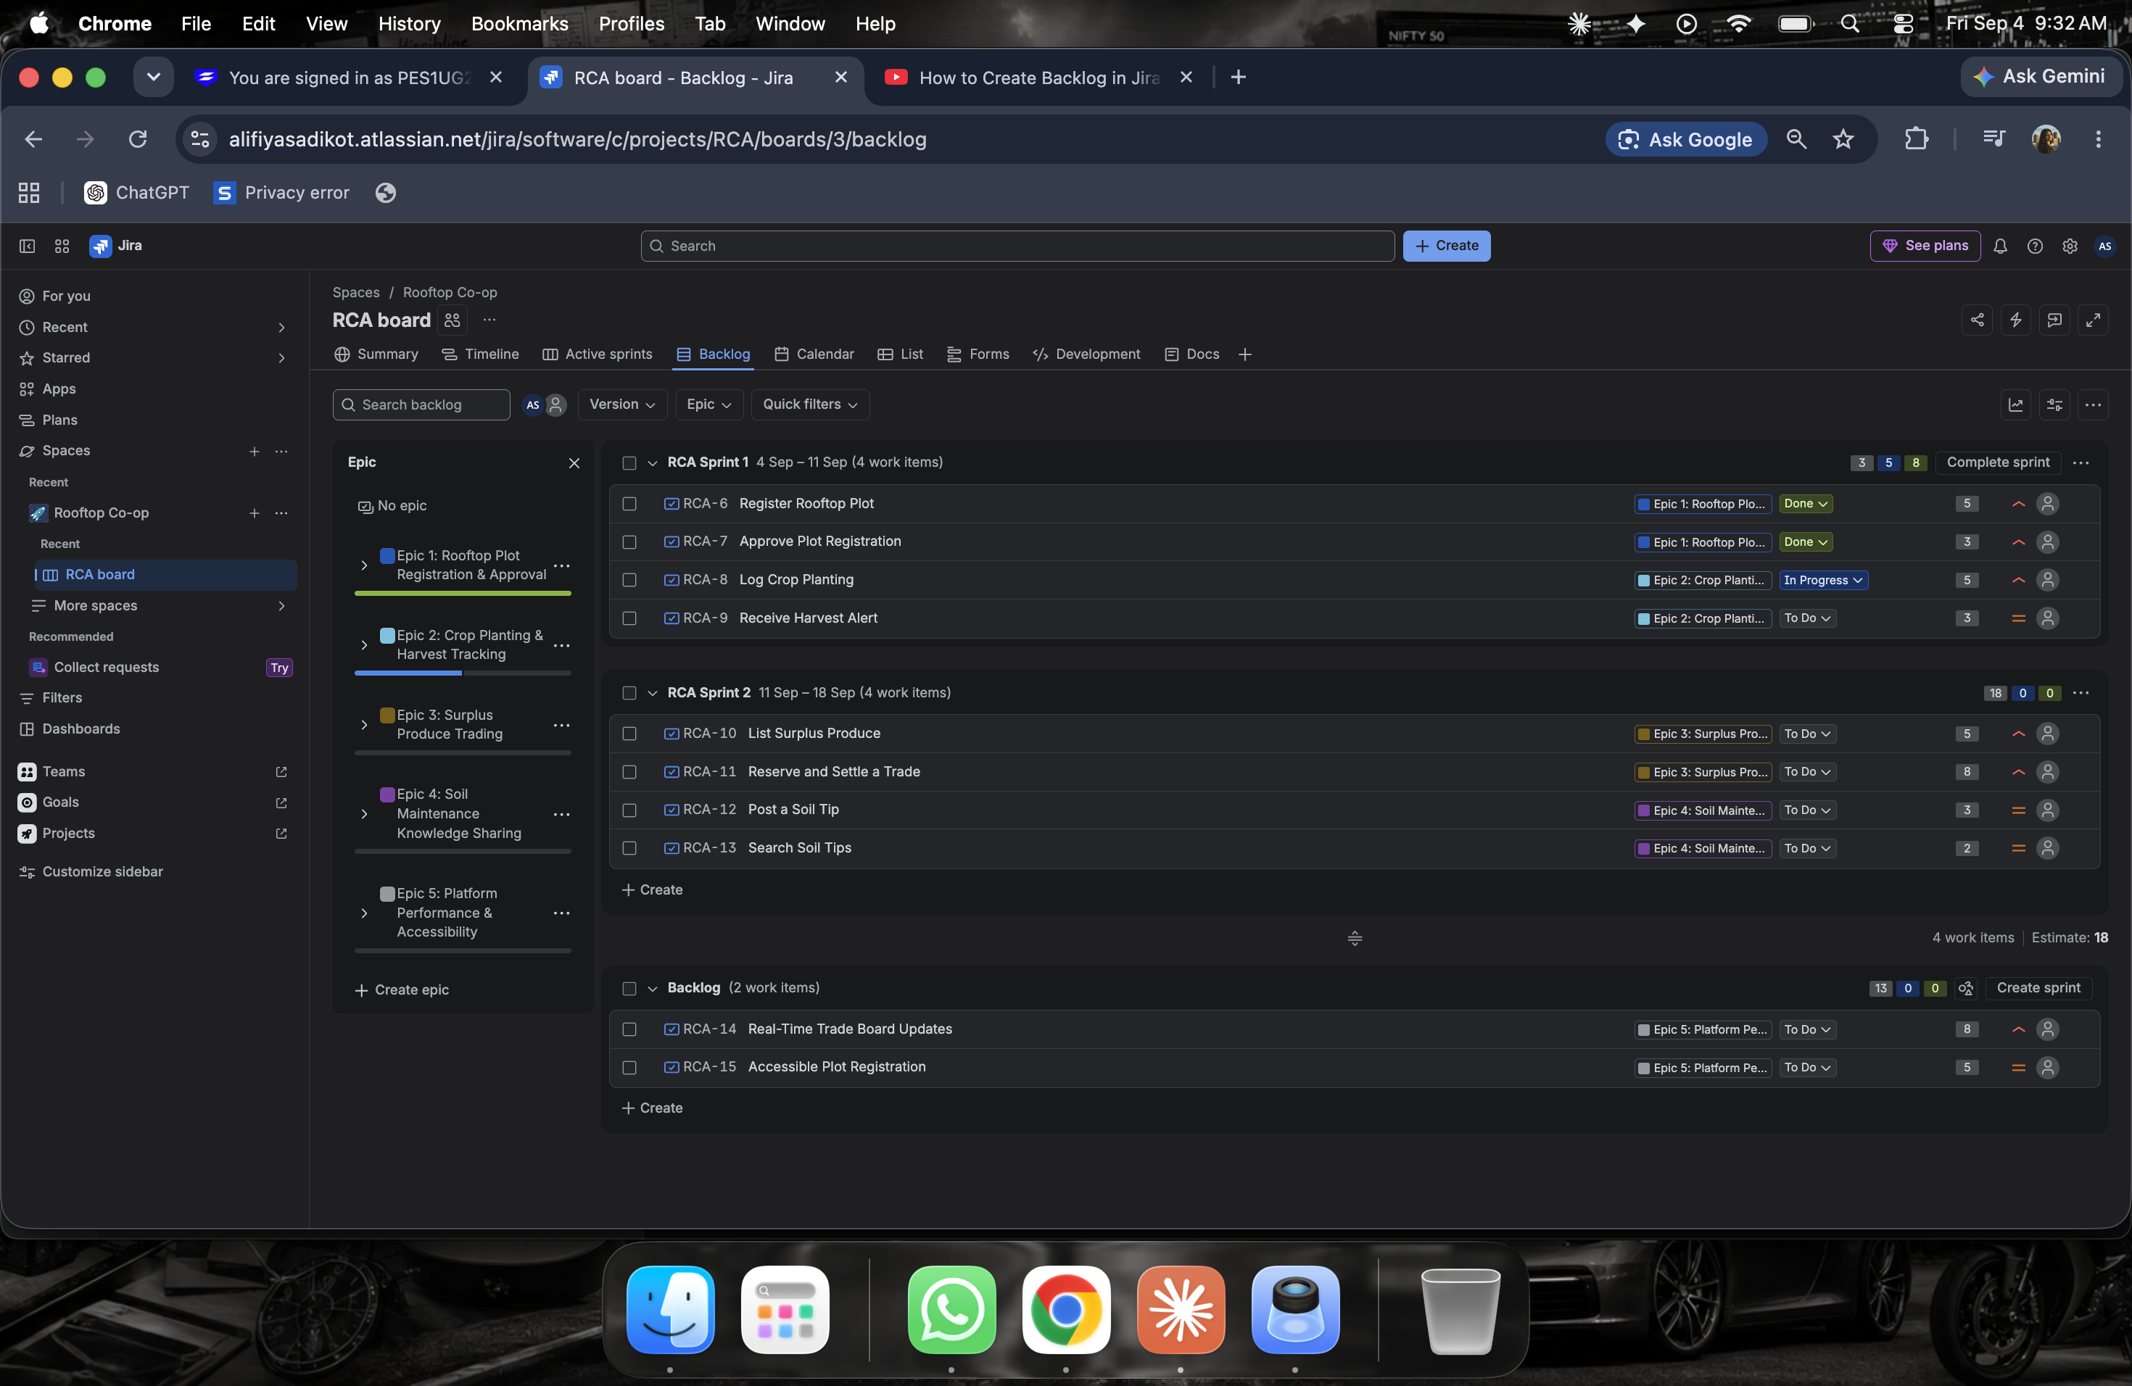
Fig 1: RCA Backlog — 5 Epics, 10 User Stories across Sprint 1, Sprint 2 and remaining Backlog with story points
4.2 Active Sprint Board — Sprint 1 (In Progress)
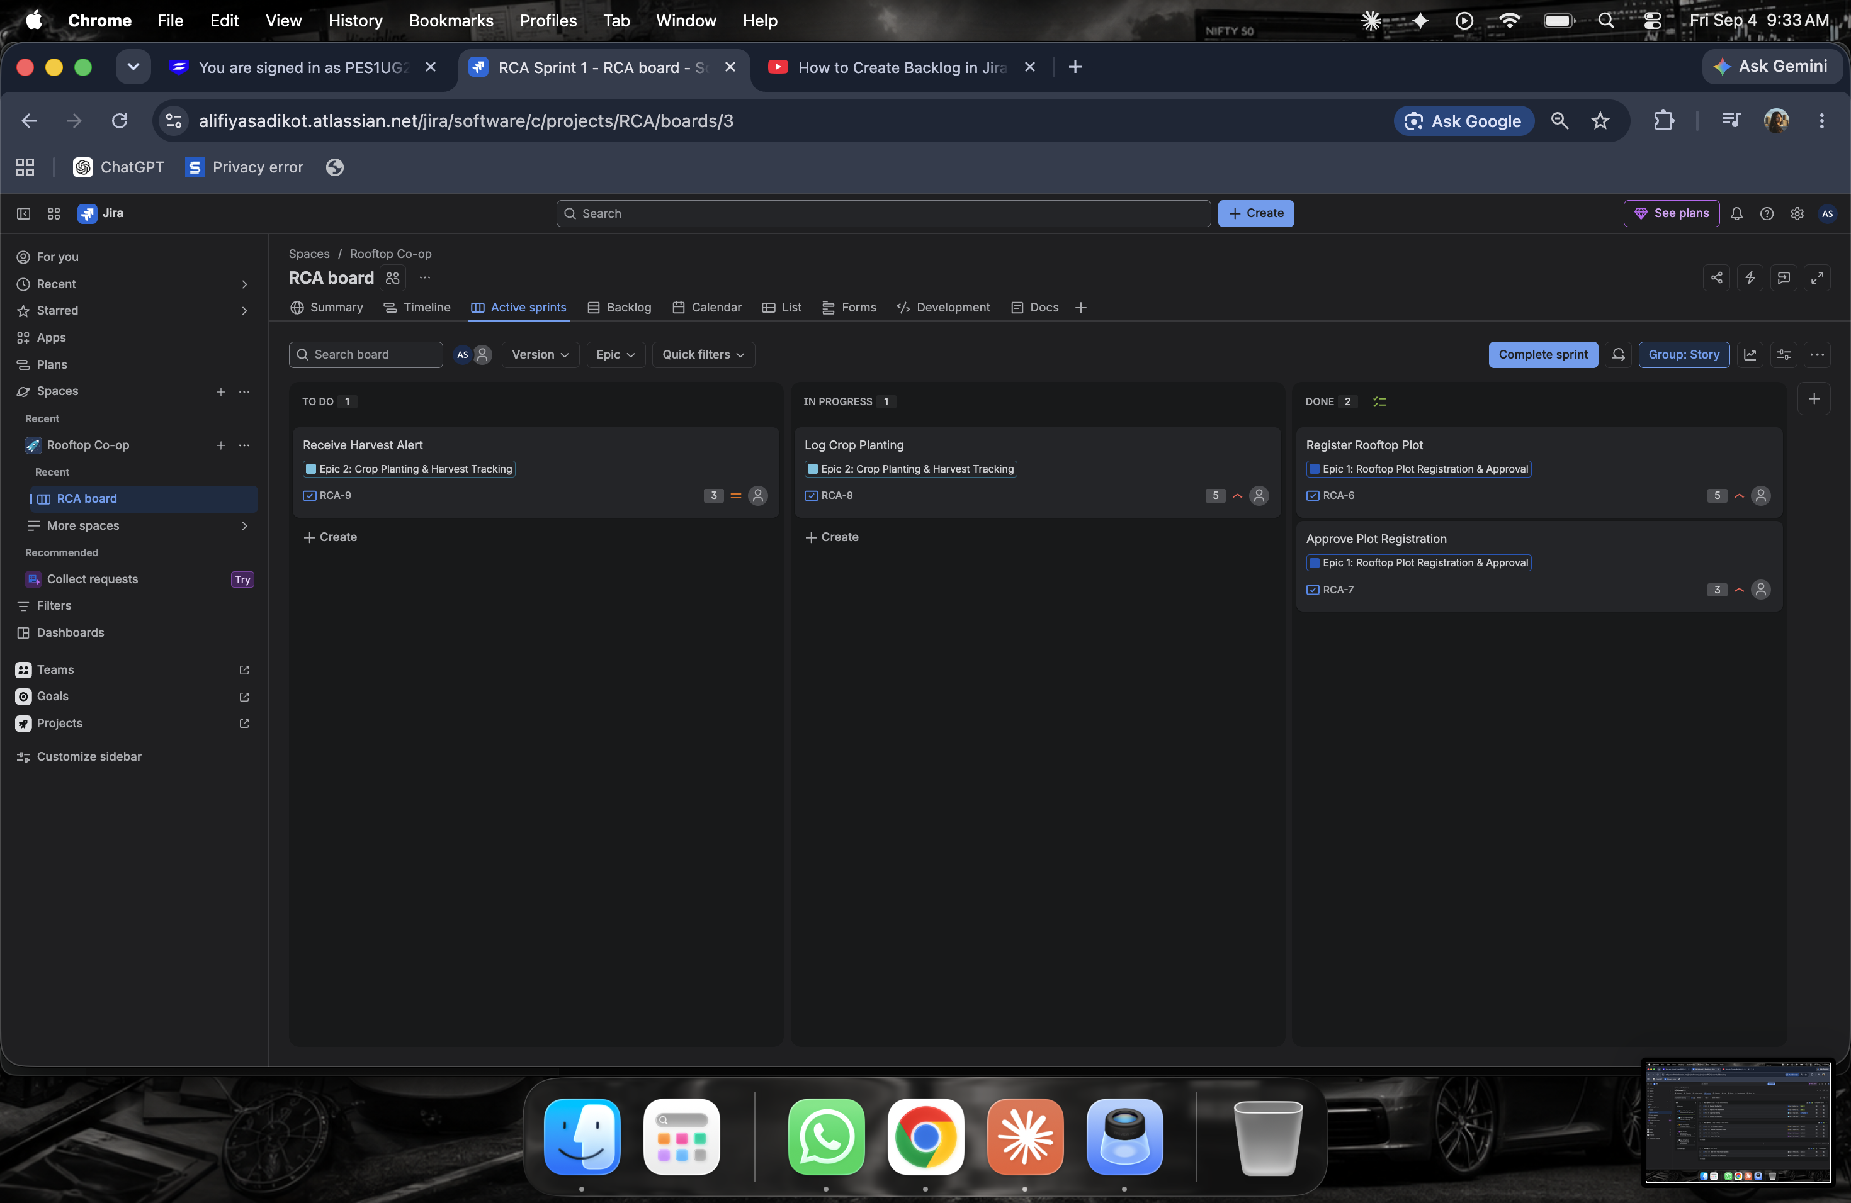
Fig 2: Sprint 1 Active Board — Register Rooftop Plot & Approve Plot Registration (Done), Log Crop Planting (In Progress), Receive Harvest Alert (To Do)
4.3 Active Sprint Board — Sprint 2 (In Progress)
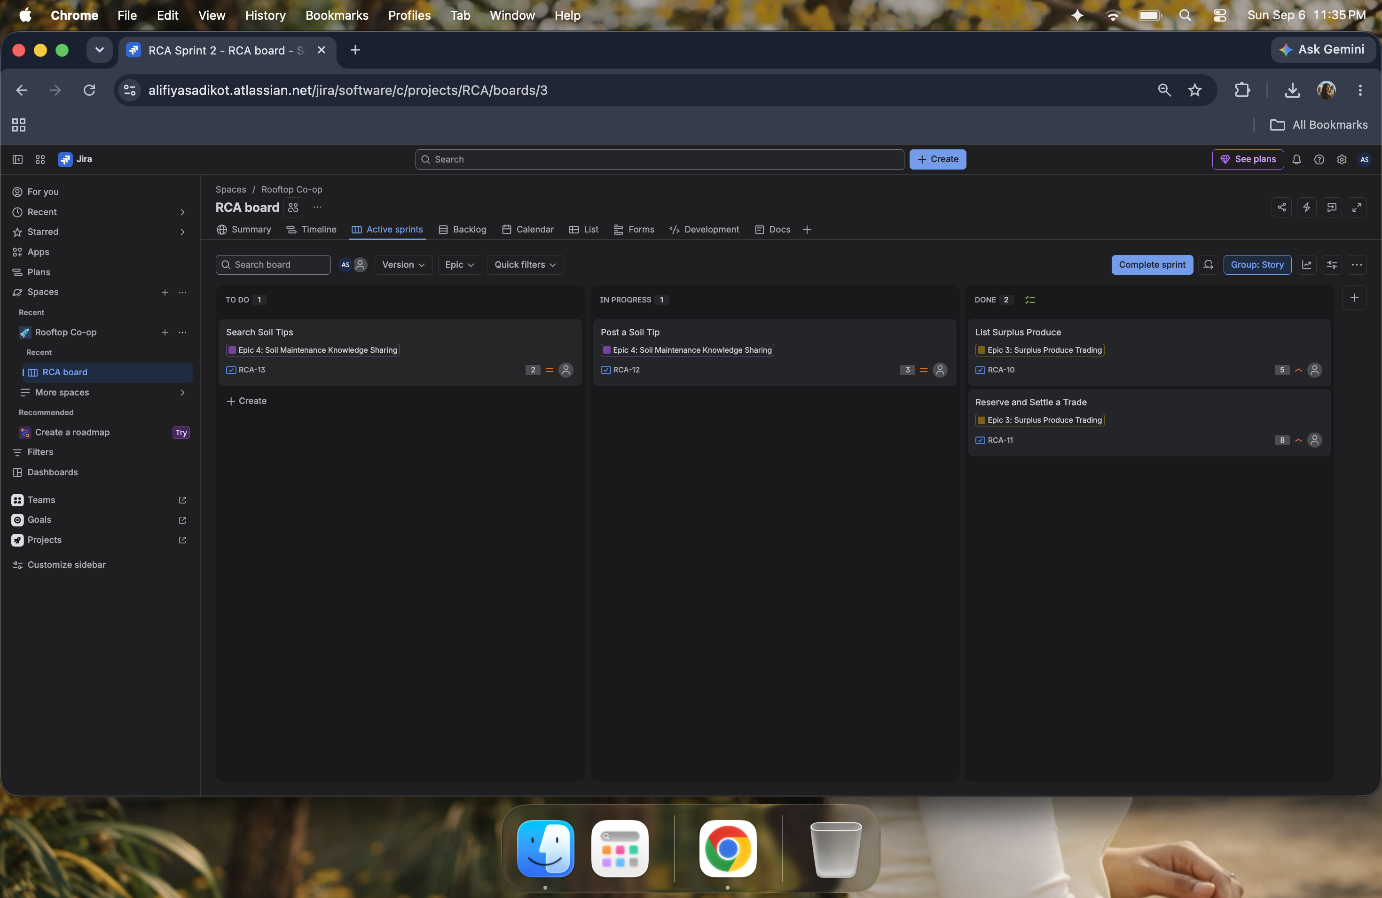
Fig 3: Sprint 2 Active Board — List Surplus Produce & Reserve and Settle a Trade (Done), Post a Soil Tip (In Progress), Search Soil Tips (To Do)
4.4 Sprint 2 Board — All Stories Completed
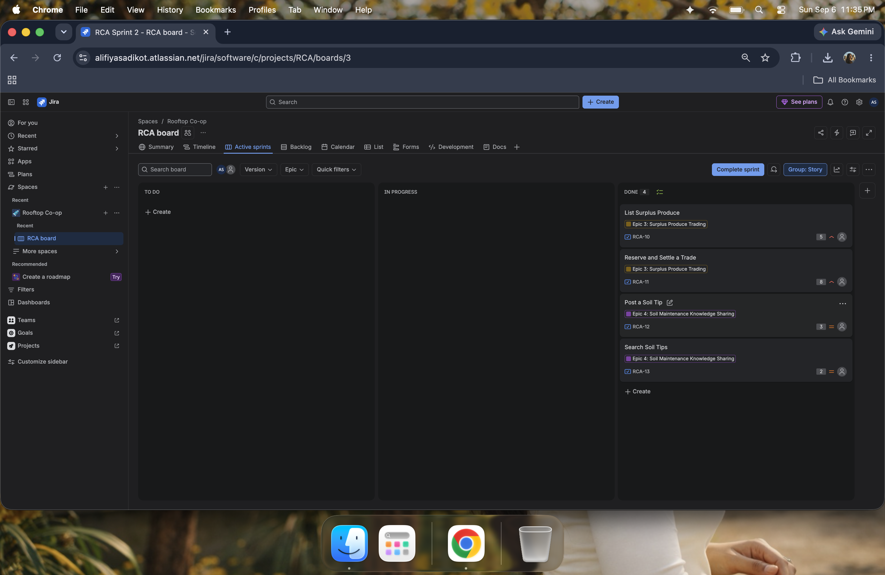
Fig 4: Sprint 2 with all 4 stories moved to Done
4.5 Complete Sprint 2 — Sprint Completion Dialog
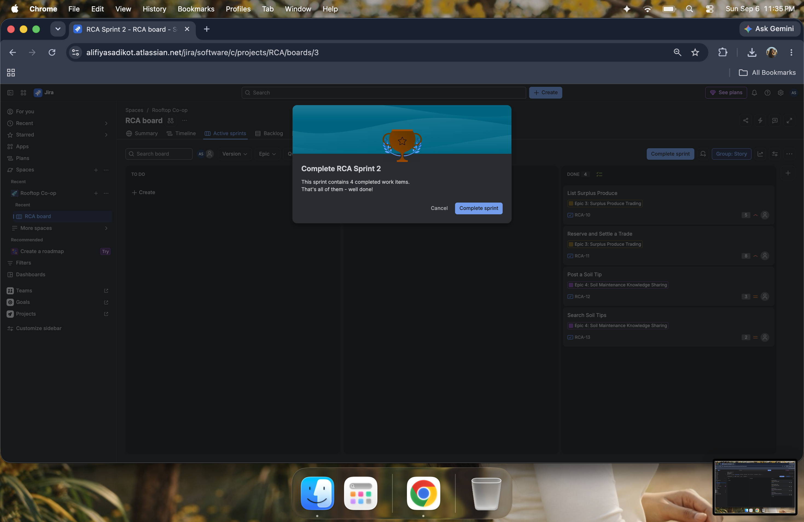
Fig 5: Jira confirmation dialog — 4 completed work items, sprint complete
4.6 Post-Sprint Backlog — Remaining Epic 5 Stories
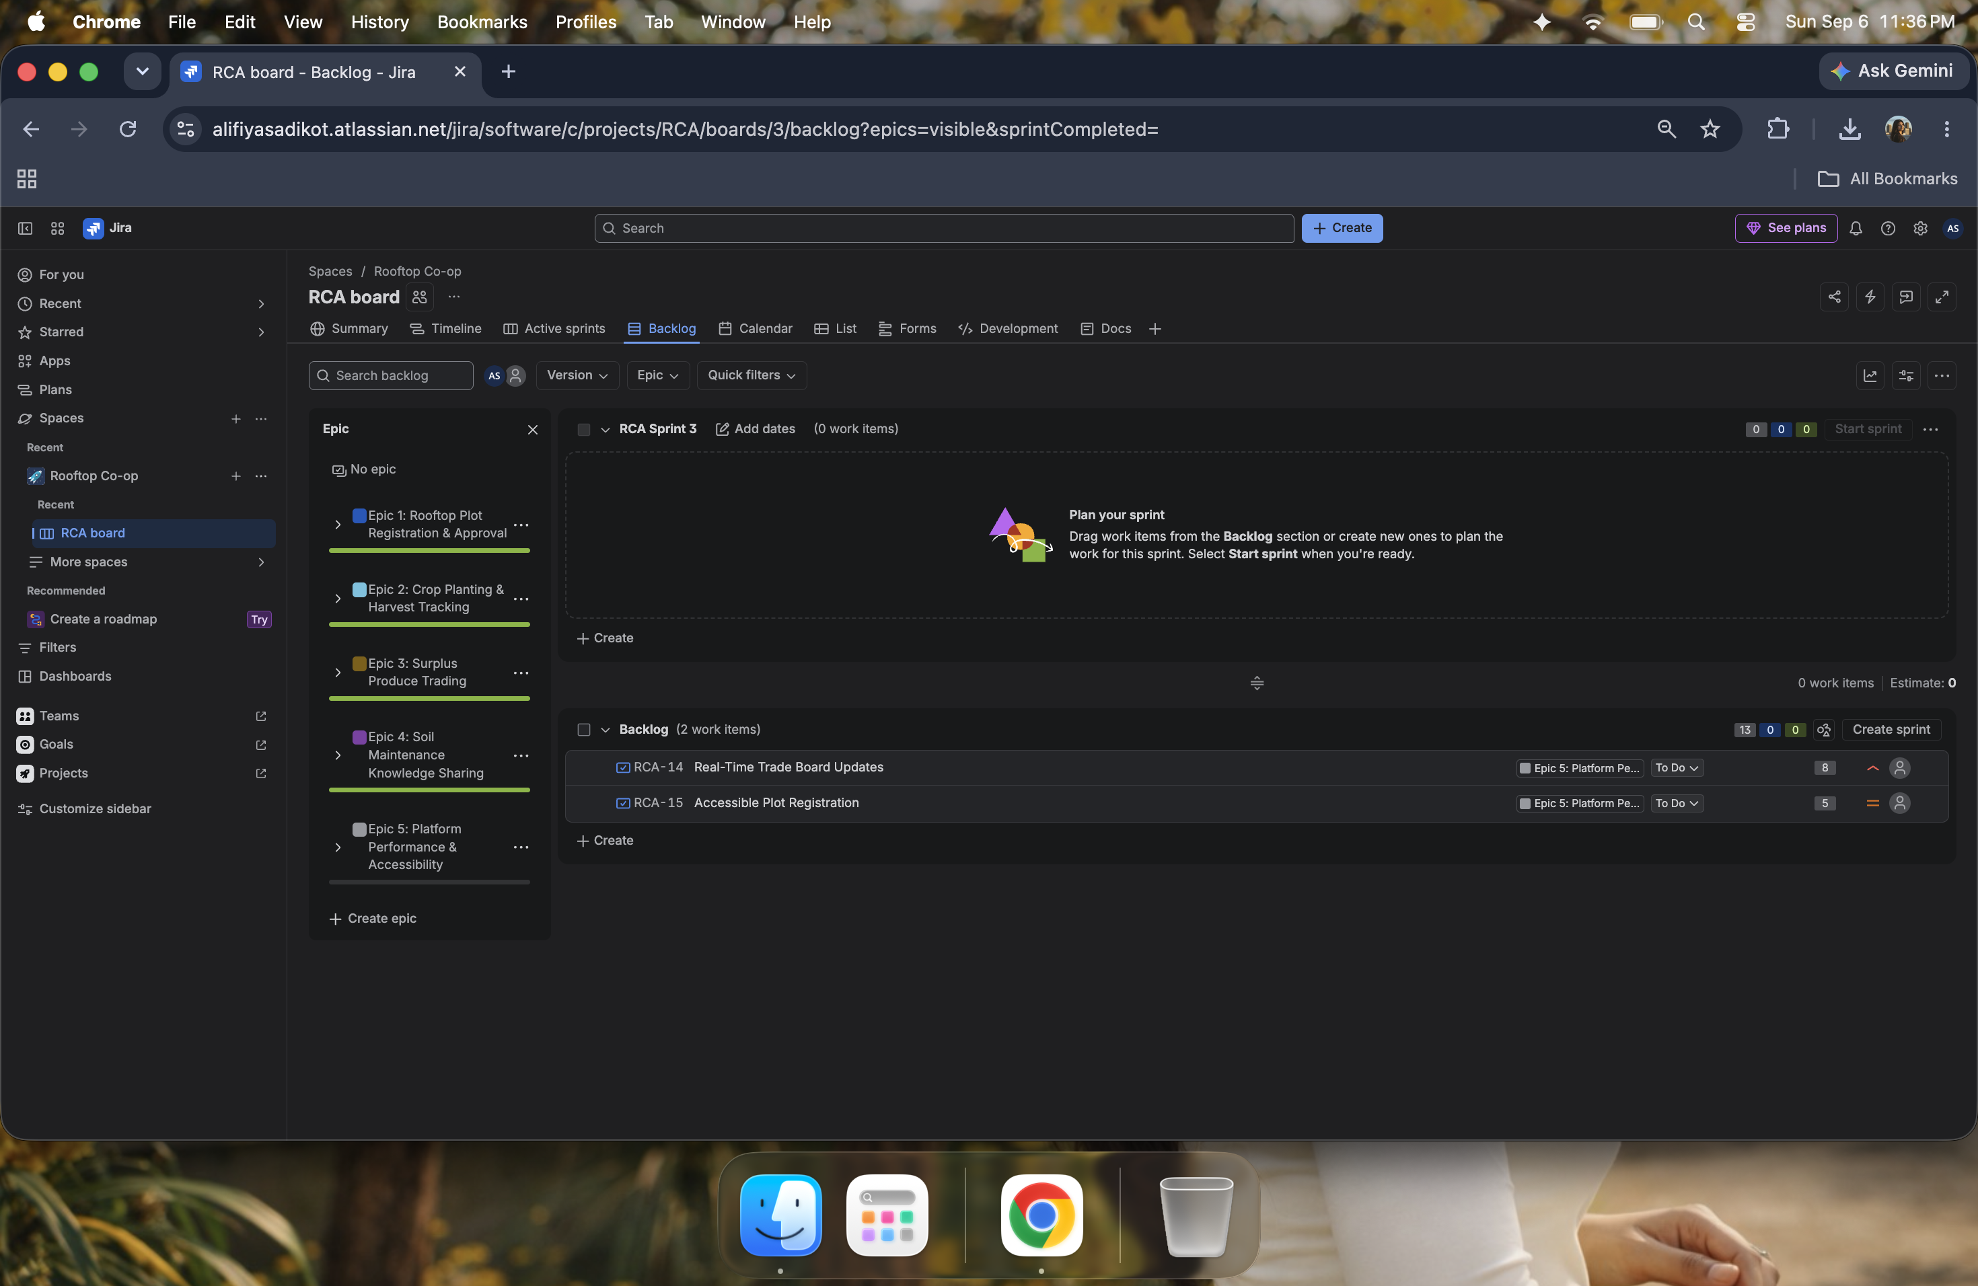
Fig 6: Backlog after both sprints — Epic 5 stories remain for Sprint 3
4.7 Burndown Chart — RCA Sprint 1
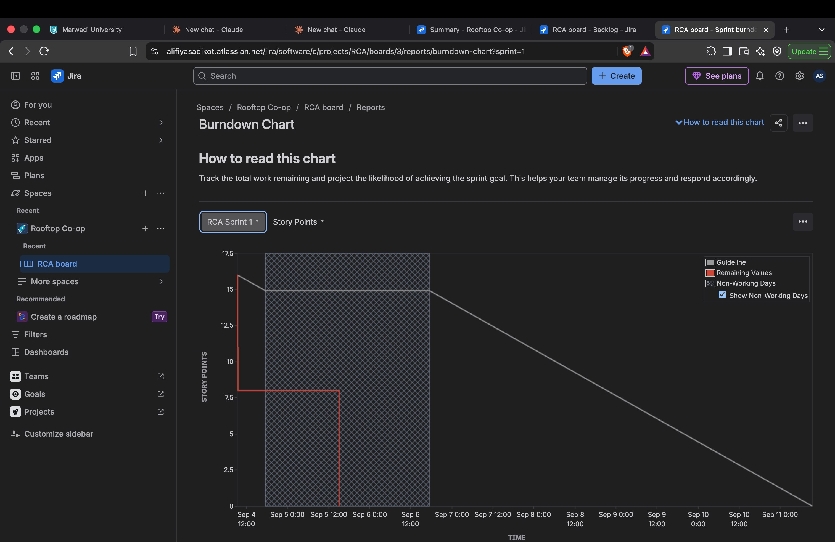
Fig 7: Sprint 1 Burndown Chart — Story Points remaining vs Time (Sep 4 → Sep 6)
4.8 Burndown Chart — RCA Sprint 2
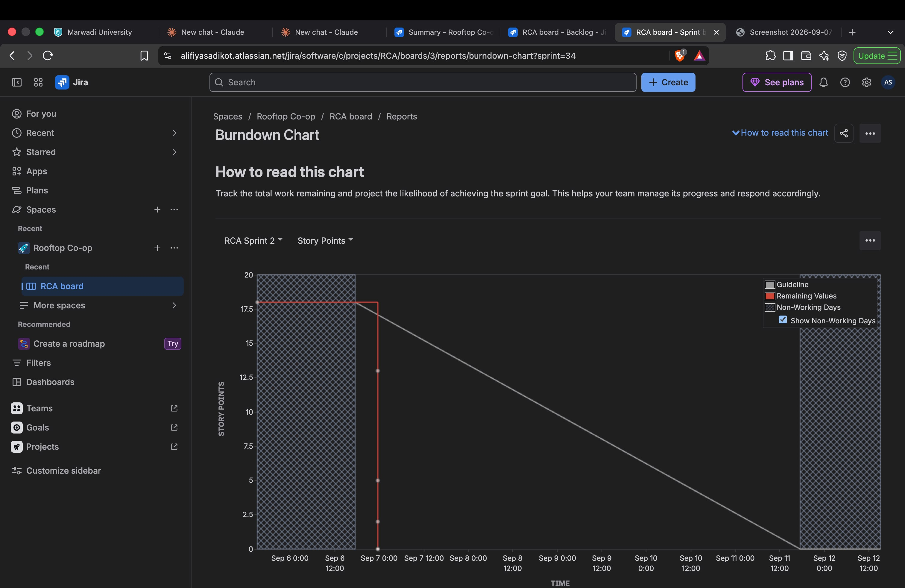
Fig 8: Sprint 2 Burndown Chart — all 18 story points burned down by sprint close on Sep 7

5. Reflection Questions
Q1. Did your estimations reflect the actual effort required for each story?
Largely yes. Stories tied to system logic and validation — such as Story 1.1 (Plot Registration, 5 pts), Story 2.1 (Log Crop Planting, 5 pts), and Story 3.2 (Reserve and Settle a Trade, 8 pts) — were estimated higher because they involve computed fields such as harvest-window calculation and concurrency-safe trade settlement. Simpler CRUD-style stories like Story 4.2 (Search Soil Tips, 2 pts) and Story 1.2 (Approve Plot Registration, 3 pts) were given lower estimates since their logic is straightforward. Moving cards through To Do → In Progress → Done felt proportionate to the assigned story points. Story 3.2 was the most likely to be underestimated in a real team setting given its barter/payment confirmation edge cases.
Q2. Was your backlog well-prioritized?
Yes. The four High-priority functional epics — Plot Registration (Epic 1), Crop Tracking (Epic 2), and Surplus Trading (Epic 3) — were sequenced first, matching the priority column from the Lab 1 requirements table. The Soil Knowledge Sharing epic (Epic 4) was placed at Medium priority because it provides supplementary rather than core value. The NFR-driven Platform Performance and Accessibility epic (Epic 5) was deliberately deferred to the backlog as a Sprint 3 item: performance hardening and accessibility polish are only meaningful once the functional trading flow exists and can be measured.
Q3. How did your simulated sprint align with your initial plan?
Sprint 1 aligned closely — all four stories (1.1, 1.2, 2.1, 2.2) were completed for 16 story points. Sprint 2 similarly completed all four trading and knowledge-sharing stories (3.1, 3.2, 4.1, 4.2) for 18 points. The only deliberate deviation was leaving Epic 5 stories in the backlog rather than force-fitting them into Sprint 2, keeping each sprint focused and within a realistic 16–18 point capacity band. As confirmed in the Jira completion dialog (Fig 5), Sprint 2 ended with 4 work items fully completed.
Q4. What insights did the burndown chart give about team capacity and planning?
The Burndown Charts for Sprint 1 and Sprint 2 (Figs 7–8) show a step-function drop in remaining story points rather than a smooth daily decline — a characteristic pattern in simulated sprints where cards are moved to Done in batches. Sprint 1 started at 16 pts and Sprint 2 at 18 pts; both ended at 0. In a live team context, a late sharp drop signals batched work rather than continuous integration, which is a risk for merge conflicts and integration bugs. The two-sprint structure demonstrated a realistic capacity target for a small team, with Epic 5 stories (13 pts) properly deferred to Sprint 3.

6. Deliverables Summary
Deliverable | Status | Notes
Jira Backlog with Epics and User Stories | ✓ Screenshot | Fig 1 — 5 Epics, 10 Stories
Story Point Assignments | ✓ Screenshot | Fig 1 — 47 total story points
Active Sprint Board — Sprint 1 | ✓ Screenshot | Fig 2 — To Do / In Progress / Done
Active Sprint Board — Sprint 2 | ✓ Screenshot | Figs 3 & 4 — In Progress and Done
Sprint Completion Confirmation | ✓ Screenshot | Fig 5 — "Well done!" dialog
Post-Sprint Backlog (Epic 5 items) | ✓ Screenshot | Fig 6 — Sprint 3 stretch items
Burndown Chart — Sprint 1 | ✓ Screenshot | Fig 7 — Story points vs time
Burndown Chart — Sprint 2 | ✓ Screenshot | Fig 8 — Story points vs time
Reflection Document | ✓ Completed | Section 5 above

— End of Lab 2 Submission — Sadikot Alifiya Mustafabhai | PES1UG25CS841 —

